DATA VISUALIZATION USING
MICROSOFT POWER BI
BISM2202 Assessment Report - Version A
Student Name: __________
Student ID: __________
Total Questions: 20
Total Points: 20
Screenshots marked as placeholders must be replaced with genuine Power BI Desktop screenshots before submission.

Q1 | 0.5 points
What is the top 20 locations based on count of order number?
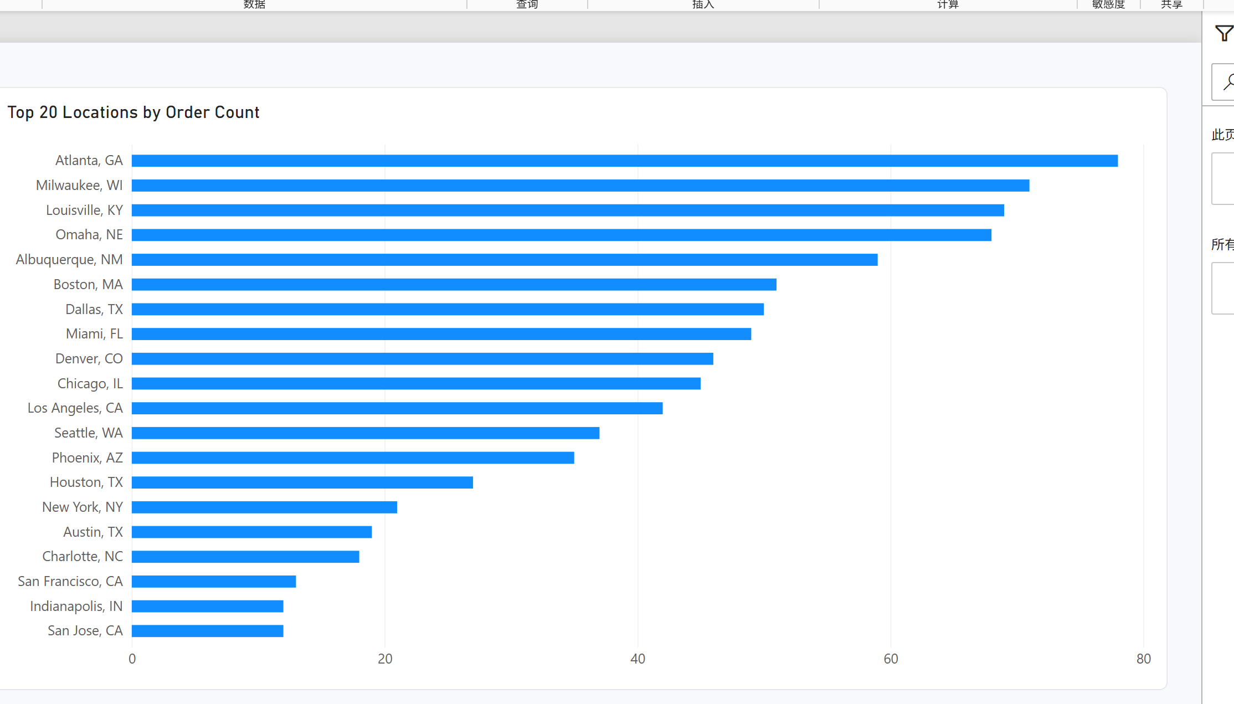
Figure Q1. Power BI visualization.
Observation / answer / explanation
Atlanta, GA ranked first with 78 orders, followed by Milwaukee, WI with 71 and Louisville, KY with 69. The horizontal ranking makes the difference between the leading locations easy to compare.

Q2 | 0.5 points
What is the average Delivery Duration (min) by Pizza Size?
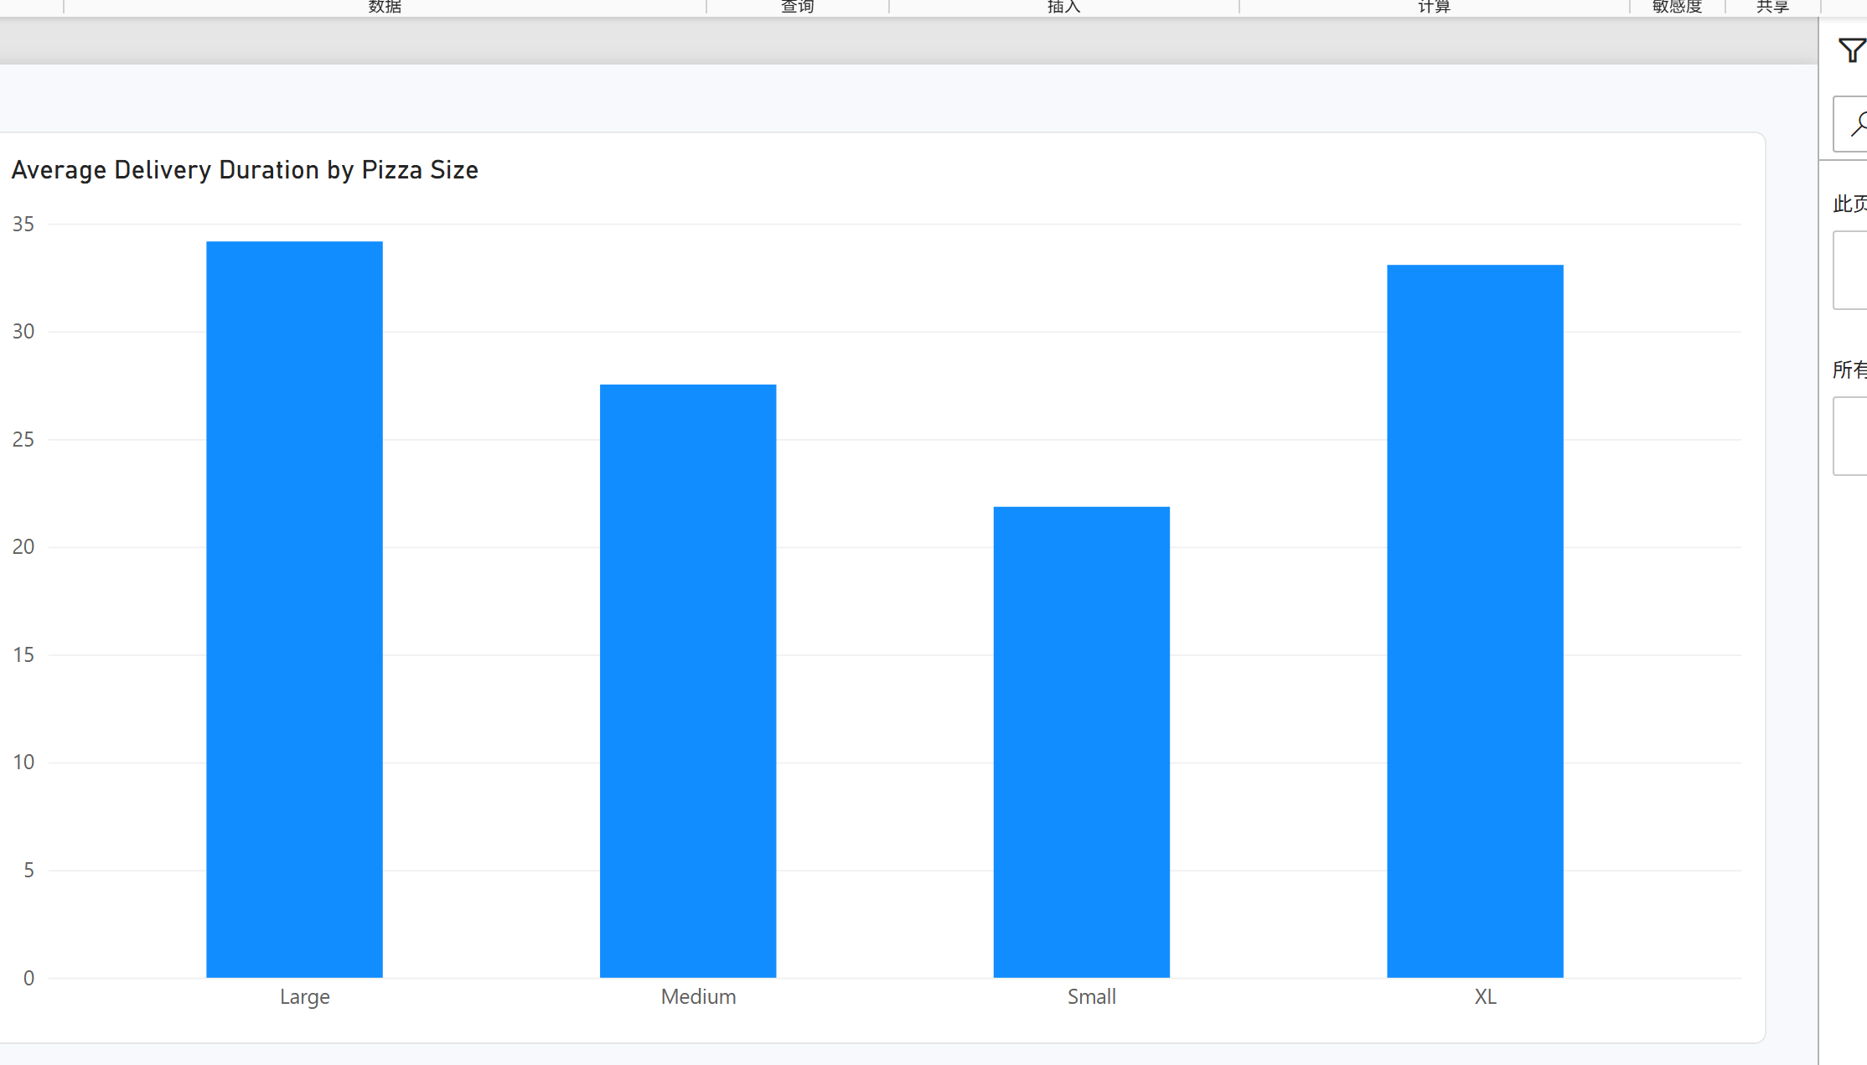
Figure Q2. Power BI visualization.
Observation / answer / explanation
Large pizzas had the longest average delivery duration at 34.17 minutes, while Small pizzas had the shortest at 21.86 minutes. XL pizzas were close to Large pizzas at 33.08 minutes.

Q3 | 0.5 points
What is the share of orders by Pizza Size?
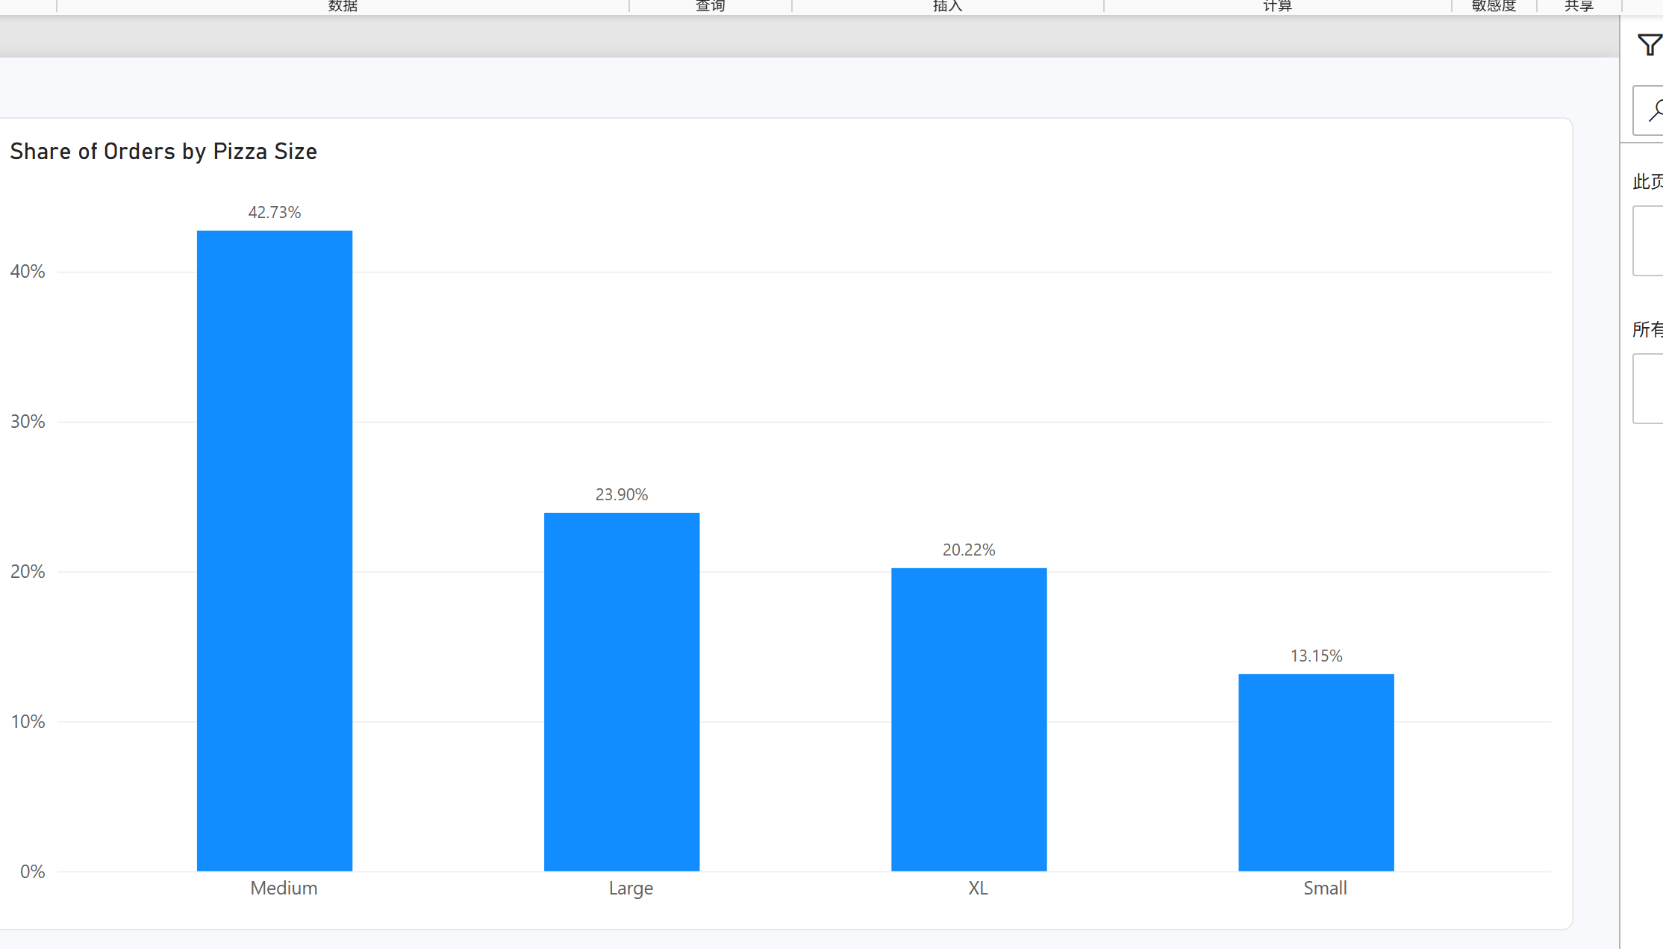
Figure Q3. Power BI visualization.
Observation / answer / explanation
Medium pizzas accounted for the largest share, with 429 orders (42.73%). Small pizzas had the smallest share, with 132 orders (13.15%).

Q4 | 0.5 points
How many orders were placed with each Payment Method?
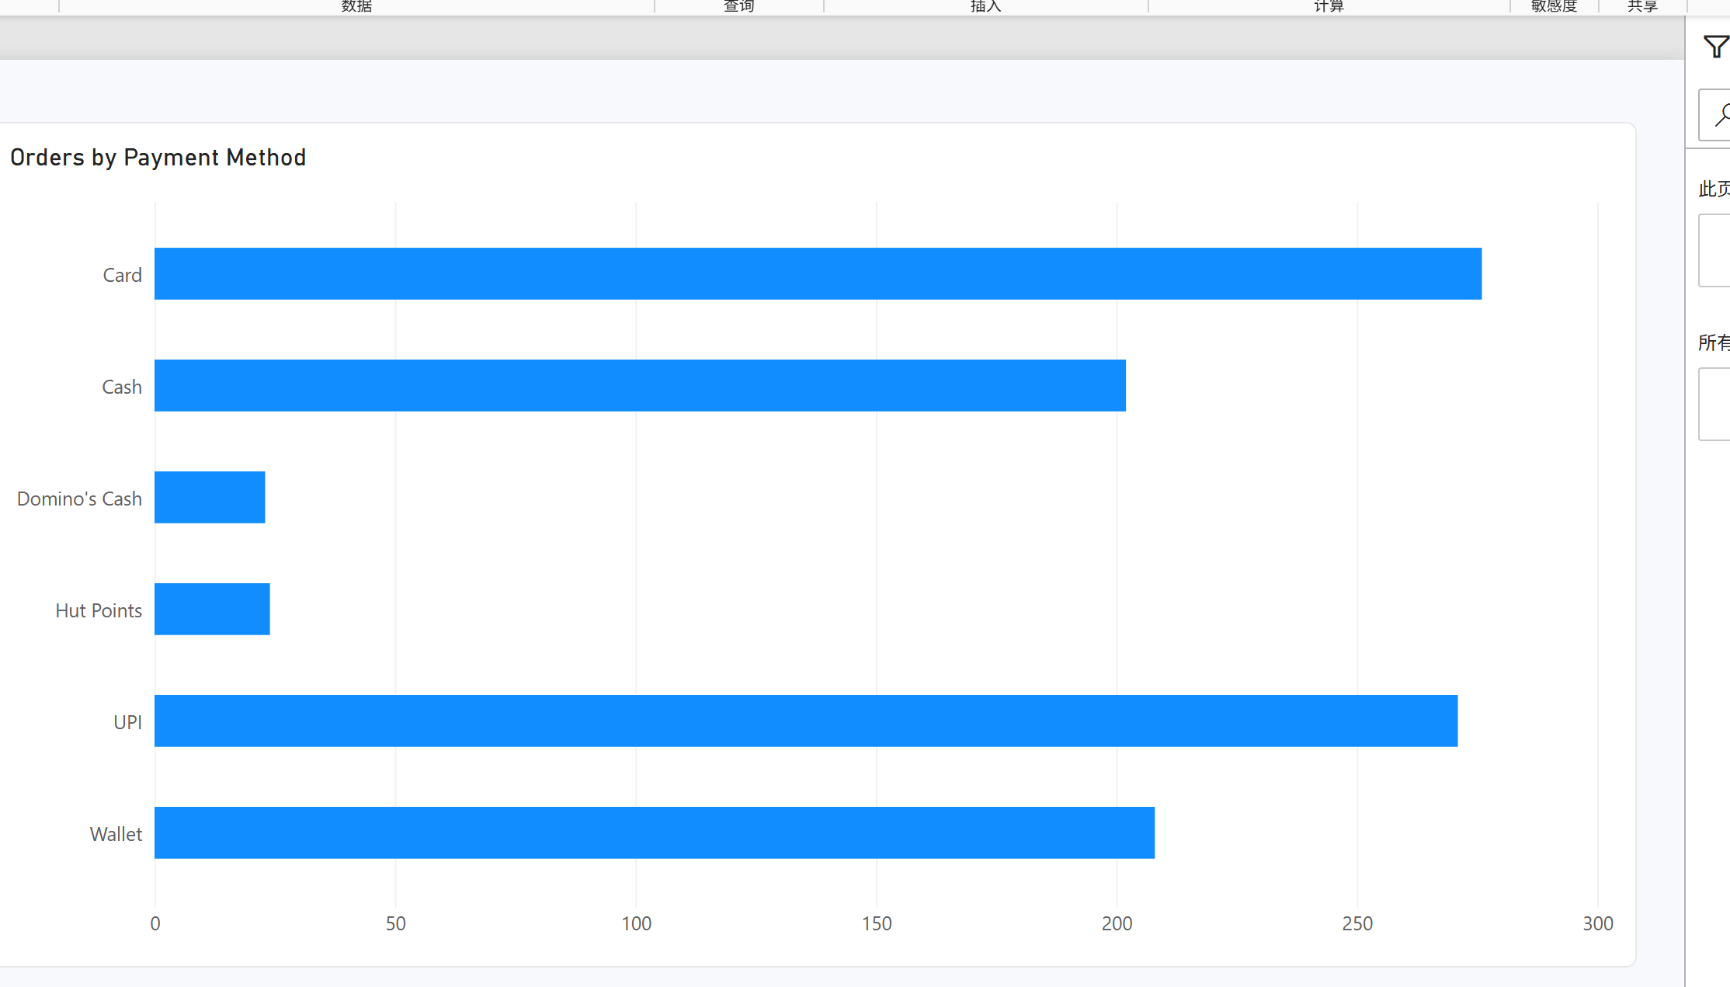
Figure Q4. Power BI visualization.
Observation / answer / explanation
Card was the most common payment method with 276 orders, only five more than UPI at 271. Hut Points and Domino's Cash were much less common, at 24 and 23 orders respectively.

Q5 | 0.5 points
What is the share of orders by Traffic Level?
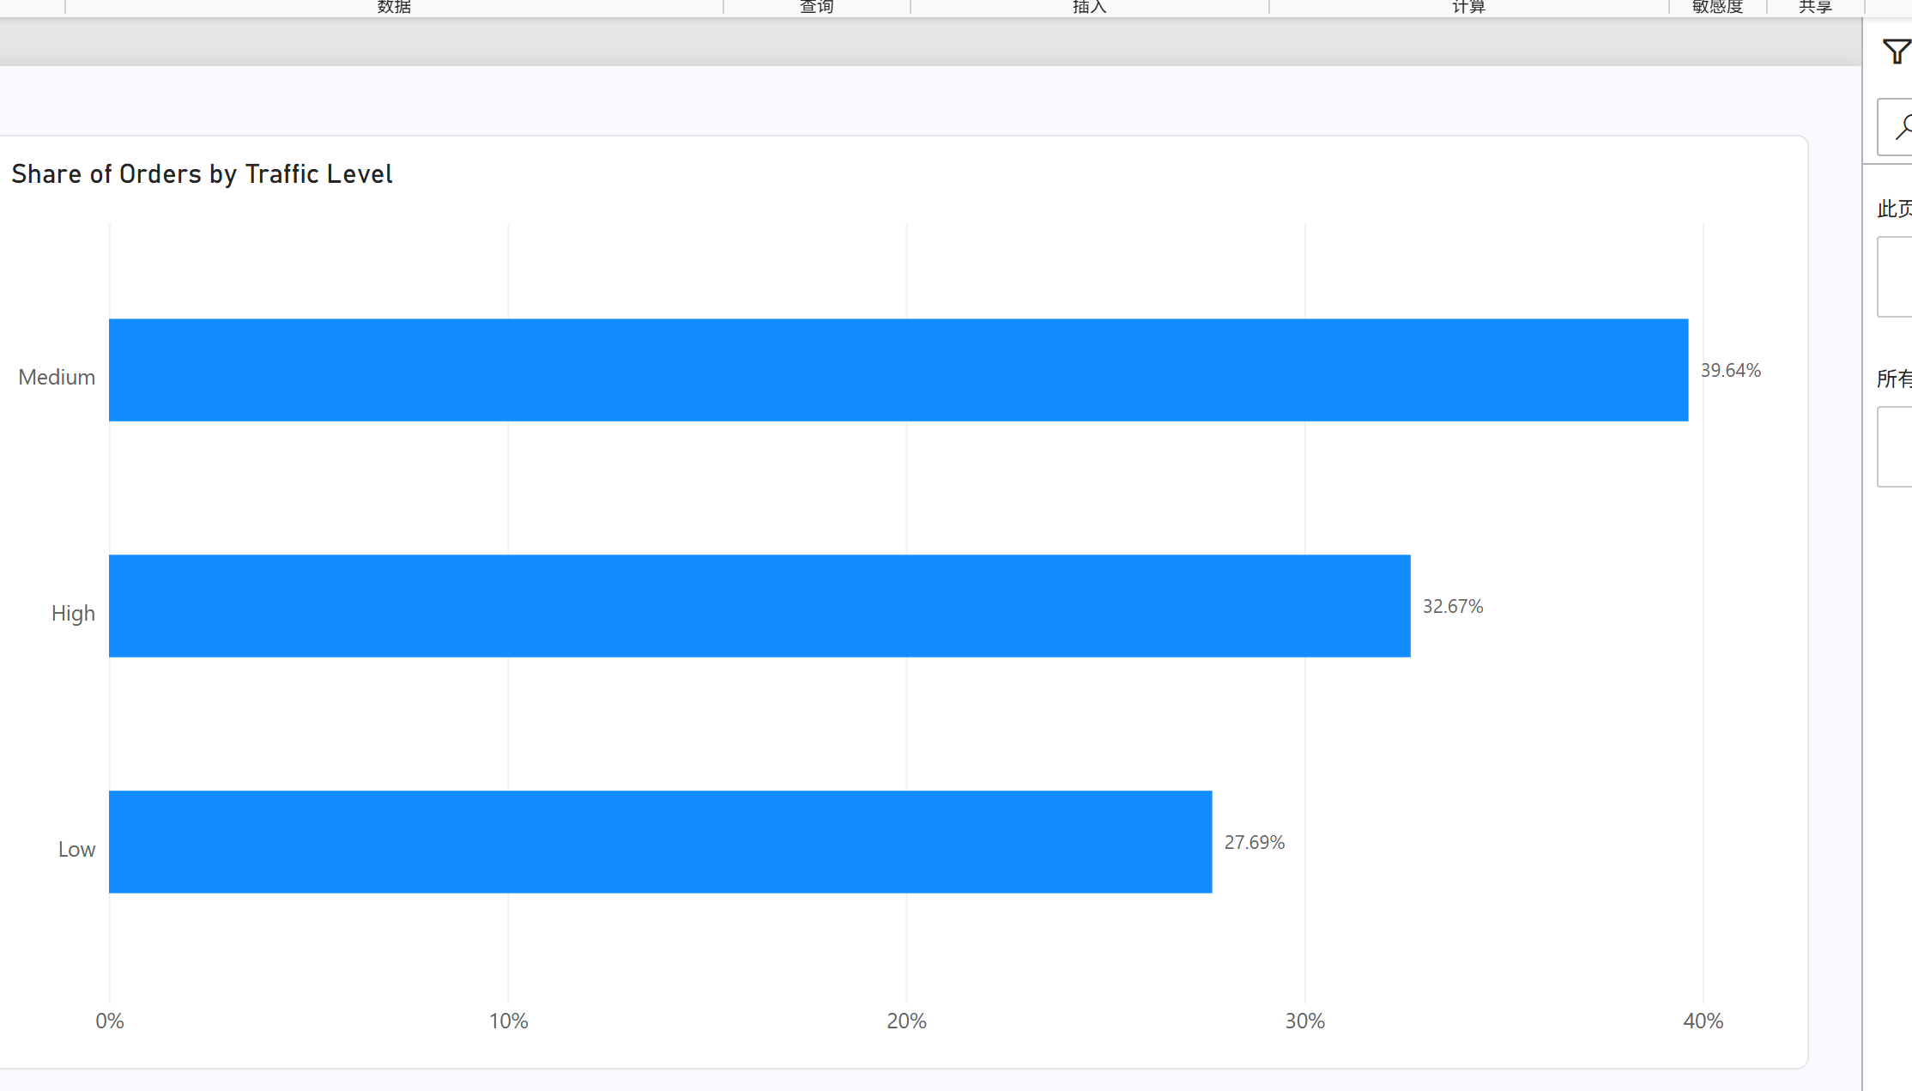
Figure Q5. Power BI visualization.
Observation / answer / explanation
Medium traffic represented the largest share of orders at 39.64% (398 orders). High traffic accounted for 32.67%, while Low traffic represented 27.69%.

Q6 | 0.5 points
What is the average Toppings Count for weekend vs. weekday orders?
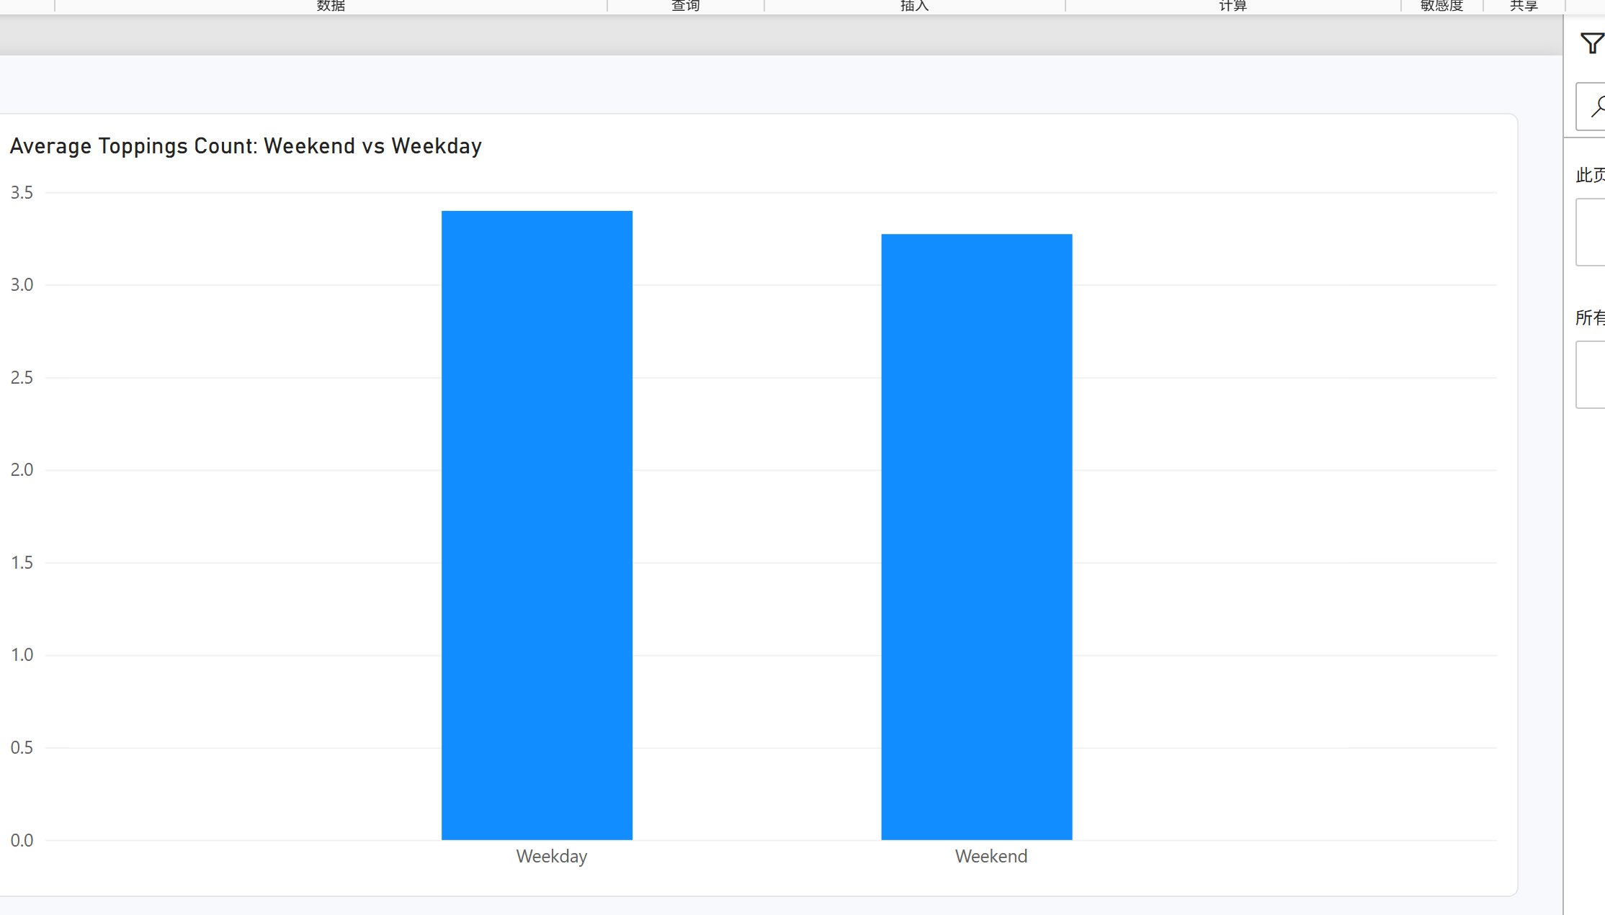
Figure Q6. Power BI visualization.
Observation / answer / explanation
Weekday orders averaged 3.40 toppings, compared with 3.27 on weekends. The difference was small, at about 0.13 toppings per order.

Q7 | 0.5 points
Which locations have the highest average Delivery Duration (min)?
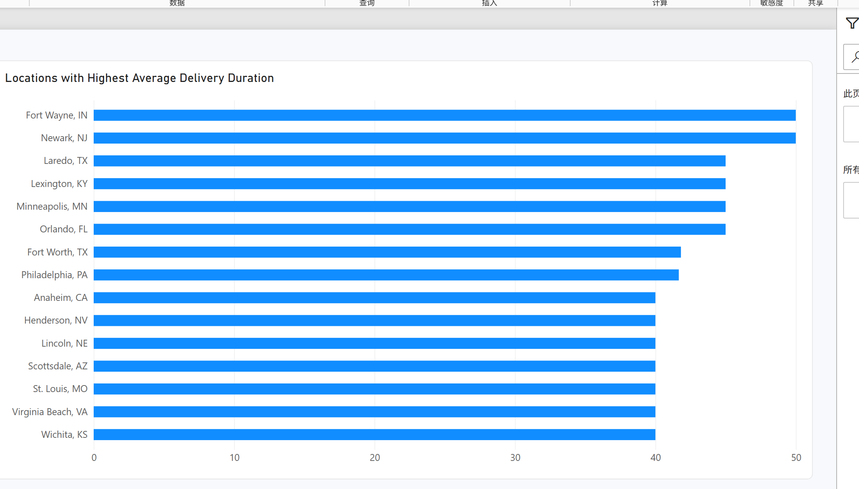
Figure Q7. Power BI visualization.
Observation / answer / explanation
Fort Wayne, IN and Newark, NJ had the highest average delivery duration at 50.00 minutes. Laredo, Lexington, Minneapolis, and Orlando followed at 45.00 minutes, so several locations shared the next-highest result.

Q8 | 0.5 points
How many orders were placed during peak hours vs. non-peak?
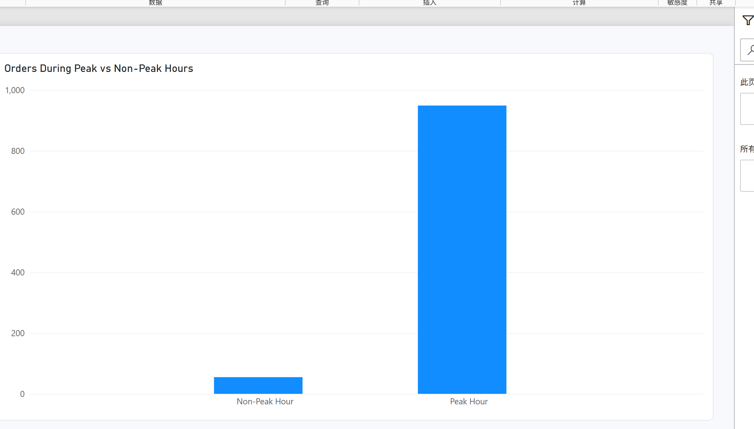
Figure Q8. Power BI visualization.
Observation / answer / explanation
Peak hours contained 949 orders (94.52%), compared with only 55 non-peak orders (5.48%). Most observations in this dataset therefore fall in the peak-hour category.

Q9 | 1 point
How does order volume trend across Order Month?
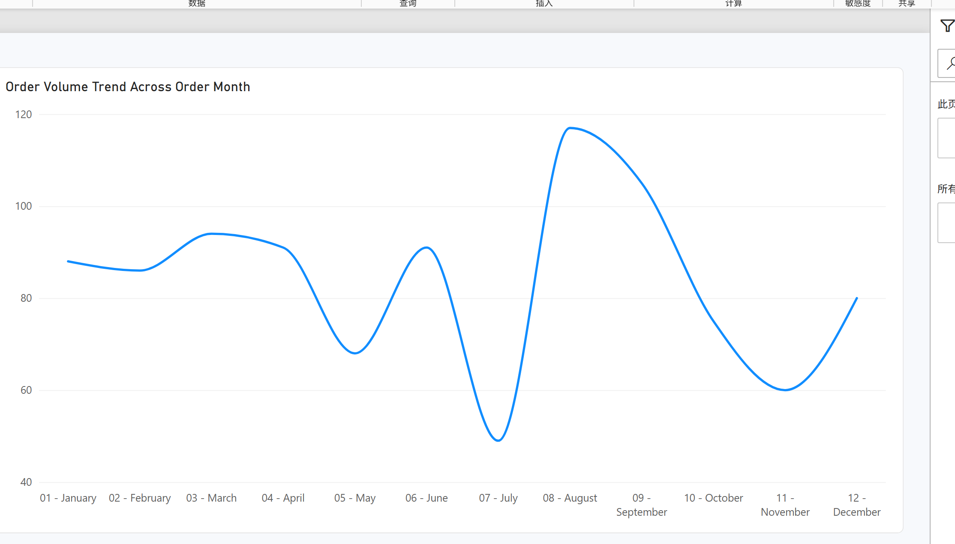
Figure Q9. Power BI visualization.
Observation / answer / explanation
Order volume was highest in August with 117 orders, followed by September with 105. July was the lowest month with 49 orders. These totals combine the same month across all source years, as requested by the Order Month wording.

Q10 | 1 point
What is the average Toppings Count by Pizza Size?
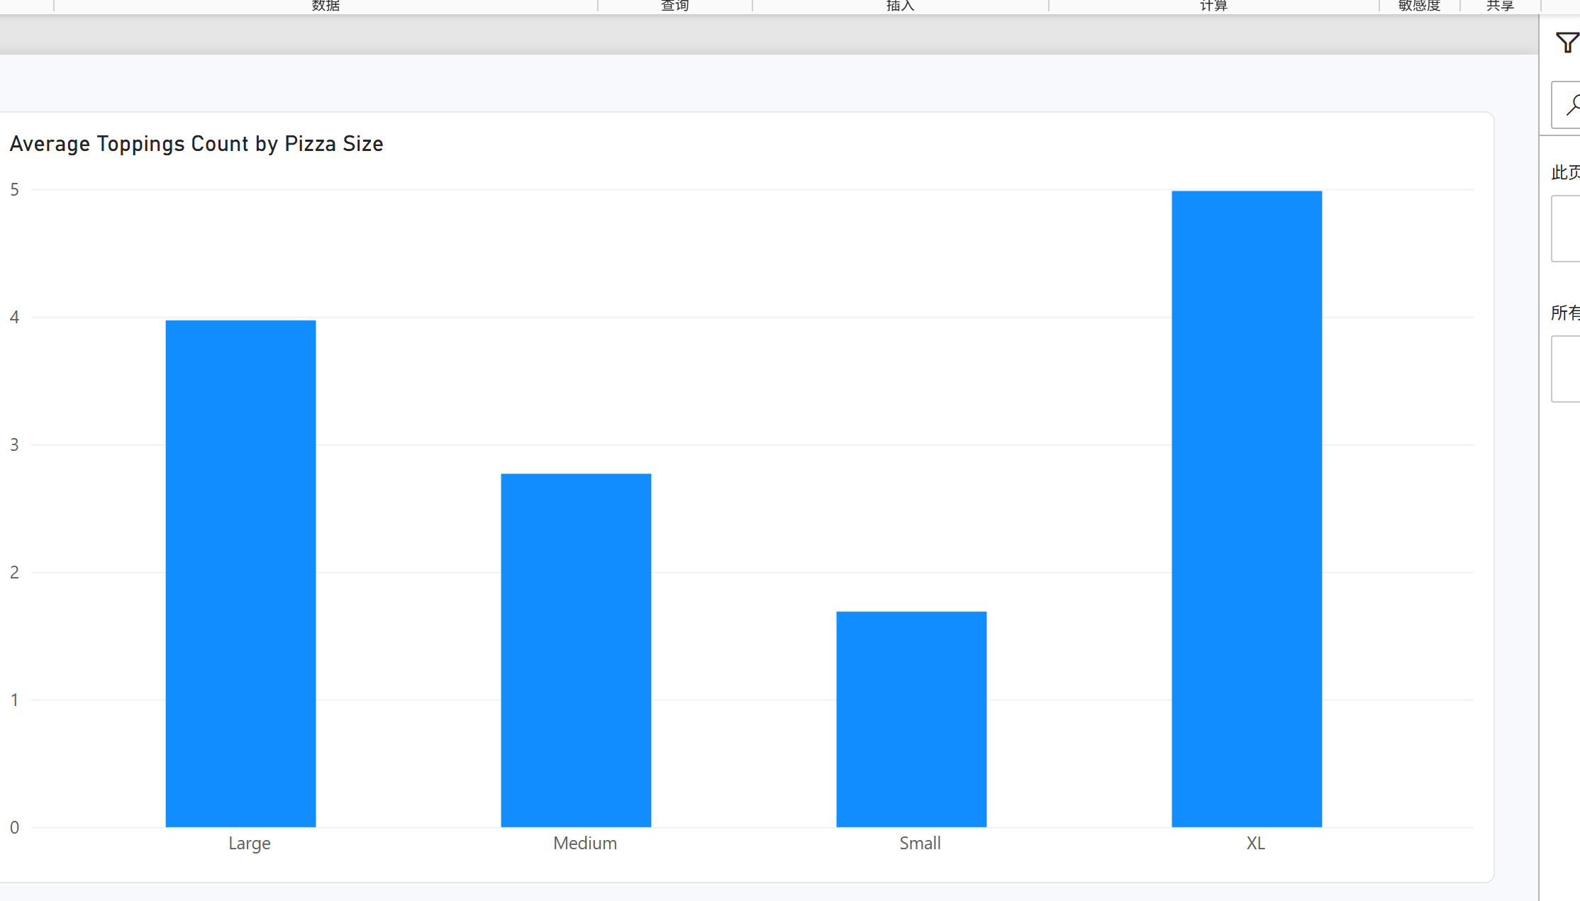
Figure Q10. Power BI visualization.
Observation / answer / explanation
XL pizzas had the highest average toppings count at 4.99, followed by Large pizzas at 3.97. Small pizzas had the lowest average at 1.69 toppings.

Q11 | 1 point
Which 2 restaurants have the lowest average Delay (min) i.e., the fastest, most reliable performers?
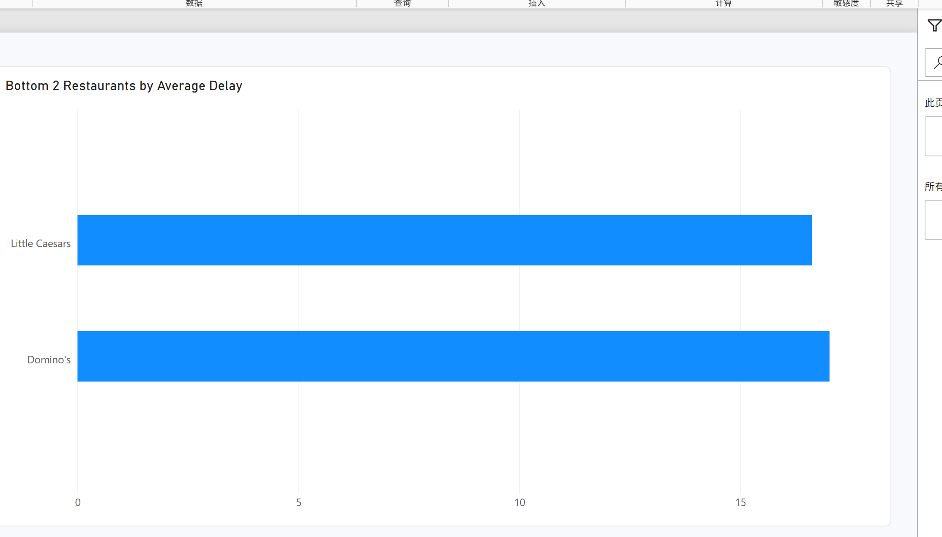
Figure Q11. Power BI visualization.
Observation / answer / explanation
Little Caesars recorded the lowest average delay at 16.62 minutes. Domino's was second at 17.02 minutes, so these are the two lowest-delay restaurants under the assignment definition.

Q12 | 1 point
Which 5 Pizza Types have the highest average Delivery Duration (min)?
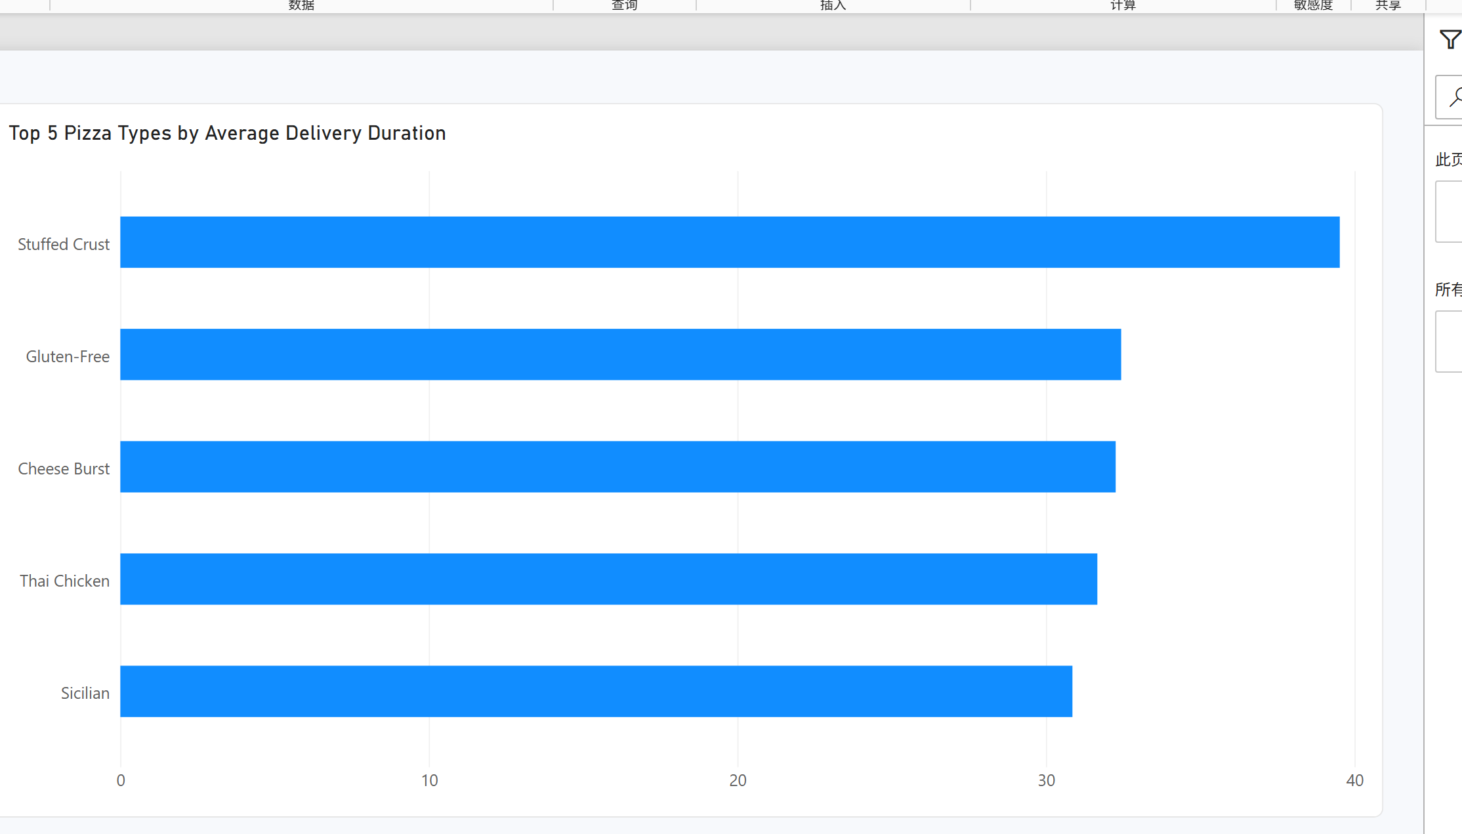
Figure Q12. Power BI visualization.
Observation / answer / explanation
Stuffed Crust had the highest average delivery duration at 39.52 minutes. Gluten-Free (32.44), Cheese Burst (32.26), Thai Chicken (31.67), and Sicilian (30.86) completed the top five.

Q13 | 1 point
How does order volume vary by Order Hour across a typical day?
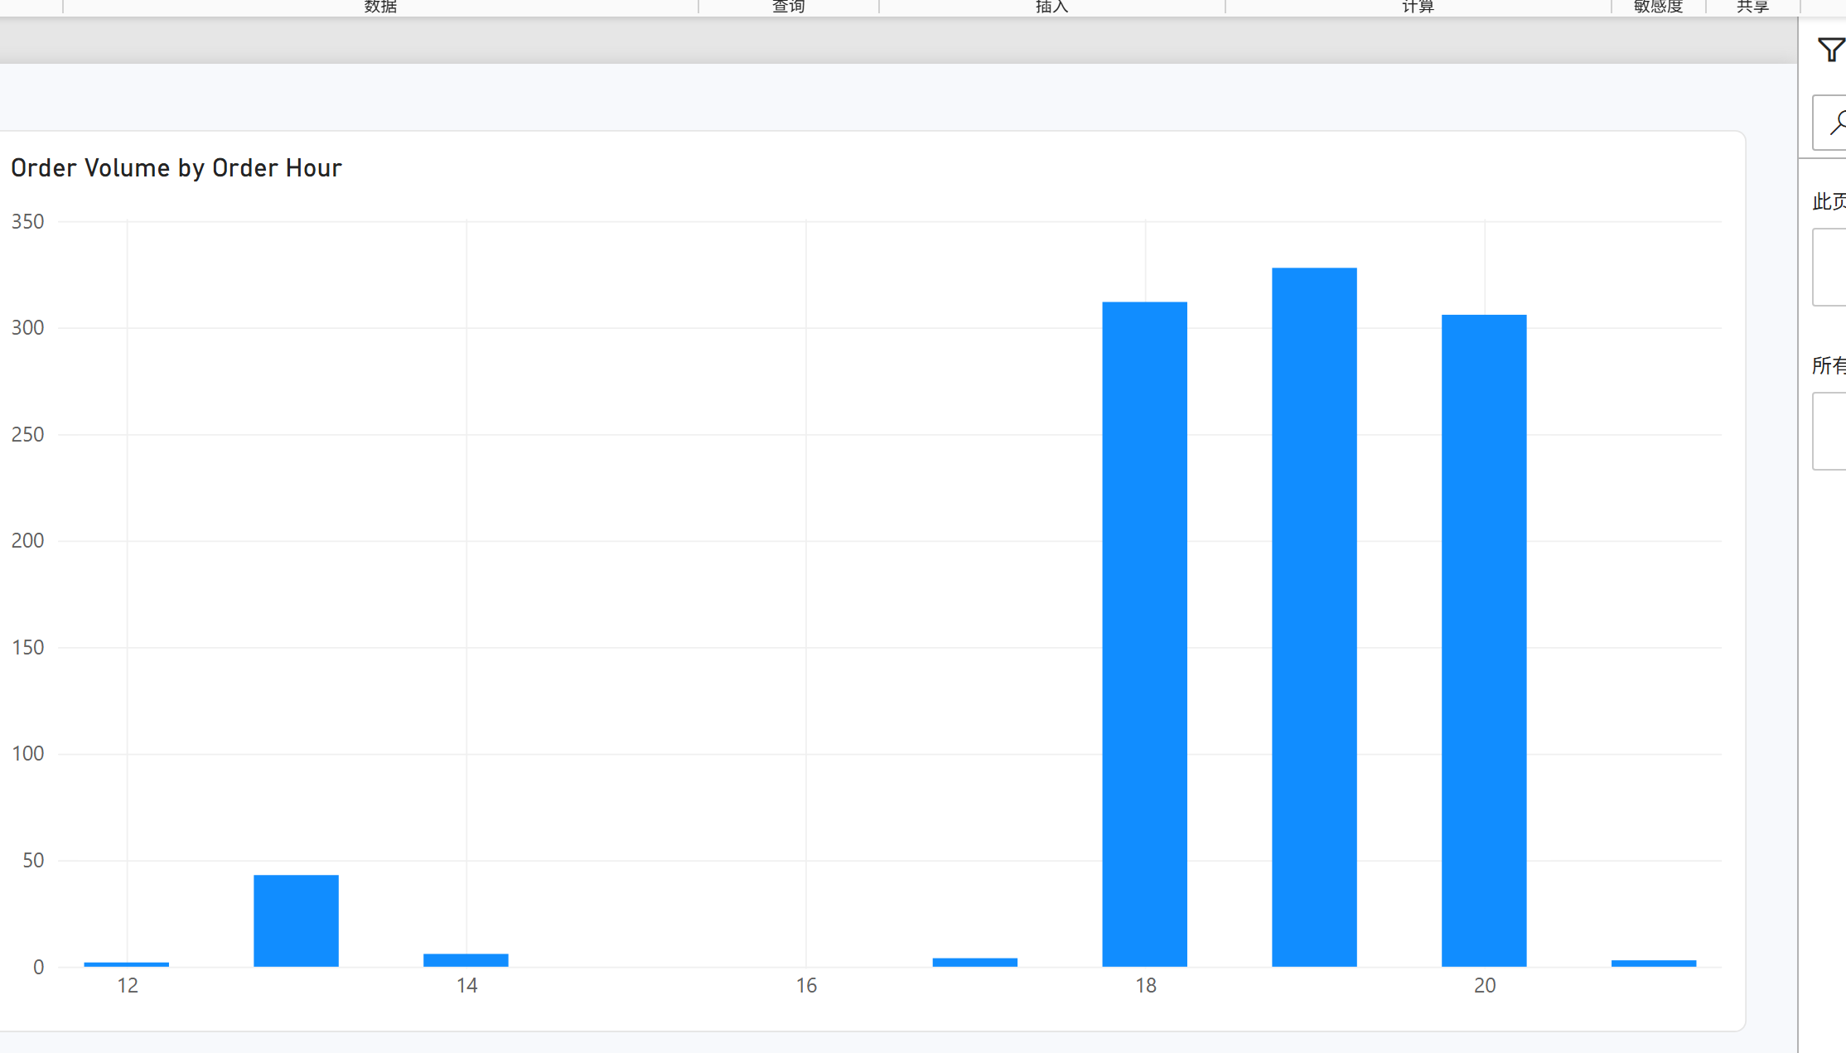
Figure Q13. Power BI visualization.
Observation / answer / explanation
The largest hourly order volume occurred at 19:00 with 328 orders. The nearby 18:00 and 20:00 periods were also busy, with 312 and 306 orders, while the remaining observed hours were much quieter.

Q14 | 1 point
What is the average delay (min) by Traffic Level?
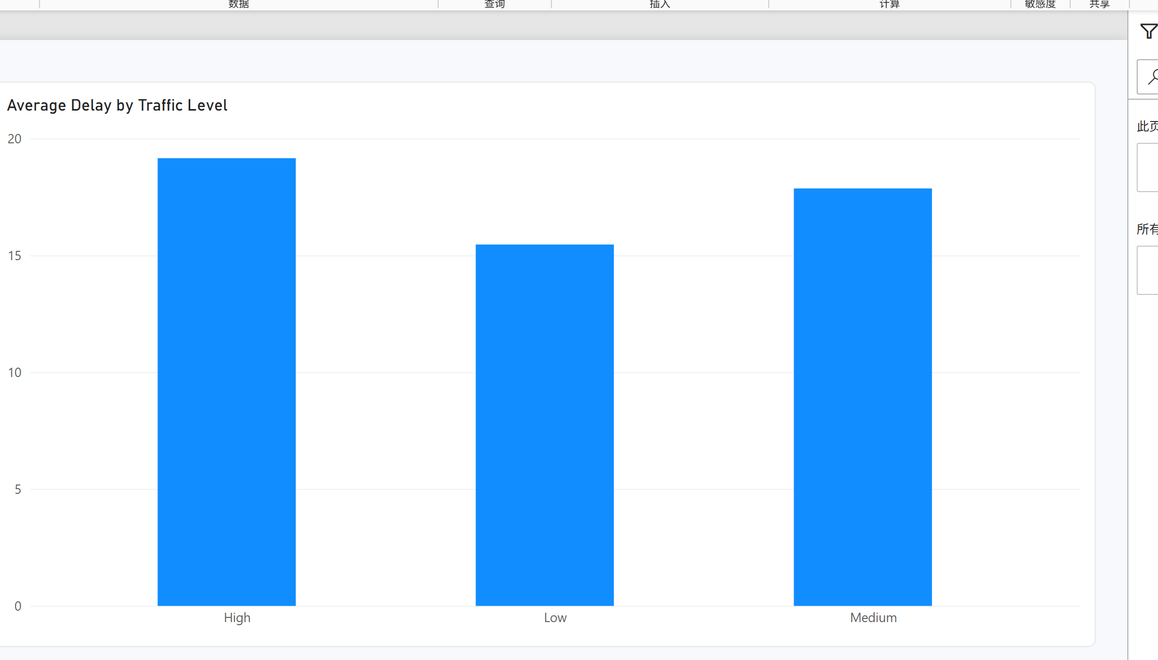
Figure Q14. Power BI visualization.
Observation / answer / explanation
Average delay increased across the traffic categories: 15.46 minutes for Low, 17.86 for Medium, and 19.16 for High traffic. The pattern shows an association between heavier traffic and longer delay in this dataset.

Q15 | 1 point
What proportion of orders fall into each Pizza Complexity category?
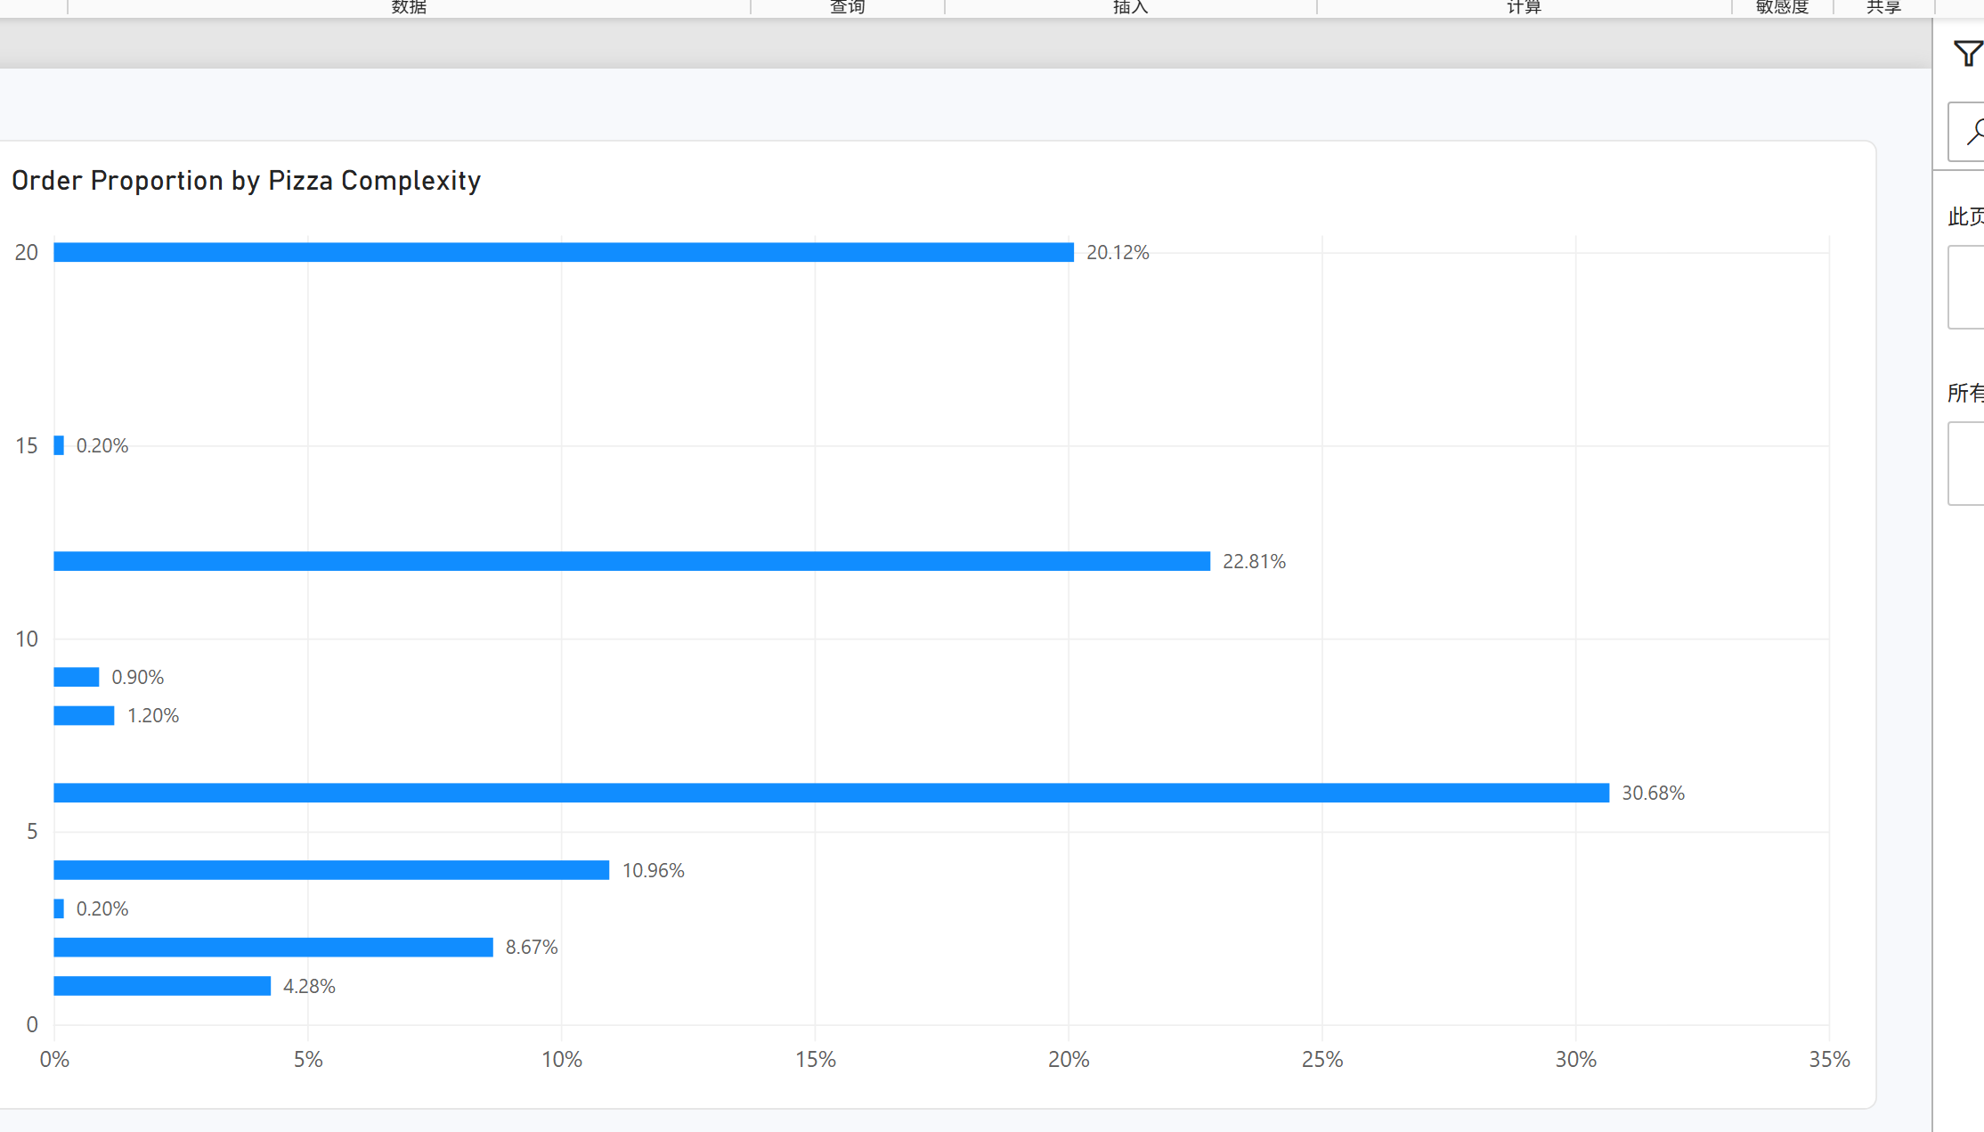
Figure Q15. Power BI visualization.
Observation / answer / explanation
Pizza Complexity 6 was the largest category, with 308 orders (30.68%). Complexity 12 represented 22.81% and Complexity 20 represented 20.12%, while categories 3 and 15 each contained only two orders.

Q16 | 1 point
Build a table of average Delivery Duration and Delay by Restaurant Name and use the Fx (Format by field value) button to visually highlight the fastest and slowest restaurants.
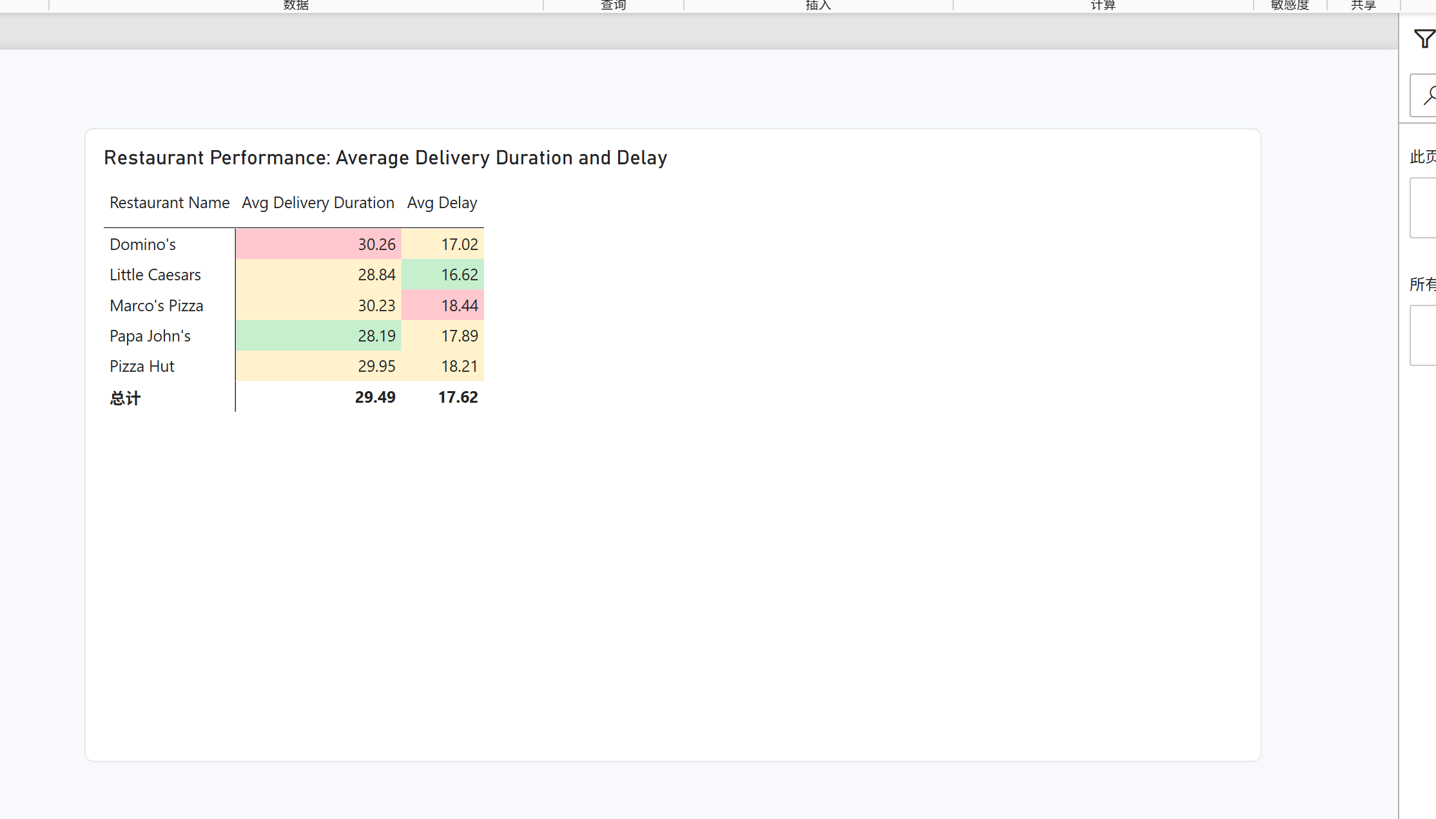
Figure Q16. Power BI visualization.
Observation / answer / explanation
The conditional formatting identifies Papa John's as the fastest restaurant by average delivery duration at 28.19 minutes, while Domino's was slowest at 30.26 minutes. Little Caesars had the lowest average delay at 16.62 minutes, whereas Marco's Pizza had the highest at 18.44 minutes. The fastest delivery-duration restaurant is therefore not the same as the lowest-delay restaurant.

Q17 | 2 points
How does order volume vary by Order Hour, alongside average Delay (min)?
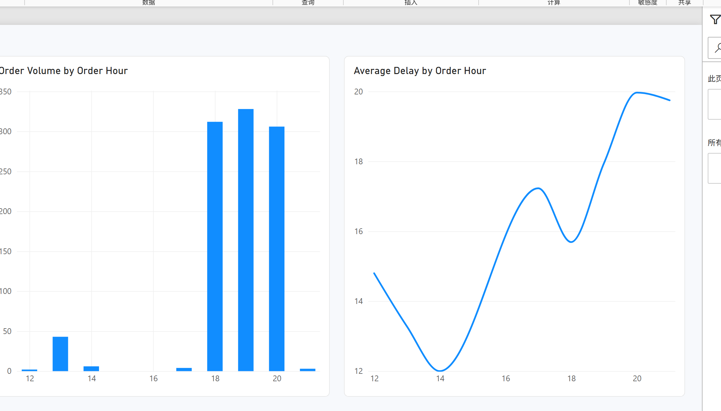
Figure Q17. Power BI visualization.
Observation / answer / explanation
Order volume peaked at 19:00 with 328 orders, but the highest average delay occurred at 20:00 at 19.97 minutes. The volume and delay peaks did not fully coincide. The 21:00 delay was also high at 19.75 minutes, but that hour contained only three orders and should be read cautiously.

Q18 | 2 points
How does average Topping Density vary by Pizza Type, alongside order volume?
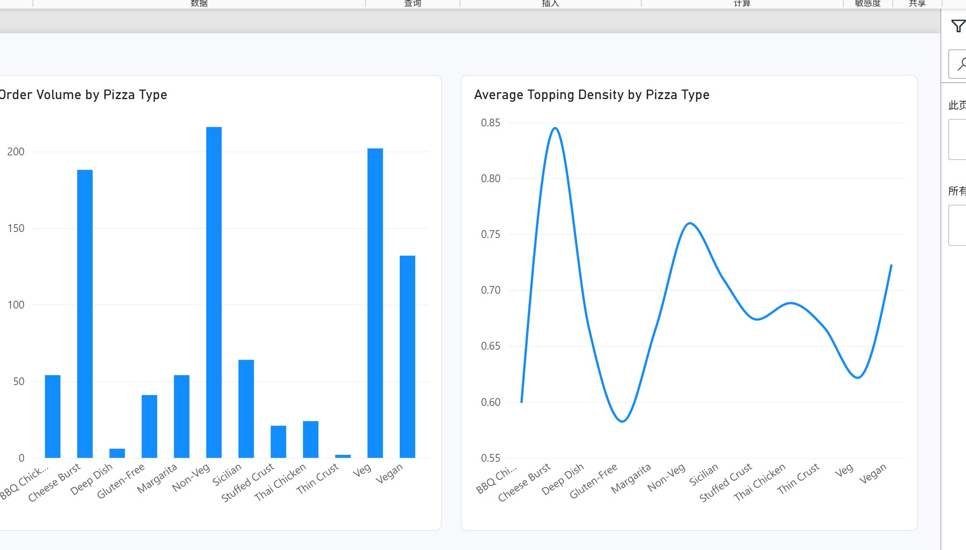
Figure Q18. Power BI visualization.
Observation / answer / explanation
Non-Veg had the largest order volume at 216 and an average topping density of 0.760. Cheese Burst combined high volume (188 orders) with the highest average density, 0.845. The supplied density field equals toppings per kilometre, so it should not be interpreted as a pure pizza-size measure.

Q19 | 2 points
What is the percentage breakdown of orders by Traffic Level within each Payment methods, filterable by order time?
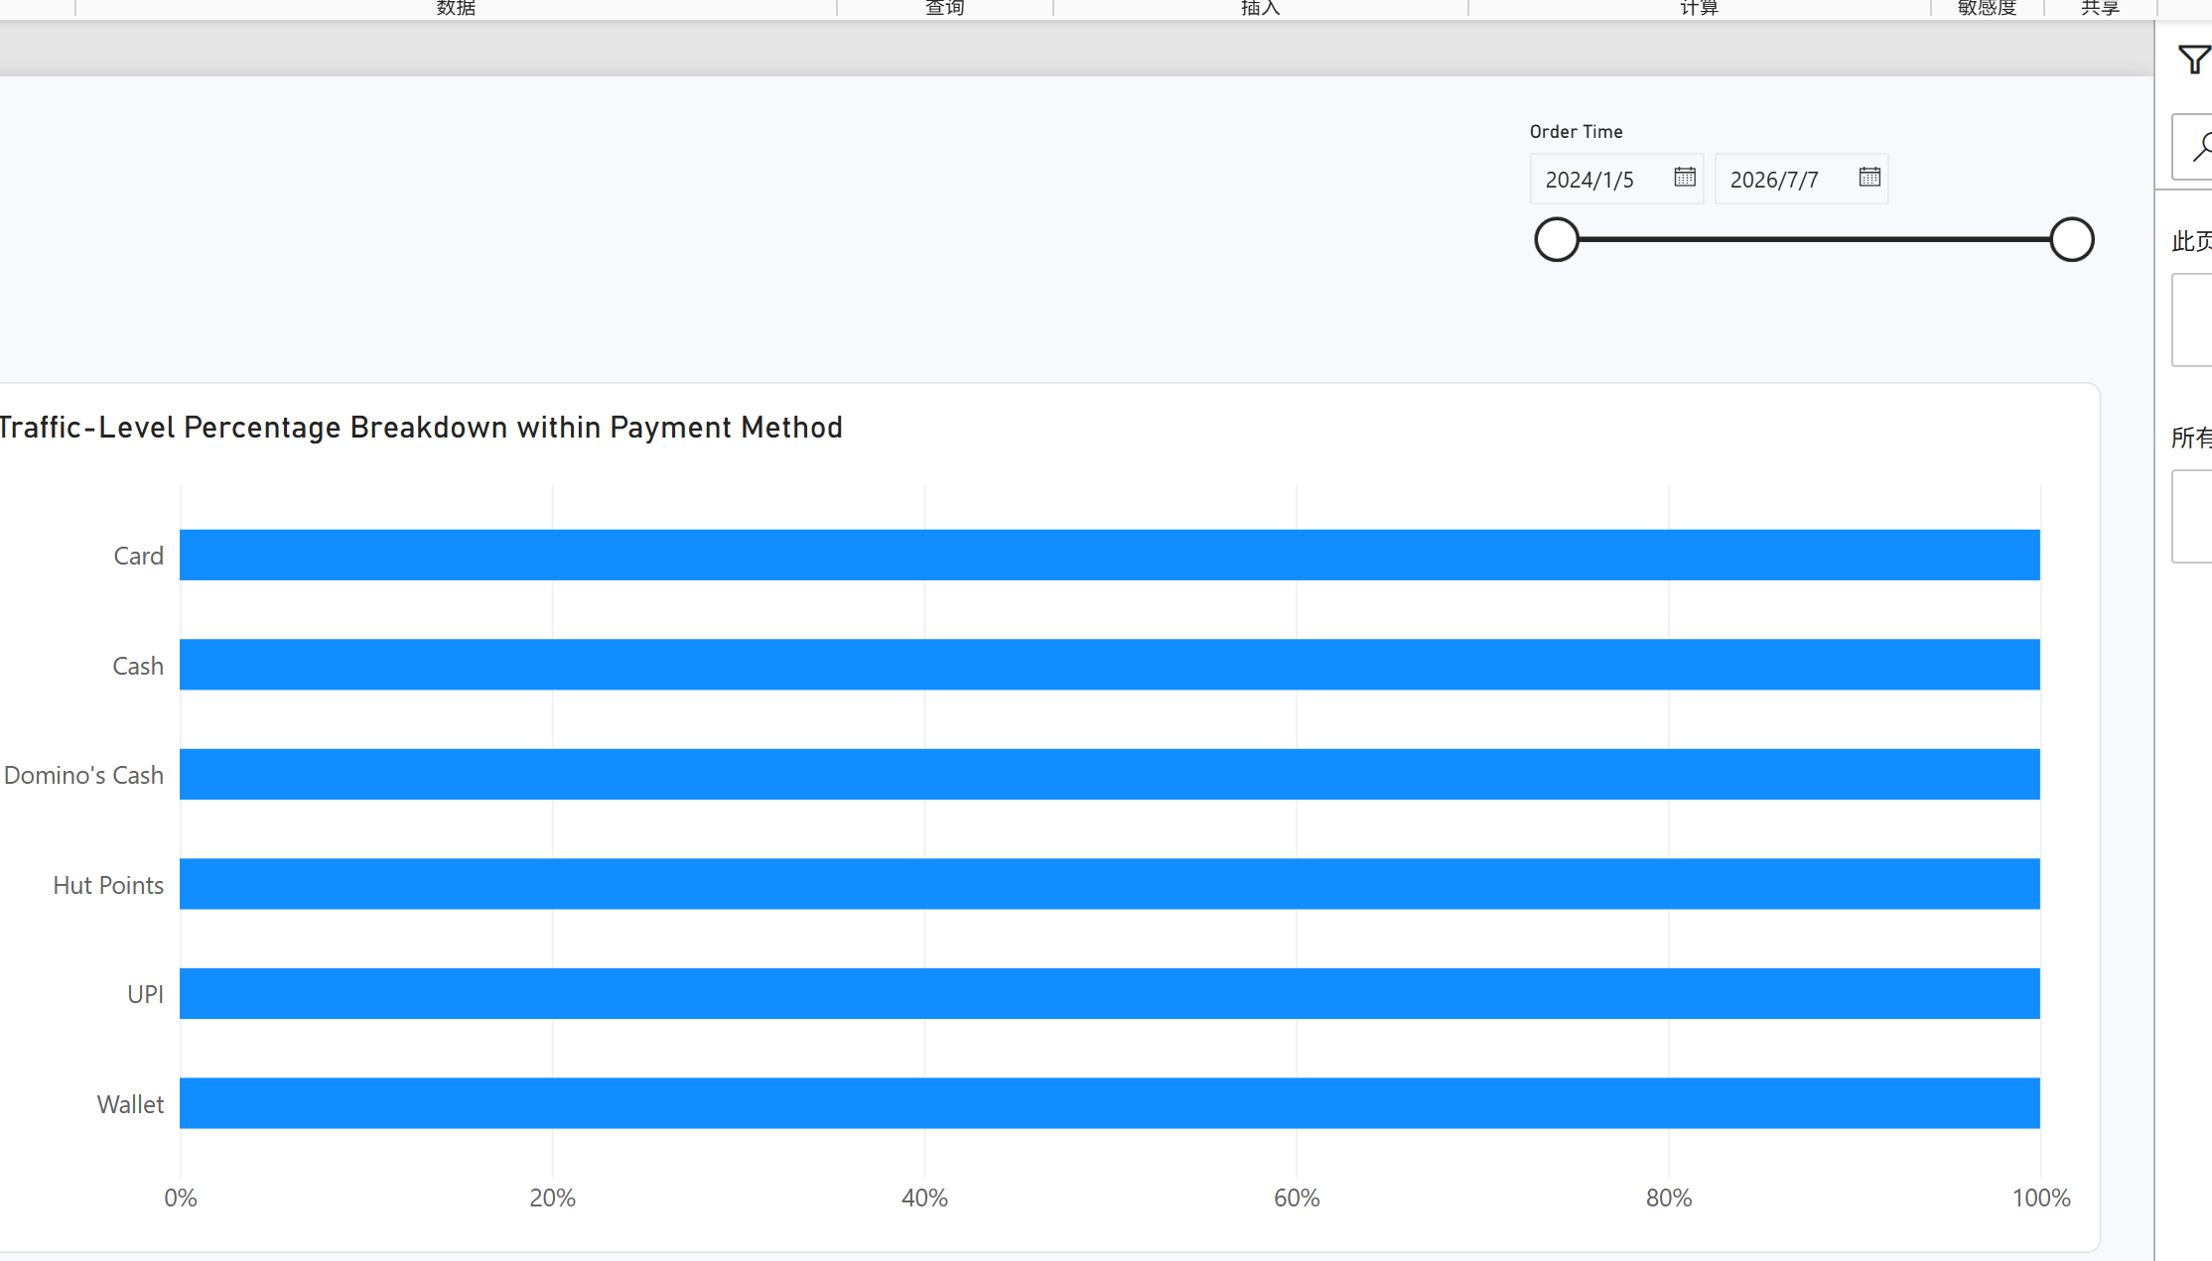
Figure Q19. Power BI visualization.
Observation / answer / explanation
Traffic composition differed by payment method. High traffic made up 44.57% of Card orders, Medium traffic was largest for Cash (48.02%) and UPI (47.60%), and Low traffic was largest for Wallet (44.71%). Hut Points was 95.83% High traffic, but it contained only 24 orders, so its percentage is based on a small group.

Q20 | 2 points
Design three different charts or tables that use conditional formatting (or highlight them by using different colors) in a single dashboard. Explain why each one matters, what it represents, how they should be read together, and what insights emerge from viewing them as a whole.
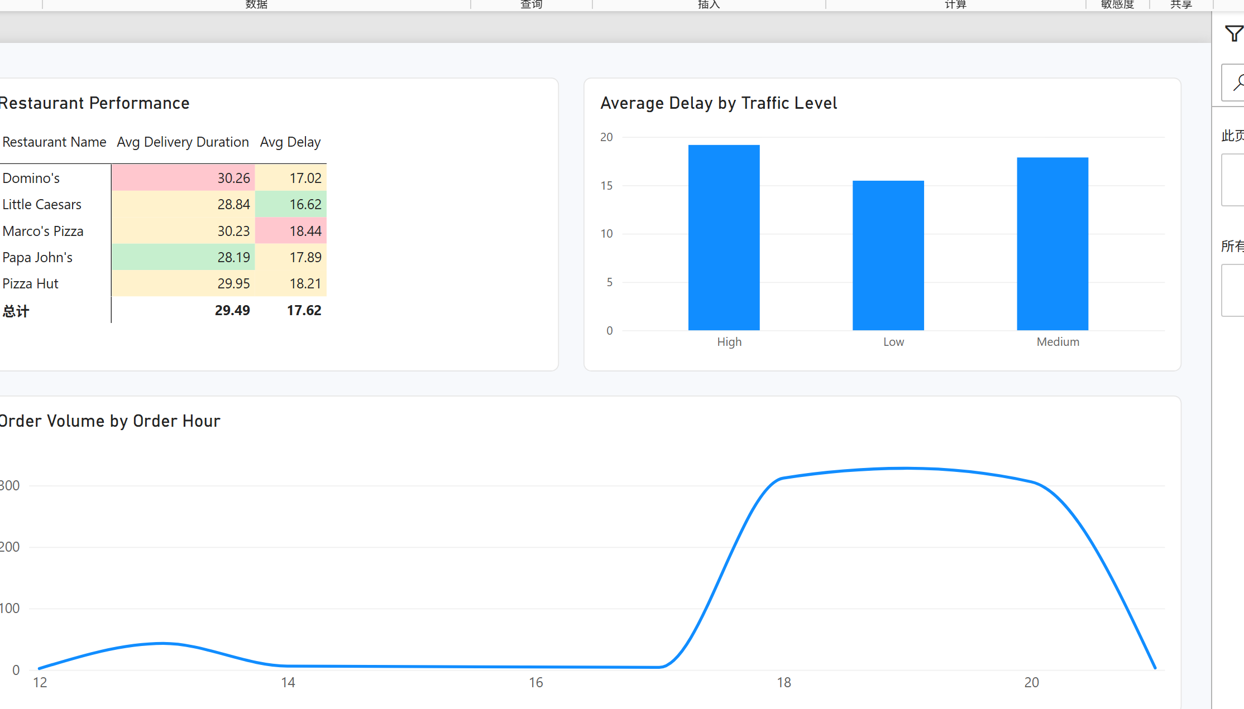
Figure Q20. Power BI visualization.
Observation / answer / explanation
The restaurant table identifies where delivery time and delay are highest or lowest, the traffic chart shows that average delay rises from Low to High traffic, and the hourly combo chart shows when operational pressure is greatest. Read together, they separate three useful views: restaurant performance, delivery conditions, and time-of-day demand.
Papa John's had the shortest average delivery duration (28.19 minutes), while Marco's Pizza had the highest average delay (18.44 minutes). High traffic also had the highest average delay (19.16 minutes), and the order-volume peak at 19:00 was followed by the delay peak at 20:00. These patterns point to specific restaurants and periods for closer operational review without claiming that the visualized relationships prove causation.

