DATA VISUALIZATION USING
MICROSOFT POWER BI
BISM2202 Assessment Report - Version B
Student Name: __________
Student ID: __________
Total Questions: 20
Total Points: 20
Screenshots marked as placeholders must be replaced with genuine Power BI Desktop screenshots before submission.

Q1 | 0.5 points
What is the top 20 locations based on count of order number?
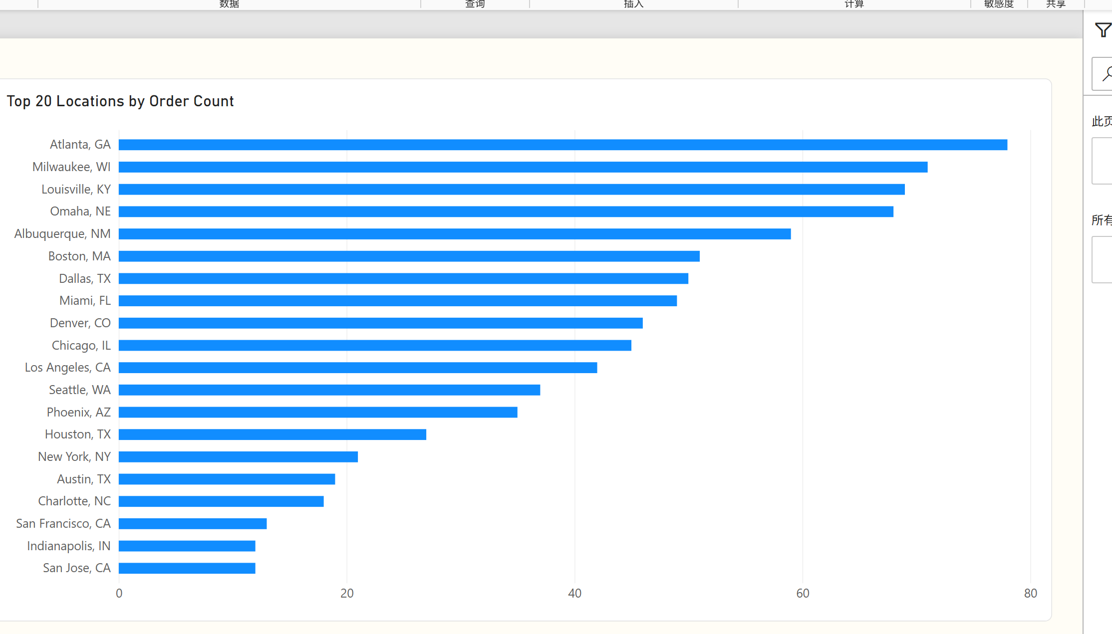
Figure Q1. Power BI visualization.
Observation / answer / explanation
The compact ranking keeps Atlanta, GA as the leading location at 78 orders, ahead of Milwaukee, WI (71) and Louisville, KY (69). The alternative orientation emphasizes the size gap among the top demand locations.

Q2 | 0.5 points
What is the average Delivery Duration (min) by Pizza Size?
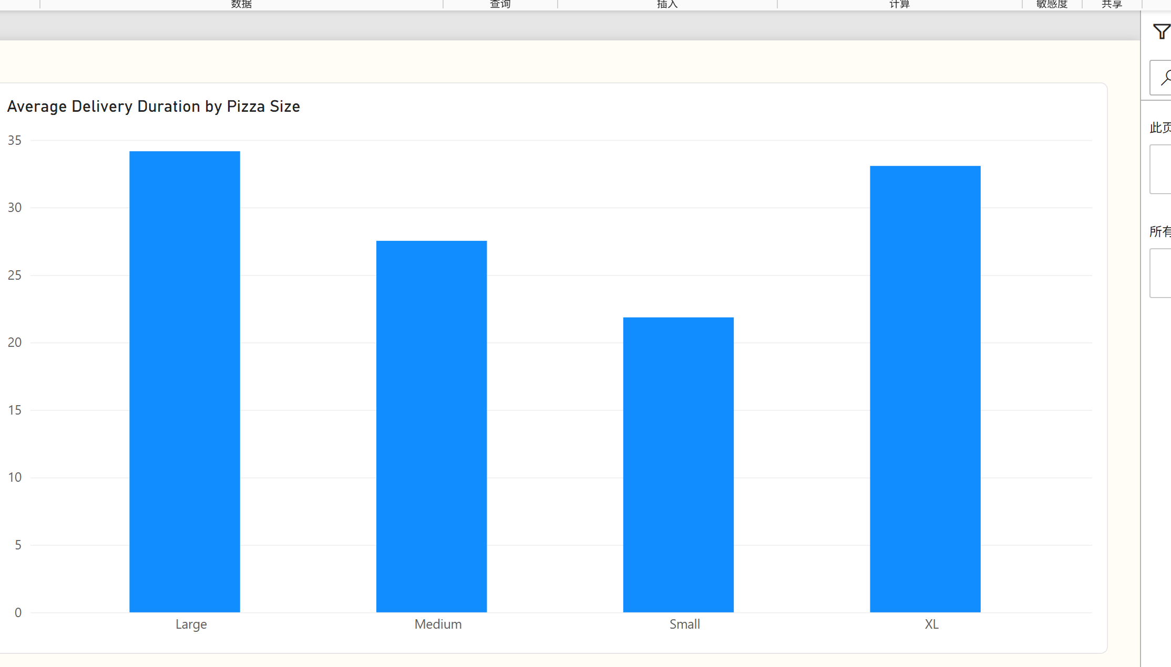
Figure Q2. Power BI visualization.
Observation / answer / explanation
The bars place Large pizzas at the longest average delivery time, 34.17 minutes. Small pizzas are clearly lower at 21.86 minutes, while XL and Large are relatively close.

Q3 | 0.5 points
What is the share of orders by Pizza Size?
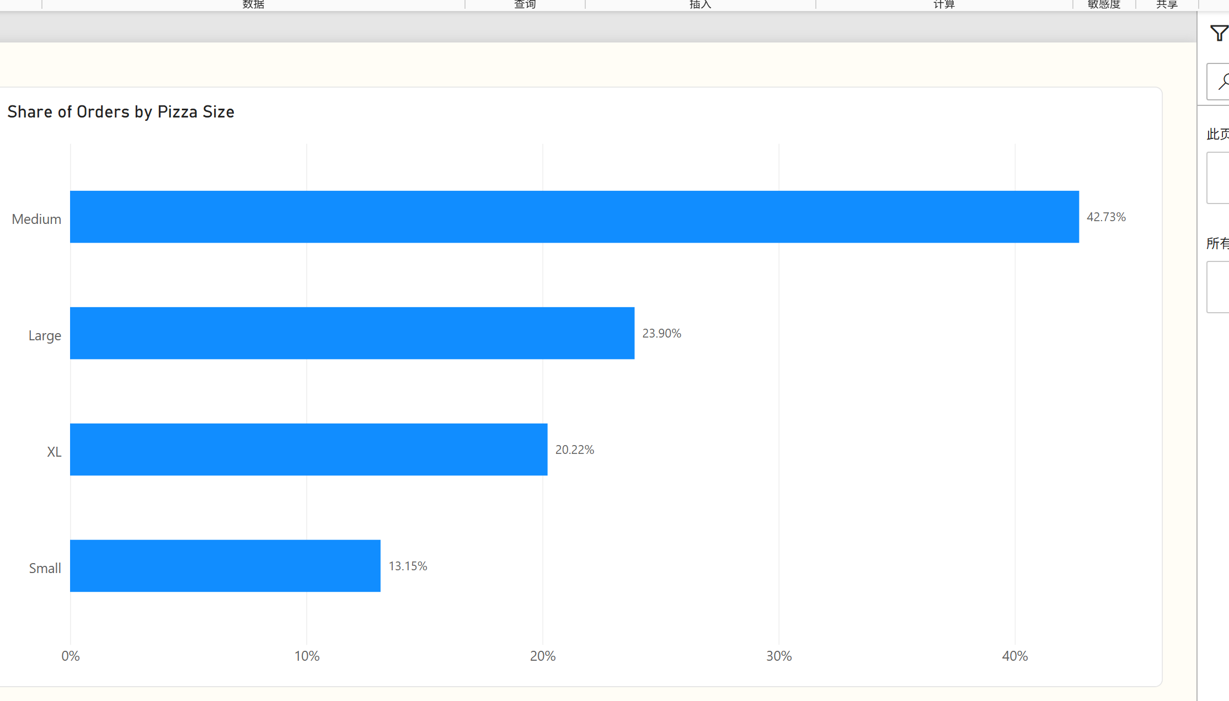
Figure Q3. Power BI visualization.
Observation / answer / explanation
The treemap gives the largest area to Medium pizzas, which generated 429 orders or 42.73% of the total. Small pizzas occupy the smallest area at 132 orders or 13.15%.

Q4 | 0.5 points
How many orders were placed with each Payment Method?
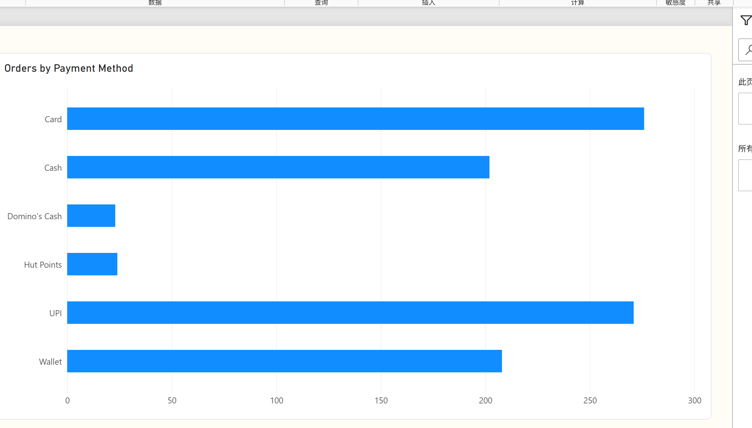
Figure Q4. Power BI visualization.
Observation / answer / explanation
The horizontal ranking shows Card (276) and UPI (271) as the two dominant payment methods. Wallet and Cash follow at 208 and 202, while the two restaurant-specific methods each have fewer than 25 orders.

Q5 | 0.5 points
What is the share of orders by Traffic Level?
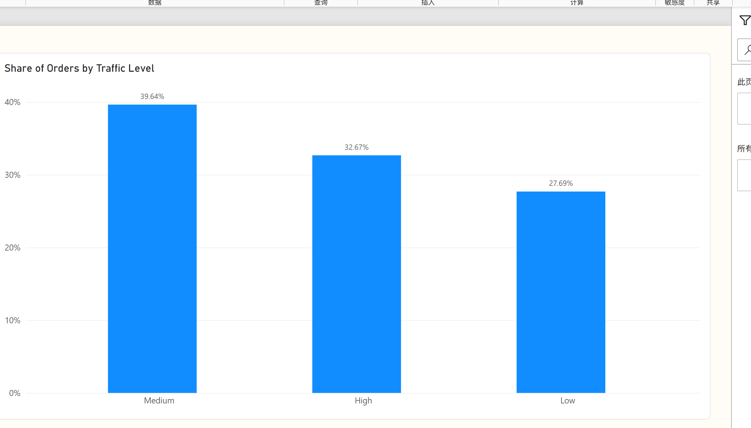
Figure Q5. Power BI visualization.
Observation / answer / explanation
Medium traffic forms the largest block at 398 orders (39.64%). High traffic contributes 328 orders (32.67%) and Low traffic contributes 278 (27.69%).

Q6 | 0.5 points
What is the average Toppings Count for weekend vs. weekday orders?
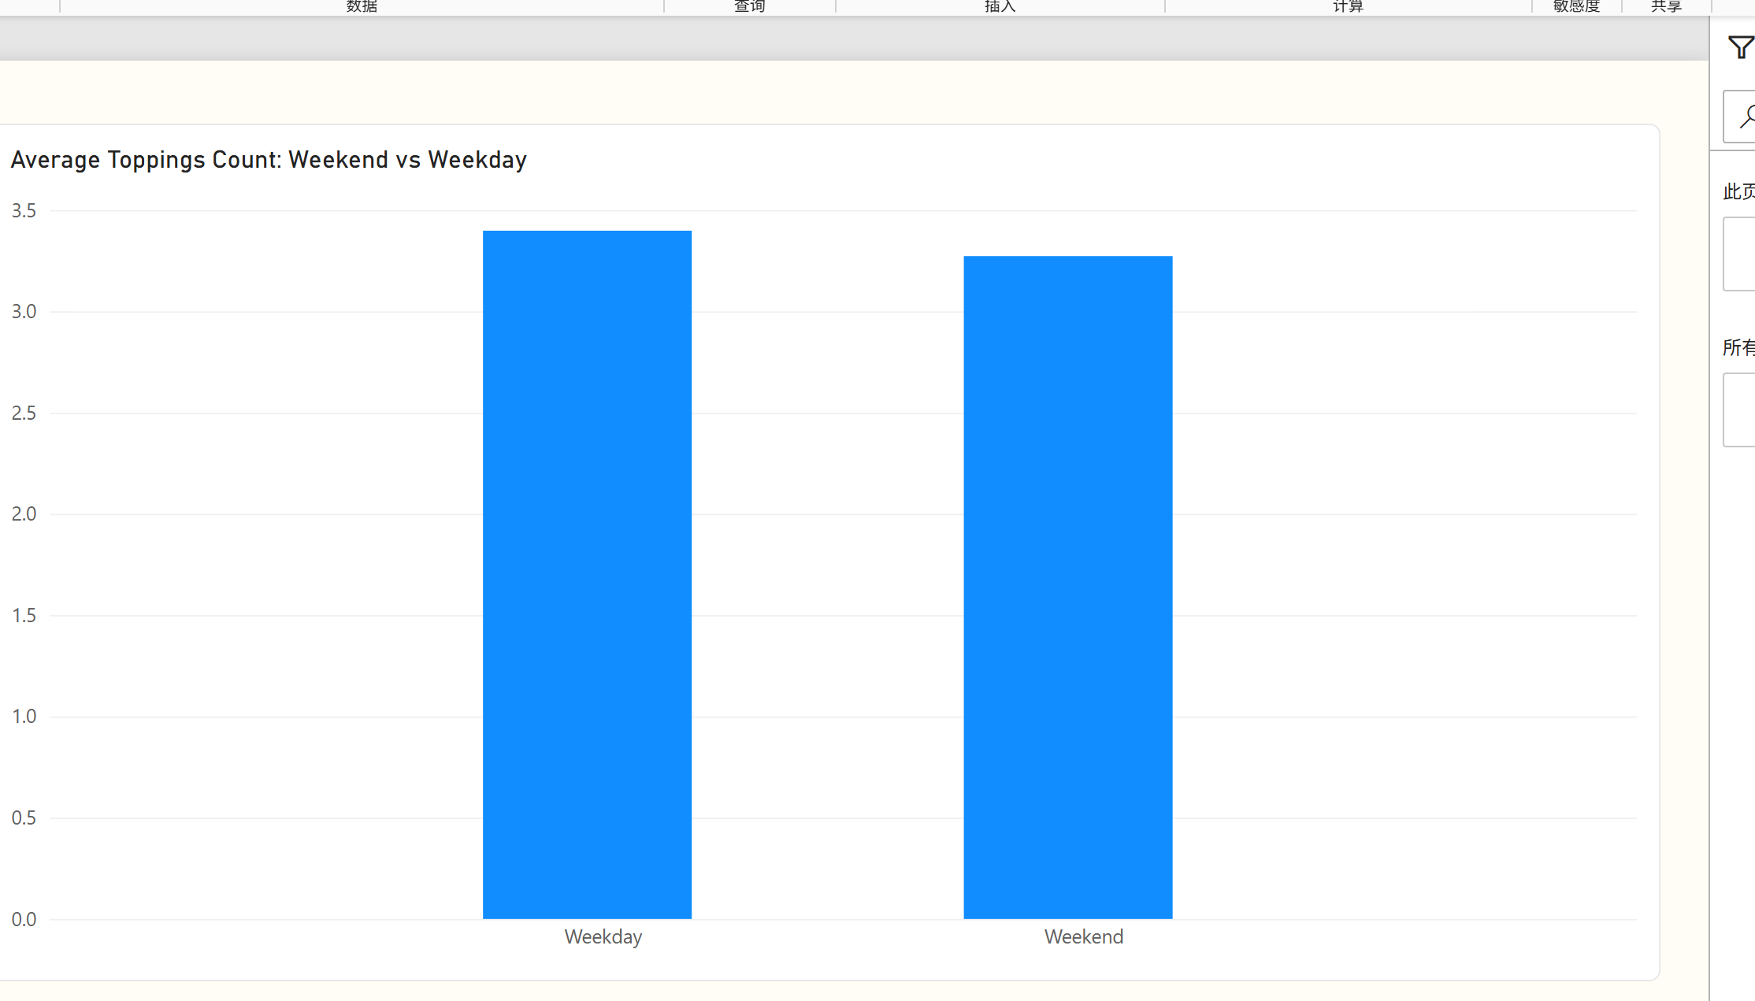
Figure Q6. Power BI visualization.
Observation / answer / explanation
Weekday orders average 3.40 toppings and weekend orders average 3.27. The short bars are close, confirming that the observed difference is only about 0.13.

Q7 | 0.5 points
Which locations have the highest average Delivery Duration (min)?
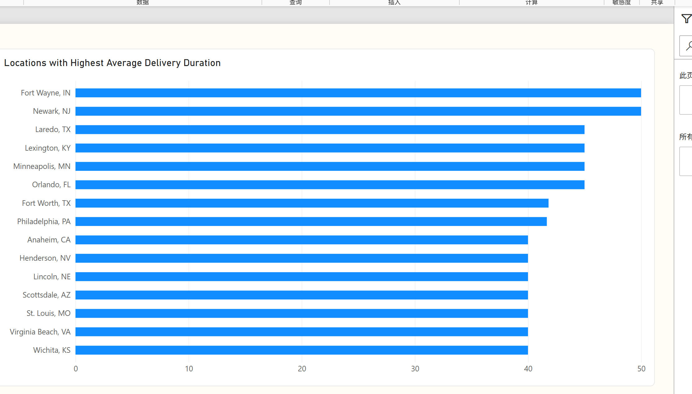
Figure Q7. Power BI visualization.
Observation / answer / explanation
Fort Wayne and Newark form the highest pair at 50.00 minutes. Four more locations share 45.00 minutes, so the column view should retain and clearly label tied results at the filter boundary.

Q8 | 0.5 points
How many orders were placed during peak hours vs. non-peak?
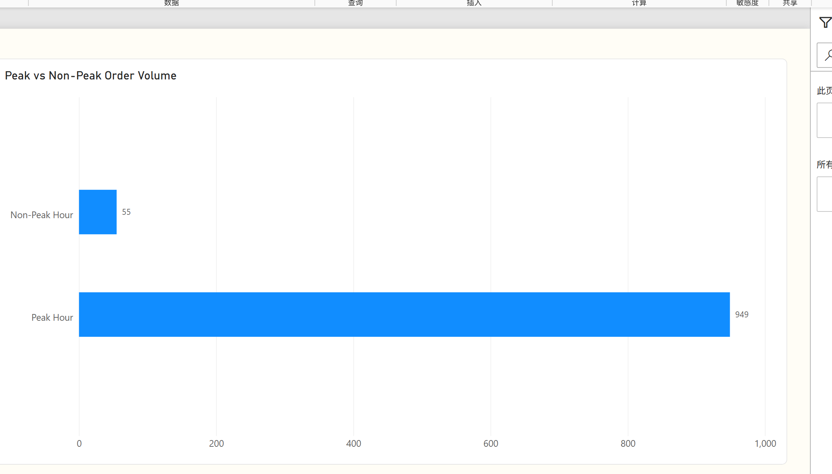
Figure Q8. Power BI visualization.
Observation / answer / explanation
The columns show a strong imbalance: 949 Peak Hour orders versus 55 Non-Peak Hour orders. Peak periods represent 94.52% of all orders in the source.

Q9 | 1 point
How does order volume trend across Order Month?
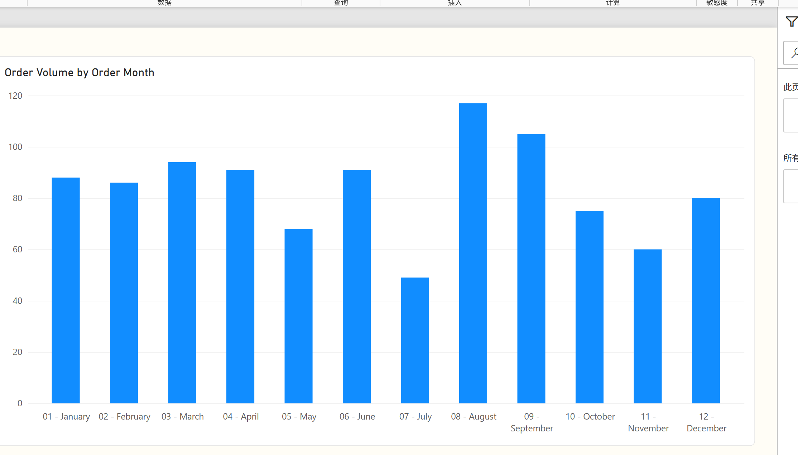
Figure Q9. Power BI visualization.
Observation / answer / explanation
The filled area rises to its highest point in August (117 orders) and remains high in September (105), before falling to 75 in October. July is the lowest month at 49 orders; the month values aggregate all years in the workbook.

Q10 | 1 point
What is the average Toppings Count by Pizza Size?
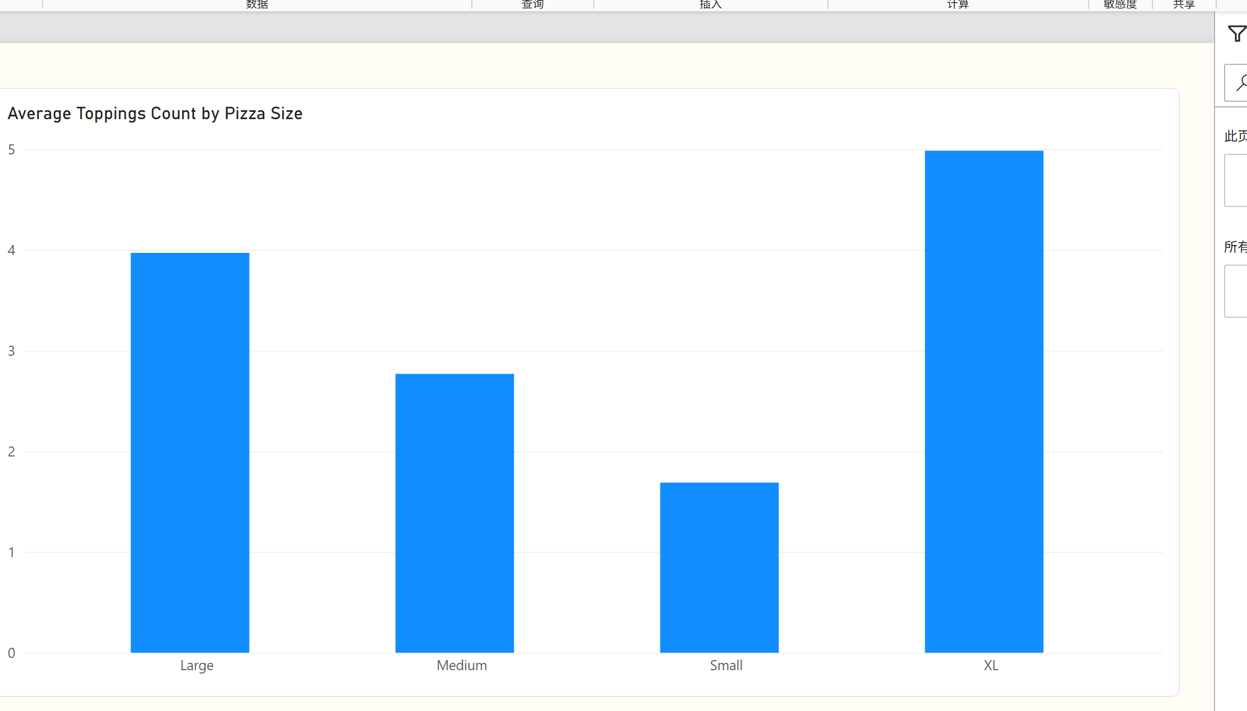
Figure Q10. Power BI visualization.
Observation / answer / explanation
XL stands out with an average of 4.99 toppings, while Small averages only 1.69. Large and Medium fall between them at 3.97 and 2.77.

Q11 | 1 point
Which 2 restaurants have the lowest average Delay (min) i.e., the fastest, most reliable performers?
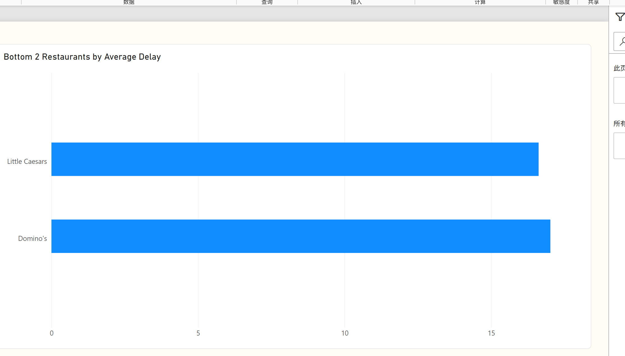
Figure Q11. Power BI visualization.
Observation / answer / explanation
Little Caesars is the first low-delay performer at 16.62 minutes, followed by Domino's at 17.02. The two-column comparison uses the same bottom-two ranking as Version A.

Q12 | 1 point
Which 5 Pizza Types have the highest average Delivery Duration (min)?
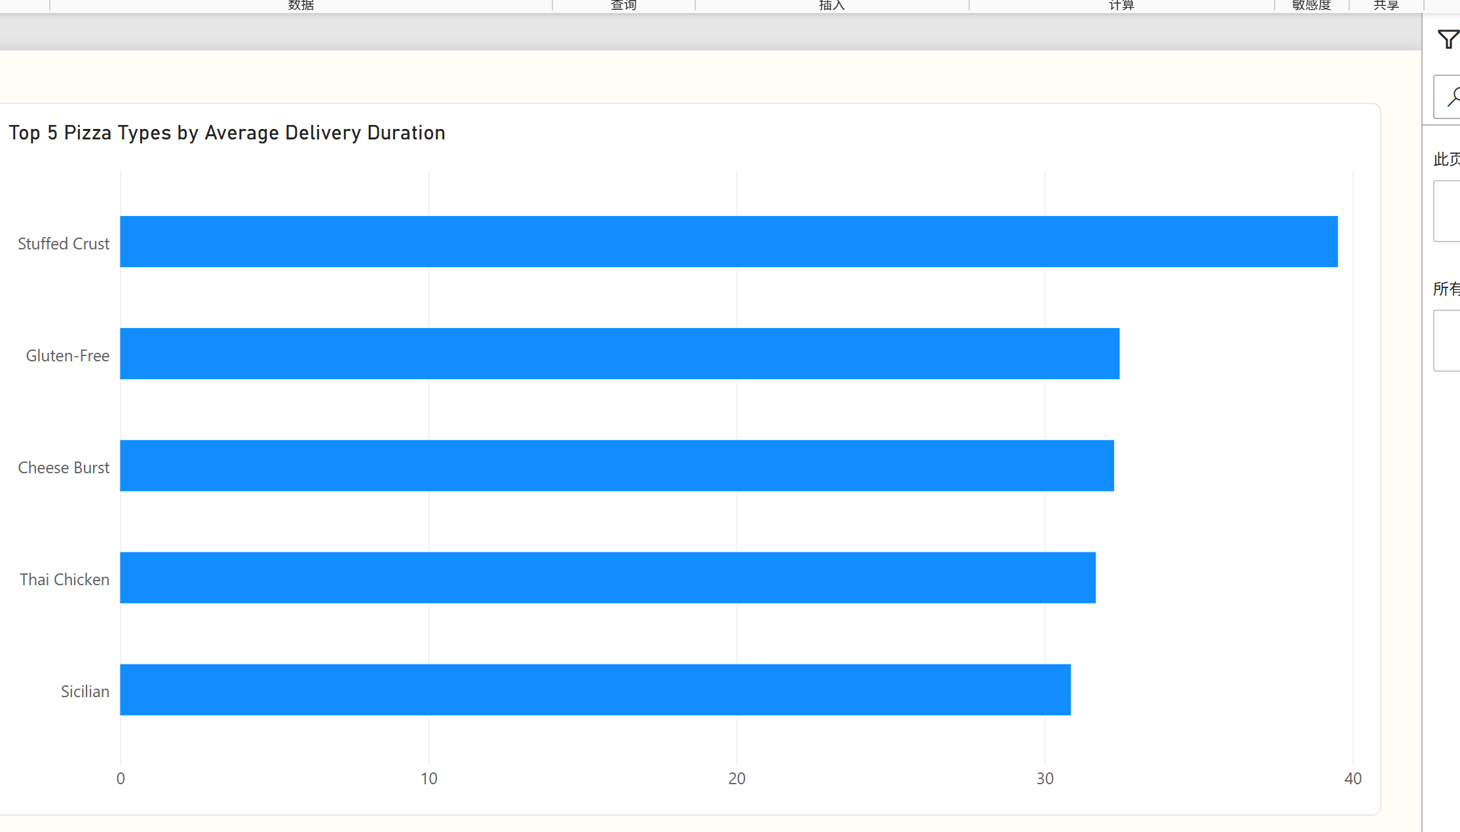
Figure Q12. Power BI visualization.
Observation / answer / explanation
Stuffed Crust is separated from the other top-five pizza types at 39.52 minutes. The next four range from 30.86 to 32.44 minutes, led by Gluten-Free.

Q13 | 1 point
How does order volume vary by Order Hour across a typical day?
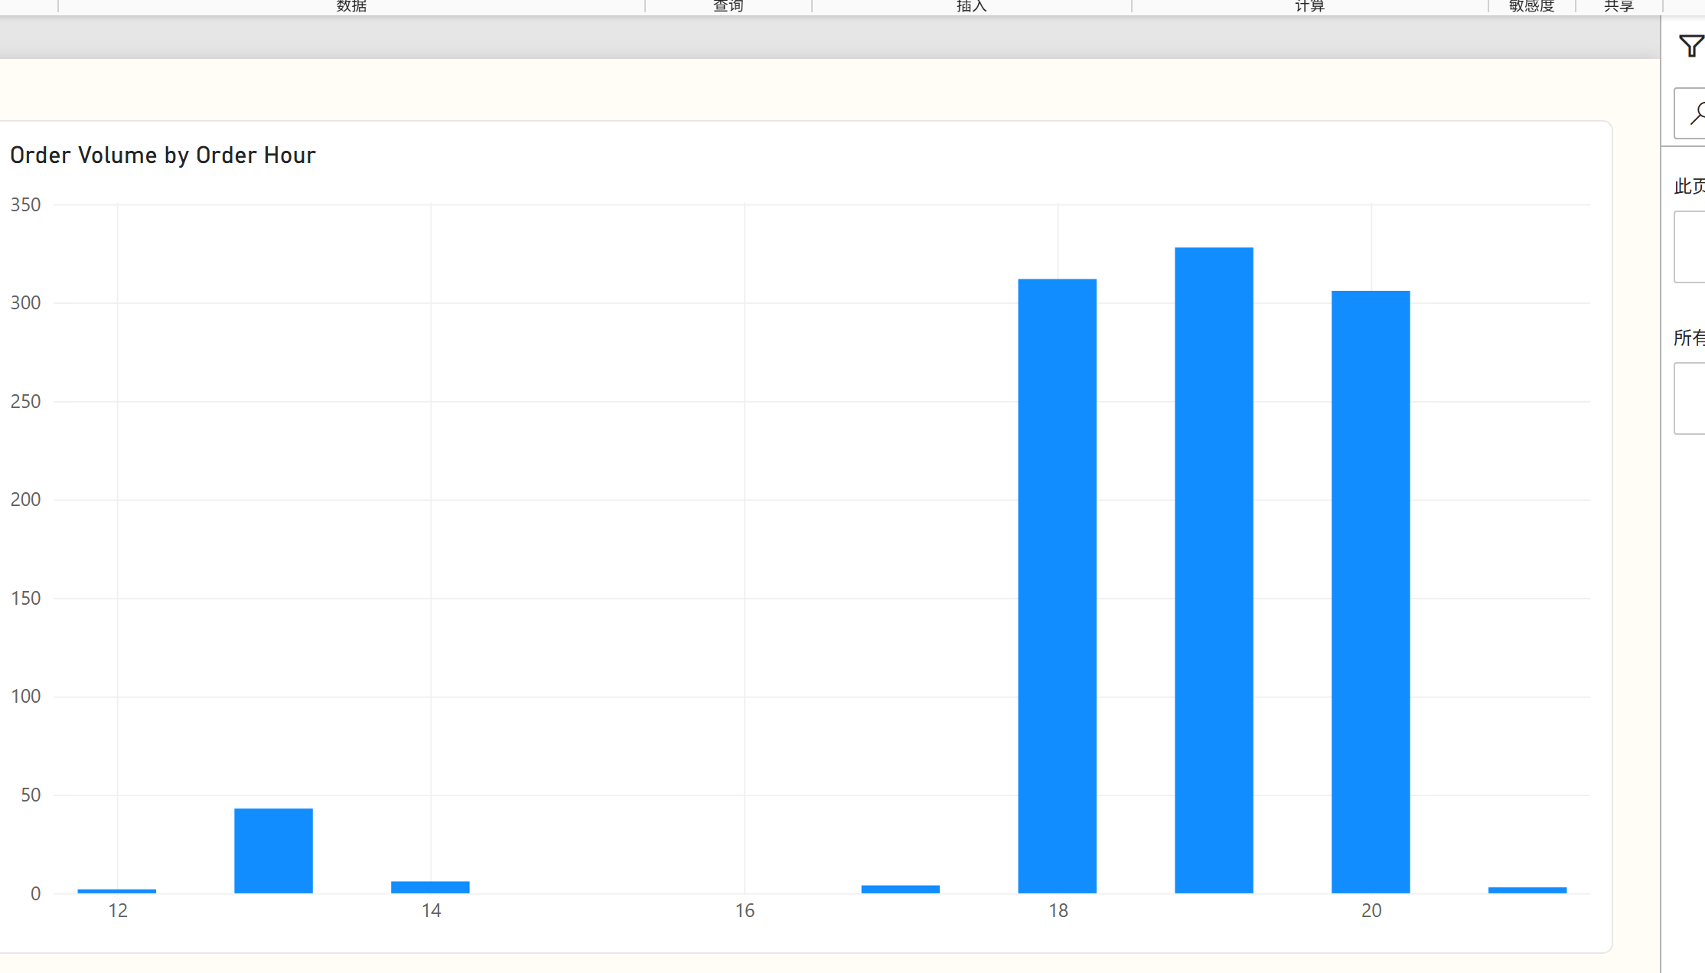
Figure Q13. Power BI visualization.
Observation / answer / explanation
The area is concentrated around 18:00–20:00. Order volume reaches 328 at 19:00, with 312 at 18:00 and 306 at 20:00; other observed hours contribute relatively few orders.

Q14 | 1 point
What is the average delay (min) by Traffic Level?
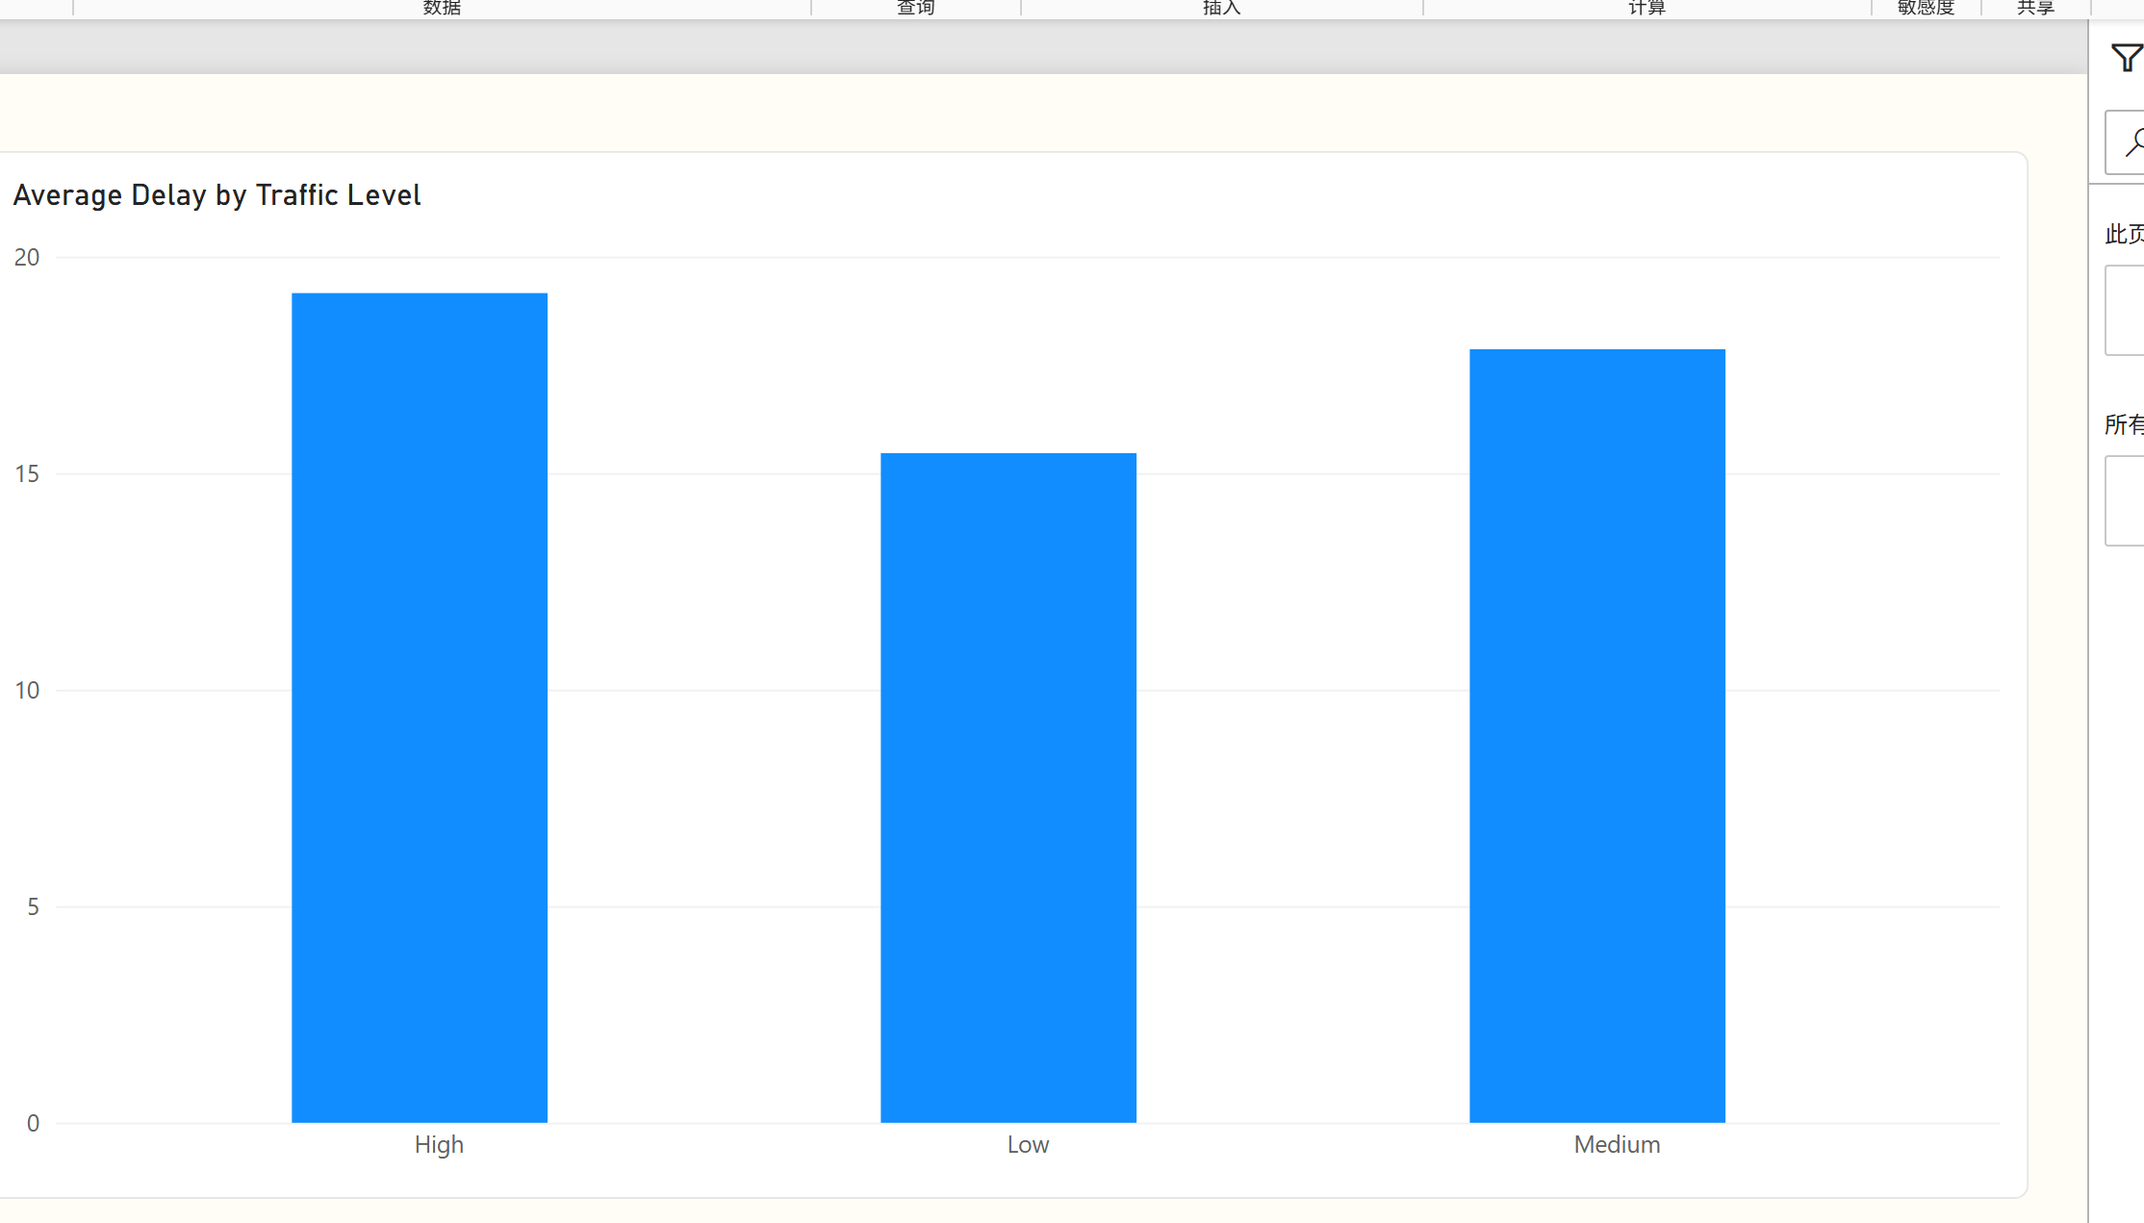
Figure Q14. Power BI visualization.
Observation / answer / explanation
The ordered bars rise from 15.46 minutes under Low traffic to 17.86 under Medium and 19.16 under High traffic. The color progression reinforces the observed association without treating it as causal proof.

Q15 | 1 point
What proportion of orders fall into each Pizza Complexity category?
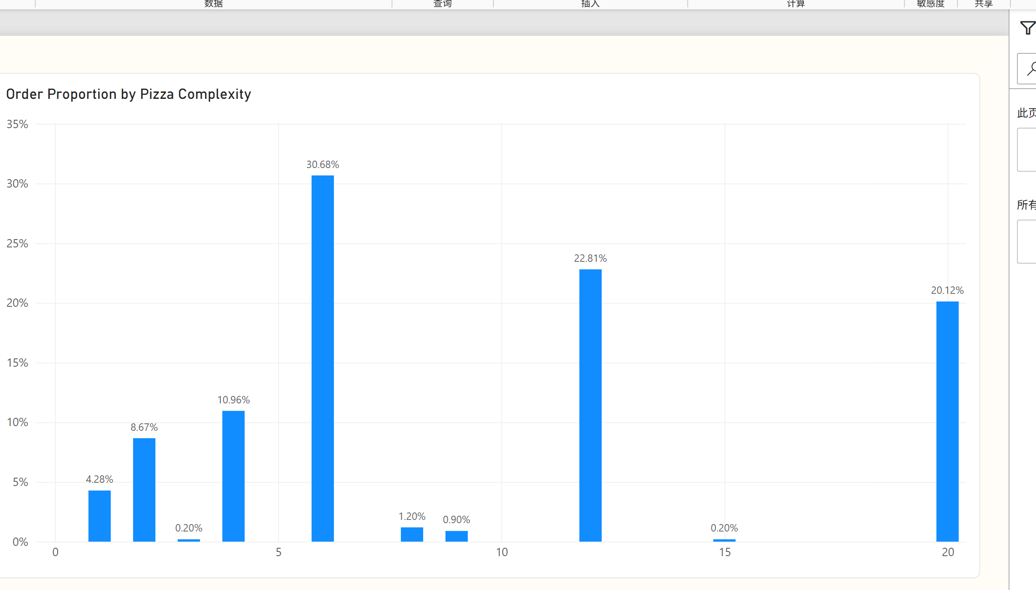
Figure Q15. Power BI visualization.
Observation / answer / explanation
Complexity 6 occupies the largest treemap area with 30.68% of orders. Complexity 12 and 20 add 22.81% and 20.12%, so these three categories together dominate the mix.

Q16 | 1 point
Build a table of average Delivery Duration and Delay by Restaurant Name and use the Fx (Format by field value) button to visually highlight the fastest and slowest restaurants.
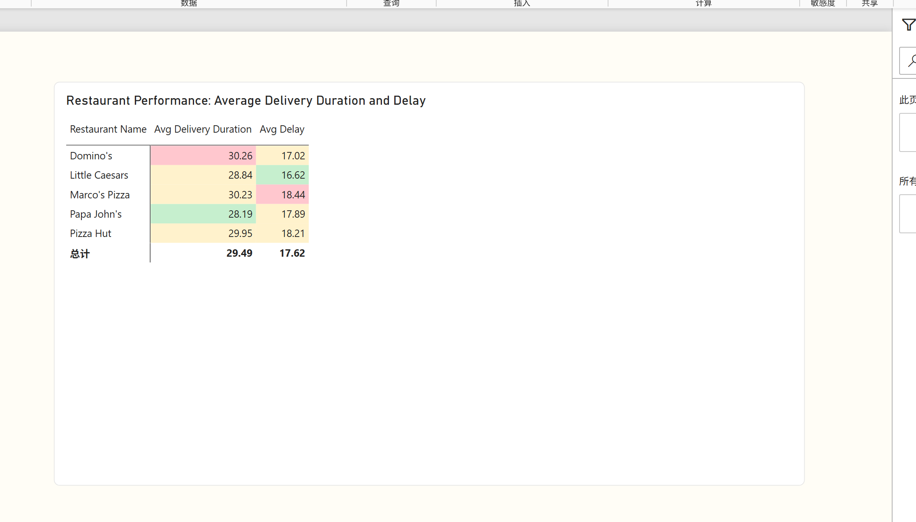
Figure Q16. Power BI visualization.
Observation / answer / explanation
The matrix highlights different leaders for the two measures. Papa John's is fastest on average delivery duration at 28.19 minutes, while Little Caesars has the lowest average delay at 16.62 minutes. Domino's has the longest average duration (30.26), and Marco's Pizza has the highest average delay (18.44).

Q17 | 2 points
How does order volume vary by Order Hour, alongside average Delay (min)?
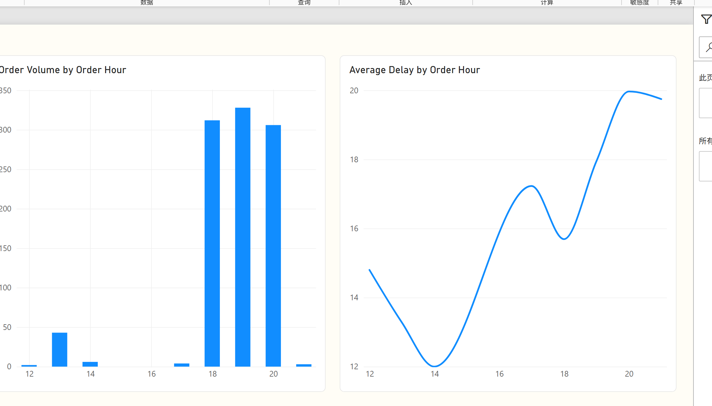
Figure Q17. Power BI visualization.
Observation / answer / explanation
The alternative combo styling shows that demand reaches its maximum at 19:00 (328 orders), while average delay reaches its maximum one hour later at 20:00 (19.97 minutes). This separation is easier to see when the delay line is emphasized on its own axis. The 21:00 value is based on only three orders.

Q18 | 2 points
How does average Topping Density vary by Pizza Type, alongside order volume?
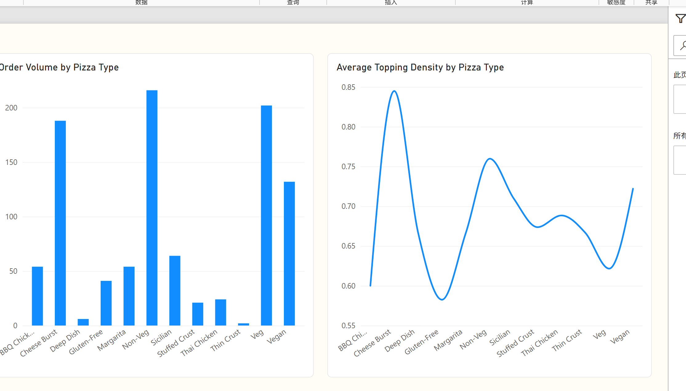
Figure Q18. Power BI visualization.
Observation / answer / explanation
Cheese Burst has the highest average topping density at 0.845 while still recording 188 orders. Non-Veg has the greatest volume at 216 with density 0.760, whereas Gluten-Free is lower at 0.582. The supplied metric is toppings per kilometre, which limits a pizza-only interpretation.

Q19 | 2 points
What is the percentage breakdown of orders by Traffic Level within each Payment methods, filterable by order time?
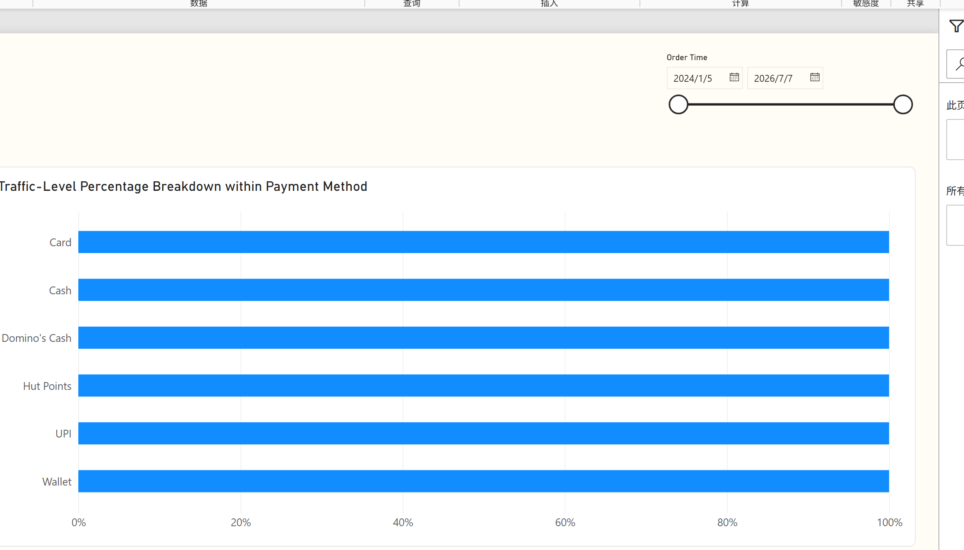
Figure Q19. Power BI visualization.
Observation / answer / explanation
The 100% bars compare composition rather than payment-method size. Card is 44.57% High traffic; Cash and UPI are mainly Medium traffic at 48.02% and 47.60%; Wallet is mainly Low traffic at 44.71%. Small groups such as Hut Points (24 orders) and Domino's Cash (23) require cautious percentage comparisons.

Q20 | 2 points
Design three different charts or tables that use conditional formatting (or highlight them by using different colors) in a single dashboard. Explain why each one matters, what it represents, how they should be read together, and what insights emerge from viewing them as a whole.
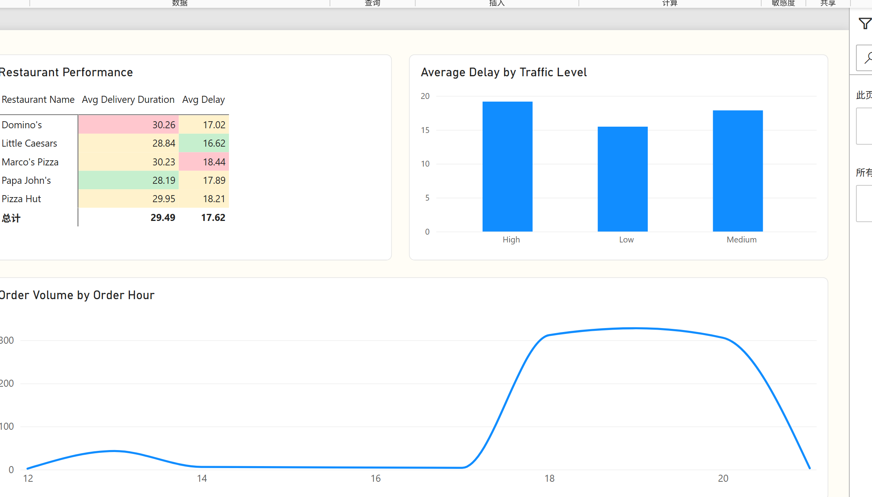
Figure Q20. Power BI visualization.
Observation / answer / explanation
The dashboard begins with demand location, then compares pizza-type delivery performance, and finishes with traffic composition inside payment methods. Atlanta leads location demand with 78 orders, while Stuffed Crust has the longest pizza-type average delivery duration at 39.52 minutes.
The traffic-payment view adds operating context: Card is weighted toward High traffic, while Cash and UPI are weighted toward Medium traffic and Wallet toward Low traffic. Using the Order Time slicer lets the viewer test whether these patterns remain stable across different periods. Together, the three visuals connect where demand occurs, which pizza types take longer, and the conditions surrounding each payment mix.

