CLOUDREST WINES
MySQL Database System Design and Implementation
Human Resources, Workforce Planning and Wellbeing Perspective
Course: BISM2207 System Development
Team / company: Cloudrest Wines
Contributors: Zixuan Shen | Feiyue Ma | Xinzhu Wang | Chengye Jiang
Database: MySQL 8.4.x / MySQL Workbench
Submission date: Team confirmation required
Finalisation package — outstanding course inputs are listed explicitly

Document status and required student completion
Finalisation status: REPORT + CODE PACKAGE READY. The final database contains accepted cleaned supplied data and additional test data. Order reconciliation is 182 = 132 imported + 1 exact copy rejected + 15 ambiguous-pair rows quarantined + 34 other rows quarantined. Student-only video, RiPPlE, Buddycheck and genuine contribution confirmation remain. Task 8 is WAITING FOR COURSE MATERIAL: Week 11 assigned business scenario. No submission date or alias mapping is invented.

AI use declaration
Task | AI used for | Human validation / limitation
1 | Planning | Sequencing/risk suggestions; team must confirm dates and ownership.
2 | Design decisions | Alternatives and critique; decisions validated against case and schema.
3 | Functionality/rules | Drafting and SQL alternatives; rules executed in MySQL.
4 | ER model | Schema-to-Workbench automation; structure derived from validated SQL.
5 | Data dictionary | Mechanical consistency checking; semantic wording reviewed.
6 | Data quality | Bounded cleaned supplied-data import executed; assumptions and quarantines disclosed, reconciliation complete.
7 | Queries | SQL drafting/critique; all outputs independently executed.
Video | Script structure and timing support | Students rehearse, understand, modify and present the material themselves.

Task 1 — Project Plan with Risk Register
Task Description | Responsible Team Member(s) | Final Deliverable Owner | Estimated Hours | Target Completion Date | Actual Completion Date | Expected Output / Evidence | Risk or Challenge | Mitigation Strategy | AI Used / How Used
Requirements and planning | Mia | Mia | 8 | Week 4 | Pending | Traceability matrix | Requirement omission | Cross-check case | Extraction/check
HR scope and KPIs | Mia / Rianna | Mia | 5 | Week 4 | Pending | Defined measures | Metric not calculable | Define numerator/denominator | Alternatives/critique
Base and HR ER model | Zora / All | Zora | 28 | Week 7 | Pending | Workbench model and alternatives | Cardinality error | Peer review against case | Modelling critique
Design decisions | Mia / Zora | Mia | 10 | Week 8 | Pending | Four cited decision records | Weak trade-offs | Trace each to ER | Draft/critique
Schema and rules | Jason / Zora | Jason | 32 | Week 10 | Pending | Clean SQL and five rules | Build failure | Empty-database tests | SQL review
Data dictionary | Zora / Jason | Zora | 16 | Week 10 | Pending | Complete Word tables | Schema drift | Automated consistency check | Mechanical QA
Official cleaning | Jason / Mia | Jason | 23 | Week 10–11 | In progress | v4 audit/staging/reconciliation | Ambiguous duplicate order/product rows | Preserve raw rows; quarantine ambiguity | Profiling/consistency checks
Test data and integrity | Jason / Rianna | Jason | 20 | Week 10 | Pending | Five tests and histories | Trivial coverage | Scenario-based data | Coverage critique
Six analytical queries | Rianna / Jason | Rianna | 28 | Week 11 | Pending | Queries/view/procedure/EXPLAIN | Join inflation | Manual reconciliation | SQL alternatives
Reflection | All | Rianna | 10 | Week 12 | Pending | Genuine RiPPlE evidence | Fabrication risk | Save real iterations | Reflection subject
Video | All | Rianna | 12 | Week 12 | Pending | Five-minute demonstration | Over time | Timed rehearsal | Structure/timing
Final integration and QA | Mia / All | Mia | 10 | Week 12 | Pending | Submission package/audit | Cross-file mismatch | Automated and human QA | Consistency checking

Responsibility-name mapping: The signed Team Charter names are Zixuan Shen, Feiyue Ma, Xinzhu Wang and Chengye Jiang. The earlier planning draft uses Mia, Zora, Rianna and Jason as responsibility aliases. Their one-to-one mapping must be confirmed by the team before final submission and is not guessed here.

Expanded risk register
Risk | Why it may occur | Affected task | Likelihood | Impact | Prevention | Contingency / response | Owner
Schema drift after tutor feedback | PK/FK changes affect ERD, dictionary, SQL and video | Tasks 3–7 | High | High | Treat schema SQL as source of truth; rebuild and regress | Freeze changes, rerun tests, regenerate all dependent artifacts | Zora / Jason
Ambiguous v4 duplicate order/product rows | Repeated pairs differ in quantity, price, refund or status | Task 6 | High | High | Preserve raw staging rows and source row numbers | Quarantine whole affected orders; document reasons without aggregation | Jason / Mia
Reset historical start dates | Workbook states some current-customer start dates were reset on export | Task 6 | Medium | Medium | Record source limitation and preserve raw value | Do not invent lost dates; disclose limitation | Jason / Mia
Multiple simultaneous current history rows | Dated associations can accidentally create duplicate current facts | Tasks 3–5 | Medium | High | Non-overlap triggers and one-current-primary-phone controls | Reject conflicting writes and correct staging periods | Jason / Zora
Wine composition below/above 100% | Total is a cross-row business rule | Tasks 3–5 | Medium | High | Validate total before active product release and lock released recipe | Deactivate product, correct composition, rerun validation | Jason / Zora
Labour-hour inconsistency | Manual hour totals can disagree with shift times | Tasks 3 and 7 | Medium | High | Store actual assignment times/breaks and derive hours | Correct source times and rerun workforce metrics | Jason / Rianna
Task 7 results become stale | Late schema/data changes alter query outputs or EXPLAIN | Task 7/video | High | High | Execute all six queries against the frozen build | Recapture outputs and update interpretations together | Rianna / Jason
Evidence from wrong build | Screenshots/video may not match submitted SQL | Tasks 3,6,7/video | Medium | High | Rebuild portable SQL immediately before evidence capture | Recapture evidence from the frozen build | All / Mia

This round: finalisation responsibilities
These are prospective responsibilities for the current finalisation round and do not claim historical contributions. NEEDS HUMAN CONFIRMATION: alias → real-name mapping.
Member | Finalisation responsibility
Zixuan Shen | Final integration, Task 1 Risk Register, consistency, tutor-feedback traceability, Word report, AI declaration and submission QA.
Feiyue Ma | Workbench model, latest .mwb, full UML ER and six domain views, Task 4, Task 5 schema/dictionary consistency and ER screenshots.
Xinzhu Wang | SQL integrity, T01–T11, official v4 staging/import/cleaning, Task 6 before/after evidence, exceptions and reconciliation.
Chengye Jiang | Six Task 7 queries, result screenshots, Query 6 EXPLAIN, actual-number interpretation, personal video demonstration to be completed by the student later.

Checkpoint sequence
Milestone | Evidence
Week 3 | Team confirmed; contacts shared
Week 4 | Case understanding, HR perspective, functionality plan
Week 7 | Draft ER model and decisions
Week 8 Fri | Iteration Tasks 1–7
Week 10 | Normalisation, cleaning plan, business rules
Week 11 | Draft queries and assigned scenario
Week 12 | Report, SQL and video
Week 13+1 | Buddycheck

Task 2 — Design Decision Record

Selected perspective and sustainability initiative
Cloudrest Wines extends the complete winery base model through the Human Resources, Workforce Planning and Wellbeing perspective. Its sustainability initiative measures training coverage and incidents per 1,000 labour hours, supported by overtime, qualification expiry, corrective-action and wellbeing indicators. This differentiates the system from a conventional personnel register: management can relate workforce preparation and exposure to safety outcomes by operational area and period. The design stores only the detail needed for responsible follow-up, while aggregated reporting reduces unnecessary exposure of sensitive wellbeing information.

Decision 1 — Model customer types with a supertype and subtypes
Challenge and source. All customers share identifiers, email, phone, address and order behaviour. Individuals require names/date of birth while businesses require company name, ABN, type and contact names (Wine Company Case, pp. 4–5, “Customers”).
Alternatives. A single customer table could contain every attribute, with type-dependent nullable columns. Alternatively, separate individual and business tables could duplicate all shared contact and order relationships. The selected model uses customer as the supertype and individualcustomer/businesscustomer as subtype tables.
Selected design, justification, trade-off and ER traceability. customer is the supertype and individualcustomer/businesscustomer are subtypes. The structure avoids duplicated common attributes and inapplicable NULLs, supports 3NF and gives every order one enforceable customer FK. Type-specific controls improve data quality and reduce accidental exposure of date of birth. The trade-off is an extra join. The ER traces one customer to exactly one subtype and to dated contact associations.

Decision 2 — Separate an address from its time-dependent use
Challenge and source. Employee role, supervisor, address and phone history must be retained; customer delivery uses the current physical address; supplier contact details support procurement (Wine Company Case, pp. 1, 3–5).
Alternatives. Address columns could be copied into every owner table. A second option is a shared address table with owner ID/type columns, but that creates a polymorphic foreign key MySQL cannot enforce. The selected model stores address structure once and uses typed association tables such as employeeaddress and customeraddress with start/end timestamps.
Selected design, justification, trade-off and ER traceability. A shared address plus typed employeeaddress, customeraddress and supplieraddress associations provide enforceable FKs and preserve validity periods without overwriting. phone is similarly reused by dated owner-specific associations. A shipment retains its address key. More joins and overlap controls are required, but temporal accuracy, controlled updates and extensibility outweigh the performance cost at course scale. The ER traces each owner to contact history and the shipment to the actual address used.

Decision 3 — Separate training definition, delivery and attendance
Challenge and source. The HR perspective requires course, provider, completion, renewal and competency data and annual coverage by operational area (BISM2207 Assessment Specification, p. 2, “Human Resources”).
Alternatives. A single employee-training table could repeat course and provider text for every participant. A course table plus employee completion record would reduce repetition but could not represent multiple employees attending one delivery or distinguish repeated sessions. The selected design uses trainingcourse, trainingsession and trainingattendance.
Selected design, justification, trade-off and ER traceability. trainingcourse, trainingsession and trainingattendance separate definition, delivery and outcome. This removes update anomalies, validates attendance controls and supports repeated/company-wide delivery. Two indexed joins are the accepted OLTP/reporting trade-off. The ER traces course 1:M session and session M:N employee through attendance.

Decision 4 — Model incidents and involved employees as many-to-many
Challenge and source. A workplace event may involve several affected employees, witnesses or reporters; the HR perspective requires incident type, severity, corrective action and lost time (BISM2207 Assessment Specification, p. 2).
Alternatives. Storing one employee ID in incident is simple but cannot accurately represent multi-person events. Repeating the incident once per employee creates contradictory copies of severity and corrective action. The selected model stores the event once and associates people through incidentemployee, including involvement role and employee-level lost hours.
Selected design, justification, trade-off and ER traceability. incident stores the event once and incidentemployee records people and involvement roles; correctiveaction depends on the incident. This prevents contradictory copies, permits privacy-aware person/area analysis and avoids duplicate incident-rate numerators. The associative table is additional complexity but correctly represents cardinality. The ER traces incident M:N employee and incident 1:M corrective action.

Task 3 — Database Functionality and Business Rules
Stakeholder | Need / Risk | Database Requirement | Design Response | Priority / Trade-off
Owners / management | Reliable compliance data | Integrated history and decision queries | Normalised schema and six queries | Reporting convenience vs integrity
HR manager | Accurate private HR records | Temporal roles/classifications | Dated HR tables; restricted notes | Privacy first
Supervisors | Current teams and workload | One supervisor at a time | Overlap trigger | Integrity first
Permanent employees | Correct history | Current and historical contacts | Dated associations | High
Casual / seasonal employees | Correct seasonal status | CASUAL + SEASONAL dimensions | Separate type/pattern | Avoid conflation
Safety / compliance | Multi-person/near-miss evidence | Roles and zero lost hours | Incident association | Evidence accuracy
Customers | Postal contact, physical delivery | Multiple addresses | Shipment trigger | Delivery integrity
Suppliers | Retained contact changes | Temporal address/phone | Supplier associations | Extra joins accepted
Reporting users | Reproducible private metrics | Aggregates and safeguards | Defined query logic | Accuracy/privacy
Community | Safe responsible operations | Auditable training/actions | Traceable records | Public value/privacy

3a. Functionality description
Cloudrest Wines needs a transactional database because spreadsheet and document records no longer scale to business growth, biosecurity reporting and sustainability evidence (Wine Company Case, p. 1). The MySQL system integrates personnel, vineyard plantings, harvests, wines, bottles, suppliers, customers and orders. The selected HR perspective adds qualifications, training, shifts, labour hours, incidents, corrective actions and confidential wellbeing check-ins (BISM2207 Assessment Specification, p. 2). It supports annual safety/sustainability training coverage and incident rates per 1,000 labour hours.
The design targets 3NF and OLTP use. Repeating phones and addresses are separate entities; temporal association tables preserve employee, customer and supplier contact history. Course definitions, delivered sessions and individual attendance are separated. Many-to-many facts use associative tables, including wine composition, incident involvement and training attendance. Role, supervisor, address, phone and price histories retain effective dates rather than overwriting facts.
Controls combine types, NOT NULL, candidate keys, foreign keys, CHECK constraints and triggers. Row constraints reject invalid dates and domains. Triggers enforce rules needing other rows or tables, such as non-overlapping supervision and paid, non-cancelled, current, physical shipment addresses with shipment dates on or after order receipt. The submitted rule script uses transactions and rollback. Standalone screenshot tests were followed by a clean verifier rebuild before final query capture, removing all setup rows. Employee/customer contact histories are stored with effective dates; the test data follows sensible current-contact patterns, while the current schema does not claim an exactly-one-current rule for every employee/customer phone or address association.
Privacy is handled in the submitted build through data minimisation: routine decision-support output uses IDs or aggregates and excludes confidential wellbeing notes. The SQL submission does not define production MySQL users/roles or application authorisation policies, so the report does not claim database-level access control that is absent from the code. A production deployment would add least-privilege database roles and application-level access control for TFNs, dates of birth, contact data, incident participation and wellbeing details.
Payroll, payment instruments, delivery costing and unrelated inventory remain outside scope, consistent with the case. The system provides reliable operational evidence without adding enterprise functions the four-person team could not explain or validate.

Stakeholder and community requirements
Exception coverage includes multi-person incidents; employee role, supervisor, address and phone changes; supplier address and phone changes; simultaneous customer physical/postal addresses; high overtime without an incident; confidential wellbeing notes; and a serious near miss with zero lost hours.

3a.1 Tutor-feedback integrity revisions
The revised schema addresses the specific integrity gaps identified in tutor review.
- Vineyard planting and harvest. vineyardplanting is identified by vineyard, vintage and grape variety, allowing more than one variety in the same vineyard/year. harvest stores the same grape-variety key and references the exact planting row. - Refund grain. refund stores productId with customerOrderId and uses a composite foreign key to orderline, so a refund cannot refer to a product that was not part of the order. - Picking-pack history. joinedDate is part of the packmember primary key. A picker can leave and later rejoin the same pack, while an overlap trigger prevents simultaneous membership periods. - Historical contacts. Employee and supplier address periods cannot overlap for the same address kind. Customer address history records a purpose (Primary, Delivery, Billing or Correspondence) and cannot overlap within the same purpose. This permits legitimate concurrent Delivery and Billing addresses in the supplied v4 data. Employee, customer and supplier phone history allows retained numbers but prevents more than one current primary phone. - Wine composition. Row percentages remain individually constrained, while a cross-row validation procedure requires a wine recipe to contain at least one variety and total exactly 100% before an active product is released. Released recipes are locked against ad-hoc composition edits until their products are deactivated. - Shift integrity. shiftassignment no longer stores independent regular/overtime totals alongside shift times. It stores actual start time, actual end time and break minutes. Labour hours and overtime are derived in reporting queries, removing the duplicate fact that the tutor identified. - Role history. Existing role-overlap triggers already implement the tutor clarification that the previous role must finish before the next active role starts. - Sustainability reporting. The selected HR perspective is measured through two explicit quantitative indicators: annual completion coverage for both Safety and Sustainability training, and workplace incidents per 1,000 actual labour hours. The second metric uses the revised derived assignment hours as its denominator.
These controls are additional to the five assessed Task 3b rules below. They are included because they protect the model and the final decision-support results even where they are not selected as one of the five screenshot rules.

3b. Five assessed database-enforced business rules

Rule 1 — Historical role dates
- Rule: An employee role end date/time cannot precede its start date/time. - Case source: Personnel requires role history with start and end dates (Wine Company Case, pp. 1–2). - Mechanism: chk_employeerole_dates CHECK. - Violation: database/tests/task3b_ruleviolations.sql creates a temporary test employee inside a transaction and inserts an end in May before a June start. - Expected result: MySQL Error 3819 naming chk_employeerole_dates. - Genuine Workbench evidence: Genuine local Workbench capture available in docs/evidence/final-workbench (2026-10-07); submitting students review before submission.
Readable SQL submitted for Turnitin
-- Rule 1: role end cannot precede start
-- Expected: Error 3819 naming chk_employeerole_dates
-- =========================================================
ROLLBACK;
START TRANSACTION;
INSERT INTO employee
(employeeId, firstName, lastName, taxFileNumber, employmentStartDate, employmentEndDate)
VALUES
('EMP9999', 'Rule', 'Test', '998877665', '2026-01-01', NULL);
INSERT INTO employeerole
(employeeId, roleId, operationalAreaId, startDateTime, endDateTime,
workTimeType, employmentType, employmentPattern)
VALUES
('EMP9999', 'ROLE07', 'AREA04', '2026-06-01 09:00:00', '2026-05-01 09:00:00',
'PARTTIME', 'PERMANENT', 'ONGOING');
-- After screenshot, run this line alone:
ROLLBACK;
-- =========================================================
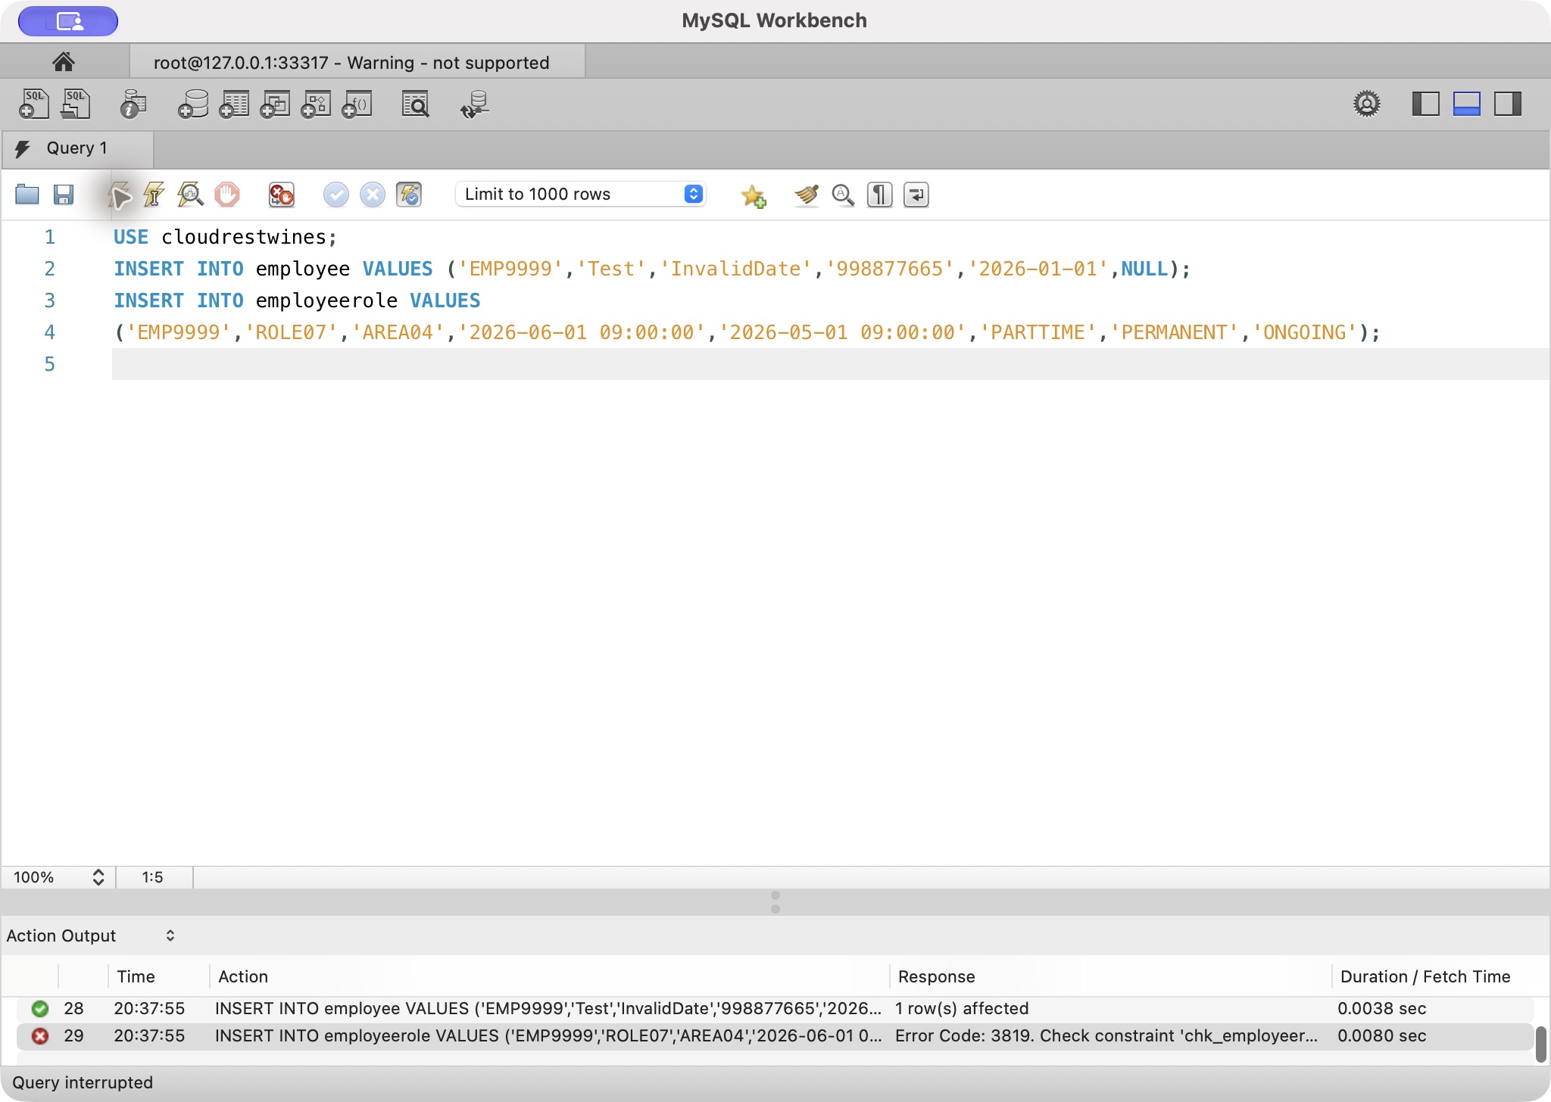
Rule 1: genuine local MySQL Workbench execution, 2026-10-07

Rule 2 — Bottle reorder explanation
- Rule: reorderFlag = FALSE requires a nonblank explanation. - Case source: Bottle quality problems and reasons for not reordering must be recorded (Wine Company Case, p. 3). - Mechanism: chk_bottletype_reorder CHECK. - Violation: database/tests/task3b_ruleviolations.sql supplies NULL inside an isolated transaction. - Expected result: MySQL Error 3819 naming chk_bottletype_reorder. - Genuine Workbench evidence: Genuine local Workbench capture available in docs/evidence/final-workbench (2026-10-07); submitting students review before submission.
Readable SQL submitted for Turnitin
-- Rule 2: reorder FALSE requires a nonblank comment
-- Expected: Error 3819 naming chk_bottletype_reorder
-- =========================================================
ROLLBACK;
START TRANSACTION;
INSERT INTO bottletype
(bottleTypeId, capacityMl, bottleShape, material, bottleColour,
inventoryQuantity, usualUnitCost, reorderFlag, reorderComment)
VALUES
('BOTL099', 750, 'Test', 'GLASS', 'Green', 0, 1.00, FALSE, NULL);
-- After screenshot, run this line alone:
ROLLBACK;
-- =========================================================
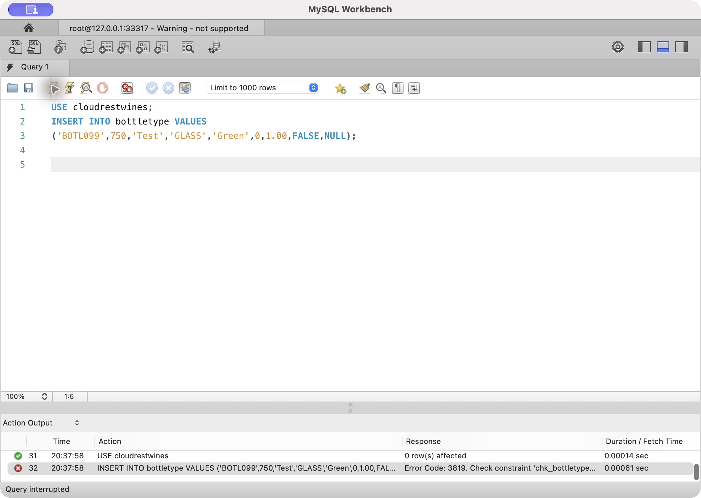
Rule 2: genuine local MySQL Workbench execution, 2026-10-07

Rule 3 — Current physical shipment address
- Rule: Shipment must use the customer's current physical address, never a PO Box or Private Bag. - Case source: Orders are delivered to the current physical address and not postal addresses (Wine Company Case, p. 5). - Mechanism: shipment insert/update triggers inspect address and current customeraddress rows. - Violation: database/tests/task3b_ruleviolations.sql uses current PO Box ADDR0004. - Expected result: MySQL Error 1644 with the physical-address message. - Genuine Workbench evidence: Genuine local Workbench capture available in docs/evidence/final-workbench (2026-10-07); submitting students review before submission.
Readable SQL submitted for Turnitin
-- Rule 3: shipment must use the customer's current physical address
-- Expected: Error 1644 with the physical-address message
-- =========================================================
ROLLBACK;
START TRANSACTION;
INSERT INTO shipment
(shipmentId, customerOrderId, addressId, shippedDate)
VALUES
('SHIP0999', 'CORD0001', 'ADDR0004', CURRENT_DATE);
-- After screenshot, run this line alone:
ROLLBACK;
-- =========================================================
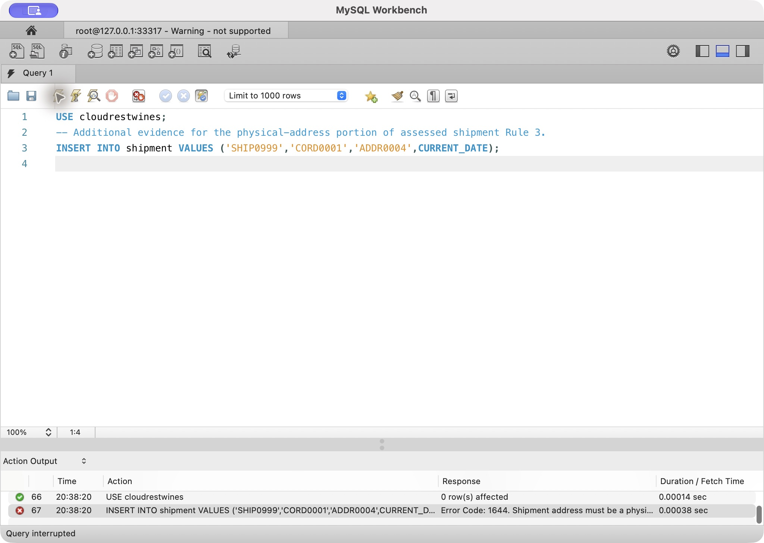
Rule 3: genuine local MySQL Workbench execution, 2026-10-07

Rule 4 — Paid before shipment
- Rule: An order must have paidFlag = TRUE before shipment. - Case source: The order is shipped only after accounting confirms payment (Wine Company Case, p. 5). - Mechanism: shipment insert/update triggers read customerorder.paidFlag. - Violation: database/tests/task3b_ruleviolations.sql creates an unpaid order inside a transaction and attempts shipment. - Expected result: MySQL Error 1644: Order must be paid before shipment. - Genuine Workbench evidence: Genuine local Workbench capture available in docs/evidence/final-workbench (2026-10-07); submitting students review before submission.
Readable SQL submitted for Turnitin
-- Rule 4: order must be paid before shipment
-- Expected: Error 1644, Order must be paid before shipment
-- =========================================================
ROLLBACK;
START TRANSACTION;
INSERT INTO customerorder
(customerOrderId, customerId, receivedDate, paidFlag, orderStatus)
VALUES
('CORD0998', 'CUST001', CURRENT_DATE, FALSE, 'PENDING');
INSERT INTO shipment
(shipmentId, customerOrderId, addressId, shippedDate)
VALUES
('SHIP0998', 'CORD0998', 'ADDR0003', CURRENT_DATE);
-- After screenshot, run this line alone:
ROLLBACK;
-- =========================================================
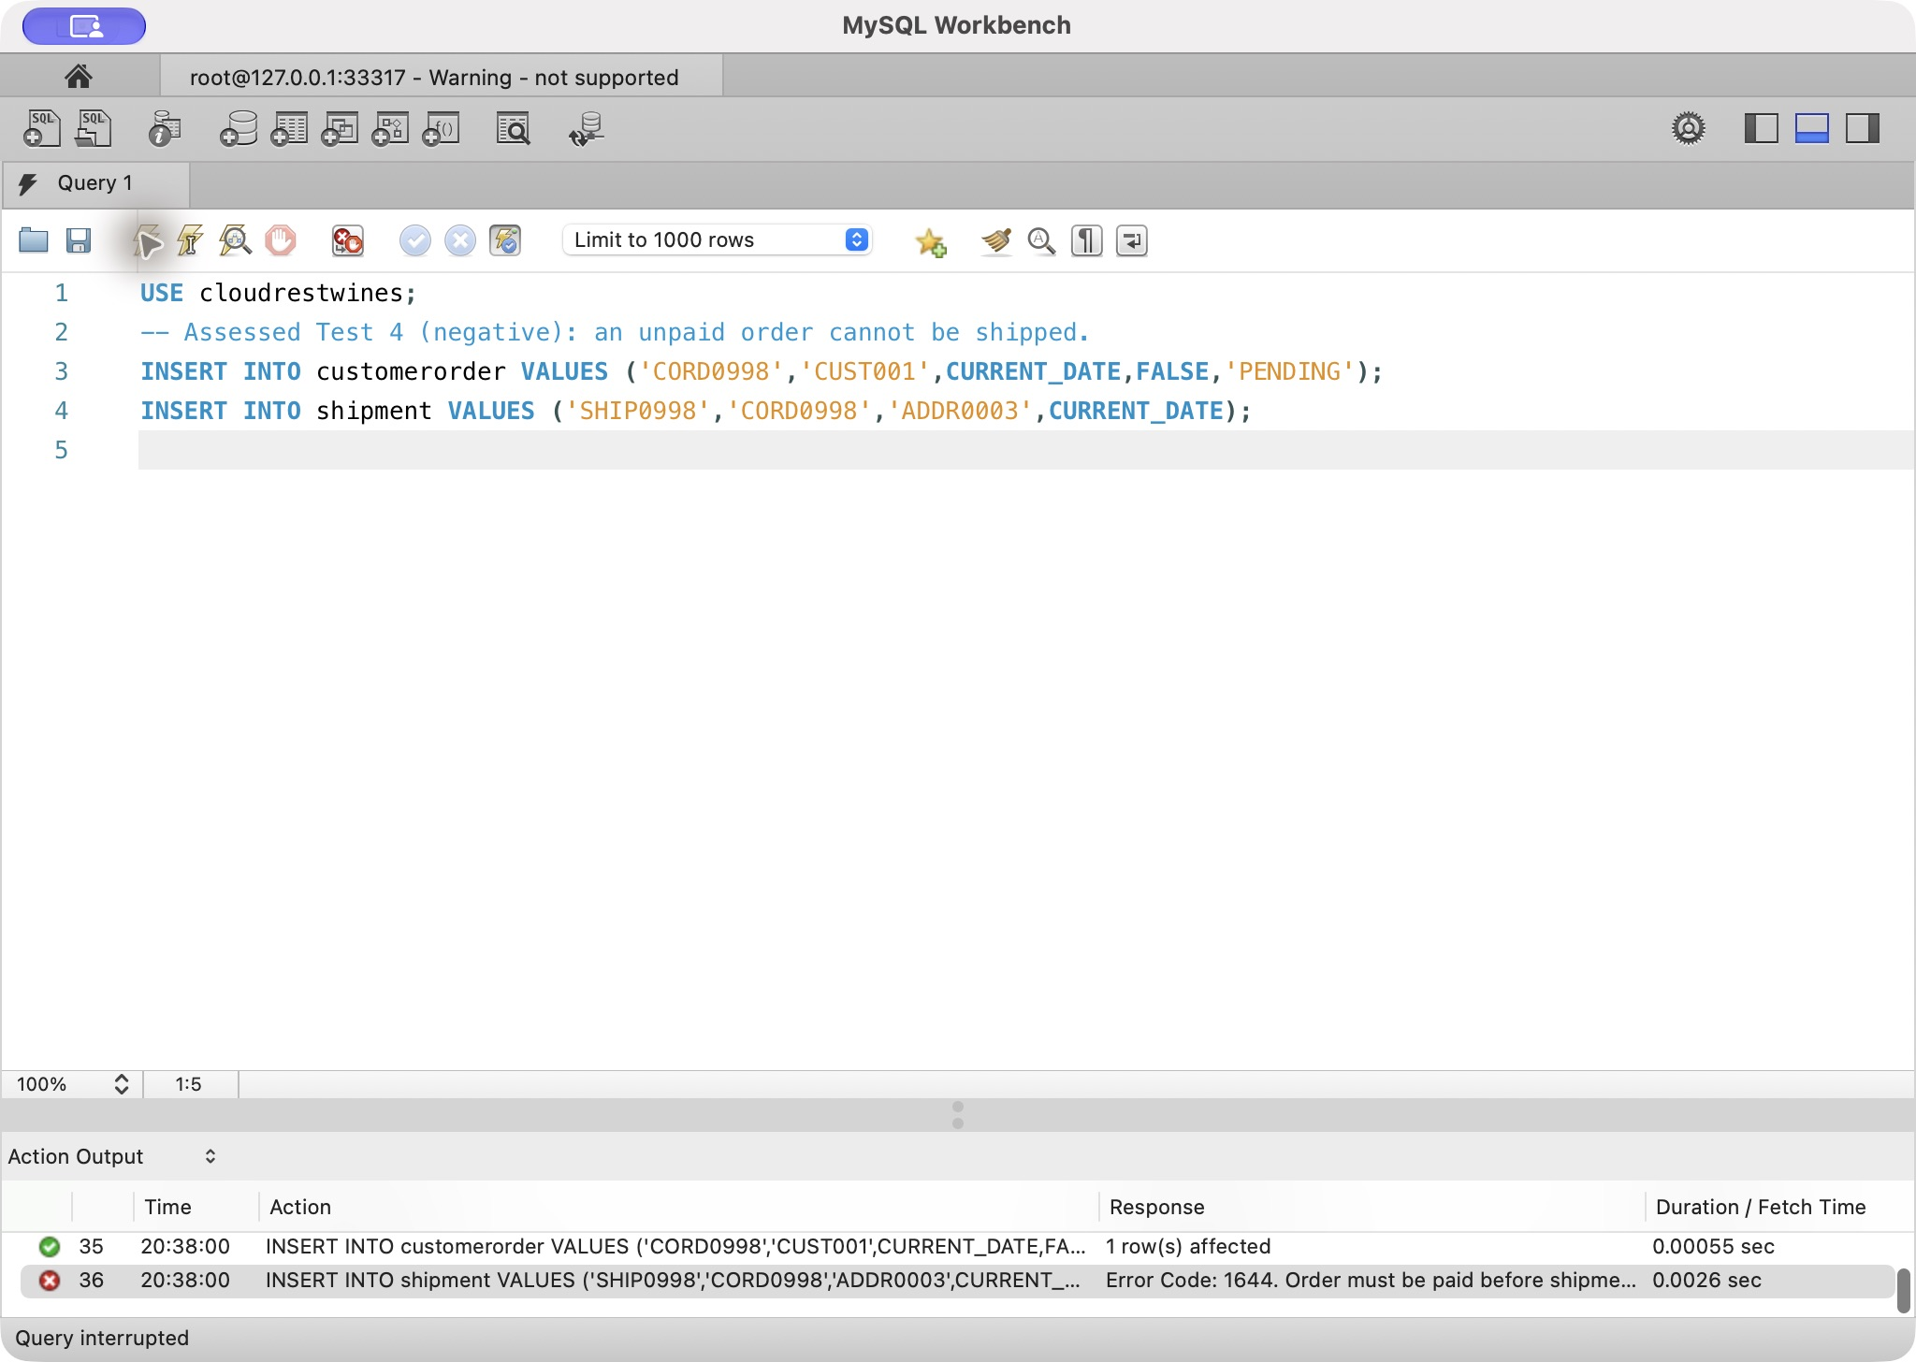
Rule 4: genuine local MySQL Workbench execution, 2026-10-07

Rule 5 — One supervisor at a point in time
- Rule: A supervised employee may have only one supervisor at any point in time. - Case source: Each supervised employee reports to only one supervisor and supervisor history is retained (Wine Company Case, p. 1). - Mechanism: supervision insert/update overlap triggers. - Violation: database/tests/task3b_ruleviolations.sql inserts a second current supervisor for EMP0008 inside an isolated transaction. - Expected result: MySQL Error 1644 with the overlapping-supervision message. - Genuine Workbench evidence: Genuine local Workbench capture available in docs/evidence/final-workbench (2026-10-07); submitting students review before submission.
The submitted rule script rolls back its transactions; standalone screenshot setup rows were removed by the final clean rebuild. Readable assessed SQL is in database/tests/task3b_ruleviolations.sql. Legal-age, postal-address completeness, cancelled-shipment and shipment-date validation remain additional controls rather than assessed Task 3b rules.
Readable SQL submitted for Turnitin
-- Rule 5: supervised employee has only one supervisor at a point in time
-- Expected: Error 1644 with the overlapping-supervision message
-- =========================================================
ROLLBACK;
START TRANSACTION;
INSERT INTO supervision
(employeeId, supervisorId, startDateTime, endDateTime)
VALUES
('EMP0008', 'EMP0001', '2026-02-01 09:00:00', NULL);
-- After screenshot, run this line alone:
ROLLBACK;
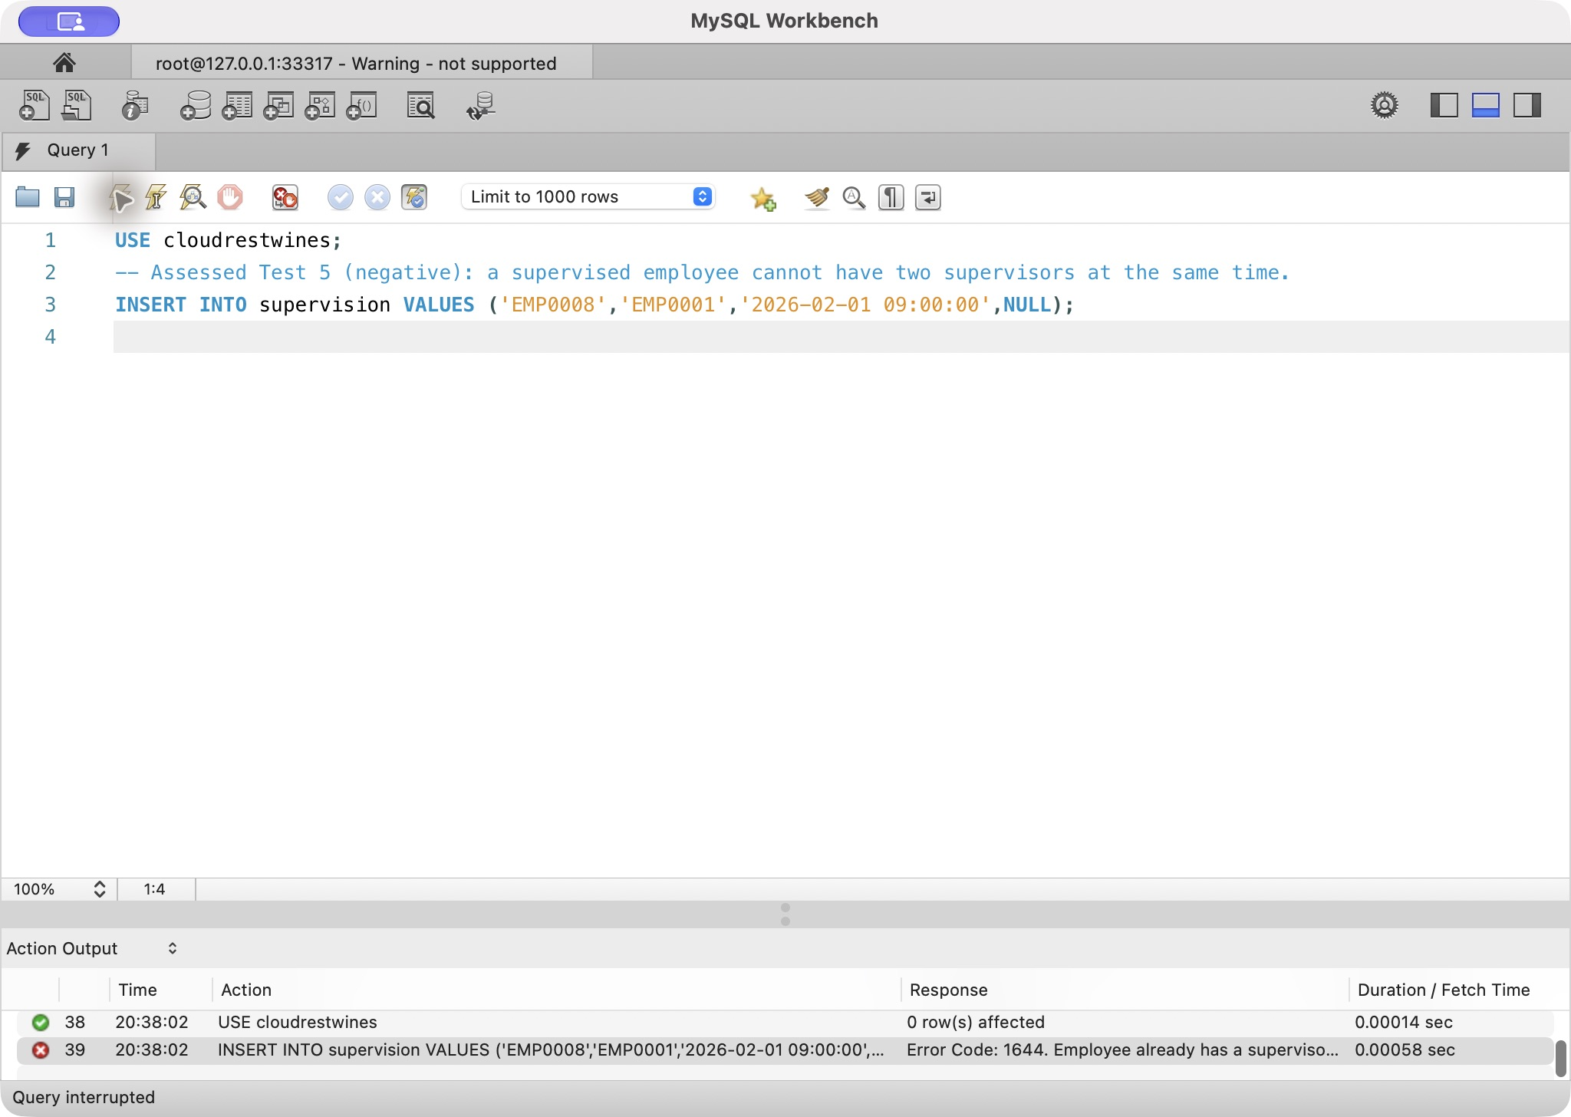
Rule 5: genuine local MySQL Workbench execution, 2026-10-07

Task 4 — ER Diagram with Annotated Alternatives
The editable MySQL Workbench model contains one complete diagram and six domain views. The full view demonstrates scope; the domain figures preserve readable attributes, keys and UML cardinalities. Assumptions are stated explicitly and do not contradict the case.
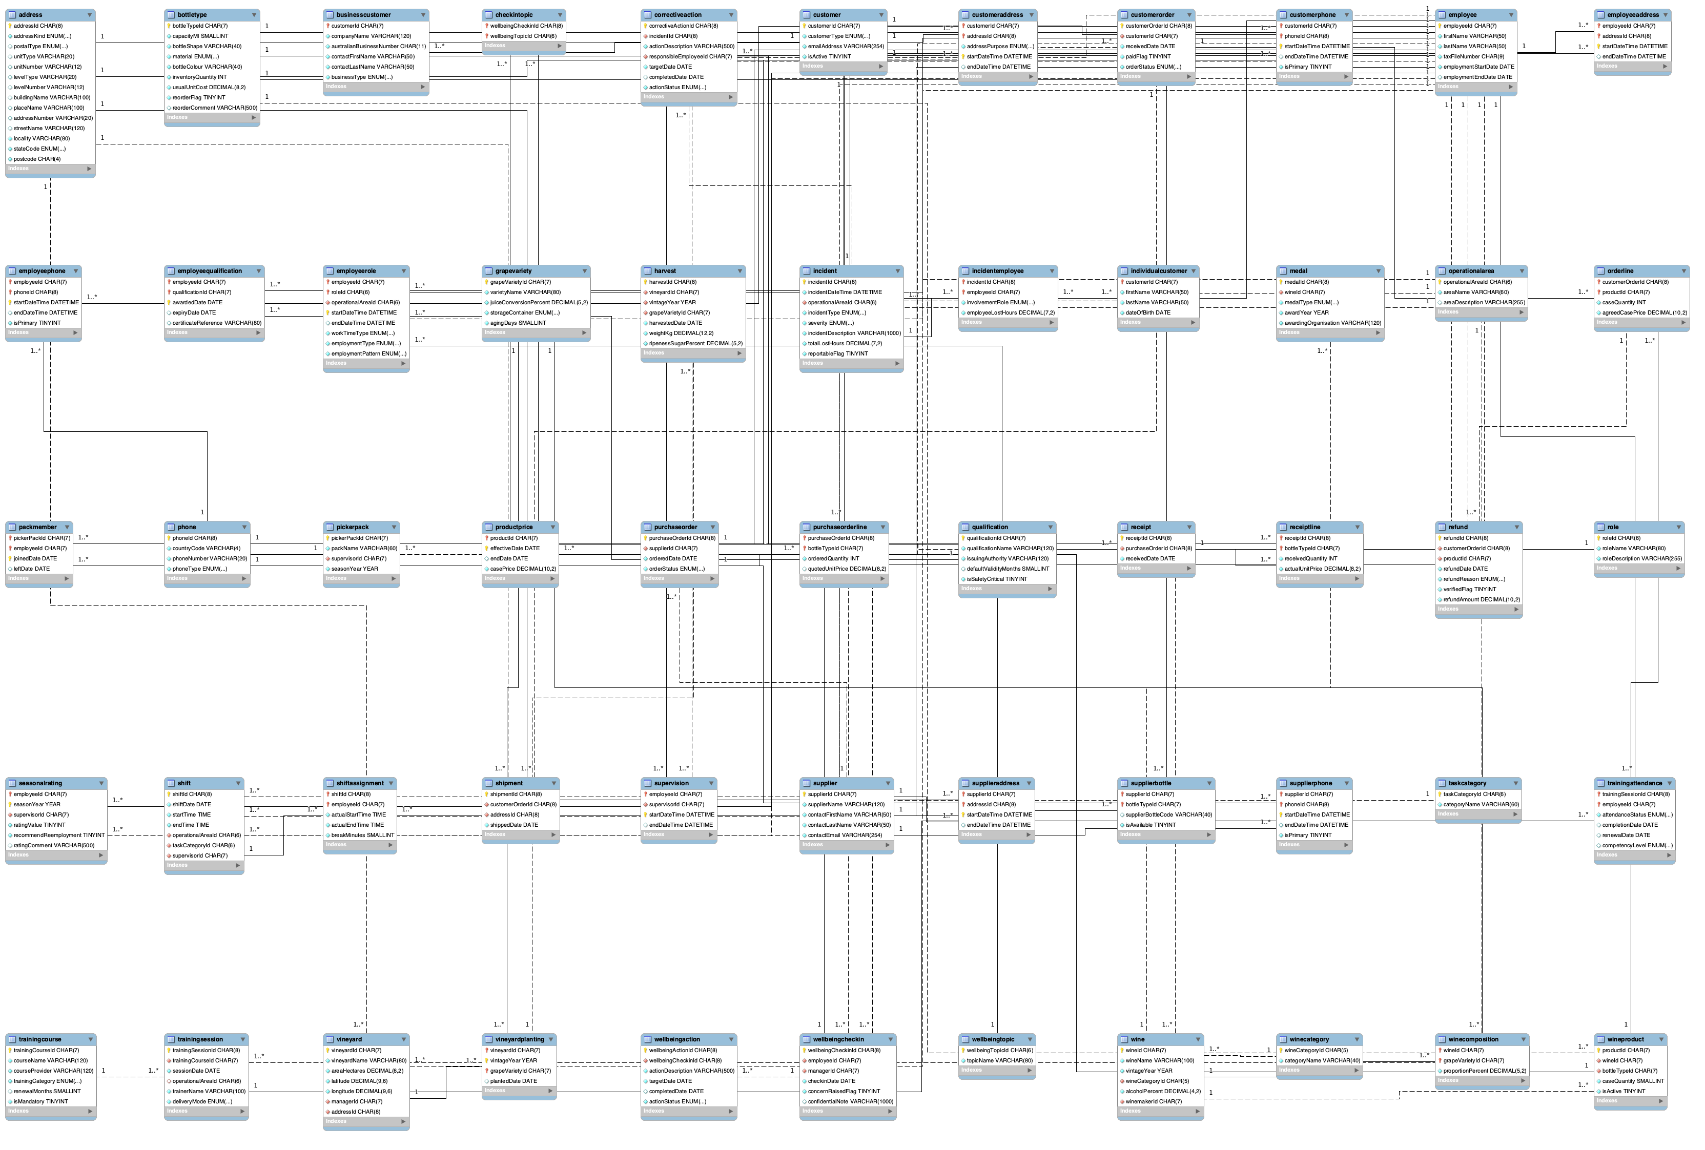
Figure — Complete UML Workbench model. Read individual attributes in the enlarged domain views and original PNG.

Assumptions
Area | Assumption | Reason
Employee names | Names are split into first and last name for all employees | The case says employee name but does not prescribe structure; splitting supports contact and reporting use
Concurrent roles | An employee has at most one active role period; the previous role must finish before the next starts | Tutor confirmed that the previous role should finish before the next role starts; the existing overlap trigger enforces this
Supervisor history | An employee has no more than one supervisor at any instant | Explicit case requirement
Employment classification | Full/part-time, permanent/casual and ongoing/seasonal are independent dimensions | Prevents a seasonal casual from being misclassified as a third legal employment type
Supplier contact history | Supplier address periods cannot overlap within the same address kind, and only one current primary phone is allowed | Preserves history while allowing different legitimate address kinds and preventing duplicate current facts
Employee/customer contact history | Employee address periods cannot overlap within the same address kind; customer address periods cannot overlap within the same business purpose; employee and customer phone history permits only one current primary phone | Tutor requires current-history integrity, while the official v4 workbook demonstrates that a customer can legitimately have concurrent Delivery and Billing addresses
Owners | Christine is represented as an employee/owner role so supervisor FKs remain enforceable | Supervisors report to Christine and the model needs an identifiable parent record
Picking pack | The minimum four-person requirement is checked operationally before scheduling/finalisation and is not enforced by the current database schema | Enforcing the minimum on each member insert would prevent incremental pack construction; adding lifecycle status plus a finalisation trigger would be a future extension
Vineyard manager | The manager is the current manager; a future extension could add dated vineyard-management history | Case states one manager and no employee manages more than one vineyard, but does not explicitly request this history
Wine recipe | Composition rows must total 100% before an active product is released; released recipes are locked against ad-hoc composition edits | MySQL cannot express this cross-row total with a normal CHECK, so release-boundary validation preserves staged recipe entry while enforcing the tutor requirement
Product identity | Wine, bottle type and case quantity uniquely define a product | Directly follows the case definition of product
Shipment | Each customer order has at most one shipment and the shipment retains its physical address ID; cancelled orders and shipment dates before order receipt are rejected | The case prohibits back orders and requires a single shipment to the current physical address
HR incident rate | One incident is counted once per operational area regardless of people involved | Prevents multi-person incidents being double-counted in the sustainability numerator
Incident lost hours | Employee-level `incidentemployee.employeeLostHours` is the detailed source used by the sustainability query; `incident.totalLostHours` is retained as an event-level summary and must be reconciled in QA rather than treated as an independent authoritative fact | Avoids double-counting multi-person incidents while acknowledging the retained summary field
Serious near miss | HIGH or CRITICAL severity may have zero lost hours | Severity and lost time measure different concepts; the case does not require positive lost time
Labour hours | Labour hours are derived from `shiftassignment.actualStartTime`, `actualEndTime` and `breakMinutes`; overtime is derived as hours above 8 per assignment for the current analytical rule | Removes the duplicate manual hour facts identified by the tutor and keeps one auditable source for worked time
Wellbeing privacy | Detailed notes are excluded from routine decision-support output; database users/roles and application authorisation are deployment controls outside this assessment build | The submitted SQL demonstrates data minimisation but does not claim production access-control configuration

Annotated design alternatives
Design element | Alternative | Reason selected
Customer types | One wide customer table | Supertype/subtypes reduce inapplicable NULLs while retaining a common order key.
Address history | Copied columns or polymorphic owner | Shared address with typed dated associations gives enforceable FKs and retained history.
Training structure | One repeated employee-training table | Course/session/attendance separates definition, delivery and outcome for 3NF and coverage queries.

Task 5 — Data Dictionary and Database Build
The complete data dictionary is presented as Word-ready tables and cross-checked against the validated MySQL schema to prevent divergence between the ER model, report and build. It is organised by table and records attribute name, type/size, domain/default, nullability, uniqueness, primary-key status, foreign-key reference and business purpose.
Naming compliance:
- all table names are lowercase, singular, contain no spaces and contain no underscores;
- all attributes use lowerCamelCase;
- character-bearing identifiers (for example EMP0001, WINE001, PROD001) follow the owners' request;
- compound keys are demonstrated in relationship/history tables such as winecomposition, orderline, trainingattendance and employeerole;
- the clean build has been executed under MySQL 8.4.11 from an empty database.
The data dictionary was prepared as Word-ready tables and cross-checked against the implemented MySQL schema for consistency. Every field has an explicit domain/default and a semantic business definition; automation is used internally to detect schema drift. The complete source is stored in docs/report/data-dictionary.md and appears in the Word report appendix.

Revised build verification
The final tutor-feedback build was verified under MySQL 8.4.11 on 2026-10-07: 55 base tables, 1 view, 286 columns, 72 foreign keys, 50 CHECK constraints, 30 triggers and 3 routines. The 286-row dictionary was regenerated from that live schema. The Workbench model contains 276 base-table attributes; the reporting view contributes the remaining 10 dictionary attributes. All modeled column names and primary keys match the regenerated dictionary.
Build verification: 55 base tables, 1 view, 286 columns, 72 foreign keys, 50 CHECK constraints, 30 triggers and 3 routines under MySQL 8.4.11. Statistics are read from the verified live schema, not hard-coded.

Task 6 — Data Quality Strategy and Validation

6a. Official A2 v4 source and controlled migration
The official workbook BISM2207 A2 Sem 2 2026 Data v4(1).xlsx was independently SHA-verified and re-imported from the supplied local file on 2026-10-07. SHA-256: 88362589a519b6f9aeae031fe806bcf85f0d8b513c12b11f6a4e619ee855c4ac. Raw CSV/SQL exports remain in the ignored private database/local/v4 directory. The unchanged workbook is not included in the public repository. Cleaning follows a raw-to-staging-to-production process so source errors remain reproducible and no ambiguous value is silently invented.
The three worksheets contain 182 order rows, 102 starting-address rows and 53 business rows of customer/address history. The history worksheet also contains two blank rows and one source note. Raw staging tables preserve an original Excel row number. Deterministic changes are documented separately from records that require manual or tutor confirmation.

Verified defects and corrections
The workbook contains six order rows with non-canonical Customer Id text: lower-case cust018, lower-case cust015, and spaced CUST 019. These can be corrected deterministically by trimming, removing embedded spaces and converting to upper case. After this standardisation, all 50 customer identifiers referenced by orders match a customer in the history worksheet.
Encoding damage is also deterministic. Rosewood Trail RosÃ© occurs in 24 order rows and is mechanically repaired to Rosewood Trail Rosé. Nine starting-address rows contain the mojibake dash â€“; this is repaired as an encoding defect rather than treated as a business-data change. The company name Vino Vibes Wine Exporters contains repeated whitespace in three history rows and can be normalised without changing its meaning.
One extra order row is an exact duplicate: the repeated ORD125 / PROD001 record. The first source row is retained and the later exact copy is recorded as an autocorrected duplicate.

Ambiguous records quarantined for review
The source also contains eight repeated (Order Id, Product Id) groups, representing nine extra rows. Most are not exact duplicates: quantities, prices, refund values or statuses differ. They must not be automatically summed or discarded because the workbook does not establish whether they are genuine repeated product lines, transaction events or source duplication.
Ten orders contain more than one Shipment Status across their product rows. ORD056 also contains both a blank and paid Payment Status. These findings expose a source-grain ambiguity between order-level and line-level status. The rows are retained in staging and flagged rather than forced into one status.
The starting-address worksheet has 67 distinct Full Address strings across 102 Address Id records. Nineteen full-address groups are duplicated, accounting for 35 additional Address Id rows. Two duplicate groups also differ in structural metadata such as unit/building information, so canonicalisation cannot be based on Full Address text alone.
Three phone values are shared by more than one customer. These may represent a household or business contact, or they may be source errors. They require manual review and are not changed automatically.
The source itself states that an export reset some current-customer start dates. The lost original dates cannot be recovered from the workbook and are therefore disclosed as a source limitation rather than reconstructed.

Consistency checks that pass
All 182 order rows satisfy Cases ordered × Price per case = Total paid + Refund Amount within one cent. No row has damaged cases greater than ordered cases. Where damaged cases are recorded, the damage refund equals damaged cases multiplied by the line price within one cent. Product Id consistently maps to one Wine Name, and Customer Id and Order Date are internally consistent within each Order Id after Customer Id normalisation.
Customer-address history contains no overlapping periods for the same customer and the same supplied address purpose. The source legitimately contains concurrent current Delivery and Billing rows for CUST050, which is why the revised database controls current history per address purpose rather than incorrectly allowing only one address of every kind.
Detailed profiling SQL and evidence counts are in database/cleaning/01_v4_staging.sql, database/cleaning/02_v4_profile_and_clean.sql and docs/evidence/a2-v4-data-quality-audit.md.

6b. Revised schema controls arising from the data-quality review
The cleaning exercise is connected to the production design rather than treated as a separate spreadsheet task. customeraddress.addressPurpose now represents Primary, Delivery, Billing and Correspondence uses. Current history is protected against overlapping periods for the same purpose. Employee and supplier address histories are protected by address kind, and employee/customer/supplier phone histories enforce one current primary phone where applicable.
Refund now identifies productId together with customerOrderId, with a foreign key to the actual order line. This prevents a refund from naming a product that was not purchased on that order.

6c. Test-data and integrity validation
Synthetic HR and operational data remains necessary because the official v4 workbook contains customer/order/address information and does not contain the HR training, shift, incident, qualification or wellbeing records needed for the selected perspective and Task 7 queries.
The revised test dataset additionally demonstrates:
- multiple grape varieties in the same vineyard and vintage;
- harvest linkage to the exact vineyard/vintage/grape-variety planting;
- picker leave/rejoin support through joinedDate in the Pack Member key;
- line-specific refund integrity;
- customer address purposes;
- actual shift assignment start/end times rather than duplicated manual hour totals;
- wine-composition validation before an active product is released.
The assessed five Task 3b rules remain separate from these extra regression controls.

6d. Final cleaned supplied-data import — 2026-10-08
The final portable SQL includes database/data/02_cleaned_v4_data.sql after the additional test dataset. tools/build_cleaned_v4_data.py reads the preserved private staging CSVs and produces accepted INSERTs and ID-only disposition ledgers. Existing before/after Workbench evidence remains unchanged. Final import and six-query captures are in docs/evidence/combined-database.
Source IDs map one-to-one into separate namespaces: CUST001 → VCUS001, PROD001 → VPRD001, ORD001 → VORD001 and ADDR001 → VADR0001. This preserves supplied identity without colliding with synthetic fixtures. No production schema or order-line primary key was changed.

Tables imported and verified
Table | Supplied or supplemental records | Import and verification
customer | 50 | Standardised IDs; email and source type retained; subtype/FK checks pass. Active state is an import assumption.
individualcustomer | 25 | Source names and birth dates; one subtype row per individual.
businesscustomer | 25 | Source ABN/contact names; whitespace-normalised company; OTHER means subtype unspecified. Unique ABNs pass.
address | 102 | Deterministic physical-address parsing and dash repair; retain every source ID and structured Unit/Level metadata; no canonical merge.
customeraddress | 53 | Source purposes and date/time periods preserved; foreign keys and non-overlap controls pass.
phone | 66 | Unshared source values; OTHER means unspecified type. +61 is an explicit Australian-address country assumption.
customerphone | 66 | Unshared associations only; earliest supplied customer-history start is an explicit effective-start assumption; no primary rank guessed.
winecategory | 1 | Supplemental test category CTV4, explicitly labelled.
wine | 10 | Source wine names; mandatory missing wine attributes are explicitly supplemental test values.
winecomposition | 10 | Supplemental test recipe, validated to 100%; not a factual source recipe.
wineproduct | 10 | Source Product IDs; supplemental bottle, case size and active-state attributes.
customerorder | 79 | Complete accepted orders only; consistent customer/date/header status, all source lines present.
orderline | 132 | Exact source quantities and negotiated prices; no sum, averaging or partial-order import. Live readback matches accepted source rows.

All table INSERTs passed MySQL 8.4.11 foreign-key, CHECK and trigger enforcement in an empty-database portable rebuild. Namespace row counts and source quantity/price/header readback are recorded in docs/evidence/v4-final-import-results.tsv. Existing verifier passes 73/73; no new verifier checks were added.

Explicit import assumptions and supplemental test values
The workbook omits attributes required by the stable wine/product schema. Separate supplied-product records therefore use vintage 2026, 13.5% alcohol, synthetic winemaker EMP0004, supplemental category CTV4, a 100% GRAPE01 test recipe, BOTL001 bottles and 12 bottles per case. These are added test attributes, not recovered workbook facts, actual wine recipes or factual packaging specifications. The original synthetic products and HR fixtures remain available for integrity and Task 7 demonstrations. A synthetic business ABN was changed to avoid a collision with a supplied ABN; the supplied ABN is unchanged.
Source shipped/pending values map directly to order status. A blank payment value maps to FALSE as “no confirmed payment”, not a claim of verified non-payment. Shipment dates and order-specific delivery addresses are absent, so 72 accepted shipped-order shipment-detail facts are quarantined; no shipment detail or refund date/verification is invented. Source negotiated prices belong to order lines, not an invented product price history.

Final reconciliation and quarantine
182 source order rows = 132 accepted/imported cleaned rows + 1 rejected exact copy + 15 ambiguous-pair rows quarantined + 34 other rows quarantined. Each original source row has exactly one disposition in docs/evidence/v4-import-dispositions.csv. The accepted rows form 79 complete orders; the other 24 source orders are held. Quarantine is a completed import decision, not an unresolved accounting total.
Seven non-exact repeated pairs contain 15 rows. An order containing any ambiguous pair is held as a whole, including its otherwise unique lines, to avoid presenting partial totals. Mixed shipment/payment headers and shipment statuses such as damaged, returned or partially refunded cannot safely map into the stable order enum; affected whole orders are held. The 34 other rows include this order-level closure and unsupported/mixed-status records; reasons may overlap and are listed per row rather than added as independent totals. No ambiguous lines are summed or silently deleted.
All 102 address IDs are retained separately, including the 19 repeated full-address groups; ID-specific structured metadata is preserved, so no canonical identity is guessed. Three shared phone values representing seven customer/phone associations are quarantined. The ID-only dependent-fact ledger is docs/evidence/v4-dependent-facts-quarantine.csv.

Source limitation
Export-reset customer-history starts remain exactly as supplied. Lost original dates are not reconstructed. Student-only video, RiPPlE, Buddycheck and genuine contribution confirmation remain separate from report/code readiness. Task 8 awaits the Week 11 scenario supplied by the tutor.
Test | Plain-English scenario | Expected result | One-sentence explanation
T01 | Valid completed training accepted | Accepted, then rolled back | Confirms complete HR training outcomes are supported.
T02 | Role end before start rejected | CHECK Error 3819 | Prevents impossible role history.
T03 | Reorder FALSE without comment rejected | CHECK Error 3819 | Preserves the bottle sourcing/quality explanation.
T04 | Unpaid order shipment rejected | Trigger Error 1644 | Prevents dispatch before accounting confirmation.
T05 | Overlapping supervision rejected | Trigger Error 1644 | Enforces one supervisor at a point in time.

T01 — Valid completed training accepted
T01 readable SQL
USE cloudrestwines;
START TRANSACTION;
INSERT INTO trainingattendance VALUES
('TRSE0004','EMP0007','COMPLETED',DATE_SUB(CURRENT_DATE,INTERVAL 60 DAY),DATE_ADD(CURRENT_DATE,INTERVAL 670 DAY),'COMPETENT');
SELECT 'PASS: valid completed training was accepted' AS testResult;
ROLLBACK;
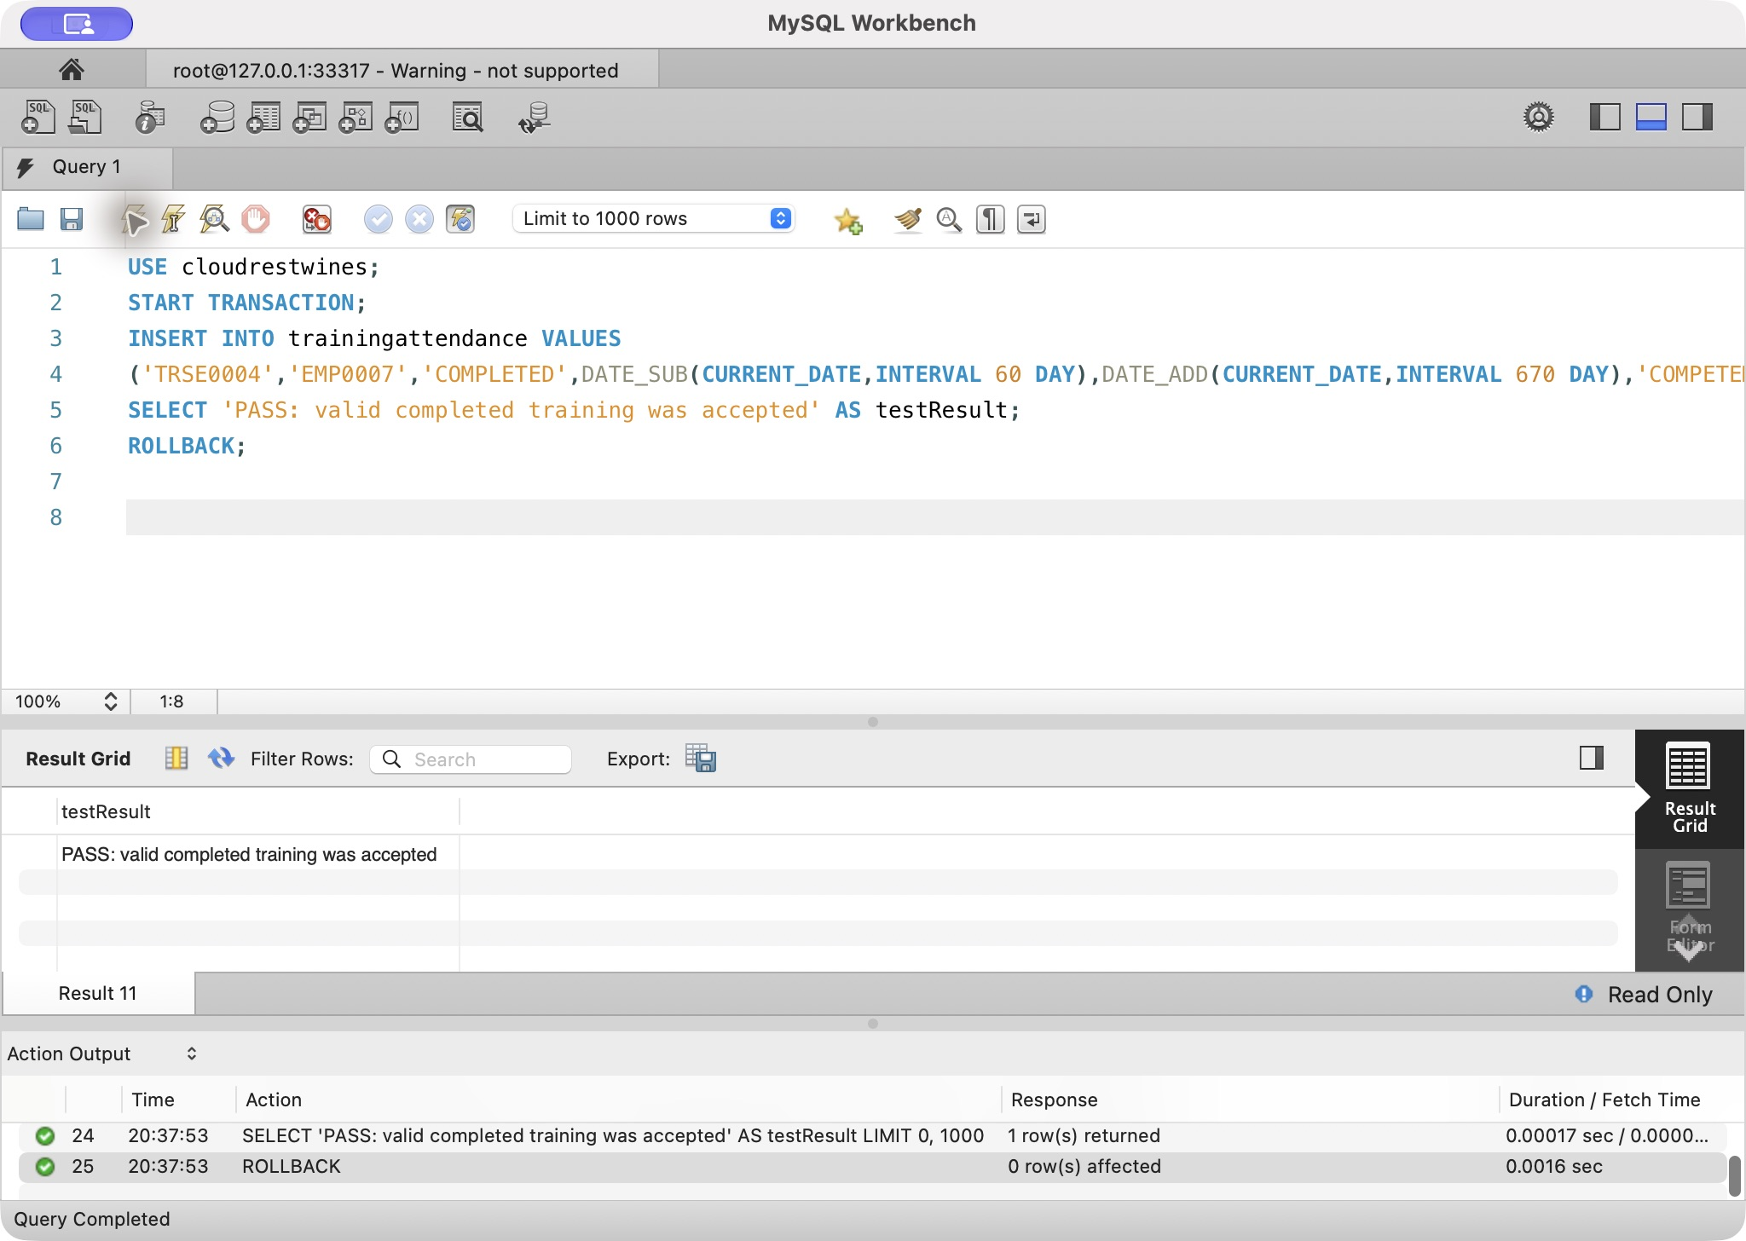
T01: genuine local Workbench execution. Accepted, then rolled back

T02 — Role end before start rejected
T02 readable SQL
USE cloudrestwines;
INSERT INTO employee VALUES ('EMP9999','Test','InvalidDate','998877665','2026-01-01',NULL);
INSERT INTO employeerole VALUES
('EMP9999','ROLE07','AREA04','2026-06-01 09:00:00','2026-05-01 09:00:00','PARTTIME','PERMANENT','ONGOING');
T02: genuine local Workbench execution. CHECK Error 3819

T03 — Reorder FALSE without comment rejected
T03 readable SQL
USE cloudrestwines;
INSERT INTO bottletype VALUES
('BOTL099',750,'Test','GLASS','Green',0,1.00,FALSE,NULL);
T03: genuine local Workbench execution. CHECK Error 3819

T04 — Unpaid order shipment rejected
T04 readable SQL
USE cloudrestwines;
-- Assessed Test 4 (negative): an unpaid order cannot be shipped.
INSERT INTO customerorder VALUES ('CORD0998','CUST001',CURRENT_DATE,FALSE,'PENDING');
INSERT INTO shipment VALUES ('SHIP0998','CORD0998','ADDR0003',CURRENT_DATE);
T04: genuine local Workbench execution. Trigger Error 1644

T05 — Overlapping supervision rejected
T05 readable SQL
USE cloudrestwines;
-- Assessed Test 5 (negative): a supervised employee cannot have two supervisors at the same time.
INSERT INTO supervision VALUES ('EMP0008','EMP0001','2026-02-01 09:00:00',NULL);
T05: genuine local Workbench execution. Trigger Error 1644

Official v4: genuine local Workbench evidence
Original before/after staging evidence below is preserved as profiling evidence, including its earlier 166-row candidate projection. Final accepted import is narrower: 132 rows in 79 complete orders. The final import screenshot and ID-only ledger show 182 = 132 imported + 1 exact copy rejected + 15 ambiguous-pair rows quarantined + 34 other rows quarantined. Raw rows and dates remain unchanged.
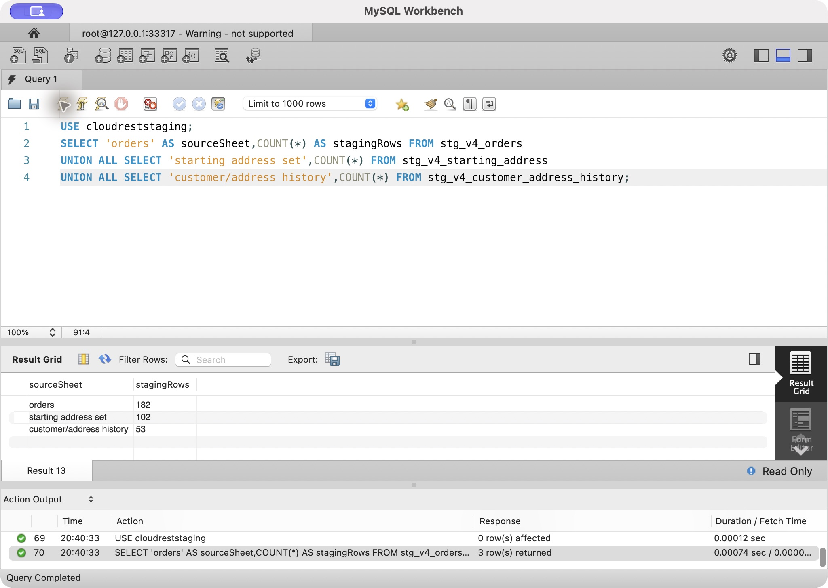
Official v4 evidence: task6-e01-1, actual Workbench output 2026-10-07
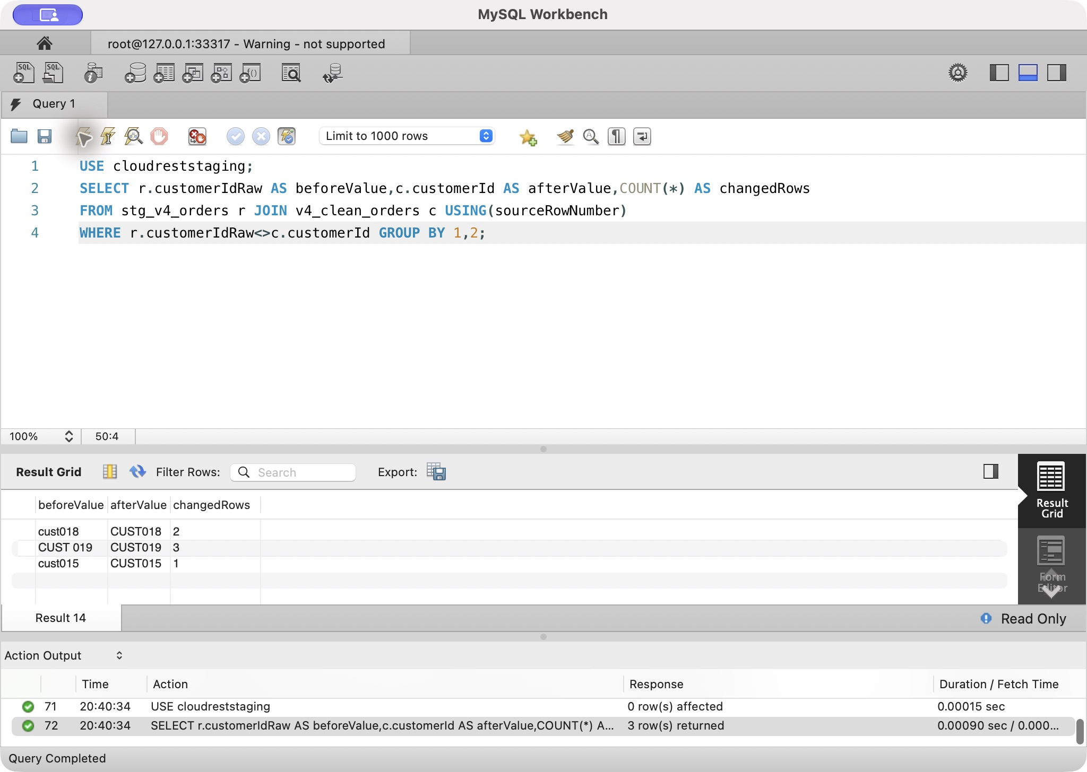
Official v4 evidence: task6-e02-1, actual Workbench output 2026-10-07
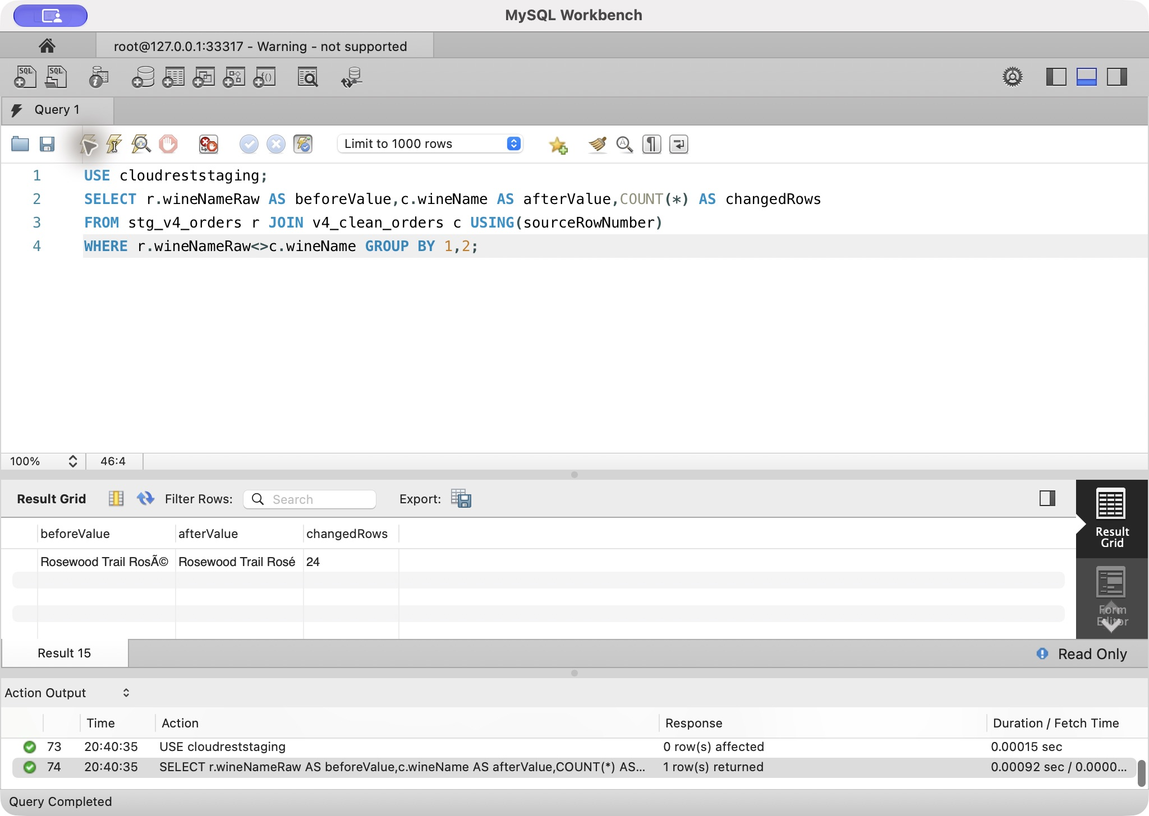
Official v4 evidence: task6-e03-1, actual Workbench output 2026-10-07
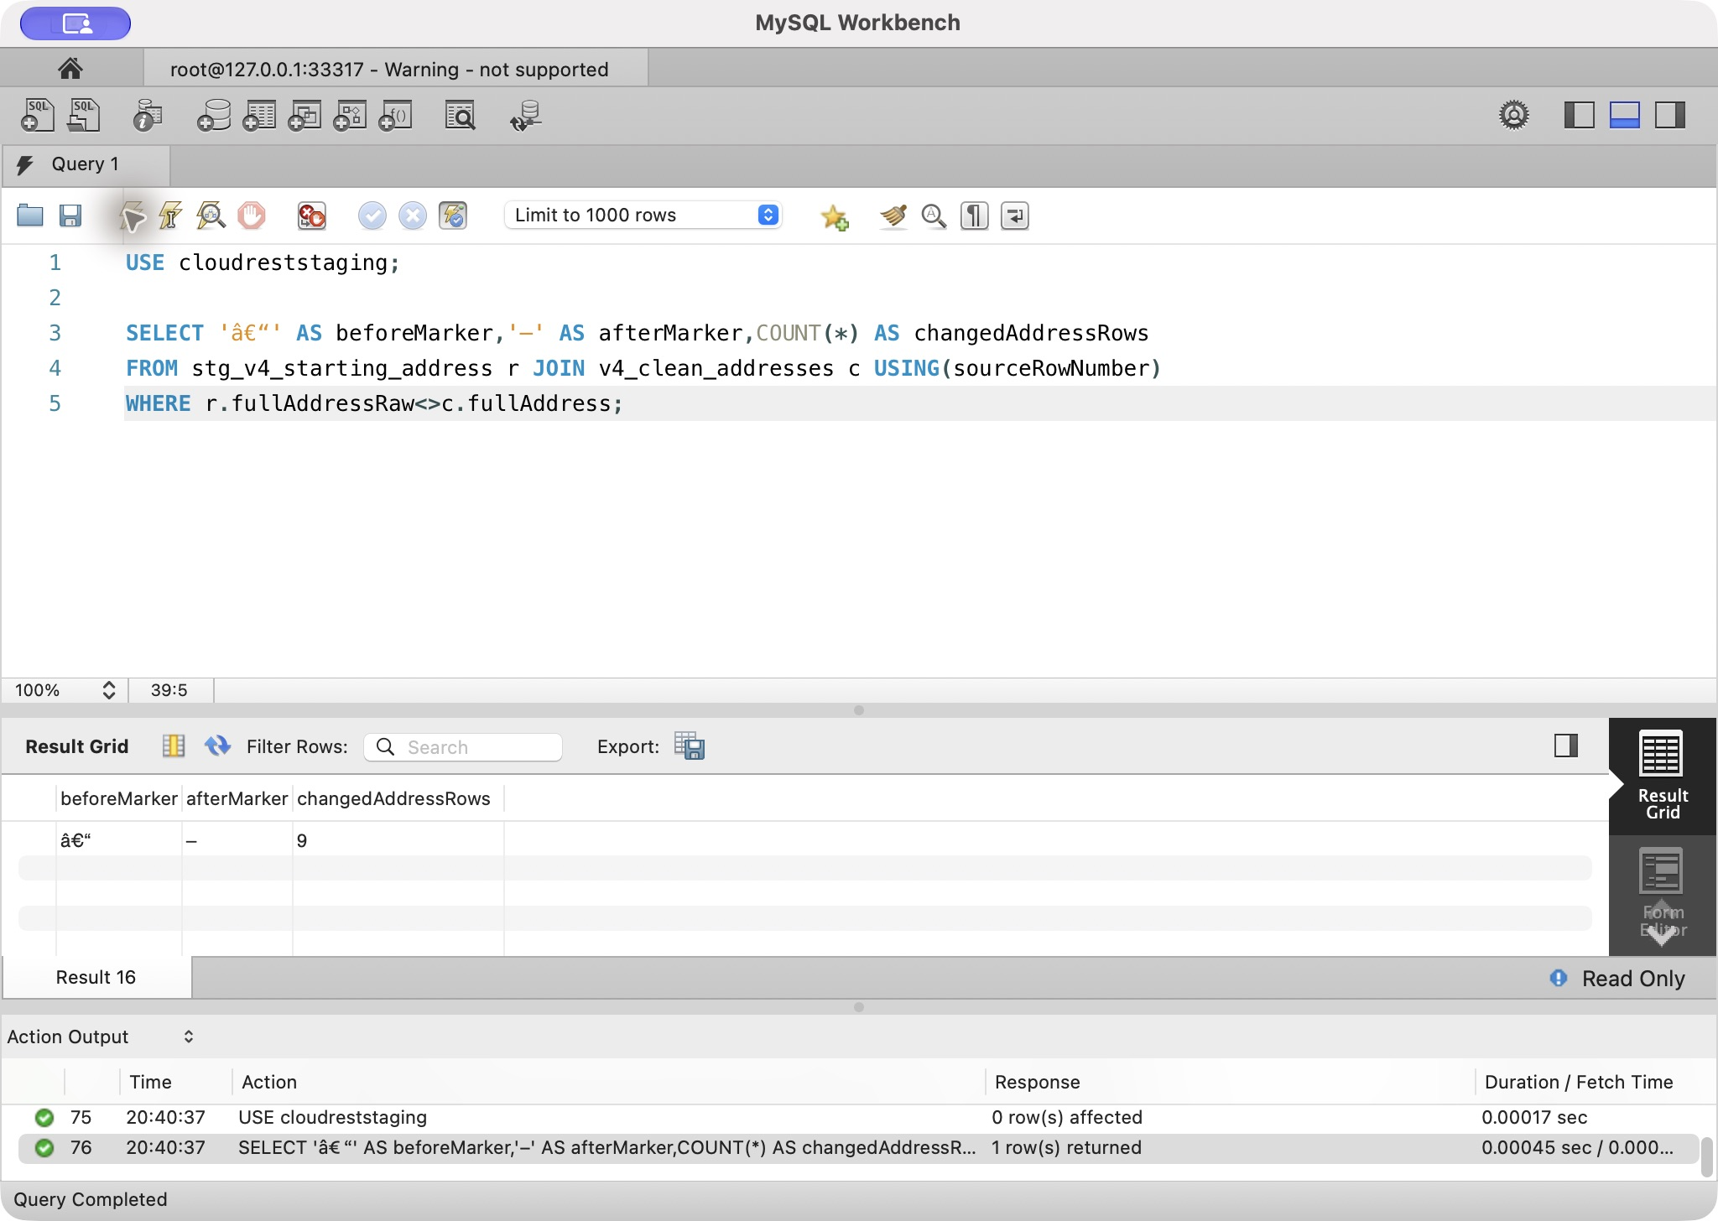
Official v4 evidence: task6-e03-2, actual Workbench output 2026-10-07
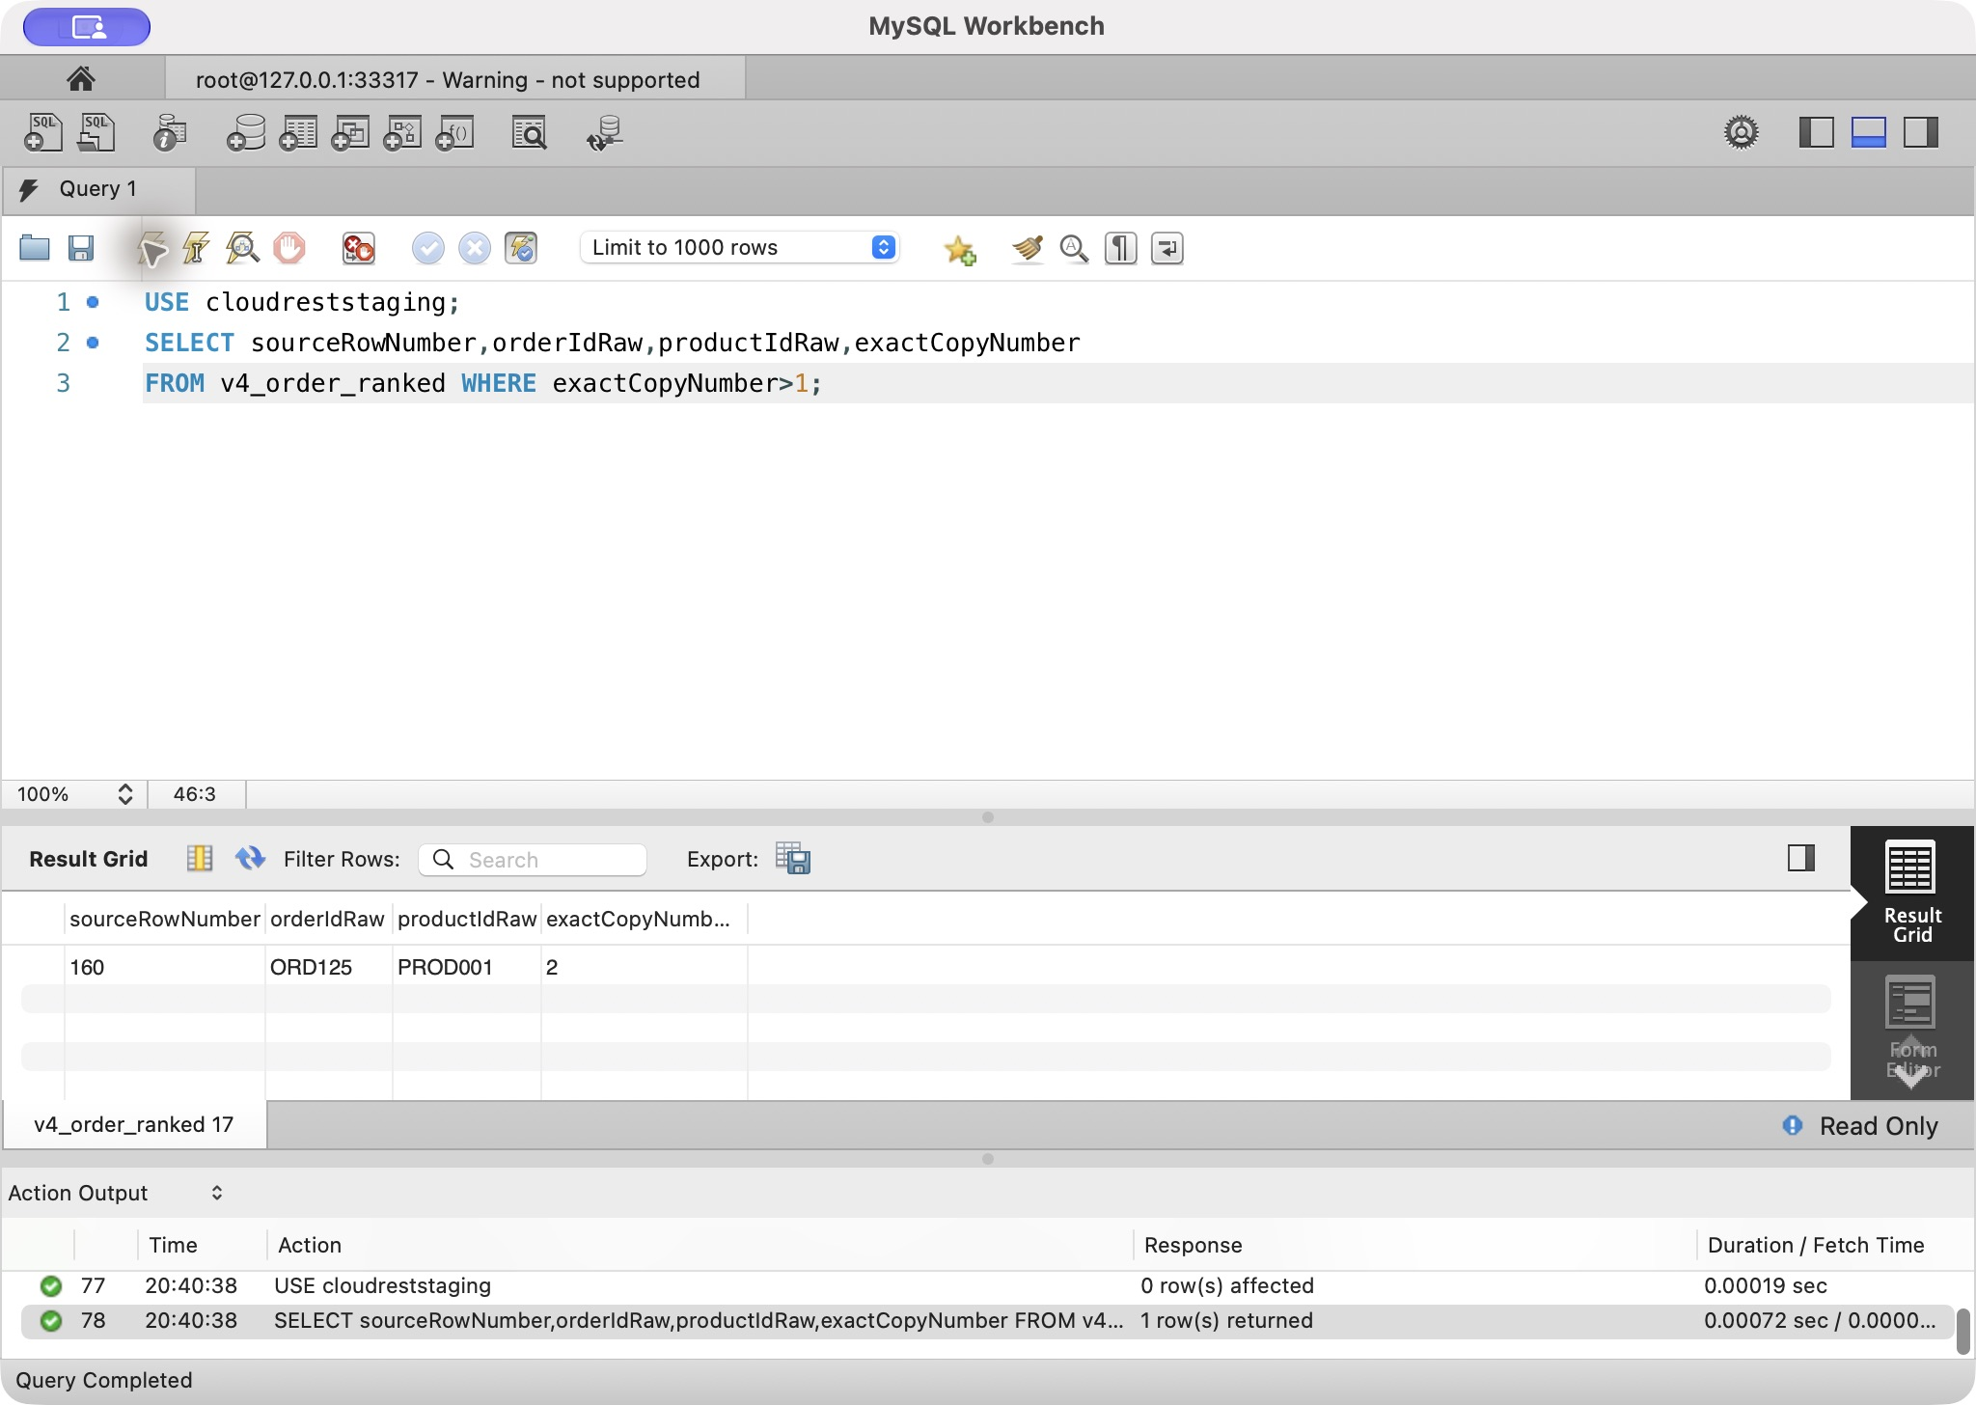
Official v4 evidence: task6-e04-1, actual Workbench output 2026-10-07
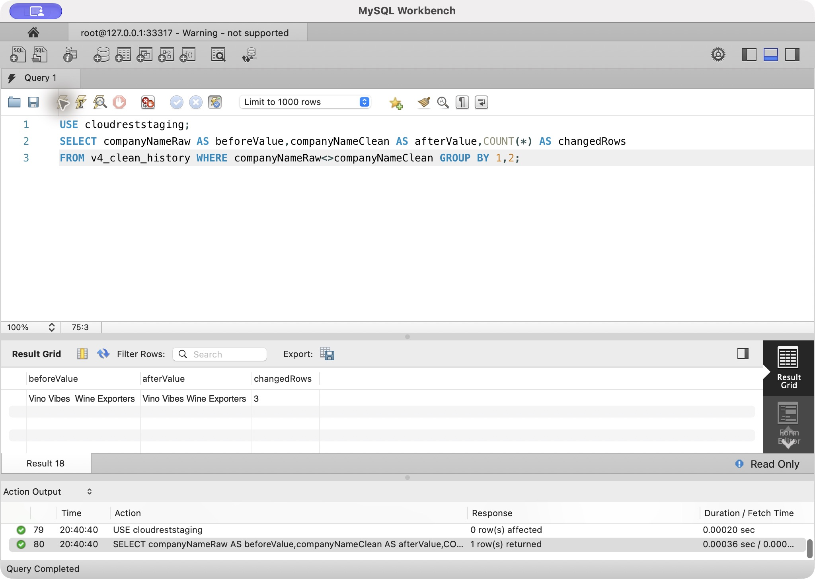
Official v4 evidence: task6-e05-1, actual Workbench output 2026-10-07
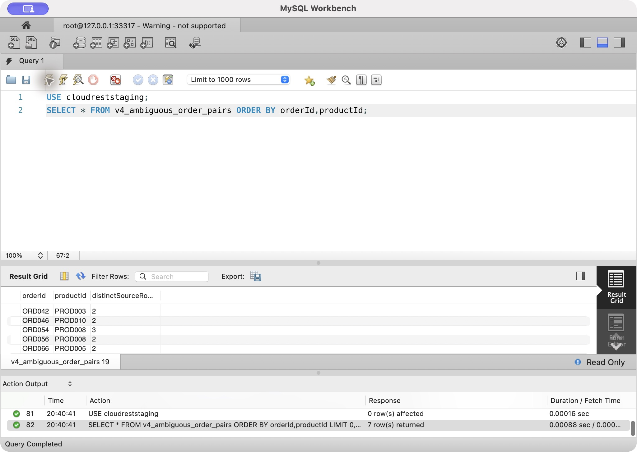
Official v4 evidence: task6-e06-1, actual Workbench output 2026-10-07
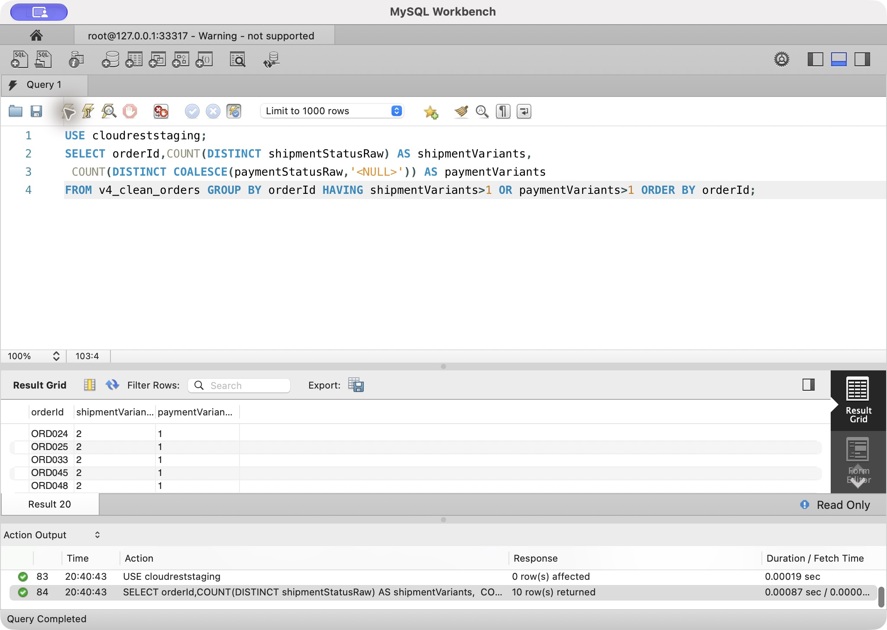
Official v4 evidence: task6-e07-1, actual Workbench output 2026-10-07
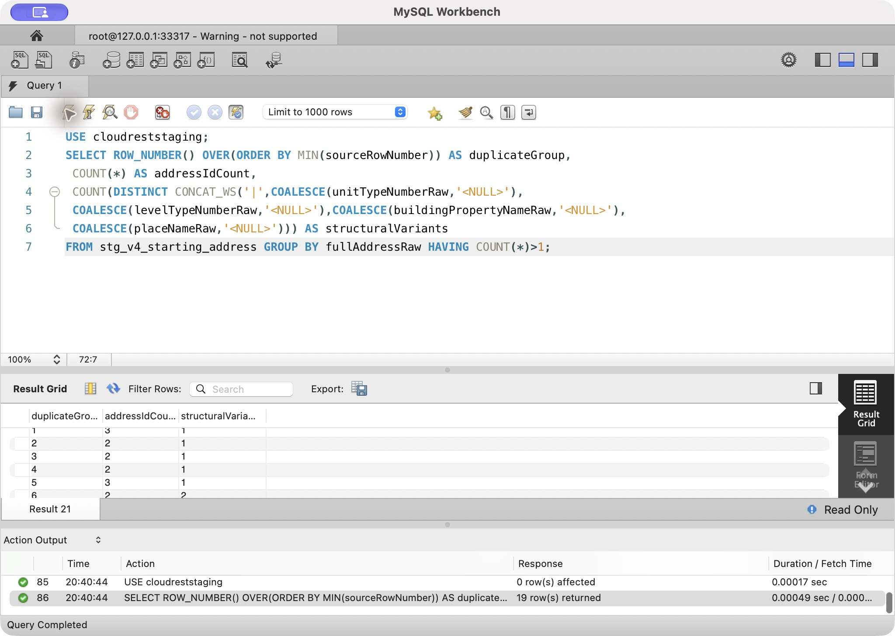
Official v4 evidence: task6-e08-1, actual Workbench output 2026-10-07
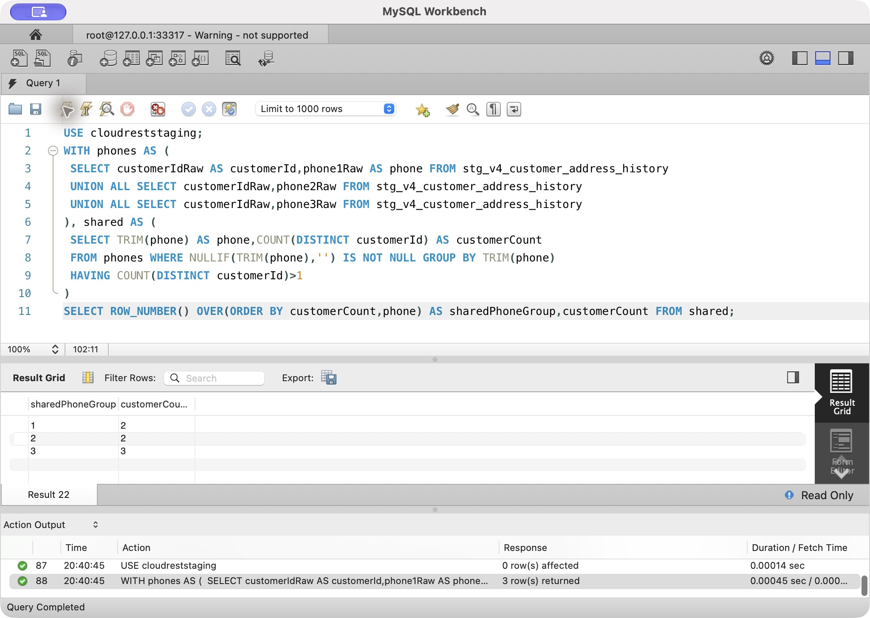
Official v4 evidence: task6-e09-1, actual Workbench output 2026-10-07
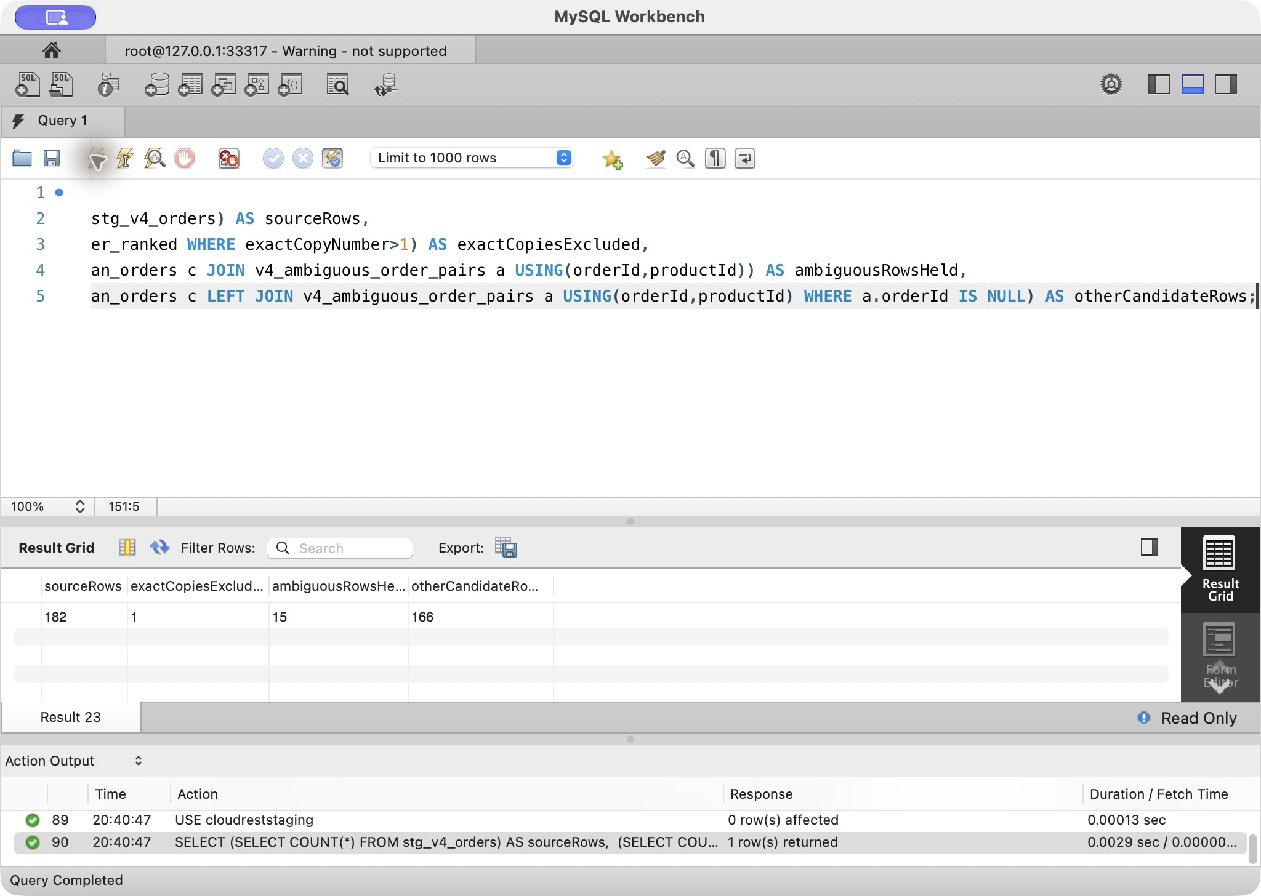
Official v4 evidence: task6-e10-1, actual Workbench output 2026-10-07
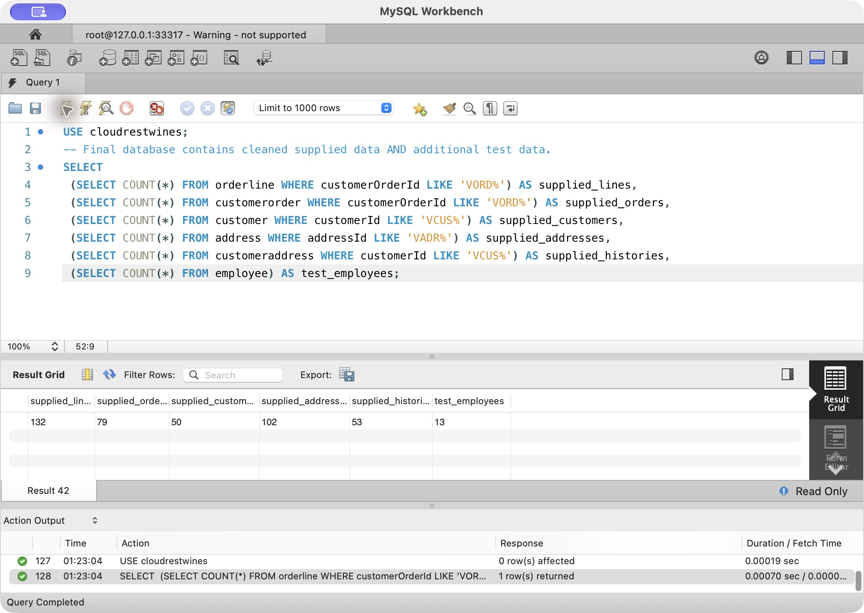
Final combined database: supplied import and retained synthetic HR, 2026-10-08

Task 7 — Decision-Support SQL Queries

Query 1 — Annual safety and sustainability training coverage

How the query works
The activeworkforce CTE reads current employeerole rows and identifies each active employee's operational area. The completion CTE joins trainingattendance to trainingsession and trainingcourse, keeps only COMPLETED attendance in the current calendar year, and limits categories to SAFETY and SUSTAINABILITY. HAVING COUNT(DISTINCT trainingCategory)=2 requires the same employee to have completed both categories.
The final query joins operationalarea to the active workforce and left-joins the completion set. It uses distinct employee counts for both numerator and denominator and NULLIF to avoid division by zero.

Business use and action
The HR Manager, Safety Officer and operational-area supervisors use the percentage to identify workforce preparation gaps. An area below target should receive additional training sessions rather than treating completion of only one category as adequate sustainability coverage.

Actual result — frozen MySQL 8.4.11 build, 2026-10-08
- Vineyard: 6 active employees, 3 completed both required categories, 50.0% coverage.
- Cellar: 4 active employees, 0 completed both categories, 0.0% coverage.
- Administration: 3 active employees, 0 completed both categories, 0.0% coverage.
The result identifies a partial gap in Vineyard and complete gaps in Cellar and Administration. The immediate management action is to schedule missing Safety/Sustainability training and then rerun the metric.
Risk / limitation: Current workforce differs from historical workforce; the calendar-year measure requires both categories.

Query 1 SQL
USE cloudrestwines;
-- Management question: Which operational areas have gaps in annual mandatory safety/sustainability training?
WITH activeworkforce AS (
SELECT er.employeeId, er.operationalAreaId
FROM employeerole er
WHERE er.startDateTime <= NOW() AND (er.endDateTime IS NULL OR er.endDateTime > NOW())
), completion AS (
SELECT ta.employeeId
FROM trainingattendance ta
JOIN trainingsession ts ON ts.trainingSessionId = ta.trainingSessionId
JOIN trainingcourse tc ON tc.trainingCourseId = ts.trainingCourseId
JOIN activeworkforce aw ON aw.employeeId = ta.employeeId
WHERE ta.attendanceStatus = 'COMPLETED'
AND tc.trainingCategory IN ('SAFETY','SUSTAINABILITY')
AND ts.sessionDate >= MAKEDATE(YEAR(CURRENT_DATE), 1)
AND (ts.operationalAreaId IS NULL OR ts.operationalAreaId = aw.operationalAreaId)
GROUP BY ta.employeeId
HAVING COUNT(DISTINCT tc.trainingCategory) = 2
)
SELECT oa.areaName,
COUNT(DISTINCT aw.employeeId) AS activeEmployees,
COUNT(DISTINCT c.employeeId) AS employeesTrained,
ROUND(100.0 * COUNT(DISTINCT c.employeeId) / NULLIF(COUNT(DISTINCT aw.employeeId),0), 1) AS coveragePercent
FROM activeworkforce aw
JOIN operationalarea oa ON oa.operationalAreaId = aw.operationalAreaId
LEFT JOIN completion c ON c.employeeId = aw.employeeId
GROUP BY oa.operationalAreaId, oa.areaName
ORDER BY coveragePercent, oa.areaName;
Query 1: actual MySQL 8.4.11 output, 2026-10-08. Combined supplied + test database; HR results use synthetic assessment records.
areaName | activeEmployees | employeesTrained | coveragePercent
Administration | 3 | 0 | 0.0
Cellar | 4 | 0 | 0.0
Vineyard | 6 | 3 | 50.0

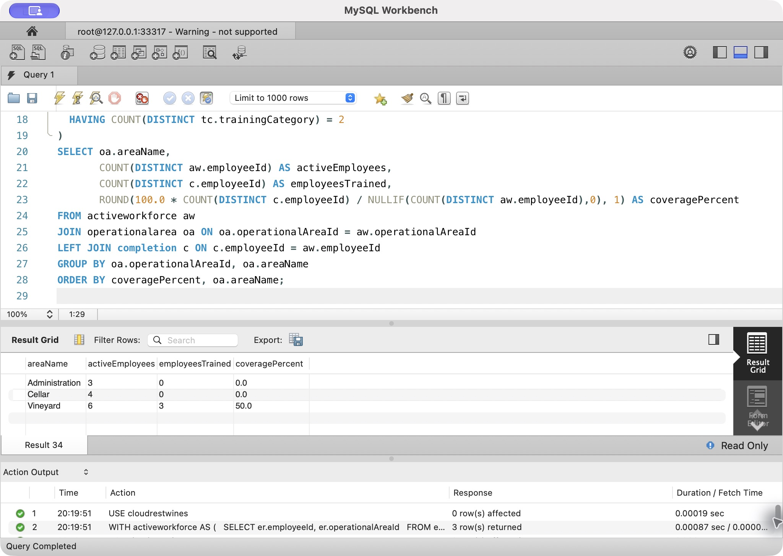
Query 1: genuine Workbench query01, combined supplied + test database, 2026-10-08

Query 2 — Incidents per 1,000 actual labour hours

How the query works
The revised shift design no longer stores independent regular/overtime hour totals. shiftassignment records actual start time, actual end time and break minutes. The assignmenthours CTE derives labour hours as the elapsed minutes minus breaks, divided by 60.
hoursbyarea aggregates those actual hours by operational area over the rolling 12 months. incidentloss reads incidents from the same rolling period, left-joins incidentemployee and sums employee lost hours while retaining one row per incident. incidentsbyarea then counts incidents once per area. The final calculation is incidentCount × 1000 / labourHours; a zero denominator returns NULL.

Business use and action
Raw incident counts can make a busy area look less safe simply because more hours are worked. The exposure-adjusted rate lets the Safety Officer and management compare operational areas on a consistent basis. High-rate areas can be targeted for investigation, training, equipment changes or corrective actions.

Actual result — frozen MySQL 8.4.11 build, 2026-10-08
- Vineyard: 88.00 actual labour hours, 2 incidents, 2 lost hours, 22.73 incidents per 1,000 hours.
- Cellar: 54.00 actual labour hours, 1 incident, 16 lost hours, 18.52 incidents per 1,000 hours.
Vineyard has the higher event frequency, while Cellar has fewer incidents but much greater lost time. Management should therefore avoid using the rate alone: Vineyard needs frequency reduction, while Cellar's severe lost-time outcome warrants focused handling/equipment controls.
Risk / limitation: Small exposure denominators make rates unstable; missing assignments or incidents bias results.

Query 2 SQL
USE cloudrestwines;
-- Sustainability measure: incidents per 1,000 actual labour hours during the last 12 months.
-- Labour hours are derived from assignment start/end times so they cannot disagree with stored hour totals.
WITH assignmenthours AS (
SELECT s.operationalAreaId,
GREATEST(
TIMESTAMPDIFF(MINUTE, sa.actualStartTime, sa.actualEndTime) - sa.breakMinutes,
0
) / 60.0 AS labourHours
FROM shift s
JOIN shiftassignment sa ON sa.shiftId = s.shiftId
WHERE s.shiftDate >= DATE_SUB(CURRENT_DATE, INTERVAL 12 MONTH)
), hoursbyarea AS (
SELECT operationalAreaId, SUM(labourHours) AS labourHours
FROM assignmenthours
GROUP BY operationalAreaId
), incidentloss AS (
SELECT i.incidentId,
i.operationalAreaId,
COALESCE(SUM(ie.employeeLostHours), 0) AS lostHours
FROM incident i
LEFT JOIN incidentemployee ie ON ie.incidentId = i.incidentId
WHERE i.incidentDateTime >= DATE_SUB(CURRENT_DATE, INTERVAL 12 MONTH)
GROUP BY i.incidentId, i.operationalAreaId
), incidentsbyarea AS (
SELECT operationalAreaId,
COUNT(*) AS incidentCount,
SUM(lostHours) AS lostHours
FROM incidentloss
GROUP BY operationalAreaId
)
SELECT oa.areaName,
ROUND(COALESCE(h.labourHours, 0), 2) AS labourHours,
COALESCE(i.incidentCount, 0) AS incidentCount,
COALESCE(i.lostHours, 0) AS lostHours,
CASE
WHEN COALESCE(h.labourHours, 0) = 0 THEN NULL
ELSE ROUND(COALESCE(i.incidentCount, 0) * 1000.0 / h.labourHours, 2)
END AS incidentsPer1000Hours
FROM operationalarea oa
LEFT JOIN hoursbyarea h ON h.operationalAreaId = oa.operationalAreaId
LEFT JOIN incidentsbyarea i ON i.operationalAreaId = oa.operationalAreaId
WHERE h.labourHours IS NOT NULL OR i.incidentCount IS NOT NULL
ORDER BY (incidentsPer1000Hours IS NULL), incidentsPer1000Hours DESC, oa.areaName;
Query 2: actual MySQL 8.4.11 output, 2026-10-08. Combined supplied + test database; HR results use synthetic assessment records.
areaName | labourHours | incidentCount | lostHours | incidentsPer1000Hours
Vineyard | 88.00 | 2 | 2.00 | 22.73
Cellar | 54.00 | 1 | 16.00 | 18.52

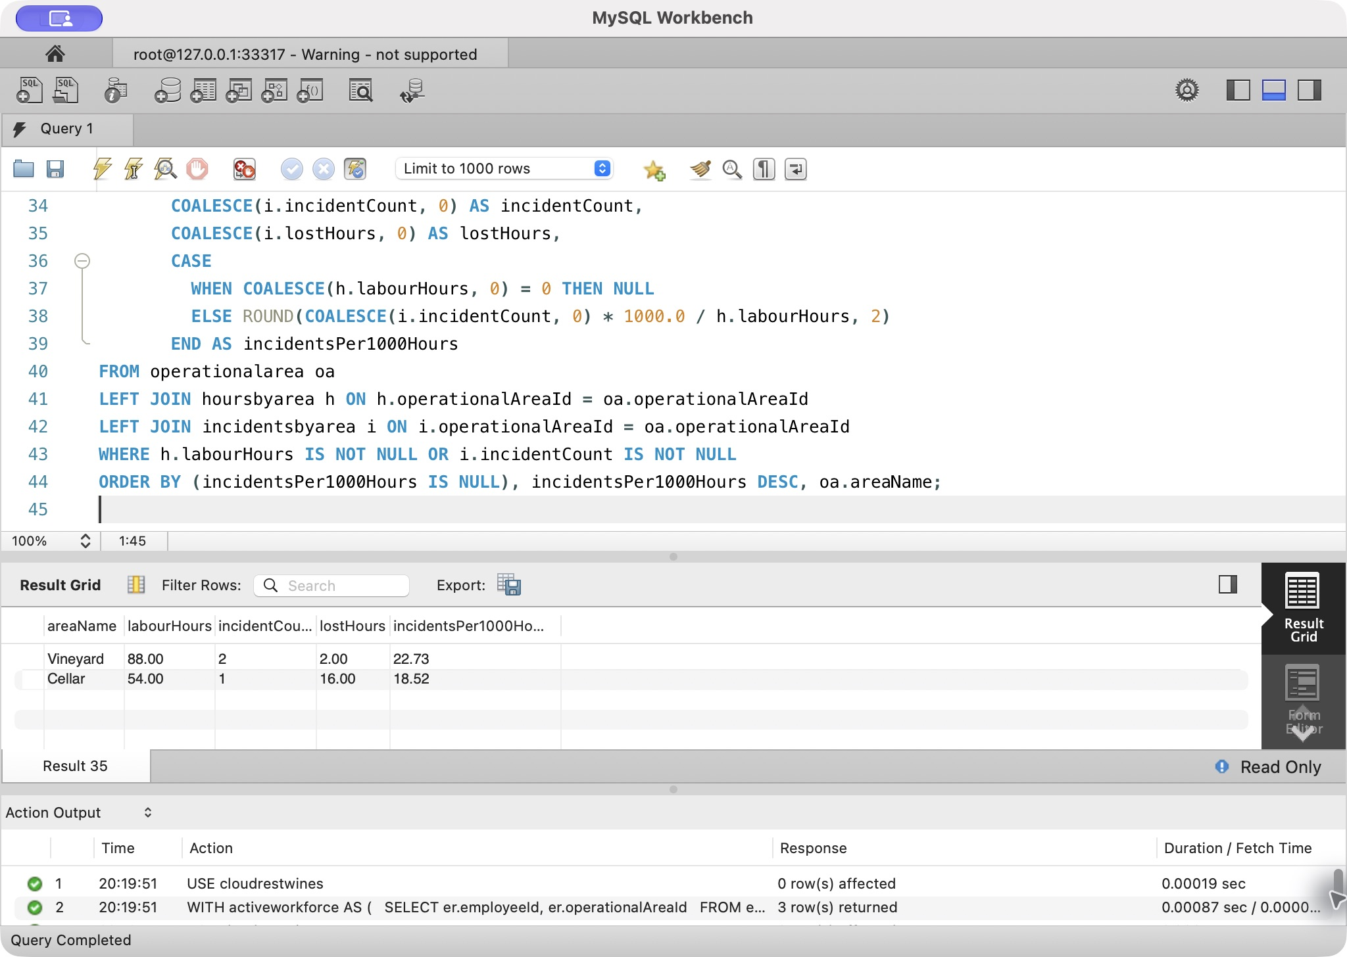
Query 2: genuine Workbench query02, combined supplied + test database, 2026-10-08

Query 3 — Incidents before and after safety training

How the query works
The completion CTE finds the first completed Safety training date for each employee. The observed CTE calculates a matched observation window using the lesser of 180 days and the number of days since training. This prevents a newly trained employee from receiving a longer pre-training window than post-training window.
The result joins employees to incidentemployee only where involvementRole='AFFECTED', then to incident. Conditional SUM(CASE ...) expressions count incidents in equal windows immediately before and after completion.

Business use and action
HR and the Safety Officer can use this as an association check when reviewing whether safety training coincides with improved outcomes. It is not a causal experiment. If incidents remain high after training, management should inspect course content, work practices and corrective actions rather than claiming training failed solely from this query.

Actual result — frozen MySQL 8.4.11 build, 2026-10-08
Five employees have completed Safety training in the fixture. EMP0008 has 1 affected incident before training and 0 after training within the matched window; the other trained employees have 0 before and 0 after. The sample is too small to claim causality, but it demonstrates how future real records could support a more meaningful before/after review.
Risk / limitation: Equal observation windows do not control confounding or work mix; the fixture cannot support causality.

Query 3 SQL
USE cloudrestwines;
-- Compare employee incidents before and after completed annual safety training using
-- equal observed windows of up to 180 days. This avoids understating post-training
-- incidents when fewer than 180 days have elapsed since training.
WITH completion AS (
SELECT ta.employeeId, MIN(ta.completionDate) AS completionDate
FROM trainingattendance ta
JOIN trainingsession ts ON ts.trainingSessionId = ta.trainingSessionId
JOIN trainingcourse tc ON tc.trainingCourseId = ts.trainingCourseId
WHERE ta.attendanceStatus = 'COMPLETED' AND tc.trainingCategory = 'SAFETY'
GROUP BY ta.employeeId
), observed AS (
SELECT employeeId,
completionDate,
LEAST(180, GREATEST(DATEDIFF(CURRENT_DATE, completionDate), 0)) AS observationDays
FROM completion
)
SELECT o.employeeId,
CONCAT(e.firstName,' ',e.lastName) AS employeeName,
o.completionDate,
o.observationDays,
SUM(CASE WHEN i.incidentDateTime >= DATE_SUB(o.completionDate, INTERVAL o.observationDays DAY)
AND i.incidentDateTime < o.completionDate THEN 1 ELSE 0 END) AS incidentsBefore,
SUM(CASE WHEN i.incidentDateTime >= o.completionDate
AND i.incidentDateTime < DATE_ADD(o.completionDate, INTERVAL o.observationDays DAY)
AND i.incidentDateTime < DATE_ADD(CURRENT_DATE, INTERVAL 1 DAY)
THEN 1 ELSE 0 END) AS incidentsAfter
FROM observed o
JOIN employee e ON e.employeeId = o.employeeId
LEFT JOIN incidentemployee ie ON ie.employeeId = o.employeeId AND ie.involvementRole = 'AFFECTED'
LEFT JOIN incident i ON i.incidentId = ie.incidentId
GROUP BY o.employeeId, e.firstName, e.lastName, o.completionDate, o.observationDays
ORDER BY incidentsBefore DESC, incidentsAfter DESC;
Query 3: actual MySQL 8.4.11 output, 2026-10-08. Combined supplied + test database; HR results use synthetic assessment records.
employeeId | employeeName | completionDate | observationDays | incidentsBefore | incidentsAfter
EMP0008 | Mia Taylor | 2026-06-30 | 100 | 1 | 0
EMP0002 | Amelia Hart | 2026-06-30 | 100 | 0 | 0
EMP0003 | Noah Reed | 2026-06-30 | 100 | 0 | 0
EMP0004 | Isla Chen | 2026-07-30 | 70 | 0 | 0
EMP0005 | Liam Singh | 2026-07-30 | 70 | 0 | 0

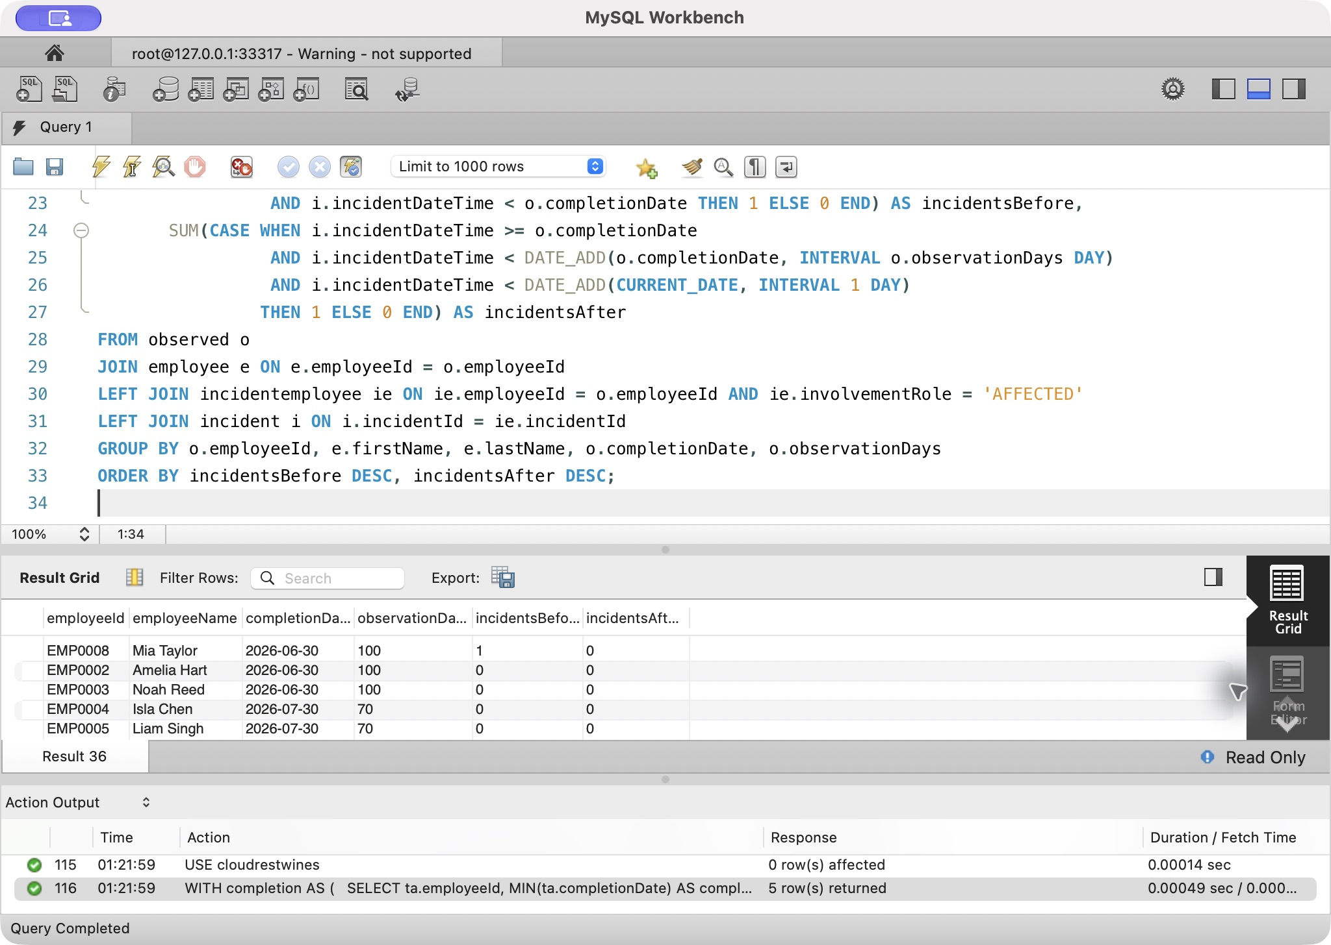
Query 3: genuine Workbench query03, combined supplied + test database, 2026-10-08

Query 4 — Recent workload, safety and wellbeing review indicators

How the query works
activeworkforce supplies every current employee with role and operational area context. assignmenthours derives worked hours from actual assignment start/end/break values for the last 30 days. workload sums up to 8 regular hours per assignment and treats hours above 8 as overtime. Separate CTEs count recent incident involvement and wellbeing check-ins with concernRaisedFlag=TRUE.
All three result sets are left-joined to the active workforce, so employees with no recent shift remain visible. A transparent CASE returns SUPERVISOR REVIEW when overtime, a recent incident or a wellbeing concern is present. No confidential wellbeing note is exposed.

Business use and action
Supervisors and HR use the query as a prioritisation list, not a medical or disciplinary score. The underlying columns show why somebody appears. Management can adjust rosters, check fatigue controls, follow up an incident or schedule a wellbeing conversation.

Actual result — frozen MySQL 8.4.11 build, 2026-10-08
Five employees are flagged for review:
- EMP0011 Jack Moore: 7 overtime hours, 1 recent incident, 1 wellbeing concern.
- EMP0009 Leo Wilson: 7 overtime hours, 1 recent incident involvement, 1 wellbeing concern.
- EMP0005 Liam Singh: 3 overtime hours.
- EMP0008 Mia Taylor: 3 overtime hours.
- EMP0013 Finn Walker: 1 overtime hour.
EMP0010 and EMP0012 have recent hours but no overtime/incident/concern indicator; other active employees remain visible with zero recent workload. The highest-priority follow-up is EMP0011/EMP0009 because multiple independent indicators are present.
Risk / limitation: Eight hours per assignment is a demonstration rule, not an asserted payroll entitlement; review flags in context.

Query 4 SQL
USE cloudrestwines;
-- Workforce review query: surface recent workload/safety/wellbeing indicators without exposing confidential notes.
-- Worked hours are calculated from actual assignment times. Overtime is the portion above 8 hours per assignment.
WITH activeworkforce AS (
SELECT e.employeeId,
e.firstName,
e.lastName,
er.operationalAreaId,
r.roleName
FROM employee e
JOIN employeerole er ON er.employeeId = e.employeeId
JOIN role r ON r.roleId = er.roleId
WHERE e.employmentStartDate <= CURRENT_DATE
AND (e.employmentEndDate IS NULL OR e.employmentEndDate >= CURRENT_DATE)
AND er.startDateTime <= NOW()
AND (er.endDateTime IS NULL OR er.endDateTime >= NOW())
), assignmenthours AS (
SELECT sa.employeeId,
GREATEST(
TIMESTAMPDIFF(MINUTE, sa.actualStartTime, sa.actualEndTime) - sa.breakMinutes,
0
) / 60.0 AS workedHours
FROM shiftassignment sa
JOIN shift s ON s.shiftId = sa.shiftId
WHERE s.shiftDate >= DATE_SUB(CURRENT_DATE, INTERVAL 30 DAY)
), workload AS (
SELECT employeeId,
ROUND(SUM(LEAST(workedHours, 8.0)), 2) AS regularHours,
ROUND(SUM(GREATEST(workedHours - 8.0, 0)), 2) AS overtimeHours
FROM assignmenthours
GROUP BY employeeId
), recentincident AS (
SELECT ie.employeeId, COUNT(DISTINCT ie.incidentId) AS incidentCount
FROM incidentemployee ie
JOIN incident i ON i.incidentId = ie.incidentId
WHERE i.incidentDateTime >= DATE_SUB(NOW(), INTERVAL 30 DAY)
GROUP BY ie.employeeId
), recentconcern AS (
SELECT employeeId, COUNT(*) AS concernCount
FROM wellbeingcheckin
WHERE checkinDate >= DATE_SUB(CURRENT_DATE, INTERVAL 30 DAY)
AND concernRaisedFlag = TRUE
GROUP BY employeeId
)
SELECT aw.employeeId,
CONCAT(aw.firstName, ' ', aw.lastName) AS employeeName,
oa.areaName,
aw.roleName,
COALESCE(w.regularHours, 0) AS regularHours,
COALESCE(w.overtimeHours, 0) AS overtimeHours,
COALESCE(ri.incidentCount, 0) AS recentIncidents,
COALESCE(rc.concernCount, 0) AS wellbeingConcernCount,
CASE
WHEN COALESCE(ri.incidentCount, 0) > 0
OR COALESCE(rc.concernCount, 0) > 0
OR COALESCE(w.overtimeHours, 0) > 0
THEN 'SUPERVISOR REVIEW'
ELSE 'NO RECENT INDICATOR'
END AS recommendedAction
FROM activeworkforce aw
JOIN operationalarea oa ON oa.operationalAreaId = aw.operationalAreaId
LEFT JOIN workload w ON w.employeeId = aw.employeeId
LEFT JOIN recentincident ri ON ri.employeeId = aw.employeeId
LEFT JOIN recentconcern rc ON rc.employeeId = aw.employeeId
ORDER BY (COALESCE(ri.incidentCount, 0) > 0) DESC,
(COALESCE(rc.concernCount, 0) > 0) DESC,
COALESCE(w.overtimeHours, 0) DESC,
employeeName;
Query 4: actual MySQL 8.4.11 output, 2026-10-08. Combined supplied + test database; HR results use synthetic assessment records.
employeeId | employeeName | areaName | roleName | regularHours | overtimeHours | recentIncidents | wellbeingConcernCount | recommendedAction
EMP0011 | Jack Moore | Cellar | Cellar Hand | 16.00 | 7.00 | 1 | 1 | SUPERVISOR REVIEW
EMP0009 | Leo Wilson | Vineyard | Seasonal Picker | 16.00 | 7.00 | 1 | 1 | SUPERVISOR REVIEW
EMP0005 | Liam Singh | Cellar | Winemaker | 16.00 | 3.00 | 0 | 0 | SUPERVISOR REVIEW
EMP0008 | Mia Taylor | Vineyard | Seasonal Picker | 16.00 | 3.00 | 0 | 0 | SUPERVISOR REVIEW
EMP0013 | Finn Walker | Vineyard | Seasonal Picker | 16.00 | 1.00 | 0 | 0 | SUPERVISOR REVIEW
EMP0002 | Amelia Hart | Vineyard | Vineyard Supervisor | 0.00 | 0.00 | 0 | 0 | NO RECENT INDICATOR
EMP0006 | Ava Martin | Administration | HR Manager | 0.00 | 0.00 | 0 | 0 | NO RECENT INDICATOR
EMP0001 | Christine Cloud | Administration | Owner | 0.00 | 0.00 | 0 | 0 | NO RECENT INDICATOR
EMP0007 | Ethan Brown | Administration | Safety Officer | 0.00 | 0.00 | 0 | 0 | NO RECENT INDICATOR
EMP0004 | Isla Chen | Cellar | Winemaker | 0.00 | 0.00 | 0 | 0 | NO RECENT INDICATOR
EMP0003 | Noah Reed | Vineyard | Grape Farmer | 0.00 | 0.00 | 0 | 0 | NO RECENT INDICATOR
EMP0012 | Ruby Thomas | Cellar | Cellar Hand | 12.00 | 0.00 | 0 | 0 | NO RECENT INDICATOR
EMP0010 | Zoe Davis | Vineyard | Seasonal Picker | 13.00 | 0.00 | 0 | 0 | NO RECENT INDICATOR

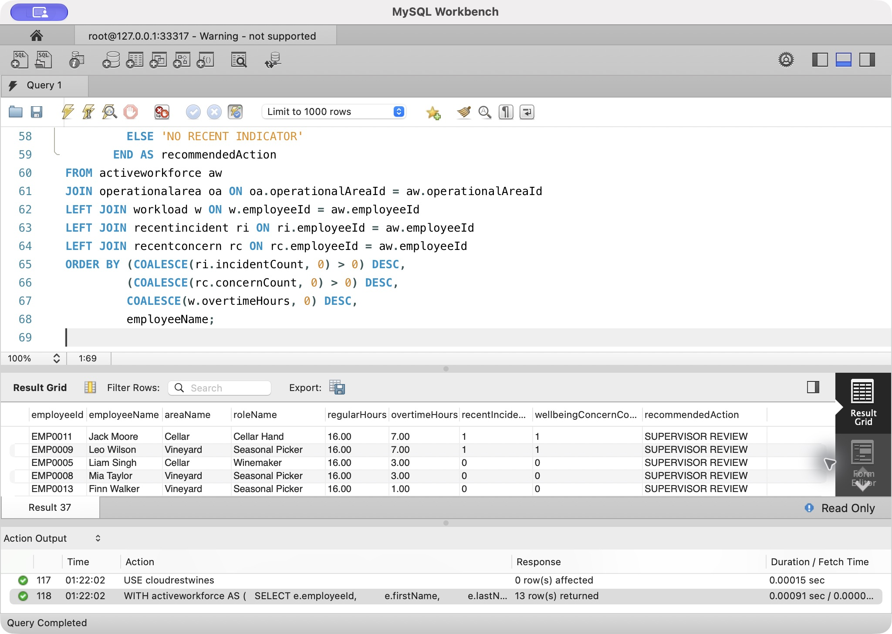
Query 4: genuine Workbench query04-left, combined supplied + test database, 2026-10-08

Query 5 — Expiring qualifications stored procedure

How the query works
getExpiringQualifications(daysAhead) validates that the parameter is non-NULL and from 0 to 730. It joins employeequalification, employee and qualification, filters expiry dates between today and today plus the requested horizon, calculates daysUntilExpiry, and sorts by expiry date.
The demonstration calls the same procedure with 30 and 90 days, proving that the database logic is reusable rather than hard-coded to one report period.

Business use and action
HR and supervisors use the short horizon for urgent renewal booking and the longer horizon for planning budgets, rosters and course capacity.

Actual result — frozen MySQL 8.4.11 build, 2026-10-08
- CALL getExpiringQualifications(30) returns EMP0002 / First Aid Certificate / 25 days.
- CALL getExpiringQualifications(90) returns the same record plus EMP0003 / Chemical Handling Permit / 80 days.
The operational action is to book EMP0002 first and include EMP0003 in the next planning cycle.
Risk / limitation: Expiry records require issuer validation; plan and confirm renewals before roster decisions.

Query 5 SQL
USE cloudrestwines;
-- Video demonstration must call both parameter values.
CALL getExpiringQualifications(30);
CALL getExpiringQualifications(90);
Query 5: actual MySQL 8.4.11 output, 2026-10-08. Combined supplied + test database; HR results use synthetic assessment records.
employeeId | employeeName | qualificationName | isSafetyCritical | expiryDate | daysUntilExpiry
EMP0002 | Amelia Hart | First Aid Certificate | 1 | 2026-11-02 | 25

employeeId | employeeName | qualificationName | isSafetyCritical | expiryDate | daysUntilExpiry
EMP0002 | Amelia Hart | First Aid Certificate | 1 | 2026-11-02 | 25
EMP0003 | Noah Reed | Chemical Handling Permit | 1 | 2026-12-27 | 80

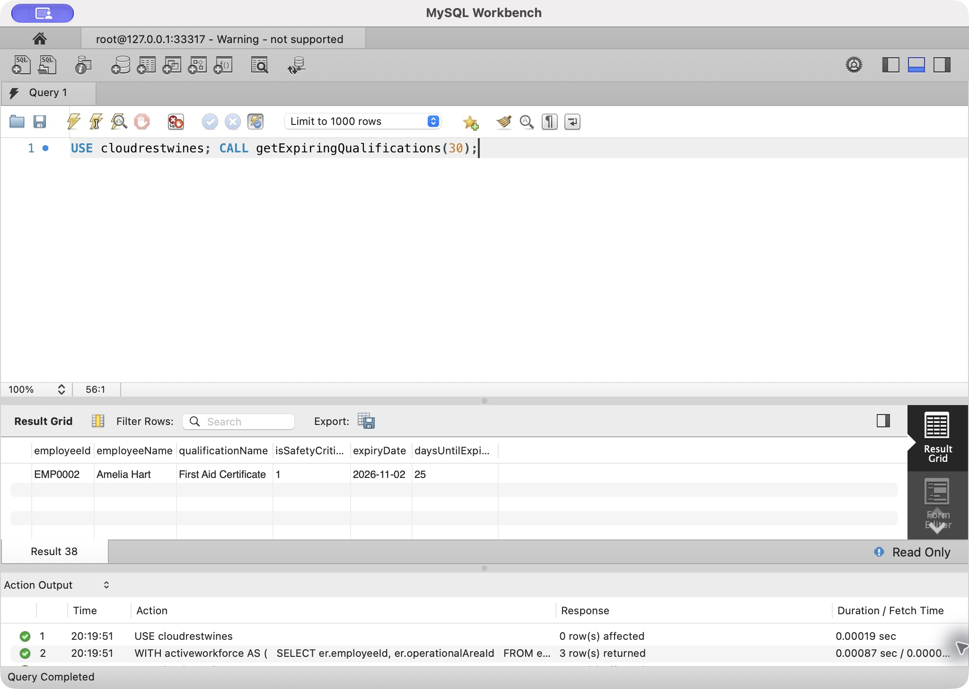
Query 5: genuine Workbench query05-30days, combined supplied + test database, 2026-10-08
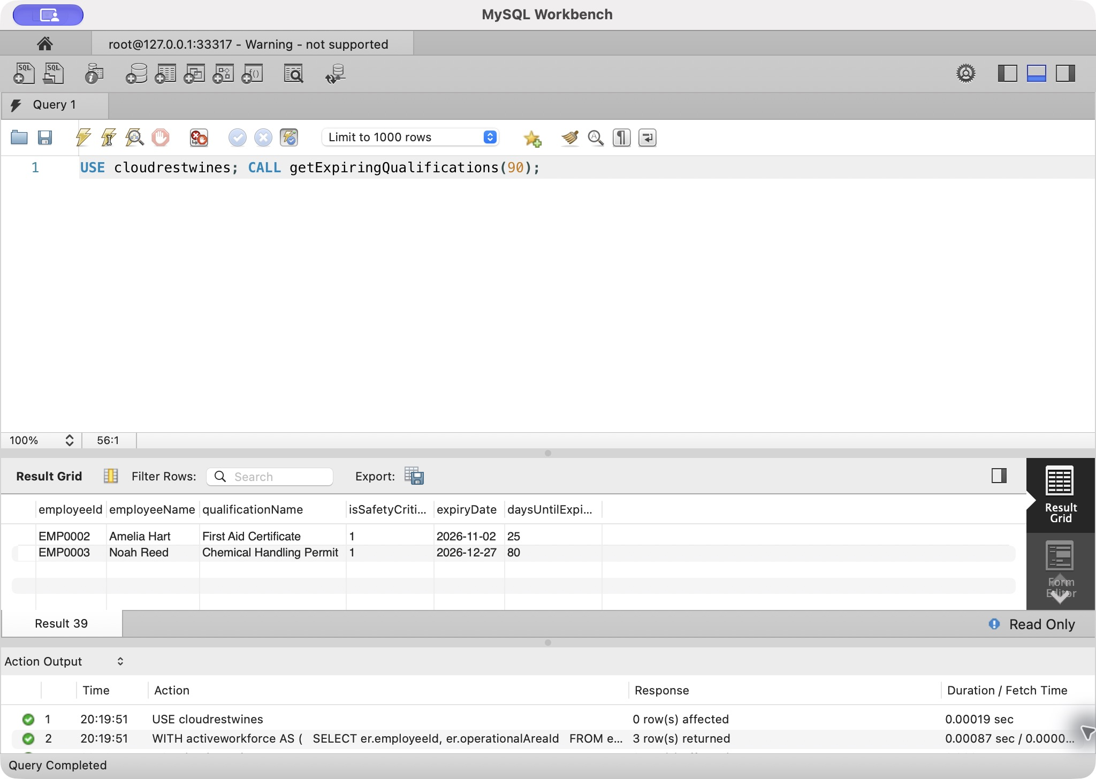
Query 5: genuine Workbench query05-90days, combined supplied + test database, 2026-10-08

Query 6 — Open corrective actions View and EXPLAIN

How the query works
openincidentaction joins correctiveaction, incident, operationalarea and the responsible employee. It excludes COMPLETED and CANCELLED actions and calculates daysOverdue with GREATEST(DATEDIFF(...),0).
The management query reads the view and orders overdue rows first, then severity, overdue days and target date. EXPLAIN is executed on the same final query to inspect the access plan.

Business use and action
The Safety Officer and managers use this list to prevent corrective actions from disappearing after an incident is recorded. Overdue actions should be escalated; high-severity actions approaching their target date should be resourced before they become overdue.

Actual result — frozen MySQL 8.4.11 build, 2026-10-08
Two actions remain open:
- ACTN0001: 5 days overdue, Low-severity incident, status INPROGRESS.
- ACTN0002: not overdue (target in 14 days), High-severity incident, status OPEN.
The ordering places ACTN0001 first because it is already overdue. ACTN0002 still deserves attention because the underlying incident severity is High.

EXPLAIN interpretation
The final Workbench and matching CLI EXPLAIN on 2026-10-08 starts with incident (i): ALL, estimated 3 rows, using temporary/filesort. correctiveaction (ca) uses ref on fk_action_incident, estimated 1 row and 66.67% filtered, using where. operationalarea and employee use eq_ref primary-key lookups, estimated 1 row. The plan remains ALL/ref/eq_ref after the combined-data rebuild. It does not establish production performance. Final screenshots and verification/final-query-results/06_openactions.tsv show the same plan.
Risk / limitation: Open-action status needs timely updates; small-fixture EXPLAIN does not establish production performance.

Query 6 SQL
USE cloudrestwines;
-- View-based management query: prioritise overdue and high-severity corrective actions.
SELECT correctiveActionId, incidentId, incidentDateTime, severity, areaName,
actionDescription, responsibleEmployee, targetDate, daysOverdue, actionStatus
FROM openincidentaction
ORDER BY (daysOverdue > 0) DESC,
FIELD(severity,'CRITICAL','HIGH','MODERATE','LOW'),
daysOverdue DESC, targetDate;
EXPLAIN
SELECT correctiveActionId, incidentId, incidentDateTime, severity, areaName,
actionDescription, responsibleEmployee, targetDate, daysOverdue, actionStatus
FROM openincidentaction
ORDER BY (daysOverdue > 0) DESC,
FIELD(severity,'CRITICAL','HIGH','MODERATE','LOW'),
daysOverdue DESC, targetDate;
Query 6: actual MySQL 8.4.11 output, 2026-10-08. Combined supplied + test database; HR results use synthetic assessment records.
correctiveActionId | incidentId | incidentDateTime | severity | areaName | actionDescription | responsibleEmployee | targetDate | daysOverdue | actionStatus
ACTN0001 | INCD0001 | 2026-09-18 01:15:05 | LOW | Vineyard | Install anti-slip surface and revise harvest briefing | Ethan Brown | 2026-10-03 | 5 | INPROGRESS
ACTN0002 | INCD0002 | 2026-09-28 01:15:05 | HIGH | Cellar | Introduce mechanical lifting aid and refresher training | Ethan Brown | 2026-10-22 | 0 | OPEN

id | select_type | table | partitions | type | possible_keys | key | key_len | ref | rows | filtered | Extra
1 | SIMPLE | i | NULL | ALL | PRIMARY,fk_incident_area | NULL | NULL | NULL | 3 | 100.00 | Using temporary; Using filesort
1 | SIMPLE | ca | NULL | ref | fk_action_incident,fk_action_employee,idx_action_status_date | fk_action_incident | 32 | cloudrestwines.i.incidentId | 1 | 66.67 | Using where
1 | SIMPLE | oa | NULL | eq_ref | PRIMARY | PRIMARY | 24 | cloudrestwines.i.operationalAreaId | 1 | 100.00 | NULL
1 | SIMPLE | e | NULL | eq_ref | PRIMARY | PRIMARY | 28 | cloudrestwines.ca.responsibleEmployeeId | 1 | 100.00 | NULL

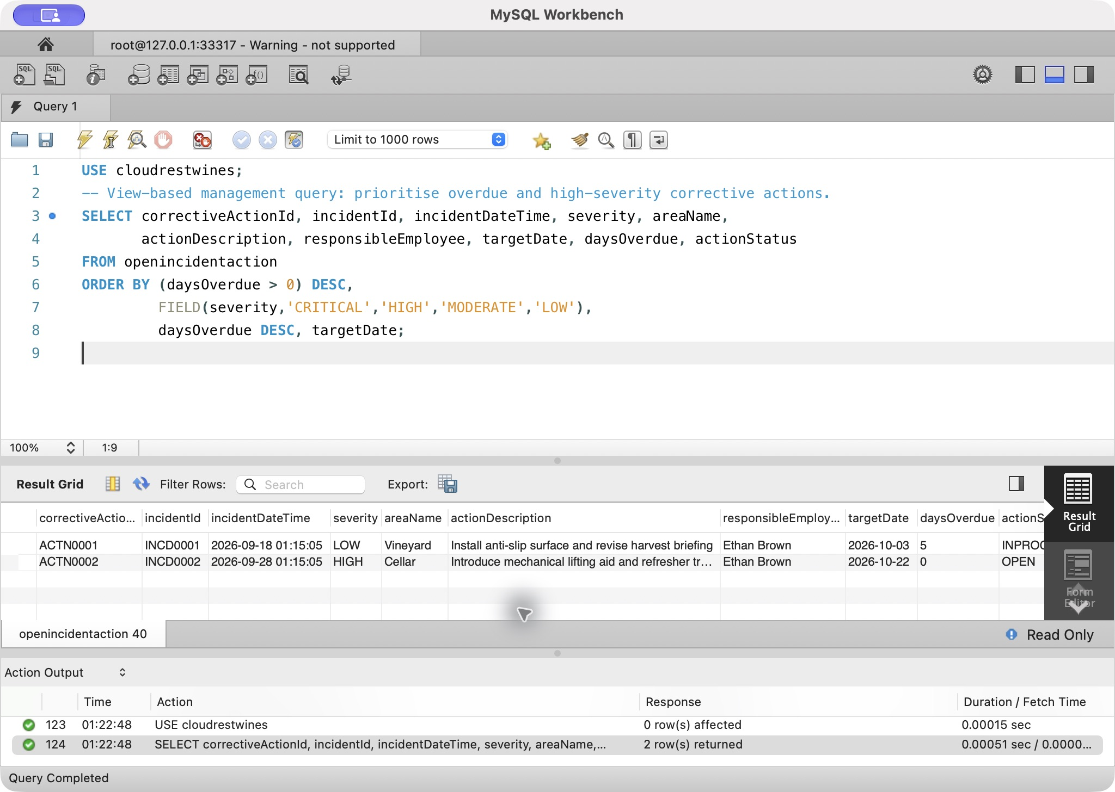
Query 6: genuine Workbench query06-results, combined supplied + test database, 2026-10-08
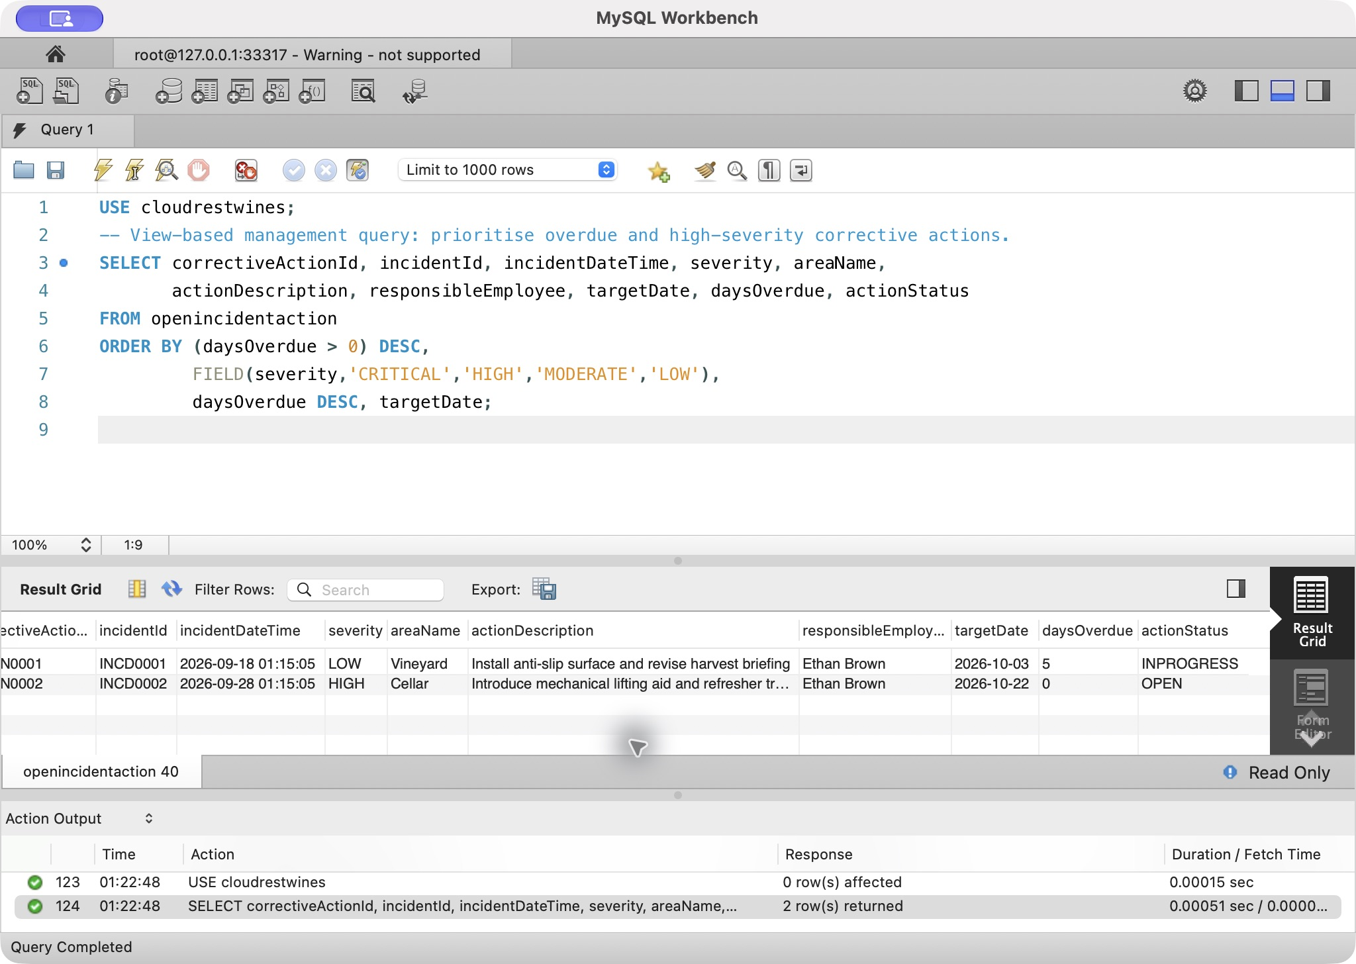
Query 6: genuine Workbench query06-results-right, combined supplied + test database, 2026-10-08
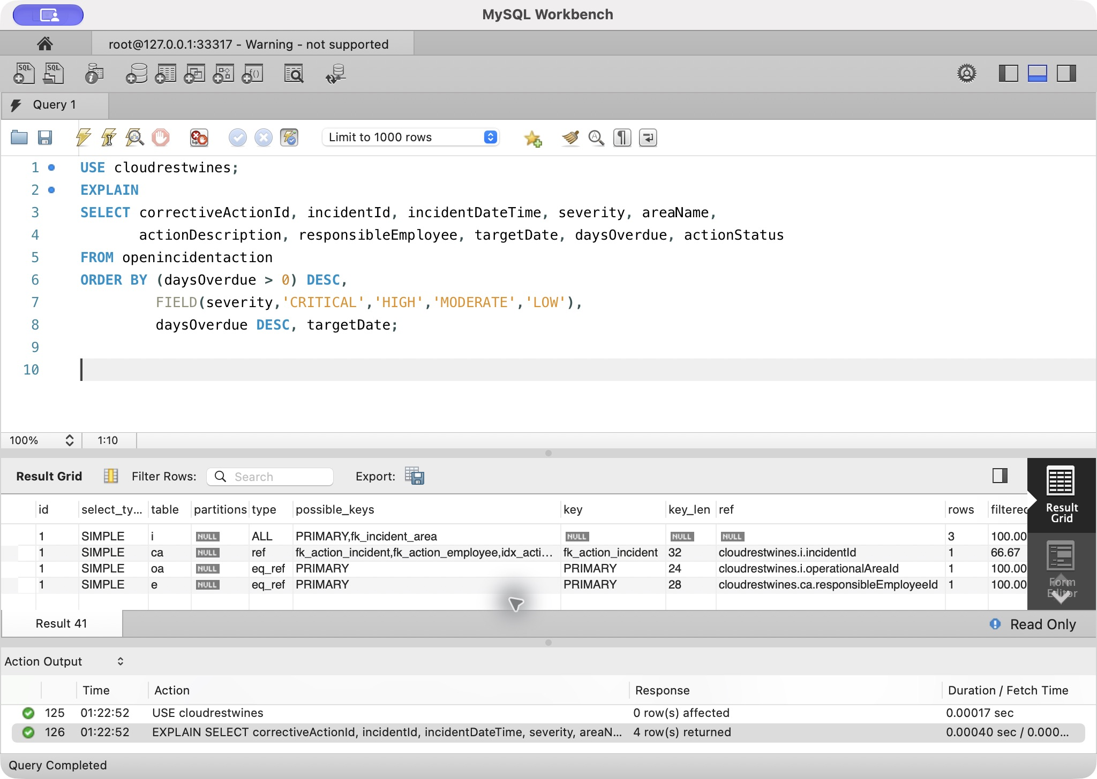
Query 6: genuine Workbench query06-explain-left, combined supplied + test database, 2026-10-08
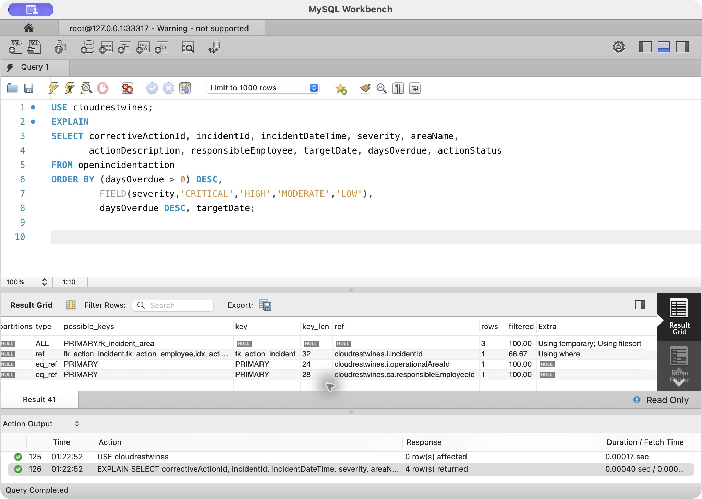
Query 6: genuine Workbench query06-explain-right, combined supplied + test database, 2026-10-08

Risks and limitations by query
Query | Risk / limitation
1 | Current workforce membership differs from historical membership; both categories must be completed in the current calendar year.
2 | Very small exposure denominators make rates unstable; missing assignments or incidents bias the metric.
3 | Equal windows reduce exposure imbalance but do not control work mix or confounding; no causal claim is supported.
4 | Eight hours per assignment is the demonstration rule, not an asserted payroll entitlement; flags require supervisor context.
5 | Expiry is only as reliable as recorded qualification dates; book renewals and verify validity with the issuer.
6 | Open actions depend on timely status updates; the small-fixture EXPLAIN does not establish production performance.

All six outputs use synthetic assessment HR records and cannot describe actual winery performance.

Final evidence rule
The numeric interpretations above are reproducible from the revised fixture, but final submission evidence must be captured after the final SQL build is frozen. If any fixture or query changes, all six outputs and the Query 6 EXPLAIN screenshot must be regenerated together.

Conclusion
Cloudrest Wines now has a reproducible 3NF MySQL OLTP design covering the complete base case and a connected HR/workforce sustainability extension. Database constraints preserve critical history and transactional integrity, while six tested queries convert operational records into training, exposure, workload, renewal and corrective-action decisions. The current report, SQL and model package is ready for delivery. Video, RiPPlE, Buddycheck and personal contribution confirmation belong to the students. Task 8 awaits the tutor-supplied Week 11 scenario.

References
BISM2207 teaching team. (2026a). Wine company case [Course case study]. The University of Queensland.
BISM2207 teaching team. (2026b). BISM2207 system development assessment specification [Course document]. The University of Queensland.
BISM2207 teaching team. (2026c). BISM2207 system development marking rubric [Course document]. The University of Queensland.
Oracle. (2026). MySQL 8.4 reference manual. https://dev.mysql.com/doc/refman/8.4/en/
Oracle. (2026). MySQL Workbench manual. https://dev.mysql.com/doc/workbench/en/

Appendix A — Workbench Domain EER Views

Personnel History
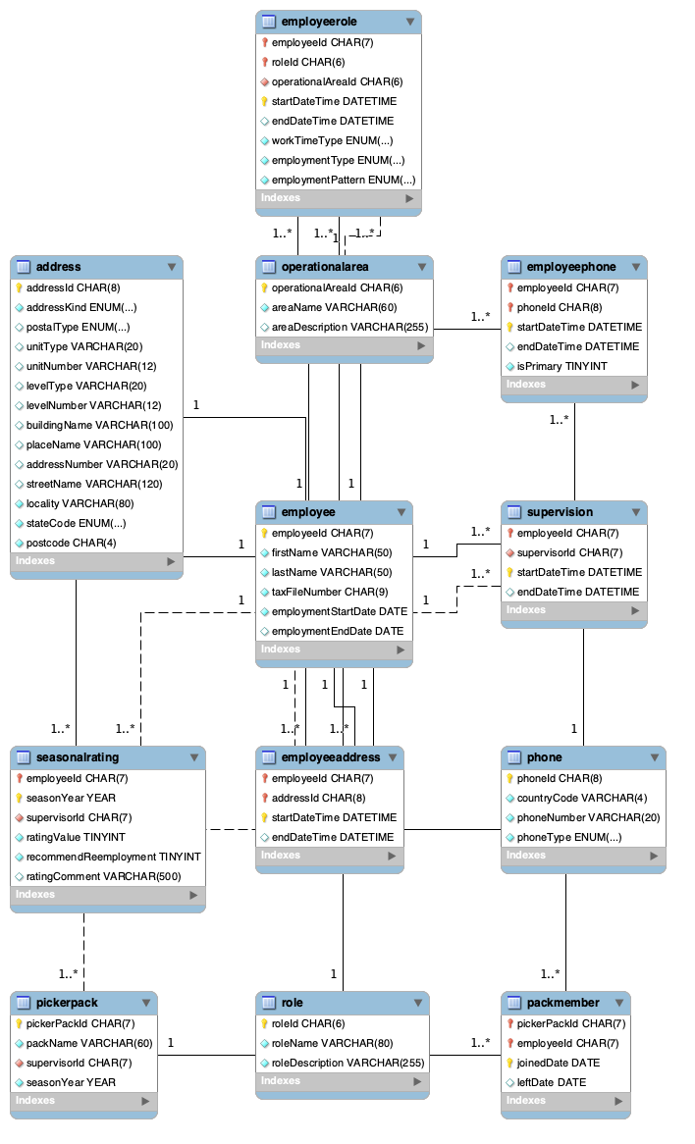
UML domain view — authoritative revised schema, 2026-10-07

HR Training Qualifications
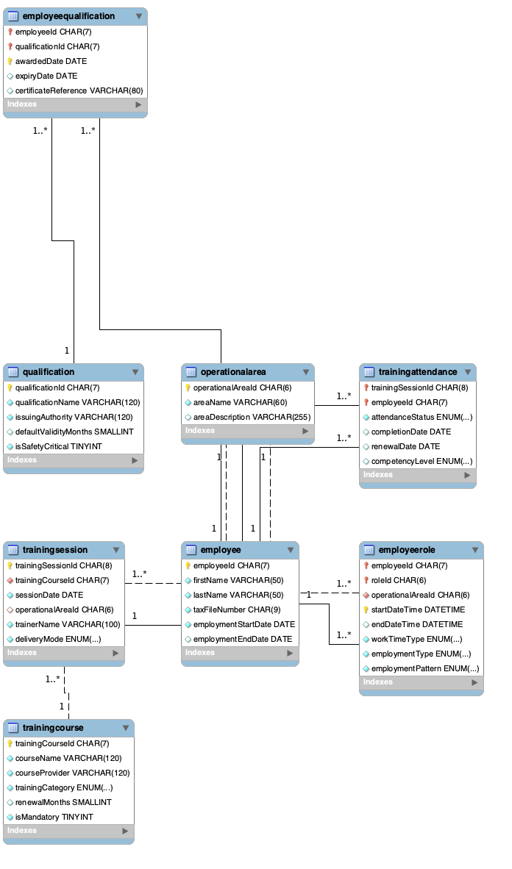
UML domain view — authoritative revised schema, 2026-10-07

HR Shifts Safety Wellbeing
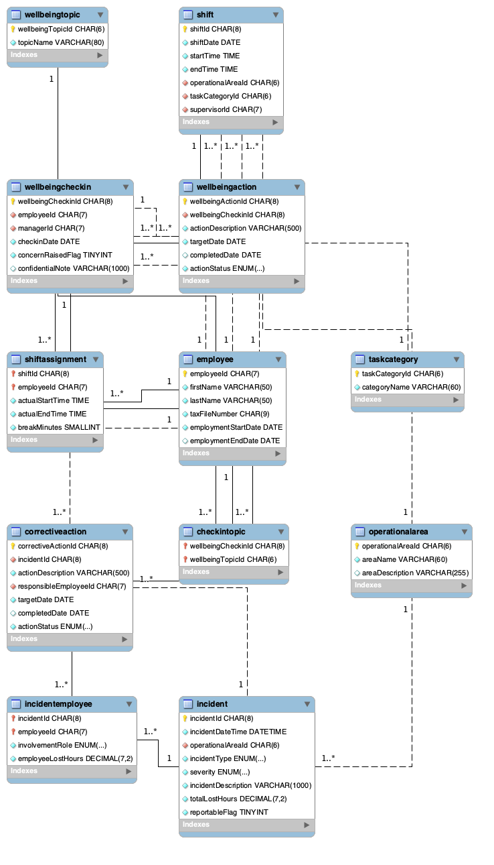
UML domain view — authoritative revised schema, 2026-10-07

Vineyard Wine Production
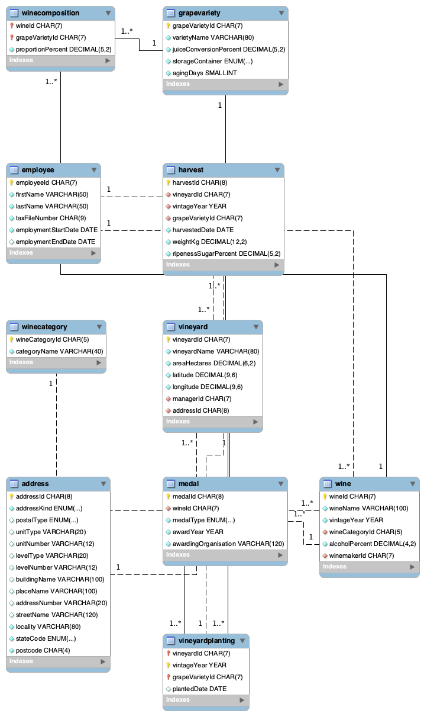
UML domain view — authoritative revised schema, 2026-10-07

Products Procurement
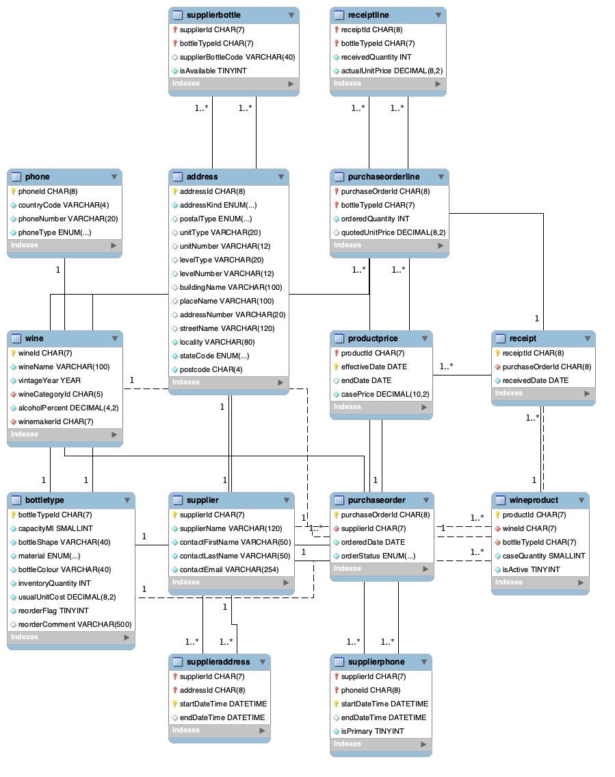
UML domain view — authoritative revised schema, 2026-10-07

Customers Orders
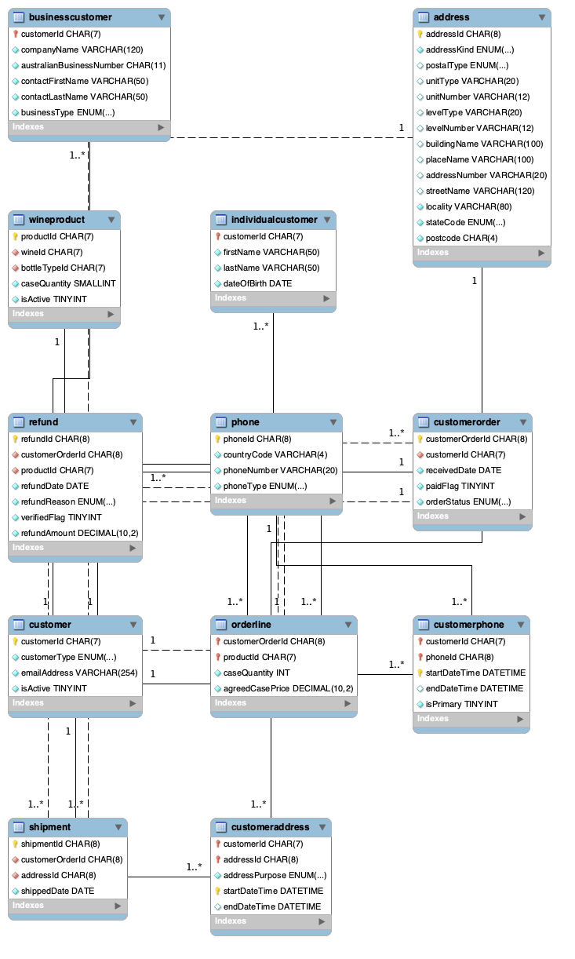
UML domain view — authoritative revised schema, 2026-10-07

Appendix B — Complete Data Dictionary
Prepared and cross-checked: The data dictionary was prepared as Word tables and cross-checked against the implemented MySQL schema for consistency. Automation is used internally to prevent field/type/key drift.

address
Attribute | Type/size | Domain/default | Null | Unique | PK | FK reference | Definition / business purpose
addressId | char(8) | Text up to the implemented char(8) size. | NO | Y | Y | — | Stable identifier for a address record.
addressKind | enum('PHYSICAL','POSTAL') | Permitted values: physical, postal. | NO | N | N | — | Records the address kind of the address.
postalType | enum('POBOX','PRIVATEBAG','OTHER') | Permitted values: pobox, privatebag, other. | YES | N | N | — | Records the postal type of the address.
unitType | varchar(20) | Text up to the implemented varchar(20) size. | YES | N | N | — | Records the unit type of the address.
unitNumber | varchar(12) | Text up to the implemented varchar(12) size. | YES | N | N | — | Records the unit number of the address.
levelType | varchar(20) | Text up to the implemented varchar(20) size. | YES | N | N | — | Records the level type of the address.
levelNumber | varchar(12) | Text up to the implemented varchar(12) size. | YES | N | N | — | Records the level number of the address.
buildingName | varchar(100) | Text up to the implemented varchar(100) size. | YES | N | N | — | Human-readable name used for the address record.
placeName | varchar(100) | Text up to the implemented varchar(100) size. | YES | N | N | — | Human-readable name used for the address record.
addressNumber | varchar(20) | Text up to the implemented varchar(20) size. | YES | N | N | — | Records the address number of the address.
streetName | varchar(120) | Text up to the implemented varchar(120) size. | YES | N | N | — | Human-readable name used for the address record.
locality | varchar(80) | Text up to the implemented varchar(80) size. | NO | N | N | — | Records the locality of the address.
stateCode | enum('ACT','NSW','NT','QLD','SA','TAS','VIC','WA') | Permitted values: act, nsw, nt, qld, sa, tas, vic, wa. | NO | N | N | — | Records the state code of the address.
postcode | char(4) | Exactly 4 numeric digits. | NO | N | N | — | Records the postcode of the address.

bottletype
Attribute | Type/size | Domain/default | Null | Unique | PK | FK reference | Definition / business purpose
bottleTypeId | char(7) | Text up to the implemented char(7) size. | NO | Y | Y | — | Stable identifier for a bottletype record.
capacityMl | smallint unsigned | Numeric value within the implemented MySQL type. | NO | N | N | — | Records the capacity ml of the bottletype.
bottleShape | varchar(40) | Text up to the implemented varchar(40) size. | NO | N | N | — | Records the bottle shape of the bottletype.
material | enum('GLASS','PLASTIC') | Permitted values: glass, plastic. | NO | N | N | — | Records the material of the bottletype.
bottleColour | varchar(40) | Text up to the implemented varchar(40) size. | NO | N | N | — | Records the bottle colour of the bottletype.
inventoryQuantity | int unsigned | Positive numeric value. | NO | N | N | — | Quantity recorded for the bottletype transaction or inventory fact.
usualUnitCost | decimal(8,2) | Non-negative numeric value. | NO | N | N | — | Monetary value recorded for the bottletype fact in Australian dollars.
reorderFlag | tinyint(1) | TRUE/FALSE; default 1. | NO | N | N | — | Indicates whether this bottle type may be reordered.
reorderComment | varchar(500) | Text up to the implemented varchar(500) size. | YES | N | N | — | Required explanation when a bottle type will not be reordered.

businesscustomer
Attribute | Type/size | Domain/default | Null | Unique | PK | FK reference | Definition / business purpose
customerId | char(7) | Text up to the implemented char(7) size. | NO | Y | Y | customer.customerId | Identifies the related customer record.
companyName | varchar(120) | Text up to the implemented varchar(120) size. | NO | N | N | — | Human-readable name used for the businesscustomer record.
australianBusinessNumber | char(11) | Exactly 11 numeric digits. | NO | Y | N | — | Eleven-digit ABN identifying an Australian business customer.
contactFirstName | varchar(50) | Text up to the implemented varchar(50) size. | NO | N | N | — | Human-readable name used for the businesscustomer record.
contactLastName | varchar(50) | Text up to the implemented varchar(50) size. | NO | N | N | — | Human-readable name used for the businesscustomer record.
businessType | enum('RESTAURANT','WINESHOP','EXPORTCOMPANY','OTHER') | Permitted values: restaurant, wineshop, exportcompany, other. | NO | N | N | — | Records the business type of the businesscustomer.

checkintopic
Attribute | Type/size | Domain/default | Null | Unique | PK | FK reference | Definition / business purpose
wellbeingCheckinId | char(8) | Text up to the implemented char(8) size. | NO | Y | Y | wellbeingcheckin.wellbeingCheckinId | Identifies the related wellbeingcheckin record.
wellbeingTopicId | char(6) | Text up to the implemented char(6) size. | NO | Y | Y | wellbeingtopic.wellbeingTopicId | Identifies the related wellbeingtopic record.

correctiveaction
Attribute | Type/size | Domain/default | Null | Unique | PK | FK reference | Definition / business purpose
correctiveActionId | char(8) | Text up to the implemented char(8) size. | NO | Y | Y | — | Stable identifier for a correctiveaction record.
incidentId | char(8) | Text up to the implemented char(8) size. | NO | N | N | incident.incidentId | Identifies the related incident record.
actionDescription | varchar(500) | Text up to the implemented varchar(500) size. | NO | N | N | — | Business description of the correctiveaction record.
responsibleEmployeeId | char(7) | Text up to the implemented char(7) size. | NO | N | N | employee.employeeId | Identifies the related employee record.
targetDate | date | Valid MySQL date value. | NO | N | N | — | Date associated with the correctiveaction record or validity period.
completedDate | date | Valid MySQL date value. | YES | N | N | — | Date associated with the correctiveaction record or validity period.
actionStatus | enum('OPEN','INPROGRESS','COMPLETED','CANCELLED') | Permitted values: open, inprogress, completed, cancelled. | NO | N | N | — | Records the action status of the correctiveaction.

customer
Attribute | Type/size | Domain/default | Null | Unique | PK | FK reference | Definition / business purpose
customerId | char(7) | Text up to the implemented char(7) size. | NO | Y | Y | — | Stable identifier for a customer record.
customerType | enum('INDIVIDUAL','BUSINESS') | Permitted values: individual, business. | NO | N | N | — | Records the customer type of the customer.
emailAddress | varchar(254) | Text up to the implemented varchar(254) size. | NO | Y | N | — | Records the email address of the customer.
isActive | tinyint(1) | TRUE/FALSE; default 1. | NO | N | N | — | TRUE/FALSE indicator for is active on the customer record.

customeraddress
Attribute | Type/size | Domain/default | Null | Unique | PK | FK reference | Definition / business purpose
customerId | char(7) | Text up to the implemented char(7) size. | NO | Y | Y | customer.customerId | Identifies the related customer record.
addressId | char(8) | Text up to the implemented char(8) size. | NO | Y | Y | address.addressId | Identifies the related address record.
addressPurpose | enum('PRIMARY','DELIVERY','BILLING','CORRESPONDENCE') | Permitted values: primary, delivery, billing, correspondence. | NO | N | N | — | Business purpose of the customer address history row: primary, delivery, billing or correspondence.
startDateTime | datetime | Valid MySQL datetime value. | NO | Y | Y | — | Inclusive start date/time of the customeraddress history period.
endDateTime | datetime | NULL for current, otherwise not earlier than startDateTime. | YES | N | N | — | Optional end date/time of the customeraddress history period; NULL identifies the current row.

customerorder
Attribute | Type/size | Domain/default | Null | Unique | PK | FK reference | Definition / business purpose
customerOrderId | char(8) | Text up to the implemented char(8) size. | NO | Y | Y | — | Stable identifier for a customerorder record.
customerId | char(7) | Text up to the implemented char(7) size. | NO | N | N | customer.customerId | Identifies the related customer record.
receivedDate | date | Valid MySQL date value. | NO | N | N | — | Date associated with the customerorder record or validity period.
paidFlag | tinyint(1) | TRUE/FALSE; default 0. | NO | N | N | — | Indicates accounting confirmation that shipment may proceed.
orderStatus | enum('PENDING','SHIPPED','CANCELLED') | Permitted values: pending, shipped, cancelled. | NO | N | N | — | Records the order status of the customerorder.

customerphone
Attribute | Type/size | Domain/default | Null | Unique | PK | FK reference | Definition / business purpose
customerId | char(7) | Text up to the implemented char(7) size. | NO | Y | Y | customer.customerId | Identifies the related customer record.
phoneId | char(8) | Text up to the implemented char(8) size. | NO | Y | Y | phone.phoneId | Identifies the related phone record.
startDateTime | datetime | Valid MySQL datetime value. | NO | Y | Y | — | Inclusive start date/time of the customerphone history period.
endDateTime | datetime | NULL for current, otherwise not earlier than startDateTime. | YES | N | N | — | Optional end date/time of the customerphone history period; NULL identifies the current row.
isPrimary | tinyint(1) | TRUE/FALSE; default 0. | NO | N | N | — | TRUE/FALSE indicator for is primary on the customerphone record.

employee
Attribute | Type/size | Domain/default | Null | Unique | PK | FK reference | Definition / business purpose
employeeId | char(7) | Text up to the implemented char(7) size. | NO | Y | Y | — | Stable identifier for a employee record.
firstName | varchar(50) | Text up to the implemented varchar(50) size. | NO | N | N | — | Human-readable name used for the employee record.
lastName | varchar(50) | Text up to the implemented varchar(50) size. | NO | N | N | — | Human-readable name used for the employee record.
taxFileNumber | char(9) | Exactly 9 numeric digits. | NO | Y | N | — | Australian tax file number; sensitive HR identifier.
employmentStartDate | date | Valid MySQL date value. | NO | N | N | — | Date associated with the employee record or validity period.
employmentEndDate | date | Valid MySQL date value. | YES | N | N | — | Date associated with the employee record or validity period.

employeeaddress
Attribute | Type/size | Domain/default | Null | Unique | PK | FK reference | Definition / business purpose
employeeId | char(7) | Text up to the implemented char(7) size. | NO | Y | Y | employee.employeeId | Identifies the related employee record.
addressId | char(8) | Text up to the implemented char(8) size. | NO | Y | Y | address.addressId | Identifies the related address record.
startDateTime | datetime | Valid MySQL datetime value. | NO | Y | Y | — | Inclusive start date/time of the employeeaddress history period.
endDateTime | datetime | NULL for current, otherwise not earlier than startDateTime. | YES | N | N | — | Optional end date/time of the employeeaddress history period; NULL identifies the current row.

employeephone
Attribute | Type/size | Domain/default | Null | Unique | PK | FK reference | Definition / business purpose
employeeId | char(7) | Text up to the implemented char(7) size. | NO | Y | Y | employee.employeeId | Identifies the related employee record.
phoneId | char(8) | Text up to the implemented char(8) size. | NO | Y | Y | phone.phoneId | Identifies the related phone record.
startDateTime | datetime | Valid MySQL datetime value. | NO | Y | Y | — | Inclusive start date/time of the employeephone history period.
endDateTime | datetime | NULL for current, otherwise not earlier than startDateTime. | YES | N | N | — | Optional end date/time of the employeephone history period; NULL identifies the current row.
isPrimary | tinyint(1) | TRUE/FALSE; default 0. | NO | N | N | — | TRUE/FALSE indicator for is primary on the employeephone record.

employeequalification
Attribute | Type/size | Domain/default | Null | Unique | PK | FK reference | Definition / business purpose
employeeId | char(7) | Text up to the implemented char(7) size. | NO | Y | Y | employee.employeeId | Identifies the related employee record.
qualificationId | char(7) | Text up to the implemented char(7) size. | NO | Y | Y | qualification.qualificationId | Identifies the related qualification record.
awardedDate | date | Valid MySQL date value. | NO | Y | Y | — | Date associated with the employeequalification record or validity period.
expiryDate | date | Valid MySQL date value. | YES | N | N | — | Date associated with the employeequalification record or validity period.
certificateReference | varchar(80) | Text up to the implemented varchar(80) size. | YES | Y | N | — | Records the certificate reference of the employeequalification.

employeerole
Attribute | Type/size | Domain/default | Null | Unique | PK | FK reference | Definition / business purpose
employeeId | char(7) | Text up to the implemented char(7) size. | NO | Y | Y | employee.employeeId | Identifies the related employee record.
roleId | char(6) | Text up to the implemented char(6) size. | NO | Y | Y | role.roleId | Identifies the related role record.
operationalAreaId | char(6) | Text up to the implemented char(6) size. | NO | N | N | operationalarea.operationalAreaId | Identifies the related operationalarea record.
startDateTime | datetime | Valid MySQL datetime value. | NO | Y | Y | — | Inclusive start date/time of the employeerole history period.
endDateTime | datetime | NULL for current, otherwise not earlier than startDateTime. | YES | N | N | — | Optional end date/time of the employeerole history period; NULL identifies the current row.
workTimeType | enum('FULLTIME','PARTTIME') | Permitted values: fulltime, parttime. | NO | N | N | — | Indicates whether the appointment is full-time or part-time.
employmentType | enum('PERMANENT','CASUAL') | Permitted values: permanent, casual. | NO | N | N | — | Legal engagement category: permanent or casual.
employmentPattern | enum('ONGOING','SEASONAL') | Permitted values: ongoing, seasonal. | NO | N | N | — | Indicates ongoing or seasonal work pattern independently of employment type.

grapevariety
Attribute | Type/size | Domain/default | Null | Unique | PK | FK reference | Definition / business purpose
grapeVarietyId | char(7) | Text up to the implemented char(7) size. | NO | Y | Y | — | Stable identifier for a grapevariety record.
varietyName | varchar(80) | Text up to the implemented varchar(80) size. | NO | Y | N | — | Human-readable name used for the grapevariety record.
juiceConversionPercent | decimal(5,2) | Numeric percentage greater than 0 and no more than 100, except alcohol is capped at 25 as implemented. | NO | N | N | — | Expected percentage of grape weight converted to juice.
storageContainer | enum('STAINLESSSTEEL','OAKBARREL','OTHER') | Permitted values: stainlesssteel, oakbarrel, other. | NO | N | N | — | Records the storage container of the grapevariety.
agingDays | smallint unsigned | Numeric value within the implemented MySQL type. | NO | N | N | — | Records the aging days of the grapevariety.

harvest
Attribute | Type/size | Domain/default | Null | Unique | PK | FK reference | Definition / business purpose
harvestId | char(8) | Text up to the implemented char(8) size. | NO | Y | Y | — | Stable identifier for a harvest record.
vineyardId | char(7) | Text up to the implemented char(7) size. | NO | N | N | vineyardplanting.vineyardId | Identifies the related vineyardplanting record.
vintageYear | year | Valid MySQL year value. | NO | N | N | vineyardplanting.vintageYear | Records the vintage year of the harvest.
grapeVarietyId | char(7) | Text up to the implemented char(7) size. | NO | N | N | vineyardplanting.grapeVarietyId | Identifies the related vineyardplanting record.
harvestedDate | date | Valid MySQL date value. | NO | N | N | — | Date associated with the harvest record or validity period.
weightKg | decimal(12,2) | Positive numeric value. | NO | N | N | — | Records the weight kg of the harvest.
ripenessSugarPercent | decimal(5,2) | Numeric percentage greater than 0 and no more than 100, except alcohol is capped at 25 as implemented. | NO | N | N | — | Harvest ripeness expressed as percentage sugar.

incident
Attribute | Type/size | Domain/default | Null | Unique | PK | FK reference | Definition / business purpose
incidentId | char(8) | Text up to the implemented char(8) size. | NO | Y | Y | — | Stable identifier for a incident record.
incidentDateTime | datetime | Valid MySQL datetime value. | NO | N | N | — | Records the incident date time of the incident.
operationalAreaId | char(6) | Text up to the implemented char(6) size. | NO | N | N | operationalarea.operationalAreaId | Identifies the related operationalarea record.
incidentType | enum('INJURY','NEARMISS','ILLNESS','EQUIPMENT','ENVIRONMENTAL','OTHER') | Permitted values: injury, nearmiss, illness, equipment, environmental, other. | NO | N | N | — | Records the incident type of the incident.
severity | enum('LOW','MODERATE','HIGH','CRITICAL') | Permitted values: low, moderate, high, critical. | NO | N | N | — | Classifies incident seriousness for safety follow-up and reporting.
incidentDescription | varchar(1000) | Text up to the implemented varchar(1000) size. | NO | N | N | — | Business description of the incident record.
totalLostHours | decimal(7,2) | Non-negative numeric value. | NO | N | N | — | Non-negative total labour hours lost because of an incident; may be zero for a serious near miss.
reportableFlag | tinyint(1) | TRUE/FALSE; default 0. | NO | N | N | — | TRUE/FALSE indicator for reportable flag on the incident record.

incidentemployee
Attribute | Type/size | Domain/default | Null | Unique | PK | FK reference | Definition / business purpose
incidentId | char(8) | Text up to the implemented char(8) size. | NO | Y | Y | incident.incidentId | Identifies the related incident record.
employeeId | char(7) | Text up to the implemented char(7) size. | NO | Y | Y | employee.employeeId | Identifies the related employee record.
involvementRole | enum('AFFECTED','WITNESS','REPORTER') | Permitted values: affected, witness, reporter. | NO | N | N | — | Records the involvement role of the incidentemployee.
employeeLostHours | decimal(7,2) | Numeric value within the implemented MySQL type; default 0.00. | NO | N | N | — | Records the employee lost hours of the incidentemployee.

individualcustomer
Attribute | Type/size | Domain/default | Null | Unique | PK | FK reference | Definition / business purpose
customerId | char(7) | Text up to the implemented char(7) size. | NO | Y | Y | customer.customerId | Identifies the related customer record.
firstName | varchar(50) | Text up to the implemented varchar(50) size. | NO | N | N | — | Human-readable name used for the individualcustomer record.
lastName | varchar(50) | Text up to the implemented varchar(50) size. | NO | N | N | — | Human-readable name used for the individualcustomer record.
dateOfBirth | date | Valid MySQL date value. | NO | N | N | — | Birth date retained to demonstrate an individual customer's legal age.

medal
Attribute | Type/size | Domain/default | Null | Unique | PK | FK reference | Definition / business purpose
medalId | char(8) | Text up to the implemented char(8) size. | NO | Y | Y | — | Stable identifier for a medal record.
wineId | char(7) | Text up to the implemented char(7) size. | NO | Y | N | wine.wineId | Identifies the related wine record.
medalType | enum('BRONZE','SILVER','GOLD','TROPHY') | Permitted values: bronze, silver, gold, trophy. | NO | Y | N | — | Records the medal type of the medal.
awardYear | year | Valid MySQL year value. | NO | Y | N | — | Records the award year of the medal.
awardingOrganisation | varchar(120) | Text up to the implemented varchar(120) size. | NO | Y | N | — | Records the awarding organisation of the medal.

openincidentaction
Attribute | Type/size | Domain/default | Null | Unique | PK | FK reference | Definition / business purpose
correctiveActionId | char(8) | Text up to the implemented char(8) size. | NO | N | N | — | Stable identifier for a openincidentaction record.
incidentId | char(8) | Text up to the implemented char(8) size. | NO | N | N | — | Stable identifier for a openincidentaction record.
incidentDateTime | datetime | Valid MySQL datetime value. | NO | N | N | — | Records the incident date time of the openincidentaction.
severity | enum('LOW','MODERATE','HIGH','CRITICAL') | Permitted values: low, moderate, high, critical. | NO | N | N | — | Classifies incident seriousness for safety follow-up and reporting.
areaName | varchar(60) | Text up to the implemented varchar(60) size. | NO | N | N | — | Human-readable name used for the openincidentaction record.
actionDescription | varchar(500) | Text up to the implemented varchar(500) size. | NO | N | N | — | Business description of the openincidentaction record.
targetDate | date | Valid MySQL date value. | NO | N | N | — | Date associated with the openincidentaction record or validity period.
actionStatus | enum('OPEN','INPROGRESS','COMPLETED','CANCELLED') | Permitted values: open, inprogress, completed, cancelled. | NO | N | N | — | Records the action status of the openincidentaction.
responsibleEmployee | varchar(101) | Text up to the implemented varchar(101) size. | YES | N | N | — | Records the responsible employee of the openincidentaction.
daysOverdue | int | Numeric value within the implemented MySQL type. | YES | N | N | — | Records the days overdue of the openincidentaction.

operationalarea
Attribute | Type/size | Domain/default | Null | Unique | PK | FK reference | Definition / business purpose
operationalAreaId | char(6) | Text up to the implemented char(6) size. | NO | Y | Y | — | Stable identifier for a operationalarea record.
areaName | varchar(60) | Text up to the implemented varchar(60) size. | NO | Y | N | — | Human-readable name used for the operationalarea record.
areaDescription | varchar(255) | Text up to the implemented varchar(255) size. | YES | N | N | — | Business description of the operationalarea record.

orderline
Attribute | Type/size | Domain/default | Null | Unique | PK | FK reference | Definition / business purpose
customerOrderId | char(8) | Text up to the implemented char(8) size. | NO | Y | Y | customerorder.customerOrderId | Identifies the related customerorder record.
productId | char(7) | Text up to the implemented char(7) size. | NO | Y | Y | wineproduct.productId | Identifies the related wineproduct record.
caseQuantity | int unsigned | Positive numeric value. | NO | N | N | — | Quantity recorded for the orderline transaction or inventory fact.
agreedCasePrice | decimal(10,2) | Numeric value within the implemented MySQL type. | NO | N | N | — | Monetary value recorded for the orderline fact in Australian dollars.

packmember
Attribute | Type/size | Domain/default | Null | Unique | PK | FK reference | Definition / business purpose
pickerPackId | char(7) | Text up to the implemented char(7) size. | NO | Y | Y | pickerpack.pickerPackId | Identifies the related pickerpack record.
employeeId | char(7) | Text up to the implemented char(7) size. | NO | Y | Y | employee.employeeId | Identifies the related employee record.
joinedDate | date | Valid MySQL date value. | NO | Y | Y | — | Date associated with the packmember record or validity period.
leftDate | date | Valid MySQL date value. | YES | N | N | — | Date associated with the packmember record or validity period.

phone
Attribute | Type/size | Domain/default | Null | Unique | PK | FK reference | Definition / business purpose
phoneId | char(8) | Text up to the implemented char(8) size. | NO | Y | Y | — | Stable identifier for a phone record.
countryCode | varchar(4) | Text up to the implemented varchar(4) size; default +61. | NO | Y | N | — | Records the country code of the phone.
phoneNumber | varchar(20) | Text up to the implemented varchar(20) size. | NO | Y | N | — | Records the phone number of the phone.
phoneType | enum('MOBILE','WORK','HOME','OTHER') | Permitted values: mobile, work, home, other. | NO | N | N | — | Records the phone type of the phone.

pickerpack
Attribute | Type/size | Domain/default | Null | Unique | PK | FK reference | Definition / business purpose
pickerPackId | char(7) | Text up to the implemented char(7) size. | NO | Y | Y | — | Stable identifier for a pickerpack record.
packName | varchar(60) | Text up to the implemented varchar(60) size. | NO | Y | N | — | Human-readable name used for the pickerpack record.
supervisorId | char(7) | Text up to the implemented char(7) size. | NO | N | N | employee.employeeId | Identifies the related employee record.
seasonYear | year | Valid MySQL year value. | NO | N | N | — | Records the season year of the pickerpack.

productprice
Attribute | Type/size | Domain/default | Null | Unique | PK | FK reference | Definition / business purpose
productId | char(7) | Text up to the implemented char(7) size. | NO | Y | Y | wineproduct.productId | Identifies the related wineproduct record.
effectiveDate | date | Valid MySQL date value. | NO | Y | Y | — | Date associated with the productprice record or validity period.
endDate | date | NULL for current, otherwise not earlier than the corresponding start/effective date. | YES | N | N | — | Date associated with the productprice record or validity period.
casePrice | decimal(10,2) | Positive numeric value. | NO | N | N | — | Monetary value recorded for the productprice fact in Australian dollars.

purchaseorder
Attribute | Type/size | Domain/default | Null | Unique | PK | FK reference | Definition / business purpose
purchaseOrderId | char(8) | Text up to the implemented char(8) size. | NO | Y | Y | — | Stable identifier for a purchaseorder record.
supplierId | char(7) | Text up to the implemented char(7) size. | NO | N | N | supplier.supplierId | Identifies the related supplier record.
orderedDate | date | Valid MySQL date value. | NO | N | N | — | Date associated with the purchaseorder record or validity period.
orderStatus | enum('PLACED','PARTRECEIVED','RECEIVED','CANCELLED') | Permitted values: placed, partreceived, received, cancelled. | NO | N | N | — | Records the order status of the purchaseorder.

purchaseorderline
Attribute | Type/size | Domain/default | Null | Unique | PK | FK reference | Definition / business purpose
purchaseOrderId | char(8) | Text up to the implemented char(8) size. | NO | Y | Y | purchaseorder.purchaseOrderId | Identifies the related purchaseorder record.
bottleTypeId | char(7) | Text up to the implemented char(7) size. | NO | Y | Y | bottletype.bottleTypeId | Identifies the related bottletype record.
orderedQuantity | int unsigned | Positive numeric value. | NO | N | N | — | Quantity recorded for the purchaseorderline transaction or inventory fact.
quotedUnitPrice | decimal(8,2) | Non-negative numeric value. | YES | N | N | — | Monetary value recorded for the purchaseorderline fact in Australian dollars.

qualification
Attribute | Type/size | Domain/default | Null | Unique | PK | FK reference | Definition / business purpose
qualificationId | char(7) | Text up to the implemented char(7) size. | NO | Y | Y | — | Stable identifier for a qualification record.
qualificationName | varchar(120) | Text up to the implemented varchar(120) size. | NO | Y | N | — | Human-readable name used for the qualification record.
issuingAuthority | varchar(120) | Text up to the implemented varchar(120) size. | NO | N | N | — | TRUE/FALSE indicator for issuing authority on the qualification record.
defaultValidityMonths | smallint unsigned | Numeric value within the implemented MySQL type. | YES | N | N | — | Records the default validity months of the qualification.
isSafetyCritical | tinyint(1) | TRUE/FALSE; default 0. | NO | N | N | — | TRUE/FALSE indicator for is safety critical on the qualification record.

receipt
Attribute | Type/size | Domain/default | Null | Unique | PK | FK reference | Definition / business purpose
receiptId | char(8) | Text up to the implemented char(8) size. | NO | Y | Y | — | Stable identifier for a receipt record.
purchaseOrderId | char(8) | Text up to the implemented char(8) size. | NO | N | N | purchaseorder.purchaseOrderId | Identifies the related purchaseorder record.
receivedDate | date | Valid MySQL date value. | NO | N | N | — | Date associated with the receipt record or validity period.

receiptline
Attribute | Type/size | Domain/default | Null | Unique | PK | FK reference | Definition / business purpose
receiptId | char(8) | Text up to the implemented char(8) size. | NO | Y | Y | receipt.receiptId | Identifies the related receipt record.
bottleTypeId | char(7) | Text up to the implemented char(7) size. | NO | Y | Y | bottletype.bottleTypeId | Identifies the related bottletype record.
receivedQuantity | int unsigned | Positive numeric value. | NO | N | N | — | Quantity recorded for the receiptline transaction or inventory fact.
actualUnitPrice | decimal(8,2) | Non-negative numeric value. | NO | N | N | — | Monetary value recorded for the receiptline fact in Australian dollars.

refund
Attribute | Type/size | Domain/default | Null | Unique | PK | FK reference | Definition / business purpose
refundId | char(8) | Text up to the implemented char(8) size. | NO | Y | Y | — | Stable identifier for a refund record.
customerOrderId | char(8) | Text up to the implemented char(8) size. | NO | N | N | orderline.customerOrderId | Identifies the related orderline record.
productId | char(7) | Text up to the implemented char(7) size. | NO | N | N | orderline.productId | Identifies the related orderline record.
refundDate | date | Valid MySQL date value. | NO | N | N | — | Date associated with the refund record or validity period.
refundReason | enum('SHORTSUPPLY','TRANSITDAMAGE') | Permitted values: shortsupply, transitdamage. | NO | N | N | — | Records the refund reason of the refund.
verifiedFlag | tinyint(1) | TRUE/FALSE. | NO | N | N | — | TRUE/FALSE indicator for verified flag on the refund record.
refundAmount | decimal(10,2) | Non-negative numeric value. | NO | N | N | — | Monetary value recorded for the refund fact in Australian dollars.

role
Attribute | Type/size | Domain/default | Null | Unique | PK | FK reference | Definition / business purpose
roleId | char(6) | Text up to the implemented char(6) size. | NO | Y | Y | — | Stable identifier for a role record.
roleName | varchar(80) | Text up to the implemented varchar(80) size. | NO | Y | N | — | Human-readable name used for the role record.
roleDescription | varchar(255) | Text up to the implemented varchar(255) size. | NO | N | N | — | Business description of the role record.

seasonalrating
Attribute | Type/size | Domain/default | Null | Unique | PK | FK reference | Definition / business purpose
employeeId | char(7) | Text up to the implemented char(7) size. | NO | Y | Y | employee.employeeId | Identifies the related employee record.
seasonYear | year | Valid MySQL year value. | NO | Y | Y | — | Records the season year of the seasonalrating.
supervisorId | char(7) | Text up to the implemented char(7) size. | NO | N | N | employee.employeeId | Identifies the related employee record.
ratingValue | tinyint | Integer from 1 to 5. | NO | N | N | — | Records the rating value of the seasonalrating.
recommendReemployment | tinyint(1) | TRUE/FALSE. | NO | N | N | — | Records the recommend reemployment of the seasonalrating.
ratingComment | varchar(500) | Text up to the implemented varchar(500) size. | YES | N | N | — | Records the rating comment of the seasonalrating.

shift
Attribute | Type/size | Domain/default | Null | Unique | PK | FK reference | Definition / business purpose
shiftId | char(8) | Text up to the implemented char(8) size. | NO | Y | Y | — | Stable identifier for a shift record.
shiftDate | date | Valid MySQL date value. | NO | N | N | — | Date associated with the shift record or validity period.
startTime | time | Valid MySQL time value. | NO | N | N | — | Records the start time of the shift.
endTime | time | Valid MySQL time value. | NO | N | N | — | Records the end time of the shift.
operationalAreaId | char(6) | Text up to the implemented char(6) size. | NO | N | N | operationalarea.operationalAreaId | Identifies the related operationalarea record.
taskCategoryId | char(6) | Text up to the implemented char(6) size. | NO | N | N | taskcategory.taskCategoryId | Identifies the related taskcategory record.
supervisorId | char(7) | Text up to the implemented char(7) size. | NO | N | N | employee.employeeId | Identifies the related employee record.

shiftassignment
Attribute | Type/size | Domain/default | Null | Unique | PK | FK reference | Definition / business purpose
shiftId | char(8) | Text up to the implemented char(8) size. | NO | Y | Y | shift.shiftId | Identifies the related shift record.
employeeId | char(7) | Text up to the implemented char(7) size. | NO | Y | Y | employee.employeeId | Identifies the related employee record.
actualStartTime | time | Valid MySQL time value. | NO | N | N | — | Actual employee start time for this shift assignment.
actualEndTime | time | Valid MySQL time value. | NO | N | N | — | Actual employee end time for this shift assignment.
breakMinutes | smallint unsigned | Non-negative numeric value. | NO | N | N | — | Unpaid break minutes deducted when deriving labour hours.

shipment
Attribute | Type/size | Domain/default | Null | Unique | PK | FK reference | Definition / business purpose
shipmentId | char(8) | Text up to the implemented char(8) size. | NO | Y | Y | — | Stable identifier for a shipment record.
customerOrderId | char(8) | Text up to the implemented char(8) size. | NO | Y | N | customerorder.customerOrderId | Identifies the related customerorder record.
addressId | char(8) | Text up to the implemented char(8) size. | NO | N | N | address.addressId | Identifies the related address record.
shippedDate | date | Valid MySQL date value. | NO | N | N | — | Date associated with the shipment record or validity period.

supervision
Attribute | Type/size | Domain/default | Null | Unique | PK | FK reference | Definition / business purpose
employeeId | char(7) | Text up to the implemented char(7) size. | NO | Y | Y | employee.employeeId | Identifies the related employee record.
supervisorId | char(7) | Text up to the implemented char(7) size. | NO | N | N | employee.employeeId | Identifies the related employee record.
startDateTime | datetime | Valid MySQL datetime value. | NO | Y | Y | — | Inclusive start date/time of the supervision history period.
endDateTime | datetime | NULL for current, otherwise not earlier than startDateTime. | YES | N | N | — | Optional end date/time of the supervision history period; NULL identifies the current row.

supplier
Attribute | Type/size | Domain/default | Null | Unique | PK | FK reference | Definition / business purpose
supplierId | char(7) | Text up to the implemented char(7) size. | NO | Y | Y | — | Stable identifier for a supplier record.
supplierName | varchar(120) | Text up to the implemented varchar(120) size. | NO | Y | N | — | Human-readable name used for the supplier record.
contactFirstName | varchar(50) | Text up to the implemented varchar(50) size. | NO | N | N | — | Human-readable name used for the supplier record.
contactLastName | varchar(50) | Text up to the implemented varchar(50) size. | NO | N | N | — | Human-readable name used for the supplier record.
contactEmail | varchar(254) | Text up to the implemented varchar(254) size. | NO | N | N | — | Records the contact email of the supplier.

supplieraddress
Attribute | Type/size | Domain/default | Null | Unique | PK | FK reference | Definition / business purpose
supplierId | char(7) | Text up to the implemented char(7) size. | NO | Y | Y | supplier.supplierId | Identifies the related supplier record.
addressId | char(8) | Text up to the implemented char(8) size. | NO | Y | Y | address.addressId | Identifies the related address record.
startDateTime | datetime | Valid MySQL datetime value. | NO | Y | Y | — | Inclusive start date/time of the supplieraddress history period.
endDateTime | datetime | NULL for current, otherwise not earlier than startDateTime. | YES | N | N | — | Optional end date/time of the supplieraddress history period; NULL identifies the current row.

supplierbottle
Attribute | Type/size | Domain/default | Null | Unique | PK | FK reference | Definition / business purpose
supplierId | char(7) | Text up to the implemented char(7) size. | NO | Y | Y | supplier.supplierId | Identifies the related supplier record.
bottleTypeId | char(7) | Text up to the implemented char(7) size. | NO | Y | Y | bottletype.bottleTypeId | Identifies the related bottletype record.
supplierBottleCode | varchar(40) | Text up to the implemented varchar(40) size. | YES | N | N | — | Records the supplier bottle code of the supplierbottle.
isAvailable | tinyint(1) | TRUE/FALSE; default 1. | NO | N | N | — | TRUE/FALSE indicator for is available on the supplierbottle record.

supplierphone
Attribute | Type/size | Domain/default | Null | Unique | PK | FK reference | Definition / business purpose
supplierId | char(7) | Text up to the implemented char(7) size. | NO | Y | Y | supplier.supplierId | Identifies the related supplier record.
phoneId | char(8) | Text up to the implemented char(8) size. | NO | Y | Y | phone.phoneId | Identifies the related phone record.
startDateTime | datetime | Valid MySQL datetime value. | NO | Y | Y | — | Inclusive start date/time of the supplierphone history period.
endDateTime | datetime | NULL for current, otherwise not earlier than startDateTime. | YES | N | N | — | Optional end date/time of the supplierphone history period; NULL identifies the current row.
isPrimary | tinyint(1) | TRUE/FALSE; default 0. | NO | N | N | — | TRUE/FALSE indicator for is primary on the supplierphone record.

taskcategory
Attribute | Type/size | Domain/default | Null | Unique | PK | FK reference | Definition / business purpose
taskCategoryId | char(6) | Text up to the implemented char(6) size. | NO | Y | Y | — | Stable identifier for a taskcategory record.
categoryName | varchar(60) | Text up to the implemented varchar(60) size. | NO | Y | N | — | Human-readable name used for the taskcategory record.

trainingattendance
Attribute | Type/size | Domain/default | Null | Unique | PK | FK reference | Definition / business purpose
trainingSessionId | char(8) | Text up to the implemented char(8) size. | NO | Y | Y | trainingsession.trainingSessionId | Identifies the related trainingsession record.
employeeId | char(7) | Text up to the implemented char(7) size. | NO | Y | Y | employee.employeeId | Identifies the related employee record.
attendanceStatus | enum('REGISTERED','COMPLETED','FAILED','ABSENT') | Permitted values: registered, completed, failed, absent. | NO | N | N | — | Records the attendance status of the trainingattendance.
completionDate | date | Valid MySQL date value. | YES | N | N | — | Date associated with the trainingattendance record or validity period.
renewalDate | date | Valid MySQL date value. | YES | N | N | — | Date associated with the trainingattendance record or validity period.
competencyLevel | enum('AWARENESS','COMPETENT','ADVANCED') | Permitted values: awareness, competent, advanced. | YES | N | N | — | Records the competency level of the trainingattendance.

trainingcourse
Attribute | Type/size | Domain/default | Null | Unique | PK | FK reference | Definition / business purpose
trainingCourseId | char(7) | Text up to the implemented char(7) size. | NO | Y | Y | — | Stable identifier for a trainingcourse record.
courseName | varchar(120) | Text up to the implemented varchar(120) size. | NO | Y | N | — | Human-readable name used for the trainingcourse record.
courseProvider | varchar(120) | Text up to the implemented varchar(120) size. | NO | N | N | — | Records the course provider of the trainingcourse.
trainingCategory | enum('SAFETY','SUSTAINABILITY','TECHNICAL','WELLBEING','OTHER') | Permitted values: safety, sustainability, technical, wellbeing, other. | NO | N | N | — | Records the training category of the trainingcourse.
renewalMonths | smallint unsigned | Numeric value within the implemented MySQL type. | YES | N | N | — | Records the renewal months of the trainingcourse.
isMandatory | tinyint(1) | TRUE/FALSE; default 0. | NO | N | N | — | TRUE/FALSE indicator for is mandatory on the trainingcourse record.

trainingsession
Attribute | Type/size | Domain/default | Null | Unique | PK | FK reference | Definition / business purpose
trainingSessionId | char(8) | Text up to the implemented char(8) size. | NO | Y | Y | — | Stable identifier for a trainingsession record.
trainingCourseId | char(7) | Text up to the implemented char(7) size. | NO | N | N | trainingcourse.trainingCourseId | Identifies the related trainingcourse record.
sessionDate | date | Valid MySQL date value. | NO | N | N | — | Date associated with the trainingsession record or validity period.
operationalAreaId | char(6) | Text up to the implemented char(6) size. | YES | N | N | operationalarea.operationalAreaId | Identifies the related operationalarea record.
trainerName | varchar(100) | Text up to the implemented varchar(100) size. | NO | N | N | — | Human-readable name used for the trainingsession record.
deliveryMode | enum('INPERSON','ONLINE','BLENDED') | Permitted values: inperson, online, blended. | NO | N | N | — | Records the delivery mode of the trainingsession.

vineyard
Attribute | Type/size | Domain/default | Null | Unique | PK | FK reference | Definition / business purpose
vineyardId | char(7) | Text up to the implemented char(7) size. | NO | Y | Y | — | Stable identifier for a vineyard record.
vineyardName | varchar(80) | Text up to the implemented varchar(80) size. | NO | Y | N | — | Human-readable name used for the vineyard record.
areaHectares | decimal(6,2) | Positive decimal hectares. | NO | N | N | — | Records the area hectares of the vineyard.
latitude | decimal(9,6) | Decimal latitude from -90 to 90. | NO | N | N | — | Records the latitude of the vineyard.
longitude | decimal(9,6) | Decimal longitude from -180 to 180. | NO | N | N | — | Records the longitude of the vineyard.
managerId | char(7) | Text up to the implemented char(7) size. | NO | Y | N | employee.employeeId | Identifies the related employee record.
addressId | char(8) | Text up to the implemented char(8) size. | NO | Y | N | address.addressId | Identifies the related address record.

vineyardplanting
Attribute | Type/size | Domain/default | Null | Unique | PK | FK reference | Definition / business purpose
vineyardId | char(7) | Text up to the implemented char(7) size. | NO | Y | Y | vineyard.vineyardId | Identifies the related vineyard record.
vintageYear | year | Valid MySQL year value. | NO | Y | Y | — | Records the vintage year of the vineyardplanting.
grapeVarietyId | char(7) | Text up to the implemented char(7) size. | NO | Y | Y | grapevariety.grapeVarietyId | Identifies the related grapevariety record.
plantedDate | date | Valid MySQL date value. | YES | N | N | — | Date associated with the vineyardplanting record or validity period.

wellbeingaction
Attribute | Type/size | Domain/default | Null | Unique | PK | FK reference | Definition / business purpose
wellbeingActionId | char(8) | Text up to the implemented char(8) size. | NO | Y | Y | — | Stable identifier for a wellbeingaction record.
wellbeingCheckinId | char(8) | Text up to the implemented char(8) size. | NO | N | N | wellbeingcheckin.wellbeingCheckinId | Identifies the related wellbeingcheckin record.
actionDescription | varchar(500) | Text up to the implemented varchar(500) size. | NO | N | N | — | Business description of the wellbeingaction record.
targetDate | date | Valid MySQL date value. | NO | N | N | — | Date associated with the wellbeingaction record or validity period.
completedDate | date | Valid MySQL date value. | YES | N | N | — | Date associated with the wellbeingaction record or validity period.
actionStatus | enum('OPEN','INPROGRESS','COMPLETED','CANCELLED') | Permitted values: open, inprogress, completed, cancelled. | NO | N | N | — | Records the action status of the wellbeingaction.

wellbeingcheckin
Attribute | Type/size | Domain/default | Null | Unique | PK | FK reference | Definition / business purpose
wellbeingCheckinId | char(8) | Text up to the implemented char(8) size. | NO | Y | Y | — | Stable identifier for a wellbeingcheckin record.
employeeId | char(7) | Text up to the implemented char(7) size. | NO | N | N | employee.employeeId | Identifies the related employee record.
managerId | char(7) | Text up to the implemented char(7) size. | NO | N | N | employee.employeeId | Identifies the related employee record.
checkinDate | date | Valid MySQL date value. | NO | N | N | — | Date associated with the wellbeingcheckin record or validity period.
concernRaisedFlag | tinyint(1) | TRUE/FALSE. | NO | N | N | — | TRUE/FALSE indicator for concern raised flag on the wellbeingcheckin record.
confidentialNote | varchar(1000) | Text up to the implemented varchar(1000) size. | YES | N | N | — | Restricted wellbeing note; excluded from routine management reporting.

wellbeingtopic
Attribute | Type/size | Domain/default | Null | Unique | PK | FK reference | Definition / business purpose
wellbeingTopicId | char(6) | Text up to the implemented char(6) size. | NO | Y | Y | — | Stable identifier for a wellbeingtopic record.
topicName | varchar(80) | Text up to the implemented varchar(80) size. | NO | Y | N | — | Human-readable name used for the wellbeingtopic record.

wine
Attribute | Type/size | Domain/default | Null | Unique | PK | FK reference | Definition / business purpose
wineId | char(7) | Text up to the implemented char(7) size. | NO | Y | Y | — | Stable identifier for a wine record.
wineName | varchar(100) | Text up to the implemented varchar(100) size. | NO | Y | N | — | Human-readable name used for the wine record.
vintageYear | year | Valid MySQL year value. | NO | Y | N | — | Records the vintage year of the wine.
wineCategoryId | char(5) | Text up to the implemented char(5) size. | NO | N | N | winecategory.wineCategoryId | Identifies the related winecategory record.
alcoholPercent | decimal(4,2) | Numeric percentage greater than 0 and no more than 100, except alcohol is capped at 25 as implemented. | NO | N | N | — | Records the alcohol percent of the wine.
winemakerId | char(7) | Text up to the implemented char(7) size. | NO | N | N | employee.employeeId | Identifies the related employee record.

winecategory
Attribute | Type/size | Domain/default | Null | Unique | PK | FK reference | Definition / business purpose
wineCategoryId | char(5) | Text up to the implemented char(5) size. | NO | Y | Y | — | Stable identifier for a winecategory record.
categoryName | varchar(40) | Text up to the implemented varchar(40) size. | NO | Y | N | — | Human-readable name used for the winecategory record.

winecomposition
Attribute | Type/size | Domain/default | Null | Unique | PK | FK reference | Definition / business purpose
wineId | char(7) | Text up to the implemented char(7) size. | NO | Y | Y | wine.wineId | Identifies the related wine record.
grapeVarietyId | char(7) | Text up to the implemented char(7) size. | NO | Y | Y | grapevariety.grapeVarietyId | Identifies the related grapevariety record.
proportionPercent | decimal(5,2) | Numeric percentage greater than 0 and no more than 100, except alcohol is capped at 25 as implemented. | NO | N | N | — | Percentage contribution of a grape variety to a wine composition.

wineproduct
Attribute | Type/size | Domain/default | Null | Unique | PK | FK reference | Definition / business purpose
productId | char(7) | Text up to the implemented char(7) size. | NO | Y | Y | — | Stable identifier for a wineproduct record.
wineId | char(7) | Text up to the implemented char(7) size. | NO | Y | N | wine.wineId | Identifies the related wine record.
bottleTypeId | char(7) | Text up to the implemented char(7) size. | NO | Y | N | bottletype.bottleTypeId | Identifies the related bottletype record.
caseQuantity | smallint unsigned | Positive numeric value. | NO | Y | N | — | Quantity recorded for the wineproduct transaction or inventory fact.
isActive | tinyint(1) | TRUE/FALSE; default 1. | NO | N | N | — | TRUE/FALSE indicator for is active on the wineproduct record.

Appendix C — Submission and Handoff Checklist
Item | Status
Portable database SQL | Completed and clean-build verified
Six query script | Completed and executed
Five Task 3b violation blocks | Completed and rejected as expected
Workbench model / EER views | Regenerated from revised schema in Workbench; UML notation
Official workbook cleaning | 132 accepted order lines / 79 orders; 50 customers / 102 addresses / 53 histories imported; 182-row reconciliation complete with disclosed quarantines
Task 8 — Week 11 scenario | WAITING FOR COURSE MATERIAL; students add the actual tutor scenario when supplied
Final Workbench screenshots | Local capture complete; submitting students review evidence and recapture if course policy requires
Four-person video | Student recording required
RiPPlE prompt logs / peer review | Genuine student activity required
Buddycheck / contribution confirmation | Student activity required; no historical hours or completion dates invented
Draft alias mapping | Not supplied; no alias-to-real-name mapping guessed

