CLOUDREST WINES
MySQL Database System Design and Implementation
Human Resources, Workforce Planning and Wellbeing Perspective
Course: BISM2207 System Development
Team / company: Cloudrest Wines
Contributors: Mia | Zora | Rianna | 1
Database: MySQL 8.4.x / MySQL Workbench
Submission date: [STUDENT TO COMPLETE]
Assessment draft — replace all bracketed course-dependent items before submission

Document status and required student completion
Important: This report contains all work currently possible from the supplied PDFs and validated local database. The official A2 workbook, Week 11 scenario, final Workbench screenshots, genuine group contribution dates, video and RiPPlE peer reviews are not available and are explicitly marked rather than fabricated.

AI use declaration
Task | AI used for | Human validation / limitation
1 | Planning | Sequencing/risk suggestions; team must confirm dates and ownership.
2 | Design decisions | Alternatives and critique; decisions validated against case and schema.
3 | Functionality/rules | Drafting and SQL alternatives; rules executed in MySQL.
4 | ER model | Schema-to-Workbench automation; structure derived from validated SQL.
5 | Data dictionary | Mechanical extraction from information_schema; wording reviewed.
6 | Data quality | Framework/test data; official workbook analysis pending.
7 | Queries | SQL drafting/critique; all outputs independently executed.

Task 1 — Project Plan with Risk Register
Task | Owner | h | Target | Status | Risk | Mitigation | AI use
Case requirements | Mia | 8 | W4 | Pending | Omission | Traceability matrix | Extraction/check
HR scope/KPIs | Mia / Rianna | 5 | W4 | Pending | Not calculable | Define measures | Critique
Base + HR ER model | Zora | 28 | W7 | Completed draft | Cardinality errors | Workbench + review | Alternatives
Design decisions | Mia / Zora | 10 | W8 | Draft complete | Weak trade-offs | Trace to model | Draft/critique
Schema / rules | 1 | 32 | W10 | Validated | Build failure | Clean rebuild/tests | SQL review
Data dictionary | Zora / 1 | 16 | W10 | Generated | Schema drift | Generate from schema | Mechanical
Official cleaning | 1 | 23 | After workbook | Blocked | Source missing | Staging framework | Pending source
Test data / integrity | 1 / Rianna | 20 | W10 | Validated | Trivial coverage | Scenario tests | Fictitious data
Six queries | Rianna | 28 | W11 | Validated | Routine lookup | Management questions | SQL review
Reflection | All | 10 | W12 | Capture pack ready | Fabrication | Save genuine logs | Subject
Video | All | 12 | W12 | Run sheet ready | Over time | Rehearse | Timing only
Final QA | Mia / All | 10 | W12 | In progress | Mismatch | Automated audit | Cross-check

Checkpoint sequence
Milestone | Evidence
Week 3 | Team confirmed; contacts shared
Week 4 | Case understanding, HR perspective, functionality plan
Week 7 | Draft ER model and decisions
Week 8 Fri | Iteration Tasks 1–7
Week 10 | Normalisation, cleaning plan, business rules
Week 11 | Draft queries and assigned scenario
Week 12 | Report, SQL and video
Week 13+1 | Buddycheck

Task 2 — Design Decision Record

Selected perspective and sustainability initiative
Cloudrest Wines extends the complete winery base model through the Human Resources, Workforce Planning and Wellbeing perspective. Its sustainability initiative measures training coverage and incidents per 1,000 labour hours, supported by overtime, qualification expiry, corrective-action and wellbeing indicators. This differentiates the system from a conventional personnel register: management can relate workforce preparation and exposure to safety outcomes by operational area and period. The design stores only the detail needed for responsible follow-up, while aggregated reporting reduces unnecessary exposure of sensitive wellbeing information.

Decision 1 — Model customer types with a supertype and subtypes
Challenge. All customers share identifiers, email, phone, address and order behaviour. Individuals require names and date of birth to evidence legal age, while businesses require company name, ABN, business type and contact names.
Alternatives. A single customer table could contain every attribute, with type-dependent nullable columns. Alternatively, separate individual and business tables could duplicate all shared contact and order relationships. The selected model uses customer as the supertype and individualcustomer/businesscustomer as subtype tables.
Choice and justification. The selected structure avoids duplicated common attributes and avoids the numerous inapplicable NULLs of a single wide table. It supports third normal form because subtype attributes depend on the customer key and type, while every order references one common customer key. The trade-off is an additional join when displaying full names, accepted in favour of stronger integrity and extension to future business categories.

Decision 2 — Separate an address from its time-dependent use
Challenge. Employees, customers and suppliers can change addresses, historical validity must be retained, postal addresses may be PO Boxes/private bags, shipments must use a current physical address, and vineyard locations do not change.
Alternatives. Address columns could be copied into every owner table. A second option is a shared address table with owner ID/type columns, but that creates a polymorphic foreign key MySQL cannot enforce. The selected model stores address structure once and uses typed association tables such as employeeaddress and customeraddress with start/end timestamps.
Choice and justification. Typed associations provide enforceable foreign keys and preserve history without overwriting prior values. A shipment stores the actual address key used, preserving the transaction even after a customer moves. Vineyard directly references an address because the case says it does not move. More joins are required, but temporal accuracy, referential integrity and OLTP-safe updates outweigh that cost.

Decision 3 — Separate training definition, delivery and attendance
Challenge. The HR perspective requires course name, provider, completion and renewal dates and competency, while management needs annual training coverage by operational area.
Alternatives. A single employee-training table could repeat course and provider text for every participant. A course table plus employee completion record would reduce repetition but could not represent multiple employees attending one delivery or distinguish repeated sessions. The selected design uses trainingcourse, trainingsession and trainingattendance.
Choice and justification. Course attributes are stored once; each delivery has its date, trainer, mode and area; each employee outcome stores status, completion, renewal and competency. This removes update anomalies and supports attendance, completion and renewal queries. The design costs two joins in reports, but those joins use indexed keys and preserve a precise operational audit trail.

Decision 4 — Model incidents and involved employees as many-to-many
Challenge. A workplace event may affect several employees and also involve witnesses or reporters. The case extension requires incident type, severity, corrective action and lost time.
Alternatives. Storing one employee ID in incident is simple but cannot accurately represent multi-person events. Repeating the incident once per employee creates contradictory copies of severity and corrective action. The selected model stores the event once and associates people through incidentemployee, including involvement role and employee-level lost hours.
Choice and justification. This design prevents event duplication, supports multiple affected employees and permits person- and area-level analysis. Corrective actions depend on the incident rather than an employee copy. The associative table adds complexity, but it is necessary for accurate cardinality and produces a stable 3NF structure suitable for future safety reporting.

Task 3 — Database Functionality and Business Rules

3a. Functionality description
Cloudrest Wines requires an operational database because its spreadsheet and document records no longer support business growth, government reporting or retained history. The proposed MySQL 8.x system integrates personnel, vineyards, grape varieties, harvests, wines, products, bottle procurement, customers and orders. The selected Human Resources, Workforce Planning and Wellbeing extension adds qualifications, training, shifts, labour allocation, incidents, corrective action and manager check-ins. These records support two defined sustainability measures: annual safety/sustainability training coverage and incidents per 1,000 labour hours.
The logical design targets third normal form. Repeating groups such as phones, wine components, order lines and training participants are represented by separate tables. Many-to-many relationships use associative tables, including winecomposition, trainingattendance and incidentemployee. Time-dependent facts are not overwritten: employee role, supervisor, phone and address associations retain start and end timestamps, while product prices retain effective dates. These structures reduce insertion, update and deletion anomalies while preserving an audit trail.
The database follows OLTP principles by storing one fact in one authoritative location, using short stable identifiers, enforcing referential integrity and separating transactions from derived reports. For example, a training course definition is stored once, each delivery is a trainingsession, and each employee outcome is a trainingattendance record. Purchase orders are separated from receipts because one order may arrive in multiple shipments. Customer orders retain the actual shipment-address key so a later customer move does not alter the historical transaction. Reporting logic is implemented through read-only queries and a view rather than storing duplicated totals.
Input controls combine appropriate types, domains and database constraints. Enumerated domains restrict employment, address, incident, training and order statuses. NOT NULL, UNIQUE and range CHECK constraints prevent incomplete or implausible records. Composite keys prevent duplicate relationship instances. Foreign keys specify deliberate update/delete actions. Triggers enforce cross-row or cross-table rules that row-level checks cannot express, including preventing overlapping role/supervisor histories and blocking shipment to a postal address. Test data includes valid cases, boundary conditions and expected failures.
Security is based on least privilege and data minimisation. TFNs, dates of birth, contact details, incident records and wellbeing notes are sensitive. Production access should be divided into administrator, HR manager, safety officer, supervisor and de-identified report-viewer roles. Ordinary reporting should identify employees by internal ID and expose aggregated concern counts rather than confidential notes. TFNs should be encrypted or masked outside authorised HR workflows, exports should omit unnecessary personal data, and all development/test records must remain fictitious. Backups and SQL exports require the same access controls as the live database.
The design deliberately excludes payroll, detailed payment instruments, delivery-cost accounting and inventory for corks, labels, barrels and packing boxes. Those functions remain in external accounting or purchasing processes, as specified by the case. This boundary keeps the database transaction-focused while providing management with reliable workforce and sustainability information.

3b. Five database-enforced business rules

Rule 1 — Historical role dates
Plain-English rule. An employee role appointment may be current with no end date, but if an end date/time is recorded it cannot precede the start date/time. This implements the case requirement to retain personnel history using start and end dates.
Mechanism. CHECK (endDateTime IS NULL OR endDateTime >= startDateTime) on employeerole.
Violation evidence. Insert a new employee role with an end in May 2026 and a start in June 2026. MySQL returns Error 3819 for chk_employeerole_dates.
Readable SQL submitted for Turnitin
USE cloudrestwines;
INSERT INTO employee VALUES ('EMP9999','Test','InvalidDate','998877665','2026-01-01',NULL);
INSERT INTO employeerole VALUES
('EMP9999','ROLE07','AREA04','2026-06-01 09:00:00','2026-05-01 09:00:00','PARTTIME','PERMANENT');
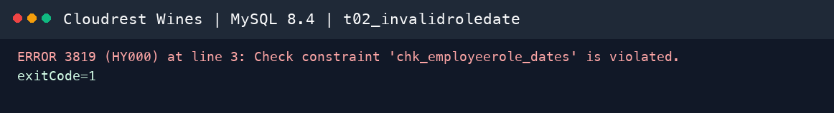
Figure — MySQL 8.4 response for Rule 1

Rule 2 — Bottle reorder explanation
Plain-English rule. When a bottle type is flagged not to be reordered, a non-blank explanation must be stored, particularly where quality or sourcing problems exist.
Mechanism. A CHECK requires either reorderFlag = TRUE or a non-empty reorderComment.
Violation evidence. Insert a bottle with reorderFlag = FALSE and a NULL comment. MySQL returns Error 3819 for chk_bottletype_reorder.
Readable SQL submitted for Turnitin
USE cloudrestwines;
INSERT INTO bottletype VALUES
('BOTL099',750,'Test','GLASS','Green',0,1.00,FALSE,NULL);
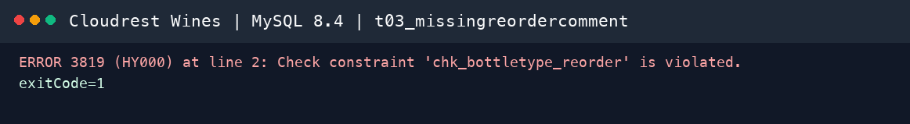
Figure — MySQL 8.4 response for Rule 2

Rule 3 — Individual customer legal age
Plain-English rule. The case requires an individual customer's date of birth to demonstrate legal age. Cloudrest Wines therefore rejects an individual younger than 18 at the time the row is inserted or updated.
Mechanism. trg_individualcustomer_legalage_insert and its update equivalent compare dateOfBirth with the date 18 years before CURRENT_DATE and raise SQLSTATE '45000' when invalid.
Violation evidence. Insert an individual customer whose birth date is only 17 years earlier. MySQL returns Error 1644 with the purpose-written legal-age message.
Readable SQL submitted for Turnitin
USE cloudrestwines;
INSERT INTO customer VALUES ('CUST099','INDIVIDUAL','underage@example.test',TRUE);
INSERT INTO individualcustomer VALUES
('CUST099','Test','Underage',DATE_SUB(CURRENT_DATE,INTERVAL 17 YEAR));
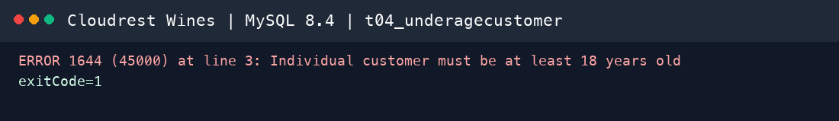
Figure — MySQL 8.4 response for Rule 3

Rule 4 — Physical shipment address
Plain-English rule. A customer order must be shipped to the customer's current physical address and never to a PO Box or private bag. It must also be paid before shipment.
Mechanism. trg_shipment_validate_insert reads the order, address and current customer-address association before allowing a shipment.
Violation evidence. Create a paid order and attempt shipment to ADDR0004, a current PO Box address. The trigger raises Error 1644 with a purpose-written message.
Readable SQL submitted for Turnitin
USE cloudrestwines;
INSERT INTO customerorder VALUES ('CORD0099','CUST001',CURRENT_DATE,TRUE,'PENDING');
INSERT INTO orderline VALUES ('CORD0099','PROD001',1,360.00);
INSERT INTO shipment VALUES ('SHIP0099','CORD0099','ADDR0004',CURRENT_DATE);
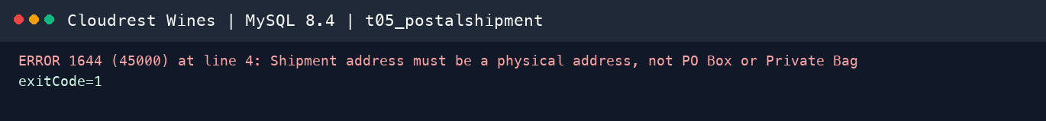
Figure — MySQL 8.4 response for Rule 4

Rule 5 — Grape juice conversion percentage
Plain-English rule. The case defines a grape variety's juice conversion ratio as a percentage. It must therefore be greater than zero and cannot exceed 100 percent.
Mechanism. CHECK (juiceConversionPercent > 0 AND juiceConversionPercent <= 100) on grapevariety.
Violation evidence. Insert a test grape variety with a conversion ratio of 120 percent. MySQL returns Error 3819 for chk_grapevariety_conversion.
The readable demonstration SQL is maintained in database/tests/task3b_ruleviolations.sql. Final MySQL Workbench screenshots should be inserted immediately after each rule in the Word report.
Readable SQL submitted for Turnitin
USE cloudrestwines;
-- Expected failure: the juice conversion ratio is a percentage and cannot exceed 100%.
INSERT INTO grapevariety VALUES
('GRAP099','Invalid Test Variety',120.00,'STAINLESSSTEEL',30);
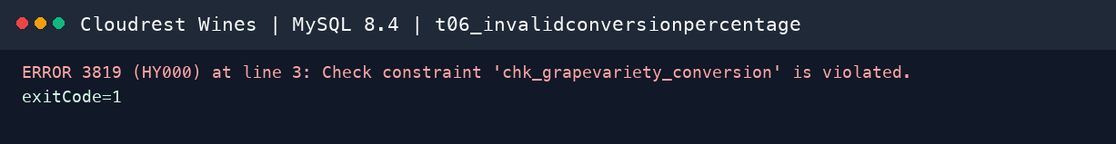
Figure — MySQL 8.4 response for Rule 5

Task 4 — ER Diagram with Annotated Alternatives
The editable MySQL Workbench model contains one complete diagram and six domain views. The full view demonstrates scope; the domain figures preserve readable attributes, keys and UML cardinalities. Assumptions are stated explicitly and do not contradict the case.
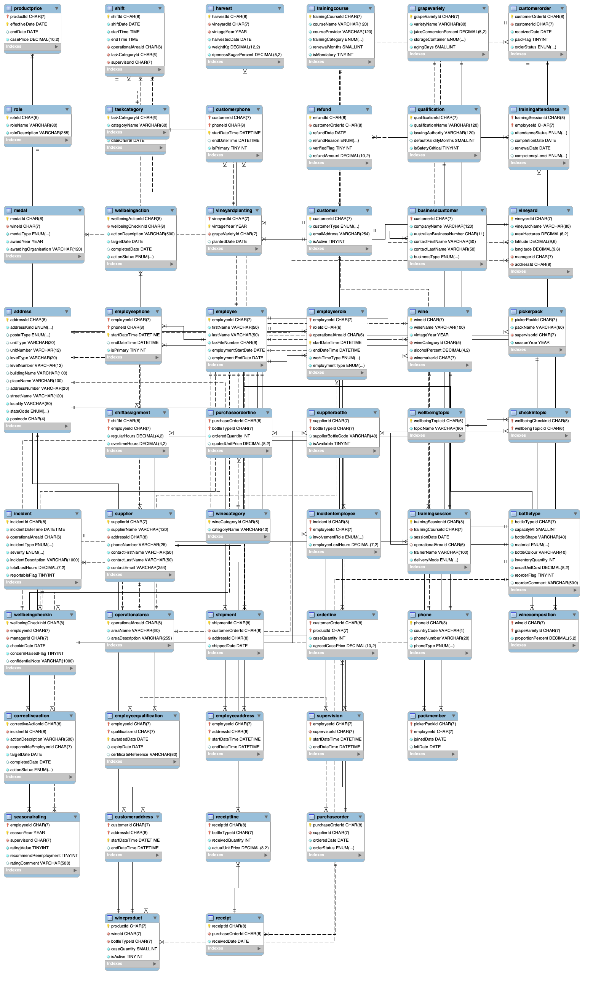
Figure — Complete Cloudrest Wines EER model generated in MySQL Workbench
Design element | Alternative | Reason selected
Customer types | One wide customer table | Supertype/subtypes reduce inapplicable NULLs while retaining a common order key.
Address history | Copied columns or polymorphic owner | Shared address with typed dated associations gives enforceable FKs and retained history.
Training structure | One repeated employee-training table | Course/session/attendance separates definition, delivery and outcome for 3NF and coverage queries.

Assumptions
Area | Assumption | Reason
Employee names | Names are split into first and last name for all employees | The case says employee name but does not prescribe structure; splitting supports contact and reporting use
Concurrent roles | The first implementation allows one active role period per employee | The case describes role changes but does not explicitly require concurrent roles; this can be relaxed if tutor confirms concurrent appointments
Supervisor history | An employee has no more than one supervisor at any instant | Explicit case requirement
Owners | Christine is represented as an employee/owner role so supervisor FKs remain enforceable | Supervisors report to Christine and the model needs an identifiable parent record
Picking pack | Minimum four members is checked at pack activation/finalisation, not on the first member insert | A row trigger would make it impossible to build a new pack incrementally
Vineyard manager | The manager is the current manager; a future extension could add dated vineyard-management history | Case states one manager and no employee manages more than one vineyard, but does not explicitly request this history
Wine recipe | Composition rows must total 100% before a wine is released | The case requires proportions; staged recipe entry means this is not enforced on each individual row insert
Product identity | Wine, bottle type and case quantity uniquely define a product | Directly follows the case definition of product
Shipment | Each customer order has at most one shipment and the shipment retains its physical address ID | The case prohibits back orders and requires a single shipment to the current physical address
HR incident rate | One incident is counted once per operational area regardless of people involved | Prevents multi-person incidents being double-counted in the sustainability numerator
Labour hours | `regularHours + overtimeHours` in shift assignments is the reportable labour-hours denominator | Required to calculate incidents per 1,000 labour hours
Wellbeing privacy | Detailed notes are restricted; decision-support queries expose only concern counts and actions | Applies data minimisation to sensitive HR information

Task 5 — Data Dictionary and Database Build
The complete data dictionary is generated directly from the validated MySQL schema to prevent divergence between the ER model, Word report and build. It is organised by table and records attribute name, type/size, domain/default, nullability, uniqueness, primary-key status, foreign-key reference and business purpose.
Naming compliance:
The generated dictionary is stored in docs/report/data-dictionary.md and will also appear in the Word report appendix. Attribute purposes are initially derived from schema/table context and are subject to a final human wording pass before submission.
Build verification: 53 base tables, 1 view, 274 columns, 69 foreign keys, 47 CHECK constraints, 11 triggers and 1 stored procedure under MySQL 8.4.11. The portable script rebuilds from an empty database without error.

Task 6 — Data Quality Strategy and Validation

6a. Cleaning and migration plan
Cloudrest Wines will use a controlled raw-to-staging-to-production pipeline. The supplied A2 workbook will first be copied unchanged and its file hash, sheet names, row counts and import date recorded. Each worksheet will be imported into a staging table using permissive text columns, ensuring malformed values are not silently lost during import. Profiling queries will identify completeness, uniqueness, consistency, validity and referential-integrity defects before any production insert.
Detection will include duplicate identifiers; blank mandatory fields; invalid dates and chronological order; inconsistent employment/status values; malformed TFNs, ABNs, postcodes, emails and phones; negative hours/weights/costs; percentages outside 0–100; multiple current history rows; and references to missing parents. Deterministic corrections—trimming, case standardisation, controlled value mapping and date conversion—will be performed with logged SQL. Ambiguous identity, address or missing-parent corrections will be quarantined for documented manual review rather than guessed.
After correction, rows will be inserted in dependency order. Quality control will reconcile source, accepted and rejected counts; query orphan checks; review exception tables; and run the full integrity suite. Before/after screenshots will show the defect query, correction SQL and verified result for every supplied table. Prevention measures include structured input controls, reference tables/enums, PK/UK/FK/CHECK constraints, triggers, least-privilege import roles and regular exception reporting.
Current limitation. The official A2 workbook has not been supplied. Therefore no claim is made that actual source errors have been found or corrected. The repository provides a reproducible framework and explicit evidence placeholders; actual errors, scripts and screenshots must be completed after receipt of the workbook.

6b. Test-data creation
Synthetic data was designed backwards from the five rules and six management questions. It includes permanent, casual and seasonal employees; several operational areas; completed, failed and absent training; 25/80/150-day qualification horizons; normal and overtime shifts; low, moderate and high incidents; open, overdue and completed corrective actions; wellbeing concerns; base winery production; procurement; and a paid customer shipment. All names, TFNs, ABNs, emails and operational events are fictitious.
AI assisted with scenario coverage and value generation. Suitability was then verified by successful FK-constrained import, domain checks, manual result reconciliation and non-empty query outputs. Boundary/negative data is executed separately so deliberately invalid rows never remain in the baseline database.

6c. Integrity suite
The SQL and genuine MySQL output are maintained under database/tests/ and docs/evidence/test-output/.
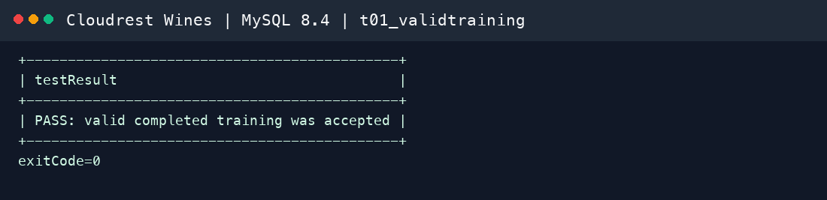
Figure — Positive integrity test accepted and rolled back

Task 7 — Decision-Support SQL Queries

Query 1 — Annual safety and sustainability training coverage
Decision. Direct training resources to operational areas below target. The query counts active workers and employees who completed both categories during the current year. Current test results show Vineyard at 50%, while Cellar and Administration are 0%; management should schedule the missing sustainability/safety sessions rather than treating attendance at either category as full coverage.
Features. Six tables/CTEs, left join, annual date logic, distinct-category validation, safe percentage calculation.
Query 1 SQL
USE cloudrestwines;
-- Management question: Which operational areas have gaps in annual mandatory safety/sustainability training?
WITH activeworkforce AS (
SELECT er.employeeId, er.operationalAreaId
FROM employeerole er
WHERE er.startDateTime <= NOW() AND (er.endDateTime IS NULL OR er.endDateTime > NOW())
), completion AS (
SELECT ta.employeeId, ts.operationalAreaId
FROM trainingattendance ta
JOIN trainingsession ts ON ts.trainingSessionId = ta.trainingSessionId
JOIN trainingcourse tc ON tc.trainingCourseId = ts.trainingCourseId
WHERE ta.attendanceStatus = 'COMPLETED'
AND tc.trainingCategory IN ('SAFETY','SUSTAINABILITY')
AND ts.sessionDate >= MAKEDATE(YEAR(CURRENT_DATE), 1)
GROUP BY ta.employeeId, ts.operationalAreaId
HAVING COUNT(DISTINCT tc.trainingCategory) = 2
)
SELECT oa.areaName,
COUNT(DISTINCT aw.employeeId) AS activeEmployees,
COUNT(DISTINCT c.employeeId) AS employeesTrained,
ROUND(100.0 * COUNT(DISTINCT c.employeeId) / NULLIF(COUNT(DISTINCT aw.employeeId),0), 1) AS coveragePercent
FROM activeworkforce aw
JOIN operationalarea oa ON oa.operationalAreaId = aw.operationalAreaId
LEFT JOIN completion c ON c.employeeId = aw.employeeId AND c.operationalAreaId = aw.operationalAreaId
GROUP BY oa.operationalAreaId, oa.areaName
ORDER BY coveragePercent, oa.areaName;
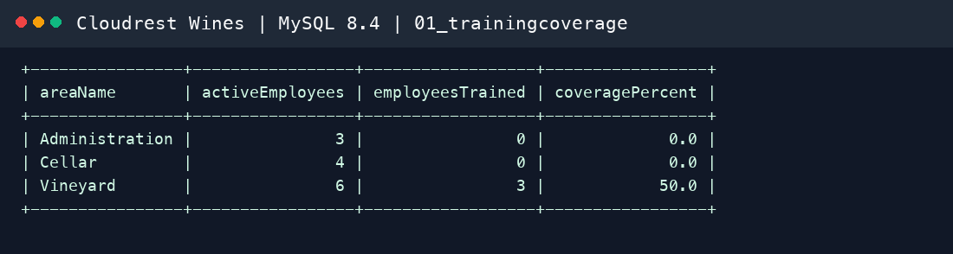
Figure — Query 1 genuine MySQL 8.4 output

Query 2 — Incidents per 1,000 labour hours
Decision. Prioritise intervention using an exposure-adjusted measure rather than raw event counts. In the current test baseline, Vineyard records 22.73 incidents per 1,000 hours and Cellar 18.52. Because the dataset is intentionally small, these are demonstration results and not real operational estimates.
Features. Rolling 12-month window, separate numerator/denominator CTEs, several joins, safe division, lost-hours context. This is sustainability query two.
Query 2 SQL
USE cloudrestwines;
-- Sustainability measure: incidents per 1,000 labour hours during the last 12 months.
WITH hoursbyarea AS (
SELECT s.operationalAreaId, SUM(sa.regularHours + sa.overtimeHours) AS labourHours
FROM shift s JOIN shiftassignment sa ON sa.shiftId = s.shiftId
WHERE s.shiftDate >= DATE_SUB(CURRENT_DATE, INTERVAL 12 MONTH)
GROUP BY s.operationalAreaId
), incidentsbyarea AS (
SELECT operationalAreaId, COUNT(*) AS incidentCount, SUM(totalLostHours) AS lostHours
FROM incident
WHERE incidentDateTime >= DATE_SUB(CURRENT_DATE, INTERVAL 12 MONTH)
GROUP BY operationalAreaId
)
SELECT oa.areaName, h.labourHours, COALESCE(i.incidentCount,0) AS incidentCount,
COALESCE(i.lostHours,0) AS lostHours,
ROUND(COALESCE(i.incidentCount,0) * 1000.0 / NULLIF(h.labourHours,0), 2) AS incidentsPer1000Hours
FROM hoursbyarea h
JOIN operationalarea oa ON oa.operationalAreaId = h.operationalAreaId
LEFT JOIN incidentsbyarea i ON i.operationalAreaId = h.operationalAreaId
ORDER BY incidentsPer1000Hours DESC;
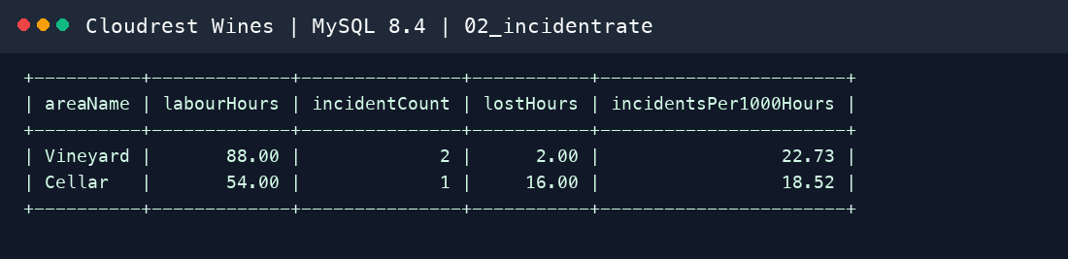
Figure — Query 2 genuine MySQL 8.4 output

Query 3 — Incidents before and after training
Decision. Assess whether annual safety training is associated with fewer employee incidents. The query uses each employee's first completed safety course and counts incidents in symmetric 180-day windows. Test employee EMP0008 changes from one incident before to zero after; the report must not claim causality from this small synthetic sample.
Features. Pre/post date arithmetic, conditional aggregation, employee/course/session/incident joins.
Query 3 SQL
USE cloudrestwines;
-- Compare employee incidents in the 180 days before and after completed annual safety training.
WITH completion AS (
SELECT ta.employeeId, MIN(ta.completionDate) AS completionDate
FROM trainingattendance ta
JOIN trainingsession ts ON ts.trainingSessionId = ta.trainingSessionId
JOIN trainingcourse tc ON tc.trainingCourseId = ts.trainingCourseId
WHERE ta.attendanceStatus = 'COMPLETED' AND tc.trainingCategory = 'SAFETY'
GROUP BY ta.employeeId
)
SELECT c.employeeId, CONCAT(e.firstName,' ',e.lastName) AS employeeName, c.completionDate,
SUM(CASE WHEN i.incidentDateTime >= DATE_SUB(c.completionDate, INTERVAL 180 DAY)
AND i.incidentDateTime < c.completionDate THEN 1 ELSE 0 END) AS incidentsBefore,
SUM(CASE WHEN i.incidentDateTime >= c.completionDate
AND i.incidentDateTime < DATE_ADD(c.completionDate, INTERVAL 180 DAY) THEN 1 ELSE 0 END) AS incidentsAfter
FROM completion c
JOIN employee e ON e.employeeId = c.employeeId
LEFT JOIN incidentemployee ie ON ie.employeeId = c.employeeId
LEFT JOIN incident i ON i.incidentId = ie.incidentId
GROUP BY c.employeeId, e.firstName, e.lastName, c.completionDate
ORDER BY incidentsBefore DESC, incidentsAfter DESC;
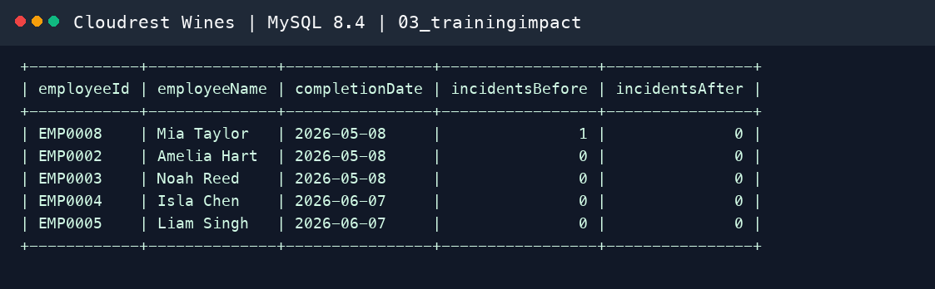
Figure — Query 3 genuine MySQL 8.4 output

Query 4 — Recent overtime and review indicators
Decision. Identify employees for supervisor workload/safety review without exposing confidential wellbeing notes. The test output flags EMP0009 and EMP0011 because each has seven overtime hours plus a recent incident and concern. Results are triage indicators, not medical or disciplinary conclusions.
Features. Last-30-days logic, three CTEs, left joins, privacy-aware output and rule-based action label.
Query 4 SQL
USE cloudrestwines;
-- Identify people for supervisor review without exposing confidential wellbeing notes.
WITH workload AS (
SELECT sa.employeeId, SUM(sa.regularHours) AS regularHours, SUM(sa.overtimeHours) AS overtimeHours
FROM shiftassignment sa JOIN shift s ON s.shiftId = sa.shiftId
WHERE s.shiftDate >= DATE_SUB(CURRENT_DATE, INTERVAL 30 DAY)
GROUP BY sa.employeeId
), recentincident AS (
SELECT ie.employeeId, COUNT(DISTINCT ie.incidentId) AS incidentCount
FROM incidentemployee ie JOIN incident i ON i.incidentId = ie.incidentId
WHERE i.incidentDateTime >= DATE_SUB(NOW(), INTERVAL 30 DAY)
GROUP BY ie.employeeId
), recentconcern AS (
SELECT employeeId, COUNT(*) AS concernCount
FROM wellbeingcheckin
WHERE checkinDate >= DATE_SUB(CURRENT_DATE, INTERVAL 30 DAY) AND concernRaisedFlag = TRUE
GROUP BY employeeId
)
SELECT w.employeeId, CONCAT(e.firstName,' ',e.lastName) AS employeeName,
w.regularHours, w.overtimeHours, COALESCE(ri.incidentCount,0) AS recentIncidents,
COALESCE(rc.concernCount,0) AS wellbeingConcernCount,
CASE WHEN w.overtimeHours >= 4 OR ri.incidentCount > 0 OR rc.concernCount > 0 THEN 'SUPERVISOR REVIEW' ELSE 'MONITOR' END AS recommendedAction
FROM workload w
JOIN employee e ON e.employeeId = w.employeeId
LEFT JOIN recentincident ri ON ri.employeeId = w.employeeId
LEFT JOIN recentconcern rc ON rc.employeeId = w.employeeId
ORDER BY (w.overtimeHours + COALESCE(ri.incidentCount,0) * 5 + COALESCE(rc.concernCount,0) * 5) DESC;
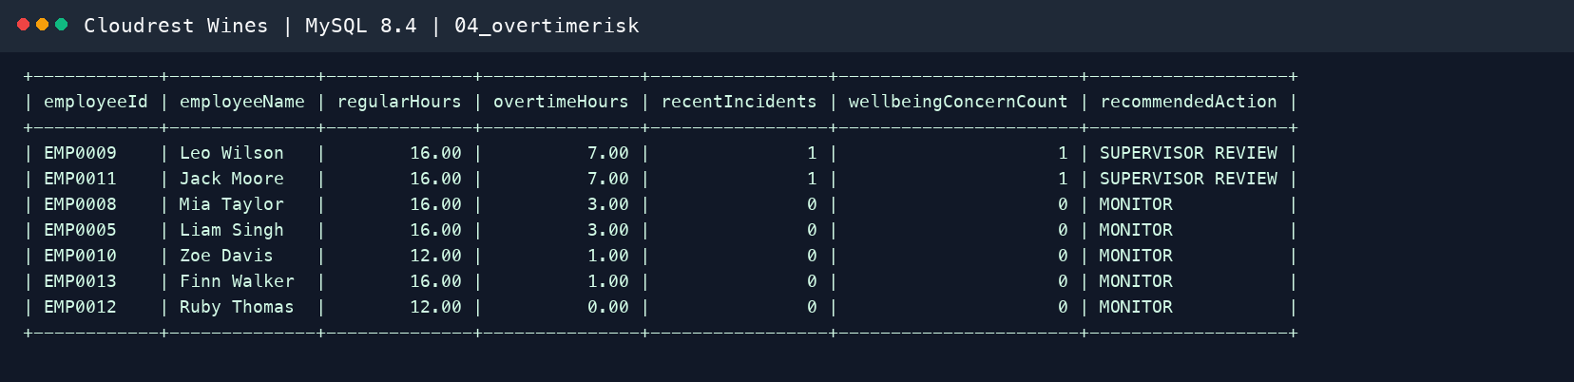
Figure — Query 4 genuine MySQL 8.4 output

Query 5 — Expiring qualifications procedure
Decision. Plan renewals using different horizons. CALL getExpiringQualifications(30) returns one first-aid certificate; CALL getExpiringQualifications(90) adds a chemical-handling permit. The parameter is constrained to 0–730 days to reject unreasonable input.
Features. Stored procedure with input parameter, two video calls, current-date interval logic, multiple joins.
Query 5 SQL
USE cloudrestwines;
-- Video demonstration must call both parameter values.
CALL getExpiringQualifications(30);
CALL getExpiringQualifications(90);
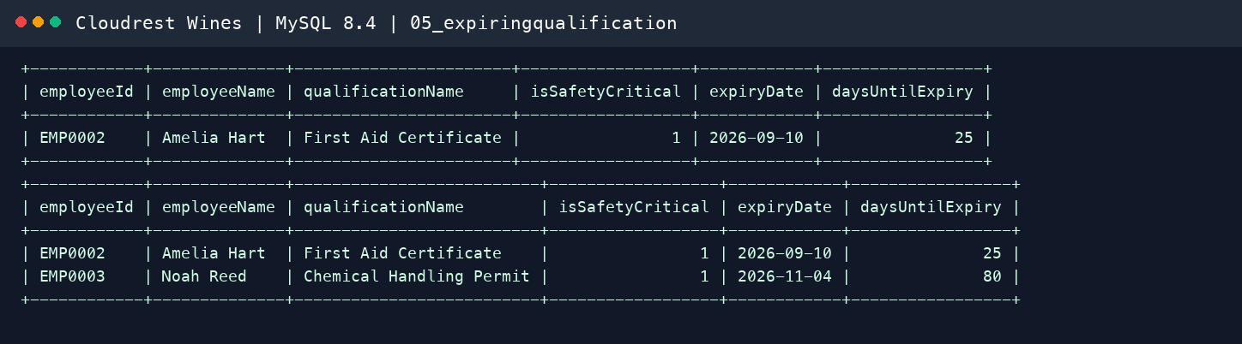
Figure — Query 5 genuine MySQL 8.4 output

Query 6 — Open corrective actions View and EXPLAIN
Decision. Prioritise overdue/high-severity corrective action. The View reports one action five days overdue and one future high-severity action. It excludes completed/cancelled actions and calculates days overdue consistently.
Features. View, multiple joins, current-date elapsed logic and EXPLAIN.
Execution-plan interpretation (under 100 words). MySQL uses idx_action_status_date with range access to filter open/in-progress actions, then resolves incident, operational-area and employee joins using eq_ref primary-key lookups (one matching row each). This indicates efficient join access. The final calculated ordering requires a temporary table and filesort because it combines daysOverdue, a Boolean expression and custom severity ordering. That is acceptable for the small action queue; if volume grows, a persisted priority or simpler indexed ordering should be evaluated without denormalising the authoritative incident data prematurely.
Query 6 SQL
USE cloudrestwines;
-- View-based management query: prioritise overdue and high-severity corrective actions.
SELECT correctiveActionId, incidentId, incidentDateTime, severity, areaName,
actionDescription, responsibleEmployee, targetDate, daysOverdue, actionStatus
FROM openincidentaction
ORDER BY (daysOverdue > 0) DESC,
FIELD(severity,'CRITICAL','HIGH','MODERATE','LOW'),
daysOverdue DESC, targetDate;
EXPLAIN
SELECT correctiveActionId, incidentId, incidentDateTime, severity, areaName,
actionDescription, responsibleEmployee, targetDate, daysOverdue, actionStatus
FROM openincidentaction
ORDER BY (daysOverdue > 0) DESC,
FIELD(severity,'CRITICAL','HIGH','MODERATE','LOW'),
daysOverdue DESC, targetDate;
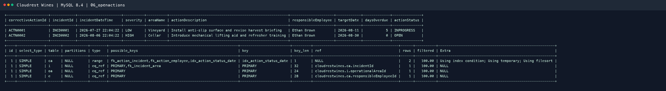
Figure — Query 6 genuine MySQL 8.4 output

Conclusion
Cloudrest Wines now has a reproducible 3NF MySQL OLTP design covering the complete base case and a connected HR/workforce sustainability extension. Database constraints preserve critical history and transactional integrity, while six tested queries convert operational records into training, exposure, workload, renewal and corrective-action decisions. Remaining work depends on course inputs or genuine student participation and is listed transparently rather than simulated.

References
BISM2207 teaching team. (2026a). Wine company case [Course case study]. The University of Queensland.
BISM2207 teaching team. (2026b). BISM2207 system development assessment specification [Course document]. The University of Queensland.
BISM2207 teaching team. (2026c). BISM2207 system development marking rubric [Course document]. The University of Queensland.
Oracle. (2026). MySQL 8.4 reference manual. https://dev.mysql.com/doc/refman/8.4/en/
Oracle. (2026). MySQL Workbench manual. https://dev.mysql.com/doc/workbench/en/

Appendix A — Workbench Domain EER Views
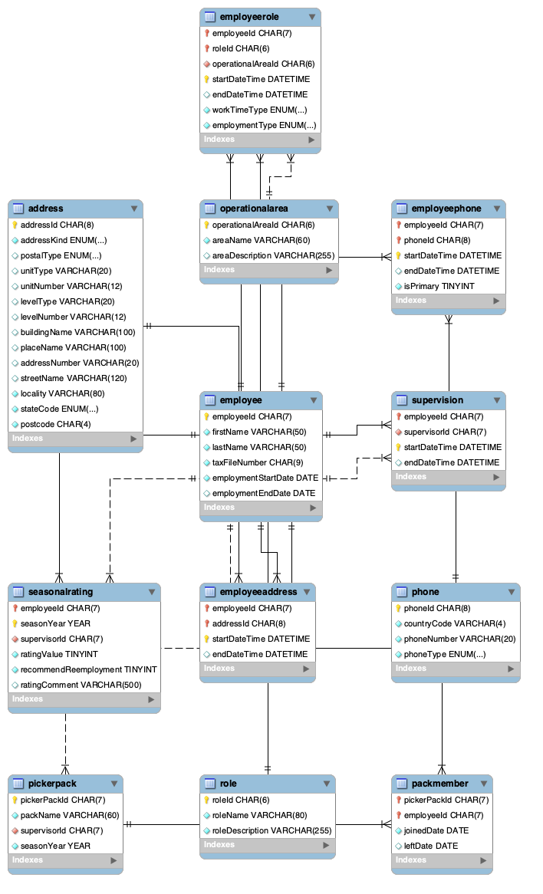
Personnel History
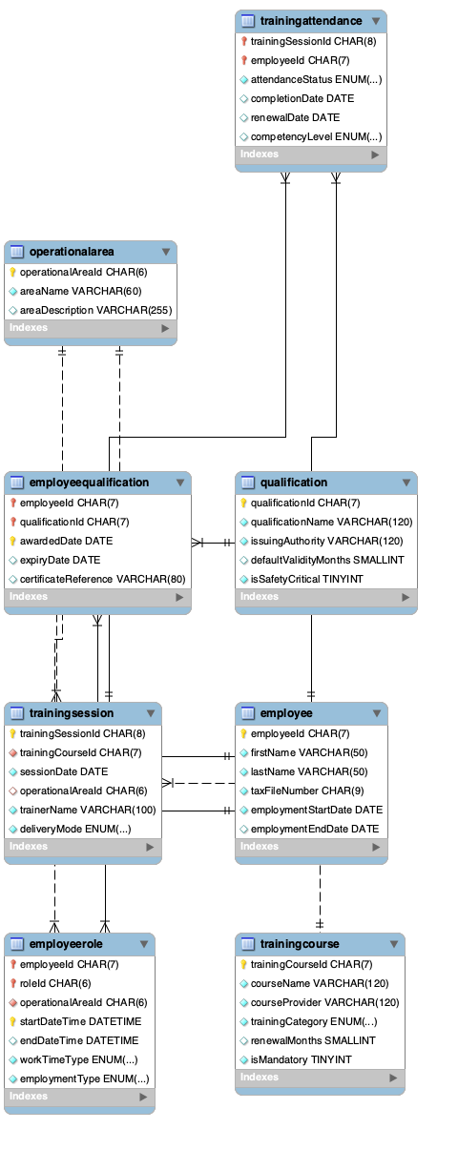
HR Training Qualifications
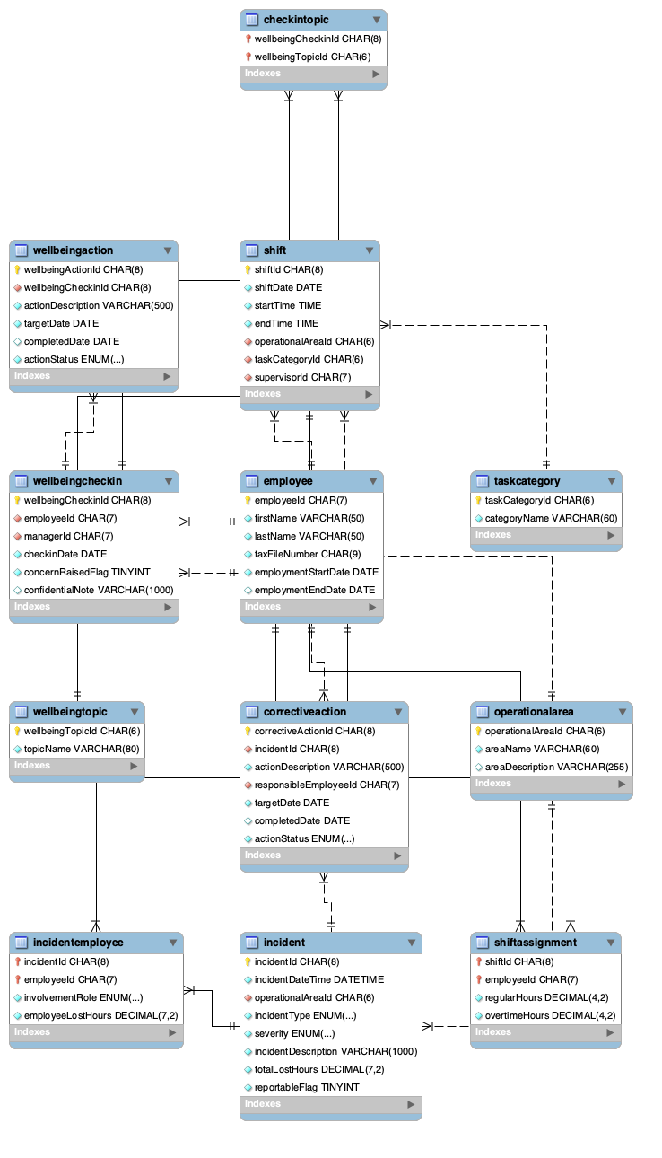
HR Shifts Safety Wellbeing
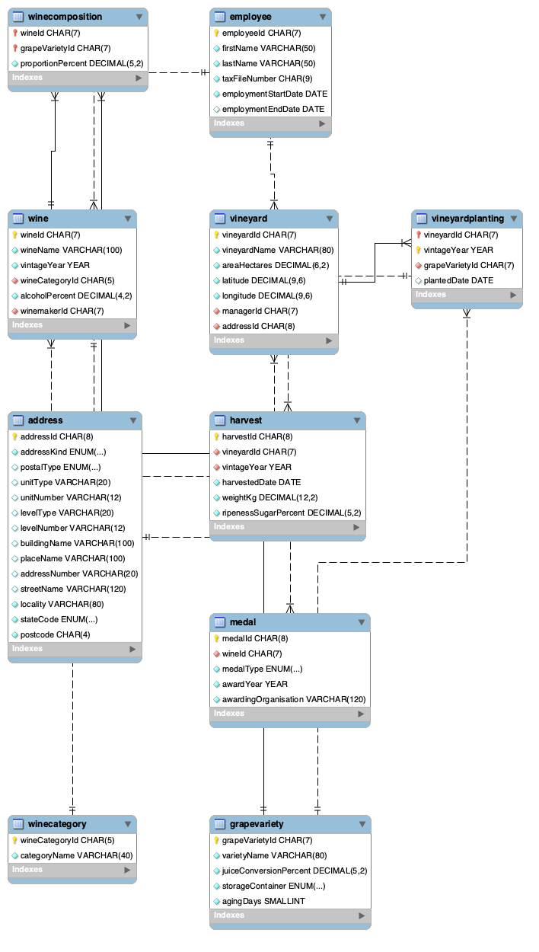
Vineyard Wine Production
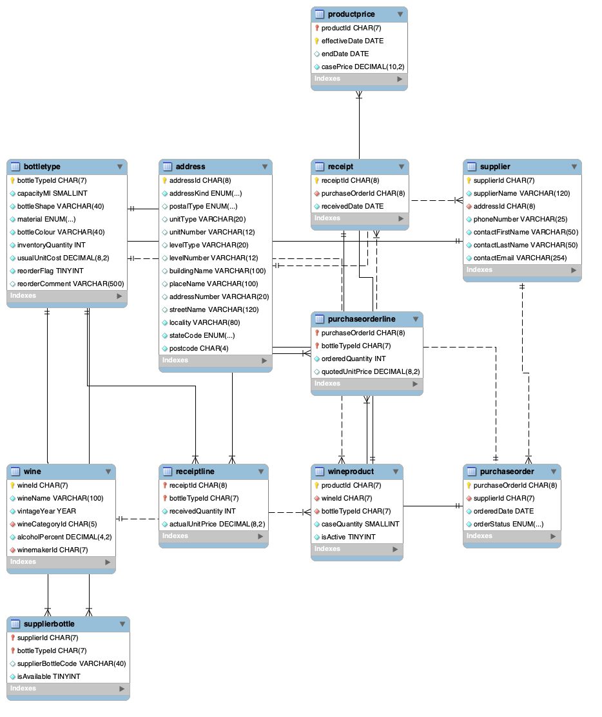
Products Procurement
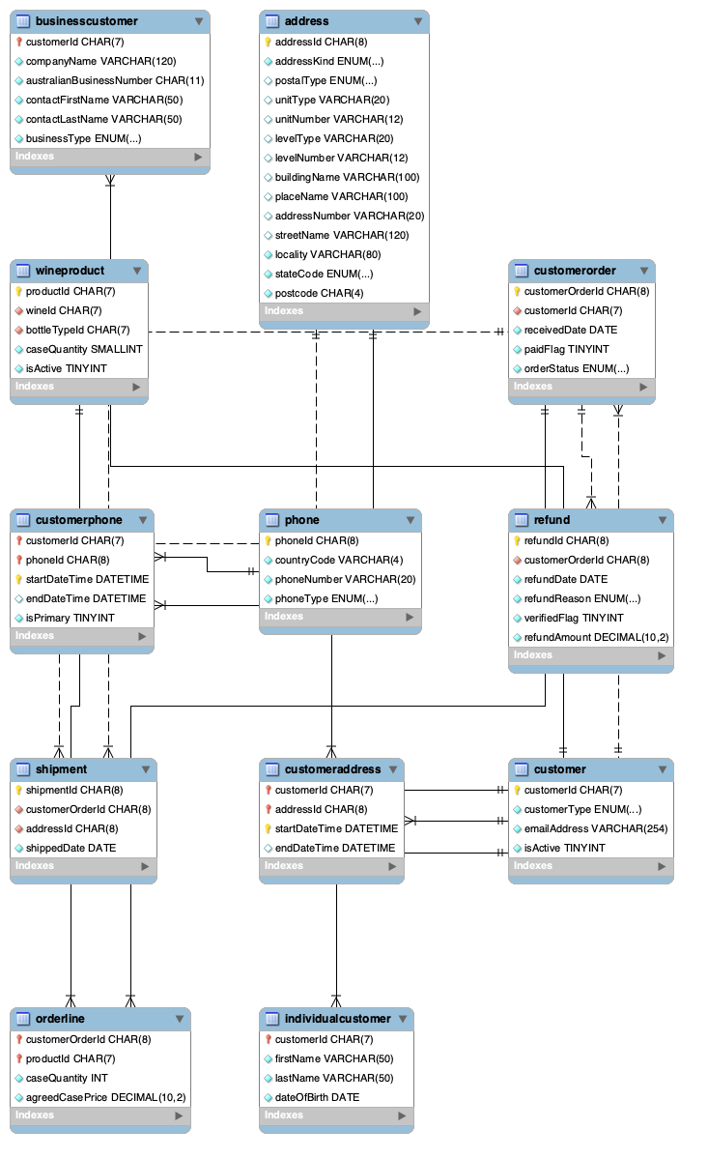
Customers Orders

Appendix B — Complete Data Dictionary
Generated evidence: This appendix is generated from information_schema after a clean build, preventing field/type/key drift. SQL CHECK and trigger definitions remain authoritative for complex domains.

address
Attribute | Type/size | Domain/default | Null | Unique | PK | FK reference | Definition / business purpose
addressId | char(8) | See schema constraints | NO | Y | Y | — | Stable identifier for a address record.
addressKind | enum('PHYSICAL','POSTAL') | enum('PHYSICAL','POSTAL') | NO | N | N | — | Business attribute `addressKind` for the `address` record.
postalType | enum('POBOX','PRIVATEBAG','OTHER') | enum('POBOX','PRIVATEBAG','OTHER') | YES | N | N | — | Business attribute `postalType` for the `address` record.
unitType | varchar(20) | See schema constraints | YES | N | N | — | Business attribute `unitType` for the `address` record.
unitNumber | varchar(12) | See schema constraints | YES | N | N | — | Business attribute `unitNumber` for the `address` record.
levelType | varchar(20) | See schema constraints | YES | N | N | — | Business attribute `levelType` for the `address` record.
levelNumber | varchar(12) | See schema constraints | YES | N | N | — | Business attribute `levelNumber` for the `address` record.
buildingName | varchar(100) | See schema constraints | YES | N | N | — | Human-readable name used for the address record.
placeName | varchar(100) | See schema constraints | YES | N | N | — | Human-readable name used for the address record.
addressNumber | varchar(20) | See schema constraints | YES | N | N | — | Business attribute `addressNumber` for the `address` record.
streetName | varchar(120) | See schema constraints | YES | N | N | — | Human-readable name used for the address record.
locality | varchar(80) | See schema constraints | NO | N | N | — | Business attribute `locality` for the `address` record.
stateCode | enum('ACT','NSW','NT','QLD','SA','TAS','VIC','WA') | enum('ACT','NSW','NT','QLD','SA','TAS','VIC','WA') | NO | N | N | — | Business attribute `stateCode` for the `address` record.
postcode | char(4) | See schema constraints | NO | N | N | — | Business attribute `postcode` for the `address` record.

bottletype
Attribute | Type/size | Domain/default | Null | Unique | PK | FK reference | Definition / business purpose
bottleTypeId | char(7) | See schema constraints | NO | Y | Y | — | Stable identifier for a bottletype record.
capacityMl | smallint unsigned | See schema constraints | NO | N | N | — | Business attribute `capacityMl` for the `bottletype` record.
bottleShape | varchar(40) | See schema constraints | NO | N | N | — | Business attribute `bottleShape` for the `bottletype` record.
material | enum('GLASS','PLASTIC') | enum('GLASS','PLASTIC') | NO | N | N | — | Business attribute `material` for the `bottletype` record.
bottleColour | varchar(40) | See schema constraints | NO | N | N | — | Business attribute `bottleColour` for the `bottletype` record.
inventoryQuantity | int unsigned | 0 | NO | N | N | — | Quantity recorded for the bottletype transaction or inventory fact.
usualUnitCost | decimal(8,2) | See schema constraints | NO | N | N | — | Monetary value recorded for the bottletype fact in Australian dollars.
reorderFlag | tinyint(1) | 1 | NO | N | N | — | Indicates whether this bottle type may be reordered.
reorderComment | varchar(500) | See schema constraints | YES | N | N | — | Required explanation when a bottle type will not be reordered.

businesscustomer
Attribute | Type/size | Domain/default | Null | Unique | PK | FK reference | Definition / business purpose
customerId | char(7) | See schema constraints | NO | Y | Y | customer.customerId | Identifies the related customer record.
companyName | varchar(120) | See schema constraints | NO | N | N | — | Human-readable name used for the businesscustomer record.
australianBusinessNumber | char(11) | See schema constraints | NO | Y | N | — | Eleven-digit ABN identifying an Australian business customer.
contactFirstName | varchar(50) | See schema constraints | NO | N | N | — | Human-readable name used for the businesscustomer record.
contactLastName | varchar(50) | See schema constraints | NO | N | N | — | Human-readable name used for the businesscustomer record.
businessType | enum('RESTAURANT','WINESHOP','EXPORTCOMPANY','OTHER') | enum('RESTAURANT','WINESHOP','EXPORTCOMPANY','OTHER') | NO | N | N | — | Business attribute `businessType` for the `businesscustomer` record.

checkintopic
Attribute | Type/size | Domain/default | Null | Unique | PK | FK reference | Definition / business purpose
wellbeingCheckinId | char(8) | See schema constraints | NO | Y | Y | wellbeingcheckin.wellbeingCheckinId | Identifies the related wellbeingcheckin record.
wellbeingTopicId | char(6) | See schema constraints | NO | Y | Y | wellbeingtopic.wellbeingTopicId | Identifies the related wellbeingtopic record.

correctiveaction
Attribute | Type/size | Domain/default | Null | Unique | PK | FK reference | Definition / business purpose
correctiveActionId | char(8) | See schema constraints | NO | Y | Y | — | Stable identifier for a correctiveaction record.
incidentId | char(8) | See schema constraints | NO | N | N | incident.incidentId | Identifies the related incident record.
actionDescription | varchar(500) | See schema constraints | NO | N | N | — | Business description of the correctiveaction record.
responsibleEmployeeId | char(7) | See schema constraints | NO | N | N | employee.employeeId | Identifies the related employee record.
targetDate | date | See schema constraints | NO | N | N | — | Date associated with the correctiveaction record or validity period.
completedDate | date | See schema constraints | YES | N | N | — | Date associated with the correctiveaction record or validity period.
actionStatus | enum('OPEN','INPROGRESS','COMPLETED','CANCELLED') | enum('OPEN','INPROGRESS','COMPLETED','CANCELLED') | NO | N | N | — | Business attribute `actionStatus` for the `correctiveaction` record.

customer
Attribute | Type/size | Domain/default | Null | Unique | PK | FK reference | Definition / business purpose
customerId | char(7) | See schema constraints | NO | Y | Y | — | Stable identifier for a customer record.
customerType | enum('INDIVIDUAL','BUSINESS') | enum('INDIVIDUAL','BUSINESS') | NO | N | N | — | Business attribute `customerType` for the `customer` record.
emailAddress | varchar(254) | See schema constraints | NO | Y | N | — | Business attribute `emailAddress` for the `customer` record.
isActive | tinyint(1) | 1 | NO | N | N | — | Boolean control/indicator for customer.isActive.

customeraddress
Attribute | Type/size | Domain/default | Null | Unique | PK | FK reference | Definition / business purpose
customerId | char(7) | See schema constraints | NO | Y | Y | customer.customerId | Identifies the related customer record.
addressId | char(8) | See schema constraints | NO | Y | Y | address.addressId | Identifies the related address record.
startDateTime | datetime | See schema constraints | NO | Y | Y | — | Date and time associated with the customeraddress event or validity period.
endDateTime | datetime | See schema constraints | YES | N | N | — | Date and time associated with the customeraddress event or validity period.

customerorder
Attribute | Type/size | Domain/default | Null | Unique | PK | FK reference | Definition / business purpose
customerOrderId | char(8) | See schema constraints | NO | Y | Y | — | Stable identifier for a customerorder record.
customerId | char(7) | See schema constraints | NO | N | N | customer.customerId | Identifies the related customer record.
receivedDate | date | See schema constraints | NO | N | N | — | Date associated with the customerorder record or validity period.
paidFlag | tinyint(1) | 0 | NO | N | N | — | Indicates accounting confirmation that shipment may proceed.
orderStatus | enum('PENDING','SHIPPED','CANCELLED') | enum('PENDING','SHIPPED','CANCELLED') | NO | N | N | — | Business attribute `orderStatus` for the `customerorder` record.

customerphone
Attribute | Type/size | Domain/default | Null | Unique | PK | FK reference | Definition / business purpose
customerId | char(7) | See schema constraints | NO | Y | Y | customer.customerId | Identifies the related customer record.
phoneId | char(8) | See schema constraints | NO | Y | Y | phone.phoneId | Identifies the related phone record.
startDateTime | datetime | See schema constraints | NO | Y | Y | — | Date and time associated with the customerphone event or validity period.
endDateTime | datetime | See schema constraints | YES | N | N | — | Date and time associated with the customerphone event or validity period.
isPrimary | tinyint(1) | 0 | NO | N | N | — | Boolean control/indicator for customerphone.isPrimary.

employee
Attribute | Type/size | Domain/default | Null | Unique | PK | FK reference | Definition / business purpose
employeeId | char(7) | See schema constraints | NO | Y | Y | — | Stable identifier for a employee record.
firstName | varchar(50) | See schema constraints | NO | N | N | — | Human-readable name used for the employee record.
lastName | varchar(50) | See schema constraints | NO | N | N | — | Human-readable name used for the employee record.
taxFileNumber | char(9) | See schema constraints | NO | Y | N | — | Australian tax file number; sensitive HR identifier.
employmentStartDate | date | See schema constraints | NO | N | N | — | Date associated with the employee record or validity period.
employmentEndDate | date | See schema constraints | YES | N | N | — | Date associated with the employee record or validity period.

employeeaddress
Attribute | Type/size | Domain/default | Null | Unique | PK | FK reference | Definition / business purpose
employeeId | char(7) | See schema constraints | NO | Y | Y | employee.employeeId | Identifies the related employee record.
addressId | char(8) | See schema constraints | NO | Y | Y | address.addressId | Identifies the related address record.
startDateTime | datetime | See schema constraints | NO | Y | Y | — | Date and time associated with the employeeaddress event or validity period.
endDateTime | datetime | See schema constraints | YES | N | N | — | Date and time associated with the employeeaddress event or validity period.

employeephone
Attribute | Type/size | Domain/default | Null | Unique | PK | FK reference | Definition / business purpose
employeeId | char(7) | See schema constraints | NO | Y | Y | employee.employeeId | Identifies the related employee record.
phoneId | char(8) | See schema constraints | NO | Y | Y | phone.phoneId | Identifies the related phone record.
startDateTime | datetime | See schema constraints | NO | Y | Y | — | Date and time associated with the employeephone event or validity period.
endDateTime | datetime | See schema constraints | YES | N | N | — | Date and time associated with the employeephone event or validity period.
isPrimary | tinyint(1) | 0 | NO | N | N | — | Boolean control/indicator for employeephone.isPrimary.

employeequalification
Attribute | Type/size | Domain/default | Null | Unique | PK | FK reference | Definition / business purpose
employeeId | char(7) | See schema constraints | NO | Y | Y | employee.employeeId | Identifies the related employee record.
qualificationId | char(7) | See schema constraints | NO | Y | Y | qualification.qualificationId | Identifies the related qualification record.
awardedDate | date | See schema constraints | NO | Y | Y | — | Date associated with the employeequalification record or validity period.
expiryDate | date | See schema constraints | YES | N | N | — | Date associated with the employeequalification record or validity period.
certificateReference | varchar(80) | See schema constraints | YES | Y | N | — | Business attribute `certificateReference` for the `employeequalification` record.

employeerole
Attribute | Type/size | Domain/default | Null | Unique | PK | FK reference | Definition / business purpose
employeeId | char(7) | See schema constraints | NO | Y | Y | employee.employeeId | Identifies the related employee record.
roleId | char(6) | See schema constraints | NO | Y | Y | role.roleId | Identifies the related role record.
operationalAreaId | char(6) | See schema constraints | NO | N | N | operationalarea.operationalAreaId | Identifies the related operationalarea record.
startDateTime | datetime | See schema constraints | NO | Y | Y | — | Date and time associated with the employeerole event or validity period.
endDateTime | datetime | See schema constraints | YES | N | N | — | Date and time associated with the employeerole event or validity period.
workTimeType | enum('FULLTIME','PARTTIME') | enum('FULLTIME','PARTTIME') | NO | N | N | — | Business attribute `workTimeType` for the `employeerole` record.
employmentType | enum('PERMANENT','CASUAL','SEASONAL') | enum('PERMANENT','CASUAL','SEASONAL') | NO | N | N | — | Business attribute `employmentType` for the `employeerole` record.

grapevariety
Attribute | Type/size | Domain/default | Null | Unique | PK | FK reference | Definition / business purpose
grapeVarietyId | char(7) | See schema constraints | NO | Y | Y | — | Stable identifier for a grapevariety record.
varietyName | varchar(80) | See schema constraints | NO | Y | N | — | Human-readable name used for the grapevariety record.
juiceConversionPercent | decimal(5,2) | See schema constraints | NO | N | N | — | Expected percentage of grape weight converted to juice.
storageContainer | enum('STAINLESSSTEEL','OAKBARREL','OTHER') | enum('STAINLESSSTEEL','OAKBARREL','OTHER') | NO | N | N | — | Business attribute `storageContainer` for the `grapevariety` record.
agingDays | smallint unsigned | See schema constraints | NO | N | N | — | Business attribute `agingDays` for the `grapevariety` record.

harvest
Attribute | Type/size | Domain/default | Null | Unique | PK | FK reference | Definition / business purpose
harvestId | char(8) | See schema constraints | NO | Y | Y | — | Stable identifier for a harvest record.
vineyardId | char(7) | See schema constraints | NO | N | N | vineyardplanting.vineyardId | Identifies the related vineyardplanting record.
vintageYear | year | See schema constraints | NO | N | N | vineyardplanting.vintageYear | Business attribute `vintageYear` for the `harvest` record.
harvestedDate | date | See schema constraints | NO | N | N | — | Date associated with the harvest record or validity period.
weightKg | decimal(12,2) | See schema constraints | NO | N | N | — | Business attribute `weightKg` for the `harvest` record.
ripenessSugarPercent | decimal(5,2) | See schema constraints | NO | N | N | — | Harvest ripeness expressed as percentage sugar.

incident
Attribute | Type/size | Domain/default | Null | Unique | PK | FK reference | Definition / business purpose
incidentId | char(8) | See schema constraints | NO | Y | Y | — | Stable identifier for a incident record.
incidentDateTime | datetime | See schema constraints | NO | N | N | — | Date and time associated with the incident event or validity period.
operationalAreaId | char(6) | See schema constraints | NO | N | N | operationalarea.operationalAreaId | Identifies the related operationalarea record.
incidentType | enum('INJURY','NEARMISS','ILLNESS','EQUIPMENT','ENVIRONMENTAL','OTHER') | enum('INJURY','NEARMISS','ILLNESS','EQUIPMENT','ENVIRONMENTAL','OTHER') | NO | N | N | — | Business attribute `incidentType` for the `incident` record.
severity | enum('LOW','MODERATE','HIGH','CRITICAL') | enum('LOW','MODERATE','HIGH','CRITICAL') | NO | N | N | — | Business attribute `severity` for the `incident` record.
incidentDescription | varchar(1000) | See schema constraints | NO | N | N | — | Business description of the incident record.
totalLostHours | decimal(7,2) | 0.00 | NO | N | N | — | Total labour hours lost because of an incident.
reportableFlag | tinyint(1) | 0 | NO | N | N | — | Boolean control/indicator for incident.reportableFlag.

incidentemployee
Attribute | Type/size | Domain/default | Null | Unique | PK | FK reference | Definition / business purpose
incidentId | char(8) | See schema constraints | NO | Y | Y | incident.incidentId | Identifies the related incident record.
employeeId | char(7) | See schema constraints | NO | Y | Y | employee.employeeId | Identifies the related employee record.
involvementRole | enum('AFFECTED','WITNESS','REPORTER') | enum('AFFECTED','WITNESS','REPORTER') | NO | N | N | — | Business attribute `involvementRole` for the `incidentemployee` record.
employeeLostHours | decimal(7,2) | 0.00 | NO | N | N | — | Business attribute `employeeLostHours` for the `incidentemployee` record.

individualcustomer
Attribute | Type/size | Domain/default | Null | Unique | PK | FK reference | Definition / business purpose
customerId | char(7) | See schema constraints | NO | Y | Y | customer.customerId | Identifies the related customer record.
firstName | varchar(50) | See schema constraints | NO | N | N | — | Human-readable name used for the individualcustomer record.
lastName | varchar(50) | See schema constraints | NO | N | N | — | Human-readable name used for the individualcustomer record.
dateOfBirth | date | See schema constraints | NO | N | N | — | Birth date retained to demonstrate an individual customer's legal age.

medal
Attribute | Type/size | Domain/default | Null | Unique | PK | FK reference | Definition / business purpose
medalId | char(8) | See schema constraints | NO | Y | Y | — | Stable identifier for a medal record.
wineId | char(7) | See schema constraints | NO | Y | N | wine.wineId | Identifies the related wine record.
medalType | enum('BRONZE','SILVER','GOLD','TROPHY') | enum('BRONZE','SILVER','GOLD','TROPHY') | NO | Y | N | — | Business attribute `medalType` for the `medal` record.
awardYear | year | See schema constraints | NO | Y | N | — | Business attribute `awardYear` for the `medal` record.
awardingOrganisation | varchar(120) | See schema constraints | NO | Y | N | — | Business attribute `awardingOrganisation` for the `medal` record.

openincidentaction
Attribute | Type/size | Domain/default | Null | Unique | PK | FK reference | Definition / business purpose
correctiveActionId | char(8) | See schema constraints | NO | N | N | — | Stable identifier for a openincidentaction record.
incidentId | char(8) | See schema constraints | NO | N | N | — | Stable identifier for a openincidentaction record.
incidentDateTime | datetime | See schema constraints | NO | N | N | — | Date and time associated with the openincidentaction event or validity period.
severity | enum('LOW','MODERATE','HIGH','CRITICAL') | enum('LOW','MODERATE','HIGH','CRITICAL') | NO | N | N | — | Business attribute `severity` for the `openincidentaction` record.
areaName | varchar(60) | See schema constraints | NO | N | N | — | Human-readable name used for the openincidentaction record.
actionDescription | varchar(500) | See schema constraints | NO | N | N | — | Business description of the openincidentaction record.
targetDate | date | See schema constraints | NO | N | N | — | Date associated with the openincidentaction record or validity period.
actionStatus | enum('OPEN','INPROGRESS','COMPLETED','CANCELLED') | enum('OPEN','INPROGRESS','COMPLETED','CANCELLED') | NO | N | N | — | Business attribute `actionStatus` for the `openincidentaction` record.
responsibleEmployee | varchar(101) | See schema constraints | YES | N | N | — | Business attribute `responsibleEmployee` for the `openincidentaction` record.
daysOverdue | int | See schema constraints | YES | N | N | — | Business attribute `daysOverdue` for the `openincidentaction` record.

operationalarea
Attribute | Type/size | Domain/default | Null | Unique | PK | FK reference | Definition / business purpose
operationalAreaId | char(6) | See schema constraints | NO | Y | Y | — | Stable identifier for a operationalarea record.
areaName | varchar(60) | See schema constraints | NO | Y | N | — | Human-readable name used for the operationalarea record.
areaDescription | varchar(255) | See schema constraints | YES | N | N | — | Business description of the operationalarea record.

orderline
Attribute | Type/size | Domain/default | Null | Unique | PK | FK reference | Definition / business purpose
customerOrderId | char(8) | See schema constraints | NO | Y | Y | customerorder.customerOrderId | Identifies the related customerorder record.
productId | char(7) | See schema constraints | NO | Y | Y | wineproduct.productId | Identifies the related wineproduct record.
caseQuantity | int unsigned | See schema constraints | NO | N | N | — | Quantity recorded for the orderline transaction or inventory fact.
agreedCasePrice | decimal(10,2) | See schema constraints | NO | N | N | — | Monetary value recorded for the orderline fact in Australian dollars.

packmember
Attribute | Type/size | Domain/default | Null | Unique | PK | FK reference | Definition / business purpose
pickerPackId | char(7) | See schema constraints | NO | Y | Y | pickerpack.pickerPackId | Identifies the related pickerpack record.
employeeId | char(7) | See schema constraints | NO | Y | Y | employee.employeeId | Identifies the related employee record.
joinedDate | date | See schema constraints | NO | N | N | — | Date associated with the packmember record or validity period.
leftDate | date | See schema constraints | YES | N | N | — | Date associated with the packmember record or validity period.

phone
Attribute | Type/size | Domain/default | Null | Unique | PK | FK reference | Definition / business purpose
phoneId | char(8) | See schema constraints | NO | Y | Y | — | Stable identifier for a phone record.
countryCode | varchar(4) | +61 | NO | Y | N | — | Business attribute `countryCode` for the `phone` record.
phoneNumber | varchar(20) | See schema constraints | NO | Y | N | — | Business attribute `phoneNumber` for the `phone` record.
phoneType | enum('MOBILE','WORK','HOME','OTHER') | enum('MOBILE','WORK','HOME','OTHER') | NO | N | N | — | Business attribute `phoneType` for the `phone` record.

pickerpack
Attribute | Type/size | Domain/default | Null | Unique | PK | FK reference | Definition / business purpose
pickerPackId | char(7) | See schema constraints | NO | Y | Y | — | Stable identifier for a pickerpack record.
packName | varchar(60) | See schema constraints | NO | Y | N | — | Human-readable name used for the pickerpack record.
supervisorId | char(7) | See schema constraints | NO | N | N | employee.employeeId | Identifies the related employee record.
seasonYear | year | See schema constraints | NO | N | N | — | Business attribute `seasonYear` for the `pickerpack` record.

productprice
Attribute | Type/size | Domain/default | Null | Unique | PK | FK reference | Definition / business purpose
productId | char(7) | See schema constraints | NO | Y | Y | wineproduct.productId | Identifies the related wineproduct record.
effectiveDate | date | See schema constraints | NO | Y | Y | — | Date associated with the productprice record or validity period.
endDate | date | See schema constraints | YES | N | N | — | Date associated with the productprice record or validity period.
casePrice | decimal(10,2) | See schema constraints | NO | N | N | — | Monetary value recorded for the productprice fact in Australian dollars.

purchaseorder
Attribute | Type/size | Domain/default | Null | Unique | PK | FK reference | Definition / business purpose
purchaseOrderId | char(8) | See schema constraints | NO | Y | Y | — | Stable identifier for a purchaseorder record.
supplierId | char(7) | See schema constraints | NO | N | N | supplier.supplierId | Identifies the related supplier record.
orderedDate | date | See schema constraints | NO | N | N | — | Date associated with the purchaseorder record or validity period.
orderStatus | enum('PLACED','PARTRECEIVED','RECEIVED','CANCELLED') | enum('PLACED','PARTRECEIVED','RECEIVED','CANCELLED') | NO | N | N | — | Business attribute `orderStatus` for the `purchaseorder` record.

purchaseorderline
Attribute | Type/size | Domain/default | Null | Unique | PK | FK reference | Definition / business purpose
purchaseOrderId | char(8) | See schema constraints | NO | Y | Y | purchaseorder.purchaseOrderId | Identifies the related purchaseorder record.
bottleTypeId | char(7) | See schema constraints | NO | Y | Y | bottletype.bottleTypeId | Identifies the related bottletype record.
orderedQuantity | int unsigned | See schema constraints | NO | N | N | — | Quantity recorded for the purchaseorderline transaction or inventory fact.
quotedUnitPrice | decimal(8,2) | See schema constraints | YES | N | N | — | Monetary value recorded for the purchaseorderline fact in Australian dollars.

qualification
Attribute | Type/size | Domain/default | Null | Unique | PK | FK reference | Definition / business purpose
qualificationId | char(7) | See schema constraints | NO | Y | Y | — | Stable identifier for a qualification record.
qualificationName | varchar(120) | See schema constraints | NO | Y | N | — | Human-readable name used for the qualification record.
issuingAuthority | varchar(120) | See schema constraints | NO | N | N | — | Boolean control/indicator for qualification.issuingAuthority.
defaultValidityMonths | smallint unsigned | See schema constraints | YES | N | N | — | Business attribute `defaultValidityMonths` for the `qualification` record.
isSafetyCritical | tinyint(1) | 0 | NO | N | N | — | Boolean control/indicator for qualification.isSafetyCritical.

receipt
Attribute | Type/size | Domain/default | Null | Unique | PK | FK reference | Definition / business purpose
receiptId | char(8) | See schema constraints | NO | Y | Y | — | Stable identifier for a receipt record.
purchaseOrderId | char(8) | See schema constraints | NO | N | N | purchaseorder.purchaseOrderId | Identifies the related purchaseorder record.
receivedDate | date | See schema constraints | NO | N | N | — | Date associated with the receipt record or validity period.

receiptline
Attribute | Type/size | Domain/default | Null | Unique | PK | FK reference | Definition / business purpose
receiptId | char(8) | See schema constraints | NO | Y | Y | receipt.receiptId | Identifies the related receipt record.
bottleTypeId | char(7) | See schema constraints | NO | Y | Y | bottletype.bottleTypeId | Identifies the related bottletype record.
receivedQuantity | int unsigned | See schema constraints | NO | N | N | — | Quantity recorded for the receiptline transaction or inventory fact.
actualUnitPrice | decimal(8,2) | See schema constraints | NO | N | N | — | Monetary value recorded for the receiptline fact in Australian dollars.

refund
Attribute | Type/size | Domain/default | Null | Unique | PK | FK reference | Definition / business purpose
refundId | char(8) | See schema constraints | NO | Y | Y | — | Stable identifier for a refund record.
customerOrderId | char(8) | See schema constraints | NO | N | N | customerorder.customerOrderId | Identifies the related customerorder record.
refundDate | date | See schema constraints | NO | N | N | — | Date associated with the refund record or validity period.
refundReason | enum('SHORTSUPPLY','TRANSITDAMAGE') | enum('SHORTSUPPLY','TRANSITDAMAGE') | NO | N | N | — | Business attribute `refundReason` for the `refund` record.
verifiedFlag | tinyint(1) | See schema constraints | NO | N | N | — | Boolean control/indicator for refund.verifiedFlag.
refundAmount | decimal(10,2) | See schema constraints | NO | N | N | — | Monetary value recorded for the refund fact in Australian dollars.

role
Attribute | Type/size | Domain/default | Null | Unique | PK | FK reference | Definition / business purpose
roleId | char(6) | See schema constraints | NO | Y | Y | — | Stable identifier for a role record.
roleName | varchar(80) | See schema constraints | NO | Y | N | — | Human-readable name used for the role record.
roleDescription | varchar(255) | See schema constraints | NO | N | N | — | Business description of the role record.

seasonalrating
Attribute | Type/size | Domain/default | Null | Unique | PK | FK reference | Definition / business purpose
employeeId | char(7) | See schema constraints | NO | Y | Y | employee.employeeId | Identifies the related employee record.
seasonYear | year | See schema constraints | NO | Y | Y | — | Business attribute `seasonYear` for the `seasonalrating` record.
supervisorId | char(7) | See schema constraints | NO | N | N | employee.employeeId | Identifies the related employee record.
ratingValue | tinyint | See schema constraints | NO | N | N | — | Business attribute `ratingValue` for the `seasonalrating` record.
recommendReemployment | tinyint(1) | See schema constraints | NO | N | N | — | Business attribute `recommendReemployment` for the `seasonalrating` record.
ratingComment | varchar(500) | See schema constraints | YES | N | N | — | Business attribute `ratingComment` for the `seasonalrating` record.

shift
Attribute | Type/size | Domain/default | Null | Unique | PK | FK reference | Definition / business purpose
shiftId | char(8) | See schema constraints | NO | Y | Y | — | Stable identifier for a shift record.
shiftDate | date | See schema constraints | NO | N | N | — | Date associated with the shift record or validity period.
startTime | time | See schema constraints | NO | N | N | — | Business attribute `startTime` for the `shift` record.
endTime | time | See schema constraints | NO | N | N | — | Business attribute `endTime` for the `shift` record.
operationalAreaId | char(6) | See schema constraints | NO | N | N | operationalarea.operationalAreaId | Identifies the related operationalarea record.
taskCategoryId | char(6) | See schema constraints | NO | N | N | taskcategory.taskCategoryId | Identifies the related taskcategory record.
supervisorId | char(7) | See schema constraints | NO | N | N | employee.employeeId | Identifies the related employee record.

shiftassignment
Attribute | Type/size | Domain/default | Null | Unique | PK | FK reference | Definition / business purpose
shiftId | char(8) | See schema constraints | NO | Y | Y | shift.shiftId | Identifies the related shift record.
employeeId | char(7) | See schema constraints | NO | Y | Y | employee.employeeId | Identifies the related employee record.
regularHours | decimal(4,2) | See schema constraints | NO | N | N | — | Regular labour hours worked on the assigned shift.
overtimeHours | decimal(4,2) | 0.00 | NO | N | N | — | Overtime hours used in workload and safety analysis.

shipment
Attribute | Type/size | Domain/default | Null | Unique | PK | FK reference | Definition / business purpose
shipmentId | char(8) | See schema constraints | NO | Y | Y | — | Stable identifier for a shipment record.
customerOrderId | char(8) | See schema constraints | NO | Y | N | customerorder.customerOrderId | Identifies the related customerorder record.
addressId | char(8) | See schema constraints | NO | N | N | address.addressId | Identifies the related address record.
shippedDate | date | See schema constraints | NO | N | N | — | Date associated with the shipment record or validity period.

supervision
Attribute | Type/size | Domain/default | Null | Unique | PK | FK reference | Definition / business purpose
employeeId | char(7) | See schema constraints | NO | Y | Y | employee.employeeId | Identifies the related employee record.
supervisorId | char(7) | See schema constraints | NO | N | N | employee.employeeId | Identifies the related employee record.
startDateTime | datetime | See schema constraints | NO | Y | Y | — | Date and time associated with the supervision event or validity period.
endDateTime | datetime | See schema constraints | YES | N | N | — | Date and time associated with the supervision event or validity period.

supplier
Attribute | Type/size | Domain/default | Null | Unique | PK | FK reference | Definition / business purpose
supplierId | char(7) | See schema constraints | NO | Y | Y | — | Stable identifier for a supplier record.
supplierName | varchar(120) | See schema constraints | NO | Y | N | — | Human-readable name used for the supplier record.
addressId | char(8) | See schema constraints | NO | N | N | address.addressId | Identifies the related address record.
phoneNumber | varchar(25) | See schema constraints | NO | N | N | — | Business attribute `phoneNumber` for the `supplier` record.
contactFirstName | varchar(50) | See schema constraints | NO | N | N | — | Human-readable name used for the supplier record.
contactLastName | varchar(50) | See schema constraints | NO | N | N | — | Human-readable name used for the supplier record.
contactEmail | varchar(254) | See schema constraints | NO | N | N | — | Business attribute `contactEmail` for the `supplier` record.

supplierbottle
Attribute | Type/size | Domain/default | Null | Unique | PK | FK reference | Definition / business purpose
supplierId | char(7) | See schema constraints | NO | Y | Y | supplier.supplierId | Identifies the related supplier record.
bottleTypeId | char(7) | See schema constraints | NO | Y | Y | bottletype.bottleTypeId | Identifies the related bottletype record.
supplierBottleCode | varchar(40) | See schema constraints | YES | N | N | — | Business attribute `supplierBottleCode` for the `supplierbottle` record.
isAvailable | tinyint(1) | 1 | NO | N | N | — | Boolean control/indicator for supplierbottle.isAvailable.

taskcategory
Attribute | Type/size | Domain/default | Null | Unique | PK | FK reference | Definition / business purpose
taskCategoryId | char(6) | See schema constraints | NO | Y | Y | — | Stable identifier for a taskcategory record.
categoryName | varchar(60) | See schema constraints | NO | Y | N | — | Human-readable name used for the taskcategory record.

trainingattendance
Attribute | Type/size | Domain/default | Null | Unique | PK | FK reference | Definition / business purpose
trainingSessionId | char(8) | See schema constraints | NO | Y | Y | trainingsession.trainingSessionId | Identifies the related trainingsession record.
employeeId | char(7) | See schema constraints | NO | Y | Y | employee.employeeId | Identifies the related employee record.
attendanceStatus | enum('REGISTERED','COMPLETED','FAILED','ABSENT') | enum('REGISTERED','COMPLETED','FAILED','ABSENT') | NO | N | N | — | Business attribute `attendanceStatus` for the `trainingattendance` record.
completionDate | date | See schema constraints | YES | N | N | — | Date associated with the trainingattendance record or validity period.
renewalDate | date | See schema constraints | YES | N | N | — | Date associated with the trainingattendance record or validity period.
competencyLevel | enum('AWARENESS','COMPETENT','ADVANCED') | enum('AWARENESS','COMPETENT','ADVANCED') | YES | N | N | — | Business attribute `competencyLevel` for the `trainingattendance` record.

trainingcourse
Attribute | Type/size | Domain/default | Null | Unique | PK | FK reference | Definition / business purpose
trainingCourseId | char(7) | See schema constraints | NO | Y | Y | — | Stable identifier for a trainingcourse record.
courseName | varchar(120) | See schema constraints | NO | Y | N | — | Human-readable name used for the trainingcourse record.
courseProvider | varchar(120) | See schema constraints | NO | N | N | — | Business attribute `courseProvider` for the `trainingcourse` record.
trainingCategory | enum('SAFETY','SUSTAINABILITY','TECHNICAL','WELLBEING','OTHER') | enum('SAFETY','SUSTAINABILITY','TECHNICAL','WELLBEING','OTHER') | NO | N | N | — | Business attribute `trainingCategory` for the `trainingcourse` record.
renewalMonths | smallint unsigned | See schema constraints | YES | N | N | — | Business attribute `renewalMonths` for the `trainingcourse` record.
isMandatory | tinyint(1) | 0 | NO | N | N | — | Boolean control/indicator for trainingcourse.isMandatory.

trainingsession
Attribute | Type/size | Domain/default | Null | Unique | PK | FK reference | Definition / business purpose
trainingSessionId | char(8) | See schema constraints | NO | Y | Y | — | Stable identifier for a trainingsession record.
trainingCourseId | char(7) | See schema constraints | NO | N | N | trainingcourse.trainingCourseId | Identifies the related trainingcourse record.
sessionDate | date | See schema constraints | NO | N | N | — | Date associated with the trainingsession record or validity period.
operationalAreaId | char(6) | See schema constraints | YES | N | N | operationalarea.operationalAreaId | Identifies the related operationalarea record.
trainerName | varchar(100) | See schema constraints | NO | N | N | — | Human-readable name used for the trainingsession record.
deliveryMode | enum('INPERSON','ONLINE','BLENDED') | enum('INPERSON','ONLINE','BLENDED') | NO | N | N | — | Business attribute `deliveryMode` for the `trainingsession` record.

vineyard
Attribute | Type/size | Domain/default | Null | Unique | PK | FK reference | Definition / business purpose
vineyardId | char(7) | See schema constraints | NO | Y | Y | — | Stable identifier for a vineyard record.
vineyardName | varchar(80) | See schema constraints | NO | Y | N | — | Human-readable name used for the vineyard record.
areaHectares | decimal(6,2) | See schema constraints | NO | N | N | — | Business attribute `areaHectares` for the `vineyard` record.
latitude | decimal(9,6) | See schema constraints | NO | N | N | — | Business attribute `latitude` for the `vineyard` record.
longitude | decimal(9,6) | See schema constraints | NO | N | N | — | Business attribute `longitude` for the `vineyard` record.
managerId | char(7) | See schema constraints | NO | Y | N | employee.employeeId | Identifies the related employee record.
addressId | char(8) | See schema constraints | NO | Y | N | address.addressId | Identifies the related address record.

vineyardplanting
Attribute | Type/size | Domain/default | Null | Unique | PK | FK reference | Definition / business purpose
vineyardId | char(7) | See schema constraints | NO | Y | Y | vineyard.vineyardId | Identifies the related vineyard record.
vintageYear | year | See schema constraints | NO | Y | Y | — | Business attribute `vintageYear` for the `vineyardplanting` record.
grapeVarietyId | char(7) | See schema constraints | NO | N | N | grapevariety.grapeVarietyId | Identifies the related grapevariety record.
plantedDate | date | See schema constraints | YES | N | N | — | Date associated with the vineyardplanting record or validity period.

wellbeingaction
Attribute | Type/size | Domain/default | Null | Unique | PK | FK reference | Definition / business purpose
wellbeingActionId | char(8) | See schema constraints | NO | Y | Y | — | Stable identifier for a wellbeingaction record.
wellbeingCheckinId | char(8) | See schema constraints | NO | N | N | wellbeingcheckin.wellbeingCheckinId | Identifies the related wellbeingcheckin record.
actionDescription | varchar(500) | See schema constraints | NO | N | N | — | Business description of the wellbeingaction record.
targetDate | date | See schema constraints | NO | N | N | — | Date associated with the wellbeingaction record or validity period.
completedDate | date | See schema constraints | YES | N | N | — | Date associated with the wellbeingaction record or validity period.
actionStatus | enum('OPEN','INPROGRESS','COMPLETED','CANCELLED') | enum('OPEN','INPROGRESS','COMPLETED','CANCELLED') | NO | N | N | — | Business attribute `actionStatus` for the `wellbeingaction` record.

wellbeingcheckin
Attribute | Type/size | Domain/default | Null | Unique | PK | FK reference | Definition / business purpose
wellbeingCheckinId | char(8) | See schema constraints | NO | Y | Y | — | Stable identifier for a wellbeingcheckin record.
employeeId | char(7) | See schema constraints | NO | N | N | employee.employeeId | Identifies the related employee record.
managerId | char(7) | See schema constraints | NO | N | N | employee.employeeId | Identifies the related employee record.
checkinDate | date | See schema constraints | NO | N | N | — | Date associated with the wellbeingcheckin record or validity period.
concernRaisedFlag | tinyint(1) | See schema constraints | NO | N | N | — | Boolean control/indicator for wellbeingcheckin.concernRaisedFlag.
confidentialNote | varchar(1000) | See schema constraints | YES | N | N | — | Restricted wellbeing note; excluded from routine management reporting.

wellbeingtopic
Attribute | Type/size | Domain/default | Null | Unique | PK | FK reference | Definition / business purpose
wellbeingTopicId | char(6) | See schema constraints | NO | Y | Y | — | Stable identifier for a wellbeingtopic record.
topicName | varchar(80) | See schema constraints | NO | Y | N | — | Human-readable name used for the wellbeingtopic record.

wine
Attribute | Type/size | Domain/default | Null | Unique | PK | FK reference | Definition / business purpose
wineId | char(7) | See schema constraints | NO | Y | Y | — | Stable identifier for a wine record.
wineName | varchar(100) | See schema constraints | NO | Y | N | — | Human-readable name used for the wine record.
vintageYear | year | See schema constraints | NO | Y | N | — | Business attribute `vintageYear` for the `wine` record.
wineCategoryId | char(5) | See schema constraints | NO | N | N | winecategory.wineCategoryId | Identifies the related winecategory record.
alcoholPercent | decimal(4,2) | See schema constraints | NO | N | N | — | Business attribute `alcoholPercent` for the `wine` record.
winemakerId | char(7) | See schema constraints | NO | N | N | employee.employeeId | Identifies the related employee record.

winecategory
Attribute | Type/size | Domain/default | Null | Unique | PK | FK reference | Definition / business purpose
wineCategoryId | char(5) | See schema constraints | NO | Y | Y | — | Stable identifier for a winecategory record.
categoryName | varchar(40) | See schema constraints | NO | Y | N | — | Human-readable name used for the winecategory record.

winecomposition
Attribute | Type/size | Domain/default | Null | Unique | PK | FK reference | Definition / business purpose
wineId | char(7) | See schema constraints | NO | Y | Y | wine.wineId | Identifies the related wine record.
grapeVarietyId | char(7) | See schema constraints | NO | Y | Y | grapevariety.grapeVarietyId | Identifies the related grapevariety record.
proportionPercent | decimal(5,2) | See schema constraints | NO | N | N | — | Percentage contribution of a grape variety to a wine composition.

wineproduct
Attribute | Type/size | Domain/default | Null | Unique | PK | FK reference | Definition / business purpose
productId | char(7) | See schema constraints | NO | Y | Y | — | Stable identifier for a wineproduct record.
wineId | char(7) | See schema constraints | NO | Y | N | wine.wineId | Identifies the related wine record.
bottleTypeId | char(7) | See schema constraints | NO | Y | N | bottletype.bottleTypeId | Identifies the related bottletype record.
caseQuantity | smallint unsigned | See schema constraints | NO | Y | N | — | Quantity recorded for the wineproduct transaction or inventory fact.
isActive | tinyint(1) | 1 | NO | N | N | — | Boolean control/indicator for wineproduct.isActive.

Appendix C — Submission and Handoff Checklist
Item | Status
Portable database SQL | Completed and clean-build verified
Six query script | Completed and executed
Five Task 3b violation blocks | Completed and rejected as expected
Workbench model / EER views | Completed
Official workbook cleaning | Pending source workbook
Week 11 scenario | Pending tutor allocation
Final Workbench screenshots | Student capture required
Four-person video | Student recording required
RiPPlE prompt logs / peer review | Genuine student activity required
Placeholder member name and dates | Student must replace

