**Proposal for Additional Analysis**

**Group Name:**

BeyondAI

**Group Member:**

Chen Yiming ([e0622334@u.nus.edu](mailto:e0622334@u.nus.edu)) Matric No: A0226328E

LIU XINGYU ([e0506559@u.nus.edu](mailto:e0506559@u.nus.edu)) Matric No: A0116430W

YEAP CHUN LIK ([e0319167@u.nus.edu](mailto:e0319167@u.nus.edu)) Matric No: A0185876H

ZHANG GUYU ([e0506558@u.nus.edu](mailto:e0506558@u.nus.edu)) Matric No: A0116427J

Proposal 1

From the data we can identify the periods where consumption of natural gas is at its peak. Furthermore, we can identify the top 5 homes with the highest average hourly consumption (per day basis). We can then make predictions of the peak-hour consumption period, enabling gas companies to refine their strategy in supplying natural gas.

Proposal 2

A customised pricing strategy can be formulated

Based on the monthly consumption data for each home, a threshold can be determined to categorise a home into 4 categories:

1. Low consumption
2. Medium consumption
3. High consumption
4. Extremely high consumption

Based on the category, a customised pricing strategy can be formulated for the different categories. Moreover, we can differentiate the type of building (single family, apartment, townhouse) based on the monthly gas consumption data, which can help construction site select the proper pipeline based on the different consumption patterns of different types of buildings.

Proposal 3: Theft detection [1]

The theft of natural gas occurs when household makes unauthorised modification to the meter, which directly taps into the distribution cable or suppressing the meter value, thus avoiding payment of gas usage. To predict and prevent such tampering which amounts to theft, and the associated monetary lost, which can be significant, gas companies should monitor gas usage and identify suspicious pattern. We can track each household’s historical usage pattern (e.g. trend in consecutive months or monthly year-on-year) and make a comparison against a new billing month. A suspicious event is flagged when the usage drastically differs from our forecast. This proposal would involve collecting more data from the same households, which may not be readily accessible.

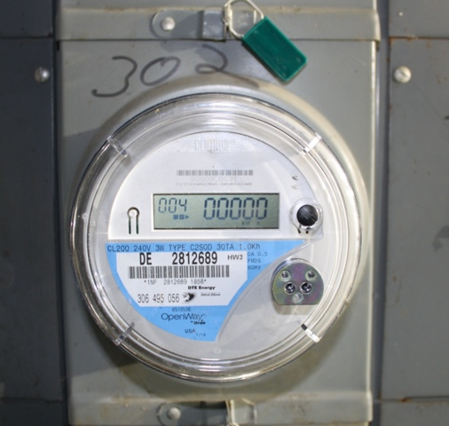

Figure 1: A model of Itron gas meter

Figure 2: the daily consumption trends for meter ID 5131 in Oct 2015 (blue) and Nov 2015 (red) are overlayed.

Figure 2 shows usage trends of a home for 2 consecutive months on a same-day period: Oct 2015 and Nov 2015, coloured in blue and red, respectively. The high consumption in Nov does not match the trend in Oct, which can be an indicator/flag for natural gas companies to conduct further scrutiny to ascertain if unauthorised tampering has occurred (such as physical inspection of the meter) or if the meter is malfunctioned.

[1] Duffy, R. (2014, July 15). People are going door-to-door offering to tamper with gas meters. Retrieved October 27, 2020, from https://uk.finance.yahoo.com/news/people-going-door-door-offering-tamper-gas-meters-101246749.html