Assignment 1.2

By issuing this command, I got the following entries:

C:\CSCIE57\homework\part1\Assignment1.2>java -jar ./target/Collections.jar edu.spring.xml.app.App

1. Autowiring by name application output
C:\CSCIE57\homework\part1\Assignment1.2\autowireByName>java -jar ./target/Collections.jar edu.spring.xml.app.App
2020-10-04 14:14:09,572 INFO [edu.spring.xml.app.Category] - <
==================Book Autowiring byName Output Start==================
Autowiring byName: Category{book=Book - {id=16, isbn='214745679', title='Whiteman Poetry', price=22.19} }
==================Book Autowiring byName Output End==================
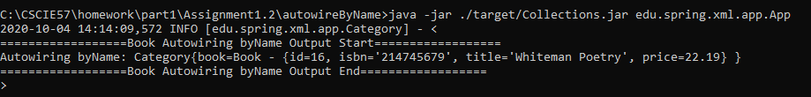

2. Autowiring by type application output
C:\CSCIE57\homework\part1\Assignment1.2\autowireByType>java -jar ./target/Collections.jar edu.spring.xml.app.App
2020-10-03 10:49:57,286 INFO [edu.spring.xml.app.Category] - <
==================Book Autowiring byType Output Start==================
Autowiring byType: Category{book=Book - {id=1, isbn='214745666', title='Pushkin Poetry', price=24.59} }
==================Book Autowiring byType Output End==================
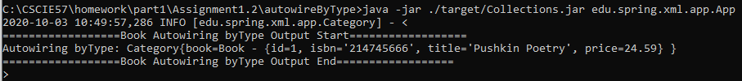

3. Autowiring by constructor output
C:\CSCIE57\homework\part1\Assignment1.2\autowireByConstructor>java -jar ./target/Collections.jar edu.spring.xml.app.App
2020-10-04 14:10:40,258 INFO [edu.spring.xml.app.Category] - <
==================Book Autowiring byConstructor Output Start==================
Autowiring byConstructor: Category{book=Book - {id=17, isbn='214745111', title='Shakespeare Poetry', price=42.29} }
==================Book Autowiring byConstructor Output End==================
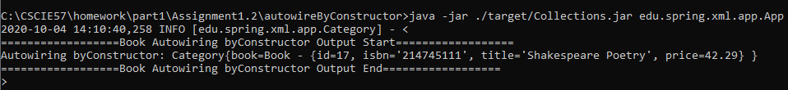

4. Autowiring by setter output
C:\CSCIE57\homework\part1\Assignment1.2\autowireBySetter>java -jar ./target/Collections.jar edu.spring.xml.app.App
2020-10-03 11:39:43,951 INFO [edu.spring.xml.app.Category] - <
==================Book Autowiring bySetter Output Start==================
Autowiring bySetter: Category{book=Book - {id=15, isbn='214745678', title='Frost Poetry', price=36.59} }
==================Book Autowiring bySetter Output End==================
