**Supplementary Appendix**

**Phase 2 Study of the Efficacy and Safety of Pembrolizumab for Relapsed/Refractory Classical Hodgkin Lymphoma**

**Moskowitz, et al**

Contents

**SUPPLEMENTARY METHODS** 2

[Description of Response Definitions according to Revised Response Criteria for   
Malignant Lymphoma1 2](#_Toc463883424)

Assessment of PD-L1 Expression Scores: Proportion Score and Histiocyte Score 3

Patient-Reported Outcomes 3

**SUPPLEMENTARY FIGURES AND TABLES** 5

**Table S1**. Study sites and Investigators for KEYNOTE-087…………………………………5

**Table S2.** Best Overall Response by Investigator Review. 9

[**Table S3.** Best Overall Response by Pooled Analysis for Patients Who Received <3   
Versus ≥3 Prior Lines of Therapy. 10](#_Toc463883430)

[**Table S4.** Best Overall Response by Pooled Analysis With Categories of: Refractory to   
First-Line Therapy (n = 74), Refractory to All Prior Lines of Therapy (n = 36), and Brentuximab Vedotin Naive (n = 35) Across Cohorts. 11](#_Toc463883431)

**Table S5.** Best Overall Response by Pooled Analysis for Relapse After ≥ 3 Prior Lines of Therapy (n=145) and Refractory to at Least One Prior Line of Therapy (n = 170) Across Cohorts. 12

**Table S6.** Change in EORTC QLQ-C30 Global Health Status/Quality of Life Score From Baseline to Week 12 Across Cohorts. 13

**Table S7.** Change From Baseline in EQ-5D Visual Analog Scale Score at Week 12 Across Cohorts. 14

**Table S8.**  Change From Baseline in EuroQol EQ-5D Utility Score (Using European Algorithm) at Week 12. 15

**Table S9.** Immune-Mediated Adverse Events and Infusion-Related Reactions in the Total Study Population (N = 210). 16

**Figure S1**. Response Characteristics in Patients in Cohort 1 (A), Cohort 2 (B), and Cohort 3 (C) 17

**REFERENCES** 20

# **SUPPLEMENTARY METHODS**

## **Description of Response Definitions according to Revised Response Criteria for Malignant Lymphoma1**

*CR: Complete remission.* Complete disappearance of all detectable clinical evidence of disease and disappearance of all disease-related symptoms if present before therapy. All lymph nodes must have regressed to normal size. The spleen, if considered to be enlarged before therapy, must have regressed in size and not be palpable on physical examination. If the bone marrow was involved by lymphoma before treatment, the bone marrow must show no evidence of disease by histology in a postbaseline biopsy. For fluorodeoxyglucose (FDG)-avid disease before therapy, mass of any size is permitted if the posttreatment scan is PET negative.

*PR: Partial response.* ≥50% decrease in sum of the product of the diameters (SPD) of 6 largest dominant nodes or nodal masses. No increase in size of nodes, liver, or spleen and no new sites of disease. Splenic and hepatic nodules must regress by ≥50% in the SPD. Bone marrow is irrelevant for determination of a PR, if the sample was positive before treatment. For FDG-avid disease before therapy, PET positivity at previously involved site is permitted.

*SD: Stable disease.* Neither meets the criteria for a response nor for progressive disease.

*Relapsed Disease (after CR)/PD: Progressive Disease (after PR, SD):* Appearance of any new lesion >1.5 cm in any axis, even if other lesions are decreasing in size. Increased FDG uptake in a previously unaffected site should only be considered relapsed or PD after confirmation with other modalities. ≥50% increase from nadir in the SPD of any previously involved nodes, or in a single involved node, or the size of other lesions (eg, splenic or hepatic nodules). To be considered PD, a lymph node with a diameter of the short axis <1.0 cm must increase by ≥50% and to a size of 1.5 × 1.5 cm or >1.5 cm in the long axis. ≥50% increase in the longest diameter of any single previously identified node >1 cm in its short axis. Lesions should be PET positive, if they were positive before therapy, unless the lesion is too small to be detected with current PET scan. Measurable extranodal disease should be assessed in a manner similar to that for nodal disease.

## **Assessment of PD-L1 Expression Scores: Proportion Score and Histiocyte Score**

An overall score for PD-L1 status of the tumor was based solely on proportion score. The proportion score was the ratio or percentage of tumor cells that demonstrated PD-L1 staining at any intensity (weak, moderate, or strong), and a proportion score of at least 1% was considered positive. An adequate sample had to contain at least 5 viable neoplastic cells overall or at least 2 viable, PD-L1–staining neoplastic cells. If neither of these conditions was met, the sample was reported as not evaluable. The histiocyte score was a semiquantitative assessment of histiocytes/macrophages that stained positive for PD-L1. The scoring rules were as follows: 0 = none; 1 = present, but less than 1% of total histiocytes; 2 = 1% to 10% of total histiocytes; 3 = greater than 10% of total histiocytes. Only tumor cells (Reed-Sternberg cells, their variants, and Hodgkin cells) were scored for PD-L1 positivity, and cells were considered to express PD-L1 only if membrane staining was recognized (partial membrane staining was sufficient). For samples with <25 tumor cells, the total number of tumor cells and the number showing membrane staining for PD-L1 were reported. For samples with ≥25 tumor cells, the estimated percentage of cells showing membrane staining for PD-L1 was reported.

## **Patient-Reported Outcomes**

The EORTC QLQ-C30 and EQ-5D questionnaires were used for the assessment of patient-reported outcomes (PROs). PROs were assessed every cycle for the first 5 cycles of treatment and every 12 weeks thereafter until progressive disease. PROs were also obtained at the treatment discontinuation visit and 30-day safety follow-up visit. PROs were administered by trained site personnel and completed electronically by patients. It was strongly recommended that all electronic PROs (ePROs) were administered before drug administration, adverse event evaluation, and disease status notification. The PROs were administered in the following order: EQ-5D followed by EORTC QLQ-C30. PRO data were summarized as part of the prespecified exploratory analysis. The treatment effect on PRO score change from baseline was evaluated at week 12 using constrained longitudinal data analysis. Patient-reported treatment effects were evaluated for all 3 cohorts combined at prespecified time points while on treatment and 30 days following treatment discontinuation as measured by change from baseline in the QLQ-C30 global health status/quality-of-life domain. In addition to the estimated mean effects, cumulative distribution and the number and proportion of patients who “improved,” “worsened,” or “remained stable” from baseline to a predefined visit were also estimated. For the EQ-5D, prespecified exploratory analyses were performed to describe the distribution of responses in the visual analog scale scores and utility scores.

# **SUPPLEMENTARY FIGURES AND TABLES**

**Table S1**. Study Sites and Investigators for KEYNOTE-087

|  |  |  |
| --- | --- | --- |
| **Site** | **Location** | **Principal Investigator** |
| Stanford Cancer Institute | Stanford, CA, USA | Ranjana Advani |
| Dana-Farber Cancer Center | Boston, MA, USA | Philippe Armand |
| The University of Texas MD Anderson Cancer Center | Houston, TX, USA | Michelle Fanale |
| The University of Chicago | Chicago, IL, USA | Justin Kline |
| Memorial Sloan Kettering Cancer Center | New York, NY, USA | Craig Moskowitz |
| University of Alabama–Birmingham | Birmingham, AL, USA | Amitkumar Mehta |
| City of Hope | Duarte, CA, USA | Robert Chen |
| Jewish General Hospital | Montreal, Canada | Nathalie Johnson |
| Hokkaido University Hospital | Sapporo, Japan | Takanori Teshima |
| Yamagata University Hospital | Yamagata, Japan | Kenichi Ishizawa |
| Keio University Hospital | Tokyo, Japan | Shinichiro Okamoto |
| Nagoya University Hospital | Nagoya, Japan | Akihiro Tomita /  Fumihiko Hayakawa |
| Kindai University Hospital | Osaka, Japan | Itaru Matsumura |
| Okayama University Hospital | Okayama City, Japan | Yoshinobu Maeda |
| Kyushu University Hospital | Fukuoka, Japan | Koji Kato |
| Austin Hospital | Melbourne, Australia | Andrew Grigg |
| Concord Repatriation & General Hospital | Concord, Australia | Robin Gasiorowski |
| Russian Oncological Research Center n.a. N.N.Blokhin of RAMS | Moscow, Russia | Dzhelil Osmanov |
| FGBU RosNIIGT FMBA of Russia | St. Petersburg, Russia | Sergey Voloshin |
| National Medical and Surgical Center n.a. N.I.Pirogov | Moscow, Russia | Vladimir Melnichenko |
| Sheba Medical Center | Ramat Gan, Israel | Arnon Nagler |
| Hadassah Ein Karem Jerusalem | Jerusalem, Israel | Dina Ben Yehuda |
| Sourasky Medical Center | Tel Aviv-Yafo, Israel | Nadav Sarid |
| Rambam Health Care Campus | Haifa, Israel | Eldad Dann |
| Christie Hospital NHS Trust | Manchester, UK | John Radford |
| Churchill Hospital | Headington, UK | Graham Collins |
| London University College Hospital | London, UK | Kirit Ardeshna |
| Akademiska sjukhuset | Uppsala, Sweden | Daniel Molin |
| Skanes universitetssjukhus | Lund, Sweden | Johan Linderoth |
| Hospital Universitario de Salamanca | Salamanca, Spain | Ramon Garcia Sanz |
| Hospital Universitario Insular de Gran Canaria | Gran Canaria, Spain | Delvys Rodriguez Abreu |
| Hospital Clinic i Provincial | Barcelona, Spain | Carmen Martinez Munoz |
| Instituto Catalan de Oncologia (ICO) - Hospital Duran i Reynals | Barcelona, Spain | Eva Domingo Domenech |
| Oslo Universitetssykehus HF | Oslo, Norway | Alexander Fossa |
| Struttura Complesa di Ematologia Istituto Nazionale dei Tumori | Milan, Italy | Paolo Corradini |
| Institute of Hematology "L. e A. Seràgnoli" University of Bologna | Bologna, Italy | Pier Luigi Zinzani |
| A.O.U. Citta della Salute e della Scienza di Torino | Turin, Italy | Umberto Vitolo |
| Debreceni Egyetem Klinikai Kozpont | Debrecen, Hungary | Arpad Illes |
| Semmelweis Egyetem | Budapest, Hungary | Judit Demeter |
| General Hospital of Thessaloniki "G. Papanikolaou" | Thessaloniki, Greece | Niki Stavroyianni |
| General Hospital of Athens - Laiko | Athens, Greece | Theodoros Vassilakopoulos |
| Klinikum der Universitaet zu Koeln | Cologne, Germany | Bastian von Tresckow |
| Medizinische Universitaetsklinik | Heidelberg, Germany | Julia Meissner |
| Institut Gustave Roussy | Villejuif, France | Vincent Ribrag |
| CHRU Lille - Hopital Claude Huriez | Lille, France | Franck Morschhauser |
| Centre Hospitalier Lyon Sud | Saint-Genis-Laval, France | Gilles Salles |
| Hopital Saint Louis | Paris, France | Pauline Brice |
| Northwest Cancer Specialists (Providence Med Center) | Portland, OR, USA | Robert Lufkin |
| Rocky Mountain Cancer Centers | Colorado Springs, CO, USA | Timothy Murphy |
| Texas Oncology | Austin, TX, USA | Jason Melear |
| New York Oncology Hematology P.C | Albany, NY, USA | Ira Zackon |

## **Table S2.** Best Overall Response by Investigator Review

|  |  |  |  |  |  |  |  |  |
| --- | --- | --- | --- | --- | --- | --- | --- | --- |
|  | **Cohort 1 After ASCT/BV  (n = 69)** | | **Cohort 2 Ineligible for ASCT and Failed BV Therapy  (n = 81)** | | **Cohort 3 No BV After ASCT  (n = 60)** | | **All Patients  (N = 210)** | |
| **n (%)** | **95% CI\*** | **n (%)** | **95% CI\*** | **n (%)** | **95% CI\*** | **n (%)** | **95% CI\*** |
| Overall response rate | 47 (68.1) | 55.8-78.8 | 54 (66.7) | 55.3-76.8 | 42 (70.0) | 56.8-81.2 | 143 (68.1) | 61.3–74.3 |
| Complete remission† | 22 (31.9) | 21.2-44.2 | 23 (28.4) | 18.9-39.5 | 18 (30.0) | 18.8-43.2 | 63 (30.0) | 23.9–36.7 |
| Partial remission | 25 (36.2) | 25.0-48.7 | 31 (38.3) | 27.7-49.7 | 24 (40.0) | 27.6-53.5 | 80 (38.1) | 31.5–45.0 |
| Stable disease | 13 (18.8) | 10.4-30.1 | 16 (19.8) | 11.7-30.1 | 11 (18.3) | 9.5-30.4 | 40 (19.0) | 14.0–25.0 |
| Progressive disease | 7 (10.1) | 4.2-19.8 | 9 (11.1) | 5.2-20.0 | 7 (11.7) | 4.8-22.6 | 23 (11.0) | 7.1–16.0 |
| Unable to determine | 2 (2.9) | 0.4-10.1 | 2 (2.5) | 0.3-8.6 | - | - | 4 (1.9) | 0.5–4.8 |

*Based on binomial exact confidence interval method.

†For complete remission, a residual mass was permitted for patients who were negative on PET scanning.

## **Table S3.** Best Overall Response by Pooled Analysis for Patients Who Received <3 Versus ≥3 Prior Lines of Therapy

|  |  |  |  |  |
| --- | --- | --- | --- | --- |
|  | **Number of Prior Lines of Therapy <3**  **(n = 28)** | | **Number of Prior Lines of Therapy ≥3**  **(n = 182)** | |
| **By Blinded Independent Central Review (BICR)** | **n (%)** | **95% CI\*** | **n (%)** | **95% CI\*** |
| Overall response rate | 20 (71.4) | 51.3-86.8 | 125 (68.7) | 61.4-75.3 |
| Complete remission | 8 (28.6) | 13.2-48.7 | 39 (21.4) | 15.7-28.1 |
| Partial remission | 12 (42.9) | 24.5-62.8 | 86 (47.3) | 39.8-54.8 |
| Stable disease | 5 (17.9) | 6.1-36.9 | 26 (14.3) | 9.5-20.2 |
| Progressive disease | 3 (10.7) | 2.3-28.2 | 27 (14.8) | 10.0-20.8 |
| Unable to determine | 0 (0.0) | 0.0-12.3 | 4 (2.2) | 0.6-5.5 |

*Based on binomial exact confidence interval method.

## **Table S4.** Best Overall Response by Pooled Analysis With Categories of: Refractory to First-Line Therapy (n = 73), Refractory to All Prior Lines of Therapy (n =23), and Brentuximab Vedotin Naive (n = 35) Across Cohorts

|  |  |  |  |  |  |  |
| --- | --- | --- | --- | --- | --- | --- |
|  | **Refractory to First-Line Therapy  (n = 73)** | | **Refractory to Any Therapy Received  (n = 23)** | | **Brentuximab Vedotin Naive  (n = 35)** | |
| **By Blinded Independent Central Review (BICR)** | **n (%)** | **95% CI\*** | **n (%)** | **95% CI\*** | **n (%)** | **95% CI\*** |
| Overall response rate | 58 (79.5) | 68.4-88.0 | 13 (56.5) | 34.5-76.8 | 25 (71.4) | 53.7-85.4 |
| Complete remission | 17 (23.3) | 14.2-34.6 | 5 (21.7) | 7.5-43.7 | 5 (14.3) | 4.8-30.3 |
| Partial remission | 41 (56.2) | 44.1-67.8 | 8 (34.8) | 16.4-57.3 | 20 (57.1) | 39.4-73.7 |
| Stable disease | 4 (5.5) | 1.5-13.4 | 6 (26.1) | 10.2-48.4 | 5 (14.3) | 4.8-30.3 |
| Progressive disease | 8 (11.0) | 4.9-20.5 | 4 (17.4) | 5.0-38.8 | 5 (14.3) | 4.8-30.3 |
| Unable to determine | 3 (4.1) | 0.9-11.5 | 0 | 0.0-14.8 | - | - |

*Based on binomial exact confidence interval method.

## **Table S5.** Best Overall Response by Pooled Analysis for Relapse After ≥ 3 Prior Lines of Therapy (n=146) and Refractory to at Least One Prior Line of Therapy (n = 170) Across Cohorts

|  |  |  |  |  |
| --- | --- | --- | --- | --- |
|  | **Relapse After ≥ 3 Prior Lines of Therapy  (n = 146)** | | **Refractory to At Least One Prior Line of Therapy Received (n = 170)** | |
| **By Blinded Independent Central Review (BICR)** | **n (%)** | **95% CI\*** | **n (%)** | **95% CI\*** |
| Overall response rate | 99 (67.8) | 59.6-75.3 | 121 (71.2) | 63.7-77.9 |
| Complete remission | 31 (21.2) | 14.9-28.8 | 36 (21.2) | 15.3-28.1 |
| Partial remission | 68 (46.6) | 38.3-55.0 | 85 (50.0) | 42.2-57.8 |
| Stable disease | 24 (16.4) | 10.8-23.5 | 23 (13.5) | 8.8-19.6 |
| Progressive disease | 20 (13.7) | 8.6-20.4 | 23 (13.5) | 8.8-19.6 |
| Unable to determine | 3 (2.1) | 0.4-5.9 | 3 (1.8) | 0.4-5.1 |

*Based on binomial exact confidence interval method.

## **Table S6.** Change in EORTC QLQ-C30 Global Health Status/Quality of Life Score From Baseline to Week 12 Across Cohorts

|  |  |  |  |  |  |  |
| --- | --- | --- | --- | --- | --- | --- |
|  | **Baseline** | | **Week 12** | | **Change From Baseline at Week 12** | |
| **n\*** | **Mean (SD)** | **n\*** | **Mean (SD)** | **n†** | **Mean (SE)** |
| All cohorts | 191 | 64.1 (21.4) | 199 | 72.4 (19.4) | 184 | 8.6 (1.6) |
| Responders (CR+PR) | 112 | 63.7 (20.4) | 121 | 74.0 (19.2) | 110 | 10.4 (2.1) |
| Patients with stable disease | 49 | 65.8 (23.0) | 50 | 73.3 (18.9) | 48 | 7.3 (3.2) |
| Patients with PD | 30 | 62.8 (22.6) | 28 | 64.0 (19.6) | 26 | 3.5 (3.6) |
| **Comparison** | **Difference in LS Means‡ (95% CI)** | | | | ***P* Value** | |
| Responder *v* nonresponder§ | 4.7 (-0.20-9.66) | | | | 0.0600 | |

Abbreviations: CI, confidence interval; CR, complete response; LS, mean least squares mean; PD, progressive disease; PR, partial response; PRO, patient-reported outcome; SD, standard deviation; SE, standard error.

*n = Number of patients in all-patients-as-treated population with each time point observation.

†n = Number of patients in all-patients-as-treated population with baseline and week 12 observations.

‡Based on constrained longitudinal data analysis model with the PRO score as the response variable, study visit and ECOG (0 *v* 1 or 2) as covariates.

§Response by investigator review at week 12; patients with PD include patients without week 12 assessments.

## **Table S7.** Change From Baseline in EQ-5D Visual Analog Scale Score at Week 12 Across Cohorts

|  |  |  |  |  |  |  |
| --- | --- | --- | --- | --- | --- | --- |
|  | **Baseline** | | **Week 12** | | **Change From Baseline at Week 12** | |
| **n\*** | **Mean (SD)** | **n\*** | **Mean (SD)** | **n†** | **Mean (SE)** |
| All cohorts | 201 | 70.3 (18.3) | 199 | 78.3 (16.9) | 191 | 8.4 (1.4) |
| Responders (CR+PR) | 119 | 68.9 (18.1) | 121 | 79.4 (16.9) | 116 | 10.9 (1.8) |
| Patients with stable disease | 49 | 72.5 (20.8) | 51 | 78.6 (16.7) | 49 | 5.4 (3.0) |
| Patients with PD | 33 | 71.8 (15.3) | 27 | 73.1 (16.9) | 26 | 2.6 (2.7) |
| **Comparison** | **Difference in LS Means‡   (95% CI)** | | | | ***P* Value** | |
| Responder *v* nonresponder§ | 4.3 (0.11, 8.59) | | | | 0.0443 | |

Abbreviations: CI, confidence interval; cLDA, constrained longitudinal data analysis; CR, complete response; LS, mean least squares mean; PD, progressive disease; PR, partial response; PRO, patient-reported outcome; SD, standard deviation; SE, standard error.

*n = Number of patients in all-patients-as-treated population with each time point observation.

†n = Number of patients in all-patients-as-treated population with baseline and week 12 observations.

‡Based on cLDA model with the PRO score as the response variable, study visit and ECOG (0 *v* 1 or 2) as covariates.

§Response by investigator review at week 12; patients with PD include patients without week 12 assessments.

## **Table S8.** Change From Baseline in EuroQol EQ-5D Utility Score (Using European Algorithm) at Week 12

|  |  |  |  |  |  |  |  |  |
| --- | --- | --- | --- | --- | --- | --- | --- | --- |
|  | | **Baseline** | | **Week 12** | | | **Change From Baseline at Week 12** | |
| **n\*** | **Mean (SD)** | **n\*** | **Mean (SD)** | | **n†** | **Mean (SE)** |
| All cohorts | | 201 | 0.74 (0.22) | 199 | 0.80 (0.21) | | 191 | 0.06 (0.02) |
| Patients who responded (CR+PR) | | 119 | 0.74 (0.22) | 121 | 0.83 (0.21) | | 116 | 0.09 (0.02) |
| Patients with stable disease | | 49 | 0.78 (0.18) | 51 | 0.81 (0.19) | | 49 | 0.03 (0.03) |
| Patients with PD | | 33 | 0.72 (0.24) | 27 | 0.69 (0.24) | | 26 | -0.02 (0.06) |
| **Comparison** | **Difference in LS Means‡   (95% CI)** | | | | | ***P* Value** | | |
| Responder vs nonresponder§ | 0.07 (0.018, 0.129) | | | | | 0.0094 | | |

Abbreviations: CI, confidence interval; cLDA, constrained longitudinal data analysis; CR, complete response; LS, mean least squares mean; PD, progressive disease; PR, partial response; PRO, patient-reported outcome; SD, standard deviation; SE, standard error.

*n = Number of patients in all-patients-as-treated population with each time point observation.

†n = Number of patients in all-patients-as-treated population with baseline and week 12 observations.

‡Based on cLDA model with the PRO score as the response variable, study visit and ECOG (0 *v* 1 or 2) as covariates.

§Response by investigator review at week 12; patients with PD include patients without week 12 assessment.

## **Table S9.** Immune-Mediated Adverse Events and Infusion-Related Reactions in the Total Study Population (N = 210)

|  |  |  |  |
| --- | --- | --- | --- |
| **Immune-Mediated Adverse Events* and Infusion-Related Reactions** | **n (%)** | | |
| **Grade 1 or 2** | **Grade 3** | **Grade 4** |
| Hypothyroidism | 28 (13.3) | 1 (0.5) | 0 |
| Infusion-related reaction | 10 (4.8) | 0 | 0 |
| Hyperthyroidism | 6 (2.9) | 0 | 0 |
| Pneumonitis | 6 (2.9) | 0 | 0 |
| Cytokine release syndrome | 5 (2.4) | 1 (0.5) | 0 |
| Hypersensitivity | 4 (1.9) | 0 | 0 |
| Colitis | 1 (0.5) | 1 (0.5) | 0 |
| Myositis | 1 (0.5) | 1 (0.5) | 0 |
| Iritis | 1 (0.5) | 0 | 0 |
| Drug hypersensitivity | 1 (0.5) | 0 | 0 |
| Enterocolitis | 1 (0.5) | 0 | 0 |
| Iridocyclitis | 1 (0.5) | 0 | 0 |
| Dermatitis psoriasiform | 0 | 1 (0.5) | 0 |

*Immune-mediated adverse events were defined as events with potentially drug-related immunologic causes, regardless of treatment attribution.

**Fig S1.** Response characteristics in patients in cohort 1 (A), cohort 2 (B) and cohort 3 (C).

**A**

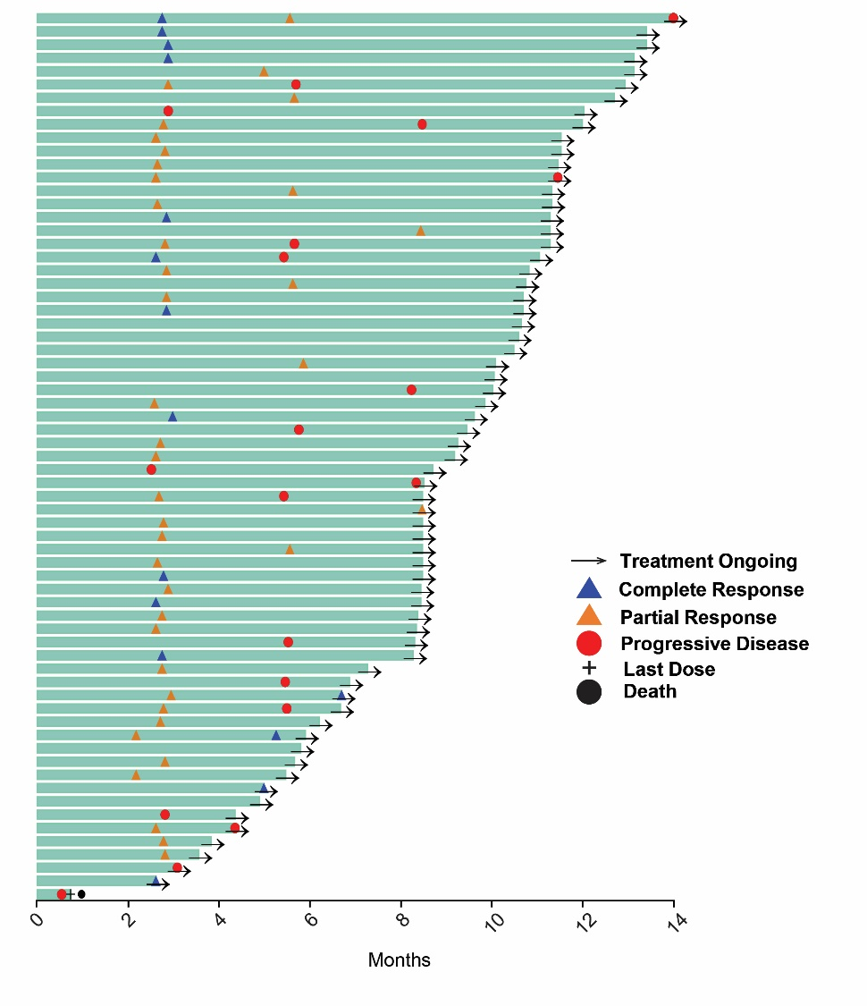

**B**

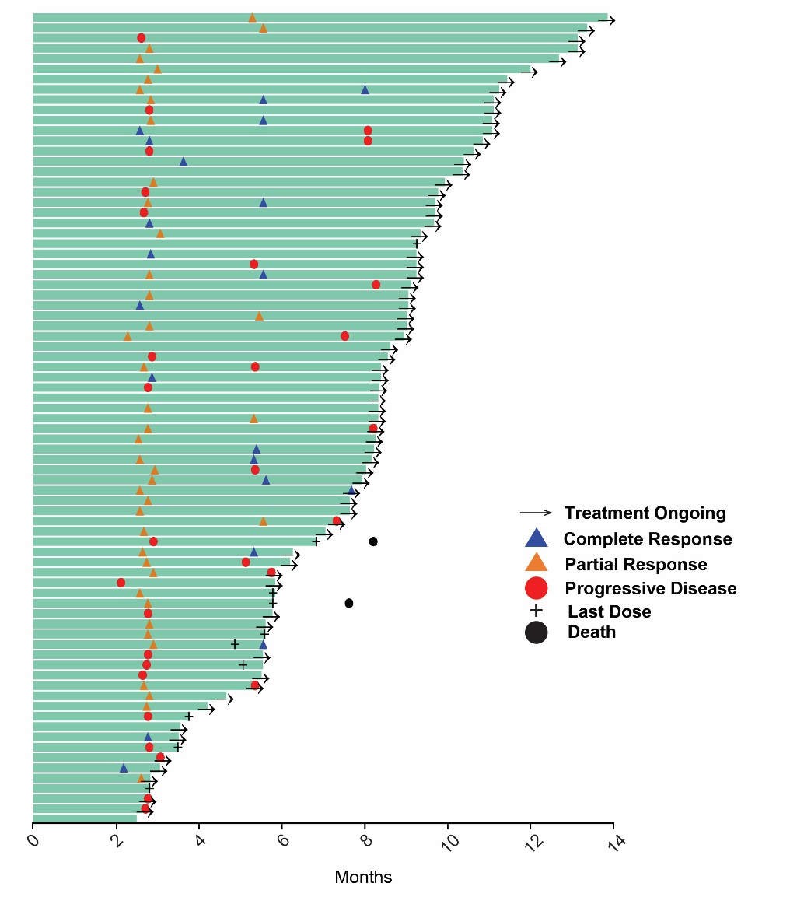

# **C**

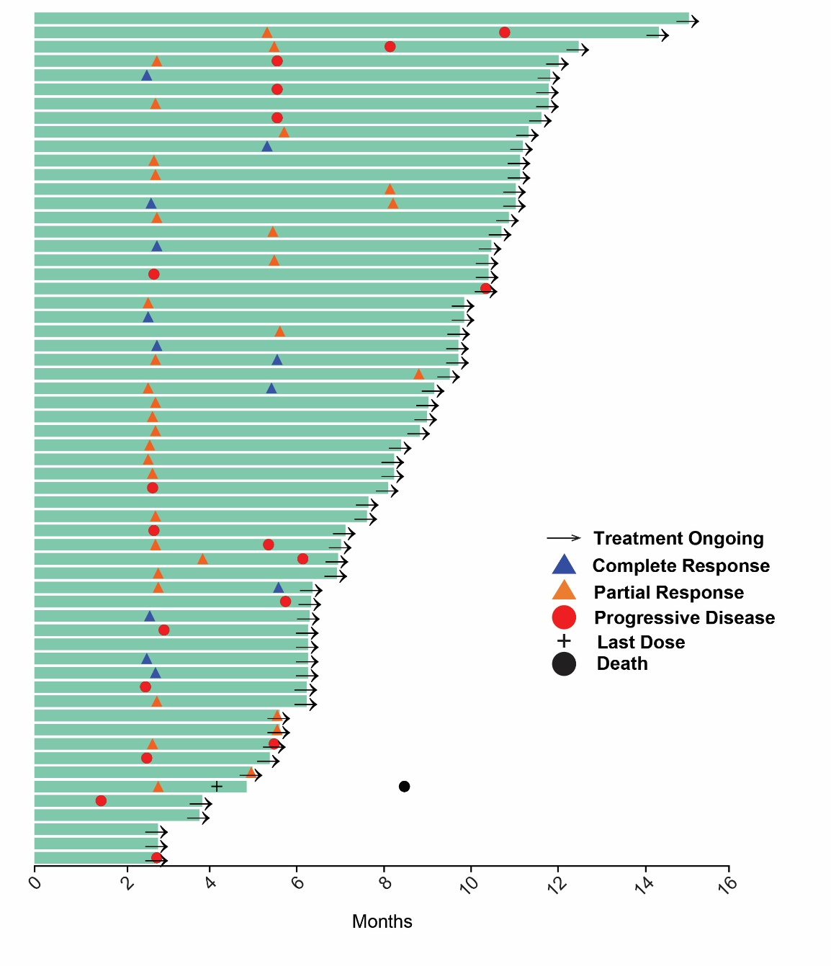

# **REFERENCE**

1. Cheson BD, Pfistner B, Juweid ME, et al. Revised response criteria for malignant lymphoma. *J Clin Oncol* 25:579-586, 2007