Empirical Application

This section presents an empirical application on gender recognition by voice using the aforementioned statistical methods. A comparison with simple logistic regression is also made.

The dataset we used is the pre-processed Gender Recognition by Voice and Speech Analysis dataset, a publicly available dataset from online resources containing 3,168 recorded voice samples by 1584 male and 1584 female speakers. 21 independent variables of acoustic properties of voice and 1 binary dependent indicator variable for gender are included in the dataset.

As a first step, we removed three variables that have shown to cause multicollinearity problem, namely; IQR, centroid, and dfrange. Next, the dataset is split into training sample for estimation of parameters, and test sample for prediction using estimated parameters. 70% of the data are randomly selected into the training sample, with the remaining 30% left for the test sample.

For estimation, we use the pre-implemented np-package in R (Racine and Hayfield, 2008) for computational simplicity. In our self-implemented Ichimura method and Klein and Spady method, we employed grid-search in the minimization process for equation (9) and (14), which is also the method proposed by Ichimura (1993). The minimization results are highly dependent on the specification of the grid for each independent variables and an appropriate resolution of the grid is necessary for precise results. As such, grid-search method suffers from the curse of dimensionality. Numerical approximation becomes infeasible in our case as the data contains 18 independent variables. We therefore decided to use the np-package which employs the npksum() and nlm() minimization procedures in R with multiple starting values to best avoid local minima. A comparison with logistic regression is also done using the logistic regression routine pre-implemented in R.

The prediction results and the true values are plotted in figure 2. A comparison of in-sample and prediction accuracy rate and approximate calculation time are also presented in table 2. The accuracy rate is defined as ratio of correct gender prediction to the total number of data points.

 | Logistic regression | Ichimura Methods | Kleinspady Method
Approximate calculation time | Smaller than 1 second | More than 3 hours | More than 3 hours
In-sample accuracy rate (training sample) | 0.971145 | 0.974752 | 0.976104
Prediction Accuracy rate (test sample) | 0.978947 | 0.977894 | 0.981052

Table 2

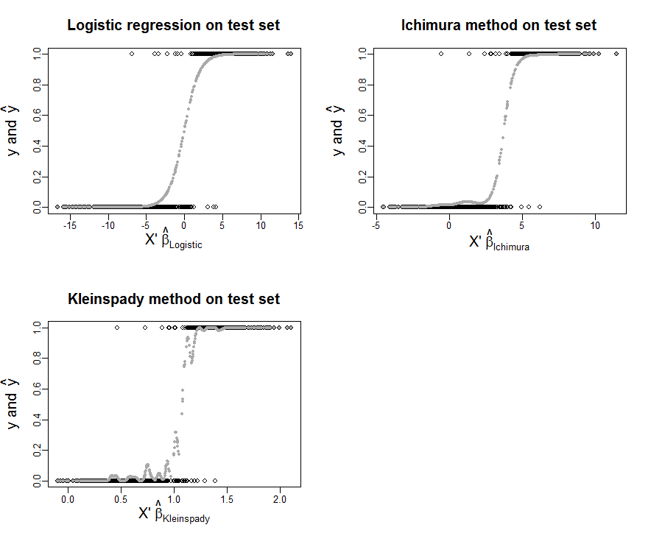
Figure 2

From the Table 2 and Figure 2, we could conclude that logistic regression would be the preferred method in this case since the improvement in accuracy rate by using semi-parametric methods are minimum while the calculation time increases significantly. However, this could be due to the fact that the underlying data fit the logistic distribution better, and thus this comparison should not be generalized to other datasets.

We also take note of the two peculiar features of the results. First, the accuracy rate is higher for test sample than in-sample accuracy rate. As the difference is relatively small, we postulate that this could be random and of no particular significance. Moreover, the fact that the training sample contains 3.5 times more data points than the test sample could exacerbate the random effect. The second feature is that the result graph from Klein and Spady method is not very smooth. This could be due to a problem with band-width selection included in the np-package (Racine and Hayfield, 2008) or the minimization process. However, as the result is not significantly worse than the other estimators, actually slightly better, we do not think that this should be of great concern.

bibliography
Hayfield, T. and Racine, J.S., 2008. Nonparametric econometrics: The np package. Journal of statistical software, 27(5), pp.1-32.

Annex
the following list shows the 21 independent variables and 1 binary gender indicator contained in the dataset.

- meanfreq: mean frequency (in kHz)
- sd: standard deviation of frequency
- median: median frequency (in kHz)
- Q25: first quantile (in kHz)
- Q75: third quantile (in kHz)
- IQR: interquantile range (in kHz)
- skew: skewness
- kurt: kurtosis
- sp.ent: spectral entropy
- sfm: spectral flatness
- mode: mode frequency
- centroid: frequency centroid
- peakf: peak frequency (frequency with highest energy)
- meanfun: average of fundamental frequency measured across acoustic signal
- minfun: minimum fundamental frequency measured across acoustic signal
- maxfun: maximum fundamental frequency measured across acoustic signal
- meandom: average of dominant frequency measured across acoustic signal
- mindom: minimum of dominant frequency measured across acoustic signal
- maxdom: maximum of dominant frequency measured across acoustic signal
- dfrange: range of dominant frequency measured across acoustic signal
- modindx: modulation index. Calculated as the accumulated absolute difference between adjacent measurements of fundamental frequencies divided by the frequency range
- label: male or female

