1. Empirical estimation methods.
Q: Does a start point for estimation on beta matter?
Theoretically an initial estimator is chosen where f’ is the derivative of the density of x_i. Then, a second update should equal to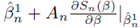. However, as argued by Ichimura (1993), “for a given sample size and hence for a given positive bandwidth, there always is a positive probability that the objective function is not differentiable, although the probability goes to 0 rather quickly..... This is the reason we resort to grid search method in the Monte Carlo study, although for a particular estimation problem the grid search method is an inefficient way to compute the optimum.”

- Empirically employing a trimming function.
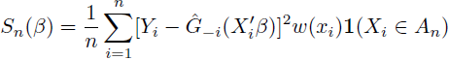
The aim of a trimming function for Ichimura is to keep p_cap(x_i’beta) not too close to zero. p_cap(x_i’beta) is estimated density on point x_i’beta. The estimation has used a batch of data around that point, within bandwidth h. Thus, with bandwidth h large enough, estimated density can be satisfying even if the true density over it is zero; on the other hand, if one event (one point) happens frequently enough, the points near it can also enjoy a positive estimate of density on those points. However, with n -> infinity and h -> 0, the estimate infinitely approaches true density.

Q(1): is p() in A_delta continuous? If so, p(x’beta) should be zero because x contains at least one continuous component and thus x’beta can take infinitely many values. Self interpretation: this is not taken into consideration here because what we care about is the estimate , which is calculated over a small range of bandwidth h. Either there exists high realizations of x_i’beta itself, corresponding to a theoretically high p(x_i’beta) guaranteed by A_delta, or it is a point very close to x_i’beta (or x_i, since a linear transformation should not take the point far away), but an estimation on this point will also be positive enough thanks to x_i’beta. Both cases satisfy the aim.

Q(2): for , what is ‘h’ here? Is it the bandwidth for x’beta? If so, why not write ||x’beta - x*’beta||<=2h? Or rather, ‘h’ just denotes a small range over x, implying x’beta won’t be far away from x*’beta as well, this question is consistent with Q(1).

- Interpretation of results.
According to Ichimura’s simulation results:
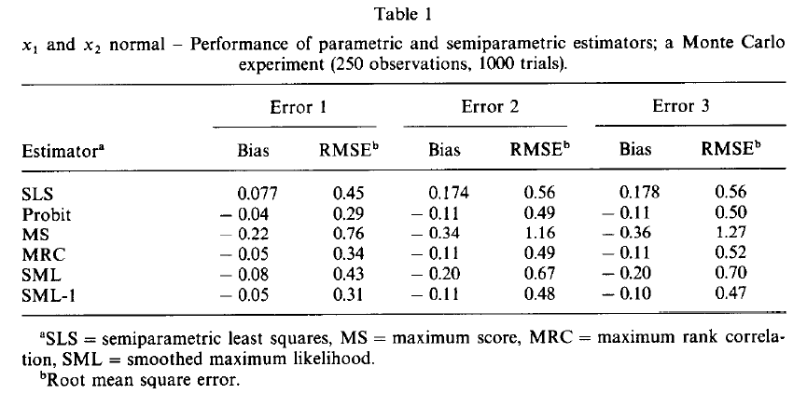
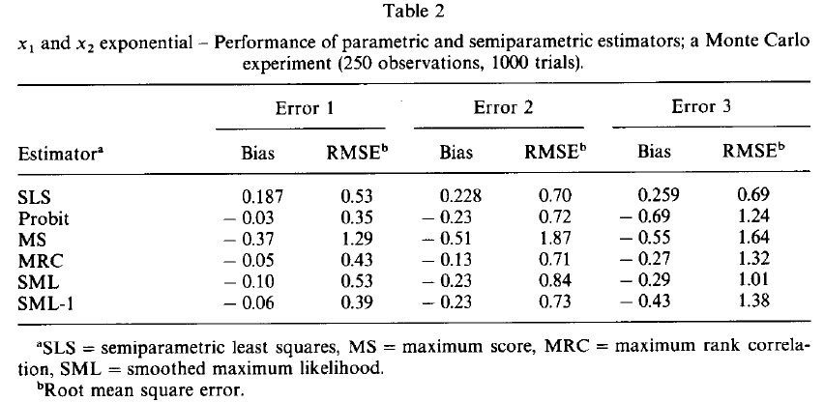
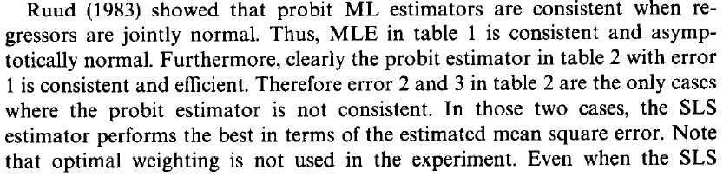
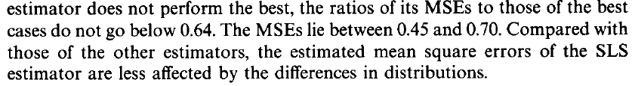
Q: how to judge, whether an estimator is consistent or not?
My interpretation here is the goal is to find one estimator the performance of which is stable over different distribution assumptions on error term.

- Asymptotically normal distribution for beta:
Statement: while n grows, the simulated distribution becomes less skewed to either right or left. The asymptotic feature is thus proven.
True_beta=7, n=1000, mc=10:
