* Lexical specification
* 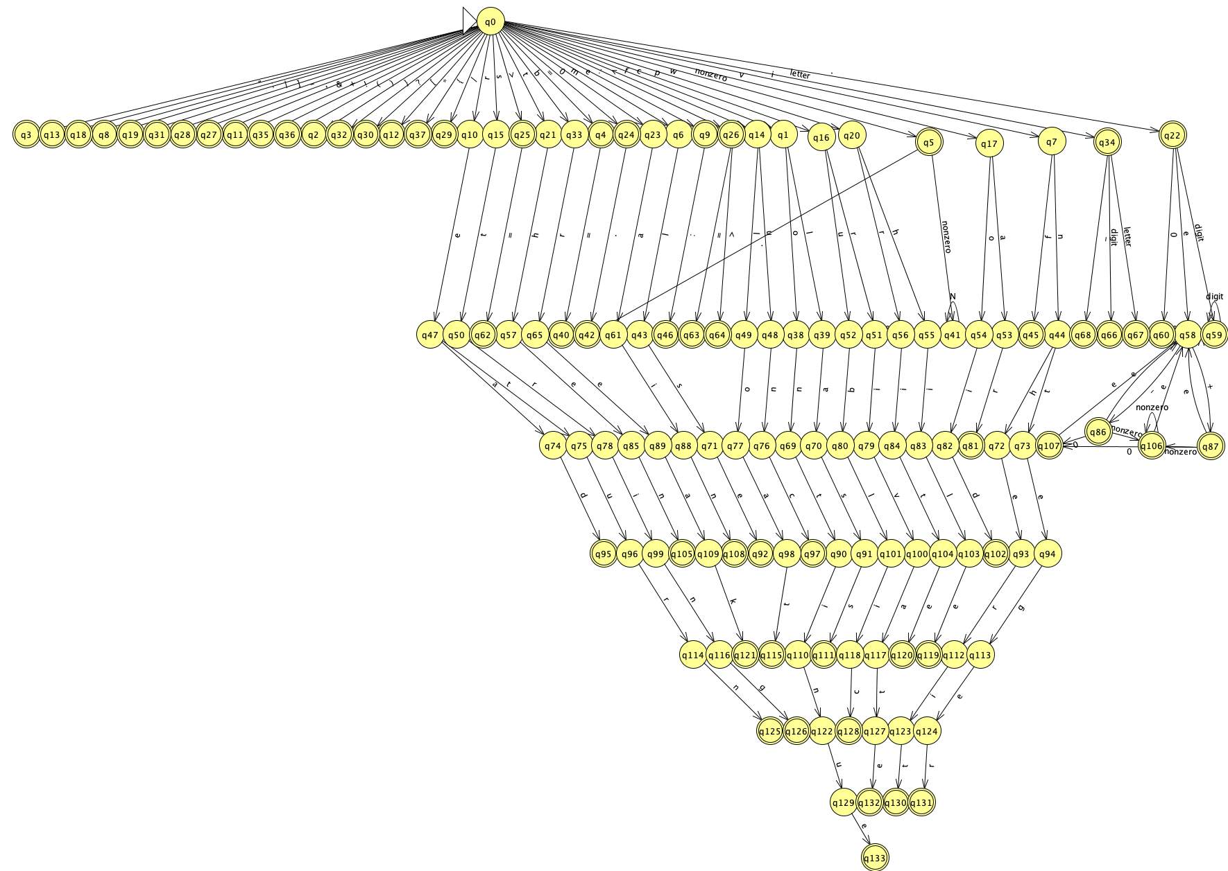Final state automaton
* Design
* Use of tools
  + Finite state automaton: JFLAP7.1 (http://www.jflap.org/)