Writing with Your Smartphone Proposal

Chen Lin
Dept. of ECE, WPI
100 Institute Road
Worcester, MA 01609
clin@wpi.edu
Xuanyu Li
Dept. of ECE, WPI
100 Institute Road
Worcester, MA 01609
xli6@wpi.edu
Muxi Qi
Dept. of ECE, WPI
100 Institute Road
Worcester, MA 01609
mqi@wpi.edu

ABSTRACT
Can a smartphone record its track of movement and recognize as English characters? Clearly, the smartphone has different sensors to orientate the location. In this paper, we use accelerometer, gravity and magnetic sensor to calculate the track of movement by phone. Then the track can be recognized as English characters and saved into note application.
Categories and Subject Descriptors
H.5.2 [Information Interfaces and Presentation]: User Interfaces – Interaction Styles, Input Devices and Strategies; D.2.2 [Software Engineering]: Design Tools and Techniques – User Interfaces; H.1.2 [Models and Principles]: User/Machine Systems – Human Factors
General Terms
Algorithms, Design, Experimentation, Human Factors
Keywords
Gesture, Activity Recognition, Accelerometers, Smartphones

INTRODUCTION

Big Vision and Simplification
In this project, we tend to create a creative application which can let us use our smartphones as pens, by recording the track of movement and saving the information.
Here is a big vision of it. The app can recognize digits, English as well as other different language character, symbols and simple drawing functions. It uses machine learning to train the system to get stronger recognition capability. Furthermore, the recorded information can be sent to a laptop. This system can be widely used in school teaching and presentation. For instance, when the speaker uses his phone writing something on the whiteboard, the writing content will shows on the slides.
To implementing the vision, we need a software running on the computer to handle the received information and using Bluetooth or Wi-Fi to connect with the phone. In addition, we need more complex algorithms to distinguish different input information.
Concerning our group size, funding, and research schedule, we simplify such vision to an app which can record the track of movement and save the information into the note application. This app gets the information as notes and saves it onto the phone. Also, users can only write English characters, and characters must not scribble.

Importance and Demand
Generally speaking, this technology provides a convenient and easy way to take notes. Imagine the following scenario. While driving to office, Bob stops at a traffic light. As he mentally sifts through his tasks for the day, he remembers that he needs to call his friend, Alice, very soon. Since Bob tends to forget his personal commitments, he decides to make a note of this task. Therefore, while keeping his gaze on the traffic lights, he draws out the phone from his pocket, and by holding it like a pen, he writes “ALICE” in the air. He does not look at any of the hand gestures he makes. Once in his office, he finds a note in his phone that reads “ALICE”. Bob calls Alice, talks to her, and deletes the note.
Without such app, we are wasting a lot nowadays, among time, energy, health, and noise aspects.
For time, with a smartphone, people tend to spend more time on it nowadays, especially for college students. Figure 1 is a result from a research collection by Business Insider on Smartphone owners’ daily time-spend [3].
We can see from that average daily time-spending is nearly 1 hour, and 25% of it is for texting. For college students, a result is on the above right [4]. We can see a 3-hour bar is representing text messaging. That is quite a large time cost requiring improvement.
For energy, when we look at our battery usage information, we always see the screen cost at the very top.
For health, I am concerning finger and wrist pain and eye protection. A recent research [5], May 2014, shows that almost half of the randomly selected sample students are experiencing pain in the thumb/wrist and with frequency of mobile phone usage increased progressively more and more people showed positive Finkelstein Test. Frequently using their finger and wrist in a repeat pattern, which is exactly what we did while texting, has a bad impact on their finger and wrist health. And another research [6], March 2014, shows the lowest frequencies of blinking were witnessed after about 40 minutes of cellphone use. In detail, we blink less frequently when watching on smartphone screen, and blink more frequently after watching than before watching. So using screen-based texting will also impact our eye health.
For noise, I am concerning another similar none-typing input solution, speech recognition, which has already been promoted as many commercial apps. But a new problem is noise. It is annoying when someone around is using speech recognition input, the ‘beep’, response, and especially possible repeating sentences.
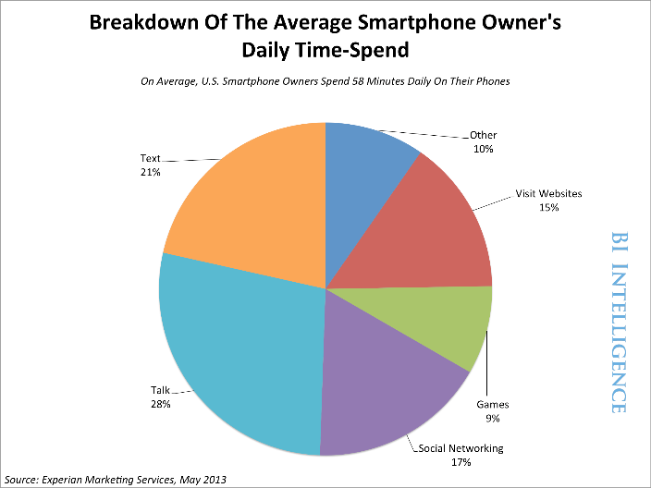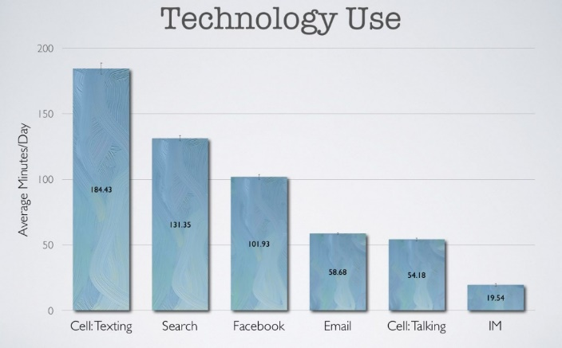
Figure 1. Average Daily Smartphone Usage Reports
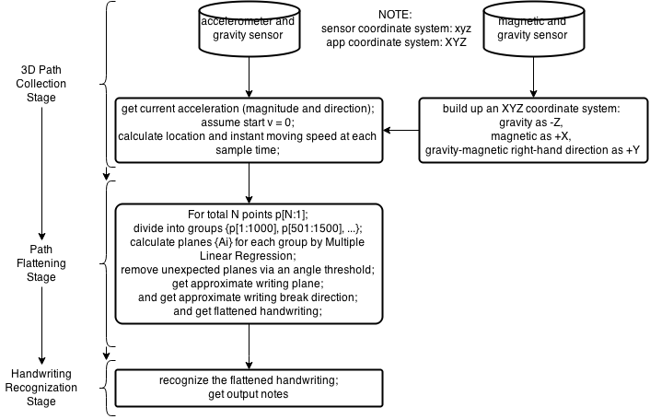
However, with our app, things are different. Our app cannot reduce the need for texting. However, it will reduce the time of completing the text. Our smartphone keyboard is too small to operate efficiently on, even with smart input suggestion, or speed texting keyboard solutions. So if our app is well implemented, the time cost will be reduced by at least 25%. More accurate data can be collected by possible researches.
Figure 2. Flow Chart of Methodology
Similarly, we do not need to use the screen display will texting. So with 21% texting daily usage for general Americans, and 33% (= 180 min / 540 min) for college students, a reduction of 20% - 30% on the screen battery usage will be reached. And also, we do not need to watch the screen, nor to typing on mobile keyboard (virtual or physical). So we will get a 25% - 50% improvement similar to energy aspect.
Last but not least, users are no longer required to speak much, so annoying noise will seldom be made while using it.

RELATED WORK
There are already some work on this topic, such as using mobile phones to write in air [1], and Magnetic Field Feature Analysis of Smartphone Application Activities Using Android MI Sensors [2].
But our approach is different. Comparing with the related paper, we save the information in the note application instead of Email. So the whole process doesn't need any internet access. It has wider adaptability.

METHODOLOGY
We tend to create a creative application which can record the track of movement and save the information into the note application.
To implement it, we intend to use accelerometer, gravity and magnetic sensor to calculate the current acceleration (magnitude and direction). We assume the initial moving speed is 0. Then calculating the location and instant moving speed at each sample time. After that, we divide the set of points into groups, calculate planes for each group by Multiple Linear Regression. Next, we will remove the unexpected plane via an angle threshold and get approximate writing plane, writing break direction and flattened handwriting track. In the end, we will recognize the flattened handwriting, get output characters and send to the note application. The flow chart is shown in figure 2.
In the part of speed and position calculation, the noise of sensors will have a significant bad impact on the result. There are two kinds of noise. One is white noise, which are Gaussian noise, background noise, and etc. White noise will have an average value of zero under a short time, so it will not have much impact during our few-second data fetching. The other is drift noise, which is commonly named as random walk in the field of sensor data applications. Such noise is acutely also white noise, but its average value comes back zero only after an extremely long time. So when we sense the data, the drift noise will have a significant effect on the result and make it not recognizable. Thus, we apply a programming band pass filter to get rid of both drift noise and white noise to get a better result. The following figure shows the methodology of the filter. The alphaL and alphaH are parameters of the low-pass and high-pass filter, which are components of this band-pass filter.
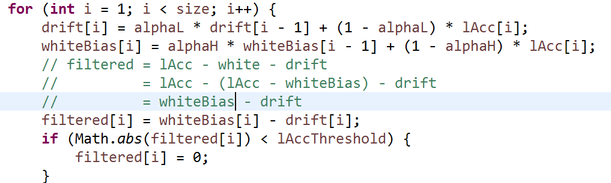
Figure 3. Algorithm of a Programmable Software Filter
Here we also use a threshold to get rid of the small errors of float number calculation.
After filtering, we integrate the acceleration data to get instant speed and position, using the following expression. The grad represents the gradient of acceleration.
Speed: speed_S + acc_S * time + 0.5 * grad * time ^ 2;
Pos: pos_S+speed_S*time+0.5*acc_S*time^2+(1/6)*grad*time^3;

SYSTEM IMPLEMENTATION
Our app’s UI is composed of two parts (one is the launcher activity, the other is the notified activity). The launcher activity is used mainly to communicate with the user who first time use this app and thus is completely unfamiliar with the functionality and how to use this app. The second one is used to display the processed result of the user input.
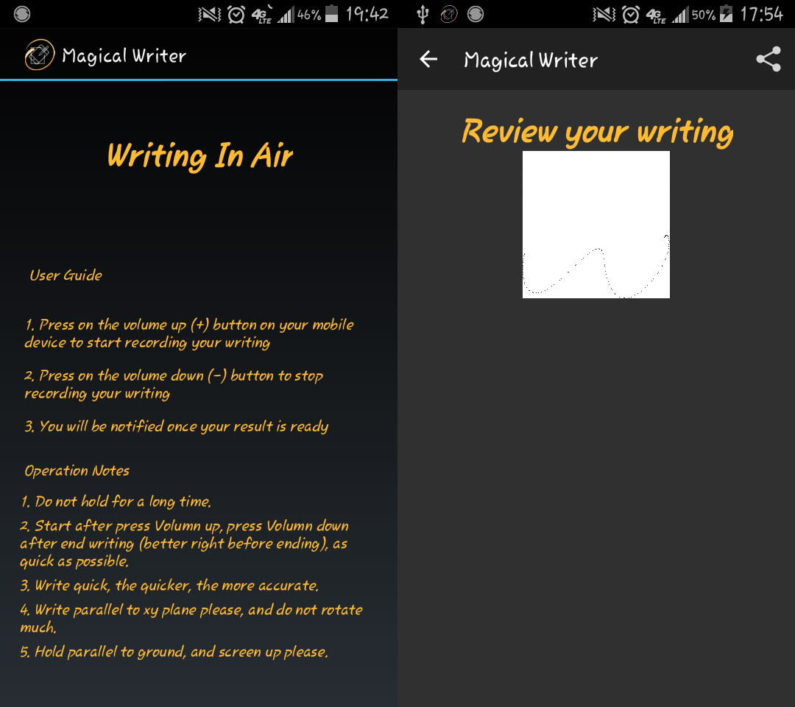
Figure 4. Screenshot Describing UI Activities
From the UI shown above, it fulfills most of the original design targets. For instance, keep the widgets and view components as few as possible, start up with a dark background instead of applying some light themes for the app. Volume buttons works as the substitution of virtual button views to control the start and end of the sensing activity. All those features above helps to reduce battery consumption at certain degree.
For operating, the users can use the Volume-Up and Volume-Down hard buttons to request a “start sensing” and an “end sensing”. After sensing data fetched, the app will automatically process the data and save the result to a local image. Then the user can request a new “start sensing” and track a new letter. The entire working flow is shown below.
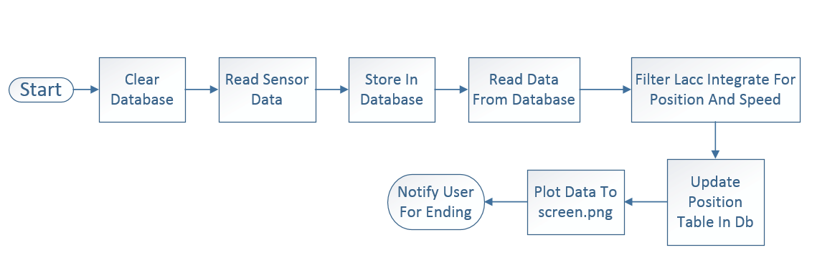
Figure 5. Working Flow
Thus, ideally, the app should not contain any UIs, which indicates that this app would be entirely a running background service, as the design purpose of this app is to save as much energy as possible. This could be achieved using IntentService and BroadcastReceivers, which is frequently used in some other android applications.

RESULT AND EVALUATION
In this section, we will present four subsections for the results we get in the project, as well as one subsection for evaluation.
To get the result, we install the app onto a black Samsung Galaxy S4 Mini, whose operating system is developed based on Android 4.4.2.
In the first subsection, we will present the output of our designed band pass filter to see how it works. In the second subsection, we will show the result of checking the methodology using MATLAB, which is faster and more accurate for data processing and analysis. The third subsection will show the image output of our app, which is a jpeg image saved in external storage, and can be viewed in phone gallery. The fourth section will present the in-app screen output, which is called by pressing notification in the notification bar. The final subsection, evaluation, will show the evaluation of our app, considering accuracy of recognition or readability.

Noise Filter
We design a band-pass filter to get rid of noise. Here is an example of the filtering result. As we can see in the figure. The first line is showing the raw data of accelerometer (Android Linear Accelerometer Sensor). As we can see, the raw data is not accurate in enough, due to discrete sampling nature of sensor listener and noise nature of physical sensors. The second line is showing the drift noise filtered out. It is the low frequency part of the raw signal, looking like a floating offset in sort time. The third line is showing the white noise filtered out. It is the high frequency part of the raw signal, having an average of zero in sort time. Finally by removing drift and white noise from raw signal, we get the fourth line, which is the filtered acceleration data used by following procedures.
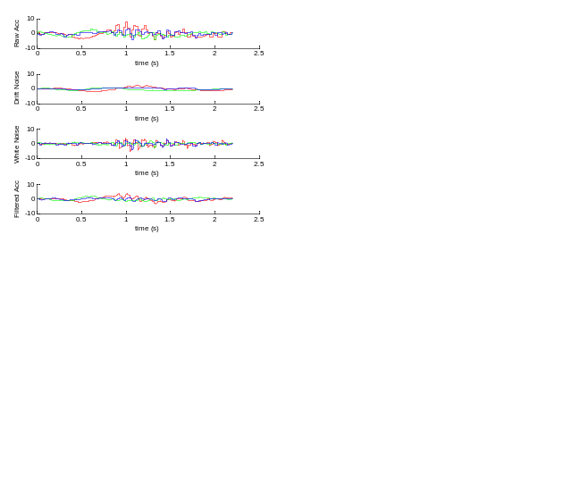
Figure 6. Example of Noise Filtering (Acceleration in ms-2)
We test the filter many times to get a proper filter parameter, and finally find that {0.97, 0.8, 0.05} is a good set of the filter parameters {alphaL, alphaH, lAccThres}. Then we come into the next stage of integration to get position.

Methodology Checking
To check the methodology, we use the mathematics analysis tool MATLAB because it is good at processing signals and programmable calculation without possible floating point number error. We have already get the filtered acceleration data and now it is time to integrate the acceleration over time to get the instant speed and position. The following figure, Figure 7, is showing an example of integration. The first line is the acceleration data. The second line is the instant speed calculated by integrating acceleration up over time. The third line is the instant position calculated by integrating speed and acceleration up over time.
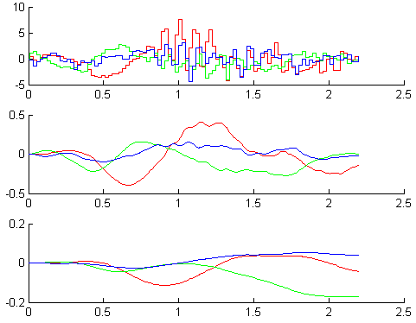
Figure 7. Example of Integration Processing
The following figure is showing an example of the result of integration. In Figure 8, the upper part is a 3D plot of our movement of writing a letter ‘B’ in air. And the lower part is a 2D plot of the flattened version of the same movement.
The result shown above indicates that our method is able to track the user’s movement and figure it out. We also test it many times on other letters and get a positive response. Thus, we apply such method in our app as java code to see if it works well under java and Android environment.
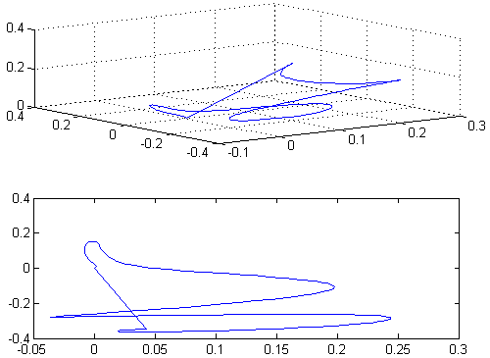
Figure 8. Example of Checking

Image Output
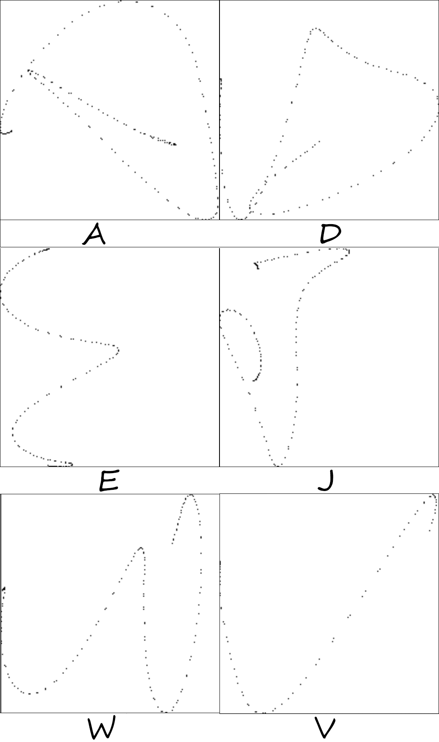
Figure 9. Example of Image Output
Our App will save the writing as an image automatically after the user presses end button (Volume Down) and the app completes processing data. The image is saved in external storage so that other apps can also get access to use it. The size of image is 50 by 50 which is small but enough to store a letter. We plot the letter as separate points generated by our sampling and processing, it can also be presented as a curve by connecting the points up in serial for future work.
The figure on the previous page shows six examples of the output. As we can see, the output is readable by person, so that this app can be used as a note generator when it is not convenient to stare at the screen. Since we haven’t apply the ‘break’ detection method, we try to write all test letters without break, such as ‘A’ and ‘E’ shown above.

Screen Output
Figure 10 shows the result of our screen output. When the app complete processing and saving image, it will throw out a notification to notify the user that he or she can see the result. In future commercial version, developers can also use an audio notification instead. The left part of the figure shows the notification in notification bar. The right part of the figure shows the Activity presenting the image. In this activity, the image is resized by ImageView component to fit the screen for reading convenience. After reading, the user can press ‘back’ button or the ‘back’ arrow at the left top to get back to main Activity. Another thing I would like to mention is that in the review Activity, Volume buttons are used for volume control not sensing control now.
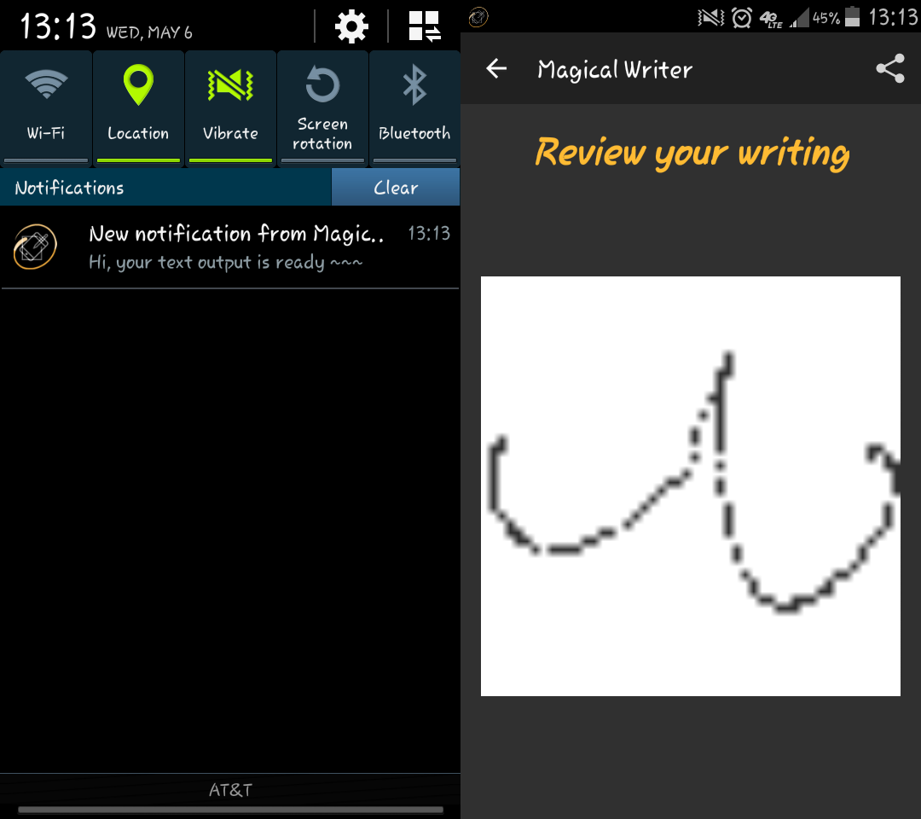
Figure 10. Example of Screen Output (Notification and Activity)
The example shows the result of letter ‘w’. And we also test other letters and get the same result as Image Output subsection.

Evaluation
We evaluate our app by accuracy. Since the OCR method has not been implemented in this app, due to the time limit. The user himself will judge whether a letter written is correctly recorded or not.
Here is a table of all 26 English capital letters under test and the test result. Among the value of the table, ‘yes’ represents ‘can be correctly recorded’, ‘no’ represents ‘cannot be correctly recorded’ and ‘NAN’ represents ‘not testable’. A letter is not testable is one that cannot be clearly written without any break, such as ‘F’.
Table 1. Result of All English Capital Letters
Letter | A | B | C | D | E | F | G
Result | yes | no | yes | yes | yes | NAN | yes
Letter | H | I | J | K | L | M | N
Result | no | yes | yes | NAN | no | yes | yes
Letter | O | P | Q | R | S | T | U
Result | yes | yes | no | no | yes | NAN | yes
Letter | V | W | X | Y | Z
Result | yes | yes | NAN | NAN | yes
So the total accuracy is 61% (16 ‘yes’ over 26). The result is not good enough for two reasons. The first is that there are letters not testable among them. The second is that the output is highly dependent on user’s operation, so it may not always generate a good output. However, anyway, our app manages to record letters and proves that the methodology implemented here works. To get more accurate results, future work is required.
For user survey, we cannot do any survey on our app because of the limited developing time. Form our developer’s view of point, the UI design is user friendly because it is simple to control, but the writing constrain makes it inconvenient to operate and requires further development. Constrains are listed below.
1. Do not hold for a long time.
2. Start after press Volume up, press Volume down after end writing (better right before ending), as quick as possible.
3. Write quickly, the quicker, and the more accurate.
4. Write parallel to my plane please, and do not rotate much.
5. Hold parallel to ground, and screen up please.

DISCUSSION
Thread separation is the core task and difficulty for the front end design. Unlike most of android apps, heavily relied on fancy or even gorgeous UI for better user experience and feedbacks. Our app is a sensor (data) driven app, that relies on large amounts of sensor data filtering and processing. This inevitably shrinks the significance of the UI design process. And makes the final release of our system to be a background service oriented system. However, for testing, we have developed UIs with more widgets, this facilitates the testing process and provides more flexibility for back end developers.

CONCLUSION
We presented the design and evaluation of Magical Writer-a sensor based system that calculate the track of movement when the user holds his phone, trying to write something in air. We use SQLite to save the data retrieving from the sensor and handle it when user finish writing. Finally, we save the information as an image so user can easily review the result easily.
From the result and evaluation, the overall result is positive and the accuracy is 61% among 26 English capital letters. But the result is highly dependent on user’s operation, so that further development is still required before becoming a commercial application.

FUTURE WORK
For the future studies we will attempt to improve the effect of the filter for data in order to make the output information more accurate. In addition, the current project can only work in horizontal plane. We plan to use least square algorism to calculate the approximate plane, plot the 3-D coordinate to the approximate plane and generate the result. This improvement can allow user writing something in any comfortable plane.
For the UI part, as mentioned before, if time available, we would do some more work to shrink reliance on UI, and convert the whole app as a background service. If this is finally achieved, then more energy could be saved, more importantly, the app’s sub functionalities could combine more coherently and thus significantly enhance the UX.

REFERENCES
- http://developer.android.com/
- Sandip Agrawal, Ionut Constandache, Shravan Gaonkar, Romit Roy Choudhury, Kevin Caves, and Frank DeRuyter. 2011. Using mobile phones to write in air. Proc. MobiSys 2011
- Hsin-Hao Chiang. 2013. Magnetic Field Feature Analysis of Smartphone Application Activities Using Android MI Sensors
- How Much Time Do We Really Spend On Our Smartphones Every Day? http://www.businessinsider.com.au/how-much-time-do-we-spend-on-smartphones-2013-6, JUN 6 2013
- Students spend a lot of time Facebooking, searching, and texting. http://blog.reyjunco.com/students-spend-a-lot-of-time-facebooking-searching-and-texting, March 7, 2011
- Maryam Ali, Muhammad Asim, Syed Hasan Danish, Farah Ahmad, Afsheen Iqbal, and Syed Danish Hasan. 2014. Frequency of De Quervain’s tenosynovitis and its association with SMS texting. Muscles Ligaments Tendons J. 2014 Jan-Mar; 4(1): 74–78.
- Jeong Sook Park, Mi Jung Choi, Ji Eun Ma, Ji Hyun Moon, and Hyo Jeong Moon. 2014. Influence of Cellular Phone Videos and Games on Dry Eye Syndrome in University Students. J Korean Acad Community Health Nurs. 2014 Mar; 25(1):12-23, March 31, 2014
- Hirsch H.G, Ehrlicher C. 1995. Noise estimation techniques for robust speech recognition. Acoustics, Speech, and Signal Processing, 1995. ICASSP-95., 1995 International Conference on (Volume: 1), 153 – 156, May 1995

