

*Reflections*

by

Drumpf Reborn

Table of Contents

Version History 3

Game Overview 4

Win/Lose Conditions 4

Game Controls 4

Game Mechanics 4

Interact 4

HUD Layout 5

Level Layouts 5

IPM Chart 5

Asset List 5

Programming 5

Art 5

Audio 6

Level Design 6

# Version History

|  |  |
| --- | --- |
| **Version** | **Change log** |
| V1.0 | Alpha Draft |
| V2.0 | Beta Draft |
|  |  |
|  |  |

# Game Overview

Reflections is a game all about using cues from the environment to explore and discover what is going on and what happened previously. The game takes place within several rooms that are unlocked through puzzles and come together to tell the story. The final room is locked until the player completes all of the previous rooms. The game is played from a first person point of view. In each room there will be a puzzle, after which is a room that contains part of the narrative of the game.

# Win/Lose Conditions

Players win by completing the puzzle within the final locked door.

The player cannot lose in the traditional sense. They “lose” when they quit the game

# Game Controls

The player moves by using the standard WASD control scheme along with the mouse to control the camera. Players can press “E” to interact with appropriate objects in the game.

# Game Mechanics

## Interact

* Certain objects locations in the game can be interacted with.
* These places are not obviously marked to encourage exploration
* Players collect these objects
* There are two types of objects:
  + Collectibles:
    - When interacted with:
      * Object added to inventory
      * Name of Object displayed on screen
    - When placing object:
      * “rummage” sound effect plays
      * Object removed from inventory
      * Environment updated to show new state
  + Environment:
    - When interacted with:
      * sound appropriate to the object plays.
      * Object state changed to show previous interaction
      * Ex: books shoved to the side

# HUD Layout

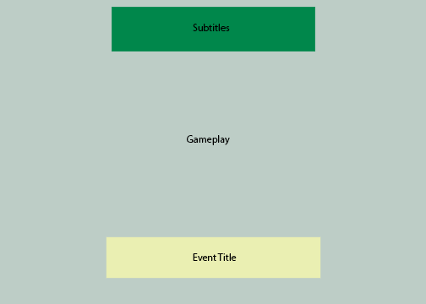

# Level Layouts

[Include a mockup of each level, complete with a key and title for each. Be sure to label important areas like player starting point, win zone, collectibles, obstacles, etc.]

# Asset List

Assets with a “*” are completed and implemented

## Programming

* Player Movement
* Interaction
* Inventory
* Destroy object
* Door event
* Mouse Camera
* Move Object
* Approach Sound Effect
* Item requirement to interact

## Art

* Door
* Bed
* Desk
* Pillow
* Chair
* Guitar
* Sofa
* Walls
* Keyboard
* Amp
* Laptop
* Cables
* Phone
* Rug
* Paper scraps
* Charger
* Shelf
* Bedside Table
* TV
* TV Shelf

## Audio

* Incinerator sound
* Effects for objects
* TV static
* Police Sirens
* Cat Screech
* Dogs Barking
* Waves for lake
* Monotone sound for quieter areas
* 2 background tracks
* Squeaky floorboard
* Stair-step clip clop

## Level Design

* Clean Bedroom
* Messy Bedroom
* Trashed living room
* Clean Living Room
* Hospital Room
* Level Hub
* Hill with bridge + coffin
* Maze
* Mask Room
* Incinerator Room
* Infinite Staircase