
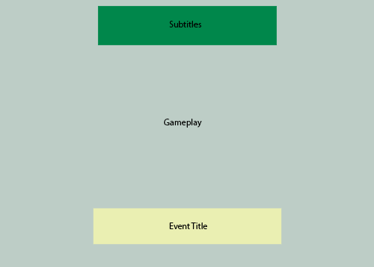

Reflections
by
Drumpf Reborn

Table of Contents
Version History 3
Game Overview 4
Win/Lose Conditions 4
Game Controls 4
Game Mechanics 4
Interact 4
HUD Layout 5
Level Layouts 6
Asset List 8
Programming 8
Art 8
Audio 9
Level Design 9

Version History

Version | Change log
V1.0 | Alpha Draft
V2.0 | Beta Draft  - updated game overview  - updated asset list  - added HUD layout  - Included level layouts  - attached scripts  - added control image  - fixed game mechanics

Game Overview
Reflections is a first person exploration game. The game takes place within several rooms that are unlocked through puzzles. These rooms contain the story. The final room is locked until the player completes all of the previous rooms. The puzzles vary from finding objects to finding the correct switch to press. There is a central hub from which the player can go to each room in the order that they unlock.

Win/Lose Conditions
Players win by completing the puzzle within the final locked door.
The player cannot lose in the traditional sense. They “lose” when they quit the game

Game Controls
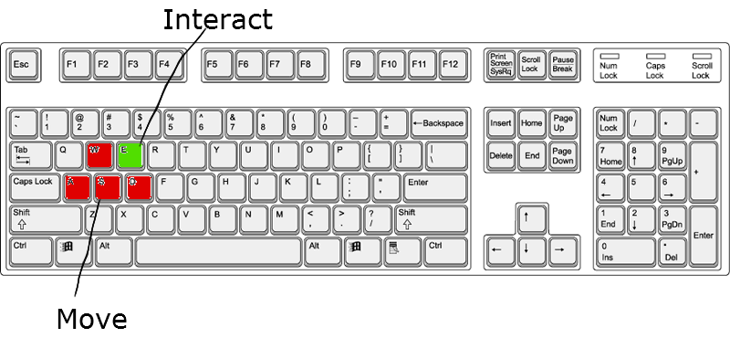
The player moves by using the standard WASD control scheme along with the mouse to control the camera. Players can press “E” to interact with appropriate objects in the game.

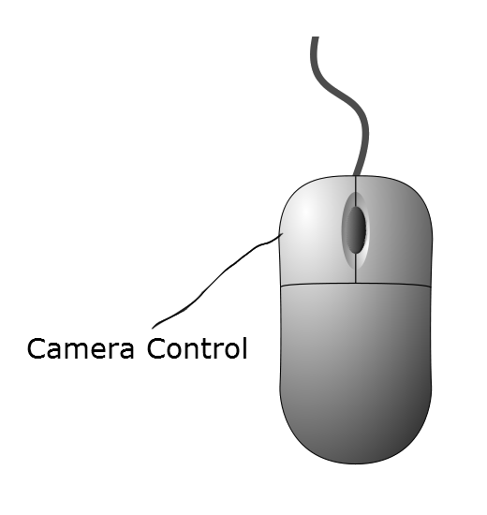
Game Mechanics

Interact
- Certain objects locations in the game can be interacted with.
- These places are not obviously marked to encourage exploration
- Players collect these objects
- There are two types of objects:
  - Collectibles:
    - When interacted with:
      - Object added to inventory
      - Name of Object displayed on screen
    - When placing object:
      - Object removed from inventory
      - Message showing use displayed on screen
      - Environment updated to show new state

  - Environment: (possibly not going to implement)
    - When interacted with:
      - sound appropriate to the object plays.
      - Object state changed to show previous interaction
      - Ex: books shoved to the side

HUD Layout

Level Layouts
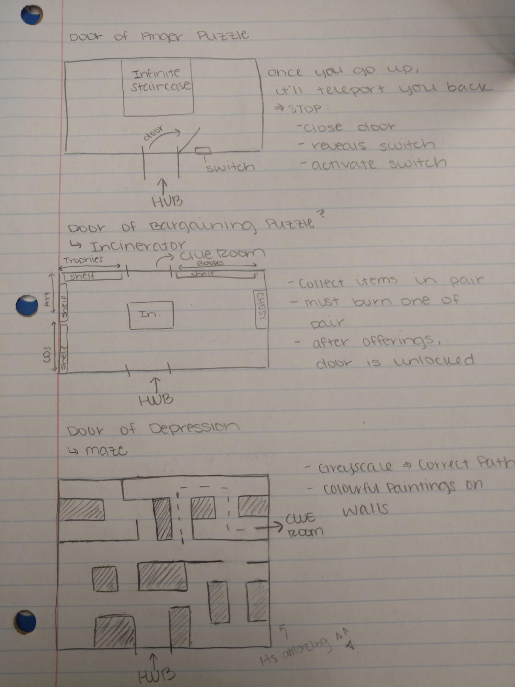

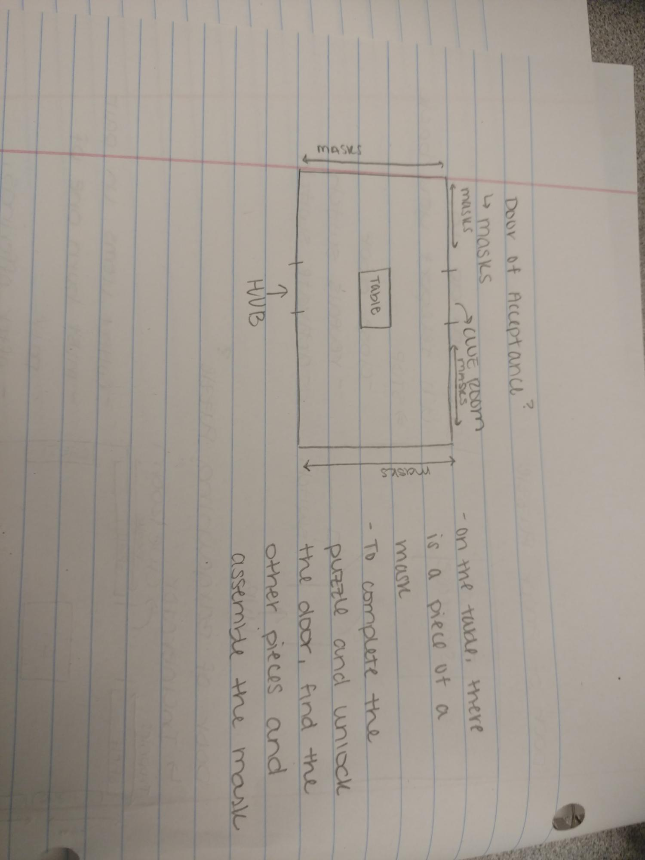

Asset List
Assets with a “*” are completed and implemented

Programming
- Player Movement*
- Interaction*
- Inventory*
- Destroy object*
- Door event*
- Mouse Camera*
- Move Object*
- Item requirement to interact*
- Subtitles*
- Captions*
- Incinerator room object limit
- Menu Navigation*
- Fading Transition*
- Infinite Stair Loop*
- Sound Event*
- Switches*
- Changing Scene*
- Puzzle solution checker*

Art
- Door*
- Bed*
- Desk*
- Pillow*
- Chair*
- Guitar*
- Sofa*
- Walls
- Keyboard*
- Amp*
- Laptop*
- Laptop Charger*
- Phone
- Rug*
- Paper scraps*
- Charger*
- Shelf*
- Bedside Table*
- TV*
- TV Shelf*
- Title Screen*
- Game Over*
- Books
- Coffin
- Mask
- 2d art:
  - Paintings for maze
    - various emotions portrayed
  - Trophy
  - Framed award
  - Toy dog
  - Child's drawing
  - Roses
  - Sunflower
  - Nameplates for previous 6 items

Audio
- Incinerator sound
- Effects for objects
- TV static
- Police Sirens
- 2 background tracks (being made)

Level Design
- Clean Bedroom*
- Messy Bedroom*
- Trashed living room*
- Clean Living Room*
- Hospital Room*
- Level Hub
- Hill with bridge + coffin
- Maze*
- Mask Room
- Infinite Staircase*

