Assignment 3- Bad Website Redesign

IASC 1P02

Leesha Young-Wood

ID:6024996

Date: November. 7th, 2019

Wireframe link: <https://wireframe.cc/jQG234>

Website I am re-designing: <https://blinkee.com/>

I have decided to redesign this website by implementing organization and structure, something the original website lacks. By keeping options/menus on the left-hand side, featured products on the right-hand side (making up most of the page). The information about the company will not be at the bottom of the page rather than randomly in the middle and the company name will clearly be listed at the top of the page whereas it was non-existent before unless you went to the ‘about’ section. There are too many animations and things blinking, the products don’t necessarily need to be this way until they are clicked on. It is too distracting on the home page.

**Rationale:** The existing website for Blinkee’s is unorganized and distracting. The heading/company name should stand out the most. In the existing website it doesn’t at all, in fact, the actual company name isn’t on the homepage. They make it look as though ‘blinkee.com’ is the company name, however that’s just the website, the name is actually ‘Magic Matt’s Brilliant Blinkee’s’. I will be making this very clear in my re-design as it will be the largest text item on the website. I do like how the current ‘blinkee.com’ is multi-coloured and flashing. I would keep this theme in the new title on the website since it represents what the company is all about, selling glowing and blinking products of any colour. This will also catch the consumers attention. For the rest of the webpage however, I have chosen 3 new colours that will catch the eye and give a ‘cheerful’ feeling, bright colours. I think it’s important this webpage has bright cheerful colours since they are selling flashy party items. I would keep all font’s black other than the company name at the very top to keep the page consistent and not distracting. The colours would be used as background colours in the boxes to separate items that are different. The colours I have chosen are listed below. I don’t think the current webpage has much alignment or repetition, so on the new webpage I would make everything left aligned other than the product images in each featured product box, if they weren’t centered it would look odd. The products currently listed on their home page are not consistent in size either and do not line up equally, this is unorganized, and I would make them all equal sizes. I also think there are too many products on the home page, I would only keep a few featured items that change every couple of weeks on the home page, and then if the consumer wants a specific product, they can use the drop-down menu on the left to pick a specific category under ‘products’. Regarding Proximity, items that are similar are in one box, while unrelated items are in different boxes. Certain fonts are too large for what they are representing. I don’t like the huge advertisement banner that changes every few seconds on the home page, it is way too large and unnecessary, certain themes/holidays should be under the product drop-down menu. There are tons of issues with the existing page, and I think I have addressed them in my new webpage!

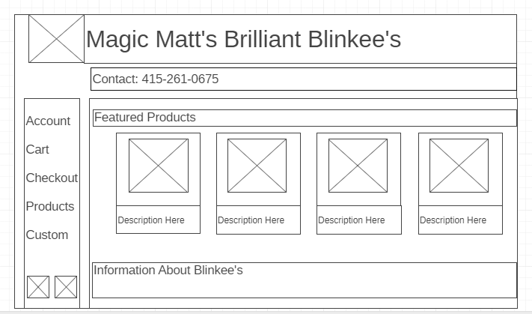

**Colour Theory:**

3-adjacent colours – Using analogous colouring. This gives the bright and cheery effect. I thought this was suitable for a company that is trying to sell flashy, bright products.

#BEFF00

#FFF400

#FFCA00

**Design Principles:**

Contrast: Using these different colours to add contrast when two items aren’t identical. This makes it obvious to the viewer that there is something different between the items.

Repetition: all product boxes are identical keeping repetition on the page to give it consistency and unity.

Alignment: keeping all items on the page left aligned to give it an edge to follow. Making it pleasing to the eye unlike the original page.

Proximity: all related items are grouped together. Menu/navigation bar is together, contact info are separated from this since it is unrelated, product list is separate from this as well since they are different. By grouping all the products together and making the website description completely separates this shows that the items placed together are related.

**I labelled the item numbers on wireframe link in the annotation boxes. **

**Item #1**

Description: Header

Font: Arial 30px

Color: Flashing Coloured Fonts

Alignment: Top Left

Media: Company Logo (left side)

Interactivity: N/A

Background: White Background

**Item #2**

Description: Contact Info

Font: Arial h2

Color: Black Font

Alignment: Left

Media: N/A

Interactivity: If you click ‘Contact’ it redirects to a page with more contact information

Background: Colour- #FFCA00 (one of the 3 adjacent colours I chose)

**Item #3**

Description: Navigation Bar

Font: Arial 20px

Color: Black Font

Alignment: Left

Media: Search Tool (bottom left) and Shopping Cart (bottom right)

Interactivity: N/A

Background: Colour- #FFF400 (one of the 3 adjacent colours I chose, the primary one)

**Item #4**

Description: Products (4)

Font: Arial h4 (product description)

Color: Black Font

Alignment: Picture-centered (otherwise it would look weird), Description- Left

Media: Product Photo

Interactivity: clicking on the product will take you to the product page

Background: Colour- #FFF400 (one of the 3 adjacent colours I chose, the primary one)

**Item #5**

Description: Information about company

Font: Arial 15px

Color: Black Font

Alignment: Left

Media: N/A

Interactivity: N/A

Background: Colour- # BEFF00 (one of the 3 adjacent colours I chose)