Practice 4

We highly encourage being environment friendly and trying all problems on your own.

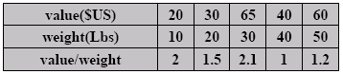
- 0/1 Knapsack Problem. There are 5 items that have a value and weight list below, the knapsack can contain at most 100 Lbs. Solve the problem using back-tracking algorithm and try to draw the tree generated.

- Solve the 8-Queen problem using back-tracking algorithm.

