Part2:
For the yeast data set, draw a plot showing how test-set accuracy varies as a function of k. Your plot should show accuracy for k = 1, 5, 10, 20, 30.
For the wine data, draw a similar plot showing test-set mean absolute error as a function of k, for k = 1, 2, 3, 5, 10.
Figure 1: Yeast data-set accuracy vs. k value
Figure 2: Mean absolute error VS. k value
For the yeast data set, construct confusion matrices for the k = 1 and k = 30 test-set results. Show these confusion matrices and briefly discuss what the matrices tell you about the effect of k on the misclassifications.
Table 3: confusion matrix for K=1 for yeast data-set
Table 4: confusion matrix for k=30 for yeast data-set
Based on the observation of comparing table 3 and table 4, our confusion matrix for k=1 and k=30 showed that with the increase of k, the more samples moved to the left and diagnal for this specific case. This is very obviously to be explained, because with the increase of k, the majority vote will give us the result which could be favored to classes with more samples in the training set. With the k increase, the majority vote will play a more significant role during classification which could be good or not good for classification based on the specific situation. The more labels you have in a training set the more probably the new sample will be classified to be.
Part3:
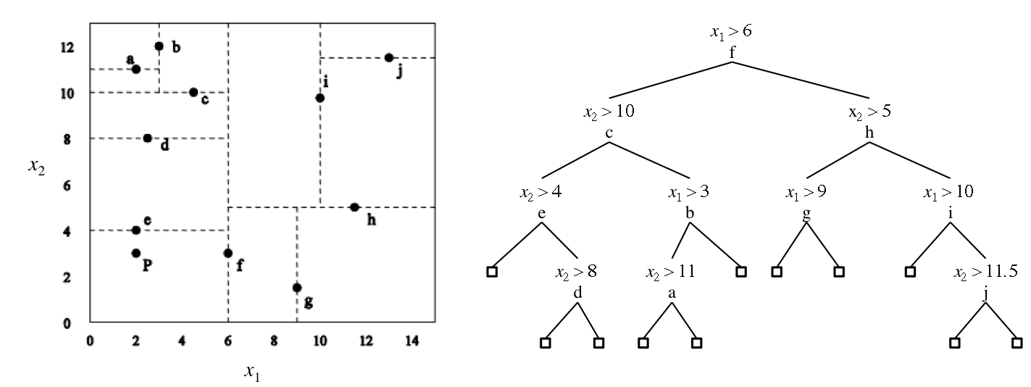
Using the k-d tree and the training set displayed in the figure below, show how the nearest neighbor for x(q) = (7, 10) would be found. Assume that, for all instances in the figure, the features (i.e. coordinates) have integer values. For each step in the search, show the distance to the current node, the best distance found so far, the best node found so far, and the contents of the priority queue. You should use Euclidean distance and assume that the coordinates of the instances in the figure below are those shown in the table below.
Instance | x1 | x2
a | 2 | 11
b | 3 | 12
c | 5 | 10
d | 2 | 8
e | 2 | 4
f | 6 | 3
g | 9 | 2
h | 12 | 5
i | 10 | 10
j | 13 | 11.5

