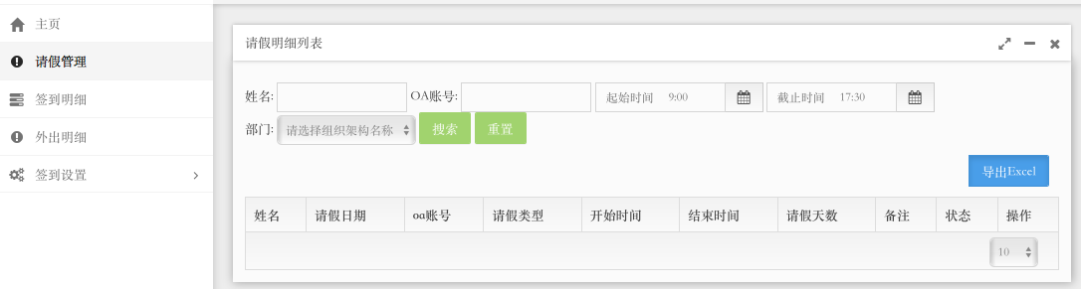

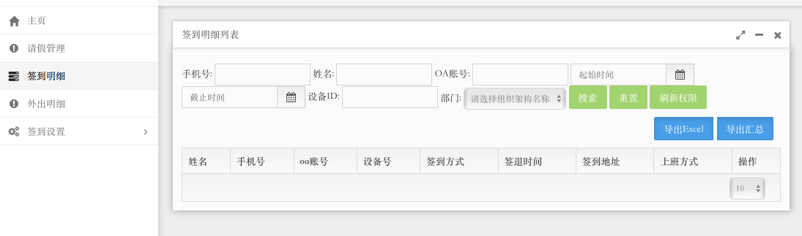

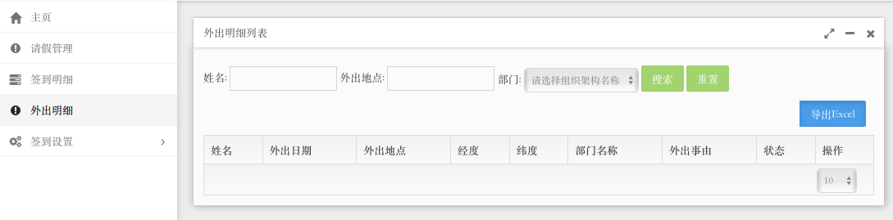

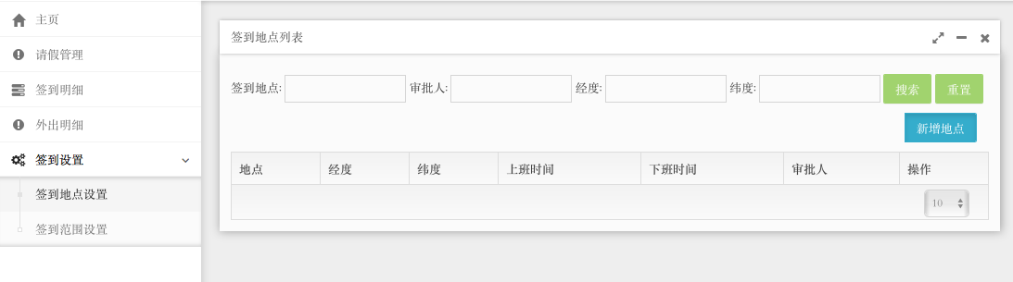

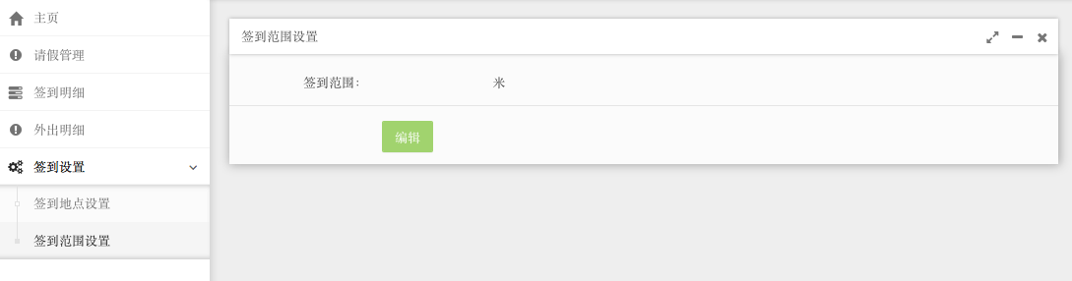

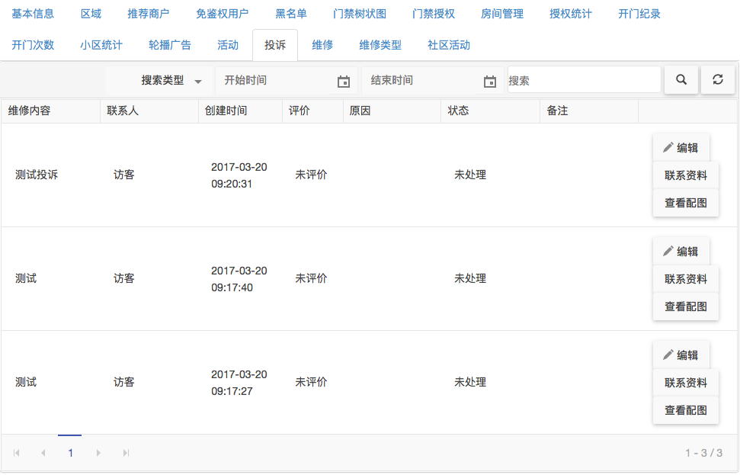

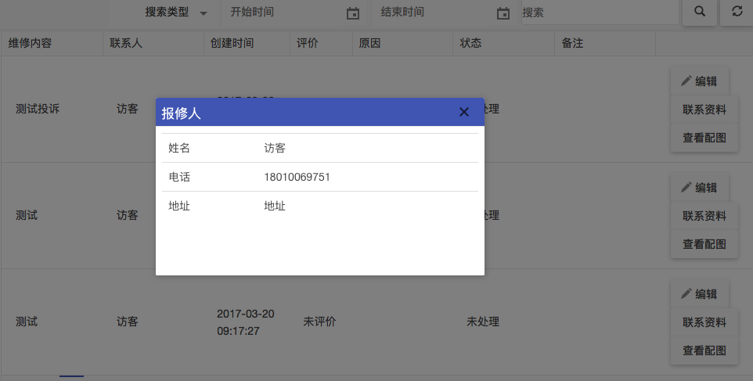

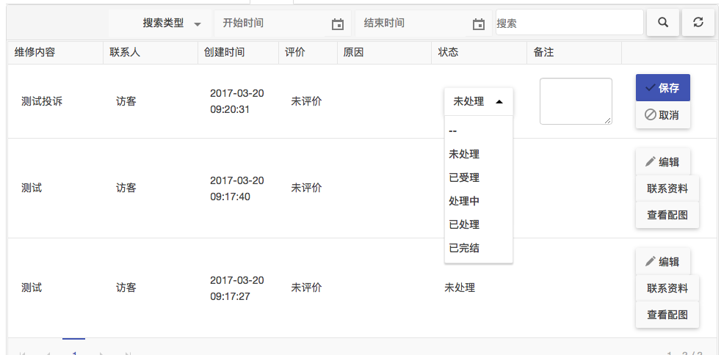

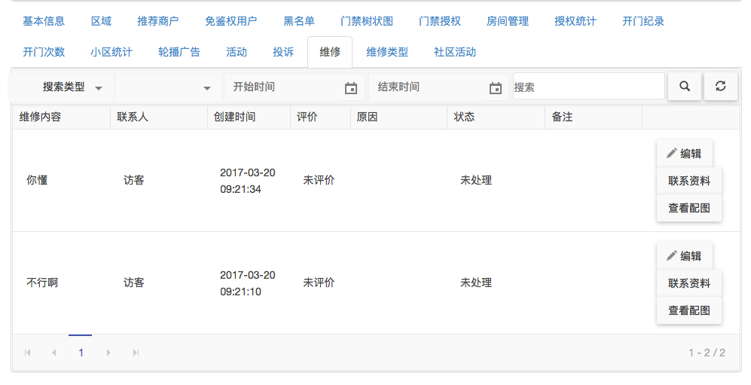

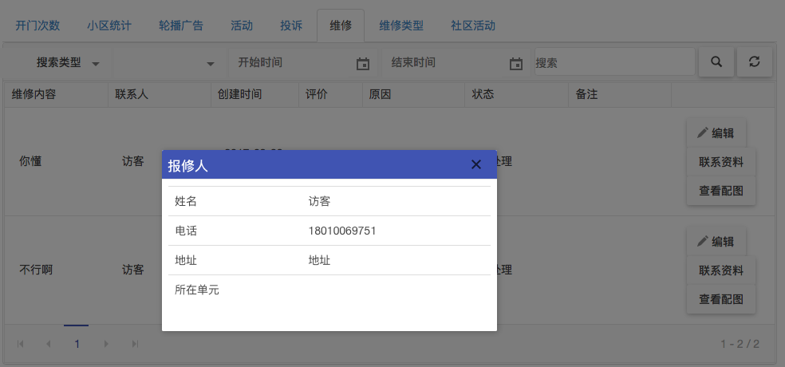

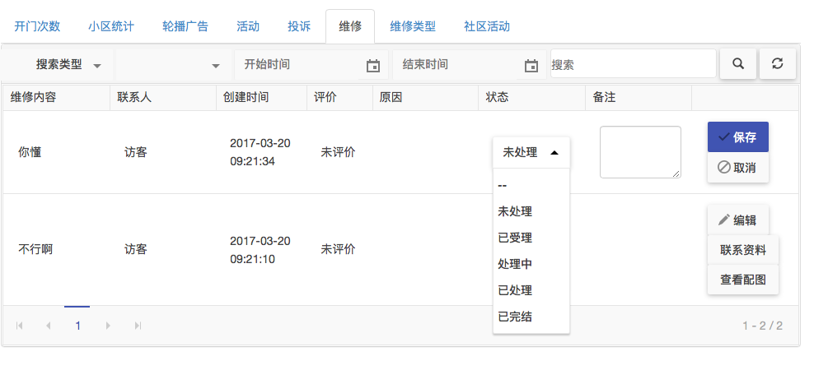

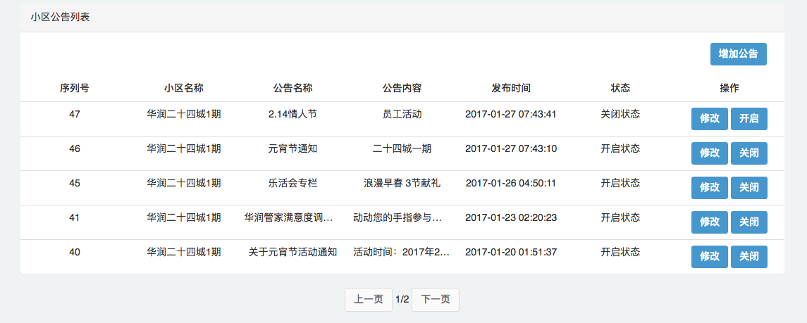

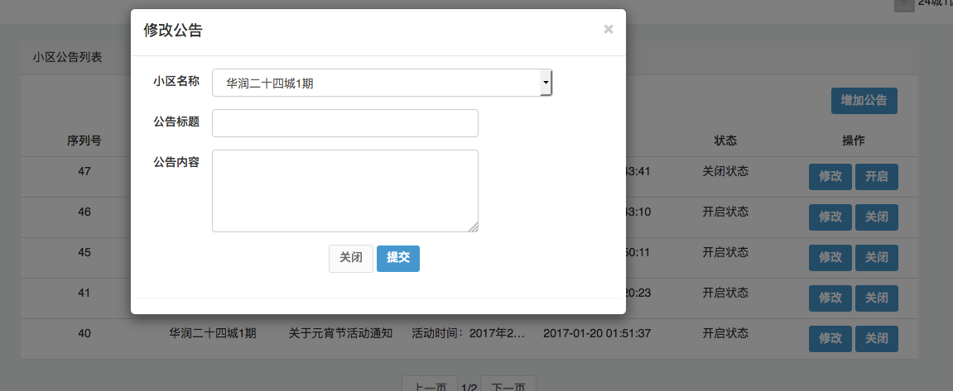

|  |  |  |
| --- | --- | --- |
| /Users/liyong/Downloads/归档/12@2x.png | /Users/liyong/Downloads/归档/9@2x.png | /Users/liyong/Downloads/归档/10@2x.png |
| /Users/liyong/Downloads/归档/11@2x.png | /Users/liyong/Downloads/归档/6@2x.png | /Users/liyong/Downloads/归档/5@2x.png |
| /Users/liyong/Downloads/归档/4@2x.png | /Users/liyong/Downloads/归档/7@2x.png | /Users/liyong/Downloads/归档/2@2x.png |
| /Users/liyong/Downloads/归档/8@2x.png | /Users/liyong/Downloads/归档/3@2x.png | ../../../111.png |
|  |  |  |
|  |  |  |
|  |  |  |
|  |  |  |