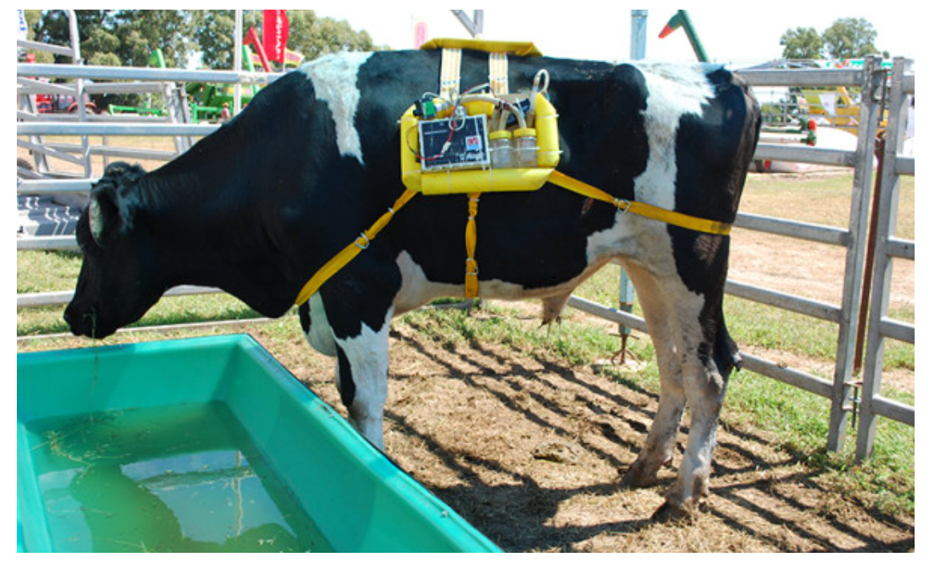

Introduction:

The “cow fart backpack” utilizes one of the most basic natural processes, fermentation, to create a sustainable energy source. This process, in which microorganisms break down biodegradable materials and use the biogas product to be converted into a new form of energy, is used in a methane collecting backpack created by Argentina’s National Institute of Agricultural Technology (INTA). The device connects the cow’s bowels to a light, air-tight backpack that captures their gas, up to 300 liters per day, to be converted into biofuel. It utilizes the natural process of anaerobic digestion within cows to sequester the harmful biogas which would otherwise be emitted into the atmosphere. The biogas is then taken and converted into electric or heat energy. While carbon dioxide is also emitted through this process, the goal is to considerably decrease the effects of methane gas emissions.

The world is currently in the midst of the largest mass extinction of species in 65 million years. Ice caps are melting, causing ocean levels to rise along with the surface temperature of the Earth [1]. Fifteen of the warmest sixteen years ever recorded have all happened since 2001 [2]. Using daily transportation, forgetting to turn off the lights in an empty room, buying food that is not locally sourced, and not recycling are all simple actions that threaten the environment and release greenhouse gases (GHGs) into the atmosphere. The world transportation sector as well as deforestation for industrialization are well-known greenhouse gas contributors. These GHGs are the cause of the rising climate. GHGs consist of nitrous oxide and other fluorinated gases, but the most threatening are carbon dioxide and methane gas. When the sun sends down rays to heat the Earth, they are absorbed, and the Earth then gives off radiation of its own [3]. These gases have the intention of returning back into space. When these GHGs are released into the atmosphere they absorb the heat from the sun, rather than letting it pass through and exit the atmosphere.

Climate change as a result of human actions is considered a major environmental threat to Earth and its inhabitants. Scientists are becoming increasingly concerned with our industries' effect on sustainability and are looking for new, sustainable energy sources. Converting organic materials into biofuel using anaerobic digestion is one method being studied. One application utilizes biogas from organic materials, specifically, animal waste. Methane gas, released from cow flatulence and solid waste, has a global warming potential 86 times that of CO2 on a 20-year time frame. Although many argue that carbon dioxide is the most threatening greenhouse gas, the effects of methane gas are approaching more quickly and will cause much more harm in the short-term [4]. The anthropogenic carbon footprint, the amount of carbon compounds created by a particular person in relation to their lifestyle and consumption of fossil fuels, is expanding exponentially. Humanity's largest and most impactful habit is the consumption of animal products and its perpetuation of animal agriculture.

Problem:

Total elimination of GHGs is not possible at this time, however, a large improvement can be made from limiting the amount of gas that is released and converting it to energy before it escapes into the atmosphere. Mitigating the effects of methane gas in the short-term while more long-term and permanent solutions are developed for CO2 and other gases is a good start to sustainable energy and a greener planet. Methane takes 51 percent of greenhouse emission. While cows produce up to 25% of methane emissions, and methane is a particularly potent greenhouse gas.

One cow a day can power a car 60 kilometers.

A cow can produce 800 liters of methane one day. Its price is $5.

Solution:

Make backpacks for cows, collect their fart gas and store it for energy.

Cows pupping everyday, we use bag to collect the gas, then take it off when it milked. Then store it in a tank. We get energy from the tank whenever we want to use it.

The term “anaerobic digestion” refers to both a natural biological process and an engineered technology. The basis of the process can be simulated to accomplish a variety of goals. Most commonly, waste treatment and energy production. Both cows and humans naturally employ this mechanism as part of the digestive process. Stomach bacteria break down food in the absence of oxygen to create a biogas and harness energy.

Among the many applications of this technology are anaerobic digestion chambers which mimic the natural digestive process that occurs within the cow's stomach by decomposing biodegradable organic materials in the absence of oxygen. This produces an organic fertilizer and biogas consisting of methane, carbon dioxide, nitrogen, and traces of hydrogen sulfide [6]. The biogas product tends to be about 60% methane which can then be burned to generate electricity and heat, or compressed for vehicle fuel. Inputs can include “wasted or spoiled food, plant clippings, animal manure, meat trimmings, and sewage”

Business model:

Considering of the characteristic of the company, we tend to build a mixed model in our company. The major model will be business to business, which fits to those big companies with thousands of cows, such as milk companies, beef companies, and so on. We sell our equipment to those rich companies and send up the circulatory system in their farm. On the other hand, we also hold on the model of business to custom. We are willing to rent our equipment to those little farm owners, then buy gas from them and send gas to the circulatory system.

Market:

With the increase of animal agriculture and cow farming expected for the coming future, the pressing demand for solutions to atmospheric damage as a result of methane gas emissions will become more crucial. Though the methane collection backpack is a thought-provoking and innovative approach to the mitigation of methane gas released through bovine enteric fermentation, the process of manure anaerobic digestion proves significantly more feasible for both economic and cultural reasons. The initial installation costs can be paid off relatively quickly by the income gained by selling both the electricity and fertilizer produced. The issue of waste disposal is also met by this technology.

We can sell our backpack to farmers who have big farms or cow company. The backpack manages to capture and collect the gases emitted through the cow's mouth or intestinal tract via a tube inserted through the cow's skin. The gas is then condensed and ready to use to provide power for the farm on which the cow lives, for example, for activities such as cooking, lighting a home or even driving a car.

Competition:

Some gas companies can become competitors of us. However, our energy sources are free, our energy produce less pollution. As of now, there are no plans to produce and use the backpack on a large scale, but the device surely shows an interesting way to approach a problem.

Our product can save electric power, since the energy from cows’ fart can be used to power the farm, which will save a lot of electricity. After that, if farm can not use up the energy, they can sell them to other farm or factories to get money. As soon as this kind of gas saving system setting up, farm can open their doors to visitors and scientists they will be both interest in seeing how this system works as will as how well it works.

Who is needed:

|  |  |  |
| --- | --- | --- |
| Controller | | Control the company |
| Scientists | Chemist | Make chemical |
| Mechanical | Build the system |
| Seller | | Sell products |

Service we need:

|  |  |
| --- | --- |
| Place to work |  |
| Ads | Rent |
| Transportation | Rent |
| Website | Build ourselves |

Conclusion:

Our bag extracted the methane about 300 liters a day. That’s enough to run a car, or a fridge for 24 hours. There are 2 billion cows in China. Suppose that 10% of them have the backpack, they can make 1 billion US dollar per day.

SOURCES

[1] K. Andersen, K. Kuhn . Cowspiracy: The Sustainability Secret. 2014. Accessed 06.23.16.

[2] “Greenhouse Gas Emissions”. United States

Environmental Protection Agency. 2017. Accessed 01.25.17.https://www.epa.gov/ghgemissions/overview-greenhousegases

[3] “Bovine Rumen”. Microbe Wiki. 2011. Accessed

02.28.17.

https://microbewiki.kenyon.edu/index.php/Bovine_Rumen

[4] D. T. Shindell, G. Faluvegi, D. M. Koch, G. A. Schmidt, N. Unger, S. E. Bauer. “Improves Attribution of Climate Forcing to Emissions”. 10.30.09. Accessed 02.24.17.http://science.sciencemag.org/content/326/5953/716.figuresonly

[5] “Animal Feeding Operations”. United States Environmental Protection Agency. Accessed 02.25.17.http://www.epa.gov

[6] J. Chakravarthi. “Biogas and Energy Production from Cattle Waste”. Energy Conversion Engineering Conference, 1997.