|  |  |  |
| --- | --- | --- |
| **Problem Chosen** E | **2020 MCM/ICM Summary Sheet** | **Team Control Number**  2001112 |

**Strategies for Managing Plastic Waste**

**Summary**

With the rapid development of plastics manufacturing, the impact of plastics on the environment is also increasing. In order to solve the problem of plastic waste, this article addresses the following issues.

**Keywords**:

Contents

1. Introduction 3

1.1 Background 3

1.2 Our Work 3

2. Assumptions and Justifications 4

3. Symbols and Definitions 5

4. Analysis and Modeling 5

4.1 Model 1: Comprehensive Evaluation 5

4.1.1 Analysis of the Problem 5

4.1.2 Establishment of Model 6

4.2 Model 2: Analytic Hierarchy Process (AHP) 8

4.2.1 Analysis of Problem 8

4.2.2 Establishment of Model 9

5. Sensitivity Analysis 11

6. Strengths and Weaknesses 11

6.1 Strengths 11

6.2 Weaknesses 11

6.3 Promotion 11

7. Conclusion 11

8. References 12

# Introduction

## Background

Since the 1950s, the manufacturing of plastics has grown exponentially because of its variety of uses, such as food packaging, consumer products, medical devices, and construction. While there are significant benefits, the negative implications associated with increased production of plastics are concerning. Plastic products do not readily break down, are difficult to dispose of, and only about 9% of plastics are recycled. Effects can be seen by the approximately 4-12 million tons of plastic waste that enter the oceans each year. Plastic waste has severe environmental consequences and it is predicted that if our current trends continue, the oceans will be filled with more plastic than fish by 2050. The effect on marine life has been studied, but the effects on human health are not yet completely understood. The rise of single-use and disposable plastic products results in entire industries dedicated to creating plastic waste. It also suggests that the amount of time the product is useful is significantly shorter than the time it takes to properly mitigate the plastic waste. Consequently, to solve the plastic waste problem, we need to slow down the flow of plastic production and improve how we manage plastic waste.

## Our Work

The specific questions are repeated as follows:

1. Develop a model to estimate the maximum levels of single-use or disposable plastic product waste that can safely be mitigated without further environmental damage. You may need to consider, among many factors, the source of this waste, the extent of the current waste problem, and the availability of resources to process the waste.
2. Discuss to what extent plastic waste can be reduced to reach an environmentally safe level. This may involve considering factors impacting the levels of plastic waste to include, but not limited to, sources and uses of single-use or disposable plastics, the availability of alternatives to plastics, the impact on the lives of citizens, or policies of cities, regions, countries, and continents to decrease single-use or disposable plastic and the effectiveness of such policies. These can vary between regions, so considering regional-specific constraints may make some policies more effective than others.
3. Using your model and discussion, set a target for the minimal achievable level of global waste of single-use or disposable plastic products and discuss the impacts for achieving such levels. You may consider ways in which human life is altered, the environmental impacts, or the effects on the multi-trillion-dollar plastic industry.
4. While this is a global problem, the causes and effects are not equally distributed across nations or regions. Discuss the equity issues that arise from the global crisis and your intended solutions. How do you suggest ICM address these issues?
5. Write a two-page memo to the ICM describing a realistic global target minimum achievable level of global single-use or disposable plastic product waste, a timeline to reach this level, and any circumstances that may accelerate or hinder the achievement of your target and timeline.

# Assumptions and Justifications

To simplify our problems, we make the following basic assumptions, each of which is properly justified.

* Suppose the six countries we selected can represent the overall level of each region.
* In fact, the factors effect each other, but in order to simplify the model, we ignore the interactions between factors.

# Symbols and Definitions

Table Symbols and Definitions

| **Symbol** | **Definition** |
| --- | --- |
| *R* | the recovery rate of plastic materials |
| *D* | the degradability rate of plastic materials |
| *RA* | the replace ability rate of plastic materials |
| *E* | the environmental damage severity of plastic materials |
| *EI* | the ecological environment index |
| *MA* | the maximum reduction of plastic waste |
| $$M_{i}$$ | total plastic waste by region |
|  |  |

# Analysis and Modeling

## Model 1: Comprehensive Evaluation

### Analysis of the Problem

First of all, we read through the relevant papers and determined the factors affecting the waste of plastic products, mainly including the recovery rate R, degradability rate D, replace ability rate RA, and environmental damage severity E, where E is defined as the inverse of the ecological environment index EI. Then by querying the data, we found the classification of plastics according to their uses, and the R, D, RA of various plastic materials under each classification. What’s more, we found the ecological environment index of each country. Consequently, we can construct a regression relationship between these factors and the maximum level of safe mitigation of plastic products without further environmental damage, which can be evaluated using least squares methods.

### Establishment of Model

To simplify the model, we select six countries to represent the overall level of each region, and they are China, Indonesia, Egypt, South Africa, India and United State. They subordinate to different economic classifications, so they are representative.

In Table 2, we have compiled the environmental impact factors of each country so that we can understand the ecological environment level of each country and the ability to manage plastic waste. MMT, million metric tons.

Table Environmental Impact Factors by Country

|  |  |  |  |  |  |  |
| --- | --- | --- | --- | --- | --- | --- |
|  | **China** | **Indonesia** | **Egypt** | **South Africa** | **India** | **United State** |
| ***EI/100*** | 0.5074 | 0.4692 | 0.6121 | 0.4473 | 0.3057 | 0.7119 |
| ***E*** | 1.9708 | 2.1313 | 1.6337 | 2.2356 | 3.2712 | 1.4047 |
| ***RA/%*** | 0.13 | 0.15 | 0.11 | 0.16 | 0.21 | 0.09 |
| ***R/%*** | 9 | 9 | 9 | 9 | 9 | 9 |
| ***D/%*** | 18.96 | 14.25 | 13.48 | 12.08 | 18.16 | 17.17 |
| $M_{i}$***/MMT*** | 60 | 9 | 5 | 1 | 9 | 35 |

The ecological environment index of each country refers to a series of indexes that reflect the quality of the ecological environment in the area evaluated. It has comprehensive characteristics, so it is very important in our evaluation model.

We speculate that there is a certain correlation between RA and E. We then perform a linear correlation analysis on these two data and find that the correlation coefficient is 0.9863. It shows that there is a clear correlation between the two, which can also be seen from the figure 1 below. And the linear fitting equation is

$$\begin{aligned}Y=0.00063X+0.0000671\#\left( AUTONUM \backslash * Arabic \right)\end{aligned}$$

After that, we also find that there is no correlation between RA and D, as you can see the figure 2 below. The correlation coefficient is 0.2138. Knowing this will help our understanding of E on a global scale, and this can help our model become more rigorous.

On this basis, we propose the concept of MA, that is the maximum reduction of plastic waste. It can be described by the following linear regression equation:

$$\begin{aligned}MA=\frac{M_{global}}{\sum_{i=0}^{5}{M_{i}}}\sum_{i=0}^{5}{M_{i}\left(R_{i}+D_{i}+{RA}_{i}\right)∙\sqrt{E_{i}}}\#\left( AUTONUM \backslash * Arabic \right)\end{aligned}$$

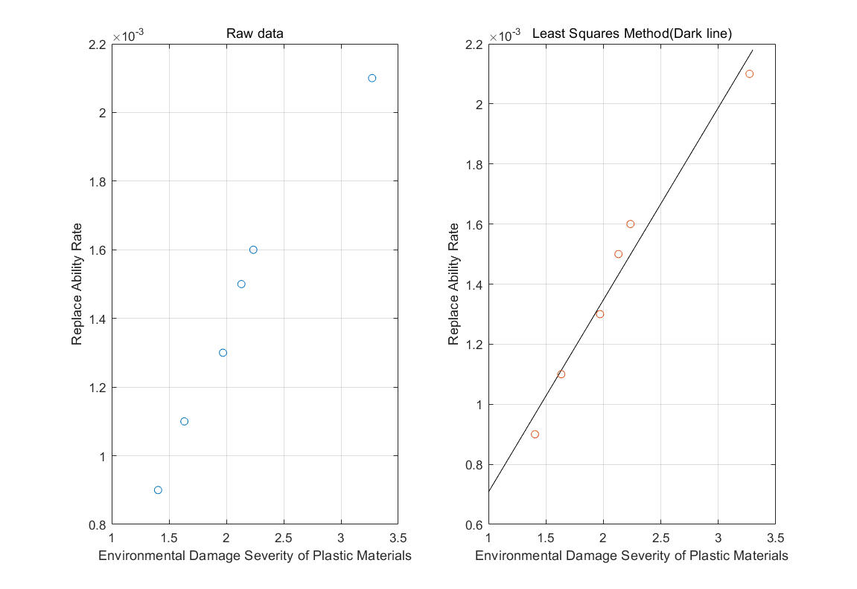

Figure Linear correlation

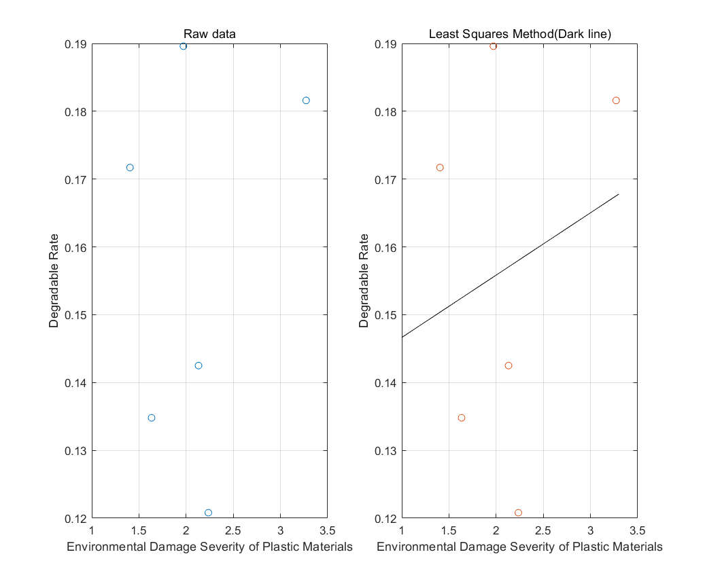

Figure Non-linear correlation

Then we insert the data in Table 2 into Equation 2, $M_{global}=302MMT,$ and the calculation result of MA is 111.27 MMT. So under our model, the maximum level of single-use or disposable plastic product that can safely be mitigated without further environmental damage is 111.27MMT, which means that with the reasonable allocation of all resources, the maximum reduction of plastic waste that can be achieved accounts for about 1/3 of the total, and this is very encouraging.

## Model 2: Analytic Hierarchy Process (AHP)

### Analysis of Problem

This question mainly explores the extent to which plastic waste can be reduced, and involves a variety of factors that affect the level of plastic waste. It is a typical hierarchical analysis question. We use mathematical modeling to solve many aspects and angles that should be considered when dealing with environmental issues. In order to achieve the best plan choice, we will mainly use the analytic hierarchy process, which is divided into three layers: the target level (A), the criterion level (C), and the solution level (P). Based on the specific requirements of this model, the criteria level considers seven factors and calculates the weight of each factor according to the specific country corresponding to the scheme level. Then perform weighting processing to obtain the priorities of various schemes and finally obtain the optimal scheme.

Further, we divide the criterion level into $Ci(i=1,2,⋯,7),$ and they are as follows:

Table the Criterion Layer

|  |  |
| --- | --- |
| **Ci** | **Meaning** |
| C1 | GDP |
| C2 | Sources and Uses of Plastics |
| C3 | the Availability of alternatives to plastics |
| C4 | Policy |
| C5 | EI |
| C6 | Annual Plastic Waste Production |
| C7 | the Impacts on the Lives of Citizens |

### Establishment of Model

The three hierarchy structure which contains criteria level and solution level is shown in following picture.

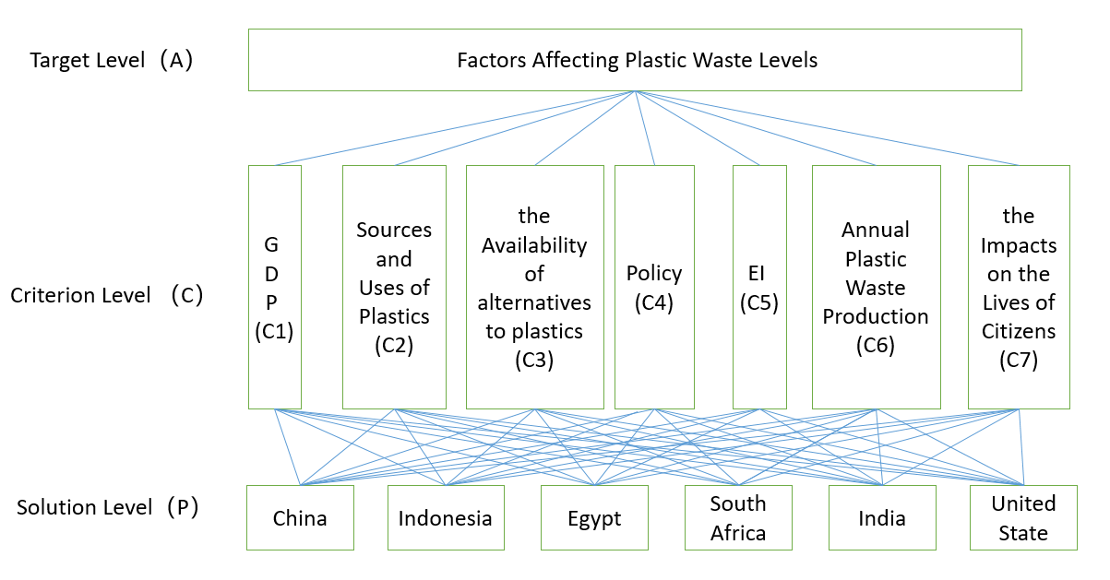

Picture the Three Hierarchy Structure of Our Model

To obtain the index weight,

* Determine the judging matrix

We use the pairwise comparison method and one-nine method to construct judging matrix $A=(a_{ij})$. $\#( AUTONUM \backslash * Arabic )$

$$\begin{aligned}a_{ij}=a_{ik}×a_{kj}\#\left( AUTONUM \backslash * Arabic \right)\end{aligned}$$

Where $a_{ij}$ is set according to the one-nine method.

The one-nine method can be seen in the Table 4.

Table One-nine scale for AHP preferences

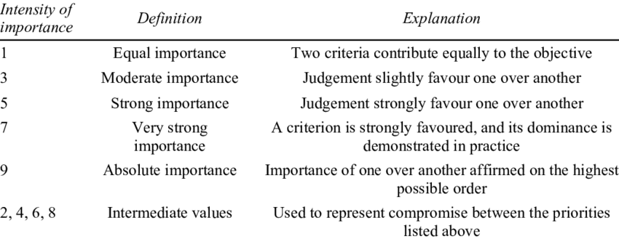

# Sensitivity Analysis

# Strengths and Weaknesses

## Strengths

## Weaknesses

## Promotion

# Conclusion

# References