|  |  |  |
| --- | --- | --- |
| **Problem Chosen** E | **2020 MCM/ICM Summary Sheet** | **Team Control Number**  2001112 |

**Strategies for Managing Plastic Waste**

**Summary**

With the rapid development of plastics manufacturing, the impact of plastics on the environment is also increasing. In order to solve the problem of plastic waste, this paper addresses the following issues by stepwise modeling.

To study the relationship between the maximum levels of plastic waste that can be mitigated and several factors, we apply Comprehensive Evaluation Model after determining the major factors. Using the data from six representative countries, we determine initial conditions for our model. It is found that the maximum reduction of plastic waste is 111.27 million metric tons.

Then Analytic Hierarchy Process (AHP) Model is established to determine the weight of each metric to countries’ evaluation grade. All metrics are adequately filled into the three-hierarchy structure, and then we obtain the metric weight based on which evaluation grade is calculated. Then we carry out weighted processing to obtain the priority of various schemes, and finally obtain the final ranking of the six countries, which means the ability of these countries to manage plastic waste. After that, we calculate that plastic waste can be reduced 13.5% to reach an environmentally safe level.

**Keywords**:

Contents

1. Introduction 2

1.1 Background 2

1.2 Our Work 2

2. Assumptions and Justifications 3

3. Symbols and Definitions 4

4. Analysis and Modeling 4

4.1 Model 1: Comprehensive Evaluation 4

4.1.1 Analysis of the Problem 4

4.1.2 Establishment of Model 5

4.2 Model 2: Analytic Hierarchy Process (AHP) 6

4.2.1 Analysis of Problem 6

4.2.2 Establishment of Model 7

4.2.3 Results & Analysis 9

4.3 Model 3: Multiple Linear Regression (MLR) 12

4.3.1 Analysis of Problem 12

4.3.2 Establishment of Model 13

4.3.3 Discussion of the Impacts for Achieving Ideal Levels 14

4.4 Solutions to Equity Issues 15

4.4.1 Reasons for Differences 15

4.4.2 Further Analysis 16

5. Sensitivity Analysis 18

6. Strengths and Weaknesses 19

6.1 Strengths 19

6.2 Weaknesses 19

6.3 Promotion 19

7. Conclusion 19

8. A Memo to the ICM 20

9. References 20

# Introduction

## Background

Since the 1950s, the manufacturing of plastics has grown exponentially because of its variety of uses, such as food packaging, consumer products, medical devices, and construction. While there are significant benefits, the negative implications associated with increased production of plastics are concerning. Plastic products do not readily break down, are difficult to dispose of, and only about 9% of plastics are recycled. Effects can be seen by the approximately 4-12 million tons of plastic waste that enter the oceans each year. Plastic waste has severe environmental consequences and it is predicted that if our current trends continue, the oceans will be filled with more plastic than fish by 2050. The effect on marine life has been studied, but the effects on human health are not yet completely understood. The rise of single-use and disposable plastic products results in entire industries dedicated to creating plastic waste. It also suggests that the amount of time the product is useful is significantly shorter than the time it takes to properly mitigate the plastic waste. Consequently, to solve the plastic waste problem, we need to slow down the flow of plastic production and improve how we manage plastic waste.

## Our Work

The specific questions are repeated as follows:

1. Develop a model to estimate the maximum levels of single-use or disposable plastic product waste that can safely be mitigated without further environmental damage. You may need to consider, among many factors, the source of this waste, the extent of the current waste problem, and the availability of resources to process the waste.
2. Discuss to what extent plastic waste can be reduced to reach an environmentally safe level. This may involve considering factors impacting the levels of plastic waste to include, but not limited to, sources and uses of single-use or disposable plastics, the availability of alternatives to plastics, the impact on the lives of citizens, or policies of cities, regions, countries, and continents to decrease single-use or disposable plastic and the effectiveness of such policies. These can vary between regions, so considering regional-specific constraints may make some policies more effective than others.
3. Using your model and discussion, set a target for the minimal achievable level of global waste of single-use or disposable plastic products and discuss the impacts for achieving such levels. You may consider ways in which human life is altered, the environmental impacts, or the effects on the multi-trillion-dollar plastic industry.
4. While this is a global problem, the causes and effects are not equally distributed across nations or regions. Discuss the equity issues that arise from the global crisis and your intended solutions. How do you suggest ICM address these issues?
5. Write a two-page memo to the ICM describing a realistic global target minimum achievable level of global single-use or disposable plastic product waste, a timeline to reach this level, and any circumstances that may accelerate or hinder the achievement of your target and timeline.

# Assumptions and Justifications

To simplify our problems, we make the following basic assumptions, each of which is properly justified.

* Suppose the six countries we selected can represent the overall level of each region.
* In fact, the factors effect each other, but in order to simplify the model, we ignore the interactions between factors.
* Suppose that the environmental safety level in Model 2 is to reduce 90% of marine plastic waste and 20% of land plastic waste.

# Symbols and Definitions

Table Symbols and Definitions

| **Symbol** | **Definition** |
| --- | --- |
| *R* | the recovery rate of plastic materials |
| *D* | the degradability rate of plastic materials |
| *RA* | the replace ability rate of plastic materials |
| *E* | the environmental damage severity of plastic materials |
| *EI* | the ecological environment index |
| *MA* | the maximum reduction of plastic waste |
| $$M_{i}$$ | total plastic waste by region |
| A | the target level of AHP |
| C | the criterion level of AHP |
| P | the solution level of AHP |
| $$λ_{max}$$ | the greatest eigenvalue of matrix |
| *w* | the weight of an impact factor |
| *CI* | Consistency Index |
| *CR* | Consistency Ratio |
| *RI* | Random Index |

# Analysis and Modeling

## Model 1: Comprehensive Evaluation

### Analysis of the Problem

First of all, we read through the relevant papers and determine the factors affecting the waste of plastic products, mainly including the recovery rate R, degradability rate D, replace ability rate RA, and environmental damage severity E, where E is defined as the inverse of the ecological environment index EI. Then by querying the data, we find the classification of plastics according to their uses, and the R, D, RA of various plastic materials under each classification. What’s more, we find the ecological environment index of each country. Consequently, we can construct a regression relationship between these factors and the maximum level of safe mitigation of plastic products without further environmental damage, which can be evaluated using least squares methods.

### Establishment of Model

To simplify the model, we select six countries to represent the overall level of each region, and they are China, Indonesia, Egypt, South Africa, India and United State. They subordinate to different economic classifications, so they are representative.

In Table 2, we have compiled the environmental impact factors of each country so that we can understand the ecological environment level of each country and the ability to manage plastic waste. MMT, million metric tons.

Table Environmental Impact Factors by Country

|  |  |  |  |  |  |  |
| --- | --- | --- | --- | --- | --- | --- |
|  | **China** | **Indonesia** | **Egypt** | **South Africa** | **India** | **United State** |
| ***EI/100*** | 0.5074 | 0.4692 | 0.6121 | 0.4473 | 0.3057 | 0.7119 |
| ***E*** | 1.9708 | 2.1313 | 1.6337 | 2.2356 | 3.2712 | 1.4047 |
| ***RA/%*** | 0.13 | 0.15 | 0.11 | 0.16 | 0.21 | 0.09 |
| ***R/%*** | 9 | 9 | 9 | 9 | 9 | 9 |
| ***D/% $M_{i}$***  ***/MMT*** | 18.96 | 14.25 | 13.48 | 12.08 | 18.16 | 17.17 |
|  | 60 | 9 | 5 | 1 | 9 | 35 |

The ecological environment index of each country refers to a series of indexes that reflect the quality of the ecological environment in the area evaluated. It has comprehensive characteristics, so it is very important in our evaluation model.

We speculate that there is a certain correlation between RA and E. We then perform a linear correlation analysis on these two data and find that the correlation coefficient is 0.9863. It shows that there is a clear correlation between the two, which can also be seen from the figure 1 below. And the linear fitting equation is

$$\begin{aligned}Y=0.00063X+0.0000671\#\left( AUTONUM \backslash * Arabic \right)\end{aligned}$$

After that, we also find that there is no correlation between RA and D, as you can see the figure 2 below. The correlation coefficient is 0.2138. Knowing this will help our understanding of E on a global scale, and this can help our model become more rigorous.

On this basis, we propose the concept of MA, that is the maximum reduction of plastic waste. It can be described by the following linear regression equation:

$$\begin{aligned}MA=\frac{M_{global}}{\sum_{i=0}^{5}{M_{i}}}\sum_{i=0}^{5}{M_{i}\left(R_{i}+D_{i}+{RA}_{i}\right)∙\sqrt{E_{i}}}\#\left( AUTONUM \backslash * Arabic \right)\end{aligned}$$

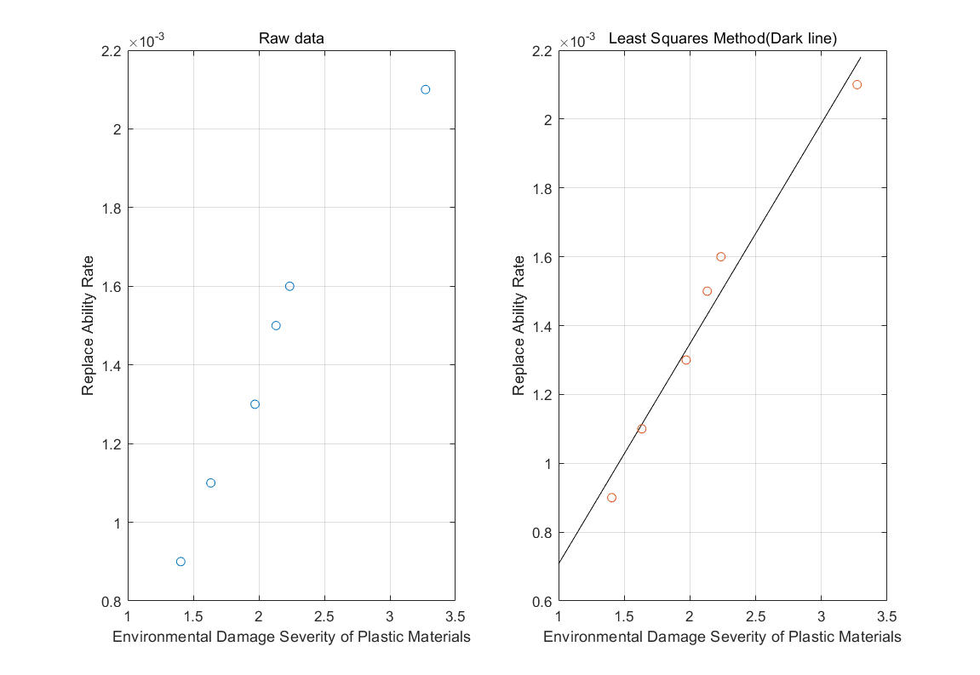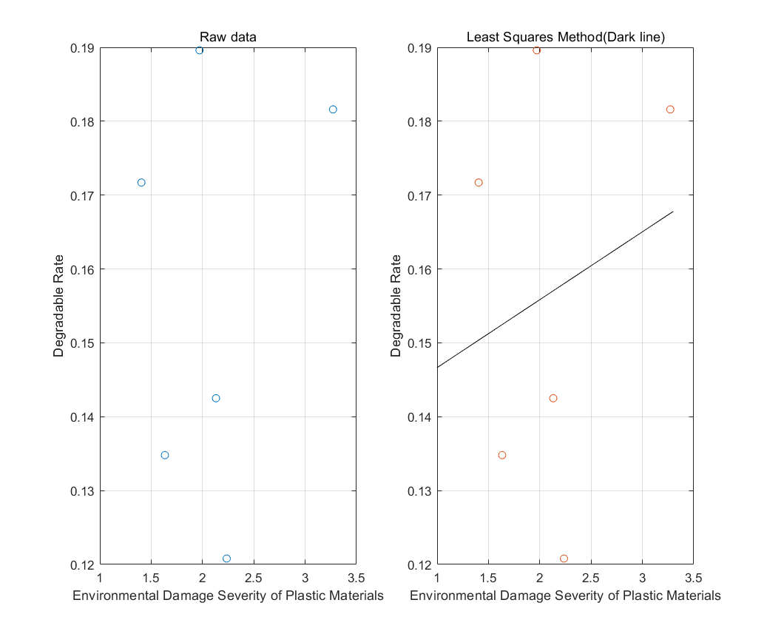

Figure Linear correlation Figure Non-linear correlation

Then we insert the data in Table 2 into Equation 2, $M_{global}=302MMT,$ and the calculation result of MA is 111.27 MMT. So under our model, the maximum level of single-use or disposable plastic product that can safely be mitigated without further environmental damage is 111.27MMT, which means that with the reasonable allocation of all resources, the maximum reduction of plastic waste that can be achieved accounts for about 1/3 of the total, and this is very encouraging.

## Model 2: Analytic Hierarchy Process (AHP)

### Analysis of Problem

This question mainly explores the extent to which plastic waste can be reduced, and involves a variety of factors that affect the level of plastic waste. It is a typical hierarchical analysis question. We use mathematical modeling to solve many aspects and angles that should be considered when dealing with environmental issues. In order to achieve the best plan choice, we will mainly use the analytic hierarchy process, which is divided into three layers: the target level (A), the criterion level (C), and the solution level (P). Based on the specific requirements of this model, the criteria level considers seven factors and calculates the weight of each factor according to the specific country corresponding to the scheme level. Then we perform weighting processing to obtain the priorities of various schemes and finally obtain the optimal scheme.

Further, we divide the criterion level into $Ci(i=1,2,⋯,7),$ and they are as follows:

Table the Criterion Level

|  |  |
| --- | --- |
| **Ci** | **Meaning** |
| C1 | GDP |
| C2 | Sources and Uses of Plastics |
| C3 | the Availability of alternatives to plastics |
| C4 | Policy |
| C5 | EI |
| C6 | Annual Plastic Waste Production |
| C7 | the Impacts on the Lives of Citizens |

One thing, these factors of the criterion level can describe their impact on the target level. For the other thing, they can describe their impact on the six countries of the solution level.

### Establishment of Model

The three hierarchy structure which contains criteria level and solution level is shown in following figure.

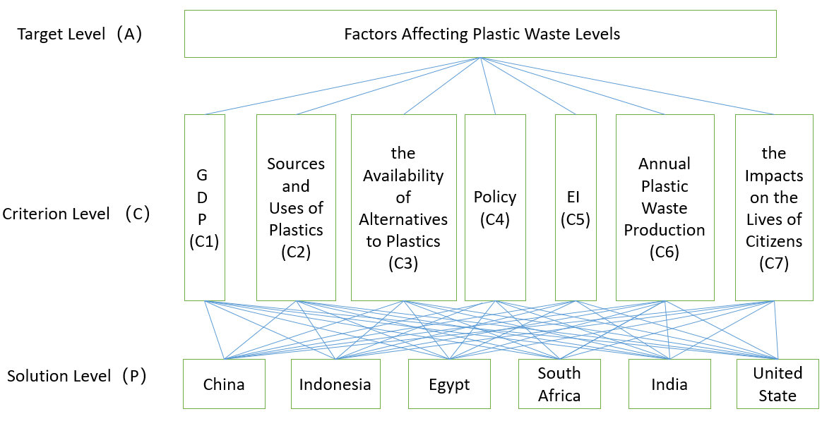

Figure the Three Hierarchy Structure of Our Model

**To obtain the index weight,**

* Determine the judging matrix

We use the pairwise comparison method and one-nine method to construct judging matrix $A=(a_{ij})$.

$$\begin{aligned}a_{ij}=a_{ik}×a_{kj}\#\left( AUTONUM \backslash * Arabic \right)\end{aligned}$$

Where $a_{ij}$ is set according to the one-nine method.

The one-nine method can be seen in the Table 4.

Table One-nine scale for AHP preferences

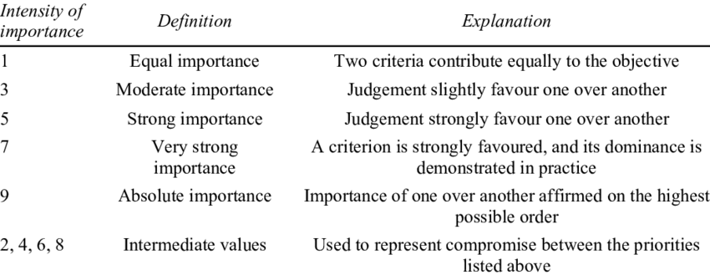

* Calculate the eigenvalues and eigenvectors

The greatest eigenvalue of matrix A is $λ_{max}$, and the corresponding eigenvector is $u={(u_{1},u_{2},u_{3},⋯,u_{n})}^{T}$. Then we normalize the u by the expression:

$$\begin{aligned}w_{i}=\frac{u_{i}}{\sum_{j=0}^{n}{u_{j}}}\#\left( AUTONUM \backslash * Arabic \right)\end{aligned}$$

* Do the consistency check

The indicator of consistency check formula:

$$\begin{aligned}CI=\frac{λ_{max}-n}{n-1}\#\left( AUTONUM \backslash * Arabic \right)\end{aligned}$$

Where n denotes the exponent number of matrix.

The expression of consistency ratio is:

$$\begin{aligned}CR=\frac{CI}{RI}\#\left( AUTONUM \backslash * Arabic \right)\end{aligned}$$

As we know, when n=7, RI=1.32. When CR <0.1, the degree of inconsistency of A is within the allowable range. At this time, the eigenvectors of A can be used as the weight vector.

* Calculate combination weight vector and check combination consistency

From the discussion above, we can obtain weight vector from level 2 to level 1:

$$\begin{aligned}w^{\left(2\right)}={\left(w_{1}^{\left(2\right)},⋯,w_{7}^{\left(2\right)}\right)}^{T} \#\left( AUTONUM \backslash * Arabic \right)\end{aligned}$$

Similarly, we can obtain the weight vector from level 3 to level 2:

$$\begin{aligned}w_{k}^{\left(3\right)}={\left(w_{k1}^{\left(3\right)},⋯,w_{k6}^{\left(3\right)}\right)}^{T},k=1,2,⋯,7\#\left( AUTONUM \backslash * Arabic \right)\end{aligned}$$

After that, we also need to do the combinatorial consistency check in order to ensure the rationality of our model. And the consistency ratio of the total ranking of the hierarchy is:

$$\begin{aligned}{CR}^{\left(p\right)}=\frac{w_{1}^{\left(p-1\right)}{CI}_{1}+w_{2}^{\left(p-1\right)}{CI}_{2}+⋯+w_{7}^{\left(p-1\right)}{CI}_{7}}{w_{1}^{\left(p-1\right)}{RI}_{1}+w_{2}^{\left(p-1\right)}{RI}_{2}+⋯+w_{7}^{\left(p-1\right)}{RI}_{7}} \#\left( AUTONUM \backslash * Arabic \right)\end{aligned}$$

And we can calculate the

$$\begin{aligned}{CR}^{\left(total\right)}=\sum_{p=2}^{3}{{CR}^{\left(p\right)}}\#\left( AUTONUM \backslash * Arabic \right)\end{aligned}$$

### Results & Analysis

To obtain the results of our model, we have compiled and collated the relevant data, and they are summarized in table 5 below.

Table data from criteria level

|  |  |  |  |
| --- | --- | --- | --- |
|  | **GDP(trillion)** | **Total Population(billion)** | **Per capita waste (tonnes)** |
| **China** | 11.06 | 1.37 | 0.044165 |
| **Indonesia** | 0.86 | 0.285 | 0.09198 |
| **Egypt** | 0.33 | 0.094 | 0.06497 |
| **South Africa** | 0.31 | 0.056 | 0.0876 |
| **India** | 2.1 | 1.03 | 0.00365 |
| **United State** | 18.12 | 0.321 | 0.122275 |
|  | **Annual plastic waste production** | **EI** | **Unmanaged plastic waste** |
| **China** | 60MMT | 50.74 | 8.82 |
| **Indonesia** | 9MMT | 46.92 | 3.22 |
| **Egypt** | 5MMT | 61.21 | 0.97 |
| **South Africa** | 1MMT | 44.73 | 0.63 |
| **India** | 9MMT | 30.57 | 0.6 |
| **United State** | 35MMT | 71.19 | 0.28 |
|  | **Policy** | | |
| **China** | Since June 1, 2008, the system of paid use of plastic shopping bags has been implemented in all supermarkets, shopping malls, and trade fairs, etc. | | |
| **Indonesia** | Producers must manage packaging and / or goods, which cannot be broken down by natural processes and difficult to break down by natural processes. | | |
| **Egypt** | Egypt Red Sea province to ban single-use plastic | | |
| **South Africa** | South African government to review policy on single-use plastics | | |
| **India** | A bold plan to ban single-use plastic in nation of 1.3 billion has been shelved | | |
| **United State** | The United States requires effective federal policy to reduce marine plastic pollution | | |

Based on the data we have already collected in table 5, we solve the model and obtain the following results: (Take A for example)

* Judging matrix:
$$A=\left[\begin{matrix}1 & 1/3 & 2 & 1/3 & 1/5 & 1/3 & 1/3 \\ 3 & 1 & 6 & 1 & 1/2 & 1/2 & 1 \\ 1/2 & 1/6 & 1 & 1/7 & 1/7 & 1/6 & 1/5 \\ 3 & 1 & 7 & 1 & 1/4 & 1/2 & 1/2 \\ 5 & 2 & 7 & 4 & 1 & 3 & 2 \\ 3 & 2 & 6 & 2 & 1/3 & 1 & 1/5 \\ 3 & 1 & 5 & 2 & 1/2 & 5 & 1\end{matrix}\right]$$

* Weight vector of criteria level:

$$w={(0.0487, 0.1327, 0.0268, 0.111, 0.3085, 0.1434, 0.229)}^{T}$$

For this level, $CI=\frac{λ_{max}-n}{n-1}=0.0961$, $CR=\frac{CI}{RI}=0.0706<0.1$.

* What’s more, we can obtain the Judging matrixes of $B_{i}$, which represent the pairwise comparison matrix of scheme pair $C_{i}, i=1,2,⋯,$ 6.

$$B_{1}=\left[\begin{matrix}1 & 5 & 6 & 6 & 3 & 1/2 \\ 1/5 & 1 & 2 & 2 & 1/3 & 1/7 \\ 1/6 & 1/2 & 1 & 1 & 1/3 & 1/8 \\ 1/6 & 1/2 & 1 & 1 & 1/3 & 1/9 \\ 1/3 & 3 & 3 & 3 & 1 & 1/6 \\ 2 & 7 & 8 & 9 & 6 & 1\end{matrix}\right] B_{2}=\left[\begin{matrix}1 & 1 & 3 & 5 & 3 & 1/3 \\ 1 & 1 & 3 & 5 & 2 & 1/4 \\ 1/3 & 1/3 & 1 & 3 & 1 & 1/5 \\ 1/5 & 1/5 & 1/3 & 1 & 1/3 & 1/9 \\ 1/3 & 1/2 & 1 & 3 & 1 & 1/6 \\ 3 & 4 & 5 & 9 & 6 & 1\end{matrix}\right]$$

$$B_{3}=\left[\begin{matrix}1 & 1/3 & 1/5 & 1/3 & 1/3 & 3 \\ 3 & 1 & 1/3 & 1 & 1/2 & 6 \\ 5 & 3 & 1 & 3 & 1/4 & 8 \\ 3 & 1 & 1/3 & 1 & 1/2 & 6 \\ 3 & 2 & 4 & 2 & 1 & 5 \\ 1/3 & 1/6 & 1/8 & 1/6 & 1/5 & 1\end{matrix}\right] B_{4}=\left[\begin{matrix}1 & 1/3 & 1/5 & 1/5 & 1/3 & 3 \\ 3 & 1 & 1/3 & 1/3 & 1/2 & 6 \\ 5 & 3 & 1 & 1 & 1/3 & 7 \\ 5 & 3 & 1 & 1 & 2 & 8 \\ 3 & 2 & 3 & 1/2 & 1 & 5 \\ 1/3 & 1/6 & 1/7 & 1/8 & 1/5 & 1\end{matrix}\right]$$

$$B_{5}=\left[\begin{matrix}1 & 2 & 1/3 & 3 & 6 & 1/5 \\ 1/2 & 1 & 1/5 & 2 & 3 & 1/6 \\ 3 & 5 & 1 & 5 & 8 & 1/3 \\ 1/3 & 1/2 & 1/5 & 1 & 3 & 1/7 \\ 1/6 & 1/3 & 1/8 & 1/3 & 1 & 1/9 \\ 5 & 6 & 3 & 7 & 9 & 1\end{matrix}\right]{ B}_{6}=\left[\begin{matrix}1 & 1/4 & 1/5 & 1/7 & 1/4 & 1/2 \\ 4 & 1 & 1/2 & 1/3 & 1 & 3 \\ 5 & 2 & 1 & 1/3 & 2 & 4 \\ 7 & 3 & 3 & 1 & 3 & 5 \\ 4 & 1 & 1/2 & 1/3 & 1 & 3 \\ 2 & 1/3 & 1/4 & 1/5 & 1/3 & 1\end{matrix}\right]$$

$$B_{7}=\left[\begin{matrix}1 & 2 & 3 & 5 & 3 & 1/3 \\ 1/2 & 1 & 2 & 3 & 2 & 1/5 \\ 1/3 & 1/2 & 1 & 3 & 1 & 1/5 \\ 1/5 & 1/3 & 1/3 & 1 & 1/3 & 1/7 \\ 1/3 & 1/2 & 1 & 3 & 1 & 1/6 \\ 3 & 5 & 5 & 7 & 6 & 1\end{matrix}\right]$$

So we can obtain the calculation result of level 3 to level 2 as shown in Table 6.

Table the calculation result of level 3 to level 2

|  |  |  |  |  |  |  |  |
| --- | --- | --- | --- | --- | --- | --- | --- |
| **k** | **1** | **2** | **3** | **4** | **5** | **6** | **7** |
| $$w_{k}^{(3)}$$ | 0.2715 | 0.185 | 0.0642 | 0.059 | 0.1231 | 0.0391 | 0.2097 |
| 0.0632 | 0.1661 | 0.1406 | 0.1213 | 0.0721 | 0.1398 | 0.1236 |
| 0.0418 | 0.0757 | 0.2686 | 0.2301 | 0.26 | 0.2193 | 0.0818 |
| 0.0407 | 0.0337 | 0.1406 | 0.3014 | 0.0529 | 0.4023 | 0.0394 |
| 0.1177 | 0.0777 | 0.3551 | 0.2584 | 0.0277 | 0.1398 | 0.0793 |
| 0.4651 | 0.4618 | 0.0309 | 0.0297 | 0.4643 | 0.0596 | 0.4662 |
| $${CI}_{k}$$ | 0.0287 | 0.0254 | 0.1176 | 0.0909 | 0.0542 | 0.0284 | 0.0328 |
| $${CR}_{k}$$ | 0.0228 | 0.0201 | 0.0933 | 0.0721 | 0.043 | 0.0225 | 0.0261 |

From the table above, we can find all of these seven vectors satisfy $CR<0.1.$

Then we use Equation 9 and Equation 10, we can calculate ${CR}^{\left(total\right)}=0.1132$, it satisfies the consistency check. So we can get the combination weight vector of the solution level to the target : ${ (\begin{matrix}0.1376 & 0.1129 & 0.1752 & 0.1267 & 0.1010 & 0.3466\end{matrix})}^{T}$. Finally, we can obtain the final ranking of the 6 countries using AHP models, which means the ability of these countries to manage plastic waste.

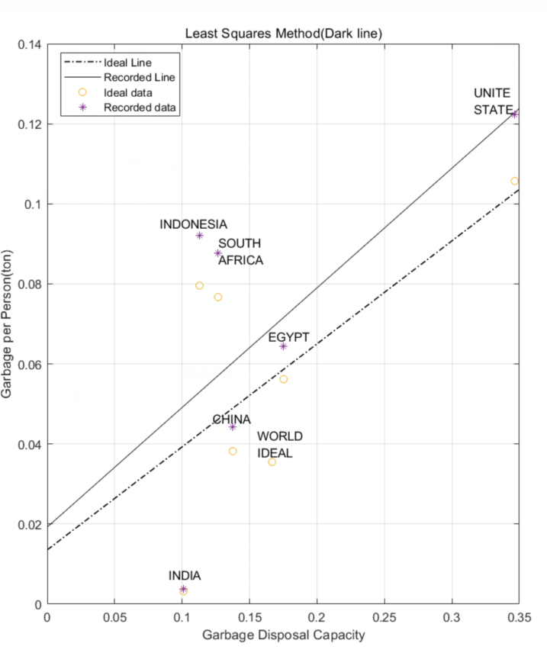

Figure Comparison of actual per capita values of plastic waste with ideal goals

Using the linear regression equation, we fit the relationship between the per capita plastic garbage and the plastic garbage capacity of each country under the ideal situation and the real situation as shown in Fig.4.

From the figure above, we can determine what each country should do faced with its waste disposal capacity. As far as India is concerned, the ideal and recorded data of it both fulfill the standard, so it should maintain the status quo. For China, it belongs to middle-income country, and it is close to the ideal line, we can know the biggest weighting factor for China is GDP from Table 6, so what should be done is to ensure that GDP development is in harmony with the environment. Next we look at South Africa and Indonesia, both of them belong to lower-middle-income countries, and their per capita plastic waste far exceeds environmental safety level, so what should be done is to regulate the sources and uses of plastics and reduce annual plastic waste production. Similarly, Egypt should attach importance to the availability of alternatives to plastics and United States should pay more attention to the impacts on the lives of citizens.

To conclude, with multiple factors in mind, plastic waste can be reduced 13.5% to reach an environmentally safe level.

## Model 3: Multiple Linear Regression (MLR)

### Analysis of Problem

In order to make a prediction about the minimal achievable level of global waste of single-use or disposable plastic products, combined with the first two questions, we employ multiple linear regression model. Because our target need to be economic and environmentally friendly, we start from the idea of the local to the whole. We first use the least square method to fit the relationship curve between GDP and its corresponding weight, so is the environment factor. Due to the stability of the above two factors, we can use the global average level instead. Then the relation matrix is constructed by using the relationship between various factors and the annual plastic waste quantity of the country, thus the proportional coefficient matrix of the two can be calculated, and then the lowest plastic waste production in the world can be obtained by using this coefficient matrix. In addition, we also need to put this data into model 1 to calculate the ideal minimum level.

Generally speaking, the topic is the discussion and improvement of the first two models, and on this basis, we discuss the impact of achieving goals.

### Establishment of Model

First of all, we improved the data in Table 6 and construct a new matrix X. And we know annual plastic waste production by country, named Y. Matrixes X and Y are shown below.

We build a multiple linear regression equation:

$$\begin{aligned}Y=XB+ξ \#\left( AUTONUM \backslash * Arabic \right)\end{aligned}$$

Where B represents the proportional coefficient matrix, and $ξ$ represents error factor matrix.

$$X=\left[\begin{matrix}0.2715 & 0.185 & 0.0642 & 0.059 & 0.1231 & 0.2097 \\ 0.0632 & 0.1661 & 0.1406 & 0.1213 & 0.0721 & 0.1236 \\ 0.0418 & 0.0757 & 0.2686 & 0.2301 & 0.26 & 0.0818 \\ 0.0407 & 0.0337 & 0.1406 & 0.3014 & 0.0529 & 0.0394 \\ 0.1177 & 0.0777 & 0.3551 & 0.2584 & 0.0277 & 0.0793 \\ 0.4651 & 0.4618 & 0.0309 & 0.0297 & 0.4643 & 0.4662\end{matrix}\right] Y=\left[\begin{matrix}60 \\ 9 \\ \begin{matrix}5 \\ 1 \\ \begin{matrix}9 \\ 35\end{matrix}\end{matrix}\end{matrix}\right]$$

So we can easily obtain matrix B with errors ignored:

$$B={(\begin{matrix}574.6142 & 747.4276 & 940.7328 & 358.612 & 1197.27 & 1167.28\end{matrix})}^{T}$$

After that, we need to discuss the problem at a global level. In order to achieve the ideal target prediction, we calculate the 4 weighting factors according to the minimum case. Considering the stability of GDP and environmental factors, now we use the least square method to fit the relationships between their values and weights.

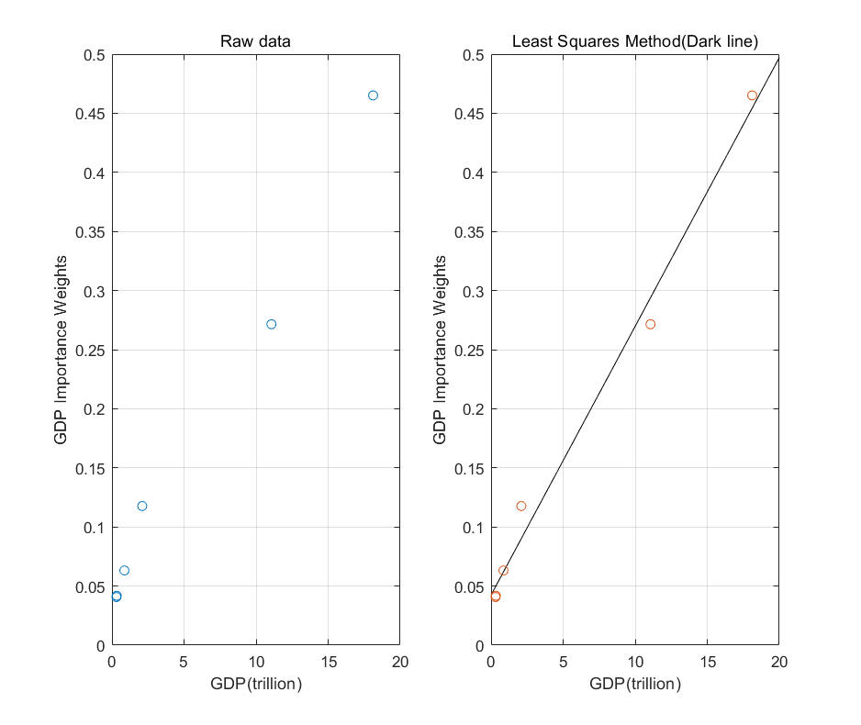 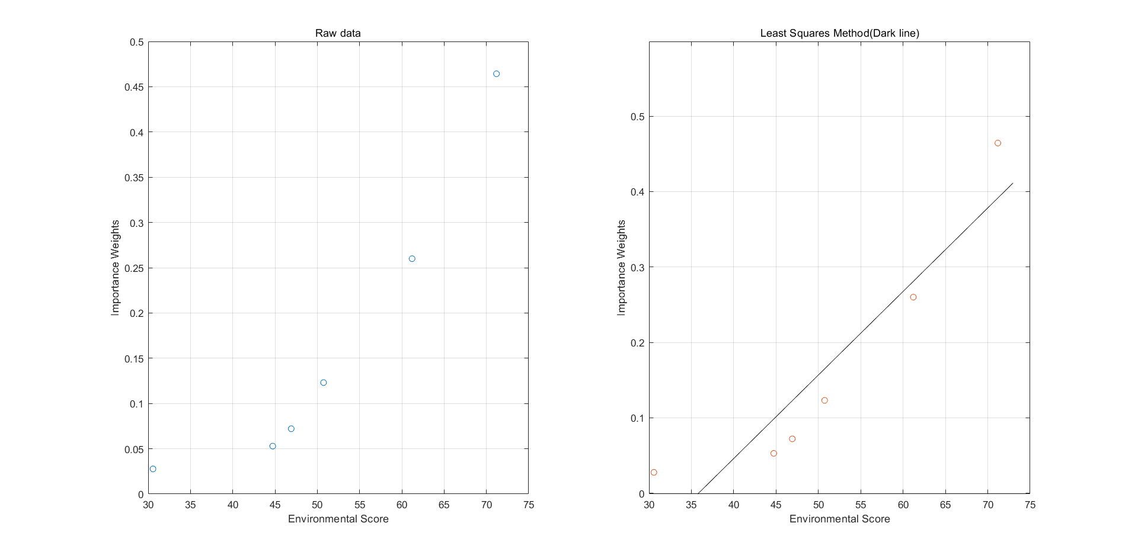

Figure GDP Fit Graph Figure Environment Fit Graph

Then we obtain the equation of GDP and EI:

$$\begin{aligned}y=0.0227x+0.0425\#\left( AUTONUM \backslash * Arabic \right)\end{aligned}$$

$$\begin{aligned}y=0.0111x-0.397\#\left( AUTONUM \backslash * Arabic \right)\end{aligned}$$

Next we substitute the means of these two factors into the equation (12) and (13) based on the discussion above. For other factors, we choose the lowest level here, so we can build the matrix $\hat{X}$ as follows:

$$\hat{X}=\left[\begin{matrix}1.745 & 0.0337 & 0.0309 & 0.3014 & 0.1154 & 0.4662\end{matrix}\right]$$

Similarly, we can obtain a multiple linear regression equation like equation (11):

$$\begin{aligned}\hat{Y}=\hat{X}B+\hat{ξ}\#\left( AUTONUM \backslash * Arabic \right)\end{aligned}$$

Then we substitute matrix B into equation (14), and we can obtain that the value of $\hat{Y}$ is 266.52. Next we substitute this value into equation (2) of model 1, and the result is 166.68MMT. This value is 54.83% of current global level and it is the minimal achievable level of global waste of single-use or disposable plastic products.

### Discussion of the Impacts for Achieving Ideal Levels

When it comes to the impact of the lowest level of disposable waste in the world, we will discuss it from four aspects: the natural environment, human life style, the impact of plastic industry and the impact on the global economy.

First of all, for the natural environment, the global minimum level calculated according to the model is 54.83% of the existing level, which will make the global discharge of 4 million tons to 12 million tons of waste to the ocean every year, and the marine ecological environment has been completely controlled. The amount of burned plastic waste will also be reduced by 55%, effectively reducing the emissions of toxic gases such as dioxins and a large number of greenhouse gases, and slowing down the problem of global warming. The amount of plastic and plastic waste discharged to the soil and the landfill site has also been reduced by about 42%, the problem of waste land use in the world has been alleviated, and the hidden dangers of natural disasters such as fire and virus have also been reduced.

Secondly, for the human way of life, people need more plastic substitutes to live. For example, China's express delivery will cancel plastic packaging, plastic shopping bags will be completely replaced by paper bags and woven fabrics, and most mineral water bottles will be replaced by glass bottles or new materials, which will reduce China's plastic waste by about 20%. The recycling of plastics is also very important. Every country will learn from Norway, which has a recycling rate of 97%. The government will also make more relevant laws to carry out strong control over plastic products, such as paying plastic use tax. The orientation of human employment will also change. According to the model we established above, in order to reach the lowest level of plastic waste, countries have to optimize the natural environment to make the environment stronger, which requires more environmental protection jobs. Meanwhile, the research and development of degradable plastics and new environmental protection materials will also be carried out in a hot way, and scholars in this field will be surprised An increase in the speed of flight.

For the impact of the plastic industry, small and medium-sized plastic enterprises around the world will face the risk of bankruptcy, and more degradable plastic industries will be established like mushrooms. Trillions of dollars of industrial industry will face severe tests such as layoffs and transformation.

Finally, for the global economy, although our model has not made corresponding changes to GDP, a series of industrial structure transformation and changes in human life style will inevitably make the global economy present a downward trend, and the increase of human life cost will make the GDP appear a low tide period, and after the rapid transformation and the research and development of plastic substitutes, the global economy can be driven by gradually returned to normal.

To sum up, although the lowest level of plastics in the world will have an impact on human life and production, it is definitely a long-term solution for the living environment of human beings in the future.

## Solutions to Equity Issues

### Reasons for Differences

There are serval reasons for the unequally distributed among countries and regions. We simply divide these reasons into four aspects: Gross domestic product (which means the need and production ability of plastic), Environmental carrying capacity (tolerance of environment), Technology (ability to solve and recycle plastic waste) and Environmental protection conscious (whether local government and people are willing to protect environment).

### Further Analysis

We analyze each aspects using data and detail information. After that, we give out some examples to possible solutions. Finally, we generalize solutions to the unbalanced distribution problem.

* **Gross domestic product (GDP)**

GDP is a monetary measure of the market value of all the final goods and services produced in a specific time period. GDP is considered the "world's most powerful statistical indicator of national development and progress". Highly developed country, which means faster product speed, can manufactured plastic quickly. Since plastic is useful in many areas of daily life (e.g. packaging, building, consumer products) and a large among of plastic is disposable, faster the production speed larger the plastic will be generated thus more plastic waste. The relationship between global GDP and world plastic are shown in Fig.7.

Figure GDP and Global Plastic Production (1960-2015)

We can learn from the figure that, typically, as Gross Domestic Product (GDP) increases, the amount of trash increases along with it, at about the same rate. However, after 1990 good news happened that we started creating less plastic, meanwhile, the increase speed of GDP has not slowed down.

* **Evaluation of Resource and Environmental Carrying Capacity (RECC)**

RECC is the foundation for the rationale behind the arrangement of land spaces for production, living, and ecological uses (e.g. plastic). Reducing the counterbalance between lack of land and huge plastic waste is the key to our solution.

* **Technology**

Since plastic are mainly disposable, we can reuse plastic products. For example, we can make trash can, plants pots or even colorful speakers, clothes, shoes using plastic. Many different interesting ideas are shown in Fig.8.

|  |
| --- |
| 图片包含 室内  描述已自动生成  图片包含 餐桌  描述已自动生成   1. (2) (3)   (1): The Portable Speaker Made from Plastic Waste  (2): Print Your City turns plastic food containers into street furniture  (3): Adidas made a running shoe that's fully recyclable  Source: <https://www.plasticsmakeitpossible.com/innovation-of-the-week/> |

Figure GDP and Global Plastic Production (1960-2015)

* **Environmental Awareness**

Environmental awareness is a broad philosophy, ideology, and social movement regarding concerns for environmental protection and improvement of the health of the environment.

After all, we conclude several solutions related to the mentioned differences.

1. From the perspective of a big country: disposable plastics cannot be abused because of the need of their own technological development. Meanwhile, per capita garbage is too much, and plastics cannot be discharged into the ocean at will. The government needs effective measures.
2. From the perspective of a small country: plastics have waste problems, low recycling rates, lack of degradable plastic technology, simple and crude methods for handling plastics, such as incineration and damage to the environment.
3. From the perspective of the United Nations: To formulate relevant laws and regulations, large and small countries share waste disposal technology
4. Big countries must have the style of big countries, take the initiative to develop related technologies, and take the initiative to recycle marine garbage.

# Sensitivity Analysis

We will analyze how the weight distribution (only for AHP) for different aspects will change while varying country.

Figure The weight of each factor for each country

**Conclusions:**

* Different countries make weight distribution sensitive which can be seen clearly in Fig.9.
* As for highly developed countries such as United State, factors 1,2 and 5 are more important. While in countries with desert (e.g. Egypt), factors 3,4,5,6 all need further concentration.
* For all six factors, we can see a highly differential weight in countries because they have different condition, as a result, we need spectacular solution for different countries.

# Strengths and Weaknesses

## Strengths

* 1. This article combines the data sets of GDP, plastic replacement material, plastic policy, RECC with plastic production and wastes data, together make two models. After that, we analyze each data set and get the degree influence degree they have on plastic waste.
  2. We make a conclusion of the solution of plastic waste problem and we also consider the influence of local characteristics, which cause special solution in some areas.
  3. From the simple point of view, we use Comprehensive Evaluation Model to estimate the maximum levels of disposable plastic. Analytic hierarchy process (AHP) model for measuring the influence of factors. Multiple linear regression better describe the solution to not equally problem.

## Weaknesses

1. Because there are some countries in war these years, plastic pollution data in these countries are missing. Due to the complexity of the social environment itself, plastic pollution level, effect may be subject to fluctuations, and the established model does not reflect these fluctuations.
2. To simplify the model, we have divided countries into six different types and picked a typical example for each type, which is our analysis object.

## Promotion

# Conclusion

# A Memo to the ICM

# References