**1 DATASETS**

**Order data in dataAnalysis1.0.**

**2 METHODOLOGY**

This section describes how we calculate the cook time for each order.

**2.1 Simple Example**

To illustrate how to calculate cook time for an order, we first need to understand that it is impossible to get an accurate time. The dishes in orders are out of control after entering kitchen, we have no idea when have they been put into pot. However, as soon as rider pick up the order, we get a timestamp for sure that the dishes in orders have all been cooked. So we calculate the time between shop accept order and rider pick up order, and we take these time as orders’ cook time. The whole life flow of an order is shown in Fig.1.

Fig. 1. Life Flow of An Order

|  |
| --- |
| Left Yellow frame: Shop Accept Order  Blue frame: Shop Cooking Process  Right Red frame: Rider Pickup |

**2.2 Calculate Method**

In order to calculate the cooking time $C_{cooking}$ for each order, we need to get timestamps exactly before and after cooking process. The timestamps we pick up for calculation are given in Table 1.

Table 1. Timestamps

|  |  |
| --- | --- |
| **Order** | **Data Type** |
| Shop Accept Order Time | Datetime |
| Rider Pickup Time | Datetime |

**2.3 Distance Calculation**

In this subsection, we describe the calculation method that turn timestamps into exactly cooking time.

Using the assumption given in subsection 2.1, we consider the time between shop accept order and rider pickup as order’s cooking time. So that, the formula of order cooking time calculation is as follow:

$C_{cooking}=delta\left({datetime}_{shopAcceptOrder}, {datetime}_{RiderPickup}\right);$

**3 MEASUREMENT RESULTS AND ANALYSIS**

In this section, we generally divided the Cooking Time into five levels <5min, 5min, 10min, 20min, >20min. The order number in different levels are shown in Fig.2.

Fig. 2. Cooking Time

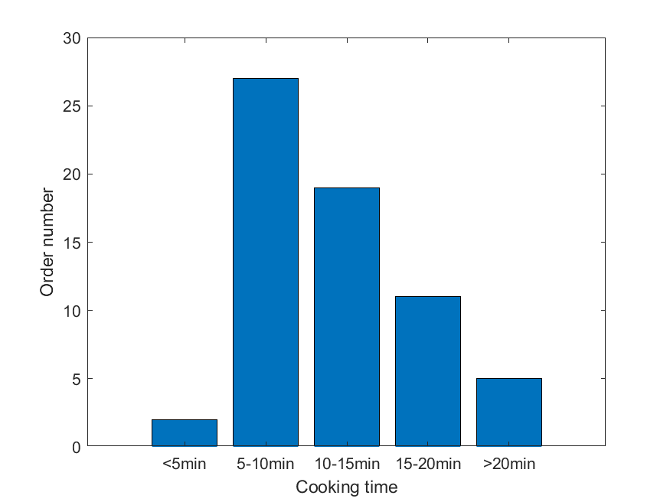

The minimum and maximum cooking time in our datasets are 3’48’’ and 26’5’’, and the proportion of cooking time less than 5’ or more than 20’ orders are less than 10%.

However, an order can contain more than one dishes, we calculate dishes number for every order and the result is shown in Fig.3.

Fig. 3. Dishes Number

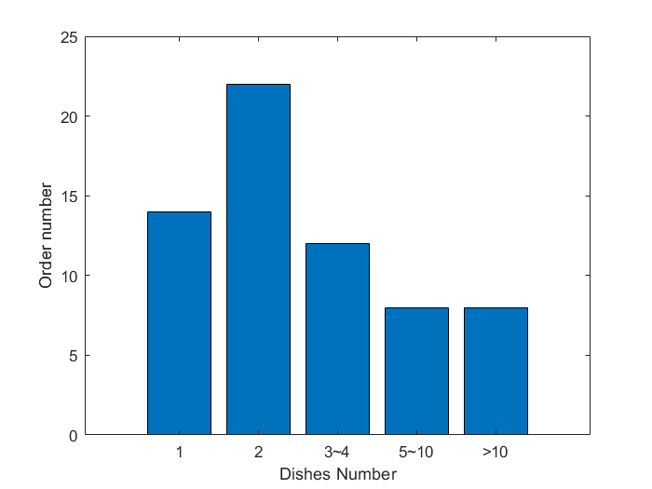

After that, we also draw graphic which show the correlation of waiting time and average waiting time of each dish with dishes number. We find that the correlation between waiting time and order’s dishes number isn’t so obvious, but average waiting time for each dish has an obviously decline when order’s dishes number increase. The result are given in Fig.4 and Fig.5.

|  |
| --- |
| Fig. 4. Waiting Time Fig. 5. Average Waiting Time |