**1 DATASETS**

We have access to order fleet, which is from ele.me company. Our datasets contain order detail amongest holiday, not holiday, weekday and weekend. The details about the data are given in Table. 1.

Fig. 1. Life Flow of An Order

|  |  |
| --- | --- |
|  | **Order** |
| Data Size | 3 thousand |
| # of Daily Records | 3 hundred |
| Format | Rider ID& Order ID& Shop ID  User& Shop GPS  Timesteps: Shop Accept Order & Rider Accept Order, Arrive Shop , Pick Up, Arrival User  Sku ID |

**• Order:** The data we get was collected from the company’s database, collecting method and datasets’ format are similar with datasets in dataAnalysis1.0. The only difference that need to be notice is that skuID is the identification of one dishe in one order.

**2 METHODOLOGY**

**Same method with dataAnalysis2.0(Addition: SkuID are matched with order)**

**3 MEASUREMENT RESULTS AND ANALYSIS**

In this section, we generally divide the Cooking Time into five levels <5min, 5min, 10min, 20min, 20-25min, 25-30min, >30min. The order number in different levels are shown in Fig.1.

Fig. 1. Cooking Time

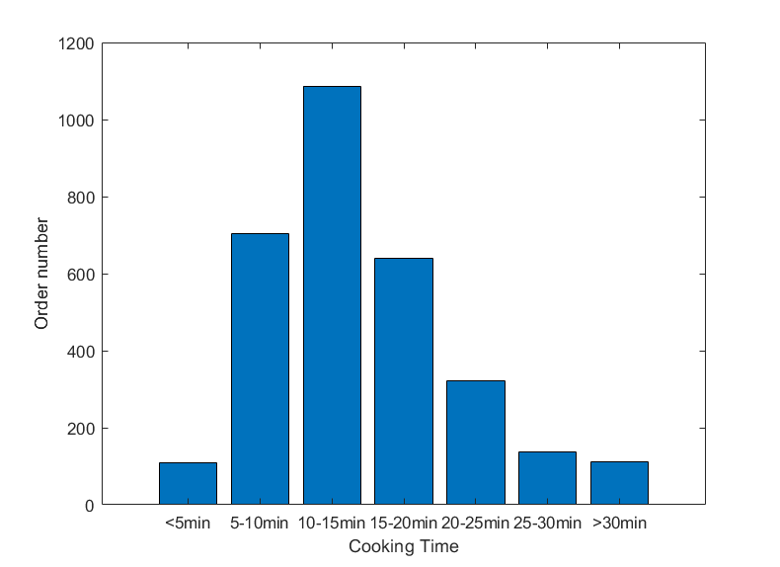

The proportion of cooking time less than 5’ or more than 30’ orders are less than 10%.

After that we also select all orders which only contain one dish, we assume that order making time are the cooking time of dish. The order number (contain one dish) in different levels are shown in Fig.2.

Fig. 2. Cooking Time of Sku

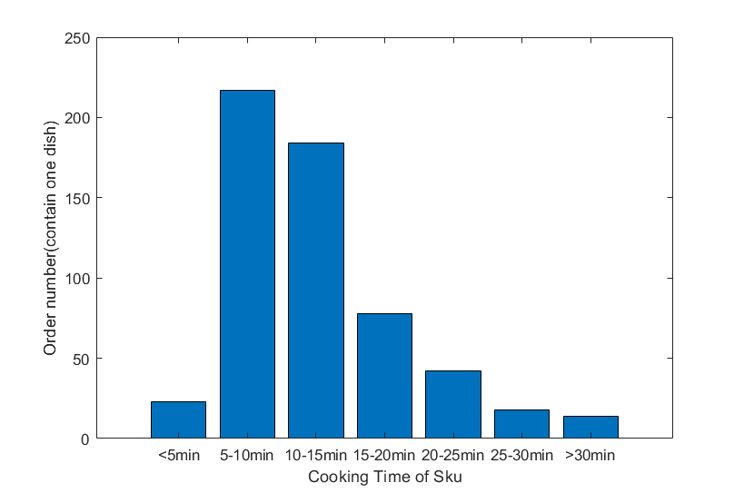

However, we find there are some issues in raw data which cause the minimum cooking time in our datasets is 44’’ and there are 2 order use less than 1 minute cooking time.