**1 DATASETS**

We have access to Shenzhen car GPS data. The details information about the data are given in Table. 1.

Table. 1. SZ Car GPS

|  |  |
| --- | --- |
|  | **Order** |
| Data Size | 36.6G |
| # of Daily Records | 3 millions |
| Format | Time& Device No.& Car ID& Rout No.&  Longitude& Latitude& Speed |

**2 METHODOLOGY**

This section describes how we calculate the waiting time for each car on the crossroad.

**2.1 GPS data selection**

We carefully2 traversal through all crossroads, and finally we select the largest and biggest crossroad in Shenzhen city center. The crossroad has dual four lanes, image of the crossroad is shown in Fig.1.

Fig. 1. Crossroad

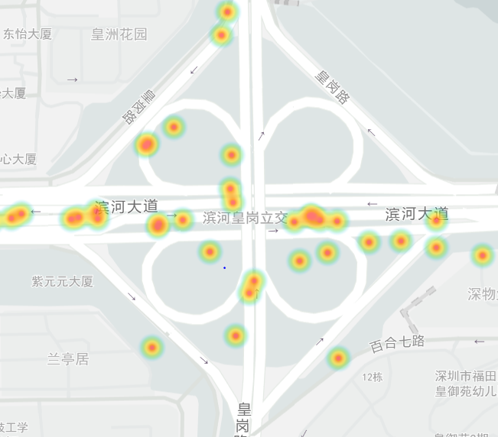

We briefly select valid car GPS data from our dataset using longitude and latitude, the GPS information for this crossroad is:

LONGITUDE=[114.066892862320,114.069961309433]

LATITUDE=[22.530742904815,22.533299647634]

**2.2 Waiting time calculation**

After that, we cluster each data by the Car ID. The data format we structured is:

CAR[Car ID]=[[Time,Longitude,Latitude]]

For each car, We pick up the first and last appearance time for each car from our selected dataset, which we treated as arrival and leaving time of the car. Then, we calculate the time delta between it arrive and leave the crossroad.

**3 MEASUREMENT RESULTS AND ANALYSIS**

In this section, we generally divide the Waiting Time into fine-grained levels between 1-10min and coarse-grained 11-15min, 16-20min, >20min. The car number in different levels are shown in Fig.4.

Fig. 4. Waiting Time

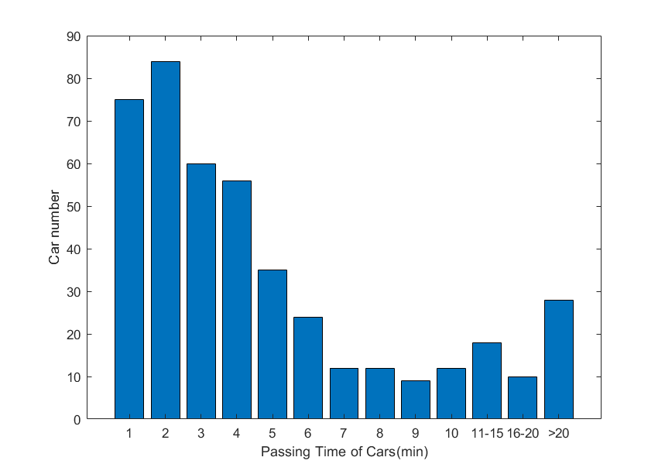

**3.1 Traffic number per min**

We can cast every GPS trace data to corresponding crossroad. After that, we calculate the passing car numbers of different time for each crossroad. We found that average traffic per minute at most crossroad are under 20, the average traffic per minute are shown in Fig.2. However, there are also some exception.

Fig. 2. Crossroad

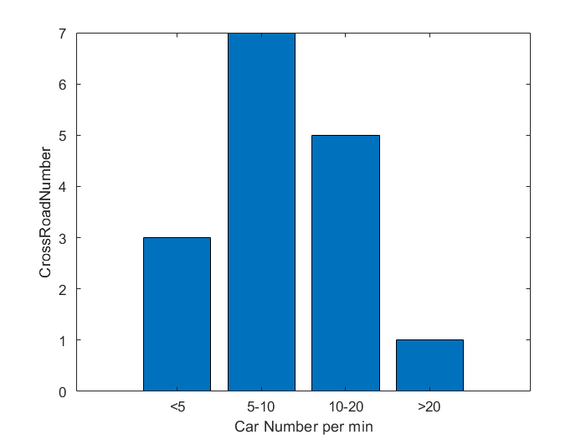

We select crossroads with traffic per minute more than 20. They are

‘Binhe Jintian Interchange Crossroad’ in:

LONGITUDE= [114.069379546421,114.070529627780]

LATITUDE= [22.534050387255,22.53495985941]

and

‘Xiangmihu Crossroad’ in:

LONGITUDE= [114.033629989306,114.036271286967]

LATITUDE= [22.541271896923,22.543950221582].

The traffic detail of the road every hour in 24h are show in Fig.3.

Fig. 3. 24h Traffic detail

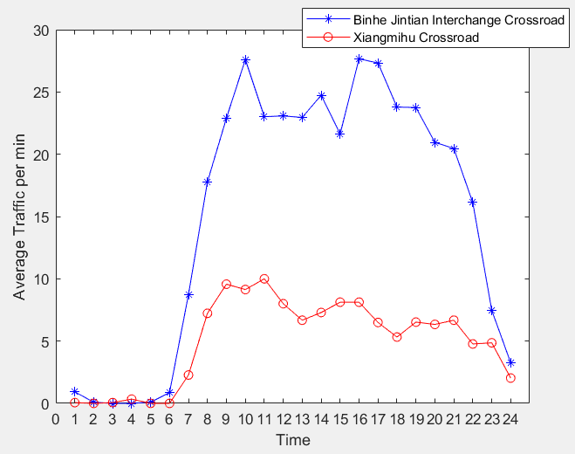

After that, we draw the heatmap of ‘Binhe Jintian Interchange’ and ‘Xiangmihu’ Crossroad, which are shown in Fig.4 and Fig .5.

|  |
| --- |
| Fig. 4. Binhe Jintian Interchange Fig. 5. Xiangmihu |