Business Requirements Document(BRD) Template
Project/Initiative
Month 20YY
Version X.XX

Company Information

Document Revisions
Date | Version Number | Document Changes
05/02/20xx | 0.1 | Initial Draft

Approvals
Role | Name | Title | Signature | Date

Introduction

Project Summary

Objectives

- 1
- Maximize search-to-booking conversion by delivering relevant, accurately priced, and real-time hotel results within 1–2 seconds of query submission.
- 2
- Provide a frictionless search experience through intelligent destination autocomplete, a clear date-range calendar with weekend highlighting, and granular guest configuration (adults + children ages).
- 3
- Enable users to efficiently narrow results using the highest-demand filters: nightly price range, guest review score (≥ 8.0), free cancellation policy, and specific amenities (Wi-Fi, parking, breakfast).
- 4
- Surface results in a hotel-card format displaying total-stay price, primary room photo, and distance to city centre — with an integrated map view toggle — to support informed decision-making, including on mobile devices.
- 5
- Support business revenue goals by allowing promoted/recommended listings (based on margin or partner agreements) and urgency-driving marketing tags (e.g. "Only 1 room left", "Best price").
- 6
- Lay the analytical foundation for inventory expansion by capturing zero-result filter combinations, while supporting multi-currency display and multi-language UI from launch.

Background
The company operates an online hotel booking platform that has been running without a dedicated search and filtering module. Hotel discovery relied on a basic listing page with no destination autocomplete, no guest-configuration logic, and no real-time availability synchronisation. Availability data was updated manually or via batch imports, leading to frequent cases where users would find and attempt to book properties that were already occupied on external channels.
A user satisfaction review and stakeholder interviews conducted in Q1 identified the search experience as the primary drop-off point in the booking funnel. Users reported difficulty finding relevant hotels quickly, frustration with seeing fully-booked properties in results, and a lack of filtering tools that match the standard set offered by market leaders such as Booking.com and Airbnb. Simultaneously, the business owner identified that without structured search-event logging, there was no visibility into which destinations and room types were in demand but unserved by the current hotel inventory.
The Hotel Search and Filtering Module project was formally initiated to address these issues. The expected benefits are: a measurable increase in search-to-booking conversion rate (Key Performance Indicator), elimination of stale-availability errors through real-time Channel Manager integration, and the establishment of a data foundation for evidence-based hotel partner recruitment.

Business Drivers
Financial
Low search-to-booking conversion rate
The current booking funnel loses a significant share of users at the search stage due to slow results, missing filters, and stale availability. Improving the search module is projected to directly increase completed bookings and platform revenue without acquiring additional traffic.
Financial
Promoted listing monetisation
The platform has no mechanism to charge hotel partners for priority placement. The recommended-listing feature creates a new revenue stream through partner promotion agreements, requiring a configurable ranking and tagging system.
Market
Competitive gap vs. Booking.com and Airbnb
Market-leading platforms offer destination autocomplete, real-time availability, rich filter panels, and integrated map view as baseline features. The absence of these on the current platform creates a perceived quality gap that drives users to competitors before the first search result loads.
Market
Unserved demand in key destinations
Without zero-result logging, the business cannot identify destinations where user demand exists but hotel supply is insufficient. Capturing this data enables evidence-based expansion into high-potential markets ahead of competitors.
Operational
Manual availability synchronisation errors
Batch-based availability updates cause double-bookings when a property is reserved on an external channel. Each incident generates a manual cancellation, customer support interaction, and potential refund — all avoidable with real-time Channel Manager API integration.
Operational
No search behaviour data for decision-making
Product and inventory decisions are currently made without data on what users search for, which filters they apply, or where searches return no results. Implementing structured audit logging and a reporting dashboard replaces guesswork with measurable signals.

Project Scope

The scope covers the end-to-end search and filtering flow: from the initial search form submission to a user selecting a hotel listing to proceed to the booking detail page. Adjacent modules (hotel detail page, booking flow, payment, user account) are out of scope for this document.

In Scope Functionality
- Search form: destination autocomplete, date-range picker, guest/children-age selector

Results list view: hotel cards with total price, photo, distance, review score, urgency tags

Map view toggle integrated within the results page

Filter panel: price slider, star rating, review score threshold, free cancellation checkbox, amenity checkboxes

Default and user-selected sort orders (Recommended, Lowest price, Top reviewed)

Real-time availability sync via Channel Manager / API (status update ≤ 5 sec)

Zero-result analytics capture for filter combinations

Responsive / mobile-adaptive layout

Multi-currency price display and multi-language UI support

Out of Scope Functionality

Hotel detail / room description page

Booking and reservation flow

Payment processing

User account, saved searches, and wishlists

Review collection and moderation

Hotel partner onboarding and content management

Revenue reporting and BI dashboards

Native mobile app (iOS / Android)

System Perspective
The following factors have been identified as likely to affect successful implementation of the Hotel Search and Filtering Module. They cover legal and regulatory compliance obligations, existing technical limitations, and budget and resource constraints. Accelerating factors are listed separately at the end of this section.

Assumptions
• Hotels have access to the TravelMate hotel portal
• Hotel staff regularly check booking notifications
• Internet connection is available for hotel staff
• Guests have valid user accounts in the system

Constraints

- Legal / Regulatory:
Ukrainian personal data protection law (Law No. 2297-VI 01.06.2010). As the platform operates in Ukraine, it is subject to the Law of Ukraine "On Personal Data Protection". Search session logs that can be linked to an identified user must be processed and stored in accordance with local data localisation and consent requirements, which may differ from or complement GDPR obligations.
- The solution must be implemented within the current project timeline

Risks

.Small team and constrained budget
The development team is small, with limited capacity for parallel workstreams. Core search features, Channel Manager integration, analytics infrastructure, and QA will compete for the same engineering bandwidth. External dependencies — such as third-party API onboarding for autocomplete, map view, and currency conversion — may introduce timeline delays outside the team's direct control. Budget constraints may also limit access to paid services or specialised expertise (e.g. security penetration testing required by FR-S-001).

Issues
- Under the Law of Ukraine "On Personal Data Protection" (Law No. 2297-VI), collection and processing of personal data — including search session identifiers and behavioural logs captured in FR-A-001 — requires a documented lawful purpose, user notification, and, in most cases, explicit written consent of the data subject. The platform must determine: (1) whether session-level search logs qualify as personal data under the law's definition (data that identifies or allows identification of a natural person); (2) the legal basis for processing under Article 11 of the Law; (3) the mechanism for obtaining and recording user consent prior to logging; and (4) the procedure for fulfilling data subject rights — access, correction, and deletion — within the timeframes established by the Law.

Business Process Overview
[Describe how the current process(es) work, including the interactions between systems and various business units. Include visual process flow diagrams to further illustrate the processes the new product will replace or enhance.
Use case documentation and accompanying activity or process flow diagrams can be used to create the description(s) of the proposed or “To-Be” processes.]

Current Business Process (As-Is)
At any point during or after deployment of web apps or web sites (internal or external) to support business activities, development/support teams may create and deploy widgets.
- CMS / database administrators for the employee portal use the CMS tool to create widgets. They can test widgets in the designated staging environment, then register them and deploy to production.
- Development teams may deploy widgets to development and testing environments set up for their development projects. They must check widget code into and out of the source code repository according to their projects’ development schedule.
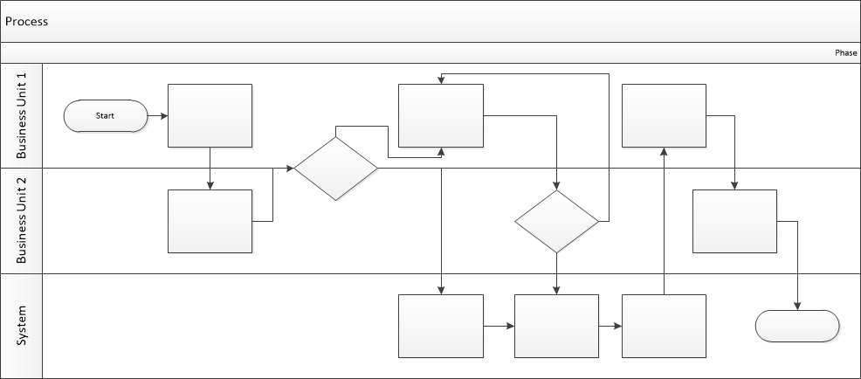

Proposed Business Process (To-Be)
- Technical Lead searches repository
- If widget is not found, user creates a new widget name record.
- WINS validates that all fields have been completed.
- WINS confirms that no similar widgets exist
- User confirms record to be created.

- User searches repository to locate existing widget description.
- WINS displays record
- User selects Edit to open and modify record
- WINS validates all fields completed correctly
- User confirms changes.
- WINS confirms changes and updates Audit table.


Stakeholder Requirements
The requirements in this document are prioritized as follows:
Value | Rating | Description
1 | Critical | This requirement is critical to the success of the project. The project will not be possible without this requirement.
2 | High | This requirement is high priority, but the project can be implemented at a bare minimum without this requirement.
3 | Medium | This requirement is somewhat important, as it provides some value but the project can proceed without it.
4 | Low | This is a low priority requirement, or a “nice to have” feature, if time and cost allow it.
5 | Future | This requirement is out of scope for this project, and has been included here for a possible future release.

Functional Requirements
Req# | Priority | Description | Rationale | Use Case Reference | Impacted Stakeholders
General / Base Functionality
FR-G-001 | 1 | The destination input field must provide real-time autocomplete suggestions (city, region, landmark) as the user types, with a minimum trigger of 2 characters and results appearing within 300 ms. | Slow results cause drop-off; total price prevents sticker-shock at checkout. | UC-01 | End userUX team
FR-G-002 | 1 | Date picker: single calendar view for check-in/out, weekend highlighting, past dates disabled | Weekend distinction helps leisure travellers; disabling past dates prevents invalid queries. | UC-01 | End use  rUX team
FR-G-003 | 1 | Guest form: adults count + each child's age (0–17) entered individually; age mandatory per child. | Child age is a pricing variable; mandatory input prevents incorrect rate calculation. | UC-01 | End user  Dev team
FR-G-004 | 1 | Results load ≤ 2 s; hotel card shows photo, name, star rating, review score, total stay price, distance to centre. | Total price prevents checkout surprise; distance is a top decision factor per survey. | UC-01  UC-02 | End user  Business owner
FR-G-005 | 1 | Hotel cards display urgency tags ("Only 1 room left", "Best price") triggered by admin-defined business rules. | Urgency cues shorten decision time and increase same-session conversion rate. | UC-02 | Business owner
Security Requirements
FR-S-001 | 1 | All API calls over HTTPS; search params validated server-side against injection. | Search inputs are user-controlled and directly reach the DB query layer; a standard attack surface. | UC-01  UC-02
Reporting Requirements
FR-R-001 | 2 | The system must provide a business owner dashboard displaying: search-to-hotel-card-click conversion rate, top 5 most-applied filters by week, and count of zero-result searches by destination. Data must refresh daily. | Conversion rate is the primary KPI for the module; filter popularity guides product prioritisation; zero-result by destination drives hotel partner recruitment. | UC-06 | Business owner
Usability Requirements
FR-U-001 | 1 | The average time-on-task for completing the search form (destination → dates → guests → submit) must not exceed 60 seconds for a first-time user, as measured in usability testing. | A 60 s ceiling ensures the form is not an obstacle; longer completion times correlate with higher abandonment before results load. | UC-01 | UX team  Dev team
Audit Requirements
FR-A-001 | 1 | Each filter interaction must be logged as a discrete event: filter name, value set, timestamp, and session ID. Log must capture both filter application and filter removal. | Filter-level audit reveals which criteria users try but abandon — a signal for inventory gaps or UX friction points. | UC-02  UC-06 | Business owner  Dev team

Non-Functional Requirements

ID | Requirement
NFR-001 | Search results rendered in browser within 2 s at 500 concurrent users.
NFR-002 | Channel Manager availability update reflected in UI within 5 s of upstream event.
NFR-003 | Autocomplete suggestions appear within 300 ms of keystroke.
NFR-004 | Module uptime ≥ 99.5% per month; planned maintenance notified 24 h in advance.
NFR-005 | Price on search card must match price at checkout start; zero discrepancy policy.

Appendices

List of Acronyms

Glossary of Terms
KPI (Key Performance Indicator)
DB — Database
Q1 — Quarter 1

Related Documents

