**Task 2. (15 points) Tune regions and monitor with jdk monitoring tools**

Take your pet or current project app for the next exercises with JVM settings via flags and console utilities.

Heap should be divided to Old and Young generations of equal size, where areas of Young generation are in following ratio: 3-Eden, 1-S0, 1-S1

-XX:NewRatio=1 -XX:SurvivorRatio=3

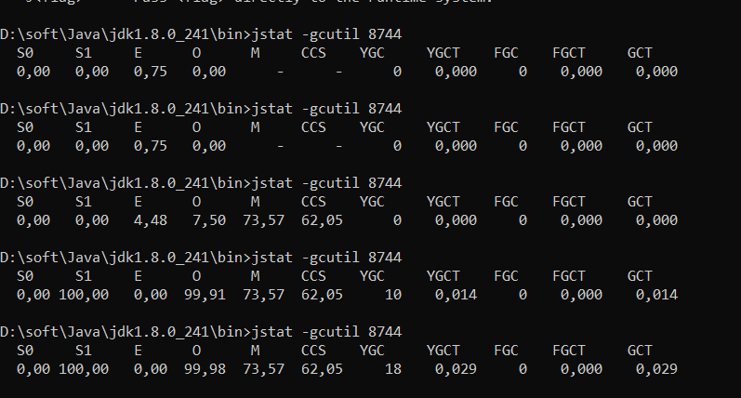

Heap should be of 512MB and divided to Old and Young generations of equal size, where areas of Young generation are in following ratio: 2-Eden, 1-S0, 1-S1

-Xms512m -Xmx512m -XX:NewRatio=1 -XX:SurvivorRatio=2

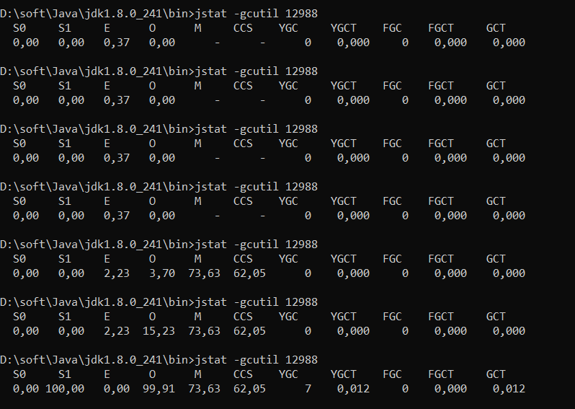

Heap should be of 512MB with Old generation of 128MB and Young generation with areas in following ratio: 3-Eden, 1-S0, 1-S1

-Xms512m -Xmx512m -XX:OldSize=128m -XX:SurvivorRatio=3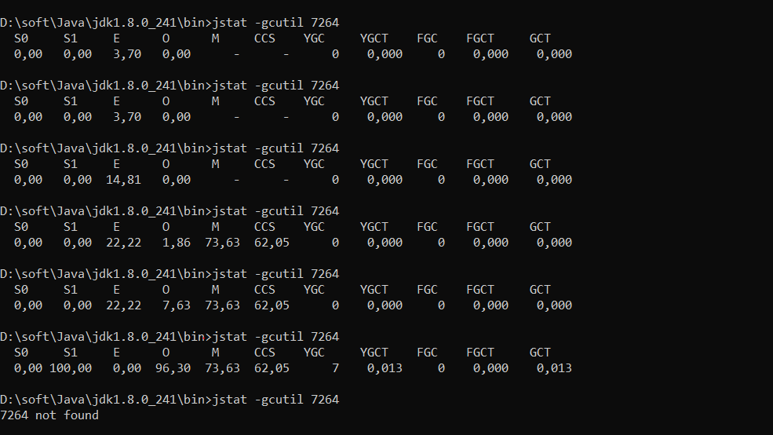

Heap should be divided to Old generation of 128MB and Young generations with areas: Eden of 384MB, S0 of 128MB, S1 of 128MB

-Xms512m -Xmx512m -XX:NewSize=384m -XX:SurvivorRatio=3

