**Answer to Question 1**

The second query fails because the condition it uses for left outer join is not appropriate. When using left outer join, attribute value will be set as null if the outer join condition fails to satisfy. In this case, since the condition is (c.customerid = f.customerid and c.name like 'William%'). Hence, users whose name do not contain 'William' also appear in the result with values of flightid and flightdate set to null.

**Modified query:**

select c.customerid, c.name, count(flightid)

from customers c left outer join flewon f on (c.customerid = f.customerid)

where c.name like 'William%'

group by c.customerid, c.name

order by c.customerid;

**or:**

with cus_name_W(cusid, cusname) as

(select c.customerid, c.name

from customers c left outer join flewon f on true

where c.name like 'William%'

group by c.customerid, c.name

order by c.customerid)

select cusid, cusname ,count(flightid)

from cus_name_W left outer join flewon on (cusid = flewon.customerid)

group by cusid, cusname

order by cusid;

**Answer to Question 2**

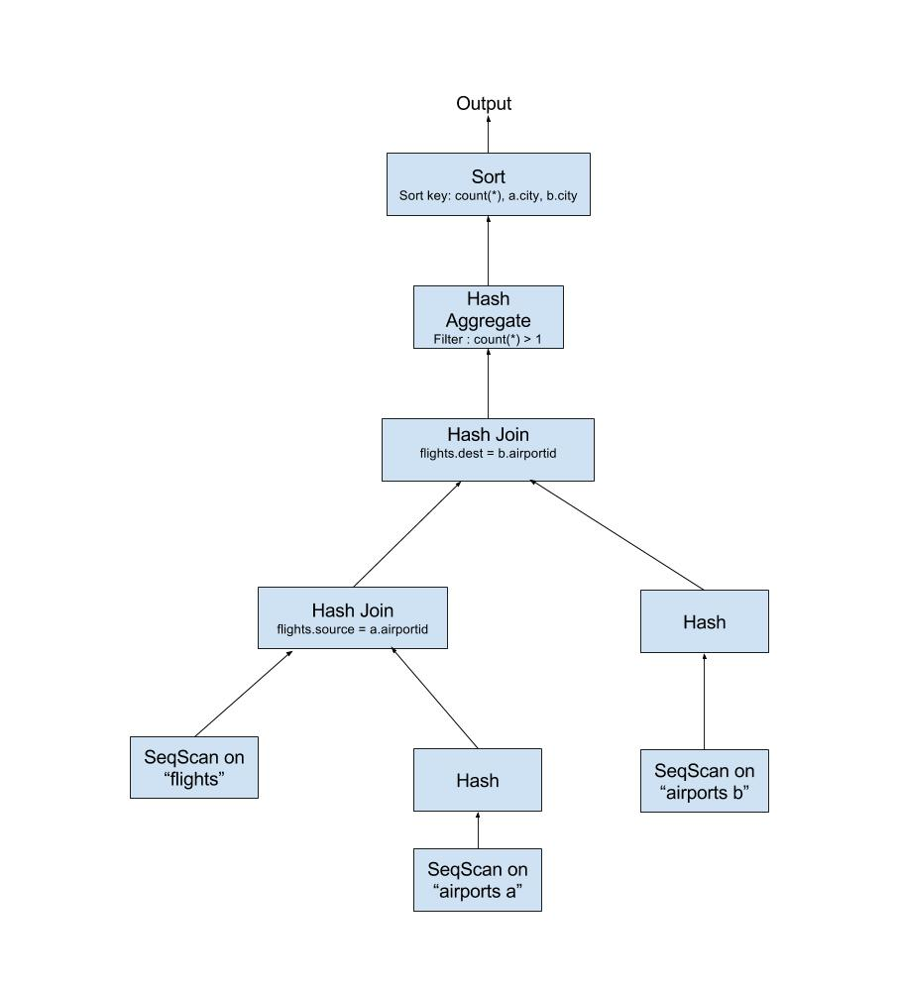

Figure 1 Q2 Query Plan

**Answer to Question 3**

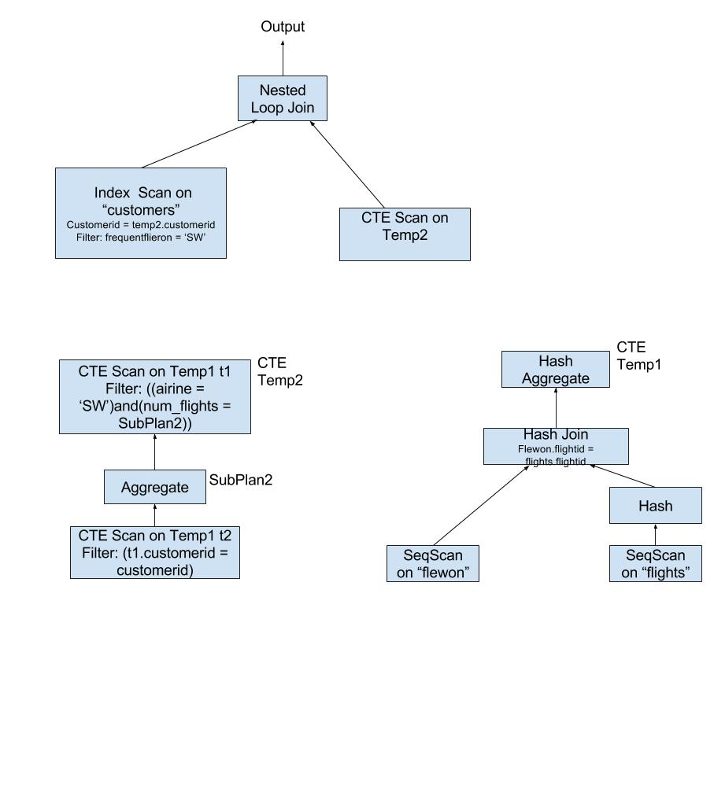

Figure Q3 Query Plan

**Answer to Question 4**

By comparing the estimated sizes and the actual ones, it can be observed that the database does not perform well on estimating the size since the differences between the estimated and actual sizes are obvious, especially in the first query.

The differences in the actual cardinalities for the two queries appear in the SeqScan of the customers, where filtering customers by the month of their birthdate. It indicates that there are much more customers who was born in January than February in the database, which leads to this apparent difference in the actual cardinality.