**OVERVIEW OF QUERYING A DATABASE WITH JDBC**

1. **Register The Driver**

**Here we Register the driver by adding the parameters/details of the database.**

**We need to select the database**

**Examples: Sql Work bench, SSMS, Oracle, Mongo DB, H2-DB etc**

**Explicit:**

**class.forName(“NameOfTheDriver”);**

**class.forName(‘’com.**mysql.jdbc.driver**”);**

**implicit:**

**DriverManager.registerDriver(New com.mysql.jdbc.Driver());**

1. **Get Connection/Establish the Connection**

JAVA

DB

**DriverManager.getConnection( url,username,password);**

**Where**

**DriverManager ----🡪 class**

**getConnection ------🡪 method**

**url,username,password ---------🡪 Arguments**

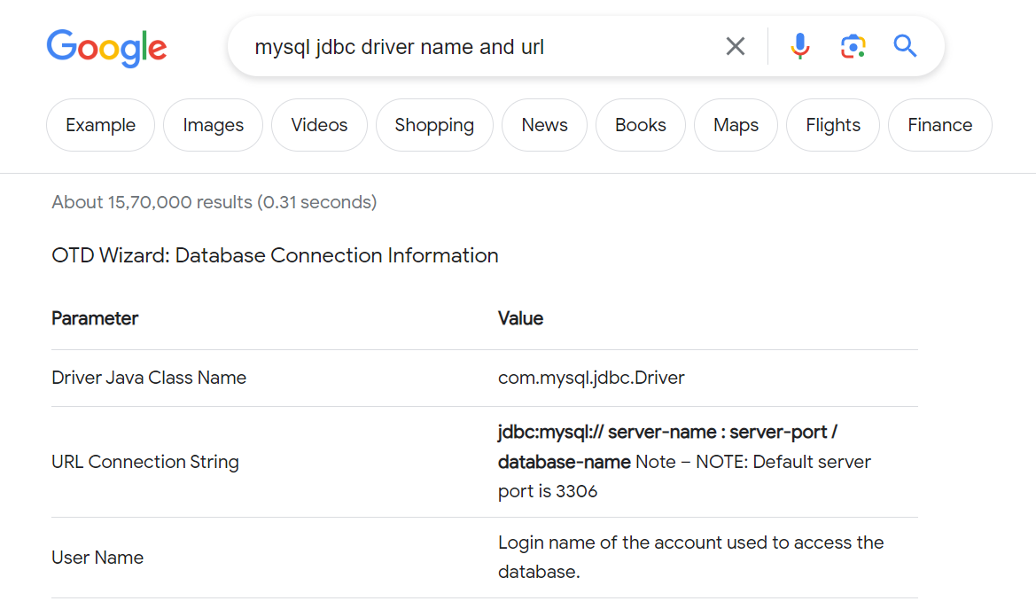

**Mysql url: jdbc:mysql:// server-name : server-port / database-name** Note – NOTE: Default server port is 3306

1. **Create the Statement Object**
2. **Execute the Query**
3. **Close the Connection**