实验报告

课程名称：计算机动画编程

实验名称——随机行为动画

实验日期： 2017.5.10 班级： 数媒1404

小组成员： 1030513312 那婉纯 1030514411 夏文利 1030514412 刘金玲

动画介绍：
本次实验中我们运用了随机行为给人物发射的文字添加了部分随机行为动画。我们给四个文字预制体添加了不同的随机行为，使用户能够自定义输入自己想要发射的文字以及想要添加的动画效果。增加了程序的可交互性。

- 实验内容：
小人发射文字有四种不同的效果,分别用了随机旋转和噪声大小的效果.
文字噪声大小实现代码：
void Update () {
float time_now = Time.realtimeSinceStartup;
float size =
Mathf.PerlinNoise(
time_now * speed, y);
size = AT_MathUtil.map(size, 0.0f, 1.0f, min, max);
Vector3 size_v= size_origin * size;
transform.localScale = size_v;
}

在这个基础上，我们还实现了用户自定义输入文字并发射
实现自定义改变文字的代码：
public class changeText : MonoBehaviour {
public GameObject wenziPre;
public GameObject wenziPre2;
public GameObject wenziPre3;
public GameObject wenziPre4;
private string selfText;
// private TextMesh text;
private InputField inputField;

// private GameObject[] pres;

// Use this for initialization
void Start () {
GameObject[] pres = {wenziPre,wenziPre2,wenziPre3,wenziPre4};
for (int i = 0; i < pres.Length; i++) {
TextMesh text = pres[i].GetComponent<TextMesh> ();
text.text = "你真美";
}
inputField = GetComponent<InputField> ();
}

public void Change () {
GameObject[] pres = {wenziPre,wenziPre2,wenziPre3,wenziPre4};
selfText = inputField.text;
for (int i = 0; i < pres.Length; i++) {
TextMesh text = pres[i].GetComponent<TextMesh> ();
text.text = selfText;
}
}
}

实现文字预设的切换的代码：
void FixedUpdate(){
if (fire) {
if (playerctr.facingRight) {
if(choice == 1){
GameObject bulletInstance = Instantiate (text, transform.position, Quaternion.Euler (new Vector3 (0, 0, 0)));
Rigidbody2D rigid = bulletInstance.GetComponent<Rigidbody2D> ();
rigid.velocity = new Vector2 (Speed, 0);
Destroy (bulletInstance, 3f);
}
if(choice == 2){
GameObject bulletInstance = Instantiate (text2, transform.position, Quaternion.Euler (new Vector3 (0, 0, 0)));
Rigidbody2D rigid = bulletInstance.GetComponent<Rigidbody2D> ();
rigid.velocity = new Vector2 (Speed, 0);
Destroy (bulletInstance, 3f);
}
if(choice == 3){
GameObject bulletInstance = Instantiate (text3, transform.position, Quaternion.Euler (new Vector3 (0, 0, 0)));
Rigidbody2D rigid = bulletInstance.GetComponent<Rigidbody2D> ();
rigid.velocity = new Vector2 (Speed, 0);
Destroy (bulletInstance, 3f);
}
if(choice == 4){
GameObject bulletInstance = Instantiate (text4, transform.position, Quaternion.Euler (new Vector3 (0, 0, 0)));
Rigidbody2D rigid = bulletInstance.GetComponent<Rigidbody2D> ();
rigid.velocity = new Vector2 (Speed, 0);
Destroy (bulletInstance, 3f);
}

} else {
if (choice == 1) {
GameObject bulletInstance = Instantiate (text, transform.position, Quaternion.Euler (new Vector3 (0, 180f, 0)));
Rigidbody2D rigid = bulletInstance.GetComponent<Rigidbody2D> ();
rigid.velocity = new Vector2 (-Speed, 0);
Destroy (bulletInstance, 3f);
}
if (choice == 2) {
GameObject bulletInstance = Instantiate (text2, transform.position, Quaternion.Euler (new Vector3 (0, 180f, 0)));
Rigidbody2D rigid = bulletInstance.GetComponent<Rigidbody2D> ();
rigid.velocity = new Vector2 (-Speed, 0);
Destroy (bulletInstance, 3f);
}
if (choice == 3) {
GameObject bulletInstance = Instantiate (text3, transform.position, Quaternion.Euler (new Vector3 (0, 180f, 0)));
Rigidbody2D rigid = bulletInstance.GetComponent<Rigidbody2D> ();
rigid.velocity = new Vector2 (-Speed, 0);
Destroy (bulletInstance, 3f);
}
if (choice == 4) {
GameObject bulletInstance = Instantiate (text4, transform.position, Quaternion.Euler (new Vector3 (0, 180f, 0)));
Rigidbody2D rigid = bulletInstance.GetComponent<Rigidbody2D> ();
rigid.velocity = new Vector2 (-Speed, 0);
Destroy (bulletInstance, 3f);
}
}
fire = false;
}
}
}

三、运行情况
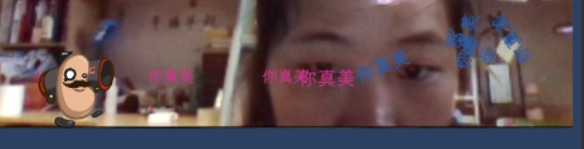
噪声大小和随机旋转
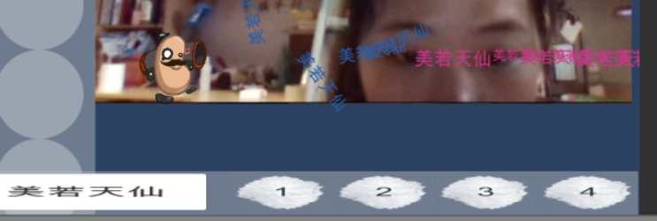
自定义输入文字

四、实验体会（包括对于本次实验的小结，实验过程中碰到的问题等）
在这个动画中，我们事先了自定义输入文字内容和给文字添加不同的动画效果。随机行为增加了动画的趣味性，在动画的很多地方都有大量的使用。在今后的学习中，我们将更深入的了解随机动画。

