4 avr. 2025

EC Central Residence a écrit : Dear Yassine Dahani,

Thank you for your reservation. We are delighted to welcome you soon. To ensure a smooth check-in experience, please inform us of your expected check-in time.

For your flawless check in, we require a picture of the ID card (issued in the EU) or Passport for all guests. Please send it to our email address: tomashproperty@gmail.com . Your data will be securely handled and we do not download it. By replying, you accept the data handling in accordance with GDPR. Please note that without a picture of your Passport or ID, we will be unable to proceed with your check-in!

Check-in (4-11pm): The key will be left at a designated shop located 5 minutes from the entrance. We will inform you about the location of the shop and the code that you need for the key pick up on the day of arrival prior to your regular check in hour.

PARKING: If you require parking, we kindly ask you to book it in advance! We provide a street parking permit for GBP 25.

PETS: Pets are welcome. The fee for pets is GBP 15 per night per pet. We are more than happy to accommodate your beloved dog or cat, but we kindly request prior notification.

SMOKING: Please note that smoking is not allowed in the apartment. Please go outside of the apartment completely if you wish to smoke and close the balcony door behind you. (Smoking is not allowed with open balcony door!) The building management and security are actively monitoring and reporting offenders to the police as it is a fire risk. The apartment has SMOKE DETECTORS as well. If you do smoke you will be reported to the police, evicted immediately and fined.

Any additional fees need to be paid in advance by card (via WorldLine link-payment ).

If you have any further questions, please do not hesitate to contact us by phone. We wish you a pleasant stay!

Best regards, Teodor (he/him) EC Central Residence Phone: +44 7440485713 Whatsapp: +36205520462

Me: Hello, Thank you. 4pm for Checkin Is very late for us. We come with the eurostar at 10 am. Is it possible to come earlier ? I am with kids, wife and bags. Best regards

EC Central Residence a écrit : Hello

Early check in ( if possible) is 65 £

24 avr. 2025

Me: I just sent my passport picture to your e-mail

26 avr. 2025

Me: Do you have received ?

EC Central Residence a écrit : Yes received

28 avr. 2025

EC Central Residence a écrit : Heure d'arrivée

EC Central Residence

1 mai | 4 mai

Détails13:00 - 14:00

EC Central Residence a écrit :Good morning, I hope you&#39;re doing well. Yes, it is possible an early check-in with extra fees. I requested the cleaning company to reschedule their visit to make sure to finish by 1pm. You&#39;ll get shortly the payment link shortly to confirm and reserve the early check-in. Thank you!

1 mai 2025

Me: Could you sent me more information about the location of the keys please ? And how much Is the earlier checkin ?

1 mai 2025

Via WhatsApp juste après son appel téléphonique m’annonçant que l’appartement n’était plus disponible. Il me propose sa solution via WhatsApp, au lieu d’utiliser la messagerie interne de Booking, surement pour que Booking n’en sache rien.

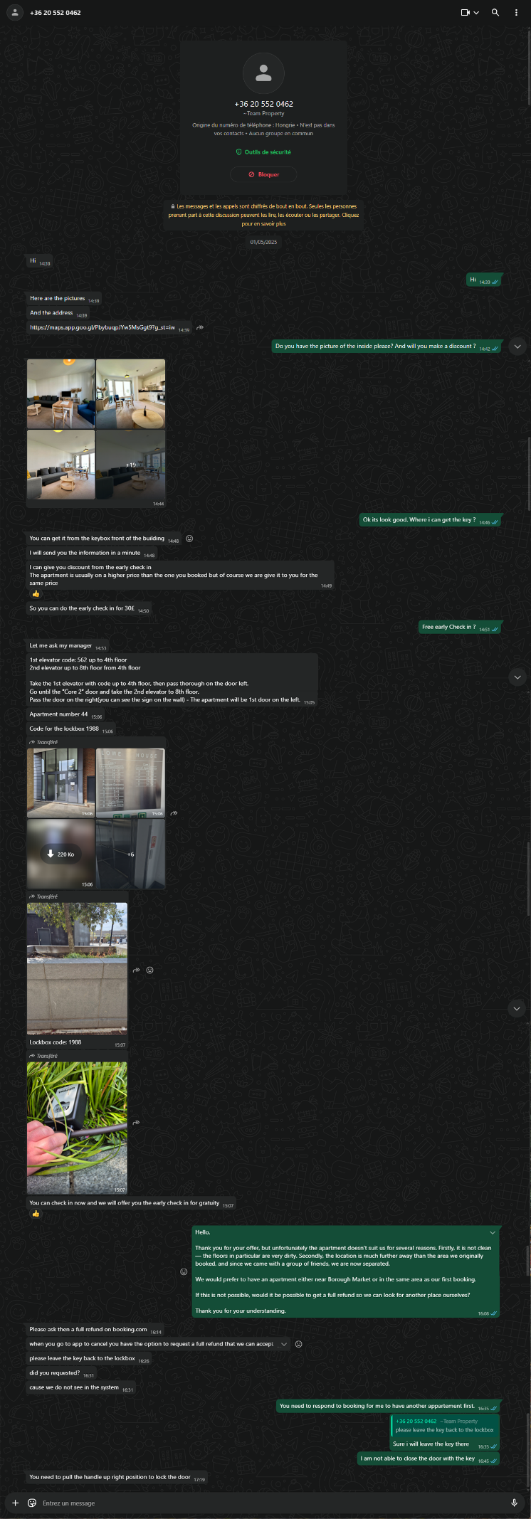

8 mai 2025

Me: Subject: Request for Refund – Reservation #4539809931

Dear owner,

I hope this message finds you well.

I am contacting you regarding the reservation I made through Booking.com (Reservation number: 4539809931) for the period from May 1st to May 4th, 2025.

On May 1st, just 2 hours before check-in, you contacted me via WhatsApp to inform me that the apartment I had booked could not be used due to damage caused by previous guests. This extremely last-minute cancellation left me and my family—my wife and our three young children—in a very stressful and vulnerable situation, in a foreign country, with all our luggage and no place to stay.

You then proposed an alternative apartment located far from the original one. We accepted it temporarily out of necessity but immediately refused it at 15:08 (London time) via WhatsApp, due to:

its poor hygiene and the smell of cigarette smoke,

its unsuitable condition (one of the beds was a camp bed),

its distance from the original location, where we had chosen to stay to be close to friends and to enjoy the neighborhood’s amenities.

Despite explaining the situation to Booking.com multiple times between 15:24 and 18:26, no suitable alternative was offered. In the end, fearing we would have to sleep on the street with our children, I had no choice but to urgently book another accommodation through Booking.com (Reservation number: 4650876191), at a much higher price: €1,478.26, compared to the original €910.52.

As the host, you are responsible for the last-minute cancellation and the poor condition of the alternative you offered. I hereby formally request that you refund the price difference of €567.74 between the cancelled reservation and the emergency accommodation.

Please note that under European consumer protection regulations and Booking.com’s own policies, hosts are expected to fulfill confirmed reservations or provide an equivalent alternative—something that was clearly not the case here.

I ask that you respond to this request within 10 calendar days of receipt. If I do not receive a positive reply within this time, I will proceed with further legal steps through consumer protection channels and small claims procedures.

I hope we can resolve this matter amicably.

Sincerely,