**User’s Guide**

**1. Installation**

Make sure you have the last version of Java installed and the required reference libraries (jars):

* Impsoundworld
* Colors
* Geometry
* Tester
* Tunes

**2. Running the Game**

If you have received this game as a jar file, simply click it to run it. Otherwise, assuming you are using the Eclipse environment, ensure you Build Path is properly configured. Also, make sure that your run configuration for this project is set so that the Main class is Frog Examples (fig. 1). You can leave the Program Arguments empty.

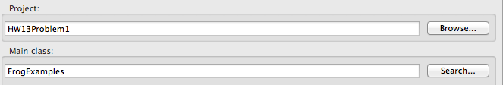

(fig. 1)

**3. Controls**

The controls of this game are simple. Use the direction arrows on your keyboard to move the frog. If you press the “q” at any time during the game, it will end.

**4. Rules/Basics**

You have three frog lives. To win the game, you must navigate your frog across the frightening roads, through the raging river rapids, until you reach the other side. Lose all three lives and the game is over. Navigate four frogs to their amphibious freedom and victory is yours!