**Plots of noisy signal and original signal**

In Figure 1, the plot of the original signal versus time is plotted. The sampling frequency is 360 Hz, and the the time vector is established based on the sampling frequency, where the interval is equal to the sampling period and time span is 1 0s. Similarly, the plot of the noisy signal versus time is plotted in Figure 2.

Figure 1: ECG Signal versus time

Figure 2: Noise versus time

**Heart Rate (Bpm)**

The heart rate is calculated as beats per minute (Bpm). In the ECG signal, the average heart rate can be calculated by dividing the the number of extrema by duration in one minute:

(1)

Where is the number of extrema and is the duration in one minute. The duration in one minute can be calculated by dividing the time span by 60 seconds. As mentioned before, the time span is 10 seconds then is . The extrema can be defined as the local maxima in ECG signal as shown in Figure 3. The final calculated Bpm is approximately 72.

Figure 3: Number of extrema and calculated

**Original and Noisy signal in frequency domain**

Before designing the low pass filter, the original signal and Noise signal in frequency domain need to be shown so that we can find the frequency such that we can find the signal that we do not want. The plot of the ECG signal in frequency time domain is given by using fast fourier transform(fft) in Figure 4. As shown in this figure, the amplitude has been normalized, the frequency is established based on the sampling frequency and it is noted that the figure plotted by using fft is symmetric.

Figure 4: ECG signal in frequency domain

The reason why fft diagram is symmetric is because of the nature of fourier transform and it can be proved in a mathematical way: Define a signal in time domain . Then the fourier transform of this signal can be expressed as:

And the fourier transform at the negative frequency can be expressed as:

Let the term and the term .So, , since the cosine term is even and sine term is odd, which can be expressed as:

And the modulus of can be expressed as:

Then clearly when the frequency is negative, the modulus is still the same:

So (5) = (6), and this can also apply in fast fourier transform (fft). The plot of the Noise in frequency domain is given in Figure 5, where the mains hum is labeled at around 135 Hz, while the mains frequency in the US is around 60Hz.

Figure 5: Noise in frequency domain

**Cut off frequency**

To design a filter to filter the noise out, the cut off frequency needs to be determined. The cutoff frequency can be determined by comparing the Figure 5 with Figure 4 and it is noted that the noise is located at the frequency which is bigger than approximately 60 Hz. So, the cutoff frequency and it can be normalized as , where is the sampling frequency.

**Filter Design**

1. **IIR filter**

The infinite impulse response can be characterized as:

Then the corresponding difference equation can be expressed as:

Based on (8), the corresponding transfer function can be calculated as:

Where and are the corresponding coefficients. To design a IIR low pass filter, we need to first determine the transfer function of the low pass filter and the coefficients need to be determined. In this filter design, to achieve the transfer function and coefficients mentioned above, the Butterworth filter has been chosen since the linear phase response it has is more than that of Chebyshev Type I and Elliptic filters. The Butterworth polynomial can be expressed as:

According to bilinear transform, , where , and is the calculated cut-off frequency which can be calculated as:

(12)

And is the sampling period. is the selected cut off frequency based on Figure 5. It is noted that when the sampling frequency , . According to the bilinear transform, the final transfer function can be expressed as , where can be replaced by:. The designed order is 17.

1. **FIR filter**

The relationship between the input sequence and output sequence in a discrete-time FIR filter can be expressed as:

Where is the number of orders and is the coefficient, which can be expressed as: , then the Z-transform of it is (15).

Compare Figure 5 with Figure 4, the wanted frequency is around 60 Hz. So, in this FIR filter design, to allow for the error, the cut-off frequency is set as around 70 Hz and since the unwanted noise is located at around 118 Hz in the frequency domain as shown in Figure 5, the stop band frequency is set as around 115 Hz to allow for some errors.

In this report, the FIR filter is designed using window method. As shown in Figure 6, the frequency response of three different window methods are plotted. It is clear that, when frequency exceeds around 110 Hz, the attenuation of Hanning Window is bigger. Since in this project, the target is to remove the noise as much as possible, so, the attenuation factor should be as big as possible, so in this report, the window method used for FIR design is Hanning Winodw, whose attenuation factor at stop band is around 44dB.

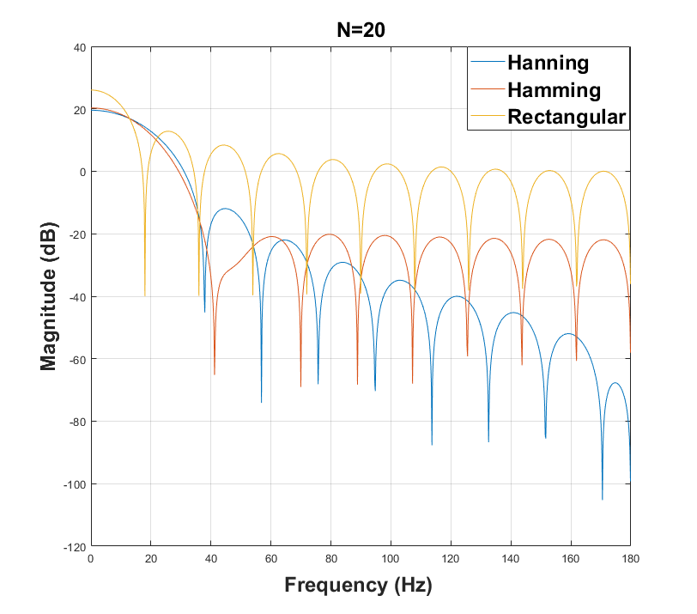

Figure 6: Frequency of Three different Window Methods

In Hanning Window, the desired order can be calculated as:

Where and are the angular frequency of stop band and pass band respectively, and the calculated minimum is 17.

**Frequency response**

Figure 7and Figure 8 plot the frequency response of IIR filter and FIR filter, respectively.

As shown in Figure 7, the cut off frequency is at around 60 Hz, where the attenuation is around 3dB as expected, and when frequency continues to increase, the attenuation continuously decreases until it reaches the point at around .

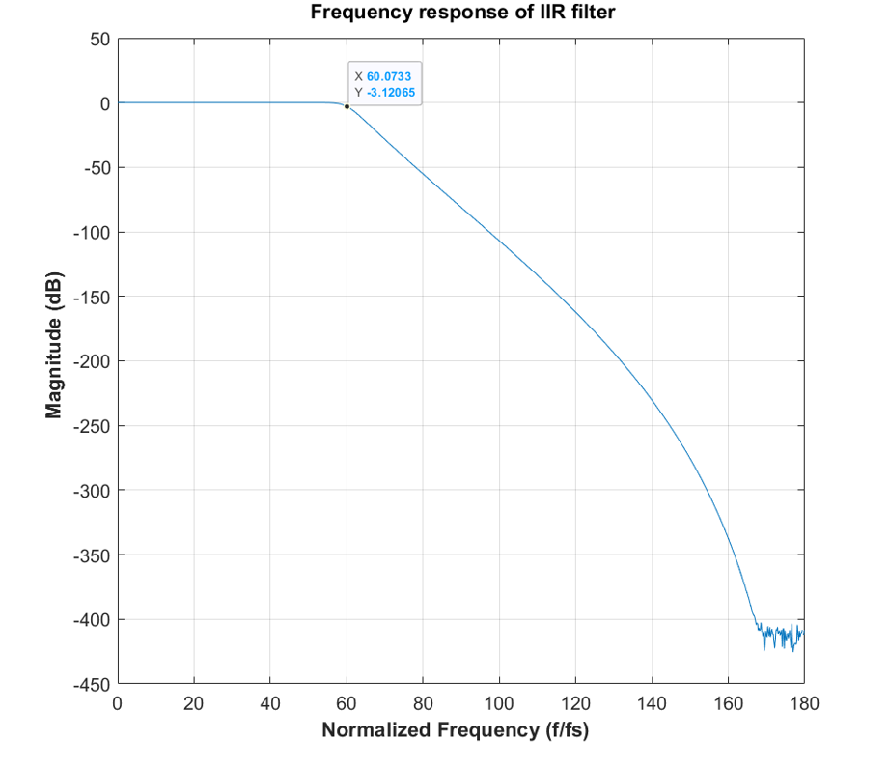

Figure 7: Frequency response of IIR filter

As shown in Figure 7, the cut off frequency is at around 60 Hz, where the attenuation is around 3dB as expected, and at around 118 Hz, the attenuation is around 44dB as expected, and as the frequency continuously increase, the attenuation continues to increase, which means the signal at the frequency which is bigger than around 118Hz will be cleared as much as possible.

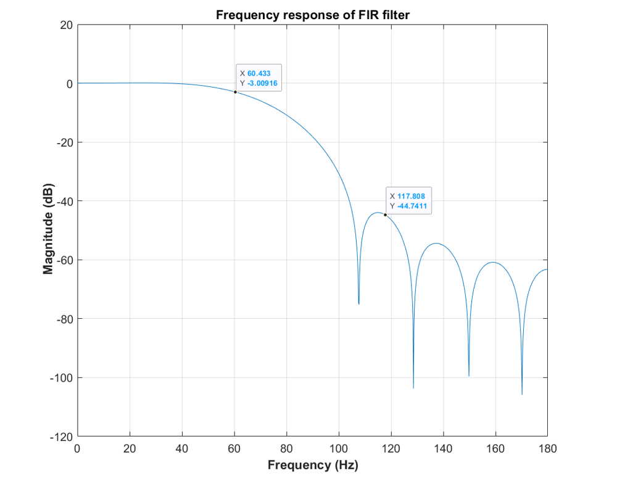

Figure 8: Frequency response of FIR filter

**Filtered Noise**

Figure 9 and Figure 10 plot the filtered noise using designed IIR and FIR filter, respectively.

As shown in Figure 9, compared with the original signal,

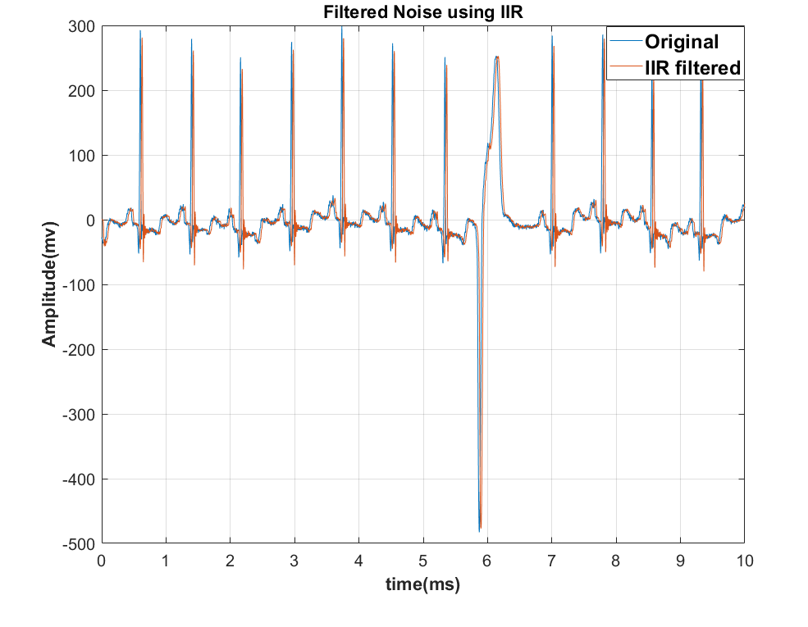

Figure 9: Filtered Noise using IIR