In this project I used two methods, with an assortment of different parameters, to find clusters of countries that have similar cultures. My optimal result split the counties into eight clusters, with the majority of them being as I would expect. Interestingly enough the elbow method says to have only five clusters, but the eight clusters made a lot more sense. The most surprising cluster is cluster 6 which has Japan, Italy, Argentina, and Poland, amongst others. Each of those countries seems to be quite a bit different from my knowledge, so I would expect them in the same cluster. Although of course, it might just be a bad cluster.

Some clusters were very expected. For example cluster 5 has all the nordic and baltic countries, which makes a lot of sense. And cluster 3 has many of the Arab countries as well as a few Latin ones, which again, is pretty expected.

Some other surprising results are that Germany is close to the US and the UK. Although it makes sense when thinking about the “western world”, I expected the cultures to be very different. Also, the fact that South Korea is in the same cluster as many South American and Eastern Europe countries. Jamaica is together with three Asian countries. And the Slovak Republic is in its own cluster, as it is very different than any other country with 100% IDV and UAI.

The actual list of clusters is as follows

1. Bangladesh China Colombia Ecuador Ethiopia Ghana Indonesia Kenya

Malaysia Nigeria Pakistan Philippines Sierra Leone Taiwan Tanzania Thailand

Trinidad and Tobago Venezuela Zambia

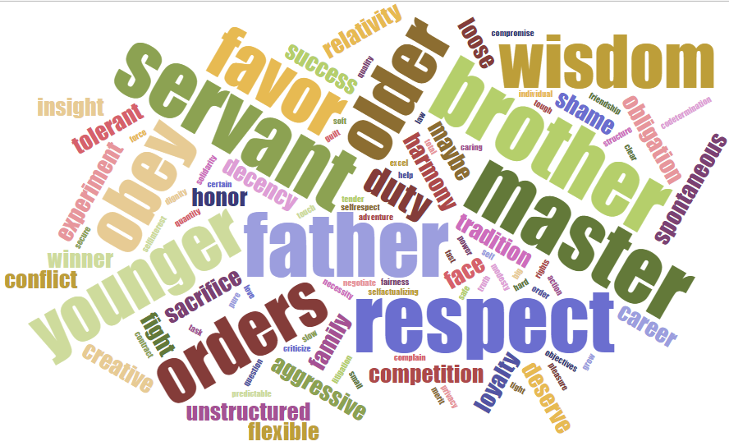

1. Australia Austria Canada Germany Ireland Israel New Zealand South Africa Switzerland United Kingdom United States

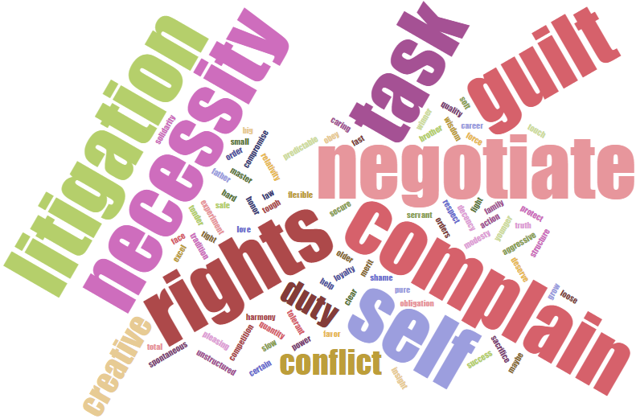

1. Brazil Egypt India Iran Iraq Kuwait Lebanon Libya Mexico Morocco Saudi Arabia

Suriname United Arab Emirates

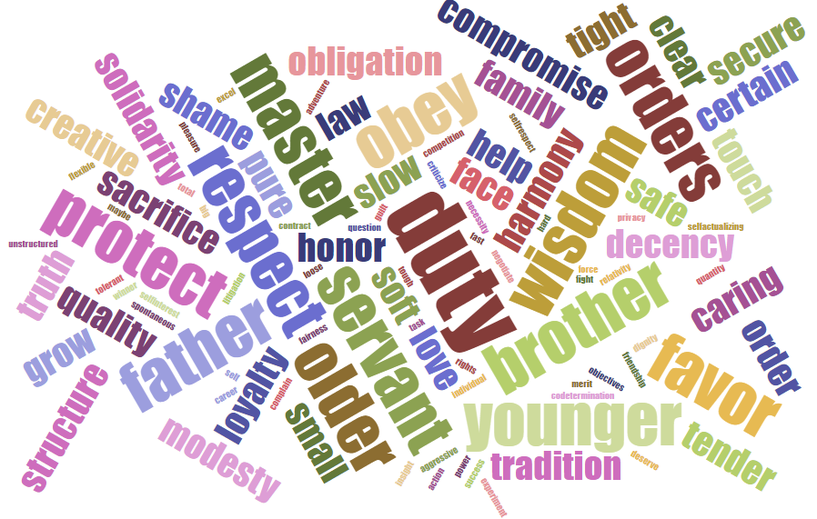

1. Bulgaria Chile Costa Rica Croatia El Salvador Greece Guatemala Panama Peru Portugal Romania Russia Serbia Slovenia South Korea Turkey Uruguay

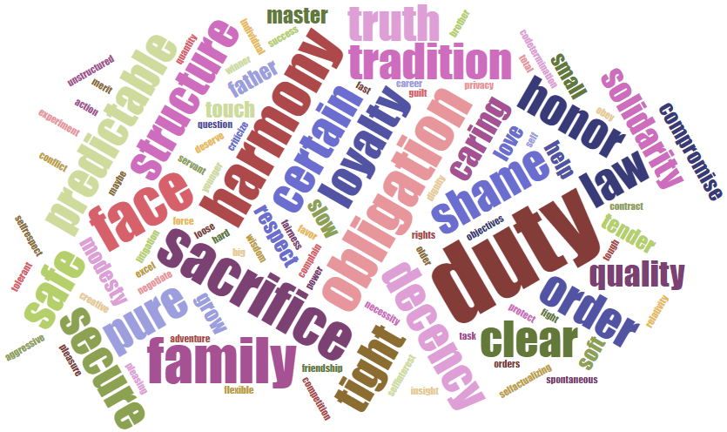

1. Denmark Estonia Finland Latvia Lithuania Netherland Norway Sweden

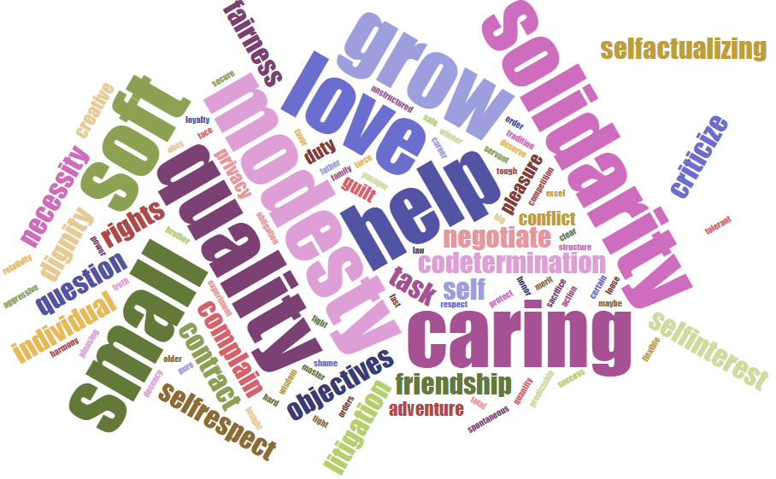

1. Argentina Belgium Czech Republic France Hungary Italy Japan Malta Poland Spain

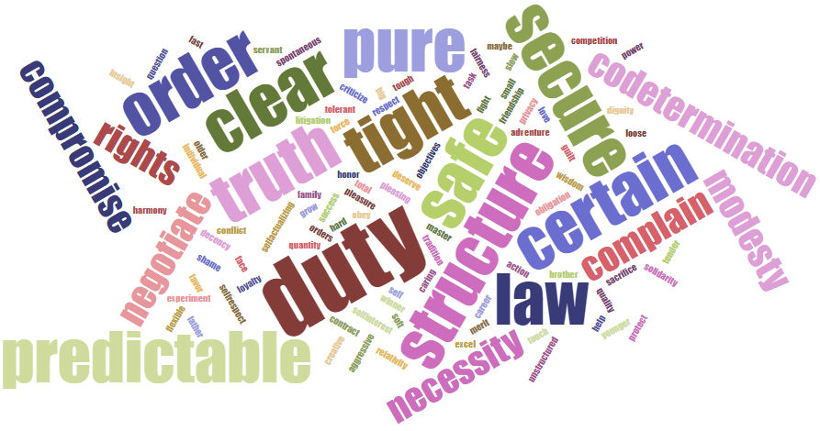

1. Slovak Rep

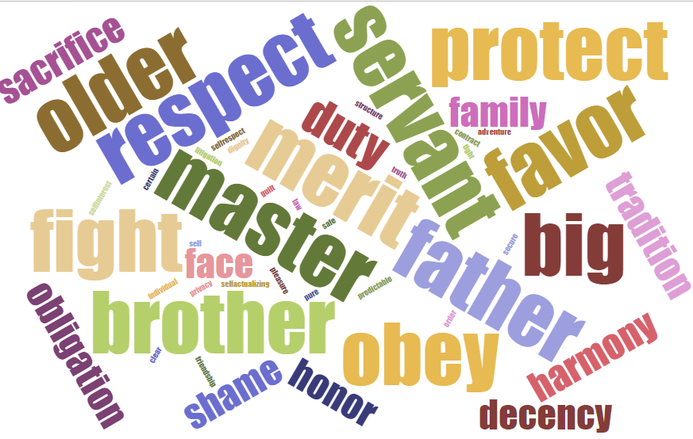

1. Hong Kong Jamaica Singapore Vietnam

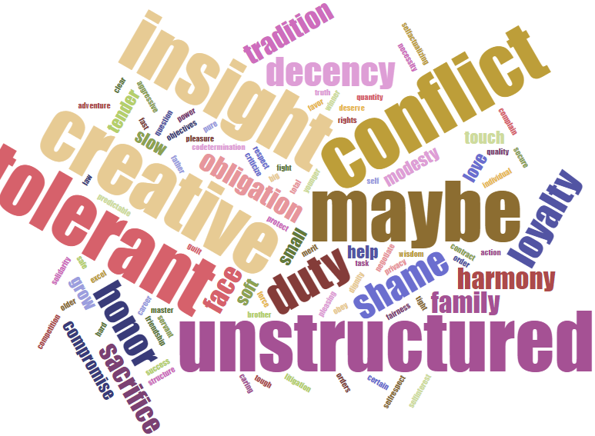

The map with the clusters colored looks like this:

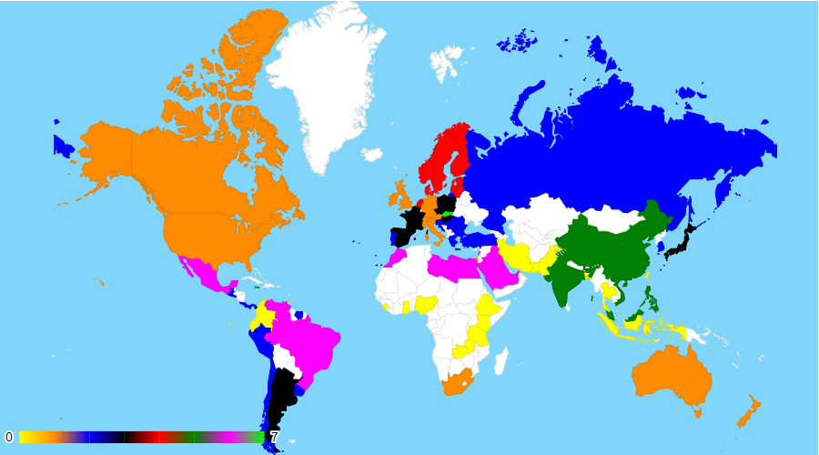

The countries in white are those that we didn’t have data on.

The code for this can be found [here](https://jsfiddle.net/rj9gpd4t/1/)