A.R.E.N.A. VIETNAM — QUALITY & COMPLIANCE
Master Quality Compliance Guideline
Manual Hand Pallet Truck (pedestrian-propelled, hydraulic lift)
Document reference | MCG-DIY-HT-PT-001
Version / status | v1.3 — Draft for CQAD approval (process flowcharts Fig. 1–3; regulatory cross-check 14/10/2026)
Issue date | 14/10/2026
Department | DIY
Product Family (QSD level) | Hand Tools
Product Sub-Family (QCP level) | Storage / Moving
Compliance pathway | PATHWAY A — CE marking · Machinery Directive 2006/42/EC → Machinery Regulation (EU) 2023/1230 from 20/01/2027 · Internal production control (Module A), no Notified Body
Target markets | EU-27 + Switzerland
Allies | HAGEBAU · ITM · BCM · DEDEMAN · JUMBO/Coop
Mode | Mode 1 — Category level (supplier / factory fields left as [___])
Source document | Product requirements – pallet truck (sample validation checklist, A.R.E.N.A. template)
Prepared by / Approved by | QS [___] / CQAD [___]

Regulatory status cross-checked on 14/10/2026 against EUR-Lex, Commission, BAuA/ZLS, CEN national catalogues and SECO publications. Items still open are listed in Annex E and marked “verify” in the text; close them before release as controlled document.

Contents

(Right-click → Update field in Word to refresh page numbers.)

1. Executive Summary
- Pathway A (CE). A manual pallet truck is lifting machinery whose only power source is directly applied human effort — within the scope of the Machinery Directive 2006/42/EC (Art. 2(a), 4th indent) and of the Machinery Regulation (EU) 2023/1230 from 20/01/2027.
- Regulatory switch-over. Units placed on the EU market up to 19/01/2027 → MD 2006/42/EC. Units placed on the market from 20/01/2027 → MR (EU) 2023/1230 (new DoC wording, Annex III EHSR, importer marking, instructions rules). Any P.O. with EU arrival on or after 20/01/2027 shall be documented under the MR.
- Conformity assessment. Not listed in MD Annex IV / MR Annex I → internal production control (MD Art. 12(2), Annex VIII; MR Module A, Annex VI). No Notified Body; A.R.E.N.A. requires an ISO/IEC 17025-accredited third-party test report.
- Harmonised standards. EN ISO 3691-5:2015 + AC:2016 + A1:2020 (pedestrian-propelled trucks; ISO 3691-5:2014 confirmed 2021, no revision found), EN 16307-5:2023 (supplementary requirements; supersedes EN 16307-5:2013, withdrawn 29/12/2023), EN ISO 12100:2010. MR: no list of harmonised standards published in the OJEU as of September 2026 (first list expected end-2026); MD citations do not automatically give presumption of conformity under MR Art. 20.
- Horizontal overlays. REACH (Art. 33 SVHC, Annex XVII entries 50 PAH and 51 phthalates for grips/wheels), POPs (EU) 2019/1021 (SCCP), PPWR (EU) 2025/40 (applicable since 12/08/2026), GPSR (EU) 2023/988 (complementary), Reg. (EU) 2019/1020 Art. 4 (EU economic operator).
- Key corrections to the source checklist: GPSD 2001/95/EC → GPSR; PPWD 94/62/EC → PPWR; dynamic test (1.1 × rated load), load holding, overload device, crushing points, data plate and instructions checks added; AQL sampling plan defined. Full log in Section 15.
- GS mark (voluntary, Germany). Where an Ally (e.g. HAGEBAU) orders GS, a ZLS-recognised GS body (TÜV SÜD / TÜV Rheinland / TÜV NORD or equivalent) tests the type to EN ISO 3691-5 + AfPS GS 2019:01 PAK, inspects the factory before award and annually thereafter; certificate max. 5 years (ProdSG §§ 20–24). Process in Section 10.
- Release (SRC) critical items: valid test report covering the variant, signed DoC in Ally language(s), CE + complete data plate incl. rated capacity, paper instructions in the destination language(s), FRI PASS (Cr 0 / Ma 2.5 / Mi 4.0), PPWR packaging data, SVHC declaration.

1.1 Process overview — compliance chain flowchart
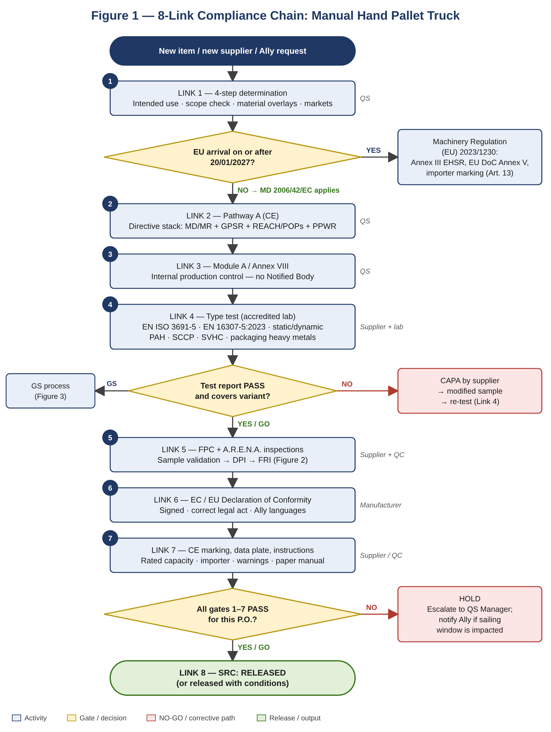
Figure 1 — Sequential 8-link chain with go/no-go gates; the MD/MR decision is taken on the EU arrival date of each P.O.

2. Link 1 — 4-Step Compliance Determination

2.1 Step I — Intended use and foreseeable misuse
Function | Horizontal transport of palletised loads up to the rated capacity Q (typically 2 000–3 000 kg at load centre c = 600 mm — confirm per offer); fork lift by pumping the tiller; controlled lowering by hand lever (and/or foot pedal).
Operating environment | Smooth, level, hard floors; indoor warehouses, shops, workshops (EN ISO 3691-5 Cl. 3 definition — verify).
User population | Professional operators and non-professional DIY customers (DIY retail channel → consumer use assumed for instructions and safety information).
Reasonably foreseeable misuse | Overloading; eccentric / off-centre loads; use on slopes or uneven ground; riding on the truck; lifting persons; use as vehicle jack; parking on gradient without brake; children playing with parked truck; tiller released under load.
Vehicle component? | No → Pathway D excluded
Biocidal claim? | No → Pathway E excluded

2.2 Step II — Directive scope check
Directive / Regulation | Scope clause | In scope? | Justification
Machinery Directive 2006/42/EC | Art. 1(1)(a); Art. 2(a) 4th indent | YES (until 19/01/2027) | Assembly for lifting loads whose only power source is directly applied human effort.
Machinery Regulation (EU) 2023/1230 | Art. 2; Art. 3 definition of “machinery” (manual lifting assemblies) — verify point | YES (from 20/01/2027) | Same scope logic carried over from MD.
LVD 2014/35/EU / EMC 2014/30/EU | Art. 1 / Art. 2 | NO | No electrical equipment.
RED 2014/53/EU / RoHS 2011/65/EU | Art. 1 / Art. 2 | NO | No radio or EEE.
Toys Reg. (EU) 2025/2509 | Art. 2 | NO | Not designed for play.
PPE (EU) 2016/425 / CPR 305/2011 | Art. 3 / Art. 2 | NO | Not PPE; not incorporated in construction works.
GPSR (EU) 2023/988 | Art. 2(1) 2nd subpara. | COMPLEMENTARY | Applies to aspects/risks not covered by MD/MR and to obligations such as accident notification (Art. 20), online sales (Art. 22) and recalls (Art. 35–37).
Market Surveillance Reg. (EU) 2019/1020 | Art. 4 | YES | Machinery listed in Art. 4(5): an EU-established economic operator is mandatory; name and contact on product, packaging or accompanying document.

2.3 Step III — Material composition overlays
Material / signal | Overlay | Requirement / action
All articles | REACH Art. 33 | SVHC declaration per shipment (Candidate List current at shipment date, > 0.1 % w/w per article).
Tiller grip, wheels (PU/rubber/PVC) — skin contact | REACH Annex XVII entry 50 | 8 PAH ≤ 1 mg/kg each (articles supplied to general public, prolonged/repetitive skin contact).
Plasticised PVC grip / hoses | REACH Annex XVII entry 51 | DEHP, DBP, BBP, DIBP ≤ 0.1 % (sum) in plasticised material.
PVC / rubber parts | POPs Reg. (EU) 2019/1021 | SCCP ≤ 1 500 mg/kg (0.15 % w/w) in articles; MCCP restriction in preparation (2026 delegated act) — monitor.
Hydraulic oil (contained in pump) | REACH / CLP | Oil is part of the article; provide SDS of the oil type for maintenance; oil type and volume in instructions.
Painted / powder-coated steel | REACH SVHC (Pb chromates) | Lead chromate pigments are SVHC/authorisation substances — confirm lead-free coating.
Steel frame / forks | CBAM (EU) 2023/956 | CN 8427 90 00 not in current CBAM Annex I → out of scope today. Commission proposal COM(2025) 989 extends CBAM to ~180 steel/aluminium downstream products from 01/01/2028 (EP ENVI: 277 lines) — check whether heading 8427 is added (verify CN on P.O.).
Wooden pallet / crate | ISPM 15 · EUDR (EU) 2023/1115 | HT-treated with IPPC mark. Packaging used solely to support/protect another product is excluded from EUDR (Annex I).
All packaging | PPWR (EU) 2025/40 | Art. 5(4): Pb+Cd+Hg+Cr(VI) ≤ 100 mg/kg; packaging data per SKU; EPR registration (see Link 8).

2.4 Step IV — Market destination
Market / Ally | Parallel requirements activated
EU-27 (all) | MD/MR + CE; EU economic operator (2019/1020 Art. 4); GPSR complementary obligations; REACH + POPs; PPWR + national EPR; instructions and DoC in official language(s) of the Member State of sale.
Switzerland — JUMBO/Coop | Machinery Ordinance (MaschV, SR 819.14) — EU-CH MRA currently recognises EU conformity under MD; Product Safety Act (PrSG, SR 930.11); instructions DE/FR/IT; Swiss distributor/importer identification. Risk: revised MaschV aligned with MR was consulted (2025); MRA update depends on ratification of the EU-CH package (expected 2027/2028 at the earliest) → confirm Swiss requirements with JUMBO/Coop for lots arriving after 20/01/2027.
France — ITM | French language (Loi Toubon); Triman + Info-tri sorting information (Code de l’environnement L.541-9-3); mineral oils in packaging inks — Law 2020-105 Art. 112 and implementing decree.
Germany — HAGEBAU | German language; GS mark (ProdSG §§ 20–24) when ordered by Ally — full process in Section 10; AfPS GS 2019:01 PAK then applies to grips and wheels.
Romania — DEDEMAN | Romanian language on instructions, warnings and DoC.
BCM | Language(s) and EPR per destination country — [confirm with Ally].

Gate 1 decision
✅ GO | Pathway A assigned with scope-clause justification (this section) — current status: GO
⚠️ CONDITIONAL | Truck variant with electric lift/travel or scale (EEE) → re-run Link 1 (LVD/EMC/RoHS/WEEE/batteries).
❌ NO-GO | Rated capacity, lift height or variant list not defined by supplier.

3. Link 2 — Pathway Assignment and Directive Stack
Directive / Regulation | Scope | hEN / reference | Pathway | Module | NB? | Declaration
MD 2006/42/EC | Yes — until 19/01/2027 | EN ISO 3691-5:2015+AC:2016+A1:2020; EN 16307-5:2023 (verify OJEU citation of 2023 edition); EN ISO 12100:2010 | A | Annex VIII (internal) | No | EC DoC (Annex II 1.A)
MR (EU) 2023/1230 | Yes — from 20/01/2027 | No MR citation published yet (Sept 2026). Until cited: apply same standards as technical solution and demonstrate Annex III EHSR directly in the technical file (no Art. 20 presumption) | A | Module A (Annex VI) — truck not in Annex I | No | EU DoC (Annex V Part A)
GPSR (EU) 2023/988 | Complementary | — | — | — | No | None (safety information, traceability)
Reg. (EU) 2019/1020 | Art. 4 | — | — | — | No | EU operator identification
REACH / POPs | Overlay | Annex XVII; Candidate List | — | — | No | SVHC declaration + test report
PPWR (EU) 2025/40 | Overlay | Art. 5(4) heavy metals + DoC/technical documentation (Art. 38–39) applicable since 12/08/2026; Art. 12 labelling from the later of 12/08/2028 or 24 months after implementing acts; recyclability via delegated acts | — | — | No | Packaging EU DoC (packaging manufacturer/supplier)

Gate 2 decision
✅ GO | Single pathway A; directive stack complete — current status: GO
⚠️ CONDITIONAL | P.O. delivery straddles 20/01/2027 → prepare dual MD/MR documentation.
❌ NO-GO | Pathway cannot be confirmed → return to Link 1.

4. Link 3 — Module Determination
Directive | Pathway | Module | NB required | NB name / no. | Certificate ref.
MD 2006/42/EC | A | Internal production control — Art. 12(2), Annex VIII | No | N/A | N/A
MR (EU) 2023/1230 | A | Module A — internal production control, Annex VI | No | N/A | N/A

Rationale: manual pallet trucks are not listed in MD Annex IV nor in MR Annex I (Parts A/B). The module is prescribed by the legislation, not chosen by the manufacturer. A.R.E.N.A. requirement: conformity evidence by ISO/IEC 17025-accredited third-party laboratory test report against the hEN(s); voluntary NB/certification body attestation is accepted but does not alter the module. No NB number follows the CE marking.

Gate 3 decision
✅ GO | Module confirmed; no NB required — current status: GO
⚠️ CONDITIONAL | Accredited lab not yet appointed — engagement plan before sample validation.
❌ NO-GO | Supplier declares NB number on marking/DoC without NB involvement (false NB reference).

5. Link 4 — Type Testing and Technical File

5.1 Type-test matrix (ITT-equivalent for Module A)
# | Test / characteristic | Reference (verify clause) | Requirement
1 | Static test | MD/MR Annex I/III 4.1.2.3, 4.1.3; EN ISO 3691-5 | 1.5 × Q at load centre c; no permanent deformation, no patent defect, no leakage.
2 | Dynamic test | MD/MR 4.1.2.3, 4.1.3 | 1.1 × Q; all functions (lift, lower, travel, steer) operate correctly.
3 | Overload / pressure-limiting device | EN ISO 3691-5 Cl. 4.4.3.3 (per source) | Set < 115 % of maximum working pressure; cannot work loose; tool/key needed to alter. Manual trucks: design shall allow fitting. A.R.E.N.A./Ally: device fitted — [confirm].
4 | Stability | EN ISO 3691-5 / EN 16307-5 | Stability verification per standard (tilt-table or calculation).
5 | Lifting / lowering control | MD/MR 1.2.1, 1.2.2, 4.1.2.6; EN ISO 3691-5 | Controls identifiable; controlled lowering under Q; no uncontrolled descent; lowering-speed limit per standard.
6 | Load holding (drift) | EN ISO 3691-5 | Drift of raised loaded forks within the limit of the standard over the specified time.
7 | Tiller and hand grips | EN ISO 3691-5 Cl. 4.2.2 (per source) | Closed-loop handle or lateral hand protection; grip cross-section within 25 mm / 35 mm concentric circles; span ≥ 120 mm per hand; operating forces per standard.
8 | Crushing / shearing points, feet protection | MD/MR 1.3.7, 1.3.8; EN ISO 13854:2019; EN ISO 3691-5 | Gaps at tiller pivot, linkage, fork rollers: fingers ≥ 25 mm or ≤ safe gap; steer-wheel feet protection per standard.
9 | Edges and surfaces | MD/MR 1.3.4 | No sharp edges, angles or rough surfaces on accessible parts.
10 | Parking brake (if fitted) | EN ISO 3691-5 | Holds laden truck on gradient specified by the standard / instructions.
11 | Marking and instructions | MD/MR 1.7.3, 1.7.4, 4.3.3, 4.4.2; EN ISO 3691-5 Cl. 7 | Content check — see Link 7.
12 | Coating performance | ISO 2409; ISO 9227 NSS; ISO 2808 | Cross-cut ≤ class 2; salt-spray hours and DFT per QSD/Ally spec [___].
13 | Chemical suite | REACH Annex XVII 50, 51; Art. 33; POPs | PAH, phthalates (grips/wheels), SCCP, SVHC screening. Validity 2 years.
14 | Packaging heavy metals | PPWR Art. 5(4) | Pb+Cd+Hg+Cr(VI) ≤ 100 mg/kg per packaging component.

Variant coverage: one report per capacity / fork length / fork width configuration, or documented worst-case justification in the technical file. Re-test on any change of frame, fork section, pump, seals, wheel material, coating system or production site.
GS orders: commission one combined test at the GS body covering the CE test matrix (items 1–14) and the GS specifications, so the same report serves the technical file and the GS certificate (Section 10).

5.2 Technical file content (MD Annex VII A / MR Annex IV)
- General description; overall drawing; detailed drawings of frame, forks, pump and tiller; hydraulic schematic and calculation notes (strength, stability).
- Risk assessment per EN ISO 12100: hazards, protective measures, residual risks (covers all misuse in 2.1).
- List of EHSR applied and harmonised standards with edition dates; justification for any deviation.
- Test reports (Section 5.1) and end-of-line test records.
- Instructions for use (all languages) and copy of DoC.
- Internal measures ensuring series conformity (FPC — Link 5).
- Retention: 10 years from the last unit placed on the market; available to authorities on reasoned request.

Gate 4 decision
✅ GO | Accredited test report covering the exact variant, current hEN editions, all 14 items addressed; technical file complete.
⚠️ CONDITIONAL | Chemical report expiring < 3 months; MR gap analysis pending for deliveries after 20/01/2027.
❌ NO-GO | Static/dynamic test missing or failed; report covers a different model; design changed since test.

6. Link 5 — Factory Production Control and Inspection

6.1 Factory prerequisites (from source, updated)
Criteria | Requirement
Factory QMS | A.R.E.N.A. QMS audit grade A/B (C = conditional with CAPA). Valid ISO 9001 certificate is considered satisfying the QMS requirement. FPC audit confirming series conformity to the tested type.
Factory CSR | amfori BSCI A/B/C (C = conditional). Valid SA8000 is considered satisfying. ISO 14001 where applicable.

6.2 FPC critical control points
Component / process | Control parameter | Frequency / record
Steel (frame, forks) | Grade and thickness vs drawing; mill certificate | Each heat / lot
Welding | WPS; welder qualification; visual weld inspection (no cracks, porosity, undercut) | Each shift; 100 % visual on load-bearing welds
Hydraulic pump | 100 % pressure/leak test; overload valve setting and seal; oil type and volume | 100 %, recorded
End-of-line load test | Static and dynamic tests per MD Annex I 4.1.2.3 / 4.1.3 (MR Annex III same numbering) — required on all lifting machinery before putting into service | 100 %, recorded per serial number
Wheels and bearings | Material (PU/nylon), diameter, free rotation | Each lot
Fasteners, pins, circlips | Presence, torque, securing | 100 % visual
Coating | DFT (ISO 2808), cross-cut (ISO 2409) | Each batch
Marking | Data plate content, serial number, CE, rated capacity | 100 %
Non-conforming product / CAPA / calibration | Segregation, disposition, 8D, gauge calibration | Per procedure; records ≥ 10 years

6.3 A.R.E.N.A. inspection schedule
Stage | Trigger | Quantity / sampling | Checklist
Sample validation | New item / new supplier / change | 1 pc (+1 pc golden sample retained) | Annex A — all items incl. static test
DPI / in-line | First order; critical order | At ≥ 20 % of goods produced | Annex A items 1–7 (static test on 1 pc)
FRI | Every shipment, mandatory | 100 % produced, ≥ 80 % packed; ISO 2859-1 / ANSI Z1.4 GI-II; Cr 0 · Ma 2.5 · Mi 4.0; functional tests at S-3 | Annex A (static test not required unless Ally requests)
Golden sample | Every P.O., each variant | Sealed reference | Per QSD

6.4 Inspection and release flowchart
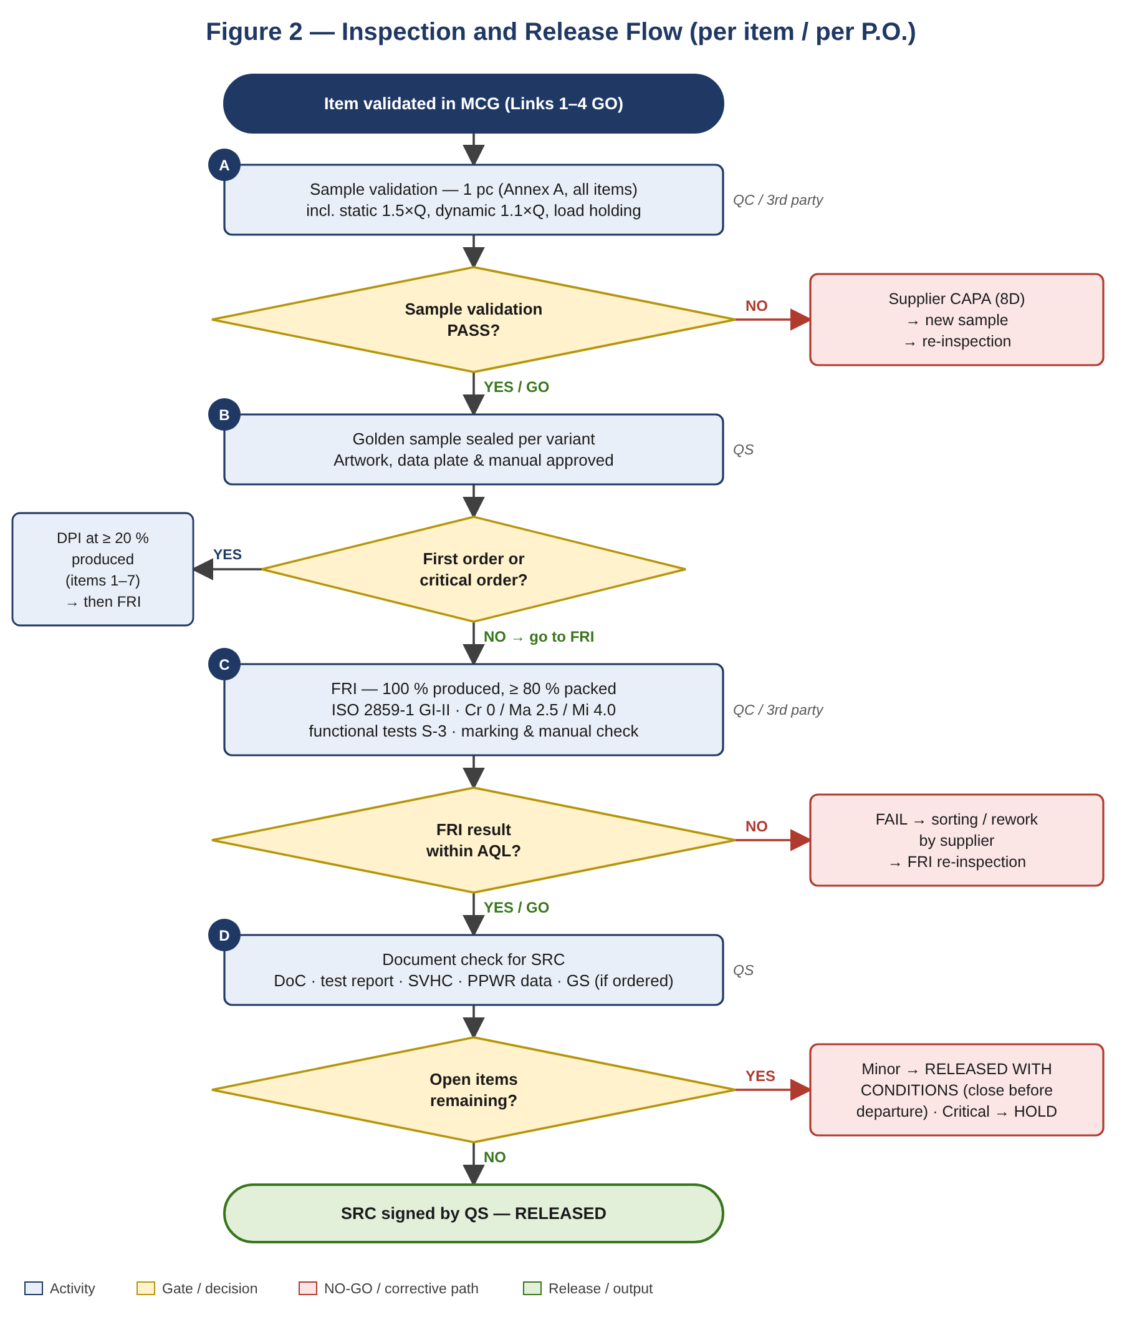
Figure 2 — Sample validation, DPI, FRI and SRC decision path with corrective loops.

Gate 5 decision
✅ GO | FPC verified; sample validation PASS; FRI booked.
⚠️ CONDITIONAL | First order — DPI mandatory before FRI.
❌ NO-GO | No end-of-line load test; FRI critical defect; FPC not established.

7. Link 6 — Declaration of Conformity
DoC element | MD 2006/42/EC — Annex II 1.A | MR (EU) 2023/1230 — Annex V
Manufacturer name and full address | Required (+ authorised representative) | Required (+ authorised representative)
Person authorised to compile technical file (established in EU) | Required | Not a DoC field — verify
Description and identification | Generic denomination, function, model, type, serial number, commercial name | Product, model, type, serial/batch; image optional
Sole responsibility statement | — | Required
Conformity statement | Machinery Directive + other applicable directives | MR + other Union harmonisation legislation
Standards | Harmonised standards with dates | Harmonised standards / common specifications with dates
NB | N/A (Annex VIII) | N/A (Module A)
Place, date, name, function and signature | Required | Required

- One DoC per model; languages of each Member State of sale (EN + DE/FR/IT/RO etc.).
- MD: the instructions shall contain the DoC or a document setting out its contents (Annex I 1.7.4.2(c)). MR Art. 21: the machinery is accompanied by the EU DoC (Annex V Part A) or the manufacturer provides the internet address where it can be accessed (A.R.E.N.A.: paper copy in the box for DIY channel). Omnibus IV (provisional agreement 09/06/2026, not yet published) introduces an electronic DoC — monitor.
- Superseded references (e.g. EN 1757-2, GPSD 2001/95/EC) on DoC → reject.

Gate 6 decision
✅ GO | DoC complete, signed, correct legal act for the placing-on-market date, correct languages.
⚠️ CONDITIONAL | Cites superseded standard edition — revise before shipment.
❌ NO-GO | DoC missing/unsigned; MD DoC used for units placed on market after 19/01/2027.

8. Link 7 — CE Marking, Data Plate and Instructions

8.1 Marking verification checklist (QC at FRI)
Element | Reference | Accept criterion | Fail class
CE marking ≥ 5 mm, Annex II 765/2008 proportions, indelible, next to manufacturer name | MD 1.7.3 / Art. 16; MR Art. 24 | Present, correct, no NB number | Critical
Manufacturer business name and full address (+ AR) | MD/MR 1.7.3 | Complete | Critical
Importer name, trade name, postal address and contact | MR Art. 13; GPSR; 2019/1020 Art. 4 | On product or, where impossible, packaging/document | Critical
Designation, series or type, serial number, year of construction | MD/MR 1.7.3 | Complete and legible | Critical
Rated capacity (kg) at load centre (mm); unladen mass | MD/MR 4.3.3; EN ISO 3691-5 data plate (verify) | Matches test report and spec | Critical
Warning pictograms (no riding, foot crushing, max load) | Risk assessment; EN ISO 3691-5 | Present, durable | Major
Swiss distributor identification (CH lots) | PrSG | Present | Major
Barcode / EAN | Ally spec | Scans correctly, position per approval | Major
Triman + Info-tri (FR lots) | L.541-9-3 C. env. | On packaging or leaflet | Major

8.2 Instructions for use — minimum content
- Intended use, rated capacity, load centre, permitted floors; prohibited uses (2.1 misuse list).
- Assembly of tiller (pin, chain/rod adjustment), commissioning check, operation (lift, neutral, lower), parking/brake.
- Maintenance: oil type, volume, refilling, air bleeding, lubrication points, inspection intervals, wear limits; residual risks.
- Manufacturer and importer identification; copy/content of DoC (MD) or DoC access (MR).
- Languages: official language(s) of each country of sale (CH: DE/FR/IT). Paper format for the DIY channel. MR Art. 10(7): digital instructions permitted (downloadable, printable, access marked on the machine, online availability for the lifetime and ≥ 10 years); paper copy free of charge on request within one month; safety information on paper where non-professional use is foreseeable.
- Layout per EN IEC/IEEE 82079-1 (assessment via assembly-instruction-assessment skill).

Gate 7 decision
✅ GO | All Critical marking elements present; instructions approved in all languages.
⚠️ CONDITIONAL | Minor label error correctable before carton sealing.
❌ NO-GO | CE/data plate/rated capacity/importer missing; wrong language; NB number without NB.

9. Link 8 — SRC Release Conditions
- Links 1–3: MCG on file; pathway and module confirmed; legal act matches EU arrival date (MD ≤ 19/01/2027 / MR ≥ 20/01/2027).
- Link 4: accredited test report valid and covering every variant on the P.O.; chemical report ≤ 2 years.
- Link 5: FRI PASS — Cr 0 / Ma 2.5 / Mi 4.0; functional tests PASS; golden sample match; DPI PASS for first order; end-of-line load-test records sighted.
- Link 6: signed DoC in required languages on file.
- Link 7: marking and instructions verified at FRI.
- PPWR: packaging weight and material per SKU recorded (Annex D); heavy-metal compliance; EPR registration of the producer for each destination country.
- REACH: SVHC declaration for the shipment on file.
- Wooden pallets: ISPM 15 HT mark verified.
Ally / market | Additional release condition
HAGEBAU (DE) | German instructions/DoC. GS lots: GS certificate valid, covering model, Ally brand/trade name and producing factory; last surveillance inspection within 12 months; GS mark artwork as approved by the GS body (Section 10.7); importer GS verification record per ProdSG § 24.
ITM (FR) | French instructions; Triman/Info-tri; mineral-oil-free packaging inks declaration.
DEDEMAN (RO) | Romanian instructions/DoC.
JUMBO/Coop (CH) | DE/FR/IT instructions; Swiss distributor identification.
BCM | Destination languages and EPR — [confirm].

SRC decision: RELEASED (all gates PASS) · RELEASED WITH CONDITIONS (minor items closed before vessel departure) · HOLD (any critical gate FAIL; escalate to QS Manager and notify Ally if sailing window impacted). Signed by QS; QC countersignature on FRI input.

10. GS Mark Certification Process (TÜV / ZLS-recognised GS body)

10.1 Legal basis and eligibility
Mark | GS — “Geprüfte Sicherheit” (tested safety). Voluntary German mark; does not replace CE marking, DoC or technical file.
Legal basis | Product Safety Act (ProdSG, in force 16/07/2021): § 20 award of the GS mark (validity ≤ 5 years or limited to a production lot); § 21 GS body duties (type test against § 3/§ 6 and AfPS specifications; production controls); § 22 further GS body duties (public certificate list, action on misuse, suspension/withdrawal); § 24 obligations of manufacturer and importer; GS symbol per the Annex (Anlage) to ProdSG.
GS body | Only a GS body recognised by the ZLS (Zentralstelle der Länder für Sicherheitstechnik) and accredited by DAkkS, listed by BAuA — e.g. TÜV SÜD, TÜV Rheinland, TÜV NORD, DEKRA, Intertek. Verify the body’s ZLS scope covers industrial trucks / machinery.
Eligibility | Ready-to-use and suitable product (“verwendungsfertig”) — manual pallet truck qualifies. § 20(2): GS not awarded where the CE legislation already provides at least equivalent requirements via third-party conformity assessment; the truck is Module A (no third party), therefore eligible (confirm with GS body).
Who holds the certificate | Manufacturer (or EU authorised representative). Ally brand / trade name and Ally model references must be listed on the certificate (trade-name extension).
Importer duty (§ 24) | Before placing a GS-marked product on the German market, the importer (Ally or A.R.E.N.A. entity acting as importer) must verify that a valid GS certificate exists and document the check (date, GS body, certificate number).
Trigger at A.R.E.N.A. | Ally order specifying GS (typically HAGEBAU, DE/AT). GS cost and lead time to be quoted at RFQ stage.

10.2 Test basis (GS specifications)
Specification | Scope for the pallet truck
EN ISO 3691-5:2015+AC:2016+A1:2020; EN 16307-5:2023 | Full safety test programme — same as Link 4 items 1–11.
EN ISO 12100:2010 | Risk assessment review by GS body.
AfPS GS 2019:01 PAK (current; mandatory for new GS certificates since 01/07/2020) | Tiller grip = category 2 (skin contact > 30 s or repeated): benzo[a]pyrene < 0.5 mg/kg, Σ15 PAH < 10 mg/kg. Wheels, covers = category 3: benzo[a]pyrene < 1 mg/kg, Σ15 PAH < 50 mg/kg. Individual PAH limits per AfPS table; category assignment confirmed by GS body.
ProdSG § 3 / instructions | German instructions and warnings checked for completeness and comprehensibility.
GS body supplementary requirements | Body-specific test programme (e.g. durability, marking durability) — obtain written test scope with the quotation.

10.3 Step-by-step obtaining process
Step | Activity | Responsible | Output / gate | Indicative lead time
1 | Confirm Ally GS requirement; define models, capacities, brand names to be covered | Merchandiser + QS | GS scope sheet | RFQ stage
2 | Select ZLS-recognised GS body; request quotation (testing, factory inspection, annual fee); confirm test scope | QS | Quotation + written test programme | 1 week
3 | Application signed by manufacturer (certificate holder); trade-name listing for Ally brand | Supplier | Application form accepted | —
4 | Technical documentation submitted (see 10.4); pre-review by GS body | Supplier + QS | Document review report; gaps closed | 1–2 weeks
5 | Samples shipped (production-representative, quantity per GS body, typically 2–3 units + spare grips/wheels) | Supplier | Sample receipt confirmation | 1 week
6 | Type testing at GS body lab; on failure → CAPA, modified samples, re-test | GS body; QS follows up | GS test report — PASS | 3–5 weeks
7 | Initial factory inspection (Fertigungsstätteninspektion) — mandatory before award: production capability, incoming control, end-of-line load test, critical components, traceability | GS body; QS attends | Factory inspection report — PASS | 1–3 weeks (scheduling)
8 | GS certificate issued (model, brand, factory, standards, validity ≤ 5 years) | GS body | GS certificate | 1 week
9 | GS mark artwork (rating plate / label / packaging) submitted for GS body approval; mark used only after certificate issue | Supplier + QS | Approved artwork | 1 week
10 | Certificate details uploaded to QC pack; Ally informed; certificate verified in GS body online database | QS | Link 8 SRC input | —

Indicative total: 6–10 weeks from complete documentation to certificate. Plan GS completion before the DPI of the first GS order.

10.3.1 GS process flowchart
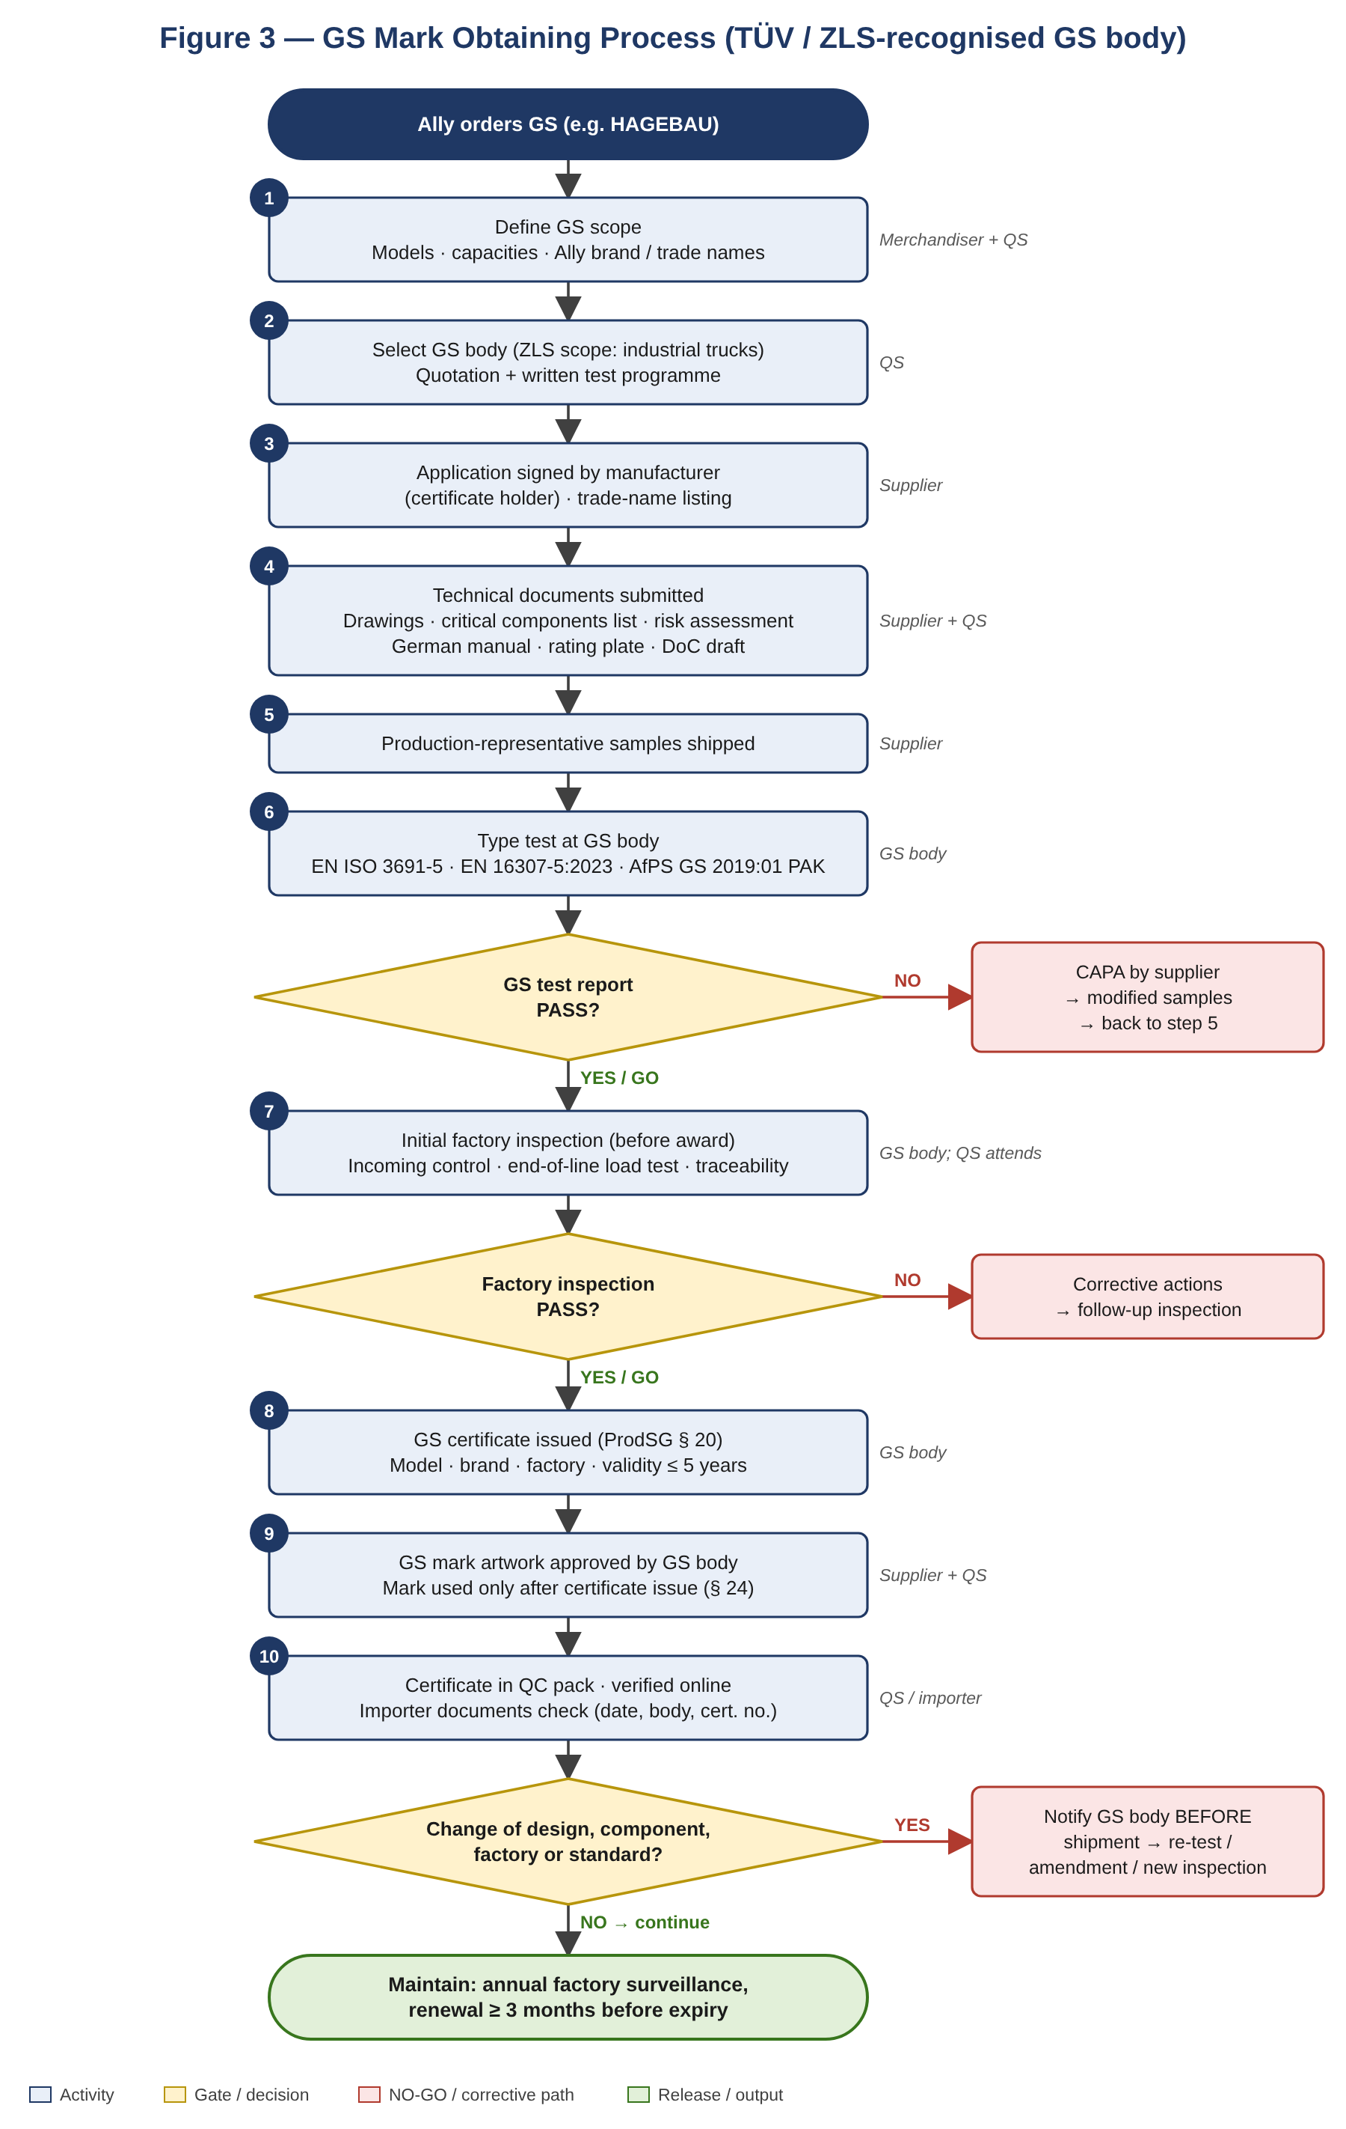
Figure 3 — GS mark obtaining process: test and factory gates, CAPA loops and change management.

10.4 Documentation package for the GS body
- Application form, company registration of manufacturer and factory address(es).
- Product description, model list, variant matrix (capacity, fork length/width, colour, brand).
- General assembly and detailed drawings; hydraulic schematic; strength and stability calculations.
- Critical components list with sub-suppliers: pump unit, seals, overload valve, fork/frame steel, wheels and rollers, tiller grip material, chain/pins, coating.
- Risk assessment (EN ISO 12100) and existing test reports (CE test report, PAH report) for recognition where accepted.
- German instructions for use, rating plate and warning label artwork; draft DoC.
- Factory QMS documents: ISO 9001 certificate, FPC plan, end-of-line test procedure, calibration list.

10.5 Surveillance and certificate maintenance
Obligation | Requirement | Frequency
Factory surveillance inspection | GS body inspects the producing factory; checks conformity to tested type and critical components list | At least annually
Follow-up / market samples | Product re-tests at the GS body’s discretion | As decided by GS body
Annual fee / licence | Maintains certificate validity | Annual
Renewal | Re-assessment against current specifications before expiry | ≤ 5 years — start ≥ 3 months before expiry
Complaint / incident notification | Inform GS body of safety-relevant complaints or recalls | Without delay

10.6 Change management
- Any change of design, critical component or sub-supplier, material, coating system, production site or added model/brand → written notification to the GS body before shipment; GS body decides on re-test and certificate amendment.
- New production site → new factory inspection before GS-marked goods are shipped from that site.
- Superseded standard or AfPS specification → GS body re-assessment; certificate may be restricted or withdrawn.
- Certificate suspended/withdrawn → stop GS marking immediately; HOLD on GS lots; notify Ally.

10.7 GS mark use
- GS symbol designed per ProdSG Annex (§ 24) combined with the GS body logo and ID / certificate number as specified by the GS body (some bodies add a QR/ID link to their certificate database). Marks liable to be confused with the GS mark are prohibited.
- Applied only to models, brands and factories listed on a valid certificate; on the product (rating plate or label) and optionally packaging.
- Use only while the certificate is valid (§ 24); stop immediately on suspension or withdrawal. Not to be applied to non-GS orders or other Allies unless covered by the certificate. Unauthorised use is an administrative offence under ProdSG (verify § 39 fine provision).

10.8 GS gate decision
✅ GO | Certificate valid; covers model, Ally brand and factory; surveillance inspection within 12 months; mark artwork approved; importer verification record (§ 24) on file.
⚠️ CONDITIONAL | Certificate renewal or change notification in progress — written GS body confirmation needed before SRC.
❌ NO-GO | No certificate; expired or withdrawn certificate; factory or model not covered; GS mark applied without approval.

10.9 RACI — GS process
Activity | Responsible | Accountable | Consulted | Informed
GS requirement and scope | Merchandiser | QS Manager | Ally, QS | Supplier
GS body selection and quotation | QS | QS Manager | Merchandiser | Ally
Application, documents, samples | Supplier | QS | GS body | Merchandiser
Testing and factory inspection | GS body | Supplier | QS | Ally
Artwork with GS mark | Supplier | QS | GS body | Ally
Surveillance, renewal, change notification | Supplier | QS | GS body | Ally, PPS-P
GS verification at FRI / SRC | QC | QS | — | Ally, PPS-L

11. Document Register
# | Document | Link | Issued by | Validity | Retention
1 | Quality Compliance Pathway (QCP) — Storage/Moving | 1–2 | QS | On change | 10 yr
2 | Quality Single Document (QSD) — Hand Tools | 1–6 | QS | On change | 10 yr
3 | Harmonised standard lookup record (MD + MR) | 1–3 | QS | On OJEU change | 10 yr
4 | Risk assessment EN ISO 12100 / DFMEA | 4 | Manufacturer / QS | On change | 10 yr
5 | Type test report EN ISO 3691-5 / EN 16307-5 (accredited lab) | 4 | Accredited lab | On change | 10 yr
6 | Chemical test report (PAH, phthalates, SCCP, SVHC) | 4 | Accredited lab | 2 yr | 10 yr
7 | Technical file (MD Annex VII A / MR Annex IV) | 4–6 | Manufacturer | Ongoing | 10 yr
8 | FPC plan and end-of-line load-test records | 5 | Supplier | On change / per lot | 10 yr
9 | QMS / CSR audit reports (ISO 9001, BSCI) | 5 | QS / 3rd party | Per certificate | 5 yr
10 | Sample validation, DPI, FRI reports (Annex A) | 5, 8 | QC / 3rd party | Per order | 5 yr
11 | Golden sample record | 5 | QS | Per order | 5 yr
12 | EC / EU Declaration of Conformity | 6 | Manufacturer | On change / legal act | 10 yr
13 | EU economic operator designation (2019/1020 Art. 4) | 6–7 | Importer / AR | On change | 10 yr
14 | Artwork, data plate and label approval | 7 | QS | Per revision | 5 yr
15 | Instruction manual assessment (EN IEC/IEEE 82079-1) | 7 | QS | Per revision | 5 yr
16 | Export packaging compliance + PPWR data record | 7–8 | QS / Merch. | Per shipment | 5 yr
17 | SVHC declaration | All | Supplier | Per shipment | 10 yr
18 | Shipment Release Certificate (SRC) | 8 | QS | Per shipment | 5 yr
19 | GS test report + GS certificate (GS orders) | 4, 10 | GS body | Max. 5 yr | 10 yr
20 | GS factory inspection reports (initial + annual) | 5, 10 | GS body | 12 months | 10 yr
21 | GS critical components list + change notifications | 5, 10 | Manufacturer / GS body | On change | 10 yr
22 | GS mark artwork approval | 7, 10 | GS body / QS | Per revision | 10 yr

12. RACI Matrix
Link | Responsible | Accountable | Consulted | Informed
1 — 4-Step determination | QS | QS Manager | Merchandiser, Ally | IQA, PPS-P
2 — Pathway assignment | QS | QS Manager | Ally | PPS-P, Supplier
3 — Module | QS | QS Manager | Accredited lab | Supplier, Ally
4 — Type test / technical file | Supplier + lab | QS | QS | Ally, PPS-P
5 — FPC / inspection | Supplier (FPC) + QC | QS | IQA, 3rd party | PPS-P, Ally
6 — DoC | Manufacturer | QS | QS (review) | Ally, PPS-L
7 — CE / marking / instructions | Supplier | QC (verify at FRI) | QS | Ally
8 — SRC release | QS | QS Manager | QC | PPS-L, Ally, Merchandiser

13. Regulatory Watch
Date | Change | Impact on this category
20/01/2027 | Machinery Regulation (EU) 2023/1230 applies; MD 2006/42/EC repealed | New DoC (Annex V), importer marking, Annex III EHSR, instructions rules; re-issue DoC and technical file; update Annex A references.
End-2026 (expected) | First Commission Implementing Decision citing harmonised standards under MR | Check citation of EN ISO 3691-5 and EN 16307-5:2023; until then no Art. 20 presumption under MR.
Pending OJ | Omnibus IV (digitalisation) — provisional agreement 09/06/2026 amending MR and ~20 product acts | Electronic DoC, digital instructions, digital contact point — update Link 6/7 when published.
27/07/2026 | Digital Omnibus on AI, Reg. (EU) 2026/1744 — amends MR Arts. 8, 20, 47 | No impact (no AI/safety software in manual truck).
01/01/2028 (proposed) | CBAM downstream extension COM(2025) 989 | Check whether CN 8427 is included; if yes, embedded-emissions data from supplier.
12/08/2026 → | PPWR (EU) 2025/40 staged obligations | Since 12/08/2026: Art. 5(4) + packaging DoC. Art. 12 labelling: later of 12/08/2028 or 24 months after implementing acts (harmonised-label act planned Q4 2026). Art. 44 harmonised producer registers pending — register under existing national EPR schemes (e.g. LUCID in DE). Recyclability grades via delegated acts.
Jan / Jun yearly | REACH Candidate List updates | Refresh SVHC declarations per shipment.
2027/2028 | Swiss MaschV revision (aligned with MR) and EU-CH MRA update | MRA update conditional on EU-CH package ratification; confirm CH documentation for lots after 20/01/2027.
Ongoing | AfPS GS specifications (PAH) and GS body test-programme updates | GS certificates re-assessed against current specifications at renewal or change; monitor AfPS publications.
In force | GPSR (EU) 2023/988 (since 13/12/2024) | Accident notification via Safety Business Gateway; online listing information.

14. Companion Skills Reference
Link | Deliverable | Companion skill
1–2 | QCP Storage/Moving; hEN confirmation | quality-compliance-pathway · harmonised-standard-lookup
4 | Machinery risk assessment / DFMEA; test matrix | machinery-risk-assessment · fmea-generator · essential-characteristics-testing
4–6 | Technical file | technical-construction-file
5 | FPC; supplier audit; QC pack | factory-production-control · supplier-production-line-audit · qc-pack-excel-generator
6 | QSD; DoC | qsd-generator · ce-marking-doc-dop
7 | Artwork/data plate; instructions; packaging | artwork-packaging-compliance-master · assembly-instruction-assessment · export-packaging-compliance · ppwr-doc-generator
8 | FRI validation; SRC | fri-validation · qc-pack-excel-generator
10 | GS document request to factory; GS test scope | factory-doc-request · third-party-compliance-assessment · essential-characteristics-testing

15. Change Log versus Source Checklist
# | Source item | Finding | Correction applied
1 | General Product Safety Directive 2001/95/EC | Repealed 13/12/2024 | Replaced by GPSR (EU) 2023/988 (complementary to MD/MR).
2 | Packaging Directive 94/62/EC, heavy metals ≤ 100 mg/kg | Replaced by PPWR (EU) 2025/40 from 12/08/2026 | PPWR Art. 5(4) limit retained; EPR and packaging data added.
3 | Machinery Directive 2006/42/EC only | MR applies 20/01/2027 | Dual MD/MR references; switch-over rule by EU placing-on-market date.
4 | EN ISO 3691-5 / EN 16307-5 without edition | Edition and amendment missing; EN 16307-5:2013 withdrawn 29/12/2023 | EN ISO 3691-5:2015+AC:2016+A1:2020 and EN 16307-5:2023 cited (v1.2).
5 | Static test 1.5 × Q only | Dynamic test missing (MD 4.1.2.3) | Dynamic test 1.1 × Q added.
6 | Pressure relief valve — text only | No test method | Overload attempt at 1.15–1.20 × Q added; sealing check.
7 | No load holding / lowering control test | Gap | Drift and controlled-lowering test added.
8 | No crushing / shearing point check | MD 1.3.7 gap | EN ISO 13854 gap check added.
9 | Artwork check generic | Data plate / rated load / importer not listed | Mandatory marking elements with Critical classification added.
10 | No sampling plan | Gap | ISO 2859-1 GI-II, Cr 0 / Ma 2.5 / Mi 4.0; S-3 for functional tests.
11 | Defect table lacks functional defects | Gap | Oil leak, drift, lifting failure, missing CE/data plate, wrong-language manual added (Annex B).
12 | Measurement letters (D/d, H, h, e, s, l, c, W, L, HH) undefined | Ambiguous | Parameter legend aligned with VDI 2198 type sheet (Annex C).
13 | Coating adhesion method | No standard cited | ISO 2409 cross-cut reference; 15 % = class 2.
14 | “CE certification” wording | Misleading — no NB certificate under Module A | Replaced by “DoC + accredited test report”.
15 | GS mark referenced only as Ally option | No obtaining process defined | Section 10 added: GS eligibility, step-by-step process, documents, surveillance, change management, marking, RACI.
16 | No visual process overview | Gap | Flowcharts added: Fig. 1 compliance chain (1.1), Fig. 2 inspection & release (6.4), Fig. 3 GS process (10.3.1) — v1.3.

Annex A — Sample Validation / Inspection Checklist (updated)

A.1 General information
Inspection type | ☐ Sample validation ☐ DPI ☐ FRI Re-inspection: ☐ No ☐ Yes
Reference | Packaging guideline for hardline; Offer; MCG-DIY-HT-PT-001
Ally / Supplier / Factory | [___] / [___] / [___]
Inspection location / date | [___] / dd/mm/yyyy
Legal act applied | ☐ MD 2006/42/EC (EU arrival ≤ 19/01/2027) ☐ MR (EU) 2023/1230 (≥ 20/01/2027)
Documents / QC pack | Inspection checklist · PO/PI · Offer sheet · Shipping mark · Artwork (data plate, labels, warnings) · Instructions (all languages) · DoC · Test report · SVHC declaration · Golden sample record
Product | Ally ref [___] · Supplier ref [___] · Capacity Q [___] kg · Load centre c [___] mm · Fork length [___] mm · Qty [___]
Inspector / Reviewer | [___] / [___]

A.2 Assessment summary
Criteria | Requirement | Evidence | Assessment
Factory QMS | QMS audit A/B (or ISO 9001); FPC audit | Audit report / certificate
Factory CSR | BSCI A/B/C (or SA8000); ISO 14001 if applicable | Audit report / certificate
EU Regulation | REACH (EC) 1907/2006 Art. 33, Annex XVII 50/51; POPs (EU) 2019/1021 | SVHC declaration + chemical test report
Machinery | MD 2006/42/EC → MR (EU) 2023/1230 | Signed DoC; technical file index
Product safety | GPSR (EU) 2023/988 (complementary); Reg. (EU) 2019/1020 Art. 4 | EU operator identification
Packaging | PPWR (EU) 2025/40 (Pb+Cd+Hg+Cr(VI) ≤ 100 mg/kg); FR Law 2020-105 Art. 112 (mineral oils) | Packaging test / declaration
Harmonised standards | EN ISO 3691-5:2015+AC:2016+A1:2020; EN 16307-5:2023; EN ISO 12100:2010 | Accredited test report

A.3 Defect definitions and sampling
- Critical (Cr): likely to result in a hazardous or unsafe condition, or non-compliance with a mandatory regulation.
- Major (Ma): likely to result in product failure or customer return; reduces usability or saleability.
- Minor (Mi): does not reduce usability; noticed on careful examination; may reduce saleability.
- Zone A = high visibility/touch in normal use; Zone B = partial; Zone C = none. Visual defect: Minor if visible at 30 cm, Major if visible at 100 cm.
- FRI sampling: ISO 2859-1 / ANSI Z1.4, General Inspection Level II; AQL Cr 0 · Ma 2.5 · Mi 4.0. On-site functional tests (A.4 item 7): Special Level S-3, Ac 0. Static test: sample validation and DPI only (1 pc).

A.4 Inspection details
# | Criteria | Method / requirement | Ref. | Fail class | Result
1 | Quantity | DPI: ≥ 20 % produced. FRI: 100 % produced and ≥ 80 % packed. | A.R.E.N.A. | —
2 | Packing | Method and condition; no damage, mould, infestation or odour; parts, tools, accessories per packing list; materials (poly bag, carton layers/thickness). Wooden pallet HT + IPPC mark (MB not accepted). | Packaging guideline; ISPM 15; PPWR | Mi–Ma
3 | Artwork and marking | Compare with approved artwork: shipping mark; data plate (Section 8.1 elements); CE; rated capacity; importer/EU operator; warnings; instructions in all languages; DoC; Triman (FR); GS mark (GS lots only) matches certificate — GS body logo, ID/certificate number, model; barcode clean, positioned and scanning correctly. | MD/MR 1.7.3, 1.7.4, 4.3.3 | Cr / Ma
4 | Sample comparison | Conforms to golden sample and test report: model, capacity, fork dimensions, materials, pump type, wheel material, colour. | Test report; QSD | Ma
5 | Measurement | Per PO/spec, package claims and Annex C; product tolerance table A.5; weight ± 5 %; packing dimensions and weight ± 5 %. | Spec | Pending / Ma
6 | Workmanship | No scratch, flash, dent, crack, stain on visible surfaces; parts properly assembled; screws/nuts/rivets/pins/circlips secure; no missing or wrong accessories; no colour deviation; no sharp points/edges, rust; welds free of cracks, porosity, spatter; no hydraulic oil leakage. | MD/MR 1.3.4 | Per Annex B
7.1 | Assembly | Assemble tiller step by step per instructions (pin, chain/rod adjustment). Difficult = Major; impossible or malfunction = Critical. | MD/MR 1.7.4 | Ma / Cr
7.2 | Control system | Lift by pumping tiller; neutral position holds; lower by hand lever (and foot pedal if fitted); controls identifiable and return correctly; parking brake locks (if fitted). | MD/MR 1.2.1, 1.2.2 | Cr
7.3 | Edges and surfaces | Tactile check of all accessible parts: no sharp edges, angles, rough surfaces. | MD/MR 1.3.4 | Cr
7.4 | Tiller | Closed-loop handle or lateral hand protection; grip Ø within 25–35 mm (caliper); span ≥ 120 mm per hand. | EN ISO 3691-5 Cl. 4.2.2 | Cr
7.5 | Functional verification (Q) | With rated load at c: lift to max height h3; travel ≥ 10 m on level floor; steer full lock both sides; lower controlled, no jerk/free fall. | EN ISO 3691-5 Cl. 5.2 | Cr
7.6 | Load holding | Rated load raised to h3, hold 10 min [verify duration/limit per standard]; record drift; drift within limit. | EN ISO 3691-5 | Cr
7.7 | Overload device | Attempt lift at 1.15–1.20 × Q: lifting prevented (where fitted); valve sealed / tool required. | EN ISO 3691-5 Cl. 4.4.3.3 | Cr
7.8 | Static test (SV/DPI only) | 1.5 × Q centred at c, forks raised, 10 min [verify]; measure fork-tip height before/after: no permanent deformation, crack or leak. | MD/MR 4.1.2.3, 4.1.3 | Cr
7.9 | Dynamic test | 1.1 × Q: 3 full lift/lower cycles + travel and steering; all functions operate correctly. | MD/MR 4.1.2.3, 4.1.3 | Cr
7.10 | Crushing / shearing points | Gaps at tiller pivot, pump linkage, fork rollers, steer wheels: finger gap ≥ 25 mm or guarded; feet protection at steer wheels. | MD/MR 1.3.7; EN ISO 13854 | Cr
7.11 | Leak check | After 7.5–7.9: no oil on pump, ram or floor. | FPC | Ma (Cr if lowering affected)
7.12 | Smell check | At ≈ 10 cm: no abnormal odour. | A.R.E.N.A. | Ma
7.13 | Marking rub test | 15 s water-soaked cloth, then 15 s with alcohol or hexane: marking remains legible, not easily removable, no curling. | IEC 60335-1 Cl. 7.14 method | Ma
7.14 | Coating adhesion | Metal: 6 cuts, 2 mm spacing, cross-hatch, 3M 610/810 tape pressed 1 min, removed quickly: ≤ 15 % detached (ISO 2409 class ≤ 2). Non-metal: tape only, 0 % detached. | ISO 2409 | Ma
7.15 | Coating thickness | Magnetic gauge, 5 points on frame and forks: DFT ≥ [___] µm per QSD. | ISO 2808 | Ma

A.5 Dimensional tolerances (from source)
Product size (mm) | 0.5–3 | >3–6 | >6–30 | >30–120 | >120–400 | >400–1000 | >1000–2000 | >2000–3000 | >3000–5000
Tolerance (mm) | ±0.1 | ±0.3 | ±1 | ±2 | ±5 | ±10 | ±20 | ±30 | ±50

Packing size (mm) | ≤120 | >120–400 | >400–1000 | >1000–2000 | >2000–3000 | >3000–5000
Tolerance (mm) | ±5 | ±10 | ±20 | ±30 | ±50 | ±80

Remarks #1: [___]

Annex B — Defect Classification
Defect name | Zone A | Zone B | Zone C
Poor packing / Đóng gói kém | Minor – Major
Incorrect quantity / Sai số lượng đóng gói | Major
Incorrect packaging artworks / Sai thông tin in ấn đóng gói | Major
Missing packaging artworks / Thiếu thông tin in ấn đóng gói | Major
Poor label / sticker | Major
Rubbing product marking | Major
Sharp point / Điểm bén nhọn | Critical
Sharp edge / Cạnh bén nhọn | Critical
Shear and squeeze point / Điểm cắt và chèn ép | Critical
Rust / Rỉ sét | Major | Minor
Poor finishing / Hoàn thiện xấu | Minor – Major
Stain / Bị dính sơn, vết ố | Minor – Major | Minor
Over painting / Sơn chảy | Minor – Major | Minor
Coating peel off / Bong tróc sơn | Minor – Major | Minor
Blister / Bị phồng rộp | Minor – Major | Minor
Spots / Vết đốm | Minor – Major
Discoloration / Phai màu | Minor – Major
Dirty mark / Dấu vết bẩn | Minor – Major
Poor welding / Mối hàn tệ | Major | Minor – Major | Minor
Burr / Gờ chưa mài giũa | Minor – Major
Rough surface / Bề mặt thô ráp | Minor – Major
Uneven surface / Bề mặt cao thấp không đều | Minor – Major
Deformed / Bị biến dạng | Minor – Major | Minor
Damaged / Bị hư hỏng | Minor – Major | Minor
Scratched / Bị trầy xước | Minor | Accept | Accept
Broken / Bị gãy | Minor – Major | Minor
Chipped / Bị sứt mẻ | Minor – Major | Minor
Cracked / Bị nứt | Minor – Major | Minor
Dent mark / Dấu bị cấn móp | Minor – Major
Warpage / Cong vênh | Minor – Major | Minor
Wobble / Lung lay, gập gềnh | Minor – Major
Unfitting / Không vừa vặn | Minor – Major
Loose / Lỏng lẻo | Minor – Major
Over tolerance | Pending
Incorrect material / Sai nguyên vật liệu | Major
Incorrect colour / Sai màu sắc | Major
Incorrect specification / Sai thông số kỹ thuật | Major
Difficult assembly / Lắp ráp khó | Major
Impossible assembly / Không lắp ráp được | Critical
Difficult folding / Gấp xếp khó | Major
Difficult function / Chức năng sử dụng khó | Major
Fail coating rubbing / adhesion test | Major
NEW Cracked or poor weld on load-bearing frame / fork / Mối hàn chịu lực nứt | Critical
NEW Cannot lift rated load / Không nâng được tải định mức | Critical
NEW Uncontrolled lowering or drift beyond limit / Hạ tải không kiểm soát | Critical
NEW Permanent deformation after static test / Biến dạng vĩnh viễn | Critical
NEW Overload device missing / not sealed (where required) / Thiếu van quá tải | Critical
NEW Hydraulic oil leakage / Rò rỉ dầu thủy lực | Major (Critical if lowering affected)
NEW Parking brake ineffective (if fitted) / Phanh không hiệu quả | Critical
NEW Missing / incorrect CE marking or data plate / Thiếu nhãn CE, nhãn thông số | Critical
NEW Rated capacity missing or wrong / Thiếu hoặc sai tải định mức | Critical
NEW Instructions missing or not in required language / Thiếu HDSD hoặc sai ngôn ngữ | Critical
NEW Importer / EU operator identification missing / Thiếu thông tin nhà nhập khẩu | Critical
NEW Missing / loose circlip, pin or axle fastener / Thiếu, lỏng khóa chốt | Critical
NEW GS mark applied without valid certificate, wrong model/factory, or on non-GS order / Dấu GS không hợp lệ | Critical
NEW Wheel not rotating freely / Bánh xe quay không trơn | Major
NEW Wooden pallet without ISPM 15 mark / Pallet gỗ không có dấu IPPC | Major

Reference defect photos: retain the source photo set (poor finishing, poor welding, scratched, coating peel off, rough surface, broken, dent mark) in the QC pack.

Annex C — Measurement Data Sheet
Parameter symbols aligned with the VDI 2198 type sheet for industrial trucks (replaces undefined source letters D/d, H, h, e, s, l, c, W, L, HH).
Symbol | Parameter | Specification | Claimed on package | Finding | Requirement | Result
Q | Rated capacity (kg) |  |  |  | Matches data plate & test report
c | Load centre distance (mm) |  |  |  | Matches data plate
h3 | Lift height (mm) |  |  |  | Within tolerance
h13 | Fork height, lowered (mm) |  |  |  | Within tolerance
h14 | Tiller height in operating position (mm) |  |  |  | Within tolerance
l1 / l2 | Overall length / length to fork face (mm) |  |  |  | Within tolerance
b1 / b5 | Overall width / width across forks (mm) |  |  |  | Within tolerance
s / e / l | Fork thickness / width / length (mm) |  |  |  | Within tolerance
D1 / D2 | Steer wheel / load roller diameter (mm) |  |  |  | Within tolerance
— | Grip Ø / span (mm) |  |  |  | 25–35 / ≥ 120
— | Unladen mass (kg) |  |  |  | ± 5 %; matches data plate
— | Packing dimensions (mm) |  |  |  | Conform to package claim
— | Packing gross weight (kg) |  |  |  | ± 5 %
— | Barcode |  |  |  | Correct with spec & print

Annex D — Packaging Disposal Data (PPWR)
Required for every SKU: ☐ N/A ☐ Pending ☐ Yes. Weight in grams per material.
Level | Units / pack | Paper, cardboard | Plastic foil / bags | Plastic straps | Metal | EPS | Wood
Primary (sales unit)
Transport unit

Batteries / lamps / EEE table: N/A (manual truck without electrical equipment). Re-assess if a scale or electric lift variant is added.

Annex E — Regulatory Cross-Check Log (14/10/2026)
Status: ✅ Confirmed · 🔧 Corrected in v1.2 · ⚠️ Open (verify before controlled release).
# | Item | Finding | Status | Source
1 | MR (EU) 2023/1230 application date | Applies from 20/01/2027; MD 2006/42/EC repealed; machinery placed on market before stays under MD | ✅ | EUR-Lex 32023R1230; Commission machinery page
2 | MR harmonised standards | No MR citation decision published as of Sept 2026; first list expected end-2026; MD citations ≠ MR Art. 20 presumption | 🔧 | Commission harmonised standards page; IBF Solutions; Waves Eng.
3 | EN ISO 3691-5 | EN ISO 3691-5:2015 + AC:2016 + A1:2020 current; ISO 3691-5:2014 confirmed 2021 | 🔧 | ISO.org 62807; Austrian Standards; EVS
4 | EN 16307-5 | 2023 edition supersedes 2013 (withdrawn 29/12/2023); OJEU citation of 2023 edition under MD not confirmed | 🔧 / ⚠️ | EVS EN 16307-5:2023; SIS SS-EN 16307-5:2024
5 | MR Art. 21 DoC | Accompanies machinery or internet address provided | ✅ | EUR-Lex 32023R1230
6 | MR Art. 10(7) instructions | Digital allowed with conditions; paper free on request within 1 month; paper safety info for non-professional use | ✅ (secondary sources) | tekom; ZVEI; IBF Solutions
7 | MR Art. 13 importer marking | Importer name and contact on machinery | ✅ (secondary) / ⚠️ exact wording | Taylor Wessing; operationsengineer.org.uk
8 | MR Art. 3 manual lifting definition | Lifting assembly powered solely by directly applied human effort in scope; exact point letter not confirmed | ⚠️ | EUR-Lex; COM(2021)202 summary
9 | MR amendments | Reg. (EU) 2026/1744 (AI) in force — no impact; Omnibus IV provisionally agreed 09/06/2026, not yet in OJ | ✅ / ⚠️ watch | EUR-Lex 2026/1744; Council 10980/26
10 | MD Annex I 4.1.3 | Static and dynamic tests on all lifting machinery before putting into service | 🔧 | MD Annex I text; BSI
11 | ProdSG GS sections | § 20 award (≤ 5 yr / lot; § 20(2) CE-equivalence exclusion), § 21–22 GS body, § 24 manufacturer & importer (importer documented check) | 🔧 | buzer.de; JuraForum; BGN; maschinenrichtlinie.de synopsis
12 | ProdSG fine for GS misuse | § 39 provision not confirmed | ⚠️ | gesetze-im-internet.de (not reachable from this environment)
13 | AfPS GS 2019:01 PAK | Still current; mandatory for new GS since 01/07/2020; category limits added | 🔧 | BAuA AfPS-GS-2019-01-PAK; ZLS; TÜV Rheinland info
14 | PPWR (EU) 2025/40 | Art. 5(4) + DoC since 12/08/2026; Art. 12 later of 12/08/2028 or +24 months after implementing acts; Art. 44 registers pending | 🔧 | DAERA PPWR FAQ; FDF; ppwrconnect Sept 2026
15 | POPs SCCP | 0.15 % (1 500 mg/kg) in articles confirmed; MCCP act in preparation | 🔧 | Council ST-13064-2026; Reg. (EU) 2022/2400
16 | CBAM | CN 8427 outside Annex I today; downstream extension proposed for 2028 | 🔧 watch | COM(2025) 989; PwC; European Aluminium annex
17 | Switzerland | MaschV revision aligned with MR consulted; MRA update tied to EU-CH package ratification (2027/28) | 🔧 / ⚠️ | SECO / admin.ch; Canton Zurich RRB 2025/1296
18 | GPSR (EU) 2023/988 | Applies since 13/12/2024, complementary to MD/MR | ✅ | EUR-Lex 32023R0988
19 | REACH Annex XVII entries 50 / 51 | PAH 1 mg/kg (consumer articles, skin contact); phthalates 0.1 % | ✅ | REACH Annex XVII
20 | Ally inputs | Overload valve mandatory?, salt-spray hours, DFT, BCM languages, GS order scope | ⚠️ | Ally confirmation required

