General Information
Inspection type: | Final Random Inspection | Re-inspection: [☒ No | ☐ Yes]
Ally name: | JUMBO
PO#: | 7212146930
Supplier name: | THIEN MINH PRODUCTION TRADING EXPORT IMPORT CO.,LTD
Factory name: | THIEN MINH PRODUCTION TRADING EXPORT IMPORT CO.,LTD
Inspection location: | BAU SEN HAMLET, DUC LAP COMMUNE, TAY NINH PROVINCE, VIETNAM
Inspection date: | 2026/11/11
List of documents /  QC pack:
  • PO / PI : Yes  • Shipping mark: Yes  • Artwork (logo, hangtag, labeling, marking): Yes | • Instruction manual: N/A  • CE marking, DoC / DoP: N/A  • Others: N/A
Sampling plan for shipment: | According to the standard ISO 2859-1; Single; Normal.  General inspection: Level II; Special inspection: S3
AQL levels: | Critical: 0 | Major: 2.5 | Minor: 4.0
Inspector: | Mr. Chien-Minh | Reviewer: | Bill

Inspection Result Summary
Criteria | Result | Remark
1. Quantity | Passed
2. Packing check | Passed
3. Artwork check | Passed
4. Sample comparison | Passed
5. Measurement data | Passed
6. Workmanship | Passed
7. On-site tests | N/A
8. Disposal data of the packaging | N/A
9. Other requirements | N/A
10. Close meeting | Yes

Overall Result:  Passed | When the result  is Pending/Failed | QS contacts the supplier to obtain a full explanation, assess the issues, investigate the root cause of the problem, and then proposes Corrective Action Preventive Action (CAPA).  QS writes the explanation and proposal CAPA in the table below.

Issues item | Proposal CAPA

Table of shipment items and sampling details
PO# | Ally ref | Supplier ref | Product description | Brand | Shipment q’ty | Packed q’ty | Sample size
 |  |  |  |  |  |  | II | S3
7212146930 | 7.589.906  7.589.880  7.589.901 | TM 1485  TM 1485-1  TM 1485-2 | Set of 2 square planter nested  Big size: 45 x 45 x 43 cm  Medium size: 32.5 x 32.5 x 32 cm  Material: Acacia wood FSC, plastic pot inside  Natural color, Oil finishing  Packing: 1 set / brown carton box then put on pallet:  Ctn size: 47 x 47 x 53.5 cm  Pallet size: 99 x 109 x H 112 cm (8 sets/ pallet)  Loading: 160/384/384 sets- 20DC/ 40DC/40HC ( 20/48/48 pallet - 20DC/ 40DC/40HC)  With hangtag: Colored plastic hangtag |  | 768 | 760 | 80 | 13
Total |  |  |  | Total: | 768 | 615 | 80 | 13
 |  |  |  | Total: | 768 | 80% | 10% | 2%
 |  |  |  | Acceptance major defects: |  |  | 2.5 | 5
 |  |  |  | Acceptance minor defects: |  |  | 4.0 | 7

Defects
Defect description | Cr | Ma | Mi
Photo ref : TM 1485 | 0 | 1 | 2
  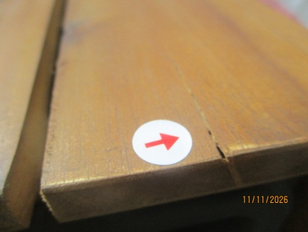 | 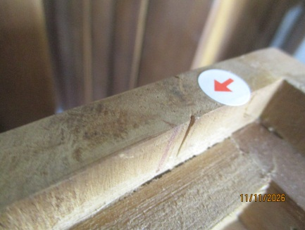 | 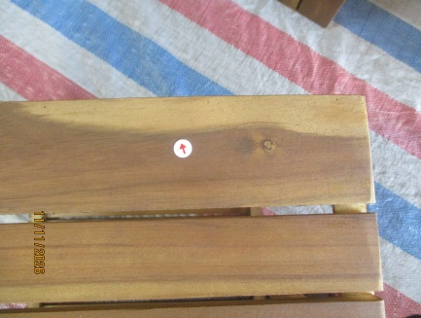
  Crack | Crack | color is not nice
  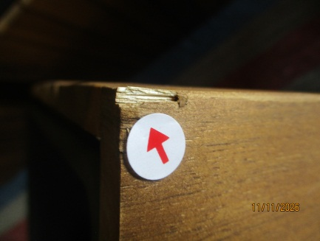 | 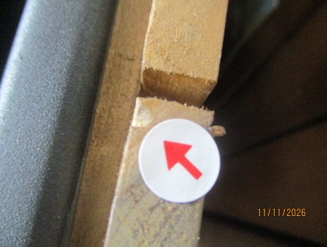 | 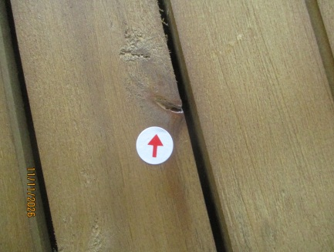
  Chip | Chip | Chip
  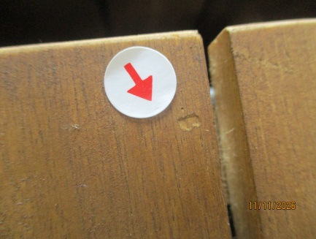 | 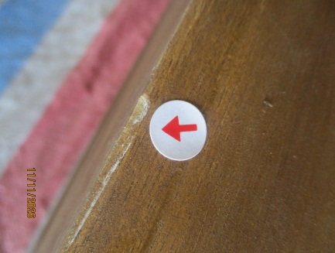 | 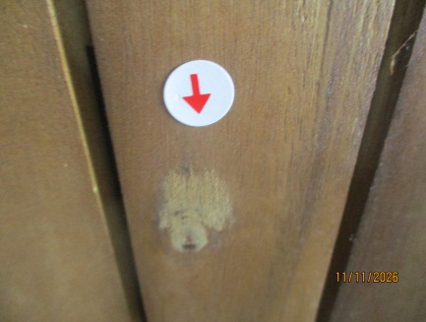
  Chip | Chip | Poor finishing
Total Defectives Found: | 0 | 3 | 6
Defectives Accepted: | 0 | 5 | 7
AQL Result: | Passed
Defect definition
• Critical Defect (Cr): A defect which is likely to result in a hazardous or unsafe condition for an individual using the product; or represents non-compliance to a mandatory regulation or law.
• Major Defect (Ma): A defect that is likely to result in a product failure or customer return. These defects are easily detected by the customer, and reduce either the usability or the salability of the item.
• Minor Defect (Mi): A defect that does not reduce the usability of the product; but will be noticed after careful examination, and may reduce salability.
- Zone A = High visibility and touchability during normal use
- Zone B = Partial visibility and touchability during normal use
- Zone C = No visibility and touchability during normal use
* Minor if defect is visible at distance 30cm. Major if defect is visible at distance 100cm.
Defect definition
• Critical Defect (Cr): A defect which is likely to result in a hazardous or unsafe condition for an individual using the product; or represents non-compliance to a mandatory regulation or law.
• Major Defect (Ma): A defect that is likely to result in a product failure or customer return. These defects are easily detected by the customer, and reduce either the usability or the salability of the item.
• Minor Defect (Mi): A defect that does not reduce the usability of the product; but will be noticed after careful examination, and may reduce salability.
- Zone A = High visibility and touchability during normal use
- Zone B = Partial visibility and touchability during normal use
- Zone C = No visibility and touchability during normal use
* Minor if defect is visible at distance 30cm. Major if defect is visible at distance 100cm.

Inspection Details
Criteria | Method / Requirement | Sample size | Result
1. Quantity | • In-line inspection: quantity at 20% of the goods produced.  • Final random inspection: quantity at 100% of the goods produced and at least 80% of goods have been packed. |  | Passed  see table
2. Packing check | • Check packing method and condition.  • Check product and transportation packaging.  • Quantity of items & accessories within the package.  • Packages must not be damaged.  • There must be no mold or mildew, animal or insect infestation or bad smell in the packages.  • Check parts, tools, accessories according to packing information  • Packing material: poly bag, carton box (carton corrugated paper: quantity of layers, thickness), etc. If using wooden pallet, it must be treated (prefer HT instead of MB) with IPPC logo marking. | S3 | Passed
3. Artwork check | Check and compare all artworks with the approved artworks available.  • Shipping mark  • Logo, hangtag, labeling, marking  • Instruction manual  • Barcode check:  - All the barcodes need to be clean.  - Positions of barcode as per approval.  - Scanning barcodes are correct with the specification & printed. | S3 | Passed
4. Sample comparison | Mass products shall conform with the golden sample / approval sample / technical file.  • Product style  • Product materials  • Product color | S3 | Passed
5. Measurement data | In conformity with client’s PO / specification, claimed on package and requirements.  • Product dimension: tolerance +/-5%  • Product weight: tolerance +/-5% for industrial materials and +/-10% for natural materials (wood, rattan, grass, bamboo, terracotta).  • Packing dimension:  • Packing weight: tolerance +/-10%  • Moisture content: check 3 points per large products (such as table, chair, wood panel) and take the average data (a+b+c)/3, check 1 point per other small products (such as handle, knob); MC must be in the range per kind of materials below. Within +/-3% limit = minor defect; Over +/-3% limit = major defect.  - Wood: 7-14% for outdoor and 7-12% for indoor  - MDF: 4-11%  - Particle board: 5-13%  - Plywood: 6-12%  - Bamboo: 12-18%  - Rattan, Water hyacinth, seagrass: 10-23% | S3 | Passed  see table
  Packing size (mm) | ≤120 | over 120-400 | over 400-1000 | over 1000-2000 | over 2000-3000 | over 3000-5000
  Tolerance (mm) | ±5 | ±10 | ±20 | ±30 | ±50 | ±80
6. Workmanship
Safety check | • Sharp edges and corner contact with user must be rounded or chamfered R ≥ 2 mm  • No shear and squeeze points in normal use  • No open tubes  • Presence of lock for folding items  • Resistance of lock  • Fold and unfold is smooth | S3 | Passed
Appearance check | • Checking that surfacing quality of the unit is accepted, no scratch/ flash/ dent/ wear & tear mark/ crack/ stain/ or similar on the visible surface  • Check the workmanships of the parts and surfaces is well done and all parts connect properly.  • Checking that each parts well assembling, screw/ nut/ rivet could not be easily detached/ or loosen by gentle force by hand  • Checking that accessories/ spare part are not missing or incorrect,  • Checking that there is not obvious color deviation (enclosure, logo etc.)  • No sharp points, sharp edges and no damage or rusty mark on all parts.  • Glue defect: forbidden using double side glue tape to fix any support parts  • Welding defect | II | Passed
7. On-site tests
Assembly check | Assembling according to the assembling instructions step by step. If there is hard to assemble or mal function, it is not allowed. | S3 | N/A
Function test | Test function based on purpose of product intend to be used such as watering test, … | S3 | N/A
Stability test | Put product on the flat surface with the angle = 8 degree; requirement: product doesn’t fall | S3 | N/A
Wobbling check | Place the sample on the floor (such as glass or marble). Without load, gap between the supporting parts and floor <5mm. | S3 | N/A
Smell check | Based on inspector’s nose from a distance about 10cm, not found any bad smell. | S3 | N/A
Adhesion test for coating | • For metal part: use knife to cut 6 lines with the gap 2mm for each line. Put 3M tap 810/610 on the sample and press for 1 minute. Then remove the tape quickly to check if there is any peel off. Within 15% peel off acceptable.  • For non-metal part: put 3M tap 810/610 on the sample and press for 1 minute. Then remove the tape quickly to check if there is any peel off. 0% peel off acceptable. | 1pc | N/A
Rubbing test on product markings | Use a cotton cloth with water, rub for 15 sec on rating label, silk-printing on product, etc.  The test is waived if the rating label is made by paper.  The marking shall be clearly, not be easily possible to remove or show curling. | S3 | N/A
Drop test (if applicable) | Perform the test according to the drop height as below, the drop shall free fall on a hard flat surface (e.g. concrete, tiles). Requirement: don't have any damage/lose function on the product and package.  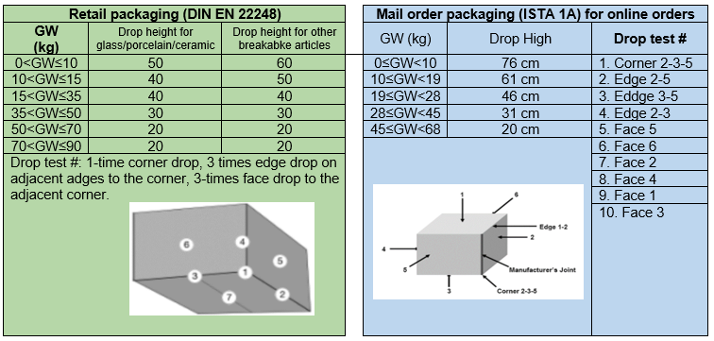 | 1pc | N/A
  Retail packaging [☐ No | ☒ Yes] | Mail order packaging [☒ No | ☐ Yes]
  - Any dimensions  - Any weights  - Delivery: Retails sale | • Delivery: Apply for DHL paket national (online sale)  - Minimum dimension: L=15 ; W=11 ; H=1 cm, Roll-shaped parcels: diameter 5 cm  - Maximum dimension: 200 cm for the longest side, Girth = (L + 2 x W + 2 x H) = 360 cm; Roll-shaped parcels: diameter 60 cm;  - Maximum weight: 31.5 kg  • If the Buyer does not mention the limitations above, then packages are accepted with any dimensions and any weight.

8. Disposal data of the packaging [☐ No | ☒ Yes]
Table 1 for materials packing [ ☒ N/A | ☐ Pending | ☐ Yes]
Product ref | #Sale unit/primary | Material packing weight of primary package unit (g) |  |  |  |  |  | #Sale unit/transport | Material packing weight of transport package unit (g)
Product ref | #Sale unit/primary | Paper, cardboard | Plastic foil, plastic bags | Plastic straps | Metal | Styrofoam | Wood | #Sale unit/transport | Paper, cardboard | Plastic foil, plastic bags | Plastic straps | Metal | Styrofoam | Wood
TM 1485 | 2 | 1245 | 79 |  |  |  |  | 16 | 2179 | 314 | 332 |  |  | 10700

9. Other requirements [☒ No | ☐ Yes]
Description of the requirement | Result

10. Close meeting [☐ No | ☒ Yes]
All findings must be summarized and presented by the inspector to the factory representative(s) at the termination of the inspection in a closing meeting.
During the closing meeting, the inspection will:
- List all the non-conformities found during the inspection.
- Explain the judgments of such findings against which specific applicable requirement (relevant standard, client’s requirement, etc.)
- Answer any question raised by the factory representative(s).
- Communicate with the factory representative(s) about CODE OF CONDUCTION FOR INSPECTION & AUDIT.

Product measurement data & Inspection photos
Product ref: TM 1485
Product description
Set of 2 square planter nested
Big size: 45 x 45 x 43 cm
Medium size: 32.5 x 32.5 x 32 cm
Material: Acacia wood FSC, plastic pot inside
Natural color, Oil finishing
Packing: 1 set / brown carton box then put on pallet:
Ctn size: 47 x 47 x 53.5 cm
Pallet size: 99 x 109 x H 112 cm (8 sets/ pallet)
Loading: 160/384/384 sets- 20DC/ 40DC/40HC ( 20/48/48 pallet - 20DC/ 40DC/40HC)
With hangtag: Colored plastic hangtag
Parameter | Specification | Claimed on package | Finding | Requirement | Result
Product dim: | Big size: 45 x 45 x 43 cm  Medium size: 32.5 x 32.5 x 32 cm | NA | Big size: 45 x 45 x 43 cm  Medium size: 32.5 x 32.5 x 32 cm | Within the tolerance | Passed
Product weight: | 6.5kg/3.3kg | NA | 7.1kg/3.1kg | Within the tolerance | Passed
Packing dim: | 109x99x112cm | NA | 109x99x112cm | Conform claimed packaging | Passed
Packing weight: | NA | NA | NA | Conform claimed packaging | N/A
Barcode: | 7627538528320  7627538528337 | NA | 7627538528320  7627538528337 | Conform the spec & scan | Passed
Moisture content: | 7-14% | NA | 10.3%;13.8%;10.3% | Within the tolerance | Passed

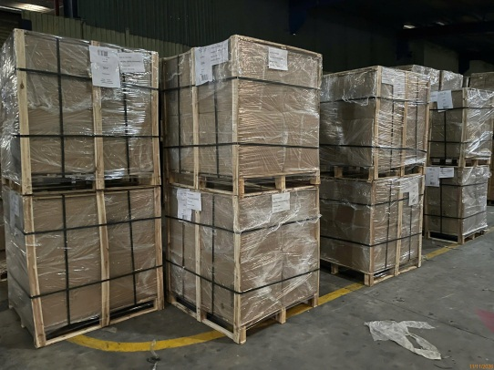 | 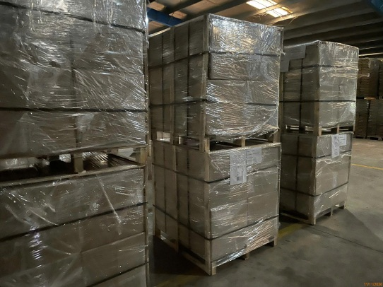 | 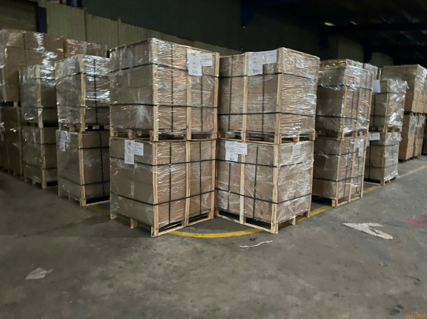
Ware house
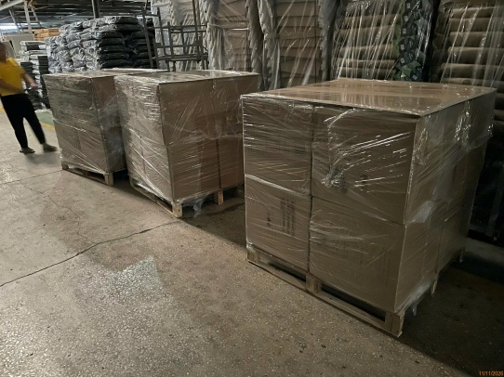 | 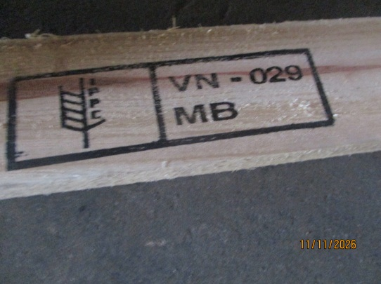 | 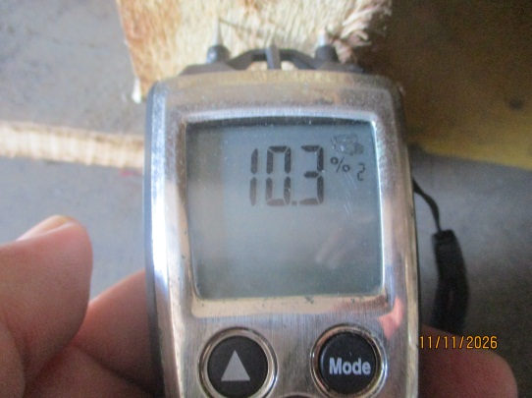
 | IPC logo | Moisture content
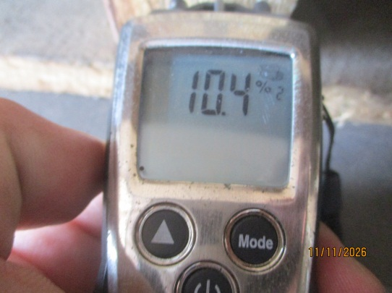 | 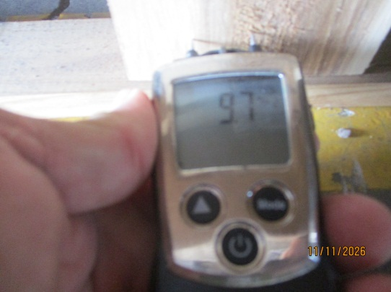 | 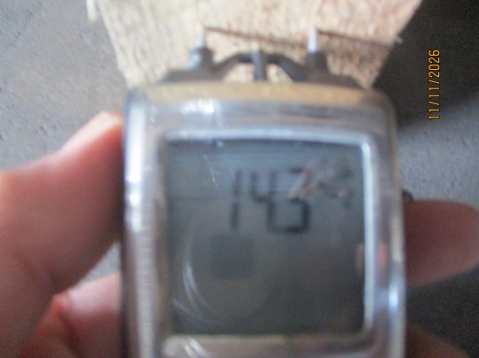
Moisture content
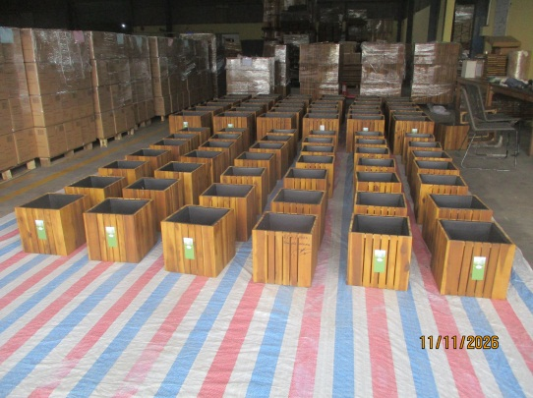 | 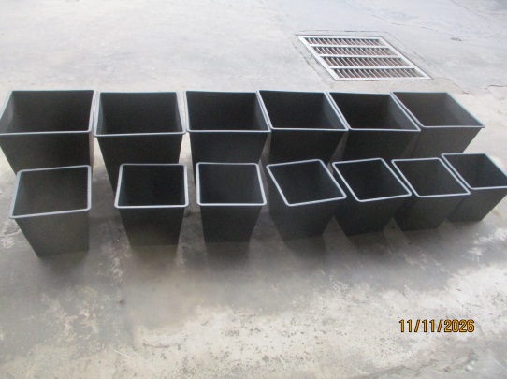 | 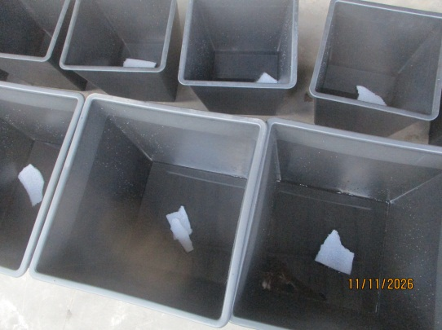
Moisture content
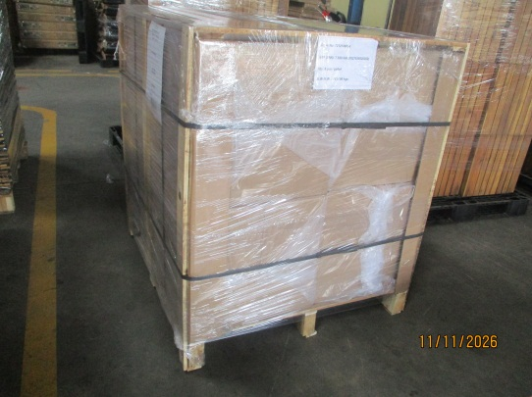 | 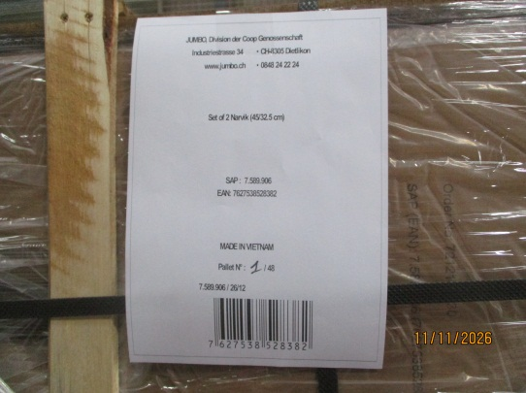 | 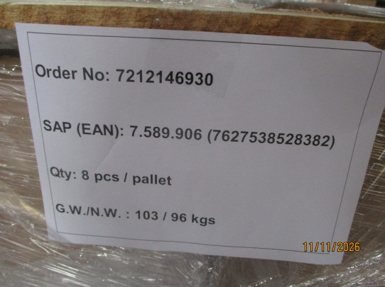
Pallet overview | Shipping mark check
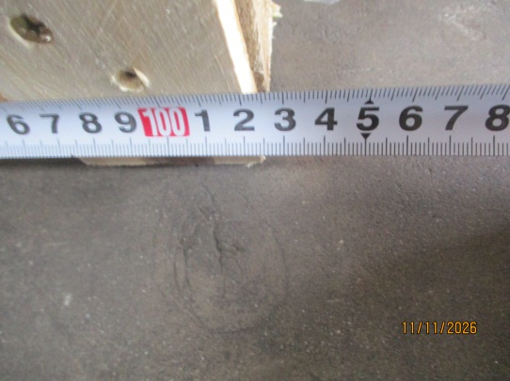 | 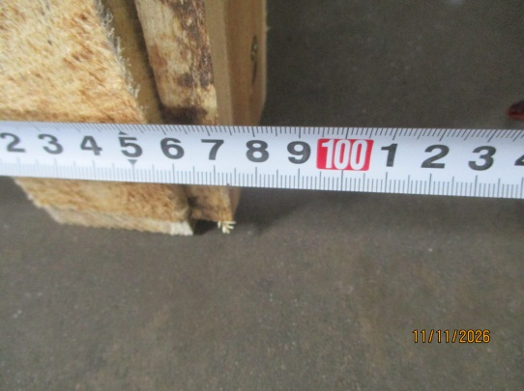 | 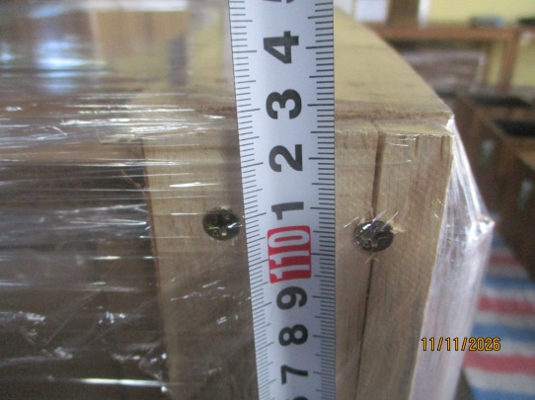
Pallet dimension
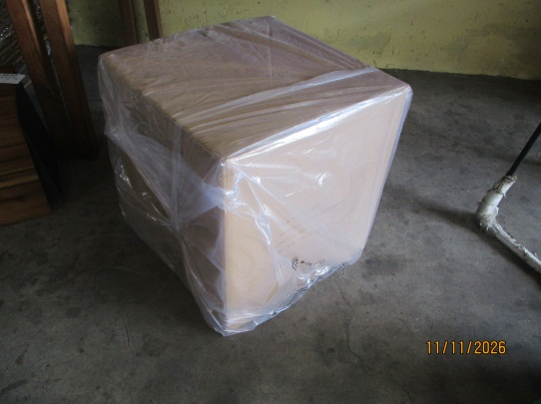 | 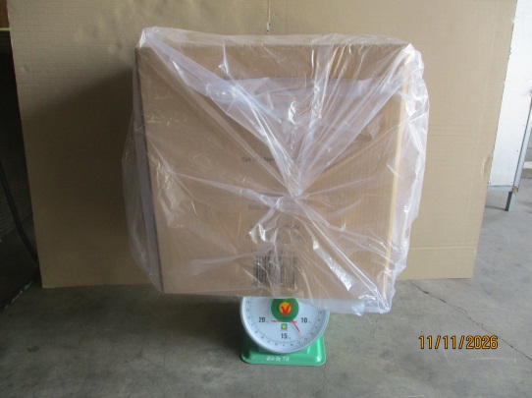 | 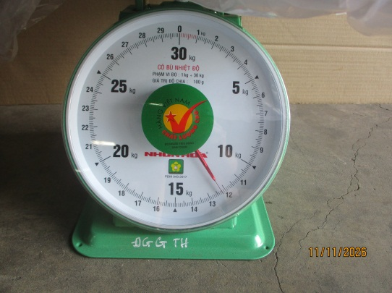
Packing overview | GW
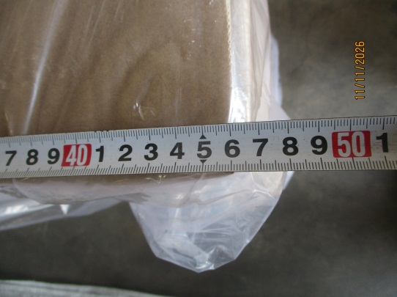 | 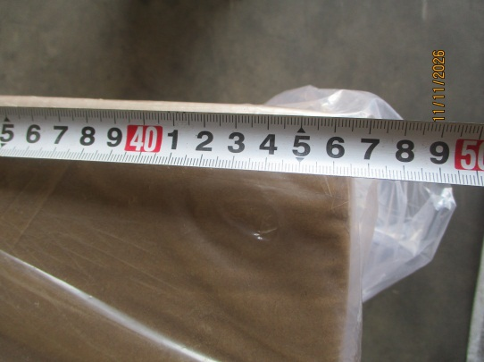 | 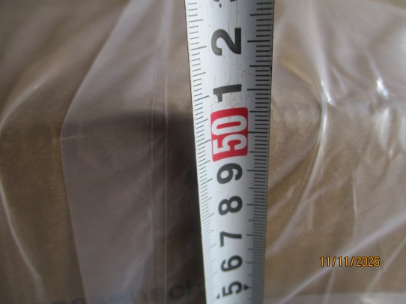
Packing dimension
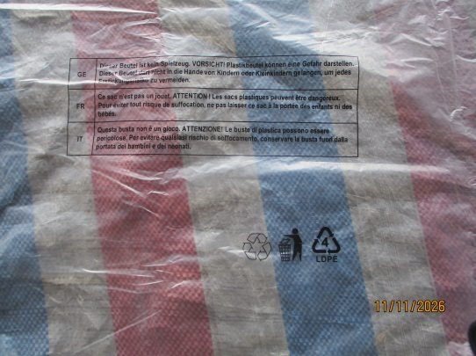 | 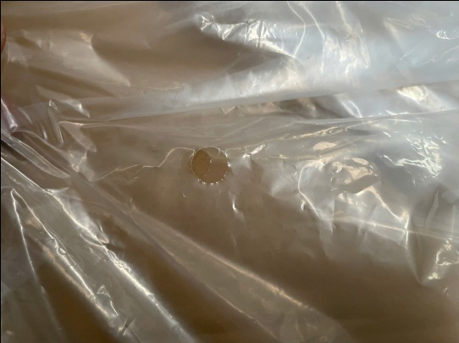 | 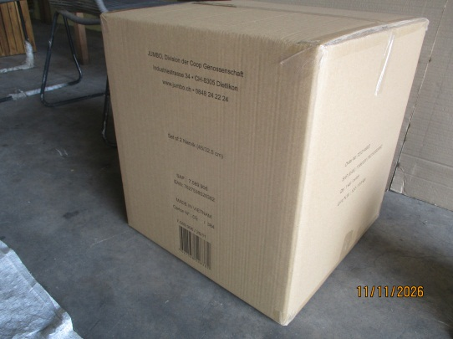
Warning | Air hole | Carton overview
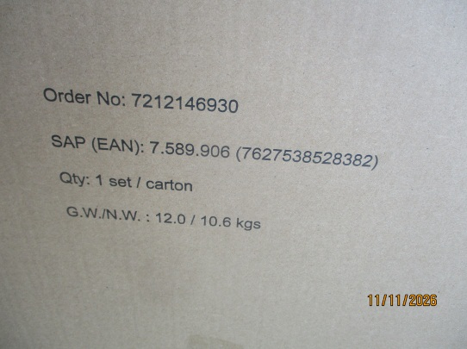 | 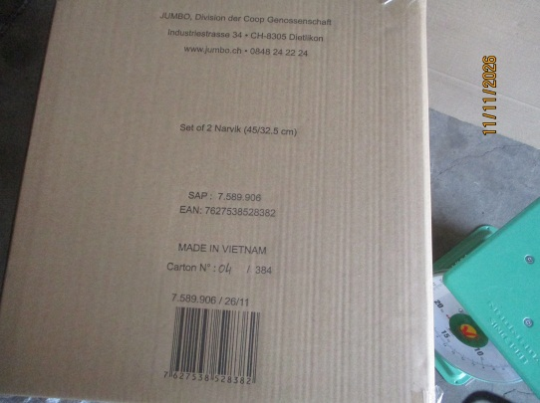 | 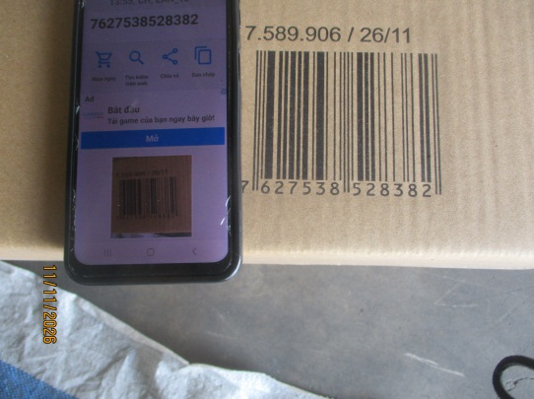
SM carton |  | Scan barcode carton
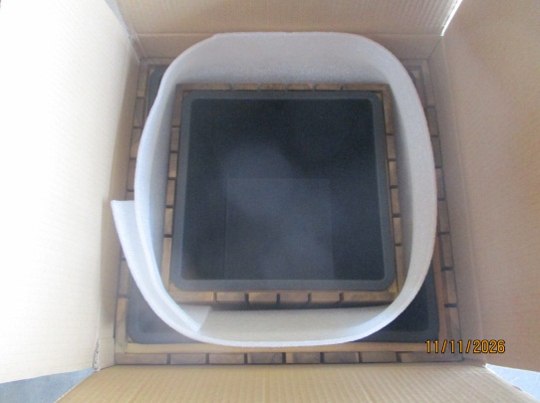 | 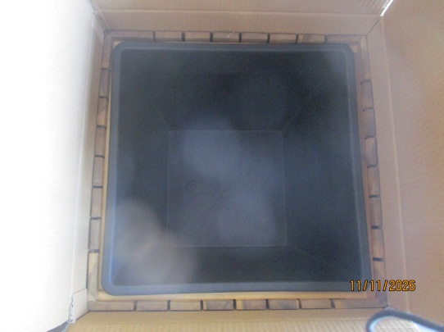 | 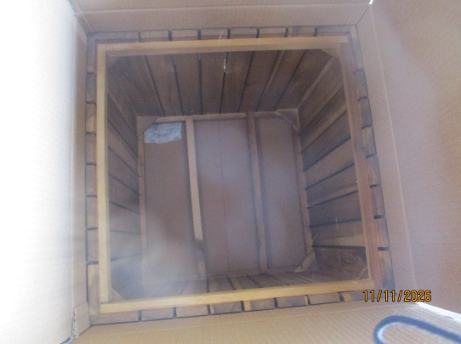
Packing method
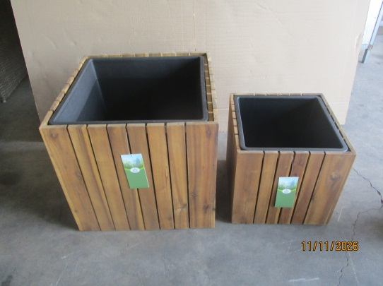 | 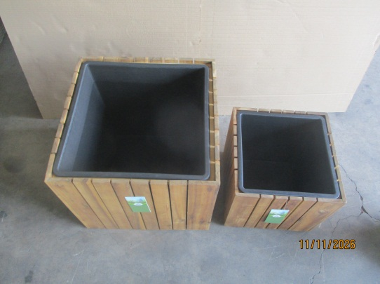 | 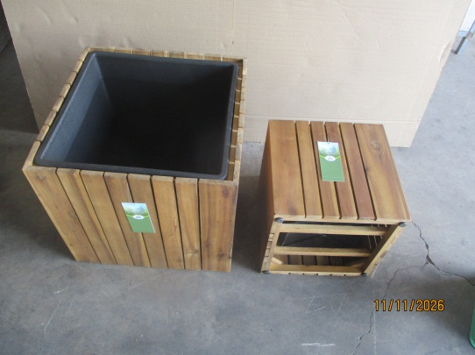
Overview
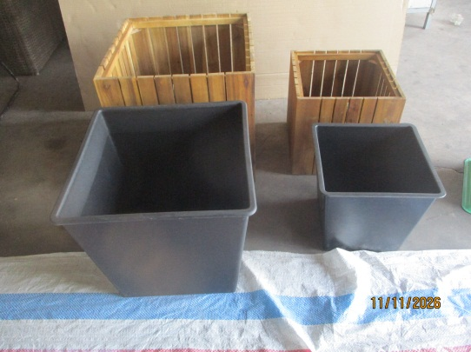 | 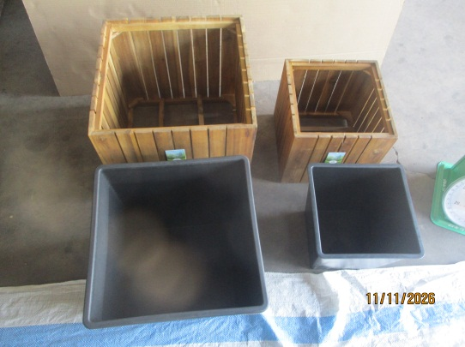 | 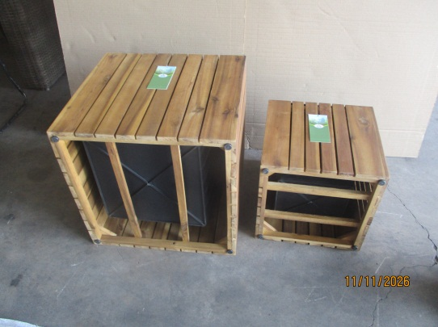
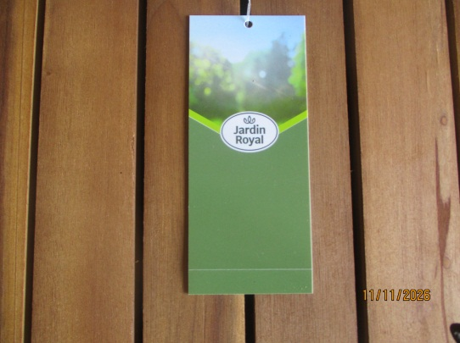 | 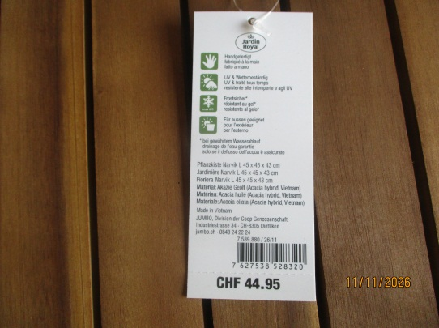 | 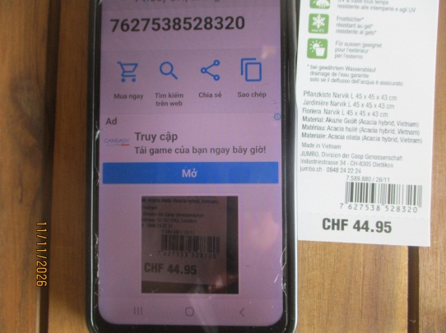
Barcode sticker |  | Scan barcode
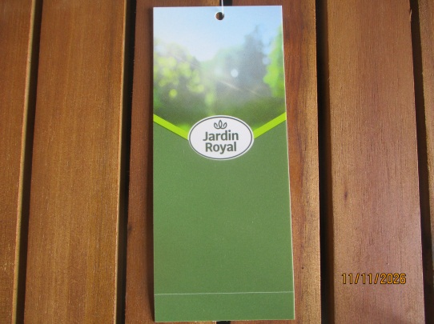 | 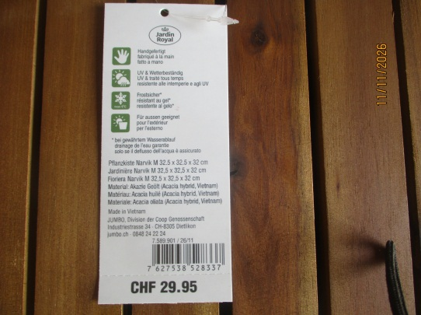 | 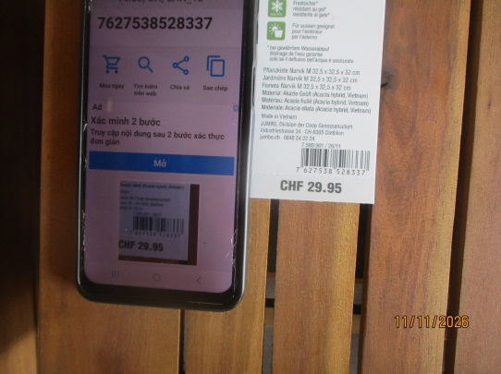
Barcode sticker |  | Scan barcode
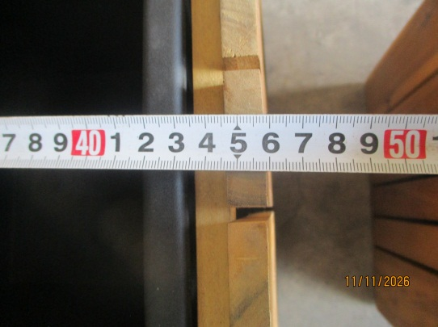 | 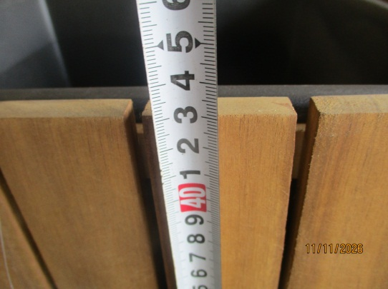 | 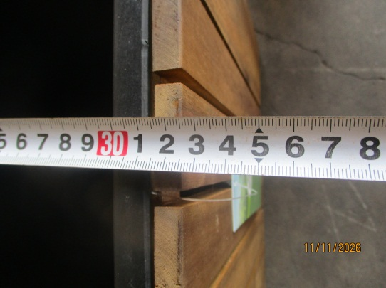
Product dimension
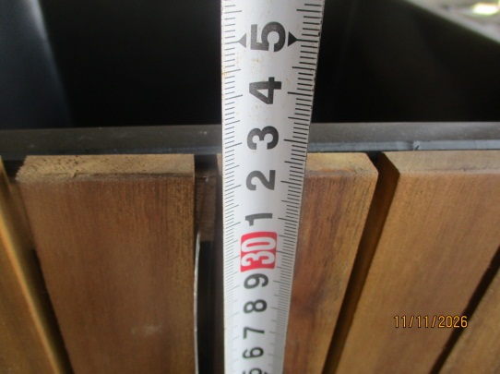 | 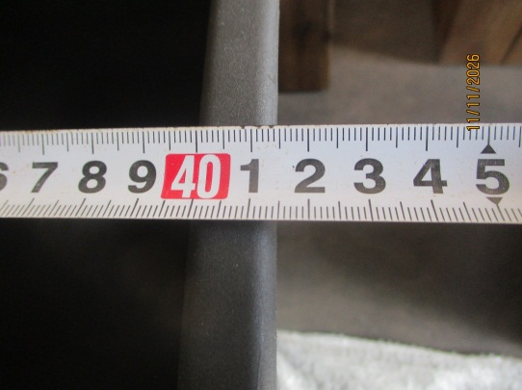 | 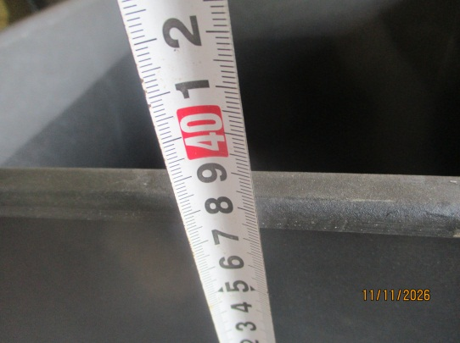
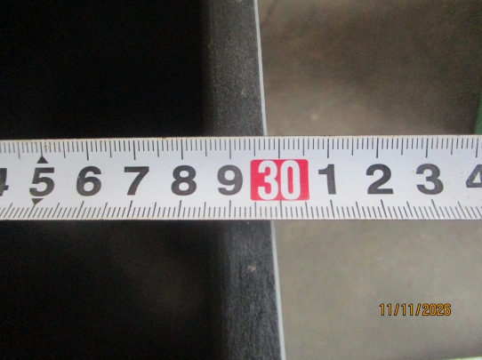 | 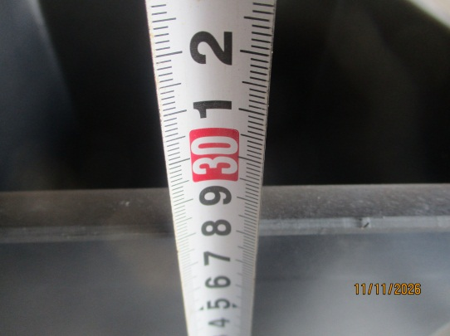 | 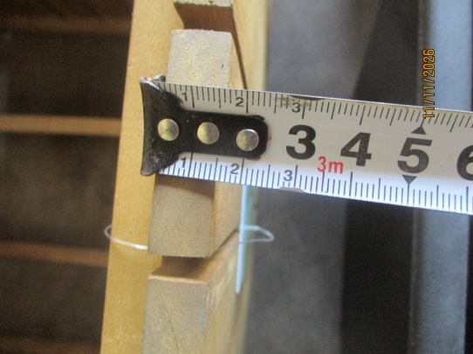
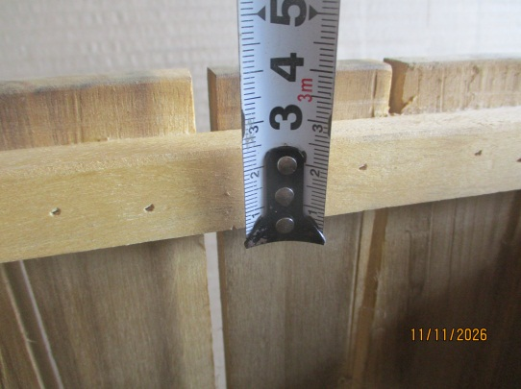 | 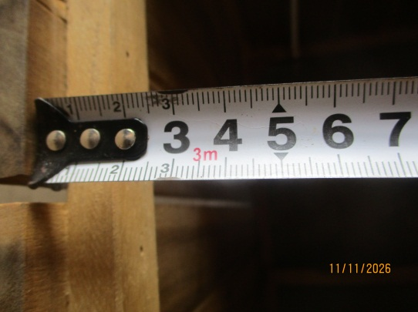 | 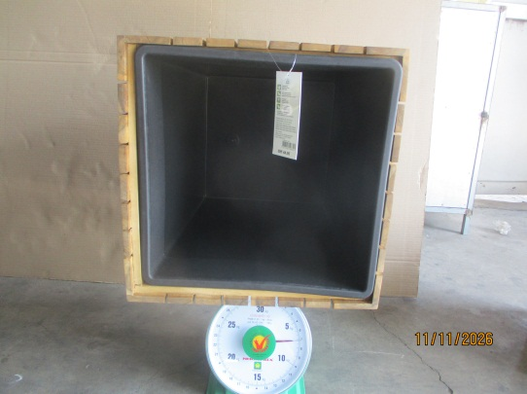
 |  | Net weight
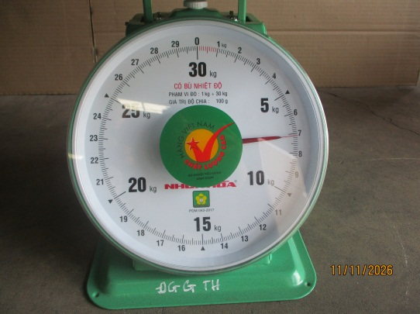 | 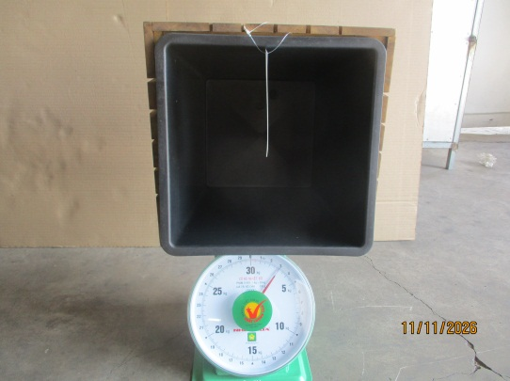 | 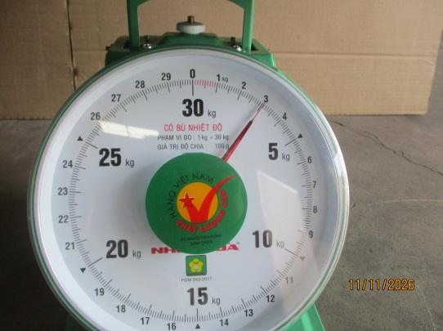
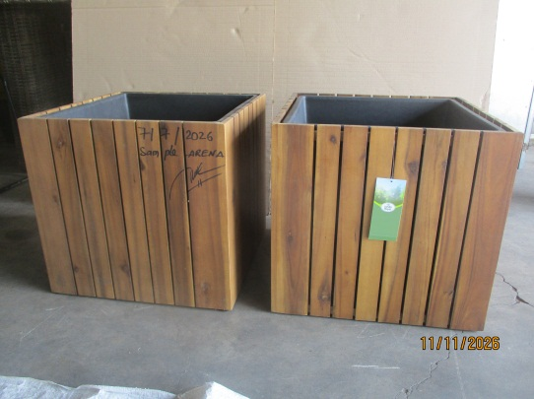 | 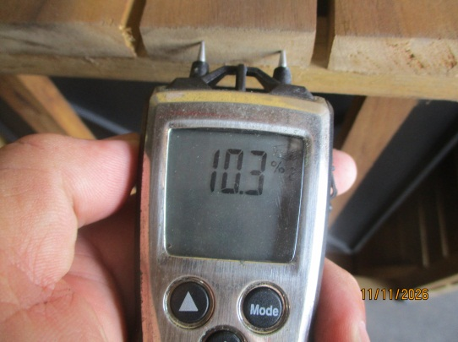 | 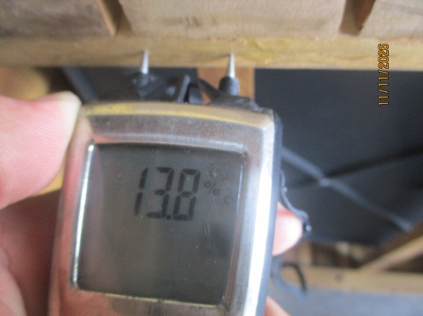
Compare Golden sample | MC
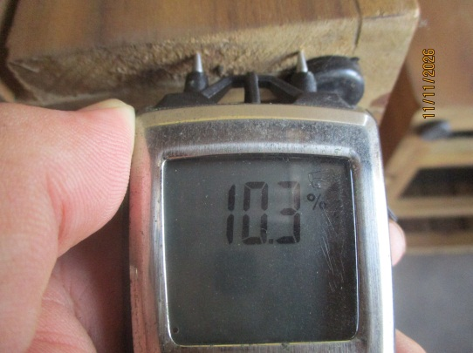 | 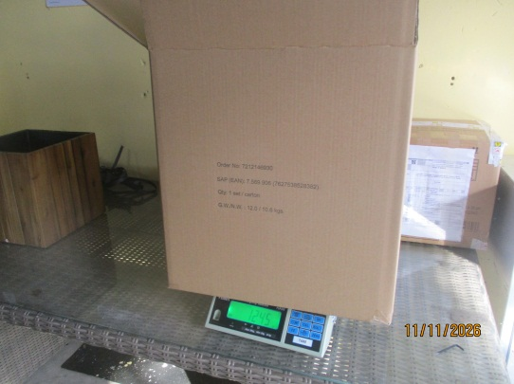 | 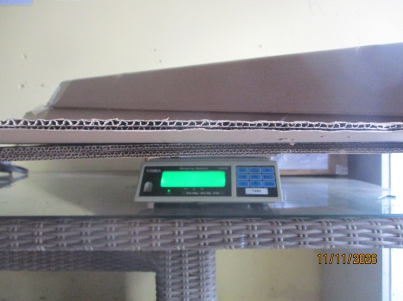
 | Carton weight
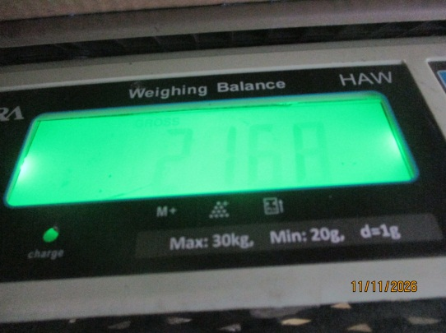 | 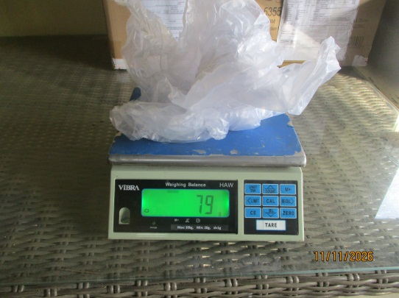 | 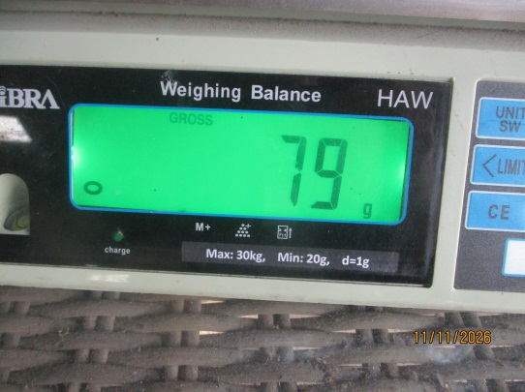
 | Plastic foil, plastic bags weight
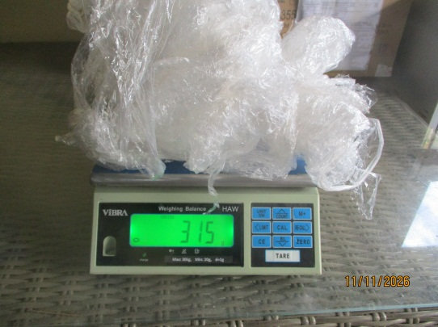 | 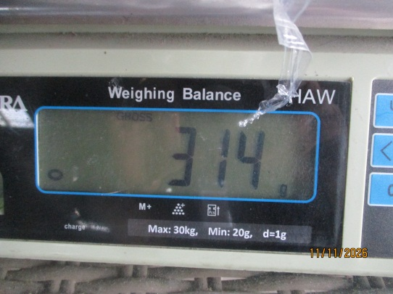 | 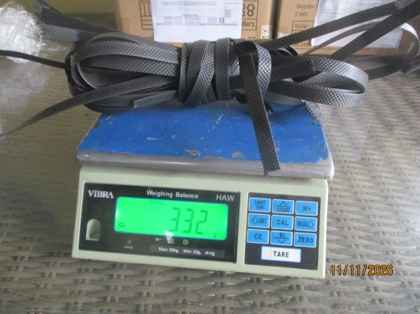
 |  | PVC wieight
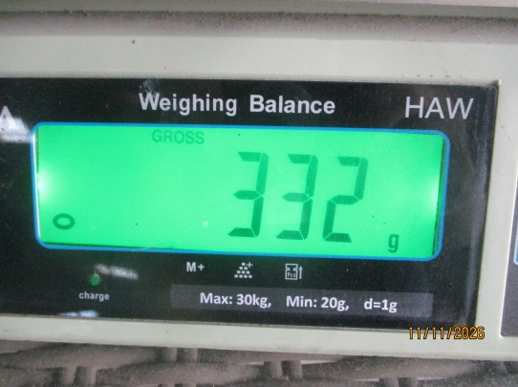 | 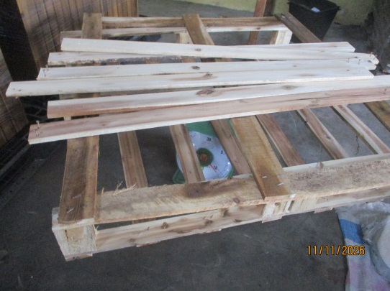 | 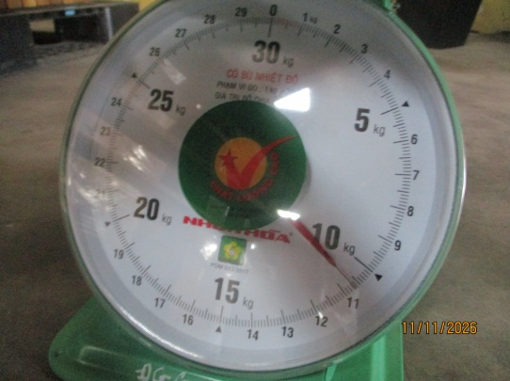
 | Pallet weight

---------- End report ----------

