Supplier corrective action request
JUMBO / THIEN MINH • PO 7212146930
Please return the completed response and supporting records to the responsible Quality Supervisor (QS) before release review. QS will confirm the response deadline and disposition. Inspection date 11 Nov 2026.
Action | Required response and closure evidence
NC-01 / NC-02  Weight & dimensions | Weight / dimension outside ±3% tolerance (5%). Containment: hold the lot; supplier to correct; re-measure. Carton net weight declaration 10.6 kg ≠ layout 9.1 kg. Correct the carton declaration after QS confirmation. Identify the affected lots and quantities, record containment and correction, and submit traceable evidence (photos, counts, re-verification records). Explain the cause and the preventive action.
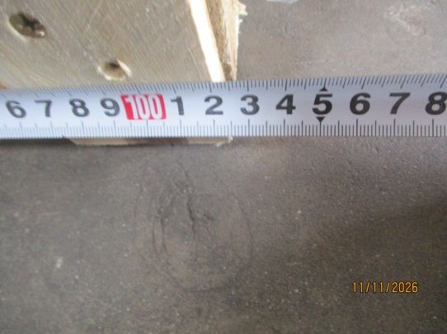  Photo 26 · Pallet dimension. |  | 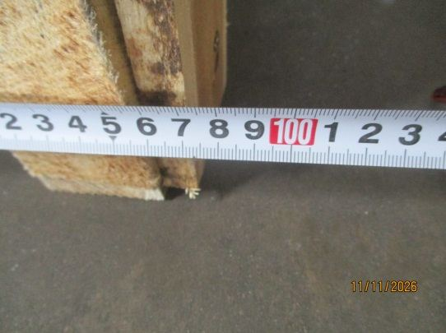  Photo 27 · Pallet dimension. | 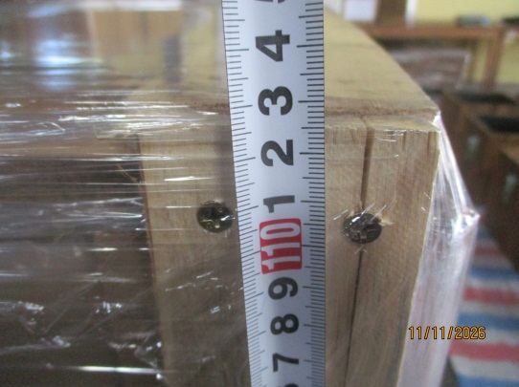  Photo 28 · Pallet dimension.
Supplier response
Field | Supplier to complete
Owner and target date
Affected lot and quantity
Containment and correction
Root cause and prevention
Verification and evidence references

