Multi-format Publishing

Automatically link to other formats in HTML documents

Charlotte Wickham

2023-03-15

|  |
| --- |
| Quarto 1.3 Feature |
| This post is part of a series highlighting new features in the 1.3 release of Quarto. Get the latest release at <https://quarto.org/docs/download>. |

Starting in Quarto 1.3, HTML pages (either standalone or in a website) can automatically include links to other formats specified in the document front matter. For example, the following document front matter:

title: Sample Page  
author: Norah Jones  
date: last-modified  
toc: true  
format:   
 html: default  
 ipynb: default

Results in an HTML page that includes a link to the additional notebook format in the right margin below the table of contents:

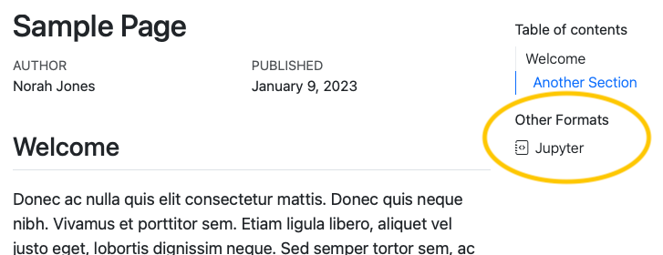

If a table of contents is enabled for the page, the additional formats will be automatically placed within the table of contents as a new section. If no table of contents is displayed, the additional formats will be displayed in the right margin at the top of the document.

Links to additional formats are displayed by default, but you can control whether they are shown or even which specific formats are included with the format-links YAML option.

Read more about this feature on the [Multi-format page](../../../..\docs/prerelease/1.3/multi-format.html) of the pre-release highlights.