Including Other Formats

## Overview

HTML pages (either standalone or in a website) can automatically include links to other formats specified in the document front matter. For example, the following document front matter:

title: Sample Page  
author: Norah Jones  
date: last-modified  
toc: true  
format:   
 html: default  
 ipynb: default

Results in an HTML page that includes a link to the additional notebook format in the right margin below the table of contents:

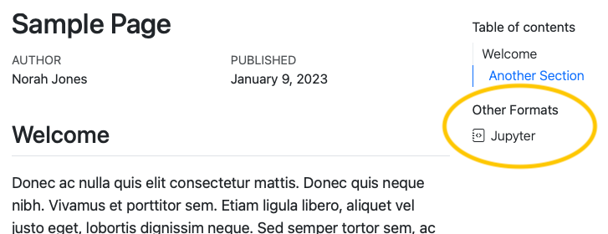

If a table of contents is enabled for the page, the additional formats will be automatically placed within the table of contents as a new section. If no table of contents is displayed, the additional formats will be displayed in the right margin at the top of the document.

Links to additional formats are displayed by default, but you can control whether they are shown or even which specific formats are included with the format-links YAML option.

|  |
| --- |
| Rendering All Formats in Standalone HTML Documents |
| The Render buttons in RStudio and VS Code will not automatically render all formats if the document isn’t part of a Quarto website. To render all formats use quarto render on the command line:  quarto render multi-format.qmd |

## Rendering Formats with the Same Extension

If your formats share a file extension, for example, both HTML pages and Revealjs presentations use .html, their outputs will overwrite each other. To include formats with the same extension, use output-file to distinguish one. For example, to include a link to a RevealJS presentation provide a distinct output-file:

title: Sample Page  
format:   
 html: default  
 revealjs:   
 output-file: document-revealjs.html

## Specifying Formats to Link

You can provide an explicit list of formats to include in the **Other Formats** section by providing a list as the value for format-links. For example, this document front matter will result in only the link to the Jupyter notebook format, excluding the PDF format:

title: Sample Page  
author: Norah Jones  
date: last-modified  
toc: true  
format:   
 html: default  
 ipynb: default  
 pdf: default  
format-links: [ipynb]

## Hiding All Links

To prevent format links from being shown at all, specify format-links: false in your document front matter. For example this front matter will not display the **Other Formats** links:

title: Sample Page  
author: Norah Jones  
date: last-modified  
toc: true  
format:   
 html: default  
 ipynb: default  
format-links: false

## Controlling Formats at a Project Level

In a Quarto Project, to control the formats and their behavior for a specific folder, provide the format and format-links options in a _metadata.yml file. Similarly, you can specify these options for an entire project by including them in the _quarto.yml project file. See [Directory Metadata](../..\docs/projects/quarto-projects.qmd#directory-metadata) or [Project Metadata](../..\docs/projects/quarto-projects.html#project-metadata) for additional details.

The format option isn’t merged like all other [metadata](https://quarto.org/docs/projects/quarto-projects.html#metadata-merging) across _quarto.yml, _metadata.yml, and the document YAML. If you have some formats specified at a project or directory level, you’ll also need to explicitly list them in the document YAML. For example, suppose you have HTML options set at the project level:

format:  
 html:  
 toc: true

In order to get an HTML document with a link to the PDF format, you’ll need to list both formats in the YAML header:

format:   
 html: default  
 pdf: default