# Windows

## Windows CIS 18.3.4

## Is this system compliant?

## Is VNC viewer installed in this Windows System?

# Ubuntu

## 1.6.1 Ensure XD/NX support is enabled

Audit: journalctl | grep 'protection: active'

Result: Compliant

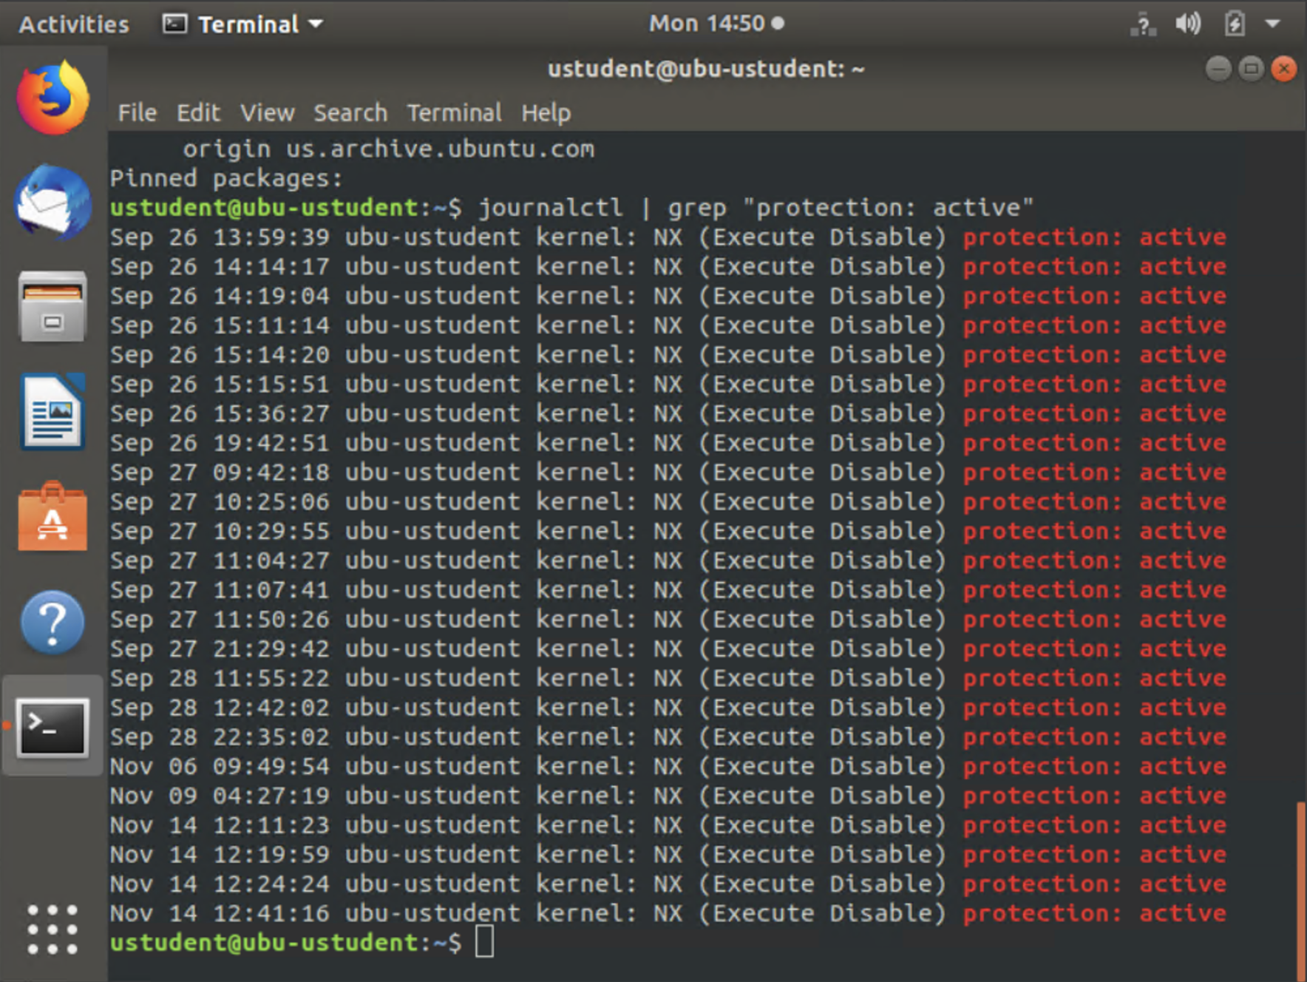

## 1.6.2 Ensure address space layout randomization (ASLR) is enabled

Audit:

# sysctl kernel.randomize_va_space

# grep "kernel\.randomize_va_space" /etc/sysctl.conf /etc/sysctl.d/*

Result: Non-compliant

## According to these checks, are native protections applied to these systems?

No, only NX support is enabled. ASLR is not enabled correctly.

## What packages are installed in this ubuntu machine?

## Is TightVNC installed on this Ubuntu machine?

# Do these applications, both for Windows and Ubuntu, bring added risks to these systems?