**Modeling Concepts**

# Introduction

# 介绍

Verilog HDL modeling language supports three kinds of modeling styles: gate-level, dataflow, and behavioral.

Verilog HDL 建模语言支持三种建模方式：逻辑门级结构化，数据流和行为描述。

The gate-level and data flow modeling are used to model combinatorial circuits whereas the behavioral modeling is used for both combinatorial and sequential circuits.

逻辑门级和数据流建模用于模拟组合逻辑电路，而行为描述建模用于模拟组合与时序逻辑电路。

This lab illustrates the use of all three types of modeling by creating simple combinatorial circuits targeting Basys3 and Nexys4 DDR boards and using the Vivado 2015.1 software tool.

本实验通过创建面向 Basys3 和 Nexys4 DDR 板的简单组合逻辑电路并使用 Vivado 2015.1 软件工具，说明了所有三种建模方式的使用。

*Please refer to the Vivado tutorial on how to use the Vivado tool for creating projects and verifying digital circuits*.

*请参阅 Vivado 教程，了解如何使用 Vivado 工具创建项目和验证数字电路。*

The Basys3 board has the following features:

* 1,800 Kbits of fast block RAM
* 33,280 logic cells in 5200 slices (each slice contains four 6-input LUTs and 8 flip-flops)
* Five clock management tiles, each with a phase-locked loop (PLL)
* 90 DSP slices
* Internal clock speeds exceeding 450MHz
* On-chip analog-to-digital converter (XADC)
* 16 User Switches
* 16 User LEDs
* 5 User Pushbuttons
* 4-digit 7-segment display
* Three Pmod connectors
* Pmod for XADC signals
* 12-bit VGA output
* USB-UART Bridge
* Serial Flash
* Digilent USB-JTAG port for FPGA programming and communication
* 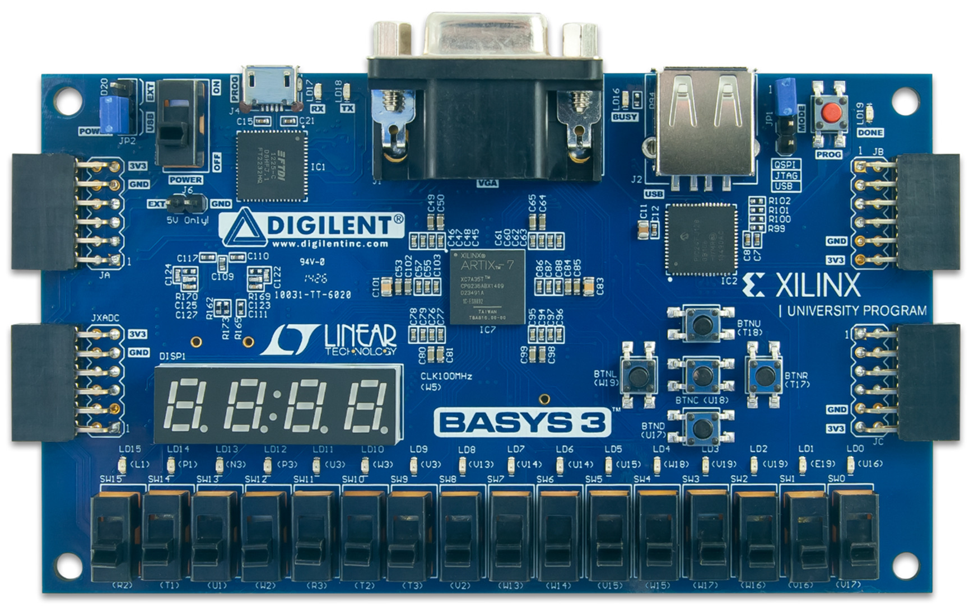USB HID Host for mice, keyboards and memory sticks The Basys3 board.is shown below.

The Nexys4 DDR board has the following features:

* 128 MiB DDR 2 SDRAM
* 16Mbytes SPI (quad mode) PCM non-volatile memory
* 16Mbytes parallel PCM non-volatile memory
* 10/100 Ethernet PHY
* USB-UART and USB-HID port (for mouse/keyboard)
* 8-bit VGA port
* 100MHz CMOS oscillator
* 72 I/O’s routed to expansion connectors
* 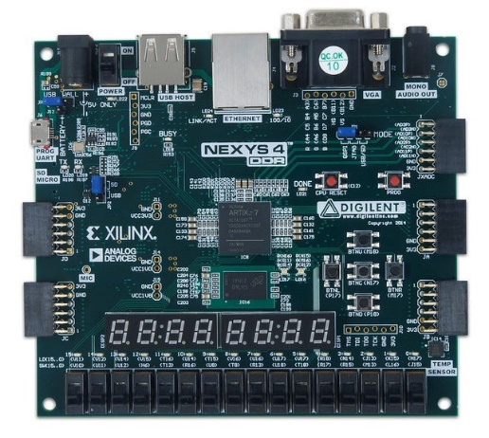GPIO includes 8 LEDs, 5 buttons,8 slide switches and 4-digit seven-segment display The Nexys4 DDR board.is shown below.

# Objectives

# 目标

After completing this lab, you will be able to:

在完成这次实验之后，你将能够：

* Create scalar and wide combinatorial circuits using gate-level, dataflow, and behavioral modeling
* 使用逻辑门，数据流和行为描述的方式创建分级而广泛的组合逻辑电路
* Write models to read switches and push buttons, and output on LEDs and 7-segment displays
* 编写读取开关与按钮（状态）并在 LED 灯与七段数字显示器上输出的模型
* Simulate and understand the design output
* 模拟并理解设计的输出
* Create hierarchical designs
* 创建分级的设计
* Synthesize, implement and generate bitstreams
* 合成、实现并生成比特流
* Download bitstreams into the board and verify functionality
* 将比特流下载到板上并验证功能

Artix-7 1-2 [www.xilinx.com/university](http://www.xilinx.com/university)



# Gate-level Modeling 第一部分

# 门级模型 Part 1

Verilog HDL supports built-in primitive gates modeling.

Verilog HDL 支持使用内置门原语建模

The gates supported are multiple-input, multiple- output, tristate, and pull gates.

支持的门包括：多输入门，多输出门，三态门，拉电阻门

The multiple-input gates supported are: **and**, **nand**, **or**, **nor**, **xor**, and **xnor** whose number of inputs are two or more, and has only one output.

The multiple-output gates supported are **buf** and **not** whose number of output is one or more, and has only one input.

The language also supports modeling of tri-state gates which include **bufif0**, **bufif1**, **notif0**, and **notif1**.

These gates have one input, one control signal, and one output.

The pull gates supported are **pullup** and **pulldown** with a single output (no input) only.

The basic syntax for each type of gates with zero delays is as follows:

**and** | **nand** | **or** | **nor** | **xor** | **xnor** [instance name] (out, in1, …, inN); // [] is optional and | is selection

**buf** | **not** [instance name] (out1, out2, …, out2, input);

**bufif0** | **bufif1** | **notif0** | **notif1** [instance name] (outputA, inputB, controlC);

**pullup** | **pulldown** [instance name] (output A);

One can also have multiple instances of the same type of gate in one construct separated by a comma such as

**and** [inst1] (out11, in11, in12), [inst2] (out21, in21, in22, in23), [inst3] (out31, in31, in32, in33);

The language also allows the delays to be expressed when instantiating gates. The delay expressed is from input to output. The delays can be expressed in form of rise, fall, and turn-off delays; one, two, or all three types of delays can be expressed in a given instance expression. The turn-off delay is applicable to gates whose output can be turned OFF(.e.g. notif1).

For example,

and #5 A1(Out, in1, in2); // the rise and fall delays are 5 units

and #(2,5) A2(out2, in1, in2); // the rise delay is 2 unit and the fall delay is 5 units notif1 #(2, 5, 4) A3(out3, in2, ctrl1); //the rise delay is 2, the fall delay is 5, and the turn- off delay is 4 unit

The gate-level modeling is useful when a circuit is a simple combinational, as an example a multiplexer. Multiplexer is a simple circuit which connects one of many inputs to an output. In this part, you will create a simple 2-to-1 multiplexer and extend the design to multiple bits.

[www.xilinx.com/university](http://www.xilinx.com/university) Artix-7 1-3

## 1-1. Create a 2-to-1 multiplexer using gate-level modeling.

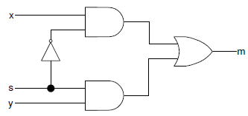

**1-1-1.** Open Vivado 2015.1 and create a blank project called *lab1_1_1* (refer Step 1 of the Vivado 2015.1 Tutorial)**.**

**1-1-2.** Create and add the Verilog module with three inputs (*x*, *y*, *s*) and one output (*m*) using gate-level modeling (refer Step 1 of the Vivado 2015.1 Tutorial).

Hint: Click the **Green Plus** button on the *Add Sources* on the New Project window. Then Click **Create File**. Name the file **lab1_1_1,** click **OK.** Verify the target language and Simulator Language are set to Verilog. Click *Next* twice.

**1-1-3.** Add the appropriate board related master XDC file to the project.

Hint: Click the **Green Plus** button on the *Add Constraints* on the New Project window. Click **Add File.** Select the Basys3_Master.xdc (for Basys3) or Nexys4DDR_Master.xdc (for Nexys4 DDR) file. Click *Next*.

**1-1-4.** Select **xc7a35tcpg236-1** (for Basys3) or **xc7a100tcsg324-1** (for Nexys4 DDR) in the *Default Part*

in the New Project window. Click Next. Click *Finish.*

**1-1-5.** A *Define Module* window will appear, Create the three inputs (x, y, s) and one output (m) by clicking under **Port Name** and entering the variables. Change the **Direction** by clicking on the drop down and selecting the correct direction. Click **OK.**

**1-1-6.** Open the **lab1_1_1.v** file to edit the content. After the closing semicolon (;) add the structural logic of the circuit above. Select **File > Save File** or CRTL-S.

**1-1-7.** Click on the *Elaborated Design* tab of the RTL Analysis.

**1-1-8.** Click on **Schematic** to view the gate-level modeling design.

**1-1-9.** Edit the XDC file. Uncomment and assign ***SW0*** and ***SW1*** to *x* and *y*, ***SW7*** to *s*, and ***LED0*** to *m.*

Save the XDC file.

**1-1-10.** Synthesize the design (refer Step 3 of the Vivado 2015.1 Tutorial).

**1-1-11.** Implement the design (refer Step 4 of the Vivado 2015.1 Tutorial).

Artix-7 1-4 [www.xilinx.com/university](http://www.xilinx.com/university)

**1-1-12.** Generate the bitstream, download it into the Basys3 or the Nexys4 DDR board, and verify the functionality (refer Step 6 of the Vivado 2015.1 Tutorial for steps involved in creating and downloading the bitstream).

## 1-2. Create a two-bit wide 2-to-1 multiplexer using gate-level modeling.

**1-2-1.** Open Vivado 2015.1 and create a blank project called *lab1_1_2***.**

**1-2-2.** Create and add the Verilog module with two 2-bit inputs (*x[1:0]*, *y[1:0]*), a one bit select input (*s*), and two-bit output (*m[1:0]*) using gate-level modeling.

**1-2-3.** Add the master XDC file to the project. Edit the added XDC file to assign ***SW0*** and ***SW1*** to *x[1:0]*,

***SW2*** and ***SW3*** to *y[1:0]*, ***SW7*** to *s*, and ***LED0*** and ***LED1*** to *m[1:0].*

**1-2-4.** Synthesize the design.

**1-2-5.** Implement the design.

**1-2-6.** Generate the bitstream, download it into the Basys3 or the Nexys4 DDR board, and verify the functionality.

# Dataflow Modeling Part 2

Dataflow modeling style is mainly used to describe combinational circuits. The basic mechanism used is the continuous assignment. In a continuous assignment, a value is assigned to a data type called **net**.

The syntax of a continuous assignment is

assign [delay] LHS_net = RHS_expression;

Where LHS_net is a destination net of one or more bit, and RHS_expression is an expression consisting of various operators. The statement is evaluated at any time any of the source operand value changes and the result is assigned to the destination net after the delay unit. The gate level modeling examples listed in Part 1 can be described in dataflow modeling using the continuous assignment. For example,

assign out1 = in1 & in2; // perform and function on in1 and in2 and assign the result to out1

assign out2 = not in1;

assign #2 z[0] = ~(ABAR & BBAR & EN); // perform the desired function and assign the result after 2 units

The target in the continuous assignment expression can be one of the following:

1. A scalar net (e.g. 1st and 2nd examples above)
2. Vector net
3. Constant bit-select of a vector (e.g. 3rd example above)
4. Constant part-select of a vector
5. Concatenation of any of the above

Let us take another set of examples in which a scalar and vector nets are declared and used

**wire** COUNT, CIN; // scalar net declaration

**wire** [3:0] SUM, A, B; // vector nets declaration

**assign** {COUT,SUM} = A + B + CIN; // A and B vectors are added with CIN and the result is

// assigned to a concatenated vector of a scalar and vector nets Note that multiple continuous assignment statements are not allowed on the same destination net.

[www.xilinx.com/university](http://www.xilinx.com/university) Artix-7 1-5

## 2-1. Connect input switches to output LEDs using dataflow modeling.

**2-1-1.** Open Vivado 2015.1 and create a blank project called *lab1_2_1***.**

**2-1-2.** Create and add the Verilog module with 8 inputs (*x_in*) and 8 outputs (*y_out*) using dataflow modeling. Use vector assignment statement as we do not need to do any processing between SW inputs.

**2-1-3.** Add the master XDC file to the project. Edit the added XDC file to assign ***SW7-SW0*** to *x_in* and

***LED7-LED0*** to *y_out*. **2-1-4.** Synthesize the design. **2-1-5.** Implement the design.

**2-1-6.** Generate the bitstream, download it into the Basys3 or the Nexys4 DDR board, and verify the functionality.

## 2-2. Model a two-bit wide 2-to-1 multiplexer using dataflow modeling with net delays of 3 ns.

**2-2-1.** Open Vivado 2015.1 and create a blank project called *lab1_2_2***.**

**2-2-2.** Create and add the Verilog module with two 2-bit inputs (*x[1:0], y[1:0]*), a one bit select input (*s*), and two-bit output (*m[1:0]*) using dataflow modeling. Each assignment statement should have 3 units delay.

As an example, a one-bit 2-to-1 multiplexer can be described as follows:

assign #3 m = (~s & x) | (s & y); // 3 units delay

**2-2-3.** Add the master XDC file to the project. Edit the added XDC file to assign ***SW0*** and ***SW1*** to *x[1:0]*,

***SW2*** and ***SW3*** to *y[1:0]*, ***SW7*** to *s*, and ***LED0*** and ***LED1*** to *m[1:0]*.

**2-2-4.** Add the provided testbench (mux_2bit_2_to_1_dataflow_tb.v) to the project.

Rename testbench file name from mux_2bit_2_to_1_dataflow to lab1_2_2. Save file.

**2-2-5.** Simulate (behavioral simulation) the design for 100 ns and analyze the output.

**2-2-6.** Synthesize the design.

**2-2-7.** Implement the design.

**2-2-8.** Generate the bitstream, download it into the Basys3 or the Nexys4 DDR board, and verify the functionality.

Artix-7 1-6 [www.xilinx.com/university](http://www.xilinx.com/university)

# Behavioral Modeling Part 3

Behavioral modeling is used to describe complex circuits. It is primarily used to model sequential circuits, but can also be used to model pure combinatorial circuits. The mechanisms (statements) for modeling the behavior of a design are:

**initial** Statements

**always** Statements

A module may contain an arbitrary number of **initial** or **always** statements and may contain one or more procedural statements within them. They are executed concurrently (i.e. to model parallelism such that the order in which statements appear in the model does not matter) with respect to each other whereas the procedural statements are executed sequentially (i.e. the order in which they appear does matter). Both **initial** and **always** statements are executed at time=0 and then only **always** statements are executed during the rest of the time. The syntax is as follows:

**initial** [timing_control] procedural_statements;

**always** [timing_control] procedural_statements;

where a procedural_statement is one of: procedural assignment conditional_statement

case_statement loop_statement wait_statement

The **initial** statement is non-synthesizable and is normally used in testbenches. The **always** statement is synthesizable, and the resulting circuit can be a combinatorial or sequential circuit. In order for the model to generate a combinatorial circuit, the **always** block (i) should not be edge sensitive, (ii) every branch of the conditional statement should define all output, and (iii) every case of case statement should define all output and must have a default case. More detailed coverage of this topic is covered in Lab 7. The destination (LHS) should be of **reg** type; either scalar or vector. For example,

reg m; // scalar reg type

reg [7:0] switches*;* // vector reg type

Here is an example of a 2-to-1 multiplexer model. Note that begin and end statements in this example are redundant. They are included for better readability

always @ (x or y or s) begin

if(s==0)

m=y;

end

else

m=x;

## 3-1. Create a 2-to-1 multiplexer using behavioral modeling.

**3-1-1.** Open Vivado 2015.1 and create a blank project called *lab1_3_1***.**

**3-1-2.** Create and add the Verilog module with three inputs (*x*, *y*, *s*) and one output (*m*) using behavioral modeling. Use the example code given above.

To declare a register, putting **reg** after the declaration of input/output and before the port name.

[www.xilinx.com/university](http://www.xilinx.com/university) Artix-7 1-7

**3-1-3.** Add the master XDC file to the project. Edit the added XDC file to assign ***SW0*** and ***SW1*** to *x* and

*y*, ***SW7*** to *s*, and ***LED0*** to *m*.

**3-1-4.** Synthesize the design.

**3-1-5.** Implement the design.

**3-1-6.** Generate the bitstream, download it into the Basys3 or the Nexys4 DDR board, and verify the functionality.

## 3-2. Create a two-bit wide 2-to-1 multiplexer using behavioral modeling.

**3-2-1.** Open Vivado 2015.1 and create a blank project called *lab1_3_2***.**

**3-2-2.** Create and add the Verilog module with two-bit input (*x[1:0], y[1:0]*), a one bit select input (*s*), and two-bit output (*m[1:0]*) using behavioral modeling.

**3-2-3.** Add the master XDC file to the project. Edit the added XDC file to assign ***SW0*** and ***SW1*** to *x[1:0]*,

***SW2*** and ***SW3*** to *y[1:0]*, ***SW7*** to *s*, and ***LED0*** and ***LED1*** to *m[1:0]*.

**3-2-4.** Synthesize the design.

**3-2-5.** Implement the design.

**3-2-6.** Generate the bitstream, download it into the Basys3 or the Nexys4 DDR board, and verify the functionality.

# Mixed-design Style Modeling Part 4

Complex systems can be described in Verilog HDL using mixed-design style modeling. This modeling style supports hierarchical description. The design can be described using:

Build-in gate primitives (gate-level modeling covered in Part 1) Dataflow modeling (covered in Part 2)

Behavioral modeling (covered in Part 3) Module instantiation

Combinations of the above.

Interconnections between various objects are done through nets (of type ***wire***). Nets may be scalar or vector. For example.

wire y; // scalar net

wire [3:0] sum; // vector net

In absence of size, the net is assumed to be the scalar type.

As an example of a mixed-style modeling, following diagram shows how one can build a 3-to1 multiplexer using multiple instances of 2-to-1 multiplexer. It also shows the symbol and the truth table.

Artix-7 1-8 [www.xilinx.com/university](http://www.xilinx.com/university)



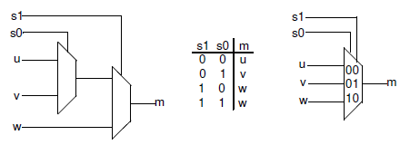

In the above diagram, u, v, w are data inputs whereas S0, S1 are select signals, and the output is m. It uses two instances of 2-to-1 multiplexer.

## 4-1. Model a 3-to-1 multiplexer using 2-to-1 multiplexers.

**4-1-1.** Open Vivado 2015.1 and create a blank project called *lab1_4_1***.**

**4-1-2.** Create a top-level Verilog module with three data inputs (*u, y, w*), two select inputs (*s0, s1*), and one bit output (*m*) using the previously defined 2-to-1 multiplexer. You can use any style designed 2-to-1 multiplexer (1-1, 2-1, or 3-1). Wire them up as shown in the above diagram.

Verify that the .v file with (u, y, w) is the top file. To set as top file right click and select **Set as Top.**

**4-1-3.** Add the used 2-to-1 model file to the project.

**4-1-4.** Add the master XDC file to the project. Edit the added XDC file to assign ***SW0, SW1***, and ***SW2*** to

*u, y,*and *w* respectively, ***SW3*** to *s0*, ***SW4*** to *s1*, and ***LED0*** to *m*.

**4-1-5.** Synthesize and implement the design.

**4-1-6.** Generate the bitstream, download it into the Basys3 or the Nexys4 DDR board, and verify the functionality.

[www.xilinx.com/university](http://www.xilinx.com/university) Artix-7 1-9

## 4-2. Model a BCD to 7-Segment Decoder.

A 7-segment display consists of seven segments, numbered a to g which can be used to display a character. Depending on the input type, a type conversion may be needed. If want to display a binary coded decimal (BCD) using 4-bit input, a BCD to 7-segment decoder is required. The table below shows the bit pattern you need to put to display a digit (note that to turn ON a segment you need to put logic 0 on the segment and the anode of the display needs to be driven logic 0 on this board).

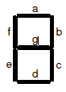

.

|  |  |  |  |  |  |  |  |
| --- | --- | --- | --- | --- | --- | --- | --- |
| Input | a | b | c | d | e | f | g |
| 0000 | 0 | 0 | 0 | 0 | 0 | 0 | 1 |
| 0001 | 1 | 0 | 0 | 1 | 1 | 1 | 1 |
| 0010 | 0 | 0 | 1 | 0 | 0 | 1 | 0 |
| 0011 | 0 | 0 | 0 | 0 | 1 | 1 | 0 |
| 0100 | 1 | 0 | 0 | 1 | 1 | 0 | 0 |
| 0101 | 0 | 1 | 0 | 0 | 1 | 0 | 0 |
| 0110 | 0 | 1 | 0 | 0 | 0 | 0 | 0 |
| 0111 | 0 | 0 | 0 | 1 | 1 | 1 | 1 |
| 1000 | 0 | 0 | 0 | 0 | 0 | 0 | 0 |
| 1001 | 0 | 0 | 0 | 0 | 1 | 0 | 0 |
| 1010 to  1111 | X | X | X | X | X | X | x |

Where x is don’t care.

The **Basys3** board contains two a four-digit common anode seven-segment LED display modules. Each of the four digits within a module is composed of seven segments arranged in a pattern shown below, with an LED embedded in each segment. Segment LEDs can be individually illuminated, so any one of 128 patterns can be displayed on a digit by illuminating certain LED segments and leaving the others dark. Of these 128 possible patterns, the ten corresponding to the decimal digits are the most useful.

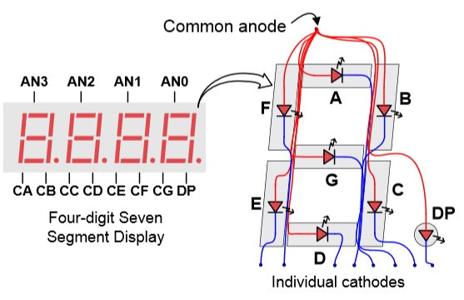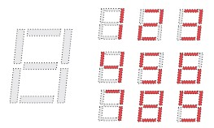

[Reference – Basys3 Reference Manual]

The anodes of the seven LEDs forming each digit are tied together into one “common anode” circuit node, but the LED cathodes remain separate. The common anode signals are available as four “digit enable” input signals to the 4-digit display. The cathodes of similar segments on all four displays are

Artix-7 1-10 [www.xilinx.com/university](http://www.xilinx.com/university)

connected into seven circuit nodes labeled CA through CG (so, for example, the four “D” cathodes from the four digits are grouped together into a single circuit node called “CD”). These seven cathode signals are available as inputs to the 4-digit display. This signal connection scheme creates a multiplexed display, where the cathode signals are common to all digits but they can only illuminate the segments of the digit whose corresponding anode signal is asserted.

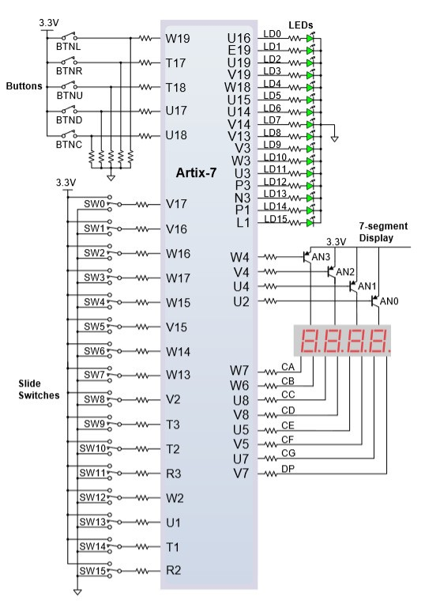 [Reference – Basys3 Reference Manual]

The **Nexys4 DDR** board contains two four-digit common anode seven-segment LED display modules. Each of the four digits within a module is composed of seven segments arranged in a pattern shown below, with an LED embedded in each segment. Segment LEDs can be individually illuminated, so any one of 128 patterns can be displayed on a digit by illuminating certain LED segments and leaving the others dark. Of these 128 possible patterns, the ten corresponding to the decimal digits are the most useful.

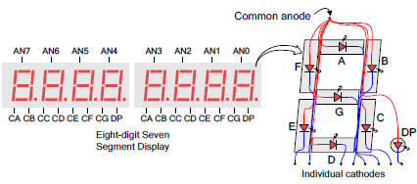

[Reference – Nexys4 DDR Reference Manual]

The anodes of the seven LEDs forming each digit are tied together into one “common anode” circuit node, but the LED cathodes remain separate. The common anode signals are available as four “digit enable” input signals to the 4-digit display. The cathodes of similar segments on all four displays are connected into seven circuit nodes labeled CA through CG (so, for example, the four “D” cathodes from the four digits are grouped together into a single circuit node called “CD”). These seven cathode signals are available as inputs to the 4-digit display. This signal connection scheme creates a multiplexed display, where the cathode signals are common to all digits but they can only illuminate the segments of the digit whose corresponding anode signal is asserted.

[www.xilinx.com/university](http://www.xilinx.com/university) Artix-7 1-11

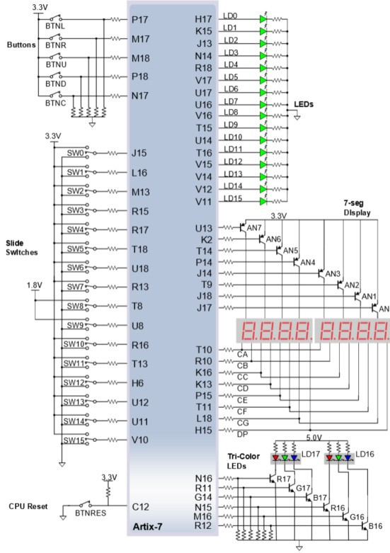[Reference – Nexys4 DDR Reference Manual]

A scanning display controller circuit can be used to show a four-digit number on this display. This circuit drives the anode signals and corresponding cathode patterns of each digit in a repeating, continuous succession, at an update rate that is faster than the human eye can detect. If the update or “refresh” rate is slowed to around 45 hertz, most people will begin to see the display flicker. You will design and use the scanning circuit starting with Lab 8 (Architecture Wizard and IP Catalog).

**4-2-1.** Open Vivado 2015.1 and create a blank project called *lab1_4_2***.**

**4-2-2.** Create a top-level Verilog module, named bcdto7segment_dataflow with 4-bit data input (*x[3:0]*), anode enable output signals (*an[3:0]*), and 7-bit output (*seg[6:0]*) using dataflow modeling (Hint: You will have to derive seven expressions for the 7 segments on paper). Assign appropriate logic to *an[3:0]* in the model so you can display only on the right most display.

**4-2-3.** Add the board related master XDC file to the project. Edit the added XDC file to assign ***SW3-SW0*** to *x[3:0]*. Assign **CA, CB, CC, CD, CE, CF, CG** to *seg[0]* through *seg[6]* and pins ***J17, J18, T9, J14, P14, T14, K2, U13*** to an7, an6, an5, an4,*an3, an2, an1, an0* (Nexys4 DDR board) or pins ***U2,U4,V4,W4*** to *an3, an2, an1, an0* (Basys3 board).

**4-2-4.** Synthesize the design.

**4-2-5.** Implement the design.

**4-2-6.** Generate the bitstream, download it into the Basys3 or the Nexys4 DDR board, and verify the functionality.

# Conclusion

In this lab, you created Vivado 2015.1 projects to develop various models. You implemented the design and verified the functionality in hardware as well as simulation. You learned three modeling styles. The gate-level and dataflow modeling are primarily used for the combinatorial circuits, whereas the behavioral modeling supports both combinatorial and sequential circuits design. In this lab you used the behavioral modeling for the combinatorial circuits design. In next few labs you will be using dataflow modeling for designing various combinatorial circuits, and starting with Lab 7, you will use the behavioral modeling to design sequential circuits.

Artix-7 1-12 [www.xilinx.com/university](http://www.xilinx.com/university)