**实验报告**

实验题目： **计数器, 计时器 和 实时时钟**

日期： 2018 年 11 月 23 日

姓名: 罗晏宸 学号: PB17000297 成绩:____________

**实验目的：**

1. 学习如何定义参数化模型，掌握建立更泛用模块的编写风格
2. 使用行为建模与IP目录的例化分别设计计数器，并加以对比
3. 使用内核和用HDL建模的附加电路设计定时器电路
4. 通过掌握的知识，创建实时的时钟

**实验内容**（截图、照片与代码）

Lab9_1_1

代码lab9_1_1.v

`timescale 1ns / 1ps

module lab9_1_1(a,b,cin,sum,cout);

    parameter SIZE = 1;

    input [SIZE-1:0] a,b;

    output [SIZE-1:0] sum;

    input cin;

    output cout;

    wire [SIZE-1:1] temp;

    defparam uFULLADDER.NOT_DELAY=1, uFULLADDER.AND_DELAY=3, uFULLADDER.OR_DELAY=3;

    fulladder_gatelevel

        uFULLADDER (.a(a[0]),.b(b[0]),.cin(cin),.sum(sum),.cout(cout));

endmodule

代码 fulladder_gatelevel.v

`timescale 1ns / 1ps

module fulladder_gatelevel (a,b,cin,sum,cout);

    parameter AND_DELAY=2, OR_DELAY=2, NOT_DELAY=2;

    input a,b,cin;

    output sum,cout;

    wire q1,q2,q3,r1,r2,s,t1,t2,t3,_a,_b,_cin,_r1,_r2;

    and #(AND_DELAY)

        uAND1 (q1,a,b),

        uAND2 (q2,b,cin),

        uAND3 (q3,a,cin),

        uAND4 (s,r1,r2),

        uAND5 (sum,t1,t2,t3);

    or #(OR_DELAY)

        uOR1 (cout,q1,q2,q3),

        uOR2 (r1,_a,b),

        uOR3 (r2,_b,a),

        uOR4 (t1,_r1,_r2,cin),

        uOR5 (t2,_cin,r1),

        uOR6 (t3,_cin,r2);

    not #(NOT_DELAY)

        uNOT1 (_a,a),

        uNOT2 (_b,b),

        uNOT3 (_cin,cin),

        uNOT4 (_r1,r1),

        uNOT5 (_r2,r2);

endmodule

代码lab9_1_1_tb.v

`timescale 1ns / 1ps

module lab9_1_1_tb();

    parameter SIZE = 1;

    reg [SIZE-1:0] a,b;

reg cin;

integer i,j;

wire cout;

wire [SIZE-1:0] sum;

lab9_1_1 DUT (.a(a), .b(b), .cin(cin), .sum(sum), .cout(cout));

initial

begin

    cin = 0;

    for ( i = 0 ; i < 1<<SIZE ; i = i + 1 )

     begin

         a = i;

         for ( j = 0 ; j < 1<<SIZE ; j = j + 1 )

         begin

             b = j;

             cin = 0;#10

             cin = 1;#10;

         end

     end

 end

endmodule

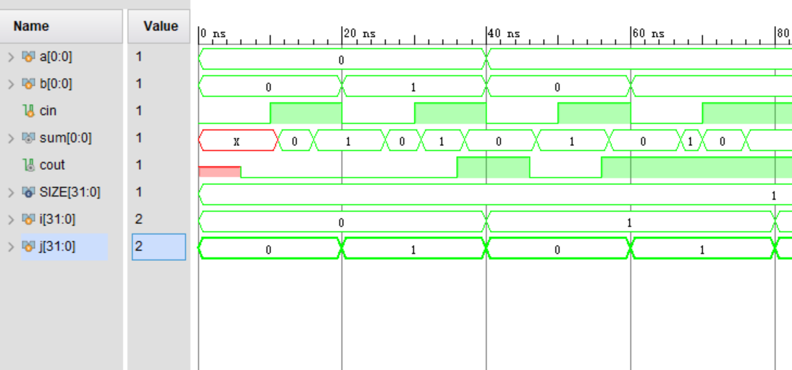

截图 1-lab9_1_1仿真

lab9_2_1

代码 up_down_Counter.v

`timescale 1ns / 1ps

(* use_dsp48 = "no" *)

module up_down_Counter #(parameter COUNT_SIZE = 8) (

input CLK100MHZ,

input up_down,

input enable,

input reset,

output reg [COUNT_SIZE - 1:0] Count

);

wire pulse,clk;

clk_wiz_0 CLOCK5M (clk,CLK100MHZ);

    Counter CLOCK (clk,~enable,pulse);

always@(posedge pulse)

begin

    if (up_down)

    begin

            if ((Count >= (1 << COUNT_SIZE) - 1) || (reset))

                Count   <= 'b0;

            else

                Count   <= Count + 'b1;

        end

        else

        begin

            if ((Count == 'b0) || (reset))

                Count   <= (1 << COUNT_SIZE) - 1;

            else

                Count   <= Count - 'b1;

        end

end

endmodule

代码Counter.v

`timescale 1ns / 1ps

module Counter(input clk,input rst,output pulse);

     reg [23:0] cnt = 0;

always @(posedge clk or posedge rst)

begin

   if (rst)

   cnt <= 23'd0;

   else

       if(cnt >= 23'd499999)

       cnt <= 23'd0;

   else

       cnt <= cnt + 23'd1;

end

    assign pulse = (cnt == 23'd499999) ? 1'b1 : 1'b0;

endmodule

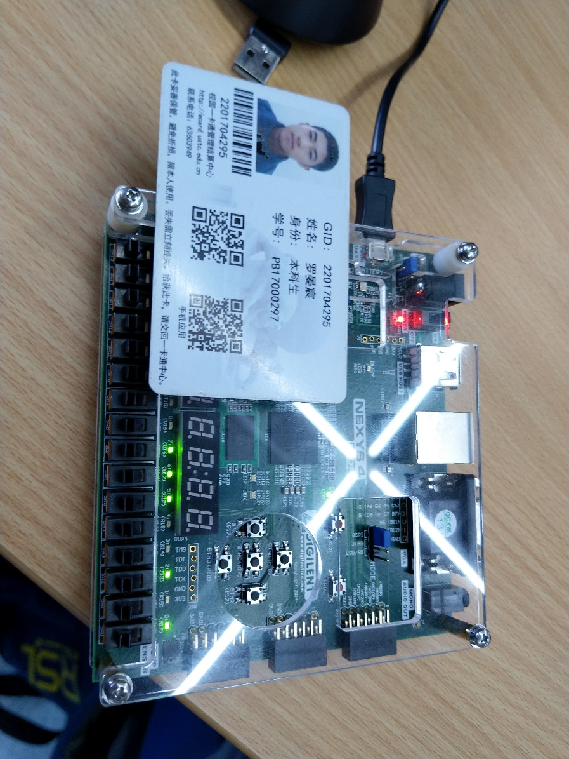

照片 1-lab9_2_1下载A

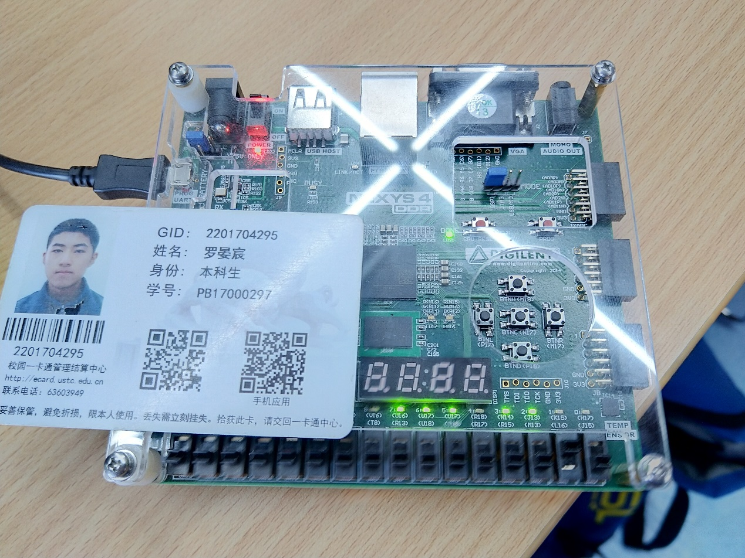

照片 2-lab9_2_1下载B

“照片 1-lab9_2_1下载A”与“照片 2-lab9_2_1下载B”的说明：本工程使用行为建模设计一个8位向上/向下计数器，A/B中switch[1]分别为开与关，表明计数器正处于向上/向下的计数状态，led[0]~led[7]的亮灭表示count的物理显示，图A/B中count分别为(11100101)­B和(11101100)B，表示彼时计数为(229)D与(236)D。

Lab9_3_1

代码lab9_3_1.v

`timescale 1ns / 1ps

module lab9_3_1(input CLK100MHZ,input reset,input enable,output [7:0] AN,output [7:0] seg);

    wire tick,second,clk;

    wire [1:0] pulse;

    wire [2:0] threshold;

    wire [3:0] Q0,Q1,Q2,Q3;

    wire [7:0] seg0,seg1,seg2,seg3;

    clk_wiz_0(clk,CLK100MHZ);

    Counter0(clk,~enable,tick);

    c_counter_binary_0 CLOCK1 (tick,1,reset,threshold[0],Q0);

    c_counter_binary_0 CLOCK2 (tick,threshold[0] & Q0[3] & Q0[0],reset,threshold[1],Q1);

    c_counter_binary_1 CLOCK3 (tick,threshold[1] & threshold[0],reset,threshold[2],Q2);

    c_counter_binary_2 CLOCK4 (tick,threshold[2] & threshold[1] & threshold[0],reset,Q3);

    Counter2(clk,pulse);

    assign seg0[7] = 1;

    assign seg1[7] = 0;

    assign seg2[7] = 1;

    assign seg3[7] = 0;

    bcdto7segment_dataflow (Q0,seg0[6:0]);

    bcdto7segment_dataflow (Q1,seg1[6:0]);

    bcdto7segment_dataflow (Q2,seg2[6:0]);

    bcdto7segment_dataflow (Q3,seg3[6:0]);

    assign seg = (pulse<=2'b01) ? ((pulse==2'b00) ? seg0 : seg1) : ((pulse==2'b10) ? seg2 : seg3);

    assign AN[0] = (pulse==2'b00) ? 0 : 1;

    assign AN[1] = (pulse==2'b01) ? 0 : 1;

    assign AN[2] = (pulse==2'b10) ? 0 : 1;

    assign AN[3] = (pulse==2'b11) ? 0 : 1;

    assign AN[4] = 1;

    assign AN[5] = 1;

    assign AN[6] = 1;

    assign AN[7] = 1;

endmodule

代码Counter.v

`timescale 1ns / 1ps

module Counter0(input clk,input rst,output pulse);

     reg [23:0] cnt = 0;

always @(posedge clk or posedge rst)

begin

   if (rst)

   cnt <= 23'd0;

   else

       if(cnt >= 23'd499999)

       cnt <= 23'd0;

   else

       cnt <= cnt + 23'd1;

end

    assign pulse = (cnt == 23'd499999) ? 1'b1 : 1'b0;

endmodule

代码Counter2.v

`timescale 1ns / 1ps

module Counter2(input clk,output reg [2:0] pulse);

     reg [20:0] cnt;

always @(posedge clk)

begin

        if(cnt >= 'd24999)

        begin

       cnt <= 'd0;

       pulse <= pulse + 'b1;

   end

   else

       cnt <= cnt + 'd1;

end

endmodule

代码bcdto7segment_dataflow.v

`timescale 1ns / 1ps

module bcdto7segment_dataflow(

input [3:0] x,

output [6:0] seg

);

assign seg[0] = ((~x[3] && ~x[2] && ~x[1] && x[0]) | (~x[3] && x[2] && ~x[1] && ~x[0])) && ~(x[3] && (x[2] | x[1]));

assign seg[1] = (~x[3] && x[2] && ~x[1] && x[0]) | (~x[3] && x[2] && x[1] && ~x[0]) | (x[3] && (x[2] | x[1]));

assign seg[2] = (~x[3] && ~x[2] && x[1] && ~x[0]) | (x[3] && (x[2] | x[1]));

assign seg[3] = ((~x[3] && ~x[2] && ~x[1] && x[0]) | (~x[3] && x[2] && ~x[1] && ~x[0]) | (~x[3] && x[2] && x[1] && x[0])) && ~(x[3] && (x[2] | x[1]));

assign seg[4] = ((~x[3] && ~x[2] && ~x[1] && x[0]) | (~x[3] && ~x[2] && x[1] && x[0]) | (~x[3] && x[2] && ~x[1] && ~x[0]) | (~x[3] && x[2] && ~x[1] && x[0]) | (~x[3] && x[2] && x[1] && x[0]) | (x[3] && ~x[2] && ~x[1] && x[0])) && ~(x[3] && (x[2] | x[1]));

assign seg[5] = ((~x[3] && ~x[2] && ~x[1] && x[0]) | (~x[3] && ~x[2] && x[1] && ~x[0]) | (~x[3] && ~x[2] && x[1] && x[0]) | (~x[3] && x[2] && x[1] && x[0])) && ~(x[3] && (x[2] | x[1]));

assign seg[6] = ((~x[3] && ~x[2] && ~x[1] && ~x[0]) | (~x[3] && ~x[2] && ~x[1] && x[0]) | (~x[3] && x[2] && x[1] && x[0])) && ~(x[3] && (x[2] | x[1]));

endmodule

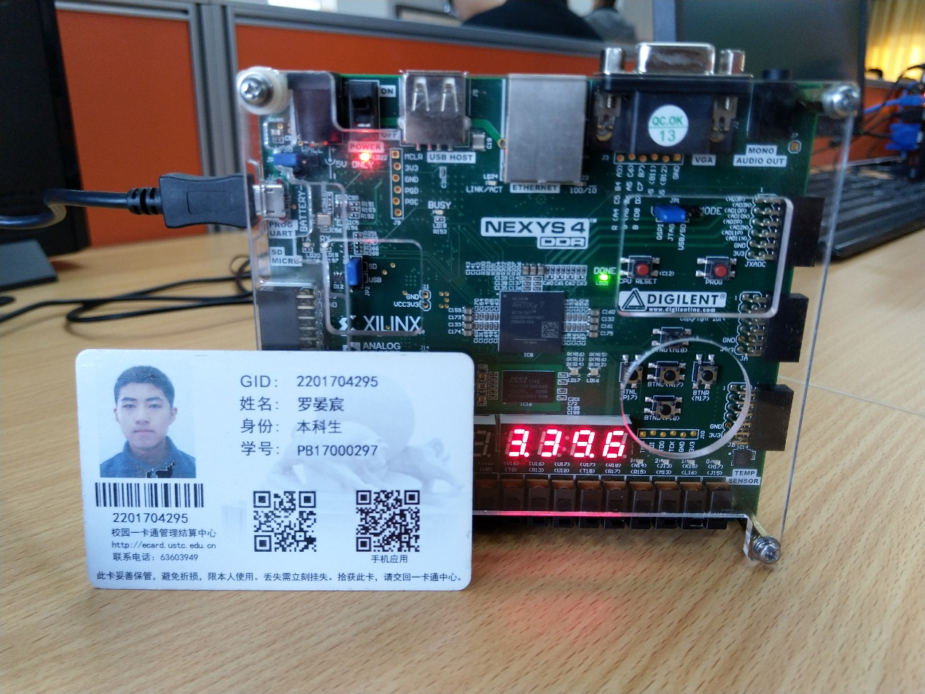

照片 3-lab9_3_1下载

“照片 4-lab9_3_1下载”的说明：本工程使用数据流建模与例化IP目录实现一个精确到0.1s的在七段数码管上以M.SS.f的格式显示的带有复位和使能功能的计时器。图中右侧四位七段数码管的显示为”3.39.6”字样，表明彼时计时为3’39.6’’

**实验总结**

本次实验中，学习了如何实现模型的参数化，便于在后续的学习与工程设计中实现更为泛用的模块；另外，通过对行为建模与例化IP对于计数器的不同实现，了解了计数与计时的实现原理，进一步的，利用已学习的知识设计了相对有实际意义的时钟应用，通过实践巩固了以上所设计的开发技术。

**课后习题**

Lab9_2_1

代码 up_down_Counter.v

`timescale 1ns / 1ps

(* use_dsp48 = "no" *)

module up_down_Counter #(parameter COUNT_SIZE = 8) (

input CLK100MHZ,

input up_down,

input enable,

input reset,

output reg [COUNT_SIZE - 1:0] Count

);

wire pulse,clk;

clk_wiz_0 CLOCK5M (clk,CLK100MHZ);

    Counter CLOCK (clk,~enable,pulse);

always@(posedge pulse)

begin

    if (up_down)

    begin

            if ((Count >= (1 << COUNT_SIZE) - 1) || (reset))

                Count   <= 'b0;

            else

                Count   <= Count + 'b1;

        end

        else

        begin

            if ((Count == 'b0) || (reset))

                Count   <= (1 << COUNT_SIZE) - 1;

            else

                Count   <= Count - 'b1;

        end

end

endmodule

代码Counter.v

`timescale 1ns / 1ps

(* use_dsp48 = "no" *)

module Counter(input clk,input rst,output pulse);

     reg [23:0] cnt = 0;

always @(posedge clk or posedge rst)

begin

   if (rst)

   cnt <= 23'd0;

   else

       if(cnt >= 23'd499999)

       cnt <= 23'd0;

   else

       cnt <= cnt + 23'd1;

end

    assign pulse = (cnt == 23'd499999) ? 1'b1 : 1'b0;

endmodule

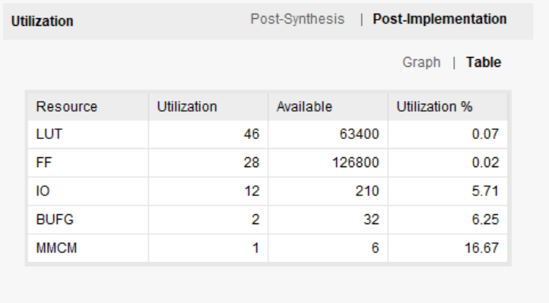

截图 2-lab9_2_1资源使用

Number of BUFG/BUFGCTRL: 2   
Number of Slice LUTs used: 46   
Number of FF used: 28   
Number of DSP48E1 slices used: 0   
Number of IOs used: 12

Lab9_2_2

代码 up_down_Counter.v

`timescale 1ns / 1ps

(* use_dsp48 = "yes" *)

module up_down_Counter #(parameter COUNT_SIZE = 8) (

input CLK100MHZ,

input up_down,

input enable,

input reset,

output reg [COUNT_SIZE - 1:0] Count

);

wire pulse,clk;

clk_wiz_0 CLOCK5M (clk,CLK100MHZ);

    Counter CLOCK (clk,~enable,pulse);

always@(posedge pulse)

begin

    if (up_down)

    begin

            if ((Count >= (1 << COUNT_SIZE) - 1) || (reset))

                Count   <= 'b0;

            else

                Count   <= Count + 'b1;

        end

        else

        begin

            if ((Count == 'b0) || (reset))

                Count   <= (1 << COUNT_SIZE) - 1;

            else

                Count   <= Count - 'b1;

        end

end

endmodule

代码Counter.v

`timescale 1ns / 1ps

(* use_dsp48 = "yes" *)

module Counter(input clk,input rst,output pulse);

     reg [23:0] cnt = 0;

always @(posedge clk or posedge rst)

begin

   if (rst)

   cnt <= 23'd0;

   else

       if(cnt >= 23'd499999)

       cnt <= 23'd0;

   else

       cnt <= cnt + 23'd1;

end

    assign pulse = (cnt == 23'd499999) ? 1'b1 : 1'b0;

endmodule

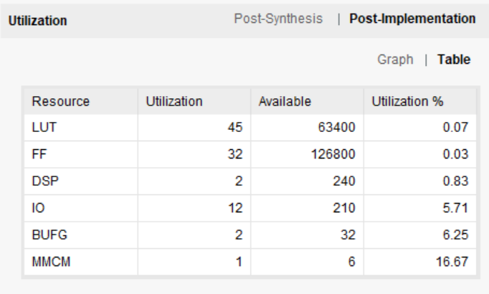

截图 3-lab9_2_2资源使用

Number of BUFG/BUFGCTRL: 2   
Number of Slice LUTs used: 45   
Number of FF used: 32   
Number of DSP48E1 slices used: 2   
Number of IOs used: 12

Lab9_2_3

代码up_down_Counter.v

`timescale 1ns / 1ps

module up_down_Counter #(parameter COUNT_SIZE = 8) (

input CLK100MHZ,

input up_down,

input enable,

input reset,

output [COUNT_SIZE - 1:0] Count

);

wire pulse,clk;

clk_wiz_0 CLOCK5M (clk,CLK100MHZ);

    Counter CLOCK (clk,~enable,pulse);

    c_counter_binary_0 UpCounter (pulse,enable,reset,up_down,Count);

endmodule

代码Counter.v

`timescale 1ns / 1ps

module Counter(input clk,input rst,output pulse);

     reg [23:0] cnt = 0;

always @(posedge clk or posedge rst)

begin

   if (rst)

   cnt <= 23'd0;

   else

       if(cnt >= 23'd499999)

       cnt <= 23'd0;

   else

       cnt <= cnt + 23'd1;

end

    assign pulse = (cnt == 23'd499999) ? 1'b1 : 1'b0;

endmodule

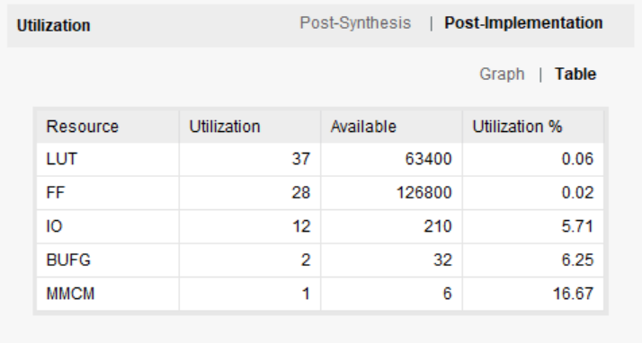

截图 4-lab9_2_3资源使用

Number of BUFG/BUFGCTRL: 2   
Number of Slice LUTs used: 37   
Number of FF used: 28   
Number of DSP48E1 slices used: 0   
Number of IOs used: 12

Lab9_2_4

代码与Lab9_2_3相同

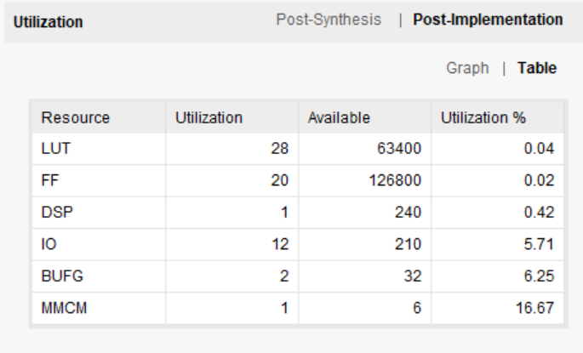

截图 5-lab9_2_4资源使用

Number of BUFG/BUFGCTRL: 2   
Number of Slice LUTs used: 28   
Number of FF used: 20   
Number of DSP48E1 slices used: 1   
Number of IOs used: 12