Yicheng Li

CSC 491

Assignment 2

4th May 2021

The program has 3 pages. (From left to right)

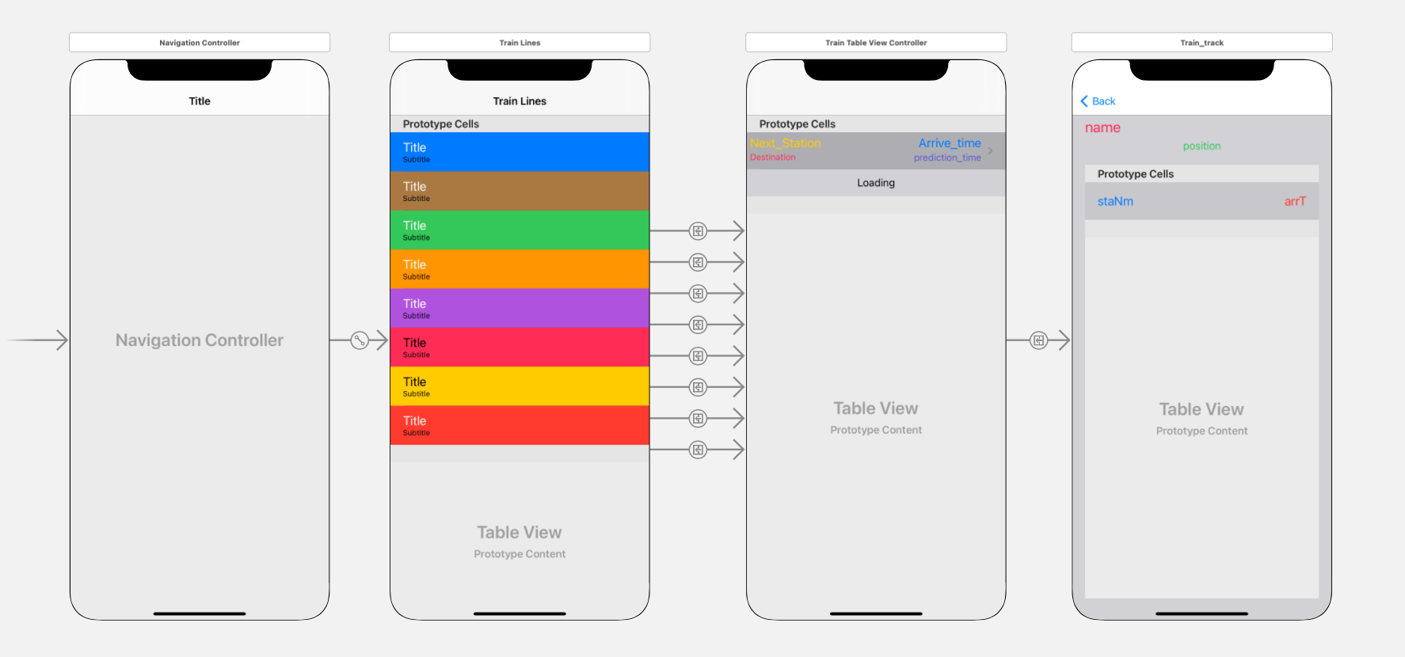

The first page (Line_TableViewControlle.swift) is used to display the line name (from Train_lines.swift), such as red line, blue line, etc.

On this page, each "cell.textLabel" displays the line name, and "cell.detailTextLabel" displays the starting point and destination of the line. When the cell is clicked, the page will pass the line's name (eg: Red is red line, G is green line) to the second page.

The second page (Train_TableViewControll.swift) is used to display all trains on the route. Each Cell will list "next stop", "destination", " prediction time", and "arrival time". The definition of Cell is in Train_TableViewCell.swift

When the user visits the second page, the program only makes a request to CTA once, and this page will not automatically update the data.

When the user clicks on the cell(every train) on the second page, the program will pass the runnumber (train’s ID) of the train to the third page (Train_Track.swift)

The third page is composed of two Labels and a TableView. A label is used to display the runnumber passed from the second page. Another label is used to display the location of the train (longitude, latitude, and heading)

The TableView is used to list the stations where the train will arrive in the future and the time of arrival. On this page, the program will request data every 10s.

CTA developer Key: 0026aab046d24b35a347a42d75b77306

API (page 2): http://lapi.transitchicago.com/api/1.0/ttpositions.aspx

Ex: http://lapi.transitchicago.com/api/1.0/ttpositions.aspx?key=0026aab046d24b35a347a42d75b77306&rt=Red&outputType=JSON

JSON:

{

"ctatt":

{

"tmst":"2021-05-03T23:02:21",

"errCd":"0",

"errNm":null,

"route":

[

{

"@name":"red",

"train":

[

{

"rn":"830",

"destSt":"30089",

"destNm":"95th/Dan Ryan",

"trDr":"5",

"nextStaId":"40190",

"nextStpId":"30037",

"nextStaNm":"Sox-35th",

"prdt":"2021-05-03T23:01:20",

"arrT":"2021-05-03T23:04:20",

"isApp":"0",

"isDly":"0",

"flags":null,

"lat":"41.85323",

"lon":"-87.63098",

"heading":"163"

}

]

}

]

}

}

API(page 3): http://lapi.transitchicago.com/api/1.0/ttfollow.aspx

Ex: http://lapi.transitchicago.com/api/1.0/ttfollow.aspx?key=0026aab046d24b35a347a42d75b77306&runnumber=131&outputType=JSON

JSON:

{

"ctatt":

{

"tmst":"2021-05-04T13:38:31",

"errCd":"0",

"errNm":null,

"position":

{

"lat":"41.99026",

"lon":"-87.65908",

"heading":"357"

},

"eta":

[

{

"staId":"40760",

"stpId":"30147",

"staNm":"Granville",

"stpDe":"Service toward Howard",

"rn":"802",

"rt":"Red Line",

"destSt":"30173",

"destNm":"Howard",

"trDr":"1",

"prdt":"2021-05-04T13:37:52",

"arrT":"2021-05-04T13:38:52",

"isApp":"1",

"isSch":"0",

"isDly":"0",

"isFlt":"0",

"flags":null

}

]

}

}