Yicheng Li

CSC 491

Assignment 3

18th May 2021

The program has just only one page as shown as followed.

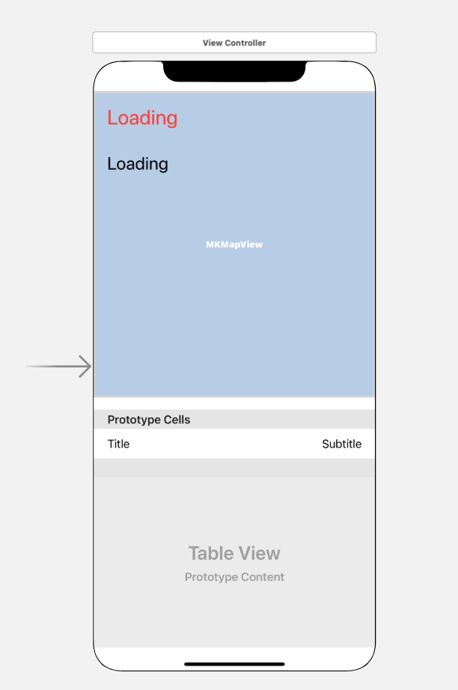

There are 4 parts:

1. Station_State (red text) is used to display the arrival or departure location.
2. Location (black text) is used to list the current GPS location.
3. mapView is used to display the map, it is 2D.
4. St_List(TableView ) is used to list the train’s information that closes to the station.

The logic of the program is very simple.

When the mobile phone is close to a train station, the Station_State will show “Arriving XXXX”, and the “getCloseTrain” function will use the CTA API to obtain 6 pieces of train information near the station. When the phone passes the station, the Station_State will show “leaving XXXX”, the tableView will not update until close to the next station.

For example:

http://lapi.transitchicago.com/api/1.0/ttarrivals.aspx?key=0026aab046d24b35a347a42d75b77306&mapid= 40380&max=6&outputType=JSON

That means get trains information in 40380(station ID).

And the return json like: {

"ctatt":{

"tmst":

"2021-05-18T03:43:40",

"errCd":"0",

"errNm":null,

"eta": [

{

"staId":"40380",

"stpId":"30374",

"staNm":"Clark/Lake",

"stpDe":"Subway service toward Forest Park",

"rn":"143",

"rt":"Blue",

"destSt":"0",

"destNm":"Forest Park",

"trDr":"5",

"prdt":"2021-05-18T03:43:22",

"arrT":"2021-05-18T03:44:22",

"isApp":"1",

"isSch":"1",

"isDly":"1",

"isFlt":"1",

"flags":null,

"lat":null,

"lon":null,

"heading":null

}, … ]

}

}

Use “destNm” to know the train’s direction and use “prdt” to know when the train will arrive.

In the GPX file (redline.gpx), the tracking is following the CTA red-line, but not pass all the stations. It just lists the location from 95th/Dan Ryan to Clark/Division. But in the program (stations[], line 22), all the stations in red-line were listed. Thus, there are some stations that will never visit.

The CPX file look like that (from 95th to 87th):

<wpt lat="41.722596" lon="-87.624391">

<name>95th/Dan Ryan</name>

</wpt>

<wpt lat="41.723596" lon="-87.624411"/>

<wpt lat="41.725596" lon="-87.624471"/>

<wpt lat="41.727596" lon="-87.624531"/>

<wpt lat="41.729596" lon="-87.624571"/>

<wpt lat="41.731596" lon="-87.624631"/>

<wpt lat="41.733372" lon="-87.624707"/>

<wpt lat="41.735372" lon="-87.624717">

<name>87th</name>

</wpt>

The GPS information of the station comes from Google and Wikipedia.

The points between the stations are added (guess) by myself, and their intervals are not the same, so the speed is not uniform. At the same time, some points may be wrong, which will make the tracked trajectory a bit strange.

Errors: Sometimes when it runs in the IOS simulator, it may have some thread errors. But re-run it, it can run as normal. I guess it was caused by the GPX file.