Yicheng Li

CSC 491

Assignment 4

25th May 2021

The programmer's main page consists of a “List”, as shown in the figure below. (line 11)

All the code of the program is in “ContentView.swift”.

When the user clicks on a different item in the list, it will jump to a different page.

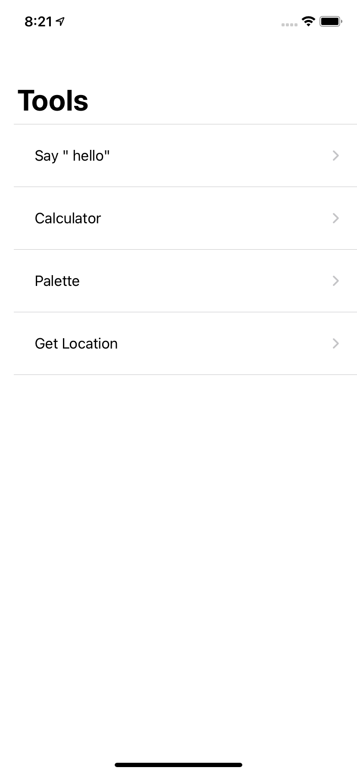

The first page consists of a “Text”, “TextField”, and a “Button”. (line 40)

The function is very simple:

Enter a string in the “TextField”, and then click the “Button”, the user will get an alert message with the input string.

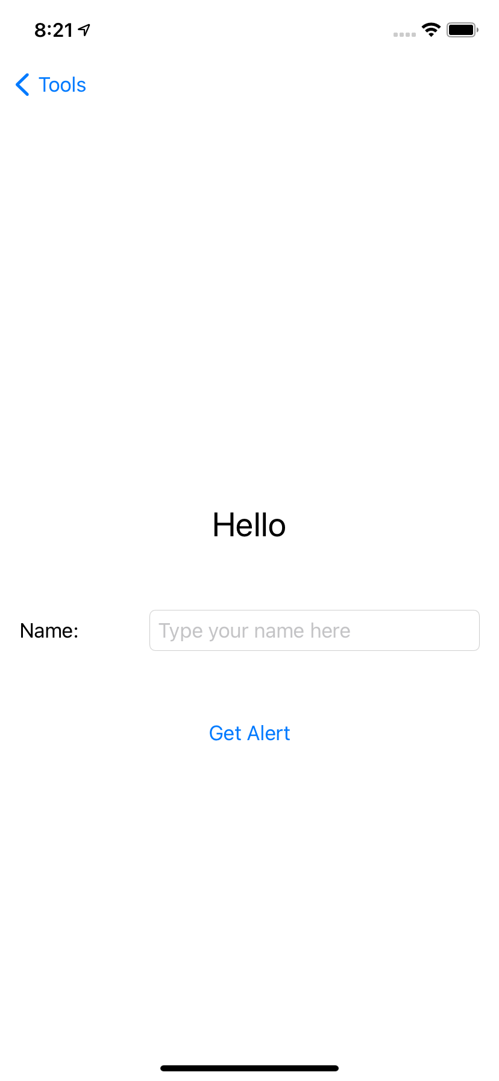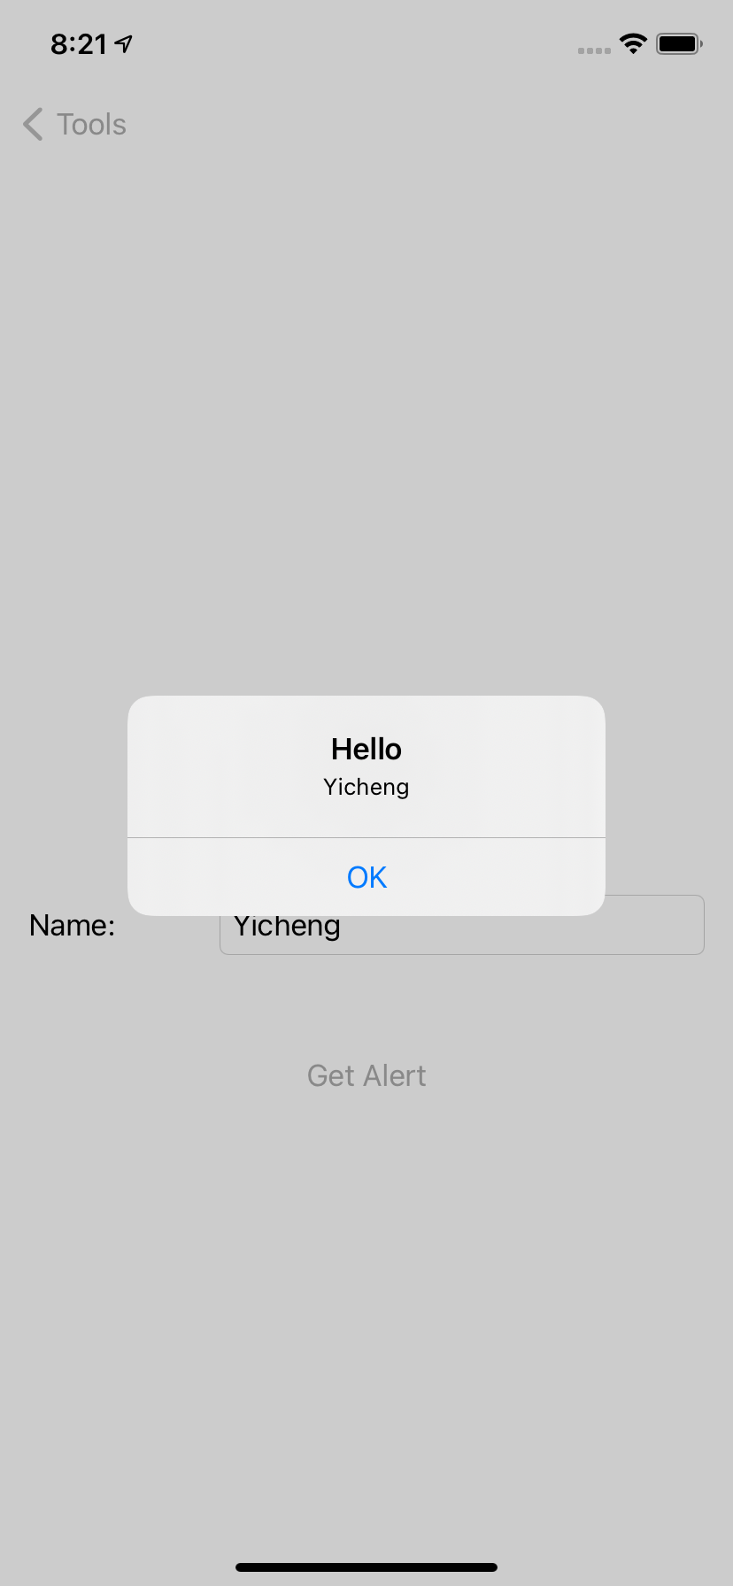

The second page is a simple calculator. (line 64)

It has some bugs in float type operations

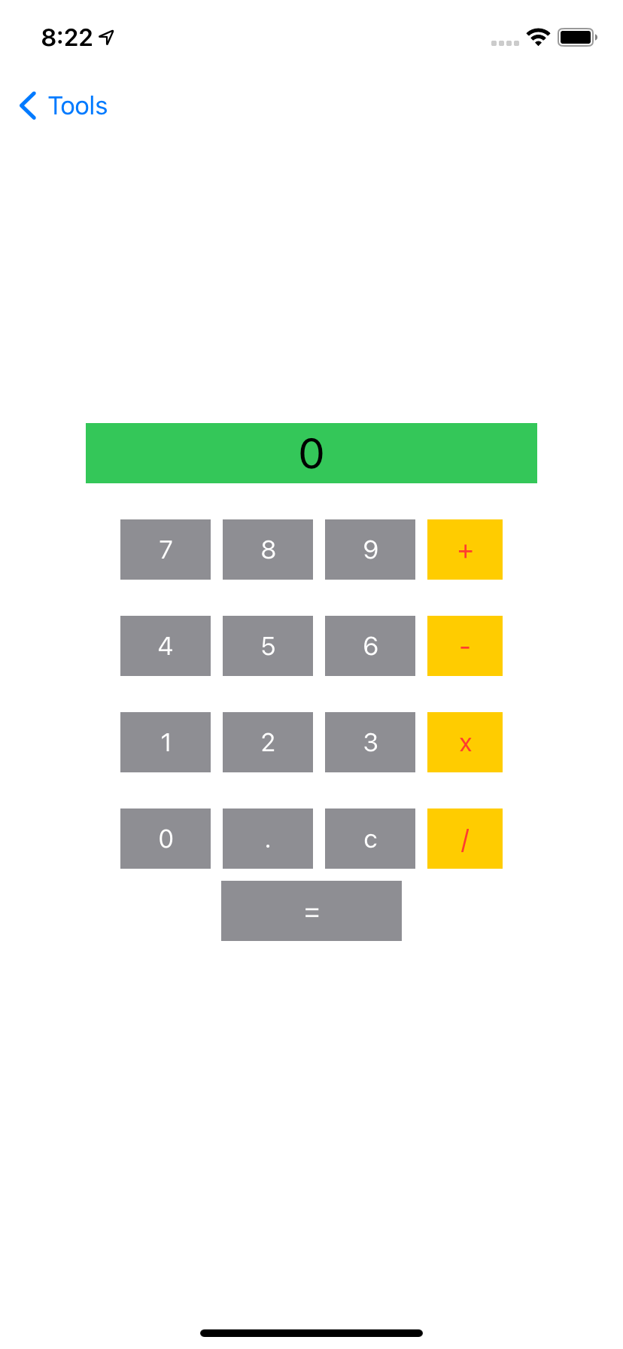

The third page is composed of three “Sliders” and a “Text”. (line 439)

The three “Sliders” represent the red, green, and blue values.

When the value of the slider is adjusted, the color of the “Text” will change.

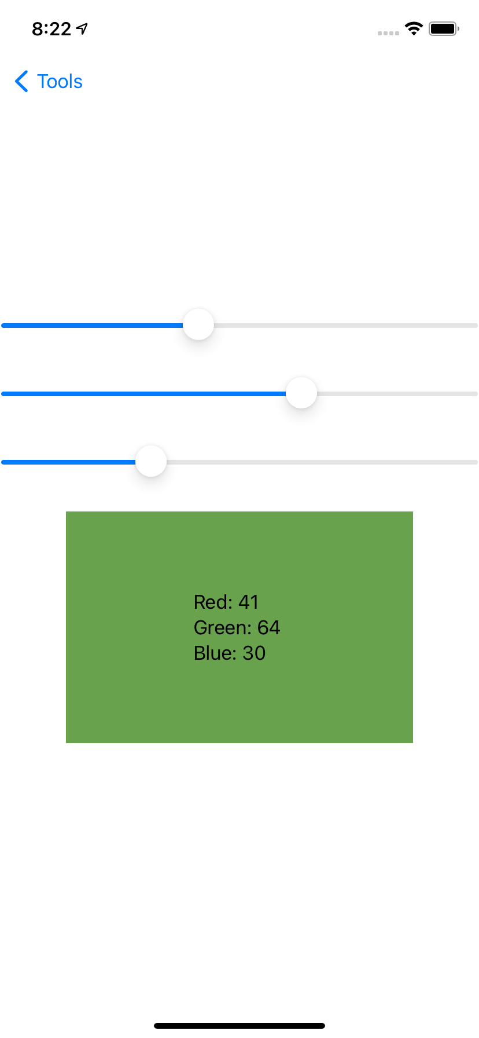

The fourth page uses Toggle. (line 461)

When Toggle is turned off, the user's GPS information will be displayed below.

When Toggle is turned on, the user's location will be displayed on the map below.

