Stair Climbing Hexapod
Using the V-Rep simulator
André Humberto Trigo de Bordalo Morais
Mestrado Integrado em Engenharia Informática e Computação, Faculdade de Engenharia, UP
Porto, Portugal
ei07122@fe.up.pt

Abstract — This electronic document document describes the main steps taken in order to implement a hexapod-type robot that is able to climb a variety of stairs while regulating his body to be as stable as possible. The project was developed using the V-Rep development environment for simulation and development of lua scripts.
Keywords – hexapod; robotics; VREP, inverse kinematics.
- Introduction
Robotics has been a field of study related with enabling humans, or helping them dealing with problems. To an handicapped person this help could be more valuable than for the ones that do not recur to it.
A day to day task that occurs is the step climbing. Classical wheelchairs do not deal ideally with this challenge, although there are some advances done in the field(ferencia para cena das cadeiras fixes)
As an alternative approach the project developed aimed to produce a simulation of a stable hexapod type robot, stable enough so thathandicapped humans could use them to help climb stairs.
This paper documents the reasoning and results related with the robot and tests developed as well as the general composition of a model of this type.
- Hexapod Model
  - Base
The base is constituted by 2 hexagonal parallel shapes that provide support for mounting the leg's servos and links.
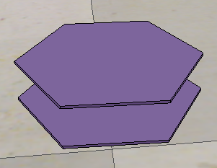
- Hexapod base

  - Legs
Each leg is composed by 3 links, 2 of them connecting the servos and the last one is used as the foot tip (Figure 2).
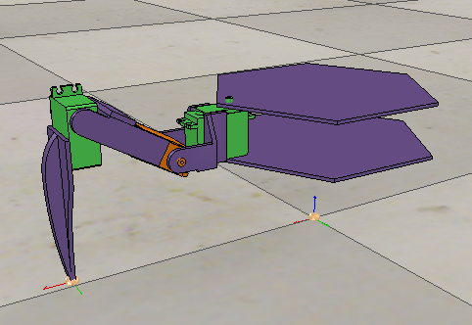
- Hexapod leg
Each leg is mounted between matching vertexes of each hexagon, connected by a servo part. Repeating this process rotating 60º against the body base finished the robot structure(Figure 3).
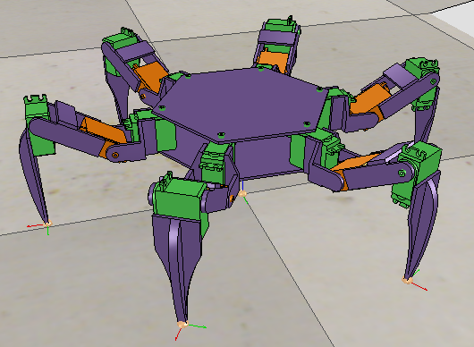
- Complete hexapod
  - Sensors
The hexapod uses three laser sensors: two mounted pointing to the front leg tip and one mounted below the base part pointed perpendicular to it (also perpendicular to the ground when in a starting position) as in Figure 4
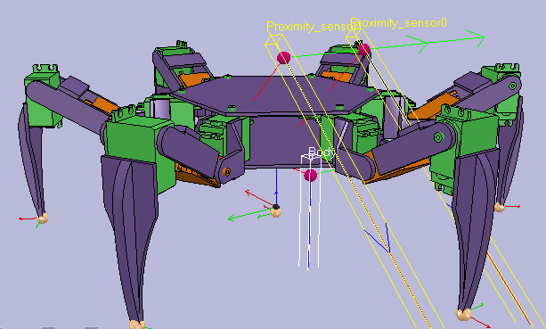
- Hexapod sensors
- Walking
In order to achieve walking capability each leg is aggregated in a inverse kinematics group. With this approach all the calculations for the servos positions are handled by the simulator as long as there is a target point for each leg tip.
The walking cycle is divided in four phases each comprised of a partial step movement with a respective step height and amplitude relative to the full step size .

- Body control
To keep the body in an horizontal position a PD controller that takes as input the distance between the ground and the base, controlling the body orientation in order to do so[3].
When the first tip touches higher ground (figure 5)it causes an angle difference between the plan normal vector and the laser ray vector.
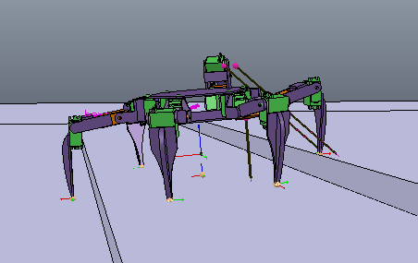
- Start Climbing
The controller tries to minimize this angle difference while maintaining the body height relative to the first leg when it shifts to another stair (figure 6 and 7)
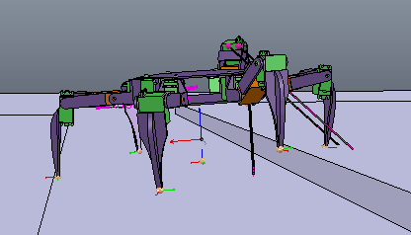
- Pre Shift

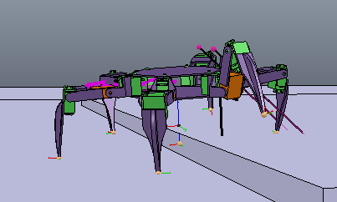
- After Shift

- Results
To test the model and the implementation two scenes where created: one with a simple ascending ramp and the other with some steps with varying distance between them.
In the ramp scene simulation the robot is stable, finding and keeping an horizontal position during the whole movement. The same has not been verified in the stairs scene. The first version of the robot calculated the new body angle ass soon as he sensed a difference in the ground vector and maintained that angle during the whole ramp. This is more than enough for a constant inclination ramp. To solve the stair climbing problem, since the distance from the ground may not be the same for the whole step, there is a need for a more frequent change of the inclination offset in order to achieve more stability.
- Conclusions
V-Rep proves to be a relevant environment in robot simulation enabling a satisfactory simulation for the hexapod model, providing a good starting point to study the stair climbing problem. This project used the Lua scripting language to control the robot actuators and process the sensor data, what did not prove to be an easy task. This fact adding to be forced to use the default code editor (in the linux version) which lacked some basic functionalities proved to be a disadvantage compared to other simulation environments. The API manual for the Lua functions exits[4] but most of the examples use deprecated functions which sometimes do not behave as expected. In order to improve stability a future work could be experimentation with other type of sensors, for exemple, pressure sensors in each leg tip's point.

References

- Hexapod tutorial. Retrieved January 03, 2017, from http://www.coppeliarobotics.com/helpFiles/en/hexapodTutorial.htm .
- Inverse Kinematics tutorial. Retrieved January 03, 2017, from http://www.coppeliarobotics.com/helpFiles/en/inverseKinematicsTutorial.htm .
- A. Bordalo, “Reactive wall follower robot”, unpublished.
- Regular API function list. Retrieved January 03, 2017, from http://www.coppeliarobotics.com/helpFiles/en/apiFunctionListCategory.htm .

