Task 1
Default settings: testing accuracy 0.369;
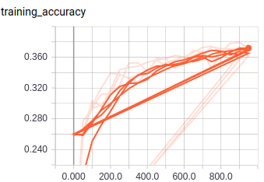
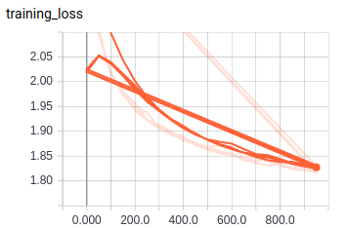

Learning rate 0.0001: testing accuracy 0.208; learning rate 0.1: testing accuracy 0.2252.

Batch size 500, other parameters default: first attempt 0.3731; second attempt 0.3752. More stable training result.

Task 2
Testing accuracy 0.4683
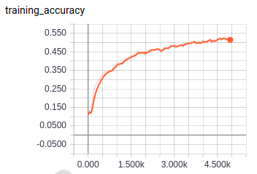
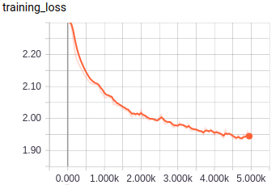

Task 3
Testing accuracy 0.5688
