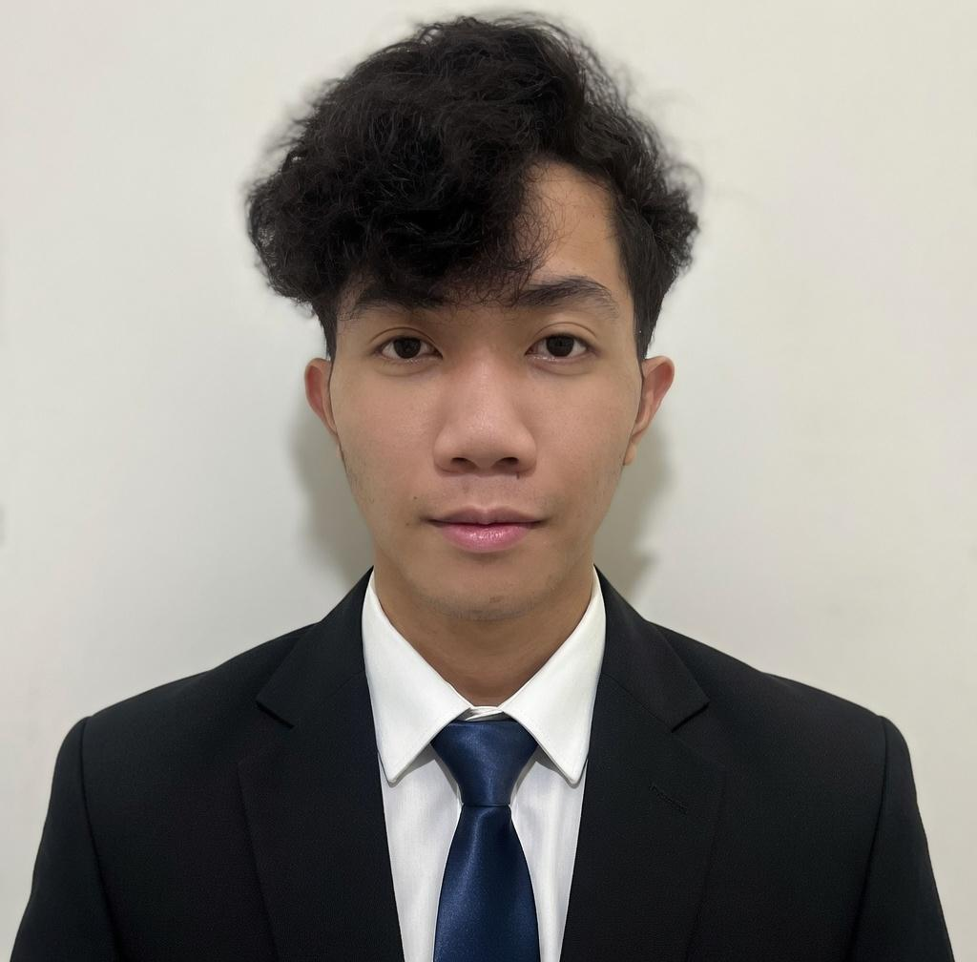  Contact  blanzalycos@gmail.com  0995 678 3687  Lipa City, Batangas  Technical Skills  Languages  Python · Java · C++ · JavaScript · TypeScript  Web Development  HTML5 · CSS3 · JavaScript · TypeScript  Databases  Supabase · DBSQL · MySQL  Data & Analytics  Pandas · R · tidyverse  Tools  Git · VS Code · Linux/CLI  Soft Skills  - Analytical Thinking  - Problem Solving  - Self-Directed Learning  - Attention to Detail  - Team Collaboration  - Technical Writing  DataCamp Courses & Certifications  - Intro to Python  - Intermediate Python  - Intro to R  - Intermediate R  - Intro to the Tidyverse  - Data Manipulation w/ Pandas  - Statistical Fundamentals  - Exploratory Analysis Theory  - Statistical Experimentation | Lycos B. Blanza  Software Developer • BS Computer Science • De La Salle Lipa  Objective  Motivated Computer Science student with hands-on experience building AI-powered platforms, embedded safety systems, and full-stack applications. Passionate about privacy-conscious, user-centered software. As well as a graphic designer with strong skills in video editing and web design, allowing me to create both functional and visually engaging digital solutions. Seeking a Software Developer role to apply technical skills and grow through real-world challenges.  Education  Projects  SafeSeat — AI Vehicle Safety Platform · Undergraduate Thesis  - Designed a consent-driven multi-sensor seat system monitoring occupant physiological and behavioral states in real time to identify potential health or safety risks.  - Implemented sensor fusion: mmWave radar, INF-MLX90614, FSR, and MPU — feeding into anomaly detection algorithms for live risk assessment.  - Built context-aware emergency logic adapting to driver status, passenger presence, and user-defined escalation settings.  - Privacy-first architecture: session-scoped data, no long-term storage, full granular user consent model.  DocVia — AI-Powered Document Learning Platform  - Transformed PDF uploads into structured interactive lessons with roadmap segmentation and a segmented lesson view.  - Integrated an AI Tutor Chat for context-based Q&A and a microtask/quiz generator to reinforce active recall.  - Built a document management system for organizing and revisiting uploaded learning materials.  Fitness Tracker App — Workout Tracking Application  - Developed a mobile-style app for logging workouts, tracking health metrics, and visualizing progress over time.  - Focused on clean UX and daily usability for fitness-oriented users.
  College | BS Computer Science — De La Salle Lipa | 2026 – Present
  Senior HS | LCC Silvercrest School | 2022 – 2023
  Junior HS | Bolbok Integrated National High School | 2019 – 2020
  Elementary | Sampaguita Elementary School | Grad. 2009

