SUPPLEMENTAL FIGURES:

S12: The relationship between total beta diversity and Turnover importance. Boundary 1 indicates the first observation in which Turnover Importance > 0, and boundary two indicates the point at which observations of Turnover importance > 0 outnumber observations of Turnover importance < 0. When Turnover importance >0, then compositional turnover is a greater contributor to total Beta Diversity than Nestedness, and when it is <0, Nestedness is a greater contributor to total Beta Diversity than turnover.

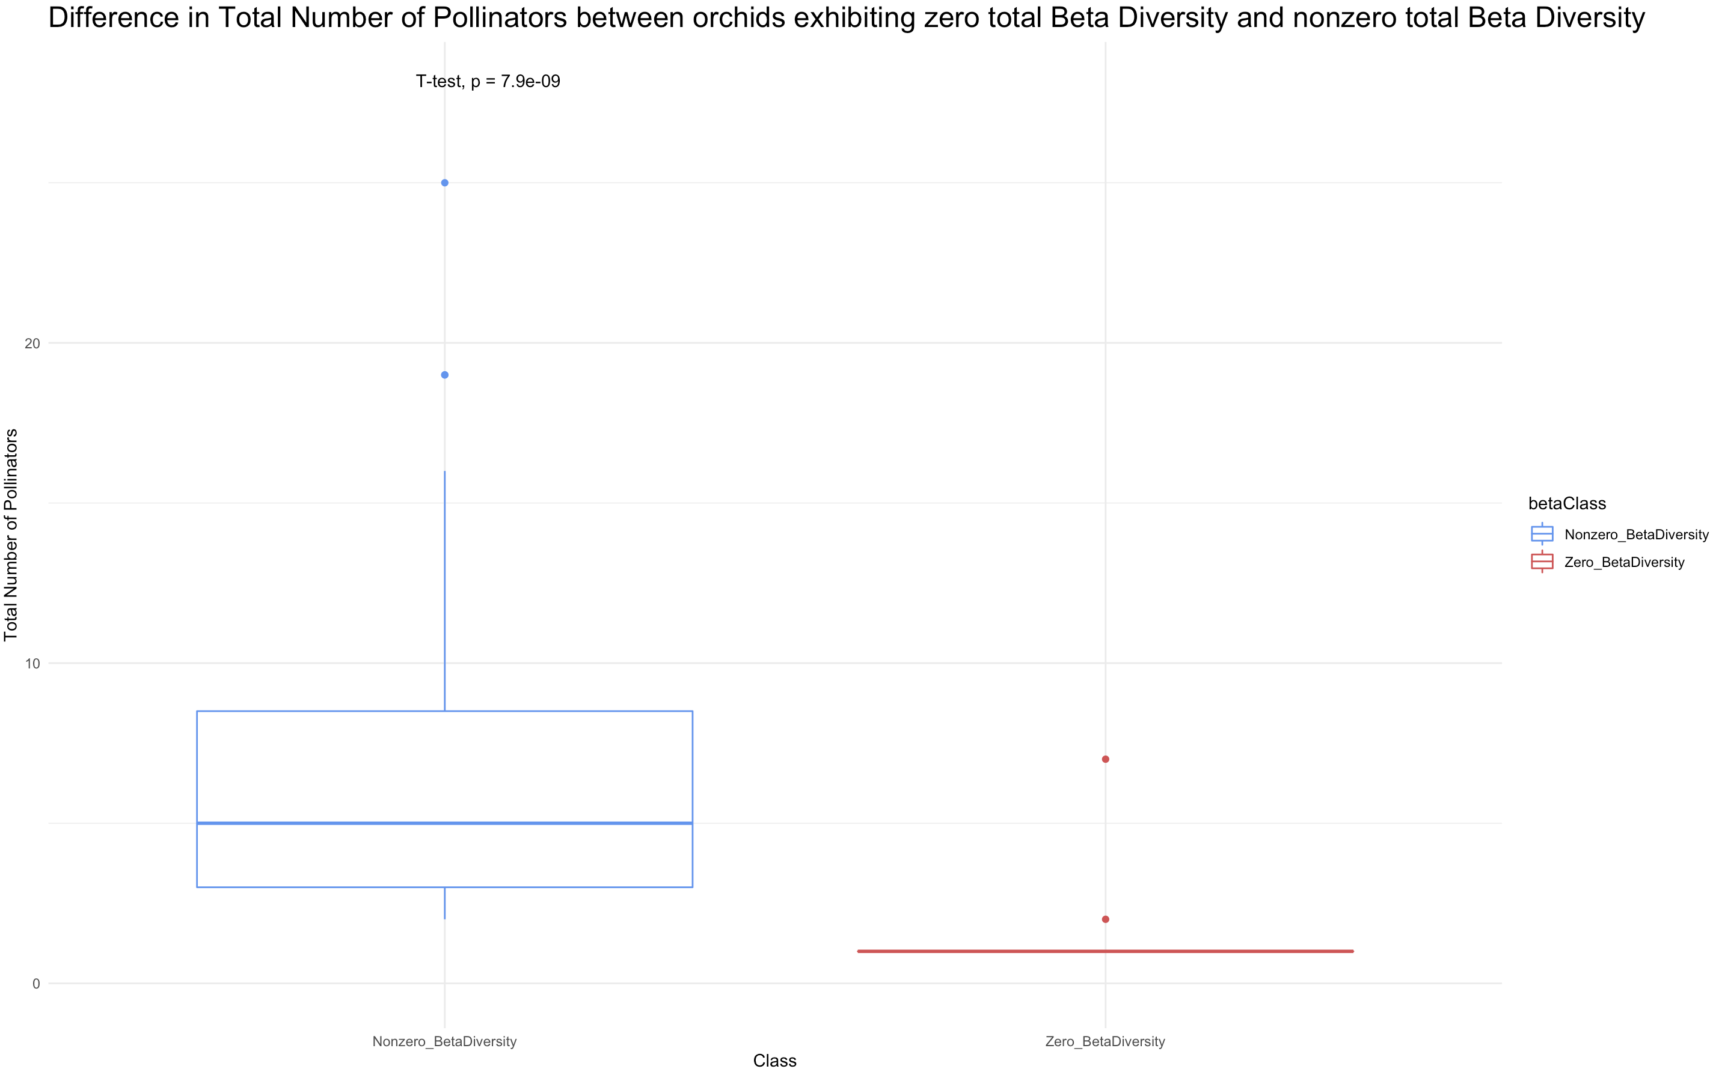

S13: the distribution of total number of pollinators between orchids exhibiting nonzero total beta diversity and zero total beta diversity. There is a significant difference between groups. All but two orchids with zero total beta diversity have only one known pollinator.

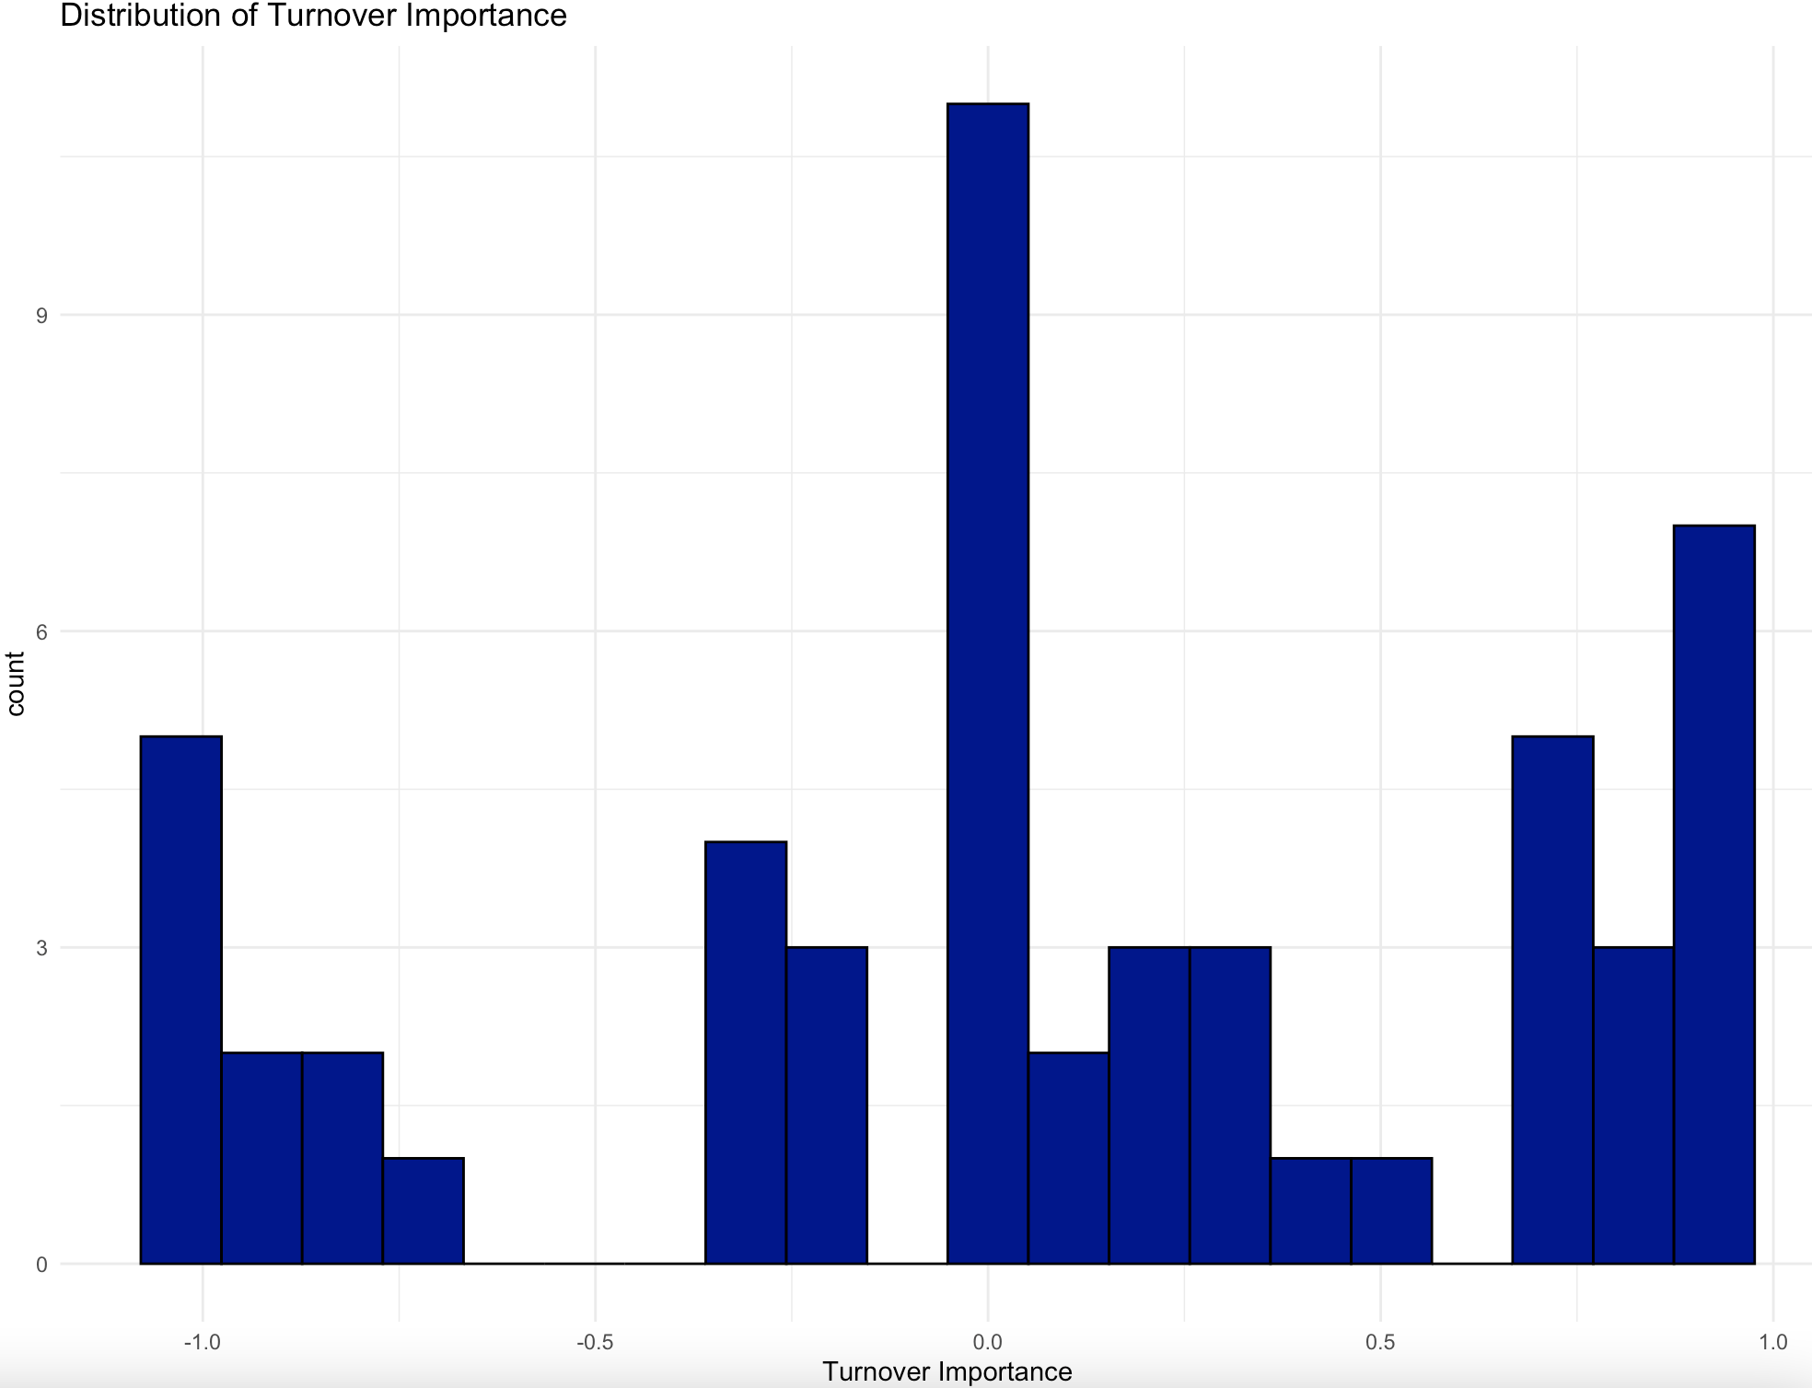

S14: Distribution of the relative impact of compositional turnover in pollinator communities among native North American orchids. Samples to the left of 0 have increasingly greater nestedness importance. Values to the right of 0 have increasingly greater Turnover importance.

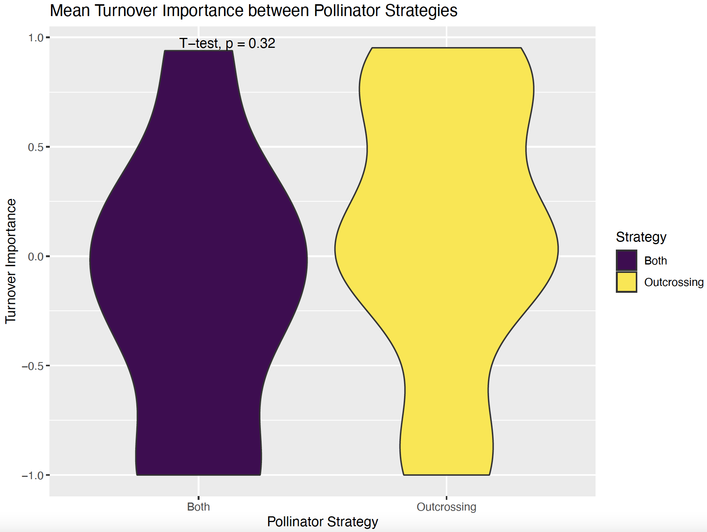

S15: A violin plot showing differences in mean Turnover importance scores for alternate pollinator strategies. Purple depicts orchids that both self and outcross, while yellow depicts orchids that only outcross.

S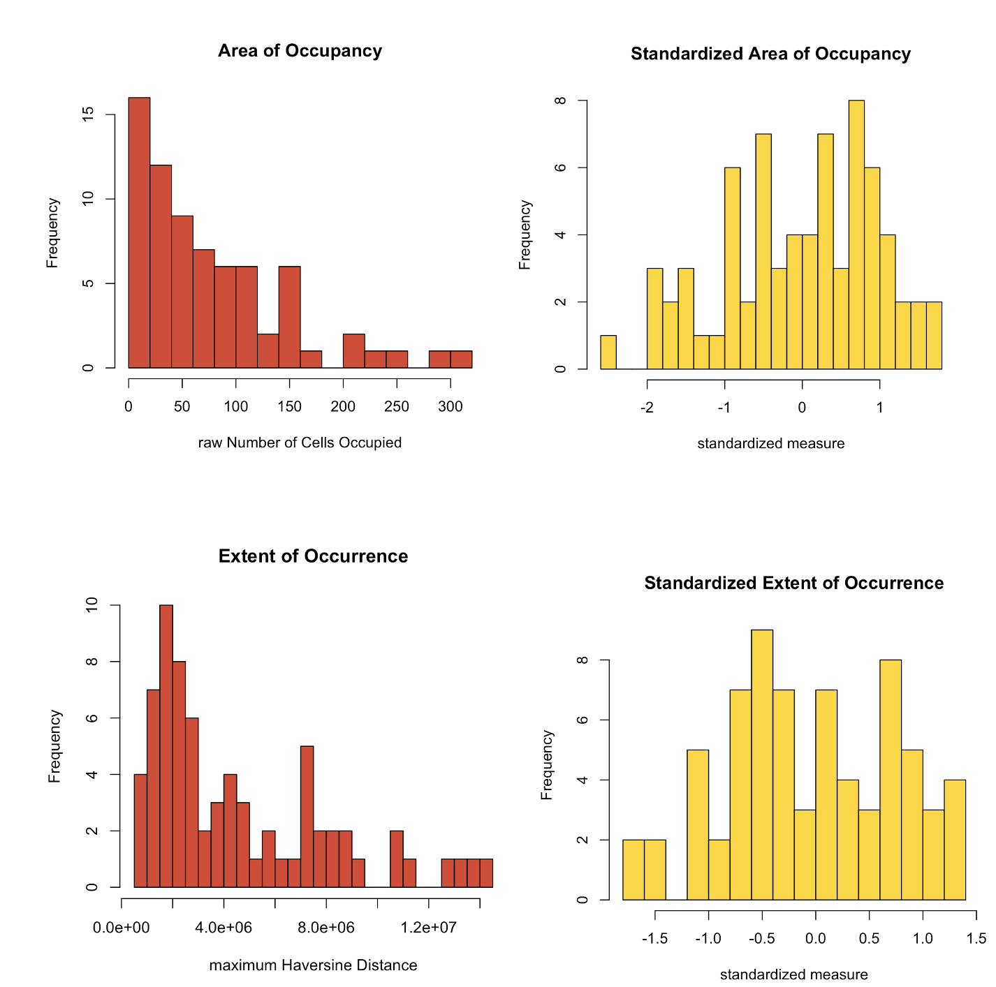

S16: Raw and standardized values for EOO and AOO. EOO has a stronger right tail than AOO, indicating that there are some orchids with large EOO but smaller AOO.

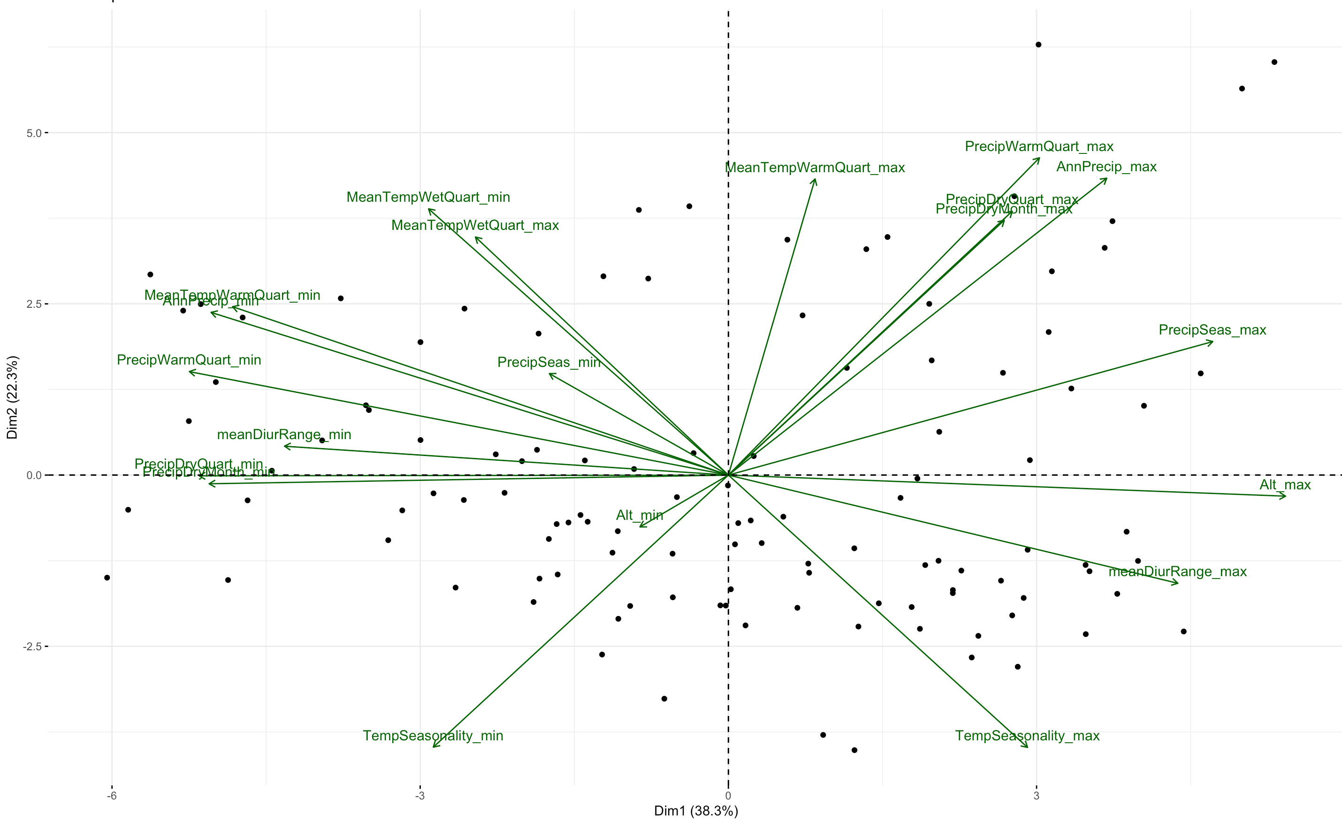

S17: PCA of climatic niche variables for all orchids with available occurrence data. PC1 scores were extracted and used to represent position in niche space, or “niche breadth”.

