**Flowering time is consistent between years for *Echinacea angustifolia***

This analysis aims to assess how consistent flowering time is for a given plant across years. Phenology is difficult to define in a perennial plant, such *as Echinacea angustifolia*: flowering time shifts from year to year and plants may not flower every year. But flowering time has been shown to affect reproduction in E. angustifolia, as earlier plants have higher seed set than those that flower later in the season (Ison and Wagenius 2014). The question remains whether the same plants are flowering early each year.

**Materials and Methods**

Plants in this analysis are from an experimental plot established in 1996. This experimental plot contains *Echinacea* collected as seed from nineteen different nearby remnants and planted in the years 1996-1999. Remnants vary in size: the largest is a 45 ha preserve with 1000-6000 flowering plant per year owned by the Nature Conservancy and the smallest is less than one ha with 0-4 flowering plants per year. Individuals in the experimental plot are planted on a grid and the plot is similar to nearly populations in topography, density of plants, and pollinator community.

*Echinacea* usually flowers from late June to early August. Most plants produce one cone-shaped capitulum, but plants can have as many as 10 or more. Uniovulate disc florets on each head are arranged in concentric circular rows and flowering progresses regularly from the bottom most rows to the top of the head. Florets shed pollen on one day and styles emerge from those florets the next day. We’ve collected flowering phenology information (first and last day an individual shed pollen) every year since 2005.

**Statistical Analysis**

I used plants sown in 1996 in my analysis because it is the oldest cohort in the common garden experimental plot and would have the largest numbers of flowering plants during the study period. This cohort contains plants from seven different remnants. If a plant had multiple heads I took the earliest start date per head and latest end date per head as the plant’s flowering period. I used an individual’s first flowering day (FFD) as my primary way to assess differences and consistency in flowering time. FFD was highly correlated with an individuals end date within years (Pearson’s correlation test; r = 0.86, p < 0.001).

I looked at each plants first flowering day (FFD) in three ways to assess the most appropriate manner to account for year-to-year differences in growing season time and duration. Day after first (DAF) is the number of days a plant began flowering after the first plant in that given year began flowering. A DAF of 1 signified an individual was the first plant to flower and a DAF of 10 signified a plant began flowering 10 days later (Figure 1A). Day of year (DOY) is the date on which a plant began flowering and represents the data in its orginal form (Figure 1B). Day after median (DAM) ranked plants by median FFD in a given year. Individuals that began flowering on the same day as the median FFD received a rank of zero. Those that began flowering two days prior to the median FFD received a rank of -2 and those that began flowering 2 days after the median FFD received a rank of 2 (Figure 1C).

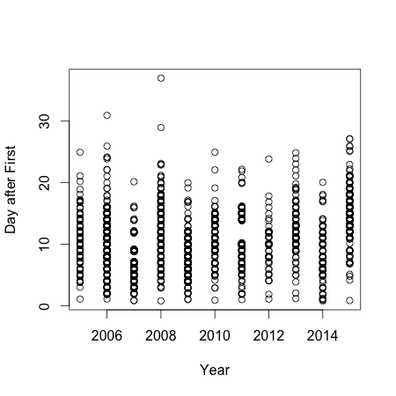

**Figure 1.** Distribution of FFDs of all plants in all study years. A) Flowering rank based on the first flowering individual in every year. B) FFDS as calendar day of year. C) FFD transformed to day after median score. Years when the experimental plot was burned are denoted with asterisks.

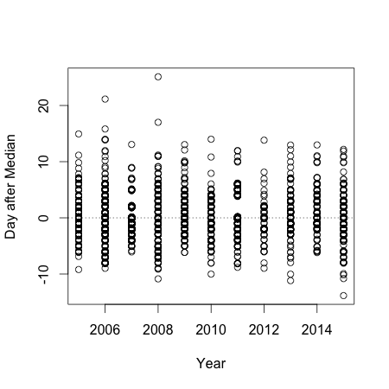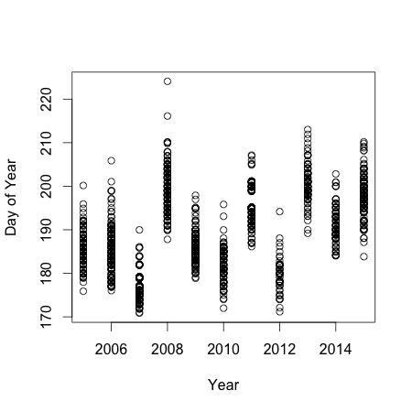

**A**

**B**

**C**

*

*

*

*

*

*

*

*

*

*

*

*

*

*

*

To assess whether individuals consistently flower at the same time relative to each other I created a null model that, for every plant that flowered in a given year, reassigned DAM values based on all the dates in each year. These DAM values were reassigned at random, with replacement, for all years. This model shuffled dates that individuals flowered in a given year, but retained individual interannual variation in flowering time. I resampled the model 10,000 times and excluded plants that only flowered once during the study period. I tested two parameters from this model – annual DAM and mean DAM. Annual DAM was calculated by the range in each individuals FFD across the study period, and mean DAM is an individuals average DAM score across the study peroid. If individuals are consistent in their FFD across years, then the variance of the mean DAM values of the observed data would be greater than the variances obtained through resampling the null model. Likewise, if individuals are consistent than the variance of the annual DAM values (the difference between an individuals min and max DAM) of the observed data would be smaller than the variances obstaind through resampling the null model.

**Results**

Consistency varied on a plant by plant basis (Figure 3). The variance of mean DAM ranks was significant in comparison to the null model (bootstrap, p < 0.001, Figure 4), whereas the variance of the range of DAM ranks in comparison to the null model was only marginally significant (bootstrap, p = 0.06, Figure 5).

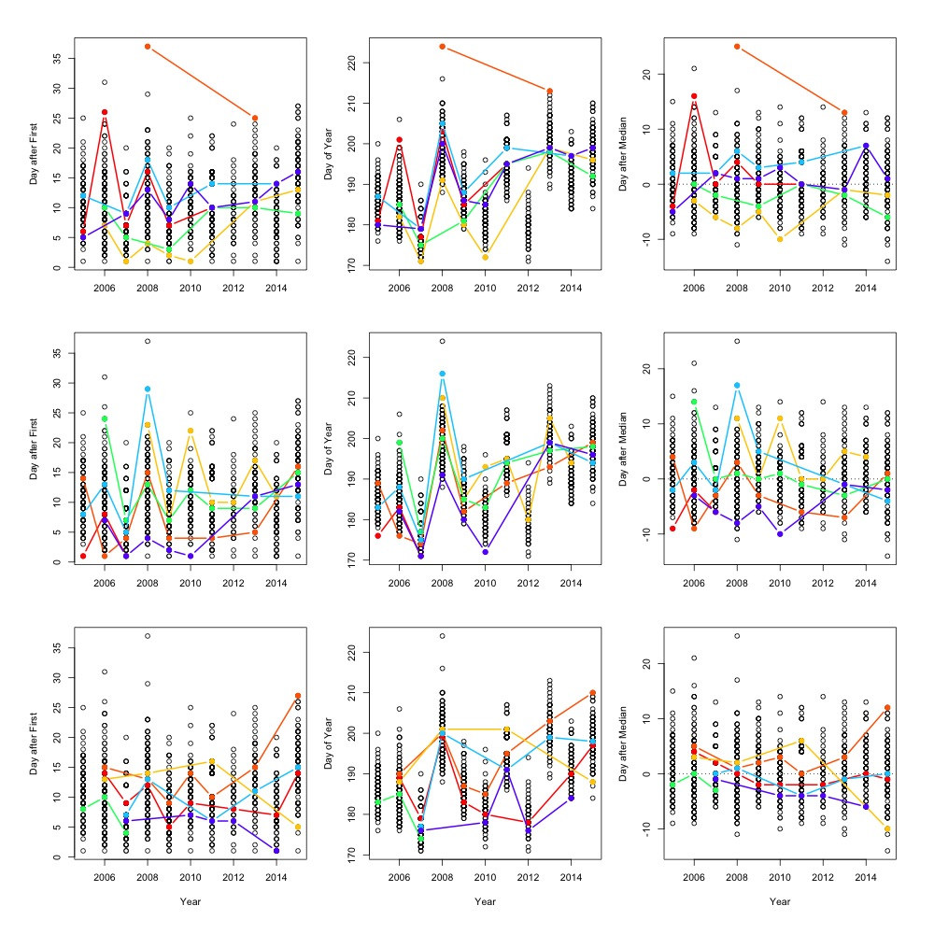

**Figure 3.** Three “case studies” comparing an individual’s FFD across ranks. Each row has 6 unique plants chosen arbitrarily. Colors across rows correspond to the same individual.

**3**

**2**

**1**

**A**

**C**

**B**

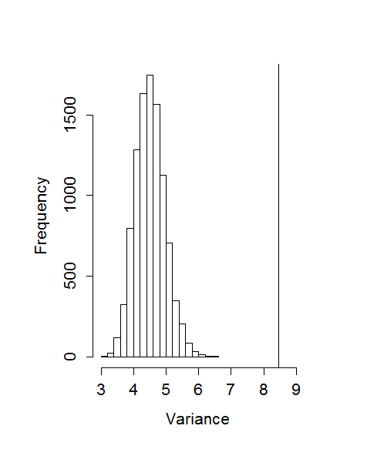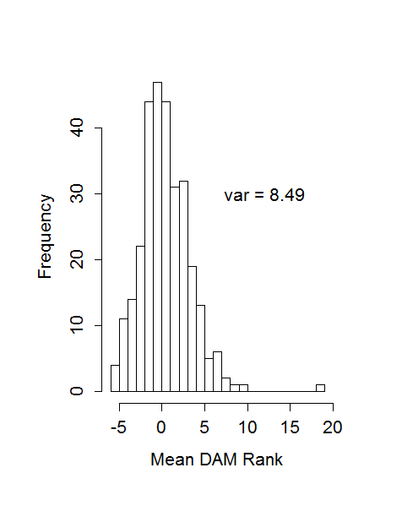

**Figure 4**. A) Mean Day after Median value for all individuals that flowered more than once during the study period. B) Variances of 10000 bootstrap resamples of Mean Day after Median ranks. The vertical line indicates variance of the observed data.

**A**

**B**

**Figure 5**. A) DAM ranges for individuals that flowered more than once throughout the study period. B) Variances of 10000 bootstrap resamples of DAM ranges. Vertical line indicates variance of the observed data in graph A).

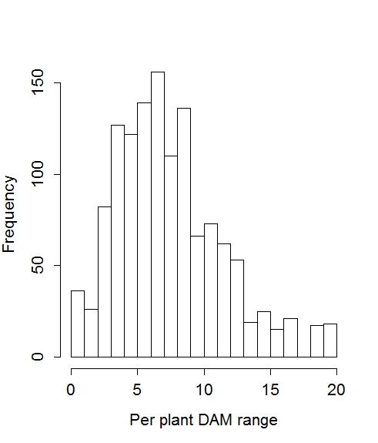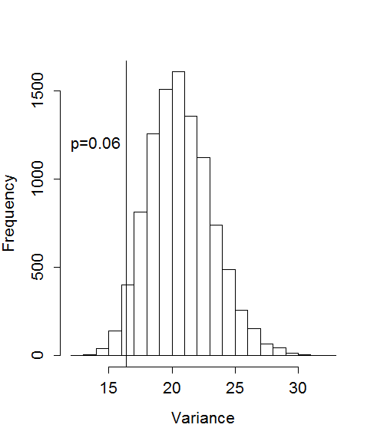

**B**

**A**

**Discussion**

I have demonstrated that plants consistently began flowering at similar times in relation to each other between years. Many other studies have demonstrated consistency in phenology in other species and systems, however these studies are only comparing flowering phenology across two or three years(McIntosh 2002, Ollerton and Lack 1998, Primack 1980). This is the first study that I’ve found that demonstrates consistency on a longer time scale.

Consistent flowering phenology suggests both a genetic component to flowering time as well as the existence of early and late individuals (Gross and Werner 1983). While selection on flowering time varies among species and study systems, in *E. angustifolia* earlier flowering plants have been shown to have higher seed set than later flowering plants (Ison and Wagenius 2014).

Relative consistency did vary considerably, however, and suggests that perhaps certain plants are more plastic in their phenological cues than others. If we categorize plants as “early” or “late” by their DAM (≤ 0 is early and >0 is late) we can see that some plants are consistently early across years (i.e. below the dashed lined in Figure 3C) and some are consistently late. These figures also show, however, that some plants are not very consistent across years (Figure 3, row 1, red).

Burn years (2006, 2008, 2011, 2013) all had significantly positive correlated FFD ranks with one exception (2006 and 2013). Burning has been shown to extend (Wrobleski and Kauffman 2003) and delay phenology (Ooi et al. 2004) in other study systems, however the later flowering times in three of the four burn years (Figure 1B) could also be due to weather or other abiotic factors.

**Literature Cited**

Gross, R. S., and P. A. Werner. 1983. Relationships among Flowering Phenology, Insect Visitors, and Seed-Set of Individuals: Experimental Studies on Four Co-occurring Species of Goldenrod (Solidago: Compositae). Ecological Monographs 53:95–117.

Hendry, A. P., and T. Day. 2005. Population structure attributable to reproductive time: isolation by time and adaptation by time. MEC Molecular Ecology 14:901–916.

Ison, J. L., and S. Wagenius. 2014. Both flowering time and distance to conspecific plants affect reproduction in Echinacea angustifolia, a common prairie perennial. Journal of Ecology n/a–n/a.

McIntosh, M. E. 2002. Flowering Phenology and Reproductive Output in Two Sister Species of Ferocactus (Cactaceae). Plant Ecology 159:1–13.

Ollerton, J., and A. Lack. 1998. Relationships between flowering phenology, plant size and reproductive success in shape Lotus corniculatus (Fabaceae). Plant Ecology 139:35–47.

Ooi, M. K. J., T. D. Auld, and R. J. Whelan. 2004. Delayed Post-Fire Seedling Emergence Linked to Season: A Case Study with Leucopogon Species (Epacridaceae). Plant Ecology 174:183–196.

Primack, R. B. 1980. Variation in the Phenology of Natural Populations of Montane Shrubs in New Zealand. Journal of Ecology 68:849–862.

Wrobleski, D. W., and J. B. Kauffman. 2003. Initial Effects of Prescribed Fire on Morphology, Abundance, and Phenology of Forbs in Big Sagebrush Communities in Southeastern Oregon. Restoration Ecology 11:82–90.