INTRODUCTION

**Phenology and repeatability:**

* Flowering phenology as a functional trait, especially in prairie plants – what we already know.
* Why phenology matters – flowering earlier confers higher fitness.
* What do we still not understand – nature of lifetime phenology in a long lived, non masting perennial plant
  + Repeatability and consistency of traits

**Study questions:**

1. Is flowering phenology (i.e. timing) a repeatable trait in the perennial plant, *Echinacea angustifolia*?
2. Is flowering duration a repeatable trait in *E. angustifolia*?
3. Can flowering timing be attributed to spatial location in the experimental plot?

METHODS

**Plant background:**

The narrow leaf purple coneflower, *Echinacea angustifolia* (Asteraceae), is native to northern tallgrass prairie remnants in the Midwestern United States. *E .angustifolia* is a long-lived perennial with a singular taproot, and reproduces through seed. *E. angustifolia* exhibits sporophytic self-incompatibility, which prevents selfing and fertilization between closely related individuals (CITE). Therefore successful reproduction relies both on the availability of generalist pollinators and diverse pollen (Wagenius and Lyon 2010). *E. angustifolia* plants typically flower from late June to early August. Individuals don’t usually begin flowering until their third year. Most plants do not flower every year, instead persisting as basal rosettes, and vary in the span between flowering years. On average plants live for XXX years. When they do flower, plants send up at least one flowering head (capitula), and may produce up to 10 flowering heads in a given year. Each capitula consists of a row of sterile ray florets at the base and a series of disc florets arranged in concentric rings up the conical head. All the anthers in a single row of disc florets shed pollen on the same day and flowering progresses from the bottom towards the top of the conical head.

*To do: Add in photo of Echinacea flowering head to reference at the end of paragraph?*

**Common garden experimental plot and field methods:**

We used a long-term common garden experimental plot that was planted with *E. angustifolia* seeds in the spring (?) of 1996 and 1997. Seeds came from 8 different remnants in the 1996 planting (n = 646), and 15 different remnants in the 1997 planting (n=591). Seeds in the experimental plot were randomized prior to sowing and planted on a 1 x 1 meter grid (Figure X). The experimental plot is 25 x 50m and is similar to nearby remnants in terms of topography, elevation, and pollinator visitation. The experimental plot is burned every 2-3 years in the spring or fall to mimic natural disturbance.

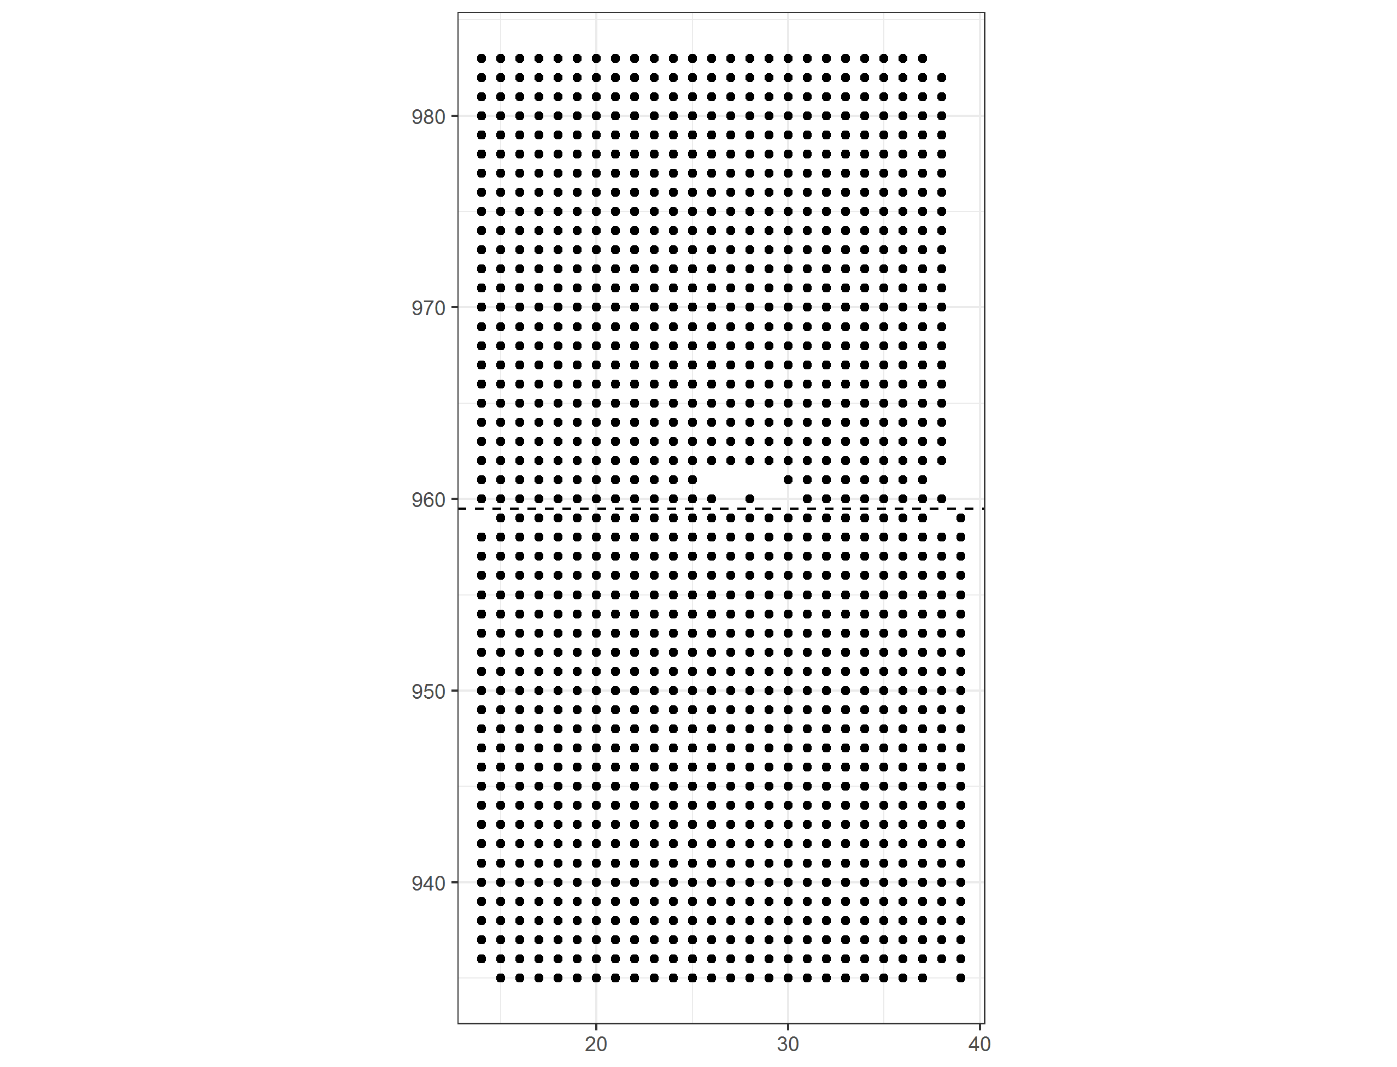

**Figure X.** Common garden experiment plot layout. Plants were randomly sown on a 1x1 m grid arrangement. Numbers on the X and Y axes indicate experiment specific positions. The dashed lined separates the 1996 (lower) from the 1997 (upper) plantings. 1,237 seeds were sown in the experiment.

Flowering phenology data has been collected in the experimental plot from 2005 to 2019. During the flowering season plants are checked every other day. Each flowering head on a plant is recorded as having begun flowering when its anthers begin shedding pollen. Flowering heads are monitored until they end flowering. If a plant had more than one flowering head in a given year, we used the earliest start date and latest end date as the full flowering period for that plant. We used the first flowering day (FFD) as a proxy for flowering time, which is the first day the plant began shedding pollen. FFD has been used as a measure of flowering phenology both in *E. angustifolia* (Ison and Wagenius 2014)and in other prairie species (Craine et al. 2012).

**Statistical background/methods:**

We used the R package rptR to analysis the repeatability of flowering phenology (Stoffel et al. 2017). P-values are deteremined via likelihood ratio tests that compare the fitted model to a model where the grouping variable (here the individual plant identification code) is removed (ibid). Year was included as a fixed effect in the model due to year-to-year fluctuations in weather and the overall timing of the flowering period.

RESULTS

**Flowering summary:**

Plants that did not flower (n = 770) or only flowered once (n = 108) during the study period were excluded, which left 467 plants in the analysis.

The number of flowering plants as well as their timing varied from year to year. The average number of times a plant flowered within the study period was 5.63 (Figure X). Two plants flowered in 11 of the 13 study years. Year to year weather fluctuations as well as burning, may have

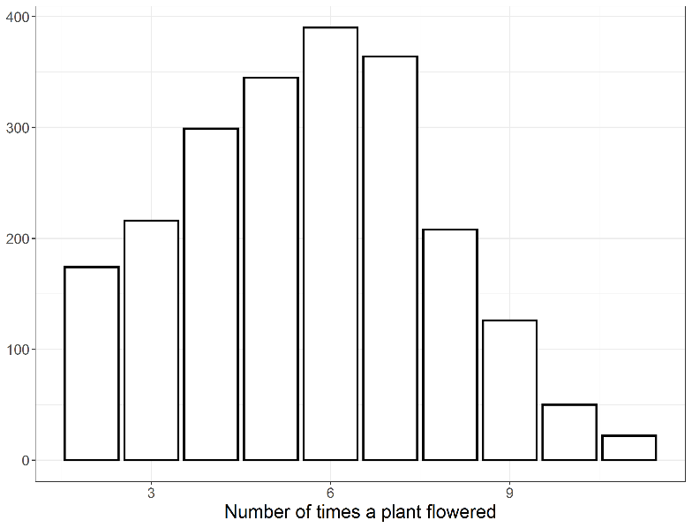

Figure X. Histogram of the number of times plants flowering within the study period (2005 to 2013). The overall average was 5.63.

Peak flowering day, the day at which the most plants were flowering at the same time, ranged from July 3rd to August 8th, with a median peak flowering day across all 13 years on July 14th (Figure X).

Across all study years (except 2010 where data was aggregated by plant instead of by head), average flowering duration per head was 13.1 days (+/- 3.19 days – standard deviation). Flowering duration did vary from year to year, however, with averages ranging from 10.2 to 15.1 (Figure X).

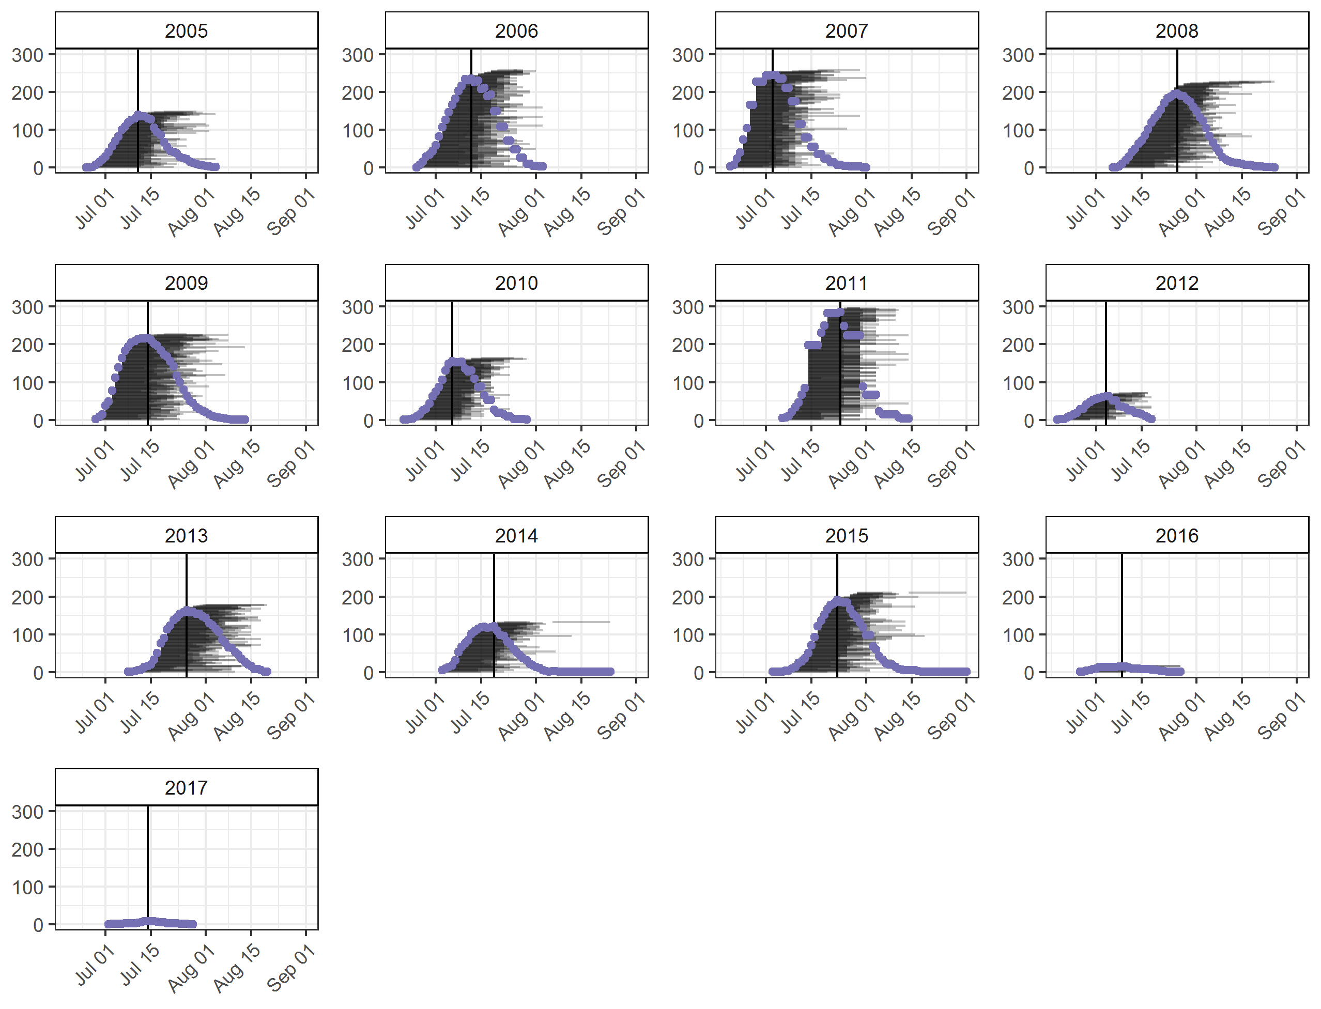

**Figure X.** Flowering schedules for each year. Horizontal lines represent the flowering period for an individual plant. Purple dots indicate the total number of flowering plants in the experimental plot on a given date. The vertical lines in each pane indicate the peak flowering day for a given year, the day on which the greatest number of plants were flowering.

**Literature Cited**

Craine, J. M., E. M. Wolkovich, E. Gene Towne, and S. W. Kembel. 2012. Flowering phenology as a functional trait in a tallgrass prairie. New Phytologist.

Ison, J. L., and S. Wagenius. 2014. Both flowering time and distance to conspecific plants affect reproduction in Echinacea angustifolia, a common prairie perennial. Journal of Ecology.

Stoffel, M. A., S. Nakagawa, and H. Schielzeth. 2017. rptR: repeatability estimation and variance decomposition by generalized linear mixed-effects models.

Wagenius, S., and S. P. Lyon. 2010. Reproduction of Echinacea angustifolia in fragmented prairie is pollen-limited but not pollinator-limited. Ecology 91:733–742.