**Lydia Alford**

811 Ferrara Circle, Unit A, Temple, TX 76502    phone number: xxxx xxxxxxxxxxxxxxxx@gmail.com

**Performance Summary:**

* Strong communicator, both visually and written, confidently delivers presentations
* Analytical
* Empathetic Leader
* Community Builder
* Diplomatic

**Work Experience:**

Content Developer at University of Phoenix; Austin, TX; full-time, (2020-current)

* Partnered with product teams to implement cross-functional change
* Increased the B2B partnership by 27%
* Re-built internal web pages to increase traffic and effectiveness by 30%
* Conducted user research through surveys, interviews, and focus groups

Finance Advisor at University of Phoenix; Dallas, TX; full-time (2018-2020)

* Analyzed data and researched financial accounts
* Worked with students to balance their accounts

Advertising and Marketing at Skyview Ranch; Millersburg, OH; full-time, (2011-2016)

* Worked in a fast-paced environment with various stakeholders to build campaigns
* Created essential HTML and CSS content using Dream Weaver
* Worked with developers, finance, marketing, and HR to create content for stakeholders

**Skills:**

Figma, Sketch, Miro, Adobe CC, HTML, CSS, PowerPoint, Microsoft Office, managing end-to-end research, qualitative and quantitative UX research, Agile methodology, UX Design,

**Education:**

Bachelor of Business in Advertising and Public Relations with a minor in Graphic Design, Pensacola Christian College, 250 Brent Lane; graduated Fall 2018

**Lydia Alford**

811 Ferrara Circle, Unit A, Temple, TX 76502    phone: xxxxxxxxxxxxxx xxxxxxxxxx@gmail.com

**Performance Summary:**

* Strong communication skills, both visual and written, with the ability to confidently deliver a polished presentation to stakeholders
* Content Management experience with a cross-functional team of developers
* Thorough attention to detail
* HTML and CSS

**Work Experience:**

**UX and Design Teacher at Perdu University: Present**

Taught classes on the principles of design and UX research at Perdu University to engage and encourage students in their professional pursuits.

**Senior UX Researcher: Google (2029-Present)**

Planned and oversaw the process used by UX teams to translate user insight into experiences. Created functional features to address needs. Worked with product managers, visual designers, and additional members of development teams while being the user’s voice to translate needs into the design.

**UX Researcher: Cisco Systems (2026-2029)**

Conducted primary and secondary user research to evaluate quantitative and qualitative research. Worked closely with cross-functional teams to identify issues and create an empathic user experience and then presented these findings in oral and written presentations to help the UX team better understand the user experience.

**Junior UX Designer: Salesforce (2023-2026)**

Assisted in wireframing, sketching, prototyping, and creating user flows. Helped organize and analyze research to help create a better understanding of user usability.

**Skills:**

Graphic Design, Adobe CC, Research, Figma, Adobe XD, Sketch, Microsoft Office, research, information architecture, wireframing, prototyping, visual communication, user flows, empathy mapping, Agile, user research

**Education:**

Bachelor of Business in Advertising and Public Relations with a minor in Graphic Design, Pensacola Christian College, 250 Brent Lane; graduated Fall 2018

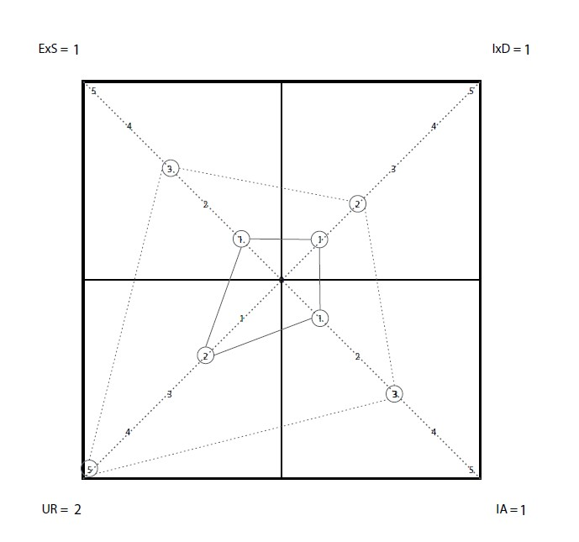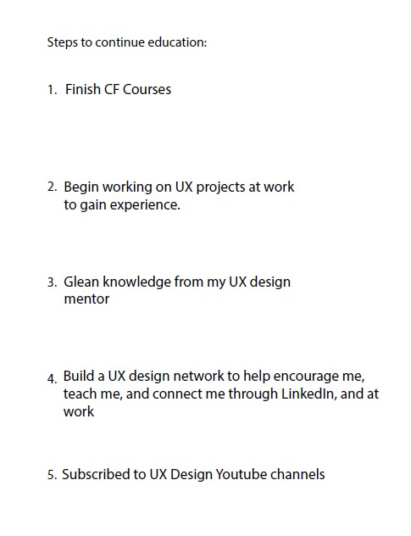**Design Profile: Ranking**

**Case Study One: Salesforce App, Cloud Computing Enterprise Software Consulting**

The software for Salesforce is user-friendly on an excellent tool for users as a customer success platform, but the app has a 3.9-star review compared to the Salesforce desktop software, which has a 4.5-star review. The app needs to be easier to navigate and easy to use on the go, the app is glitchy, and users report having the most challenging time with being “clunky” and slow. I would want to re-create a platform with obvious iconography and easier navigation.

**Case Study Two: Prudential Retirement App, Retirement Planning**

Retirement and finances can be tricky to navigate and Prudential Retirement app is just that, it’s tricky to navigate. Information on the portfolios is only available online but would be so helpful to have on the app so users can make informed decisions when looking at changing portfolios. The app also has very little education on how to make informed decisions, so users are left feeling stuck making decisions. The app needs a mapping facelift so it’s easier and more obvious where to navigate. It also needs a feature that can teach users how to make informed retirement decisions.

**Case Study Three: EPIC, Medical Charting Software**

Nurses chart everything and EPIC is one of the main software out there those nurses use to complete a patient’s chartings. However, EPIC is considered a nightmare by many healthcare providers saying it’s difficult to navigate and takes forever to load and fill out a chart. I would want to find an easier way of making the charting more user-friendly to reduce the time nurses spend on charting as well as develop an easier way for nurses to log in and out.

**Case Study Four: Instacart, a Grocery delivery app**

I want to create a feature where you can customize your grocery experience by scheduling multiple grocery hauls ahead of time and customizing each order rather than having to order groceries each week.